RUN-WAY : A Multi-Tiered Virtual Fashion Showcase and Engagement Platform

Prepared by:
Cabuenas, Rhea Rose A.
Godinez, John Matthew
Reguero, Jhamir T.

Submitted to:
Mr. Benedict Castro
ERD (Entity Relationship Diagram) – RUN-WAY

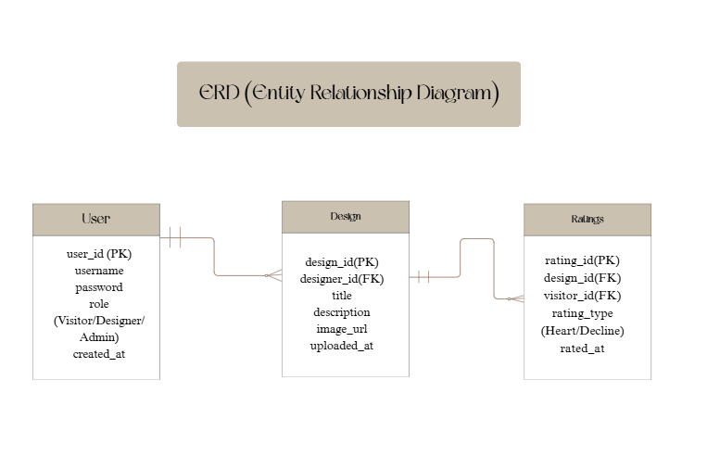

DATA DICTIONARY
User Table
Field Name | Data Type | Description
user_id | INT (PK) | Unique identifier for each user
username | VARCHAR | Display name of the user
password | VARCHAR | Encrypted password for login
role | ENUM | User role: Visitor, Designer, or Admin
created_at | DATETIME | Timestamp of account creation

Design Table
Field Name | Data Type | Description
design_id | INT (PK) | Unique identifier for each design
designer_id | INT(FK) | References user_id of the designer
title | VARCHAR | Title of the fashion design
description | TEXT | Description or concept of the design
image_url | VARCHAR | Link to the uploaded design image
upload_at | DATETIME | Timestamp of design upload

Rating Table
Field Name | Data type | Description
rating_id | INT(PK) | Uniques identifier for each rating
design_id | INT(FK) | References desing_id being rated
visitor_id | INT(FK) | References user_id of the visitor
rating_type | ENUM | Rating value: Heart or Decline
rated_at | DATETIME | Timestamp of when the rating was submitted

