AIRIQ · EXPLORATORY DATA ANALYSIS
Daily air quality across 26 Indian cities · 30 November 2020 – 25 May 2023
23,504 daily readings · 8 pollutants · CPCB NAAQS benchmarks · Atmos Design System v1.1.0 · 02 October 2026

1. Executive summary
This report profiles the dataset behind the AirIQ dashboards: daily ambient air-quality readings from the CPCB continuous monitoring network, packaged inside Air_Pollution_Dashboard.twbx. Every number below is computed directly from that extract, so the report and the dashboards can never disagree. The dashboard's headline analytical window is the two complete years 2021–2022 (18,928 records); this analysis covers the full extract.
RECORDS ANALYSED  23,504  26 cities × 904 reporting days | UNHEALTHY DAYS  71%  share of city-days at AQI ≥ 4 | PM2.5 EXCEEDANCE  49%  days above the 24-h NAAQS limit
WORST · BEST CITY  Delhi · Aizawl  avg AQI 4.81 vs 2.78 | PEAK SEASON  Winter  every city peaks Nov – Mar | YOY CHANGE 2021→22  -0.9%  national avg AQI 3.89 → 3.86

- Air is unhealthy most of the time. 71% of all city-days sit at AQI ≥ 4, and 53% fall in the worst category (5). Clean-air days are the exception, not the rule.
- A north-Indian pollution belt stands out. Delhi, Jorapokhar, Amritsar, Patna and Lucknow average AQI 4.7+ with roughly 95% unhealthy days, while Aizawl, Coimbatore, Kochi, Ernakulam and Bengaluru stay near 2.9.
- Particulates are the binding constraint. PM2.5 exceeds its 24-hour NAAQS limit on roughly half of all days and PM10 on two of five; every other pollutant is compliant on 96%+ of days. Mean PM2.5 runs at ~2.3× the annual limit.
- Seasonality is strong and consistent. The national average climbs from a monsoon trough near 2.8 (Jul–Aug) to winter peaks above 4.7 (Nov–Feb); all 26 cities peak between November and March.
- Year-over-year, air barely improved. National average AQI moved 3.89 → 3.86 (-0.9%) between the two complete years — structurally flat.
- Data quality is excellent. 26 cities × 904 days with zero nulls and zero duplicates; only 3 calendar days are absent from the entire network.

2. Dataset & data quality
The extract is a tidy daily panel: one row per city per day, an ordinal AQI index, and daily mean concentrations for eight pollutants. The AQI is a 1–5 category scale (1 = best, 5 = worst); the workbook classes days at AQI ≥ 4 as unhealthy and bins city averages into Low (≤ 3.3), Moderate (≤ 4.2) and High.
Field | Type | Description
city | Text | Monitoring city — 26 stations across India
date | Date | Calendar day, 30 Nov 2020 → 25 May 2023
aqi | Integer | Ordinal air-quality index, 1 (best) → 5 (worst); ≥ 4 = unhealthy day
co | Number | Daily mean carbon monoxide concentration
no | Number | Daily mean nitric oxide concentration
no2 | Number | Daily mean nitrogen dioxide concentration
o3 | Number | Daily mean ground-level ozone concentration
so2 | Number | Daily mean sulphur dioxide concentration
pm2_5 | Number | Daily mean fine particulate matter (PM2.5) concentration
pm10 | Number | Daily mean coarse particulate matter (PM10) concentration
nh3 | Number | Daily mean ammonia concentration

- 23,504 rows · 26 cities · 904 reporting days per city (every city reports on exactly the same days).
- Coverage: 904 of 907 calendar days (99.7%). The three absent dates — 21 Jul 2022, 10 Dec 2022, 24 Feb 2023 — are missing network-wide, not per city.
- Zero null values across all 11 fields and zero duplicate (city, date) keys — no imputation or cleaning was required.
- Edge years are partial (Dec 2020: 32 days; Jan–May 2023: 144 days), so year-over-year comparisons in this report use the complete years 2021 and 2022.
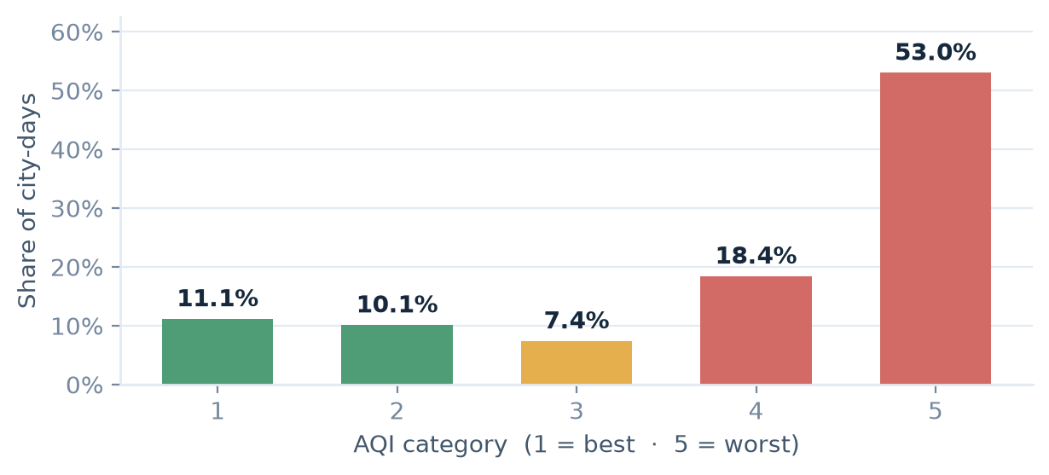
Figure 1 · Share of city-days by AQI category, all 26 cities, Nov 2020 – May 2023. Green = below the unhealthy threshold, red = AQI ≥ 4.

3. Where pollution concentrates
Average exposure differs more between cities than between years. Mean PM2.5 spans 204 µg/m³ in Delhi against 33 in Aizawl — a six-fold gap — and the share of unhealthy days ranges from below 40% to above 96%.
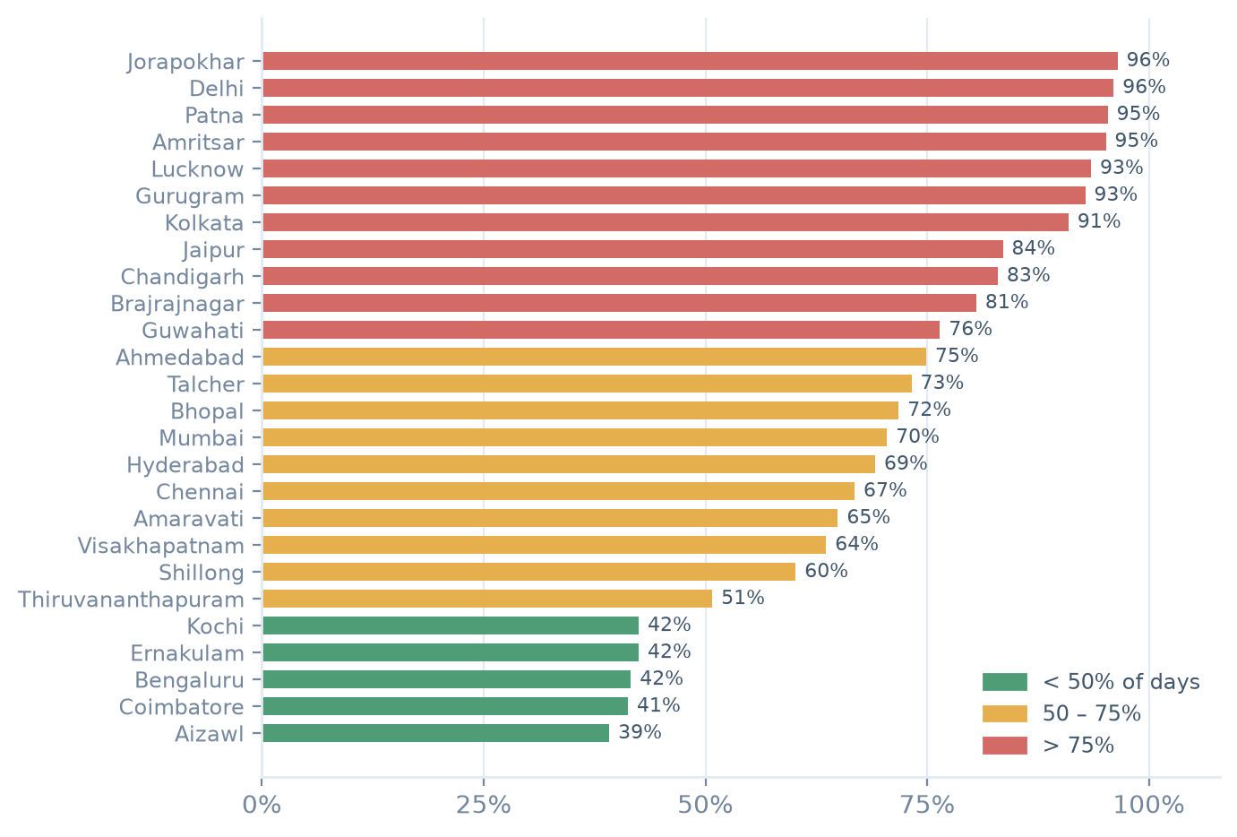
Figure 2 · Share of days at AQI ≥ 4 by city, full period. Colour follows the workbook status scale: green < 50%, amber 50–75%, red > 75%.
Rank | City | Avg AQI | Unhealthy days | Mean PM2.5 (µg/m³)
1 | Delhi | 4.81 | 96.0% | 204
2 | Jorapokhar | 4.81 | 96.5% | 142
3 | Amritsar | 4.78 | 95.1% | 177
4 | Patna | 4.76 | 95.4% | 178
5 | Lucknow | 4.70 | 93.5% | 155
22 | Bengaluru | 2.86 | 41.6% | 32
23 | Kochi | 2.82 | 42.5% | 33
24 | Ernakulam | 2.82 | 42.5% | 33
25 | Coimbatore | 2.80 | 41.3% | 32
26 | Aizawl | 2.78 | 39.2% | 33
⋮ 16 cities in between ⋮
The most burdened cities form a contiguous belt — Delhi NCR, the Indo-Gangetic plain and the Jharkhand coal corridor (Jorapokhar, Talcher) — while coastal and southern cities (Aizawl, Kerala’s Kochi and Ernakulam, Coimbatore, Bengaluru) breathe consistently cleaner air.

4. Pollutants vs NAAQS limits
Each pollutant is benchmarked against the Indian NAAQS limits the workbook uses: a 24-hour limit (the “exceedance” test behind the drilldown’s Percentage-of-Days chart) and an annual limit (the reference line in the Avg-Concentration chart). Particulates dominate both tests; CO clears its annual limit on average, but only marginally.
Pollutant | Mean | Median | 24-h limit | Days above | Annual limit | Mean vs annual
PM2.5 | 98.6 | 58.9 | 60 | 49.3% | 40 | 246%
PM10 | 121.8 | 75.8 | 100 | 39.2% | 60 | 203%
NO2 | 25.0 | 16.4 | 80 | 4.2% | 40 | 63%
CO | 1,113.2 | 701.0 | 4,000 | 3.2% | 1,000 | 111%
SO2 | 16.0 | 8.0 | 80 | 2.8% | 50 | 32%
NO | 6.0 | 0.0 | 80 | 1.9% | 40 | 15%
O3 | 35.1 | 28.2 | 180 | 0.1% | 100 | 35%
NH3 | 12.1 | 6.5 | 400 | 0.0% | 400 | 3%

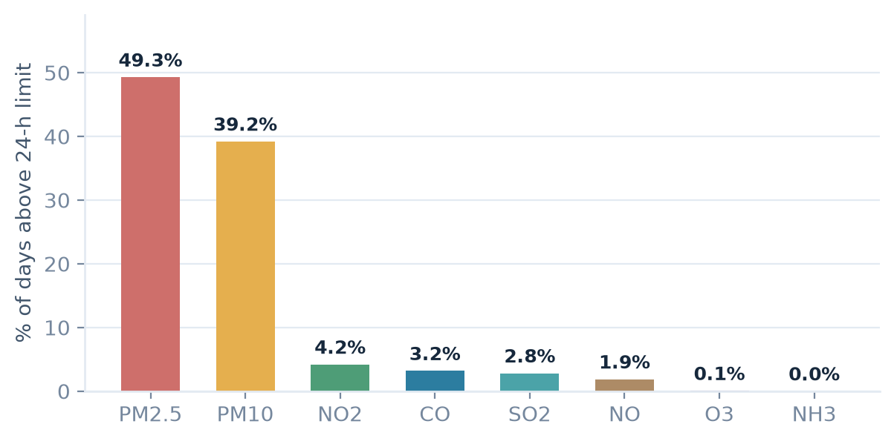
Figure 3 · Share of days above the NAAQS 24-hour limit by pollutant, full period. Bars use each pollutant’s fixed palette colour.
Average concentrations rank CO (1,113), PM10 (122) and PM2.5 (99) highest — the same top five the Nationwide Overview’s “Top 5 Pollutants” card shows. Medians sit well below means for every pollutant: the distributions are right-skewed, driven by episodic winter spikes rather than a uniformly high baseline.

5. Seasonality & year-over-year trend
Pollution in India is a winter problem. The national average AQI bottoms out during the monsoon (Winter 4.69 (93% unhealthy) · Pre-monsoon 3.85 (67% unhealthy) · Monsoon 2.96 (46% unhealthy) · Post-monsoon 4.31 (82% unhealthy)) and peaks between November and February. 26 of 26 cities record their worst month inside the November–March window; none peaks between April and October.
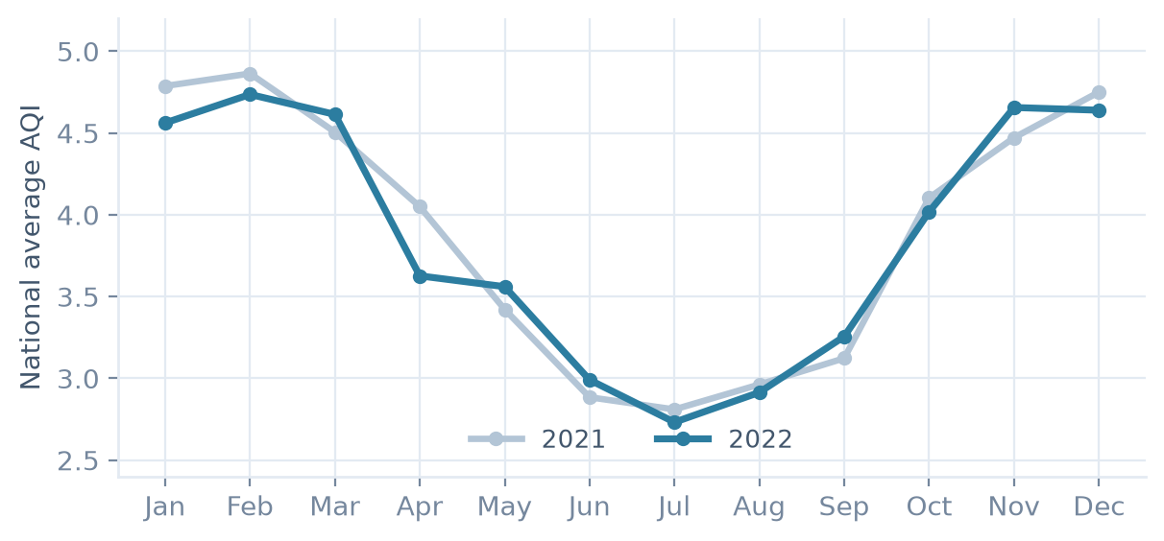
Figure 4 · National monthly average AQI, 2021 vs 2022. The two years trace an almost identical seasonal curve.
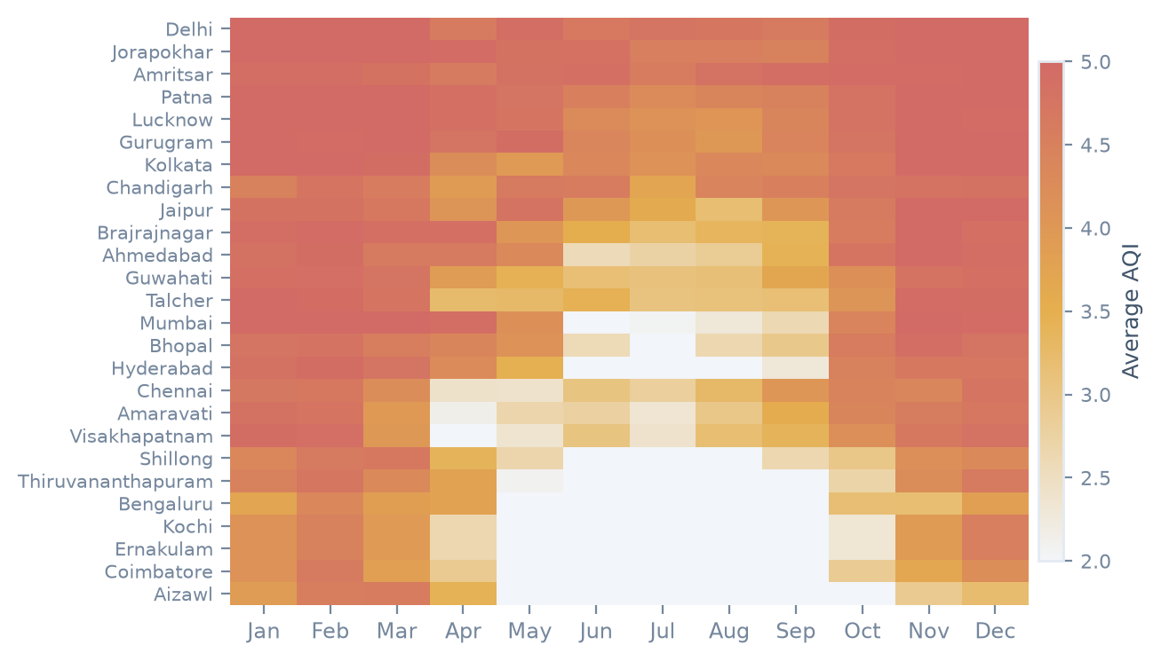
Figure 5 · Average AQI by city and month, 2021–2022. Cities are ordered worst to cleanest; darker red = higher AQI.

6. Key findings & how they reach the dashboard
- 1. Unhealthy air is the norm. 71% of city-days are at AQI ≥ 4 and 53% in the worst category — the headline KPI band on the Nationwide Overview.
- 2. Geography is destiny. Avg AQI spans 4.81 (Delhi) to 2.78 (Aizawl); the north-Indian belt vs south/northeast split is the dataset’s strongest pattern.
- 3. PM2.5 is the pollutant to manage. It breaches the 24-h limit on ~49% of days and averages ~2.3× the annual limit; PM10 follows. Gaseous pollutants are largely compliant.
- 4. Winter is the danger window. Every city peaks Nov–Mar, with ~95% unhealthy days in winter vs ~46% in the monsoon — the timing story told by the monthly trend and the peak-month KPIs.
- 5. 2022 looked like 2021. National average AQI 3.89 → 3.86 (-0.9%), so year filters change the picture far less than city or season.
- 6. The data can be trusted. Zero nulls, zero duplicates, 99.7% calendar coverage — no cleaning layer between the extract and the dashboards.

Analysis in this report | Where it appears in the dashboard
City ranking & unhealthy-day share (Fig. 2) | Average AQI by City — bubble map, Nationwide Overview
Monthly 2021 vs 2022 profile (Fig. 4) | Monthly AQI Trend by Year — matrix, Nationwide Overview
Pollutant concentration ranking (§4) | Top 5 Air Pollutants by Avg Concentration — bars, Nationwide Overview
Annual NAAQS compliance (§4) | Avg Concentration vs annual-limit reference — bars, City Drilldown
24-hour exceedance rate (Fig. 3) | Percentage of Days above the limit — bars, City Drilldown
Peak-month & seasonality (Fig. 5) | Peak Pollution Month — KPI cards on both dashboards

Method & reproducibility — every statistic and figure in this document is computed live from the packaged extract inside Air_Pollution_Dashboard.twbx, and every colour resolves to the Atmos tokens in theme/palette.json. Re-run after any data or palette change:
python3 theme/make_eda_doc.py

AirIQ EDA · generated from the workbook extract · Atmos Design System v1.1.0 · 02 Oct 2026

