INDIA AIR QUALITY INTELLIGENCE
Tableau Dashboard Suite · Design & Documentation
Atmos Design System v1.1.0 · 02 October 2026 · Workbook: Air_Pollution_Dashboard.twbx

1. What was delivered
The original workbook contained 16 worksheets and two dashboards styled with ad-hoc colors (yellow panels, black title bars, a dark basemap, mixed fonts). This delivery rebuilds both dashboards on a professional card-based layout, introduces the Atmos modular color system, adds a city locator map, and ships a theme builder that can re-skin the entire workbook from a single token file.
Item | Description
Air_Pollution_Dashboard.twbx | The themed Tableau workbook — fully editable in Tableau Desktop. Two dashboards, 17 worksheets, all filters and parameters preserved.
theme/palette.json | Design tokens — the single source of truth for every color and font size in the workbook and this document.
theme/apply_theme.py | Theme builder: restyles worksheets, pins mark colors, rebuilds dashboards, generates button assets and design previews. Idempotent.
preview/*.png | Design previews of both dashboards, rendered from the same layout spec and tokens.
DESIGN_SYSTEM.md | Developer-facing reference version of this document.
This document | Editable stakeholder documentation — regenerate any time with theme/make_doc.py.

2. The data
Daily ambient air-quality readings published by the CPCB continuous monitoring network: 26 Indian cities, January 2021 – December 2022 (18,928 daily records). Each record carries an AQI index (1–5 scale; unhealthy ≥ 4) plus concentrations of eight pollutants — CO, NO, NO₂, O₃, SO₂, PM2.5, PM10 and NH₃ — benchmarked against Indian NAAQS annual and 24-hour limits.

3. Dashboard guide

3.1 Nationwide Overview
The executive landing view: national KPIs, a city-level AQI map, and the two signature analytical charts. A Year filter in the header compares 2021 vs 2022 across every chart; the header button drills into city-level detail.
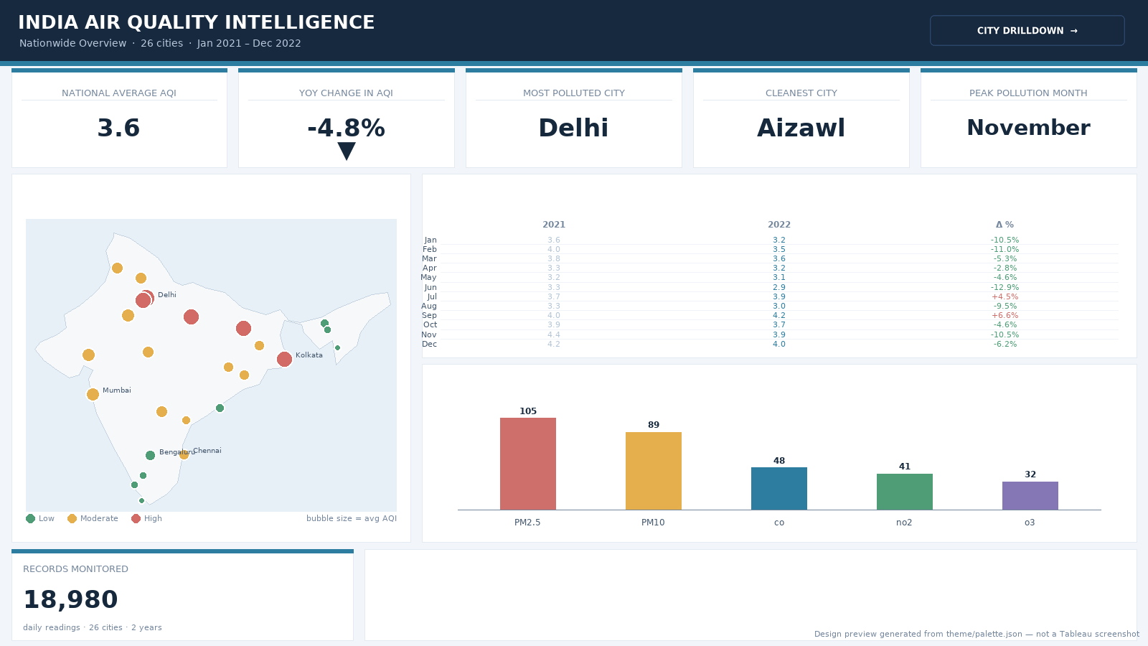
Band | Contents
Header | Title + subtitle, Year filter (dropdown), City Drilldown navigation button, brand accent rule
KPI band | National Average AQI · YoY Change in AQI · Most Polluted City · Cleanest City · Peak Pollution Month
Chart grid | Average AQI by City (bubble map, color = category, size = avg AQI) · Monthly AQI Trend by Year (matrix) · Top 5 Air Pollutants by Avg Concentration (bars)
Footnote band | Records Monitored stat card + “How to read” guidance

3.2 City Drilldown
The analytical deep-dive. A control strip drives every chart: pick a city and a pollutant and the whole page updates — including a locator map that zooms to the selected city. A header button returns to the national overview.
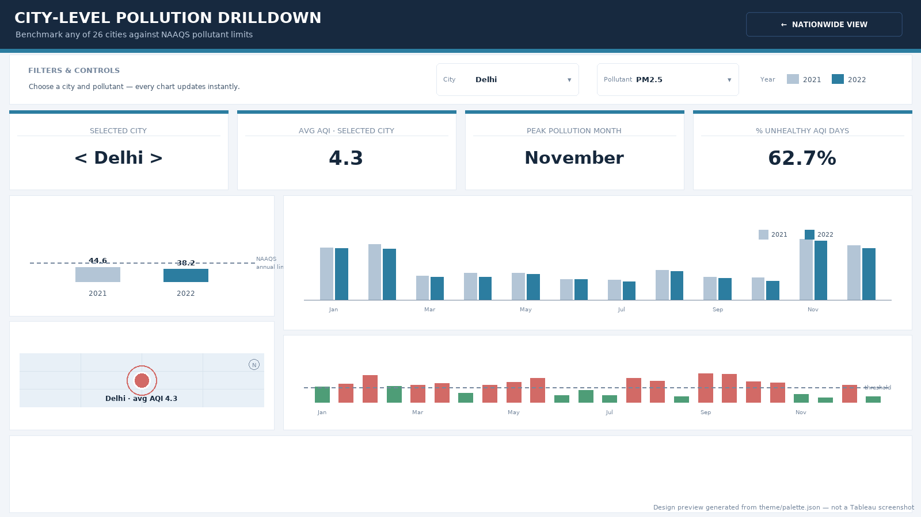
Band | Contents
Header | Title + subtitle, Nationwide View navigation button, brand accent rule
Control strip | City filter (dropdown) · Pollutant parameter · Year color legend
KPI band | Selected City · Avg AQI · Peak Pollution Month · % Unhealthy AQI Days
Chart grid | Average concentration of the selected pollutant, 2021 vs 2022, against the NAAQS annual limit · Selected City Location (locator map) · Monthly concentration trend by year · % of days above the NAAQS 24-hour limit
Footnote band | “How to read” guidance + source note

4. The Atmos design system
Every color used anywhere — dashboard chrome, worksheet surfaces, mark colors, fonts, buttons, and this document — resolves to a token in theme/palette.json. Discrete mark colors are additionally pinned in the workbook XML as value → color maps, so the same value always renders the same color on every sheet.

4.1 Surfaces, ink and lines
Group | Token | Hex |  | Applied to
Surface | canvas | #F2F5F9 |  | Dashboard background
Surface | card | #FFFFFF |  | All cards; worksheet table and title backgrounds
Surface | header | #17293F |  | Dashboard header band
Ink | heading | #16283C |  | Chart titles, KPI values, emphasis text
Ink | body | #42566C |  | Worksheet text, footnotes
Ink | muted | #75879D |  | KPI labels, captions, reference lines, tooltips
Ink | inverse | #FFFFFF |  | Title text on the header
Ink | inverseMuted | #B9C8DB |  | Subtitle text on the header
Line | hairline | #E3EAF2 |  | Card borders
Line | headerRule | #33517A |  | Navigation button border

4.2 Brand, series and status
Group | Token | Hex |  | Applied to
Brand | primary | #2C7DA0 |  | Accent rule, KPI card accent strips, Avg-AQI marks, 2022 series, parameter highlight
Brand | primaryDark | #1F5F80 |  | Reserved for emphasis / hover
Series | prior (2021) | #B3C5D6 |  | Prior-year marks and bars
Series | current (2022) | #2C7DA0 |  | Current-year marks and bars
Status | good | #4E9D77 |  | Low AQI category; within NAAQS limits
Status | moderate | #E5AF4E |  | Moderate AQI category
Status | bad | #D26A66 |  | High AQI category; exceedance days

4.3 Categorical and pollutant palette
Group | Series | Hex |  | Applied to
Pollutant | PM2.5 | #CE6F6B |  | Fixed color for PM2.5 — bars, legends, encodings
Pollutant | PM10 | #E5AF4E |  | Fixed color for PM10 — bars, legends, encodings
Pollutant | CO | #2C7DA0 |  | Fixed color for CO — bars, legends, encodings
Pollutant | NO2 | #4E9D77 |  | Fixed color for NO2 — bars, legends, encodings
Pollutant | O3 | #8577B5 |  | Fixed color for O3 — bars, legends, encodings
Pollutant | SO2 | #4BA3A8 |  | Fixed color for SO2 — bars, legends, encodings
Pollutant | NH3 | #9BA75D |  | Fixed color for NH3 — bars, legends, encodings
Pollutant | NO | #AD8B66 |  | Fixed color for NO — bars, legends, encodings

4.4 Semantic color locks
- Years: 2021 → series.prior, 2022 → series.current — every year-colored mark in the workbook.
- AQI category: Low → good, Moderate → moderate, High → bad (map bubbles and legends).
- Exceedance flag: Normal → good, High → bad (days above the NAAQS 24-hour limit).
- Pollutants: each of the eight pollutants keeps one fixed color across all sheets.

4.5 Typography
Role | Font | Size | Weight
Dashboard title | Tableau Bold | 22 | Bold
Dashboard subtitle | Tableau | 10 | Regular
Chart titles | Tableau Bold | 12 | Bold
KPI labels | Tableau | 10 | Regular (uppercase)
KPI values | Tableau Bold | 18–26 | Bold
Footnotes | Tableau | 9 | Regular
Tableau’s bundled font family is used throughout so the workbook renders identically on every machine — no font installation required.

4.6 Layout grid
- 1% page margins and 1% gutters between cards on both dashboards.
- Full-bleed navy header band (9.5% height) followed by a brand accent rule.
- Bands stack vertically: header → controls (drilldown) → KPI band → chart grid → footnote.
- Sizing mode is Automatic, so the percent-based grid adapts to any screen.

5. Worksheet reference
Worksheet | Type | Shows | Used on
National AQI | KPI | National average AQI (Year filter aware) | Nationwide · KPI band
% Change | KPI | Year-over-year change in average AQI | Nationwide · KPI band
Most Polluted City | KPI | City with the highest average AQI | Nationwide · KPI band
Cleanest City | KPI | City with the lowest average AQI | Nationwide · KPI band
Peak Pollution Month | KPI | Month with the highest average AQI | Nationwide · KPI band
Total Records Monitored | KPI | Count of daily readings in scope | Nationwide · footnote
Map | Map | Bubble map of average AQI for all 26 cities | Nationwide · chart grid
Monthly Y Variation | Matrix | Monthly average AQI for 2021, 2022 and the YoY delta | Nationwide · chart grid
Top 5 Pollutants | Bar chart | Top five pollutants by average concentration | Nationwide · chart grid
City Selector | KPI | Name of the city currently selected by the filter | Drilldown · KPI band
Avg AQI | KPI | Average AQI for the selected city | Drilldown · KPI band
C Peak Pollution Month | KPI | Peak pollution month for the selected city | Drilldown · KPI band
Unhealthy AQI Days | KPI | Share of days with AQI ≥ 4 for the selected city | Drilldown · KPI band
Avg Conc Year | Bar chart | Selected pollutant, 2021 vs 2022, vs NAAQS annual limit | Drilldown · chart grid
City Map | Map | Locator map that zooms to the selected city | Drilldown · chart grid
Monthly Avg Concentration | Bar chart | Monthly concentration of the selected pollutant by year | Drilldown · chart grid
Percentage of Days | Bar chart | Share of days above the NAAQS 24-hour limit, with threshold reference | Drilldown · chart grid

6. Re-theming the workbook
The color code is modular: change tokens in theme/palette.json, re-run one command, and the entire workbook — dashboards, worksheets, mark colors, map, buttons, previews and this document — re-skins together. The build is idempotent, so it can be run on an already-themed workbook at any time.
- Edit theme/palette.json (colors and/or font sizes).
- Run: python3 theme/apply_theme.py
- Optional: python3 theme/make_doc.py to regenerate this document.
- Open Air_Pollution_Dashboard.twbx in Tableau — the new theme is applied.
Example — a warmer brand in two tokens:
"brand": { "primary": "#B3541E", "primaryDark": "#8C3F16" },
"surface": { "canvas": "#F7F2EC", "card": "#FFFFFF", "header": "#3B2A1D" }

7. Quality assurance
- Generated workbook XML is well-formed and opens cleanly in Tableau.
- Zone geometry audited programmatically — no overlaps, nothing out of bounds on either dashboard.
- Every color literal in the workbook resolves to a palette token (zero stray colors).
- Data extracts (.hyper) byte-identical to the original upload — no data was touched.
- All navigation buttons resolve to their target windows; all worksheet references valid.
- Theme builder verified idempotent — consecutive runs produce identical workbook content.

Generated from theme/palette.json · Atmos Design System v1.1.0 · 02 Oct 2026

