**Assignment 1**

**Articol 1 : Forest Fire Prediction Using Image Processing And Machine Learning   
(**[**https://www.nveo.org/index.php/journal/article/view/2812/2382**](https://www.nveo.org/index.php/journal/article/view/2812/2382)**)**

Set de date

Setul de date este compus din imagini din satelit cu paduri (luate cu ajutorul API-ului de la Google). Datele folosite nu sunt disponibile.

Algoritmi folositi

Segmentarea imaginilor este facuta cu un model de U-net. Se foloseste un model R-CNN ce prezice imaginea cat timp aceasta este neprocesata si returneaza daca gaseste zone cu foc. (Yes – foc \ No – nu e foc)

Metrici / Rezultate:

Acuratete: 92%

Recall: 0.975

Precision: 0.8478

F-measure (2*recall*precision) / (recall + presision)

(2*0.975*0.8478) / (0.975+0.8478) = 0.907

**Articol 2: Deep Learning Approaches for Forest Fires Detection and Prediction**

**using satellite Images**

**(**[**https://www.sciencedirect.com/science/article/pii/S187705092403415X**](https://www.sciencedirect.com/science/article/pii/S187705092403415X)**)**

Set de date

Sunt mai multe seturi de date pe care se antreneaza modelele. Fiecare set de date este impartit in:

* Imagini cu foc
* Imagini fara foc

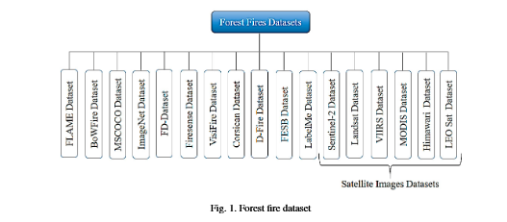

Algoritmi folositi

Modelele propuse:

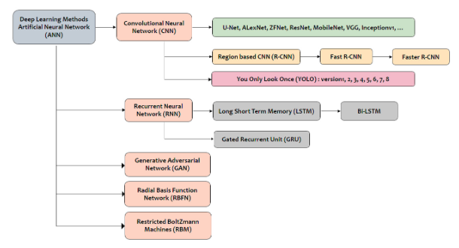

Modell ce foloseste Landsat-8 (imagini din satelit):

S-a folosit FireNet (implementat cu tensorflow)

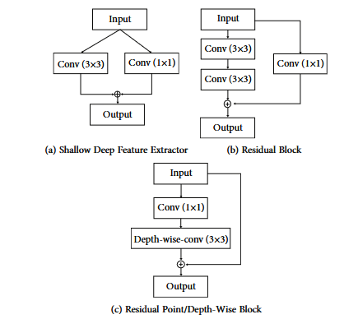

Optimizer: Adam: 0.001

Batch: 7 patches

Epoci: 250

Metrici / Rezultate:

**Overall Accuracy (OA)**: 99.95% (Australia), 99.99% (Central Africa, Brazil, Chernobyl).

**Precision**: 97.94% (Australia), 84.06% (Central Africa), 95.98% (Brazil), 95.98% (Chernobyl).

**Recall**: 97.20% (Australia), 77.27% (Central Africa), 98.04% (Brazil), 98.04% (Chernobyl).

**F1-Score**: 97.57% (Australia), 80.52% (Central Africa), 97.00% (Brazil), 97.24% (Chernobyl).

**False Positive Rate (FPR)**: 0.02% (Australia), 0.00007% (Central Africa), 0.0004% (Brazil), 0.0006% (Chernobyl).

**Miss Detection Rate (MD)**: 2.79% (Australia), 22.72% (Central Africa), 1.95% (Brazil), 4.58% (Chernobyl).

**Kappa Coefficient (KC)**: 0.975 (Australia), 0.429 (Central Africa, Brazil, Chernobyl)