**Assignment 2**

Seturile de date folosite:

alik05\_forest-fire-dataset (<https://www.kaggle.com/datasets/alik05/forest-fire-dataset>)

elmadafri\_the-wildfire-dataset (<https://www.kaggle.com/datasets/elmadafri/the-wildfire-dataset>)

kutaykutlu\_forest-fire (<https://www.kaggle.com/datasets/kutaykutlu/forest-fire>)

mohnishsaiprasad\_forest-fire-images (<https://www.kaggle.com/datasets/mohnishsaiprasad/forest-fire-images>)

phylake1337\_fire-dataset (<https://www.kaggle.com/datasets/phylake1337/fire-dataset>)

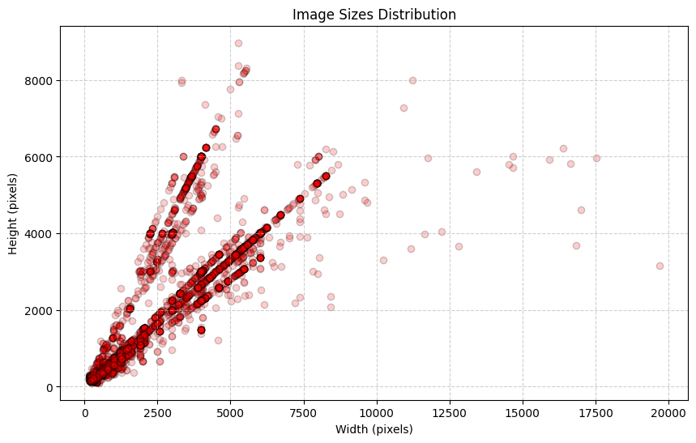

distributia marimilor imaginilor din toate seturile de date

Imaginile au fost redimensionate la 265x265 pixeli.