Game Design Document

Fill up the Following document

1. Write the title of your project.

The forest adventure

1. What is the goal of the game?

To save safari men from attacking tigers

1. Write a brief story of your game?

Two safari men are exploring the forest but is attacked by a bunch of tigers.

Save them from being killed. Shoot the tigers coming from either side.

1. Which are the playing characters of this game?

* Playing characters are the ones which respond to the user based on the input from the user
* Cars, monkeys, dinos, wizards etc, are the playing characters in the game.

|  |  |  |
| --- | --- | --- |
| Number | Character Name | What can this character do? |
| 1 | Safari man 1 | Defend |
| 2 | Safari man 2 | Defend |
| 3 | Gun | Shoot |
| 4 | Bullet | Kill the tiger |
| 5 |  |  |
| 6 |  |  |
| 7 |  |  |
| 8 |  |  |

1. Which are the Non Playing Characters of this game?

* Non Playing characters are the ones which don't have an action or a behaviour when the user interacts with the game.
* Hurdles, stones, bananas, coins, etc are non playing characters in the game.

|  |  |  |
| --- | --- | --- |
| Number | Character Name | What can this character do? |
| 1 | Tiger | Kill the safari men |
| 2 | Lion | Reduce 2 lives |
| 3 |  |  |
| 4 |  |  |
| 5 |  |  |
| 6 |  |  |
| 7 |  |  |
| 8 |  |  |

Draw your imagination of this game. What does this game look like?

* Draw the game either on your computer or on paper,
* Add images of scenes of the game to show each of the playing and non-playing characters at least once.

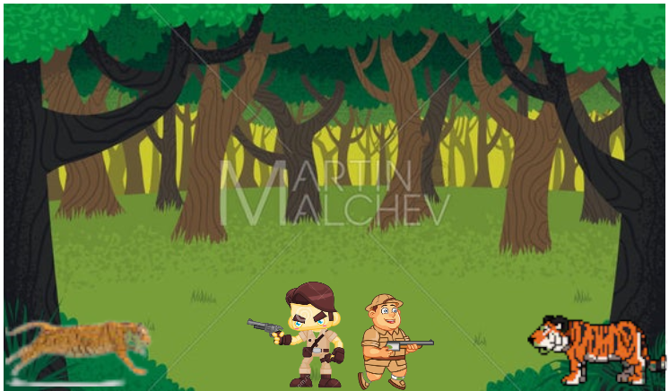

How do you plan to make your game engaging?

By increasing the speed of tigres with score