**B- Agile and Scrum**

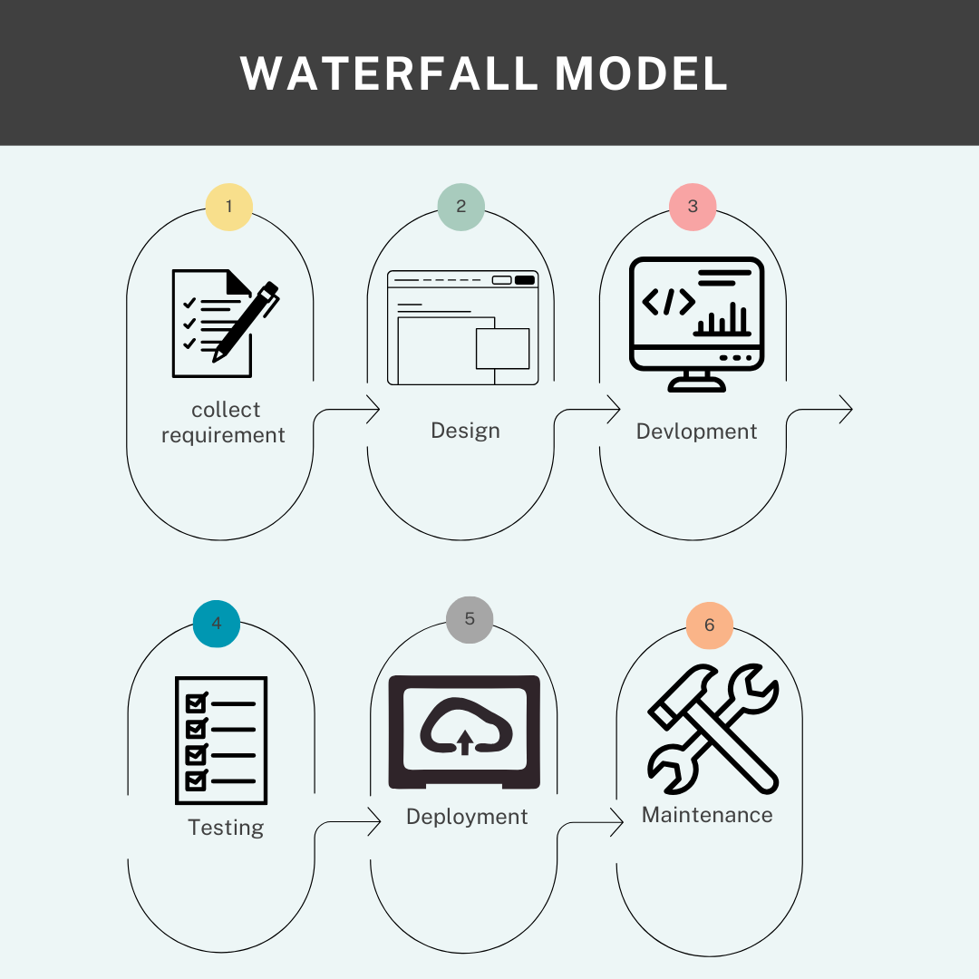

**Agile**

User for Long time Project.

You can work in every step at any time.

You can update the project.

**Waterfall**

Clear Requirement.

Step by step.

Take time.