**Grouped Column Table Widget**

**Manual Installation**

1. Copy **com.temenos.widgets.tables.groupedColumnTable** folder in your widgets folder (Ex: /{your project/templates })
2. Restart IDE.

**Auto-Installation**

1. Run IDE.
2. Make sure the “**Switch Monitor on/off**” is checked.
3. Download/ Copy the widget (**com.temenos.widgets.tables.groupedColumnTable.zip**) to monitored folder.

(**Tools** menu, **Options**, **Auto-install** tab and set in “**Download Location**” the folder where you copied the widgets.) No need to restart IDE.

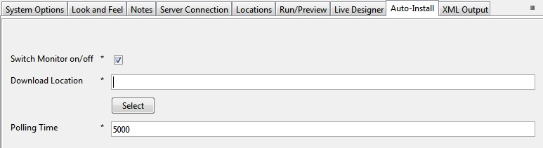

**Grouped Column Table**

**Overview:**

The purpose of the grouped column table widget is to provide a simple mechanism to group multiple table columns into a single column (but on new lines). This can have a significant benefit when showing large amounts of information in a table, as it makes better use of vertical space, rather than trying to cram everything onto one line.

**Usage:**

Create a table in edgeConnect using the standard table. Make sure the widget has been installed, and then open the display properties for the table in the presentation editor:



When you select Grouped Column Table, a new tab will appear – Widget Details. This will let you specify which columns you want grouping.



In this case, column 3 will be grouped with its previous sibling (i.e. column 2) and column 5 will be grouped with column 4.

When you run the project, then end result will be something like this:

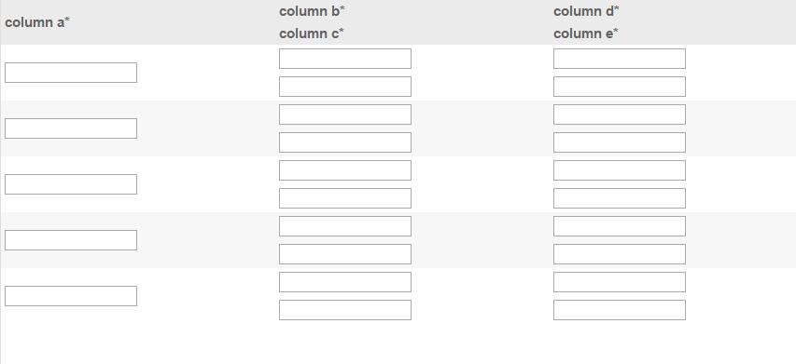

This doesn’t have any data in, but if you did, any styling would be preserved, and sorting behavior is maintained. For example, take a table which looks like this:

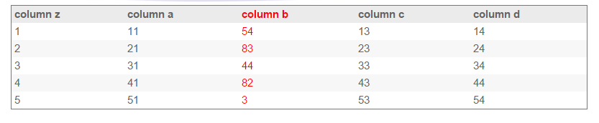

Using the Grouped Column Table widget, it will end up looking like this when the columns 3 and 5 are grouped:

