

Piwik

Analytics

User Guide

Table of Contents

Introduction 3

Preface 3

Overview 3

Prerequisites 3

Compatibility 3

Assumptions 4

Getting Started 4

Installation 4

Adding Piwik Analytics Widget 5

# Introduction

## Preface

## This User Guide is intended for Developers and provides the step by step instructions for adding Piwik Analytics to your presentation.

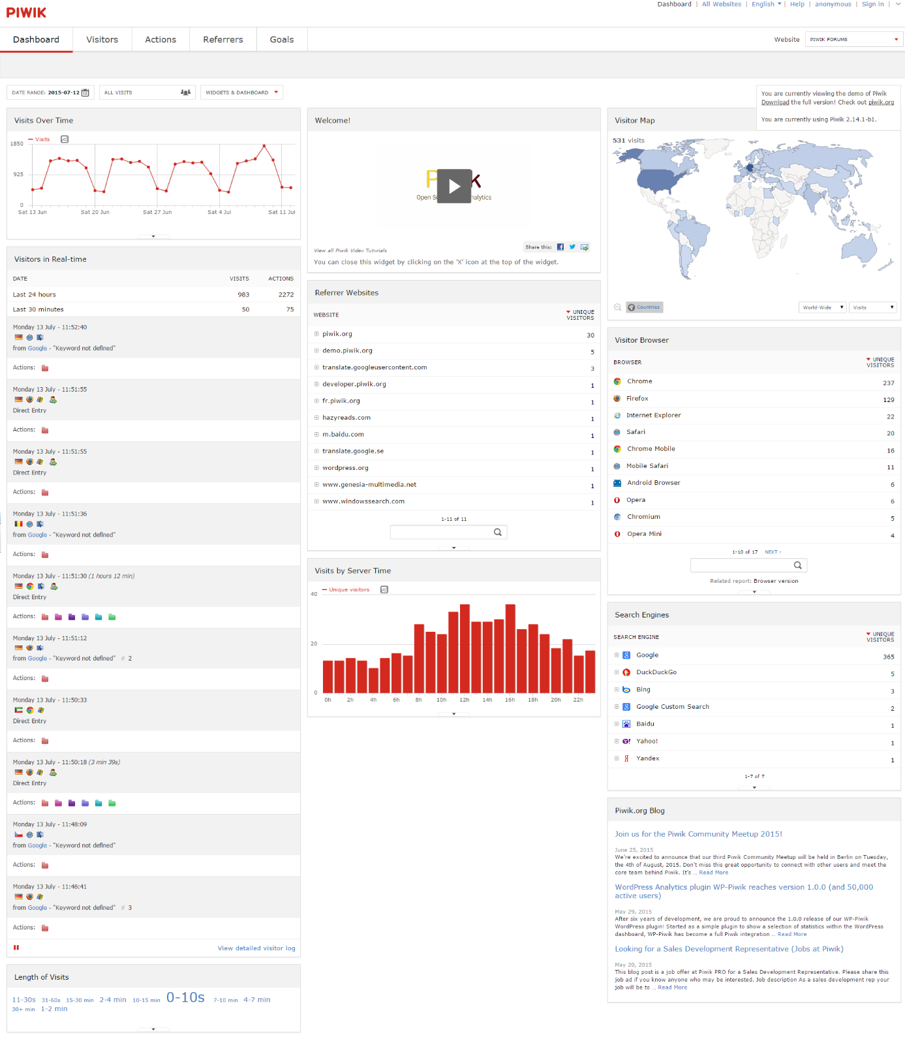

## Overview

**Piwik** it’s the leading open-source analytics platform that gives you more that just powerfull analytics:

* Free open-source software;
* 100% data ownership;
* User privacy protection;
* User-centric insights;
* Customizable and extensible.

## Prerequisites

* **EdgeConnect IDE;**
* **Piwik** software (from **piwik.org**) installed on a web server.

## Compatibility

The **Piwik Analytics Widget** is compatible with Desktop and Mobile devices.

**OBS. The user must have access to the application server.**

## Assumptions

# It is assumed that you are familiar with the edgeConnect Editors, have working knowledge on edgeConnect and you have knowledge of installing and using Piwik Analytics.

# Getting Started

## Installation

# For manual installation:

# 1. Copy com.temenos.widgets.analitycs.piwik folder in your widgets folder (Ex:

# /{your project/templates/widgets/ }).

# 2. Restart IDE.

# For auto-installation:

# 1. Run IDE.

# 2. Make sure the ‘Switch Monitor on/off’ is checked.

# 3. Download and copy the widget (com.temenos.widgets.analitycs.piwik.zip) to the

# monitored folder. (Navigate to Tools -> Options -> Auto-install tab and set in

# Download Location, the folder where you copied the widgets.) There is no need to

# restart IDE.

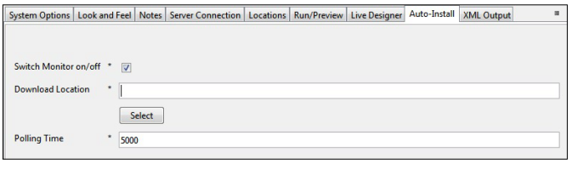

# Adding Piwik Analitycs Widget

# To add Piwik Analytics Display Item:

# Right click on the Main Phase in the Presentation Editor;

# Go to Add, go to Display Item and click on Clicky Web Analytics;

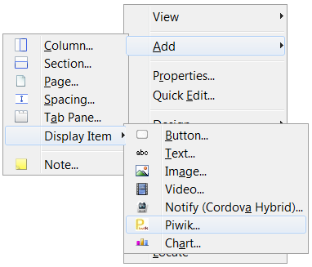

1. Right-click on the newly created display item and select **Properties**;

4. Go to **Widget Details** tab and enter the **Site id** generated by the **Piwik** application that you installed on your web server;

5. Enter the **Application URL** that represents the url where you have installed the **Piwik** application.