**Add Image Widget Button**

**Installation**

1. Distributed with the product, so no special installation requirements.

**Description**

This purpose of the Add Image widget, is to allow the developer to use a button on the screen to transfer an image from the phone to the server. One use might be for a bank to use the button to capture the image of a payee (either with the Camera or from a phone album) and store it in the database/core banking system, to be used on a sub-sequent page. Another use is in conjunction with a service such as Remote Data Capture (remote check deposit) to take a photo of a cheque.

**How to use**

1. Create a data item in the **DataStore Editor** to populate with the Base64 information of the image
2. Create a button in the **Process Editor** – this will be the element that the user clicks to add the image. You can add rules under the button – within the widgets settings (next step), you can choose if you want these rules to be executed after the contact is created or not.
3. In the **Presentation Editor** -> **Double Click on the button** -> **Appearance** -> **Button tab** -> **Display Type** -> Select the **Camera** type
4. Within Widget Details tab you have to set up the widget settings.
5. The first checkbox (Run Button Rules) controls whether the button rules are executed or not after the contact has been added
6. The next field lets the user choose the data item that store the image information. This is a text field and needs to be exposed in the current phase, either as a question (hidden) or in the phase settings.
7. Next you can set the origin of the picture (new from camera, or existing from a photo album), quality, image size transformation. There are some limits specific to Cordova and handsets, not all of the functions are supported by all handsets.
   1. Note that the Destination Type is a combo, but for now it has a single value. We plan to add direct image transfer in the future, without converting to Base64.
8. Finally you can add messages which get shown if the image is successfully captured or not.

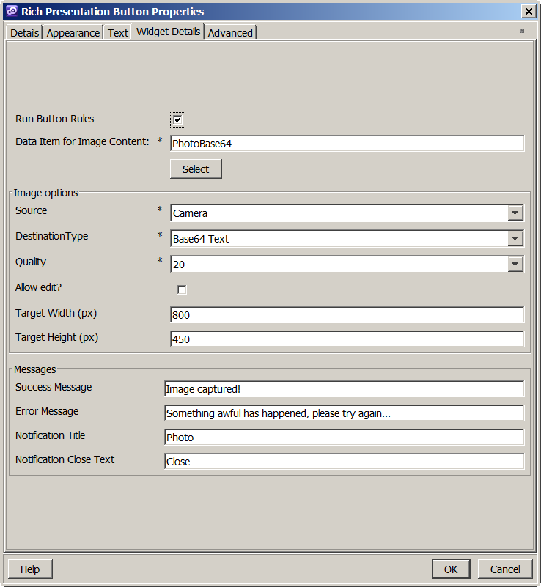

**How it works**

When the button is generated, the standard click handler is removed, and replaced by a new event handler. This prepares the camera options, then checks to see if the destination type is DATA_URL (meaning “image as Base64 text”), invoking the correct method. The other option is direct image transfer to the server, not yet implemented. Once the image is captured (from camera or from album) it is stored in the specified Data Item, ready to be sent to the server along with the rest of the form on the screen. If this is successful, the successful message is display (if defined). If there was a problem, the error message is display (if defined). If the image was saved successfully, and the developer chose for the rules to be run, the script would have been attached to the button is executed.

In the included example, the button which uses this widget is shown as the “Add Image Button” button.

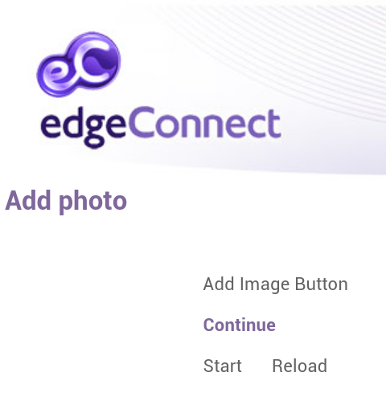

Clicking Add image launches the camera, and after the image is captured, it show the success notification

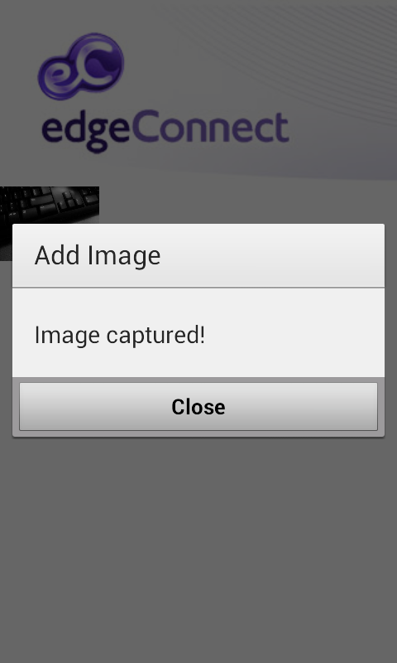

And the image is sent to server, which can be seen on the next screen (the button runs a Go To Phase rule):

