**Add Contact Widget Button**

**Installation**

1. Distributed with the product, so no special installation requirements.

**Description**

This purpose of the Add Contact widget, is to allow the developer to use a button on the screen to add/update a contact in the user’s contacts database. One use might be for a bank to use the button to add their own Call Centre number to the contacts. It is also possible to add more than one number, email addresses, urls and also a note to the contact.

**How to use**

1. Create a data structure in the **DataStore Editor** to populate with the contact details
2. Populate the data structure – this could either be as rules in the project, or via an integration component pulling the values in.
3. Create a button in the **Process Editor** – this will be the element that the user clicks to add the contact. You can add rules under the button – within the widgets settings (next step), you can choose if you want these rules to be executed after the contact is created or not.
4. In the **Presentation Editor** -> **Double Click on the button** -> **Appearance** -> **Button tab** -> **Display Type** -> Select the **com.temenos.widgets.hybrid.contacts.addContact**  type
5. Within Widget Details tab you have to set up the widget settings.
6. The first checkbox (Run Button Rules) controls whether the button rules are executed or not after the contact has been added
7. The fields let the user choose the data items that store the contact information. Some of these (numbers, emails, urls) can store multiple values as a comma separated list. The order of these will be stored in the contact as “home”, “mobile”, “work”, “other”.
8. Finally you can add messages which get shown if the contact is successfully created or not.

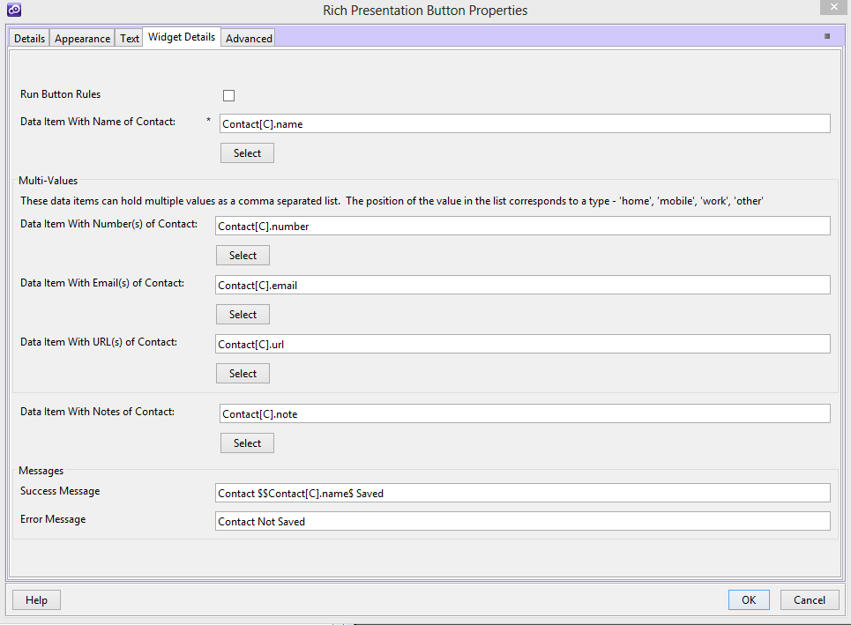

**How it works**

When the button is generated, the standard click handler is removed, and replaced by a new event handler. This checks to see if the contact already exists or if it is new. If it exists, it is deleted. The new contact is then added, and if this is successful, the successful message is display (if defined). If there was a problem, the error message is display (if defined). If the contact was saved successfully, and the developer chose for the rules to be run, the script would have been attached to the button is executed.

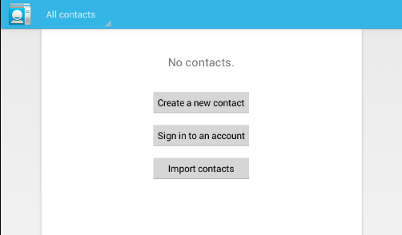

In this example, the button which uses this widget is shown as the “Save” button. It is not necessary to display the fields on the page.

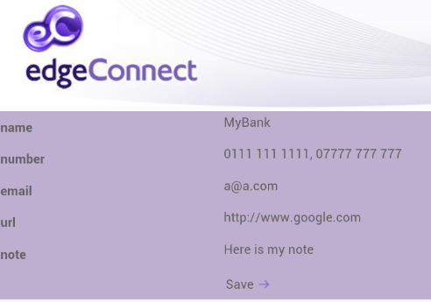

Clicking save results in the notification below

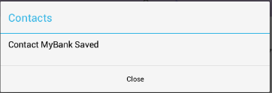

And the contact is created…

