**Skype Button Widget**

**Installation**

**Document History**

|  |  |  |  |
| --- | --- | --- | --- |
| Version | Date | Author | Comments / Change Description |
| 0.1 |  |  | Initial version |
| 0.2 | 26 Sept 2019 | Adrian Cirlomanu | Added HTTPS and SSL requirements |
|  |  |  |  |
|  |  |  |  |
|  |  |  |  |

**Table of Contents**

1 Installation 3

2 Overview 3

3 Important - use HTTPS 4

# Installation

1. Copy **com.temenos.widgets.skype.button** folder in your widgets folder (Ex: /{your project/templates })
2. Copy the content of **widget.xml** in your widget.xml file within your project

# Overview

Add a Skype button to your websites and let people get in touch with just the click of a button. Whether they're on a computer or mobile, they will get through with a voice call or an instant message.

1. You will have to insert a new display Item of **Skype Button widget** type in the **Presentation Editor**
2. Within Widget Details tab you have to set up the widget settings.

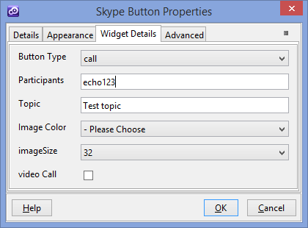

* **Button Type-** Which kind of button is displayed after the button's rendering. Currently are available 3 type of buttons:

1. call – Place an audio or video call.
2. chat – Initiate/restart a chat.
3. dropdown – Dynamically choose whether to place a call or initiate/restart a chat.

* **Participants** - A skype name (phone number) or a list of Skype Names (or phone numbers) formatted as a comma-separated list.
* **Topic** - The optional topic string for a conference call, group video chat, or multichat. Ignored if there are fewer than two participants.
* **Image Color** - Which text color variant of the image asset to use, depending on your webpage’s background.
* **Image Size** - Which size of the image asset to use.
* **video Call** - Whether this is a video call. Ignored if this Skype button type is not an explicit call or dropdown;

You can find more details on the following website ([http://msdn.microsoft.com/en-us/library/office/dn745883(v=office.15).aspx](http://msdn.microsoft.com/en-us/library/office/dn745883(v=office.15).aspx%20) )

# Important - use HTTPS

The skype content is served from a CDN (Content Delivery Network) that prefers **HTTPS** connections. When accessing a solution over plain HTTP, the widget might not load properly. When using and testing this, enable the SSL port of your deployment server.

In order to run a solution in SSL from the Developer IDE, enable the option **Developer IDE > Tools > Options > Run/Preview :: Run Jetty with SSL**

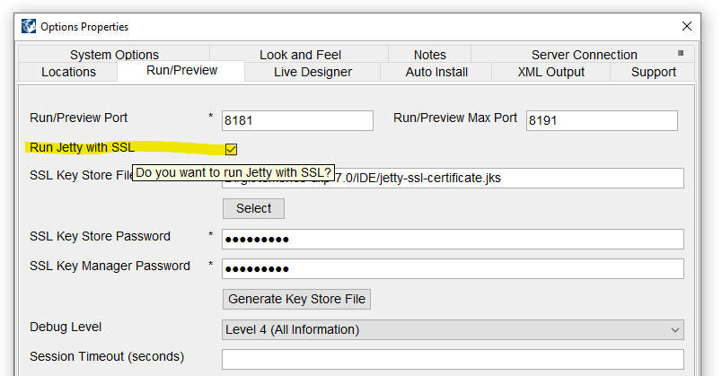

The UXP solution should now run under HTTPS. The desktop browser might show the URL as *Not secure*; this is normal for a self-signed certificate that is not issued by a recognized Certificate Authority:

