**Facebook widgets**

**Installation**

1. Copy **com.temenos.widgets.social.facebook** folder in your widgets folder (Ex: /{your project/templates })
2. Copy the content of **widget.xml** in your widget.xml file within your project

**How to use**

For all Facebook widgets you have to set up the settings within “Facebook SDK” (these are common for all Facebook widgets). See the image below.

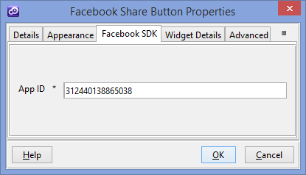

To obtain a valid app id you have to create a new application within your Facebook developer account ([**https://developers.facebook.com/apps**](https://developers.facebook.com/apps) **) .** A guide about “How to setup your application” you could find on this URL [**https://developers.facebook.com/docs/apps**](https://developers.facebook.com/docs/apps) **.**

**NOTE:** If you want the widget to publish content on user’s timeline you must have your application reviewed by a Facebook Test User and approved for publish_actions.

1. **Facebook Share Button**

**Overview**

The Share button lets people add a personalized message to links before sharing on their timeline, in groups, or to their friends via a Facebook Message.

1. You will have to insert a new display Item of **Facebook Share Button** type in the **Presentation Editor**
2. Within Widget Details tab you have to set up the widget settings .

* **URL to share-** The absolute URL of the page that will be shared. Default value is the current URL.
* **Layout -** Selects one of the different layouts that are available for the button.

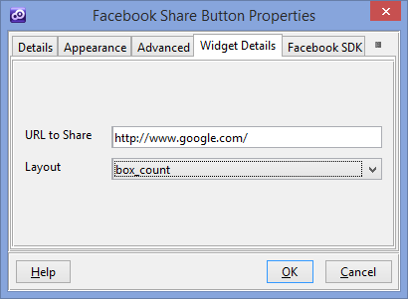

You could find more details on facebook website ( <https://developers.facebook.com/docs/plugins/share-button> )

1. **Facebook Like Button**

**Overview**

The Like button is the quickest way for people to share content with their friends. A single click on the Like button will 'like' pieces of content on the web and share them on Facebook. You can also display a Share button next to the Like button to let people add a personal message and customize who they share with.

1. You will have to insert a new display Item of **Facebook like Button** type in the **Presentation Editor**
2. Within Widget Details tab you have to set up the widget settings .

* **Action** – The verb to display on the button. Can be either "like" or "recommend"
* **Color Scheme** - The color scheme used by the widget for any text outside of the button itself.
* **URL to like** - The absolute URL of the page that will be liked. Default value is the current URL.
* **Kid directed site** - If your web site or online service, or a portion of your service, is directed to children under 13 you must enable this
* **Layout** - Selects one of the different layouts that are available for the plugin.
  + - * 1. **standard -**Minimum width: 225 pixels. Minimum increases by 40px if action is 'recommend' by and increases by 60px if send is 'true'.

Default width: 450 pixels. Height: 35 pixels (without photos) or 80 pixels (with photos).

* + - * 1. **box_count -** Minimum width: 55 pixels. Default width: 55 pixels. Height: 65 pixels.
        2. **button_count -** Minimum width: 90 pixels.Default width: 90 pixels. Height: 20 pixels.
        3. **button** **-** Minimum width: 47 pixels. Default width: 47 pixels. Height: 20 pixels.
* **Referrals** - A label for tracking referrals which must be less than 50 characters and can contain alphanumeric characters and some punctuation (currently +/=-.:_)
* **Include a share button** - Specifies whether to include a share button beside the Like button.
* **Show faces** - Specifies whether to display profile photos below the button (standard layout only). You must not enable this on child-directed sites.
* **Width** - The width of the plugin. The layout you choose affects the minimum and default widths you can use.

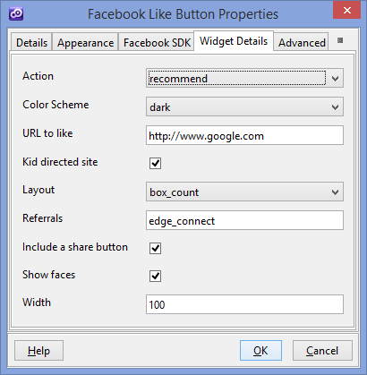

You could find more details on facebook website ( <https://developers.facebook.com/docs/plugins/like-button> )

1. **Facebook Send Button**

**Overview**

The Send button lets people privately send content on your site to one or more friends in a Facebook message, to an email address, or share it with a Facebook group.

1. You will have to insert a new display Item of **Facebook Send Button** type in the **Presentation Editor**
2. Within Widget Details tab you have to set up the widget settings .

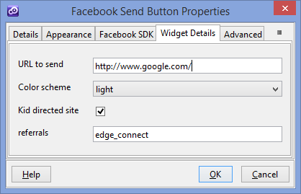

* **URL to send** - The absolute URL of the page that will be sent. Default value is the current URL.
* **Color Scheme** -The color scheme used by the widget for any text outside of the button itself.
* **Kid directed site** - If your web site or online service, or a portion of your service, is directed to children under 13 you must enable this
* **Referrals** - A label for tracking referrals which must be less than 50 characters and can contain alphanumeric characters and some punctuation (currently +/=-.:_)

You could find more details on facebook website ( <https://developers.facebook.com/docs/plugins/send-button> )

1. **Facebook embedded post**

**Overview**

Embedded Posts are a simple way to put public posts - by a Page or a person on Facebook - into the content of your web site or web page. Only public posts from Facebook Pages and profiles can be embedded.

1. You will have to insert a new display Item of **Facebook embedded post** type in the **Presentation Editor**
2. Within Widget Details tab you have to set up the widget settings .

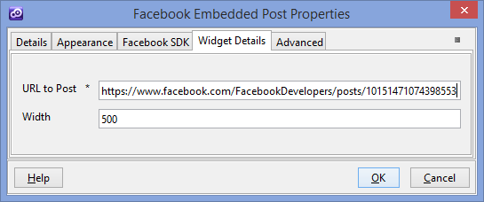

* **URL to Post** – The URL of a public post from Facebook Pages or Facebook User Profiles
* **Width** - The pixel width of the post (between 350 and 750)

You could find more details on facebook website ( <https://developers.facebook.com/docs/plugins/embedded-posts> )

1. **Facebook Follow Button**

**Overview**

The Follow button lets people subscribe to the public updates of others on Facebook.

1. You will have to insert a new display Item of **Facebook Follow Button** type in the **Presentation Editor**
2. Within Widget Details tab you have to set up the widget settings .

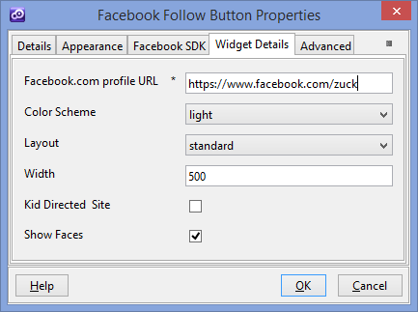

* **Profile URL** – The Facebook.com profile URL of the user to follow.
* **Color Scheme** -The color scheme used by the widget for any text outside of the button itself.
* **Layout** - Selects one of the different layouts that are available for the plugin.
  + - * 1. **standard -**Minimum width: 225 pixels. Minimum increases by 40px if action is 'recommend' by and increases by 60px if send is 'true'.

Default width: 450 pixels. Height: 35 pixels (without photos) or 80 pixels (with photos).

* + - * 1. **box_count -** Minimum width: 55 pixels. Default width: 55 pixels. Height: 65 pixels.
        2. **button_count -** Minimum width: 90 pixels.Default width: 90 pixels. Height: 20 pixels.
* **Width** - The width of the plugin. The layout you choose affects the minimum and default widths you can use
* **Kid directed site** - If your web site or online service, or a portion of your service, is directed to children under 13 you must enable this
* **Show Faces** - Specifies whether to display profile photos below the button (standard layout only). You must not enable this on child-directed sites.
* You could find more details on facebook website ( <https://developers.facebook.com/docs/plugins/follow-button> )

1. **Facebook Comments**

**Overview**

The Comments box lets people comment on content on your site using their Facebook profile and shows this activity to their friends in news feed. It also contains built-in moderation tools and special social relevance ranking.

1. You will have to insert a new display Item of **Facebook Comments** type in the **Presentation Editor**
2. Within Widget Details tab you have to set up the widget settings .

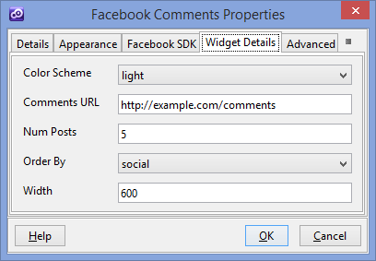

* **Color Scheme** -The color scheme used by the widget for any text outside of the button itself.
* **Comments URL** - The absolute URL that comments posted in the plugin will be permanently associated with. Stories on Facebook about comments posted in the plugin will link to this URL. Default is Current URL.
* **Num Posts** - The number of comments to show by default. The minimum value is 1. Default value is 10.
* **Order By** - The order to use when displaying comments .
* **Width** - The width of the widget. Either a pixel value or the literal 100% for fluid width. The mobile version of the Comments plugin ignores the width parameter, and instead has a fluid width of 100%.

You could find more details on facebook website ( <https://developers.facebook.com/docs/plugins/comments> )

1. **Facebook Publish Button**

**Overview**

This Publish Button is a special version of Share Button. Compared with the Share Button , this one , when is clicked will post automatically on Facebook wall without any intermediary modal dialog.

1. You will have to add a new custom button in your presentation. Within **Appereance** -> **Button tab** for ”Display Type” field you have to select “Facebook Publish Button “
2. Within Widget Details tab you have to set up the widget settings .

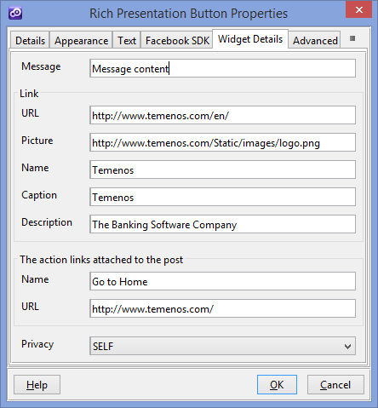

* **Message**- The main body of the post, otherwise called the status message.
* **URL** - The URL of a link to attach to the post
* **Picture** - Determines the preview image associated with the link.
* **Name** - Overwrites the title of the link preview.
* **Caption** - Overwrites the caption under the title in the link preview.
* **Description** - Overwrites the description in the link preview.
* **Action links Name** - The name or label of the action link.
* **Action link URL** - The URL of the action link itself.
* **Privacy**  - Determines the privacy settings of the post .

1. **Facebook Login Button**

**Overview**

Facebook Login is a personalized and secure way for people to sign in to your app . On the web, Facebook uses a variant of the OAuth2.0 protocol for confirming a person's identity (authentication) as well as control of what data they will share with your app (authorization) .

1. You will have to add a new custom button in your presentation. Within **Appereance** -> **Button tab** for ”Display Type” field you have to select “Facebook Login Button “
2. Within Widget Details tab you have to set up the widget settings .

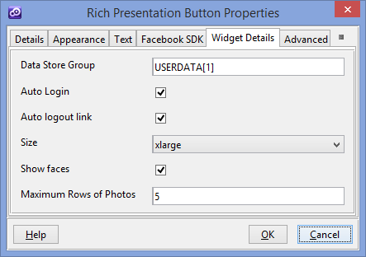

* **Data Store Group** - Data Group where to save user information after successful login. Within this data store group you should add any fields from these (id, birthday, email, first_name, last_name, picture )
* **Auto Login** - Login automatically on Page Load without any user action.
* **Auto logout link** - If enabled, the button will change to a logout button when the user is logged in.
* **Size** - Picks one of the size options for the button.
* **Show faces** - Determines whether a Facepile of logged-in friends is shown below the button. When this is enabled, a logged-in user will only see the Facepile, and no login or logout button.
* **Maximum Rows of Photos** - The maximum number of rows of profile photos in the Facepile when “Show faces” is checked. The actual number of rows shown may be shorter if there aren't enough faces to fill the number you specify.

You could find more details on facebook website ( <https://developers.facebook.com/docs/facebook-login/login-flow-for-web/v2.1> )