**Google widgets**

**Installation**

1. Copy **com.temenos.widgets.social.google** folder in your widgets folder (Ex: /{your project/templates })
2. Copy the content of **widget.xml** in your widget.xml file within your project

**How to use**

1. **Sharing interactive posts**

**Overview**

Interactive posts provide an easy and prominent way to allow users to share your site or app with their connections and invite them to take action, for example, RSVP for an event. Interactive posts can drive new users to your site, improve conversions, and increase engagement.

1. You will have to add a new custom button in your presentation. Within **Appereance** -> **Button tab** for ”Display Type” field you have to select “Sharing interactive posts“ . In order to work properly the type of the button must to be an Ajax button.
2. Within Widget Details tab you have to set up the widget settings .

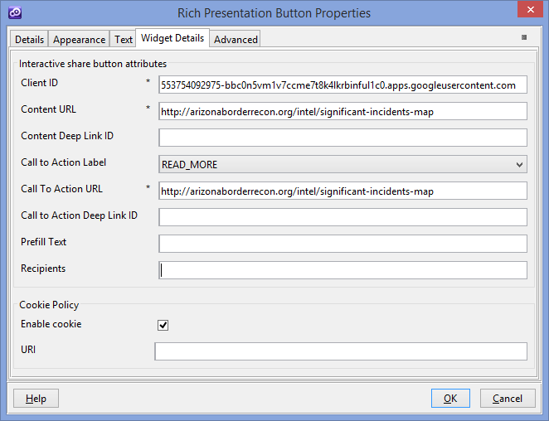

* **Client ID** - Your OAuth 2.0 client ID that you obtained from the [Google Developers Console](https://console.developers.google.com/)
* **Content URL** - The content URL points to the page that you want to render in the preview snippet in the share post. This URL can differ from the call-to-action button's URL, for example, you might link to an overview with the content URL and to a form with the call-to-action button. If you specify the Content Deep Link ID attribute and the link is clicked on a mobile device, the Google+ app launches your app and passes the Content Deep Link ID for your app to use to determine the location within your app to take the user. The protocol (http/https), host name, and port (if specified) for the content URL and the call-to-action URL must match. Because these must match, you should avoid using URL shorteners and redirects for either URL.
* **Content Deep Link ID** - Specify a URI path as a deep link ID for the content link in the shared post. The value must be 512 characters or fewer in length.
* **Call to Action Label** - The label that renders in the stream post that prompts the reader to act. This field should be a verb that accurately describe the action that will be taken. The Call to Action URL must also be specified to render the call-to-action button. The call-to-action label is automatically translated in the Google+ stream to the viewer's language.
* **Call to Action URL** - The URL that the user will be taken to when the call-to-action button is clicked from a web browser. If the button is clicked on a mobile device, the Google+ app launches your app and passes the Call to Action Deep Link ID for your app to use to determine the location within your app to take the user. The protocol (http/https), host name, and port (if specified) for the call-to-action URL and the Content URL must match. Because these must match, you should avoid using URL shorteners and redirects for either URL.
* **Call to Action Deep Link ID -** Specify a URI path as a deep link ID for the call to action button. The value must be 512 characters or fewer in length.
* **Prefill Text** - Text that is prefilled in the comment area of the share box on behalf of the user. The user can edit or remove the prefilled text. The maximum length of the prefilled text is 1042 characters.
* **Recipients** - A comma-separated list of user IDs that you want to prefill the share settings with. A maximum of ten recipients are allowed.
* **Enable cookie** - This checkbox value enable/disable the usage of cookies or session storage for the interactive share button.
* **URI** - The uri includes the scheme, site-domain and possibly port to be set for your site. The value you provide determines the scope of the cookie. The more general the uri, the broader the scope of the cookie. More details --> [https://developers.google.com/+/web/signin/reference#determining_a_value_for_cookie_policy](https://developers.google.com/+/web/signin/reference%23determining_a_value_for_cookie_policy)

You could find more details on google website ( <https://developers.google.com/+/web/share/interactive> )

1. **Google +1 Button**

**Overview**

By adding the +1 button to your website, you allow your users to recommend your content to their circles and drive traffic to your site. The +1 button can also improve the time spent on your site by providing recommendations for further reading. Use of the +1 button is subject to the [Google+ Platform Buttons policy](https://developers.google.com/+/web/buttons-policy).

1. You will have to add a new custom button in your presentation. Within **Appereance** -> **Button tab** for ”Display Type” field you have to select “Google +1 Button“ . In order to work properly the type of the button must to be an Ajax button.
2. Within Widget Details tab you have to set up the widget settings .

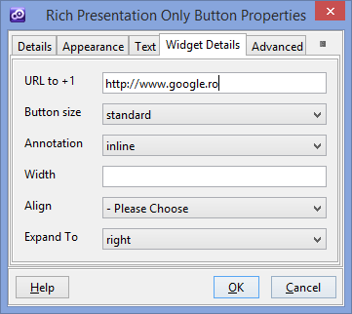

* **Url to + 1** –Sets the URL to +1. Set this attribute when you have a +1 button next to an item description for another page and want the button to +1 the referenced page and not the current page . You should set this only if you use this button for another page if is an empty field it will use the current URL.
* **Button size** - Sets the +1 button size to render.
* **Annotation** - Sets the annotation to display next to the button
* **Width** - If Annotation is set to "inline", this parameter sets the width in pixels to use for the button and its inline annotation
* **Align** - Sets the horizontal alignment of the button assets within its frame.
* **Expand To** - Sets the preferred positions to display hover and confirmation bubbles, which are relative to the button. Sets the preferred positions to display hover and confirmation bubbles, which are relative to the button. Set this parameter when your page contains certain elements, such as Flash objects, that might interfere with rendering the bubbles. For example, top will display the hover and confirmation bubbles above the button. If omitted, the rendering logic will guess the best position, usually defaulting to below the button by using the bottom value. If the confirmation bubbles can't be displayed due its position (they have not enough space) the rendering logic will choose the best position for them. In order to display properly the confirmation bubbles , you should use this widget within a section with proper width and proper margins.

You could find more details on Google website (

<https://developers.google.com/+/web/+1button/>)

1. **Google Embedded Post**

**Overview**

You can embed public Google+ posts in your site or articles with just a few lines of HTML code. Your signed-in Google+ readers can +1 or comment on your post directly from your site or follow the author. Use of embedded posts is subject to the [Embedded Content Policy](https://www.google.com/intl/en/+/policy/embedded-content.html).

1. You will have to insert a new display Item of **Google Embedded Post** type in the **Presentation Editor**
2. Within Widget Details tab you have to set up the widget settings .

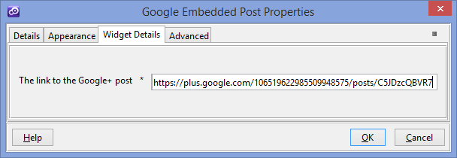

* **The link to the Google+** post

The link to the Google+ post must be in its canonical format:

<https://plus.google.com/110174288943220639247/posts/cfjDgZ7zK8o>

**Supported posts**

In addition to posts that contain text and links, the following additional types of posts are supported as embedded posts:

* Posts with images - The post will render with the image. Clicking the image directs the visitor to the image view on Google+.
* Posts with videos - The post will render with the video. Clicking the video will play the video within the embedded post.
* Posts with links to a community - Your visitors can click through to view the community as they would in the stream.

The following post types are not supported:

* Posts from within a community, including publicly reshared posts from a community.
* Posts that are restricted to a Google Apps domain
* Private posts
* Events posts
* Hangout on Air posts

You could find more details on google website (<https://developers.google.com/+/web/embedded-post/> )

1. **Google Follow Button**

**Overview**

The Google+ follow button adds a simple, smaller form factor button to your page, which quickly allows visitors to add you or your page to their circles without leaving your site. When a user clicks a Follow button, Google receives information including the URL of the page/profile/community followed, information about the user's Google profile, the user's IP address, and other browser-related information. Use of Google+ buttons are subject to the [Google+ Platform Buttons Policy](https://developers.google.com/+/web/buttons-policy).

1. You will have to insert a new display Item of **Google Follow Button** type in the **Presentation Editor**
2. Within Widget Details tab you have to set up the widget settings .

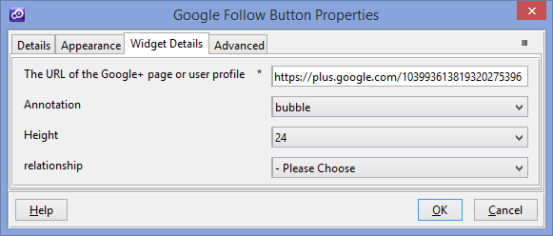

* **The URL of the Google+ page or user profile** - The URL of the Google+ page or user profile that the user might choose to follow
* **Annotation** - Sets the annotation to display next to the button.
* **Height** - The pixel height of the button to render.This height controls only the height of the button. If you use the vertical annotation, the actual height of the full widget will be larger.
* **Relationship** - Describes the relationship of the entity defined at the href location to the page the widget is added.

You could find more details on google website (<https://developers.google.com/+/web/follow/)>

1. **Google Share Button**

**Overview**

Add this button to content across your site to make sharing on Google+ easy. This button is perfect for content that users may want to share but not +1 (e.g. news or controversial content). Use of Google+ buttons are subject to the [Google+ Platform Buttons Policy](https://developers.google.com/+/web/buttons-policy).

1. You will have to insert a new display Item of **Google Share Button** type in the **Presentation Editor**
2. Within Widget Details tab you have to set up the widget settings .

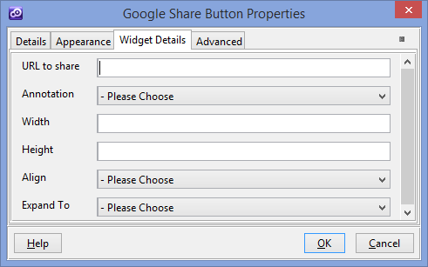

* **URL to share** - default value is current page URL . Example : <http://www.google.com>
* **Annotation** - Sets the annotation to display next to the button .
* **Width** - The maximum width to allocate to the entire share widget.
* **Height** - The height to assign the button. This may be 15, 20, 24 or 60.
* **Align** - Sets the horizontal alignment of the button assets within its frame.
* **Expand To** - Sets the preferred positions to display hover and confirmation bubbles, which are relative to the button. Sets the preferred positions to display hover and confirmation bubbles, which are relative to the button. Set this parameter when your page contains certain elements, such as Flash objects, that might interfere with rendering the bubbles. For example, top will display the hover and confirmation bubbles above the button. If omitted, the rendering logic will guess the best position, usually defaulting to below the button by using the bottom value. If the confirmation bubbles can't be displayed due its position (they have not enough space) the rendering logic will choose the best position for them. In order to display properly the confirmation bubbles , you should use this widget within a section with proper width and proper margins.

You could find more details on google website ( <https://developers.google.com/+/web/share/> )

1. **Google Hangout Button**

**Overview**

The Hangout button lets you launch a Google+ Hangout directly from your site. When you use the button, you can set up the Hangout in a variety of configurations. For example, you can specify Hangout apps that launch along with the Hangout and setup the Hangout as a regular Hangout or a Hangout On Air. Use of Google+ buttons are subject to the [Google+ Platform Buttons Policy](https://developers.google.com/+/web/buttons-policy).

1. You will have to insert a new display Item of **Google Hangout Button** type in the **Presentation Editor**
2. Within Widget Details tab you have to set up the widget settings .

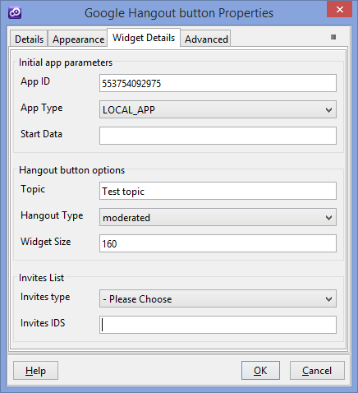

* **App ID** - The project number retrieved from the Google Developers Console that corresponds to the application that this button launches.
* **App Type** - This optional parameter specifies the type of Hangout app created when the user clicks the button. Setting this parameter changes the way that Hangout applications are loaded for the Hangout and its participants
* **Start Data** - his optional parameter specifies data to be passed to the initial instantiation of the app. Only the first participant to join the application has this value present in the response from gapi.hangout.getStartData.
* **Topic** - Pre-populates the topic field for Hangouts on Air. Note that users can change the topic of the Hangout after they have joined.
* **Hangout Type** - Pre-populates the topic field for Hangouts on Air. Note that users can change the topic of the Hangout after they have joined.
* **Hangout Type** - Specifies what type of Hangout should be started.
* **Widget Size** - Specifies the width of the button. The default value is 136.
* **Invites type** - Specifies the type of invites.
* **Invites IDS** - Invites' identifiers with comma delimiter

You could find more details on google website (<https://developers.google.com/+/hangouts/button>)

1. **Google Badge**

**Overview**

Because Google+ pages, profiles, and communities are different, this widget offer slightly different versions of the badges:

* Profiles - Allow people to easily find you on Google+ and add you to a circle directly from your website.
* Pages - Includes the profile badge features and adds some additional functionality. They help Google consolidate +1's from your website and your Google+ page, and make your website eligible for Google+ Direct Connect.
* Communities - Help people find your community and engage with other users on a topic they find interesting.

Use of Google+ badges are subject to the [Google+ Platform Buttons Policy](https://developers.google.com/+/web/buttons-policy).

1. You will have to insert a new display Item of **Google Badge** type in the **Presentation Editor**
2. Within Widget Details tab you have to set up the widget settings .

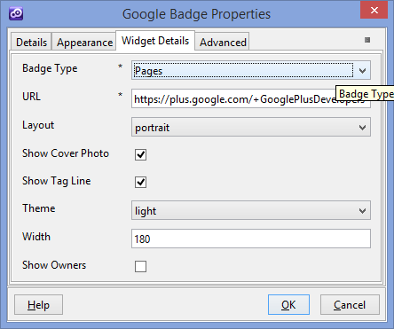

* **Badge Type** – Type of the Badge (Profile , Pages , Community )
* **URL** - The URL of the Google+ profile or of the Google+ page or of the Google+ community .
* **Layout** - Sets the orientation of the badge.
* **Show Cover Photo** - Displays the cover photo in the badge if checked and the photo exists.
* **Show Tag Line** - Displays the tag line if checked.
* **Theme** - The color theme of the badge. Use dark when placing the badge on a page with a dark background.
* **Width** - The pixel width of the badge to render. The following ranges are valid: Portrait layout 180-450 pixels , Landscape layout 273-450 pixels
* **Show Owners** - Displays a list of community owners if set to true. It's available only for badge of community type.

You could find more details on google website (<https://developers.google.com/+/web/badge/> )

1. **Google Snippet**

**Overview**

Customize the snippet people see when your page is shared. Using this widget, you can generate code for your page that indicates the images and text that best represent what's being shared. Your use of the snippet code is subject to the [Google Terms of Service](http://www.google.com/accounts/TOS).

1. You will have to insert a new display Item of **Google Snippet** type in the **Presentation Editor**
2. Within Widget Details tab you have to set up the widget settings .

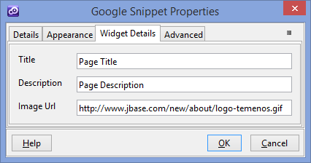

This widget generate meta data within your page's header ( within <head> tag ).

<meta property="og:type" content="article" />

<meta itemprop="og:title" content="Page Title" />

<meta itemprop="og:description" content="Page Description" />

<meta property="og:image" content="http://www.jbase.com/new/about/logo-temenos.gif" />

* **Title** – The title of the page your users are sharing
* **Description** - Description of the content your users are sharing
* **Image URL** – The URL of thumbnail of the page your users are sharing

You could find more details on google website (<https://developers.google.com/+/web/snippet/>)

1. **Google Analytics**

**Overview**

Google Analytics tracks the following kinds of data about how users interact with your site content:

* The pages on which they enter and exit your site.
* How often and how long they view individual pages.
* The extent to which they search your site for specific content.
* The extent to which they interact with things like slide shows or embedded videos.
* How frequently they click AdSense ads, and the revenue you see from those clicks.

1. You will have to insert a new display Item of **Google Analytics** type in the **Presentation Editor**
2. Within Widget Details tab you have to set up the widget settings .

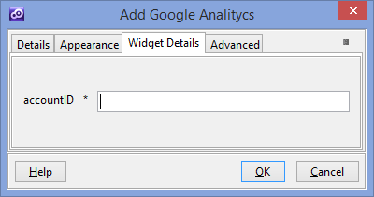

* **accountID** - The full web property ID (e.g. UA-65432-1) for the tracker object.

You could find more details on google website (<http://www.google.com/analytics/>)

1. **Google + Signin Button**

**Overview**

By adding Google+ Sign-In, you bring the power of Google to your site. When a user is signed in, you get an OAuth token for making API requests. The first time a user clicks on the sign-in button, they will see an authorization dialog. This dialog outlines how the application will use their data. The user then can consent to the authorization or cancel. After authorizing, a returning user will not be prompted again for authorization. Your use of the Google+ Sign-In button is subject to the [Google+ Platform Button Policies](https://developers.google.com/+/web/buttons-policy) and [Google+ Platform Terms of Service](https://developers.google.com/+/terms).

1. You will have to add a new custom button in your presentation. Within **Appereance** -> **Button tab** for ”Display Type” field you have to select “Google + Signin Button“ . In order to work properly the type of the button must to be an Ajax button.
2. Within Widget Details tab you have to set up the widget settings .

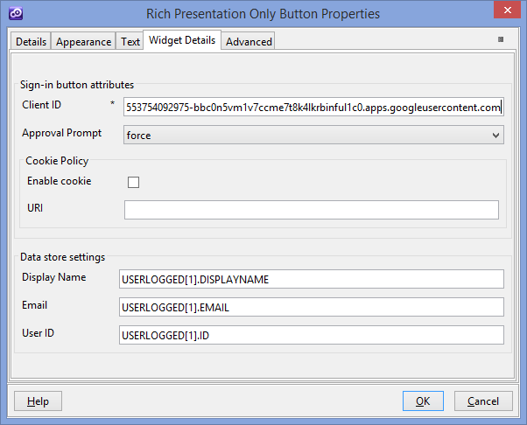

* **Client ID** - Your OAuth 2.0 client ID that you obtained from the Google Developers Console.
* **Approval Prompt** - Allows control over when the user is re-prompted for consent. When set to auto, the user only sees the OAuth consent dialog if they have not authorized your application. When set to force, the user is shown the OAuth consent dialog each time that they click the sign-in button.
* **Enable cookie** - This checkbox value enable/disable the usage of cookies or session storage for the interactive share button.
* **URI** - The uri includes the scheme, site-domain and possibly port to be set for your site. The value you provide determines the scope of the cookie. The more general the uri, the broader the scope of the cookie. More details --> [determining a value for cookie policy](https://developers.google.com/+/web/signin/reference%23determining_a_value_for_cookie_policy)
* **Data store settings** - Where to store data after a successful login.(for each of them you have to add a related question within your phase ). These values must be typed in uppercase ( see the above image ). To see how this works you could take a look on the project sample.

You could find more details on google website (<https://developers.google.com/+/web/signin/>)

1. **Google + Sign out Button**

**Overview**

You can provide your users with a way to sign out of your application in a web browser without signing out of Google. Google tracks the user's signed-in status in a persistent cookie on your domain according to your cookie policy setting. Because the state is tracked by a cookie, if the user visits your site in another browser, they could be signed in automatically in that browser.

1. You will have to add a new custom button in your presentation. Within **Appereance** -> **Button tab** for ”Display Type” field you have to select “Google + Sign out Button“
2. When the button is clicked then will be automatically log out of your application

You could find more details on google website ( <https://developers.google.com/+/web/signin/sign-out> )