**Linkedin widgets**

**Installation**

1. Copy **com.temenos.widgets.social.linkedin** folder in your widgets folder (Ex: /{your project/templates })
2. Copy the content of **widget.xml** in your widget.xml file within your project

**How to use**

For all Linkedin widgets you have to set up the settings within “Api Settings” (these are common for all Linkedin widgets). See the image below.

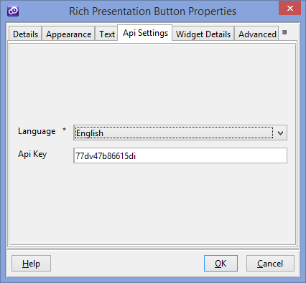

1. **LinkedIN Share Button**

**Overview**

Enable users to share your website with LinkedIn's professional audience, and drive traffic back to your site.

1. You will have to insert a new display Item of **LinkedIN Share Button** type in the **Presentation Editor**
2. Within Widget Details tab you have to set up the widget settings .

* **URL -** The url you want to share. If this attribute is not present, the plugin will share the current page's url .
* **Count mode -** Whether or not to show the share count and where it gets displayed. Defaults to not showing if this attribute is not present. Valid options are “ Vertical” and “Horizontal”
* **Show Zero -** Whether to show a zero or a placeholder in the counter if there are no shares . If the check box is checked the counter it will be shown even though there are no shares .

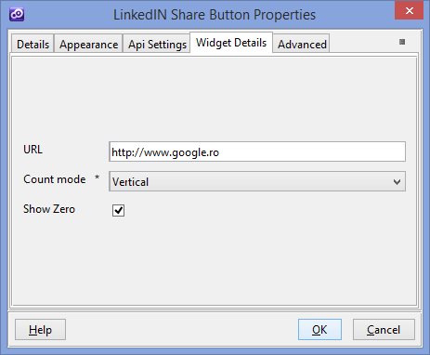

1. **LinkedIN Follow Button**

**Overview**

Any company with a LinkedIn Company Page can add a Follow button to their website, making it easy to grow their LinkedIn Company Page follower base. When members click the Follow button, they'll automatically follow that company on LinkedIn. Companies can engage with members from their Company Page and through company updates. Company updates will appear on followers' LinkedIn homepages.

1. You will have to insert a new display Item of **LinkedIN Follow Button** type in the **Presentation Editor**
2. Within Widget Details tab you have to set up the widget settings .

* **Company ID** – The identifier for you company ( You can get the ID with this tool <https://developer.linkedin.com/apply-getting-started#company-lookup> )
* **Count mode** - Whether or not to show the the follow count and where it gets displayed. Defaults to not showing if this attribute is not present.



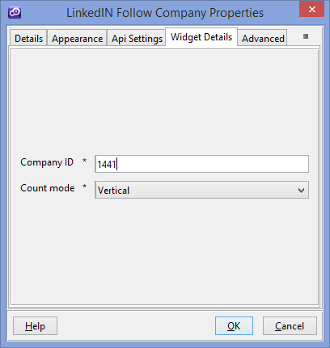

1. **LinkedIN Member Profile**

**Overview**

Bring LinkedIn member profiles to your site to help users discover common professional connections. Using the Member Profile widget allows you to give your readers an easier way to learn more about you or provide more professional social context to content on your site. You could use this plugin on your executive staff page, to indicate the author of an article, or to give more context on members who are mentioned or quoted within articles. ( See the image below)

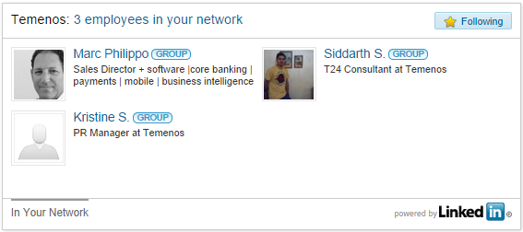

1. You will have to insert a new display Item of **LinkedIN Member Profile** type in the **Presentation Editor**
2. Within Widget Details tab you have to set up the widget settings .

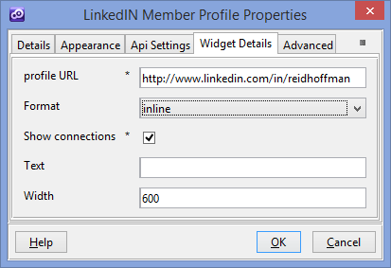

* **Profile URL** - The public profile URL of the profile you want to show. The profile URL can be obtained from the users profile on http://linkedin.com and looks like this <http://www.linkedin.com/in/reidhoffman>
* **Format** - This attribute affects how the plugin displays when rendered. There are four accepted values f: inline, click, or hover (the default),full Profile (this is an special layout with more details about user ,is different compared with the others. The “Show Connections” and “Text” settings aren’t applicable for this)
* **Show connections** - This attribute affects whether or not the connection information shows below the company's profile.
* **Text** - When the format is set to click or hover, this attribute provides the text that will appear after the LinkedIn icon
* **Width** - This attribute controls the width, in pixels, of the plugin in inline mode. It can not be set below 300 pixels as this will break the layout of the plugin. Values less than 300 will be adjusted up to 300.

1. **LinkedIN Company Insider**

**Overview**

Add the Company Insider widget to help your website visitors who are LinkedIn members discover how they're connected to companies listed on your site. This widget is showing readers how many members of a company have profiles on LinkedIn and who in their network works at the company. It also displays new hires, promotions and job changes at the company.It also works on jobs sites, so job seekers can see who they know at hiring companies. Use it anywhere to encourage professional networking on your site.

1. You will have to insert a new display Item of **LinkedIN Company Insider** type in the **Presentation Editor**
2. Within Widget Details tab you have to set up the widget settings .

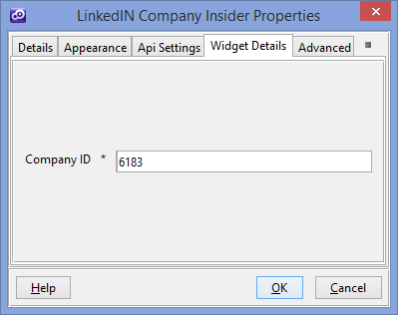

* **Company ID** – The identifier for you company ( You can get the ID with this tool <https://developer.linkedin.com/apply-getting-started#company-lookup> )

1. **LinkedIN Company Profile**

**Overview**

The Company Profile widget can show business details, the number of employees and a logo graphic, in addition to linking back to the company's LinkedIn page. Also, help users discover who they know at a company and enable them to track news and insights by using the follow button ( See the image below)

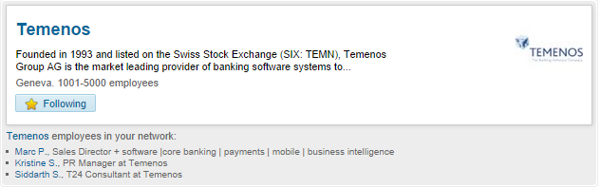

1. You will have to insert a new display Item of **LinkedIN Company Profile** type in the **Presentation Editor**
2. Within Widget Details tab you have to set up the widget settings .

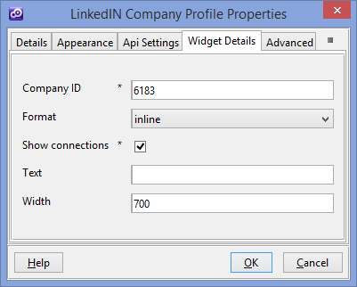

* **Company ID** – The identifier for you company ( You can get the ID with this tool <https://developer.linkedin.com/apply-getting-started#company-lookup> )
* **Format** - This attribute affects how the plugin displays when rendered. There are three accepted values : inline, click, or hover (the default).
* **Show connections** - This attribute affects whether or not the connection information shows below the company's profile.
* **Text** - When the format is set to click or hover, this attribute provides the text that will appear after the LinkedIn icon
* **Width** - This attribute controls the width, in pixels, of the plugin in inline mode. It can not be set below 300 pixels as this will break the layout of the plugin. Values less than 300 will be adjusted up to 300.

1. **LinkedIN Jobs**

**Overview**

Boost your site engagement with personalized job listings. The “Jobs widget” shows jobs posted on LinkedIn that match with user's profile in some way. It can shows jobs to a specific company or for all companies registered on Twitter . ( See the image below)

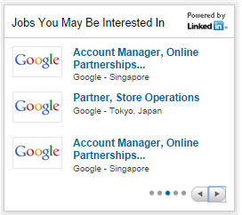

1. You will have to insert a new display Item of **LinkedIN Jobs** type in the **Presentation Editor**
2. Within Widget Details tab you have to set up the widget settings .

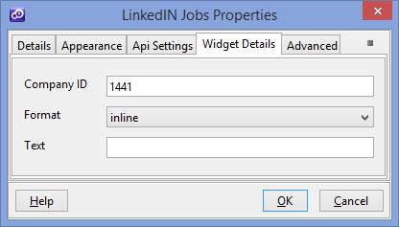

* **Company ID** – The identifier for you company ( You can get the ID with this tool <https://developer.linkedin.com/apply-getting-started#company-lookup> )
* **Format** - This attribute affects how the plugin displays when rendered. There are three accepted values : inline, click, or hover (the default).
* **Text** - When the format is set to click or hover, this attribute provides the text that will appear after the LinkedIn icon

1. **LinkedIN Login**

**Overview**

Make it easier for people to sign in or register with your site by using their LinkedIn identity.

1. You will have to add a new custom button in your presentation. Within **Appereance** -> **Button tab** for ”Display Type” field you have to select “LinkedIN “
2. Within Widget Details tab you have to set up the widget settings .

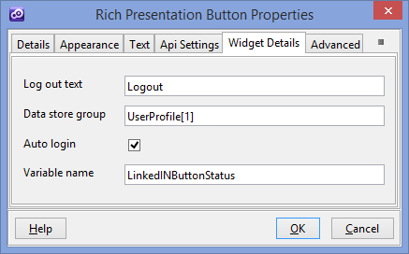

This button is used for Login and Logout actions. The transition between them is automatically , without auto login option , after the user click on the login button and he has a successful authentication the button state will change into a logout button . (whether the user has connected a specific variable as in above example $$!LinkedINButtonStatus$ is set with 'logged' value , this help us to do logical rules based on authentication status ).

* **Log out text** – the text of the button when his state is “logout”
* **Data store group** - the name of the group where to save data after a succesful login ( see above image and the project sample )**.** Within the group you can add fields as ( id , fisrtName , lastName , headline , pictureUrl ). These values are taken from user Linkedin profile.
* **Auto login** - auto click on the button when the user is already logged in with Linkedin account.
* **Variable name** - Name of the variable that is used to store the authentication status.