**Twitter Widgets**

**Installation**

1. Copy **edge.widgets.social.twitter** folder in your widgets folder (Ex: /{your project/templates })
2. Copy the content of **widget.xml** in your widget.xml file within your project
3. **Twitter Tweet Button Widget**

**Overview**

The Tweet Button is a small widget which allows users to easily share your website with their followers.

**How to use**

1. You will have to insert a new display Item of *Twitter Tweet Button* type in the **Presentation Editor**
2. On the previous item added open the **Properties** **dialog** and go to the **Widget Details** tab where you have to edit the widget options.

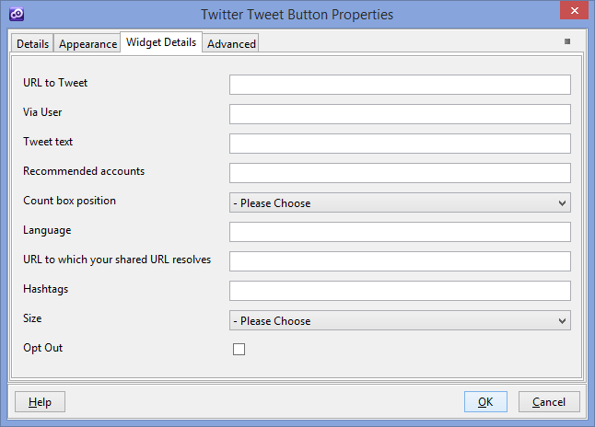

* **URL to Tweet** - URL of the page to share (default value is the current page URL )
* **Via User** - Screen name of the user to attribute the Tweet to
* **Tweet text** - Default Tweet text
* **Recommended accounts** - Related accounts . Using the related field you can suggest accounts for a user to follow once they have sent a Tweet using your Tweet Button. These suggested accounts and their basic information are shown on the last page of the Share Box flow.
* **Count box position** -The count box shows how many times the URL has been tweeted. You can choose to display or hide the count box, or place it above or next to the Tweet Button.

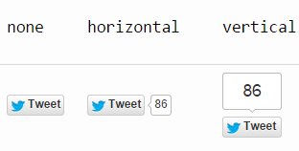

* **Language** - The language for the Tweet Button,ISO 639-1 codes. (Ex : en , ro )
* **URL to which your shared URL resolves** – default value is the url being shared.
* **Hashtags** - Comma separated hashtags appended to tweet text .
* **Size** - The size of the rendered button. The size of the button can render in either “medium”, which is the default size, or in “large” - which is the larger button.
* **Opt Out** - Twitter buttons on your site can help Twitter tailor content and suggestions for Twitter users. More details here - > <https://support.twitter.com/articles/20169421>

More informations here -> https://dev.twitter.com/web/tweet-button

1. **Twitter Follow Button Widget**

**Overview**

The Tweet Button is a small widget which allows users to easily share your website with their followers.

**How to use**

1. You will have to insert a new display Item of *Twitter Follow Button* type in the **Presentation Editor**
2. On the previous item added open the **Properties** **dialog** and go to the **Widget Details** tab where you have to edit the widget options.

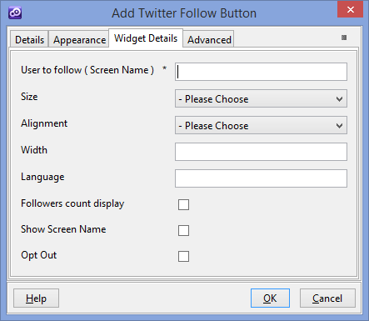

* **User to follow ( Screen Name )** - The user’s screen name that will be followed when the button is clicked.
* **Size** - The size of the button can render in either “medium”, which is the default size, or in “large” - which is the larger button. An example of what the button if size is set to large is below.



* **Alignment , Width** - You can specify the width and the alignment of the Follow Button using the width field (in pixels or percentage) and align dropdown (*left* or *right*)
* **Language** - The language for the Follow Button , ISO 639-1 codes. (Ex : en , ro )
* **Followers count display** - This checkbox controls the display of followers count
* **Show Screen Name** – This checkbox controls the display of the user screen name.
* **Opt Out** - Twitter buttons on your site can help Twitter tailor content and suggestions for Twitter users. More details here - > <https://support.twitter.com/articles/20169421>

More informations here -> https://dev.twitter.com/web/follow-button

1. **Twitter Embedded Tweets Widget**

**Overview**

Embedded Tweets make it possible for you take any Tweet and embed it directly in to the content of your article or website. Tweets display with expanded media like photos, videos, and article summaries, and also include real-time retweet and favorite counts. When embedded, Tweets are interactive and enable your readers to follow the Tweet author, and reply, retweet, favorite all directly from the page.

**How to use**

1. You will have to insert a new display Item of *Twitter Embedded Tweets* type in the **Presentation Editor**
2. On the previous item added open the **Properties** **dialog** and go to the **Widget Details** tab where you have to edit the widget options.

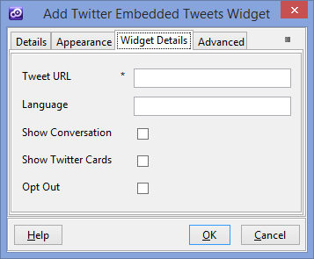

* **Tweet URL** - The URL of the Tweet to be embedded.
* **Language -** The language of the widget , ISO 639-1 codes. (Ex : en , ro )
* **Show Conversation** - For example, if you are collecting Tweets from a conversation and don't want the thread attached to every Tweet, you can show or hide the conversation using this checkbox.
* **Show Twitter Cards** – When this isn’t checked , links in a Tweet are not expanded to photo, video, or link previews.
* **Opt Out** - Twitter buttons on your site can help Twitter tailor content and suggestions for Twitter users. More details here - > <https://support.twitter.com/articles/20169421>

1. To setup the widget appearance options go within **Appearance** tab and edit the settings.

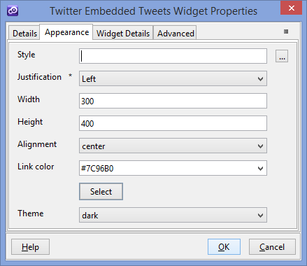

* **Width** - The maximum width of the rendered Tweet in whole pixels. This value should be between 250 and 550 pixels. Example Value: 325
* **Alignment** - Float the Tweet left, right, or center relative to its container. Typically set to allow text or other content to wrap around the Tweet.
* **Link color** - Adjust the color of Tweet links with a hexadecimal color value.
* **Theme** - Choose the theme of the widget. When set to dark, displays Tweet with light text over a dark background.

1. **Twitter Embedded Timelines Widget**

**Overview**

Embeddable timelines make it easy to syndicate any public Twitter timeline to your website . Just like timelines on twitter.com, embeddable timelines are interactive and enable your visitors to reply, Retweet, and favorite Tweets directly from your pages. Users can expand Tweets to see Cards inline, as well as Retweet and favorite counts. An integrated Tweet box encourages users to respond or start new conversations, and the option to auto-expand media brings photos front and center. These new timeline tools are built specifically for the web, mobile web, and touch devices. They load fast, scale with your traffic, and update in real-time.

**How to use**

1. You will have to insert a new display Item of *Twitter Embedded Timelines* type in the **Presentation Editor**
2. On the previous item added open the **Properties** **dialog** and go to the **Widget Details** tab where you have to edit the widget options.

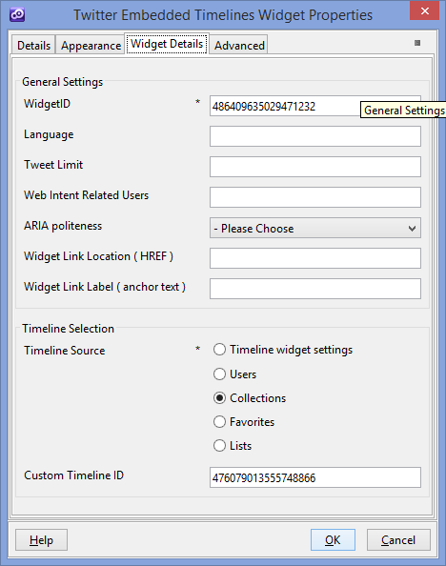

* **WidgetID** - ID for your widget taken from twitter website ( https://twitter.com/settings/widgets )
* **Language** - The language of the widget , ISO 639-1 codes. (Ex : en , ro )
* **Tweet Limit** - To fix the size of a timeline to a preset number of Tweets, value between 1 and 20 Tweets
* **Web Intent Related Users** - As per the Tweet and follow buttons, you may provide a comma-separated list of user screen names as suggested followers to a user after they reply, Retweet, or favorite a Tweet in the timeline .
* **ARIA politeness** - ARIA is an accessibility system that aids people using assistive technology interacting with dynamic web content. More info here --> <http://www.w3.org/WAI/intro/aria.php>
* **Widget Link Location ( HREF )** - Hypertext Reference for your widget ex : <https://twitter.com/temenos>
* **Widget Link Label ( anchor text )** - Widget Link Label ex : Tweets by @Temenos
* **Timeline Source** – Source of the timeline. You can embed a timeline for Tweets from an individual user, a user’s favorites, Twitter lists, or any search query (widget settings) or hashtag.
  1. **Timeline widget settings** – this use for timeline source the settings from Twitter Widget ( <https://twitter.com/settings/widgets> ) especially is used for search queries.
  2. **Users** – this use for timeline source the timeline of an individual twitter user.
     + - * **Screen Name** - The screen name of a twitter account.
         * **User ID** - The integer representation of the unique identifier for a twitter User . ex : "6253282"
         * **Show Replies** - If this checkbox is checked you specify to toggle the ‘Show Replies’ option on a per-timeline basis.
  3. **Collections** - Collections are timelines curated by Twitter users. Embedding collections lets you share your timelines with the world.
     + - * **Custom Timeline ID** - Timeline id for your custom timeline that you want to render. Use only the integer portion of the custom timeline ID.
  4. **Favorites** - Like the user timeline, a favorites timeline may be created for any public Twitter user, and displays that user’s favorited Tweets.
     + - * **Favorites Screen Name** - The screen name of a twitter account.
         * **Favorites User ID** - The integer representation of the unique identifier for a twitter User . ex : "6253282"
  5. **List** - The list timeline shows Tweets from a specific list of users. The header of the list widget contains the list name, description, and links to the list creator’s profile. Retweets by members of the list are included in the timeline. To create a list timeline you must have either created that list yourself, or subscribe to it.
     + - * **List Owner Screen Name** - The screen name of the owner of the list.
         * **List Owner ID** - The ID of the owner of the list.
         * **List ID** – The identifier of the list
         * **List Slug** – The slug of the list

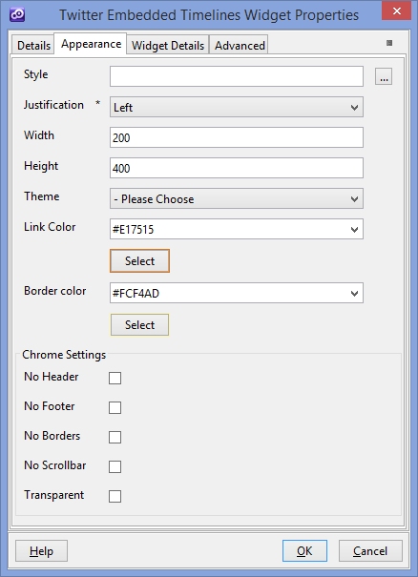

* **Width** - Set using the standard HTML width attribute on the embed code (units are pixels.)
* **Height** - Set using the standard HTML height attribute on the embed code (units are pixels.)
* **Theme** - Set the theme of the widget (dark or light )
* **Link Color** – The color of the link . Note that some icons in the widget will also appear this color.
* **Border Color** - Change the border color used by the widget .
* **No Header** - Hides the timeline header
* **No Footer** - Hides the timeline footer and Tweet box, if included.
* **No borders** - Removes all borders within the widget (between Tweets, cards, around the widget).
* **No Scrollbar** - Crops and hides the main timeline scrollbar, if visible.
* **Transparent** - Removes the background color .