**Tree Table Widget**

**Manual Installation**

1. Copy **com.temenos.widgets.tables.treeTable** folder in your widgets folder (Ex: /{your project/templates })
2. Restart IDE.

**Auto-Installation**

1. Run IDE.
2. Make sure the “**Switch Monitor on/off**” is checked.
3. Download/ Copy the widget (**com.temenos.widgets.tables.treeTable.zip**) to monitored folder.

(**Tools** menu, **Options**, **Auto-install** tab and set in “**Download Location**” the folder where you copied the widgets.) No need to restart IDE.

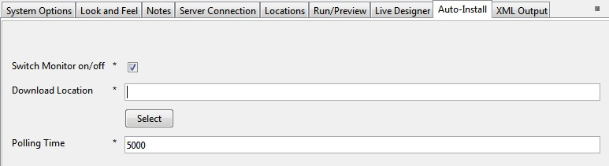

**Tree Table**

**Overview:**

The purpose of the tree table widget is to allow a flat structured data set to be displayed in a tree form, so that rows can be expanded and displayed to the user if they wish to see them. This makes it particularly useful for large data sets, where the data can be categorized.

**Usage:**

Create a table in edgeConnect using the standard table. The data group that contains the data to show must have two extra data items:

* A unique id (this can be the instance)
* The parent id

These will be used by the widget to turn the structure into a tree.

Make sure the widget has been installed, and then open the display properties for the table in the presentation editor:



When you select Tree Table, a new tab will appear – Widget Details. This will let you choose the data items which define the row id and the parent id

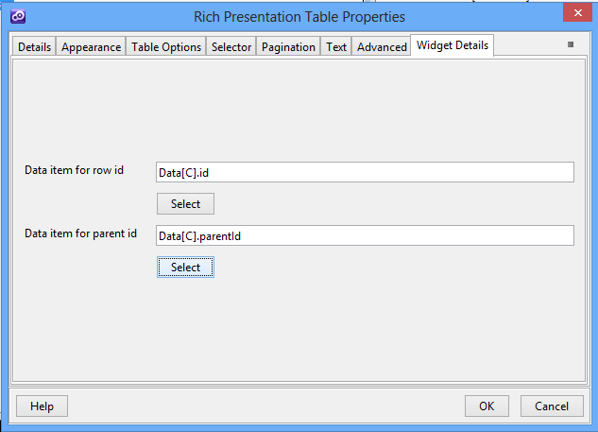

Running this project results in the following:



The table is completely collapsed to begin with. Clicking on the arrow on the left expands that row to display child rows (rows which have the first row as the parent)

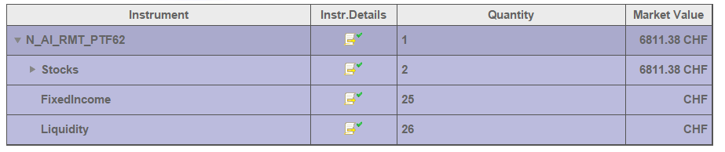

Expanding “Stocks” results in:

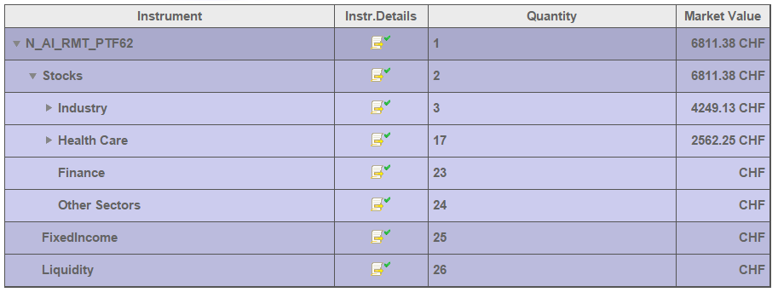

And so on.

To expand to a row by default requires a selector data item to be specified on the table whose value represents the id of the row to reveal. This is why using instances for id’s is good idea.

The styling of the table is added in the header part of the widget. Each level of nesting gets its own class, so you can set styles on rows as you deeper you go into the tree.