Problem 1:







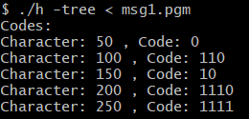

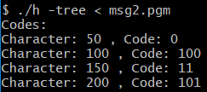

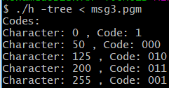

1. Images:

|  |  |  |
| --- | --- | --- |
| Image | Output | Class |
| Sena | 56221 | 57504 |
| Sensin | 60147 | 61430 |
| Earth | 39252 | 40534 |
| Omaha | 57092 | 58374 |

All numbers are less than in class

1. Images:

|  |  |  |
| --- | --- | --- |
| Image | Output | Class |
| Sena | 32020 | 32968 |
| Sensin | 37560 | 38541 |
| Earth | 32595 | 33880 |
| Omaha | 51479 | 52643 |

All numbers are less than in class

Problem 2:

b)

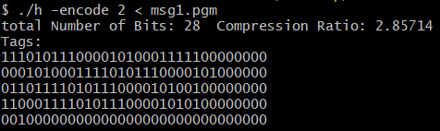

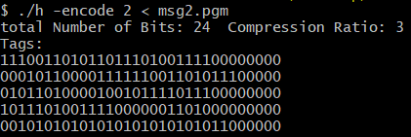

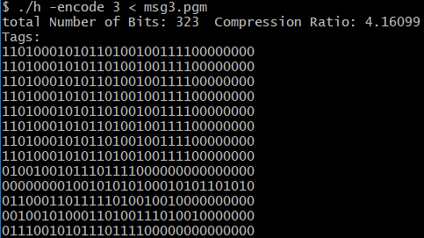

The last picture in not complete

c)



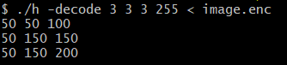

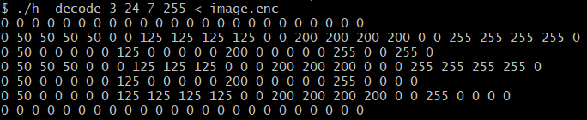

d)

|  |  |  |  |  |
| --- | --- | --- | --- | --- |
| M | Sena | Sensin | Earth | Omaha |
| 1 | 0.961319 | 0.909113 | 1.23878 | 0.946285 |
| 2 | 1.05386 | 0.992259 | 1.43404 | 1.03913 |
| 3 | 1.09726 | 1.02868 | 1.51806 | 1.07672 |
| 5 | 1.26468 | 1.25023 | 1.93579 | 1.2557 |
| 10 | 2.49985 | 2.49985 | 3.36708 | 2.49985 |

Compression ratio

Number of Bits

|  |  |  |  |  |
| --- | --- | --- | --- | --- |
| M | Sena | Sensin | Earth | Omaha |
| 1 | 545384 | 576703 | 423228 | 554049 |
| 2 | 497491 | 528378 | 365601 | 504545 |
| 3 | 477817 | 509669 | 345366 | 486929 |
| 5 | 414562 | 419354 | 270839 | 417528 |
| 10 | 209728 | 209728 | 155710 | 209728 |

The more symbols per block the better compression ratio

Problem 3:

1. Outputs:

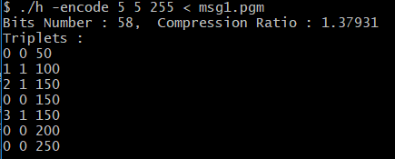

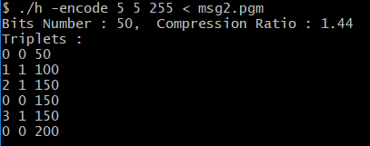

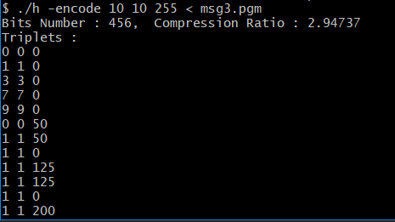

1. Outputs

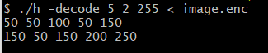

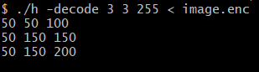

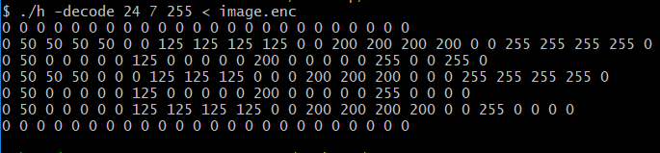

|  |  |  |  |  |
| --- | --- | --- | --- | --- |
| <s,t> | Sena | Sensin | Earth | Omaha |
| <100,100> | 1.72789 | 1.47059 | 2.17534 | 1.13256 |
| <200,200> | 1.86742 | 1.68 | 2.29428 | 1.15253 |
| <300,300> | 2.09987 | 1.73907 | 2.55658 | 1.22103 |

1. Compression ratio

Number of Bits

|  |  |  |  |  |
| --- | --- | --- | --- | --- |
| <s,t> | Sena | Sensin | Earth | Omaha |
| <100,100> | 303427 | 356515 | 241014 | 462923 |
| <200,200> | 280756 | 320158 | 205074 | 454900 |
| <300,300> | 249677 | 301476 | 345366 | 429382 |

1. Images:

|  |  |  |
| --- | --- | --- |
| Image | Output | Class |
| Sena | 34186 | 31847 |
| Sensin | 37789 | 37387 |
| Earth | 22062 | 32137 |
| Omaha | 39424 | 51393 |

Numbers are nearly the same