Artificial Intelligence
PROJECT

SUBMITTED BY:
Muhammad Abdullah – 23i-2641
Taha Khan - 23i-2647
Rehan Ahmad – 23i-2551
BS-DS(6C)

1. Introduction
AeroNet Lite is an autonomous drone delivery simulation system developed as part of the AI Semester Project for BS Data Science at FAST-NUCES. The system models a city as a 10x10 grid where each cell carries a zone type, population density, facility flags, and delivery demand. Five integrated AI modules work together to validate the city layout, select an optimal drone fleet, plan safe delivery routes, respond to mid-flight disruptions, forecast demand, and detect flight anomalies in real time.
The project demonstrates five core AI techniques: Constraint Satisfaction Problem (CSP) for layout validation, a Genetic Algorithm (GA) for fleet selection, A* Search for path planning, real-time replanning for disruption handling, and a machine learning pipeline combining regression and classification. The entire system runs as a 20-step console simulation and is visualised through an interactive Streamlit dashboard. The project folder structure follows the specification with separate directories for raw and processed data, source modules, and the report. All modules communicate through a shared grid model ensuring clean integration across the pipeline.
2. System Architecture and Shared Grid Model
The shared grid model is defined in grid_model.py and forms the backbone of the entire system. Every module reads from or writes to this shared model, ensuring that decisions in one module automatically propagate to all others. The grid is a 10x10 matrix of Cell dataclass objects, each holding the following fields.
Field | Type | Purpose
row, col | int | Cell position in the grid
zone | str | Zone type: Residential, Commercial, Industrial, Hospital, School, Open Field
density | int | Population density used for demand estimation and visualisation
is_hub | bool | Marks drone hub launch and return locations
is_charging | bool | Marks nearby charging pad locations
is_medical_pickup | bool | Marks medical supply pickup points adjacent to hospitals
no_fly | bool | Blocks routing through this cell when activated
demand | float | Estimated delivery demand, set initially then overridden by the ML pipeline

The grid is constructed using build_grid() in grid_model.py. The zone layout is manually defined across 10 rows and 10 columns to create a realistic city pattern with residential clusters, commercial corridors, industrial areas, schools, hospitals, and open fields. Density is seeded per zone type with a small random variation. Six hub positions are placed at coordinates (0,2), (1,8), (3,1), (5,5), (7,1), and (9,8), with corresponding charging pads placed within two cells of each hub. Medical pickup points are placed at (1,8) and (2,8), adjacent to the hospitals at rows 1 and 2, column 7. Delivery demand is initialised randomly per zone and later overridden by the ML pipeline output.
3. Module 1: Layout Validation Using CSP
The layout validator in layout_validator.py implements a Constraint Satisfaction Problem checker that verifies whether the manually defined city grid satisfies four operational rules before any simulation begins. Rather than generating the layout automatically, the system defines the grid and then runs a constraint checker that behaves like a CSP solver, storing all violations and reporting them with suggested fixes.
Constraint Rules
Rule R1 enforces industrial safety by checking that no industrial cell is directly adjacent (up, down, left, right) to a school or hospital. The function iterates over all industrial cells, retrieves their four-directional neighbours using get_neighbors(), and flags any neighbour whose zone is School or Hospital.
Rule R2 enforces residential coverage by verifying that every residential cell is within three Manhattan distance units of at least one drone hub. For each residential cell the minimum Manhattan distance to any hub is computed. If that distance exceeds three, the cell is flagged and a suggested hub location is calculated as the midpoint between the cell and its nearest hub.
Rule R3 enforces hub charging by checking that every drone hub has at least one charging pad within two Manhattan cells. All hubs are iterated and the distance to the nearest charging pad is measured. Any hub without a nearby charger is reported with a suggested fix.
Rule R4 enforces medical access by verifying that at least one hospital has a medical pickup point within one cell. The rule requires only one covered hospital, so the check stops as soon as any hospital-pickup pair satisfying the distance condition is found.
Actual Output
============================================================
AERONET LITE - CSP LAYOUT VALIDATION REPORT
============================================================
Layout Validity: PASSED
Rules Passed : 4/4
Rules Failed : 0/4

[PASSED RULES]
[PASS] R1 - Industrial Safety
[PASS] R2 - Residential Coverage
[PASS] R3 - Hub Charging
[PASS] R4 - Medical Access
============================================================

All four rules passed, confirming that the manually designed grid satisfies every operational constraint before the simulation proceeds.
4. Module 2: Fleet Selection Using Genetic Algorithm
The fleet selector in fleet_selector.py uses a Genetic Algorithm to determine the optimal mix of light and heavy drones under a fixed budget of $12,000. Only two drone types are used as specified in the project requirements.
Drone Type | Cost | Payload | Range | Use Case
Light Drone | $1,000 | 2 kg | 12 cells | Small parcels and nearby deliveries
Heavy Drone | $1,800 | 5 kg | 20 cells | Medical packages and longer deliveries

Fitness Function
The fitness function implements the exact formula from the project specification: score = (0.75 x coverage_percentage) - (0.25 x budget_used_percentage). Coverage is computed as the ratio of residential cells the fleet can serve, capped at 1.0. Budget used is the total fleet cost divided by the $12,000 budget. Hard constraints eliminate any chromosome where the fleet has fewer than two light drones, fewer than one heavy drone, costs over budget, or exceeds six total drones. Chromosomes that violate any hard constraint receive a fitness score of -999 and are removed from the population.
GA Design
The chromosome is a pair [light_count, heavy_count]. The initial population of 30 chromosomes is generated randomly with all hard constraints satisfied. In each of 60 generations, chromosomes are sorted by fitness and the top 50 percent become parents. Children are produced by single-point crossover, swapping either the light or heavy count between two parents. A mutation rate of 0.25 applies a delta of plus or minus one to either gene after each crossover, with the result clamped to respect minimum drone requirements and the budget ceiling.
Actual Output
============================================================
AERONET LITE - FLEET SELECTION REPORT (GA)
============================================================
Light Drones : 2 x $1000 = $2000
Heavy Drones : 4 x $1800 = $7200
Total Drones : 6
Total Cost : $9200
Budget : $12000
Remaining : $2800
Fitness Score : 0.5583
============================================================

The GA converged on a fleet of two light and four heavy drones at a total cost of $9,200, leaving $2,800 of the $12,000 budget unused. The fitness score of 0.5583 reflects the balance between high demand coverage delivered by the four heavy drones and the relatively higher cost of the heavy drone type under the specification formula.
5. Module 3: Delivery Path Planning with A* Search
The path planner in astar_planner.py implements A* Search to compute the shortest safe route between any two cells on the grid. A full delivery route follows the sequence hub to pickup to dropoff to hub, with each of the three segments solved independently by A*.
A* Design
The state space is the set of grid coordinates (row, col). From each state the algorithm expands in four directions: up, down, left, and right. The step cost is 0.8 for commercial cells to model corridor discounts and 1.0 for all other passable cells. Cells where no_fly is True are treated as blocked and skipped during expansion. The heuristic is the Manhattan distance between the current cell and the goal, which is admissible for four-directional grid movement and therefore guarantees optimality. A min-heap priority queue stores tuples of (f_cost, g_cost, position, path). A visited dictionary tracks the best g_cost seen for each position to avoid redundant expansion.
The plan_delivery_route() function calls astar() three times in sequence: hub to pickup, pickup to dropoff, and dropoff back to hub. The three resulting paths are concatenated removing duplicate junction points to form a single continuous route.
Delivery Assignment Output
The following delivery assignments and route lengths were produced by the actual simulation run.
Step 05: Delivery 1 -> Drone D5 | pickup=(9,3) dropoff=(3,7) | route=25 cells.
Step 05: Delivery 2 -> Drone D3 | pickup=(7,0) dropoff=(7,9) | route=27 cells.
Step 05: Delivery 3 -> Drone D6 | pickup=(9,0) dropoff=(4,6) | route=27 cells.
Step 05: Delivery 4 -> Drone D4 | pickup=(6,7) dropoff=(0,9) | route=21 cells.
Step 05: Delivery 5 -> Drone D1 | pickup=(3,0) dropoff=(8,7) | route=31 cells.
Step 06: 5 drone(s) dispatched. Routes confirmed via A* search.

Route Map Before No-Fly Zone Activation
Figure 1 shows the initial planned routes for all five assigned drones on the 10x10 city grid before any disruption occurs. Each drone's path is shown in a distinct colour with its label displayed on the grid. Pickup and dropoff points are marked with directional triangles labelled with the drone and delivery identifiers. The diagonal path offsets ensure that overlapping routes remain individually visible.
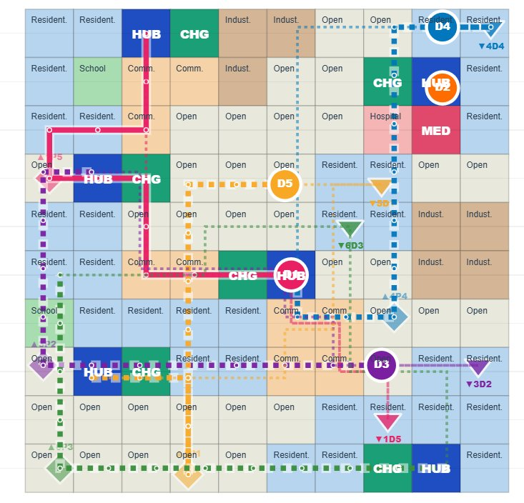
Figure 1: Initial A* planned routes for all five drones before no-fly zone activation.
6. Module 4: Real-Time Disruption Handling
The disruption handler is integrated into the 20-step simulation in delivery_simulator.py. It manages drone movement, no-fly zone activation, route conflict detection, and emergency rerouting across the simulation timeline.
No-Fly Zone Activation
At step 11 of the simulation the system activates a no-fly cell. The pick_no_fly_cell() function selects a cell that is guaranteed to lie on at least one active drone's remaining route. Hub positions, pickup coordinates, dropoff coordinates, and cells within two steps of the route end are all excluded from selection to ensure that rerouting remains feasible. The selected cell is marked by setting grid[row][col].no_fly = True, which immediately affects all subsequent A* route planning calls.
Rerouting Logic
The reroute_affected_drones() function scans every active drone's remaining path for any cell where no_fly is True. When a conflict is detected the function logs the blocking cell and calls plan_delivery_route() from the drone's current position to its delivery's pickup and dropoff coordinates. If a valid reroute is found the drone's route is replaced and its status is set to Rerouting. If no safe route exists the delivery is marked Delayed and the drone is set to Failed.
Actual Disruption Output
In this simulation run, the no-fly zone was activated at cell (5,3) at step 11, intersecting the planned routes of three drones simultaneously. All three were successfully rerouted using A* from their current positions.
Step 11: NO-FLY ZONE activated at (5,3) (intersects Drone D1 route).
Step 11: Drone D1 path blocked at (5,3). Running A* reroute.
Step 11: Drone D1 rerouted successfully | new route=25 cells.
Step 11: Drone D3 path blocked at (5,3). Running A* reroute.
Step 11: Drone D3 rerouted successfully | new route=19 cells.
Step 11: Drone D6 path blocked at (5,3). Running A* reroute.
Step 11: Drone D6 rerouted successfully | new route=23 cells.
Step 12: Rerouting complete. Drones continuing. Completed=0.

Route Map After No-Fly Zone Activation and Rerouting
Figure 2 shows the updated route map after the no-fly zone was activated at cell (5,3). The black NO-FLY cell is clearly visible in the centre-left of the grid. All three affected drones successfully computed new paths around the blocked cell using A* search from their current positions. The remaining two drones whose routes did not intersect the no-fly cell continued on their original paths without interruption.
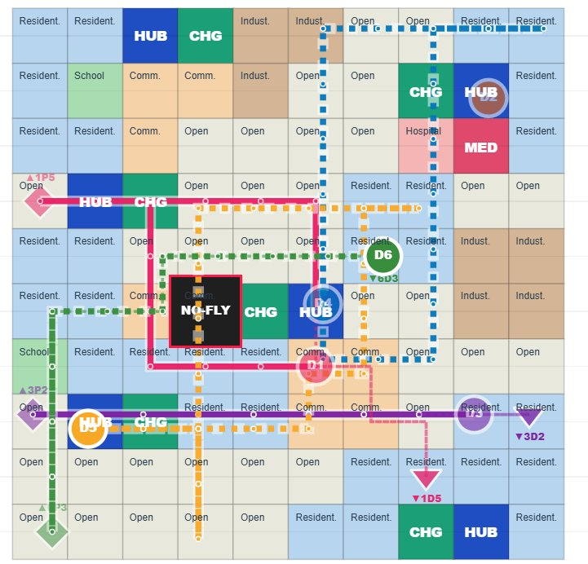
Figure 2: Route map after no-fly zone activation at (5,3). Three drones rerouted, two unaffected.
Full 20-Step Simulation Log
The complete event log produced by the simulation run is shown below.
Step 01: Grid initialized. 10x10 city layout loaded.
Step 01: Grid: 10x10 cells | Hubs: 6 | Budget: $12000.
Step 02: CSP Layout Validation PASSED. All 4 rules satisfied (R1-R4).
Step 03: Fleet selected: 2 Light + 4 Heavy | 6 drones | cost=$9200 | fitness=0.5583.
Step 04: Generated 5 deliveries.
Step 05: Delivery 1 -> Drone D5 | pickup=(9,3) dropoff=(3,7) | route=25 cells.
Step 05: Delivery 2 -> Drone D3 | pickup=(7,0) dropoff=(7,9) | route=27 cells.
Step 05: Delivery 3 -> Drone D6 | pickup=(9,0) dropoff=(4,6) | route=27 cells.
Step 05: Delivery 4 -> Drone D4 | pickup=(6,7) dropoff=(0,9) | route=21 cells.
Step 05: Delivery 5 -> Drone D1 | pickup=(3,0) dropoff=(8,7) | route=31 cells.
Step 06: 5 drone(s) dispatched. Routes confirmed via A* search.
Step 07: Drones flying. Active=5 | Completed=0.
Step 08: Drones flying. Active=5 | Completed=0.
Step 09: Drones flying. Active=5 | Completed=0.
Step 10: Drones flying. Active=5 | Completed=0.
Step 11: NO-FLY ZONE activated at (5,3) (intersects Drone D1 route).
Step 11: Drone D1 path blocked at (5,3). Running A* reroute.
Step 11: Drone D1 rerouted successfully | new route=25 cells.
Step 11: Drone D3 path blocked at (5,3). Running A* reroute.
Step 11: Drone D3 rerouted successfully | new route=19 cells.
Step 11: Drone D6 path blocked at (5,3). Running A* reroute.
Step 11: Drone D6 rerouted successfully | new route=23 cells.
Step 12: Rerouting complete. Drones continuing. Completed=0.
Step 13: Drones flying. Completed=0.
Step 14: Drone D4 completed Delivery 4 at (5,5).
Step 14: Drones flying. Completed=1.
Step 15: Demand forecast integrated. Predicted avg demand = 191.12 units (Random Forest).
Step 16: All deliveries already assigned or no idle drones available.
Step 17: Drones flying. Completed=1.
Step 18: Battery Anomaly on Drone D1 | battery dropped to 63.1%.
Step 19: No emergency returns needed. 4 drone(s) continuing normally.
Step 19: Drone D5 completed Delivery 1 at (7,1).
Step 19: Step 19 complete. Completed so far: 2/5.
Step 20: Delivery 2 marked Delayed (not finished in time).
Step 20: Delivery 3 marked Delayed (not finished in time).
Step 20: Delivery 5 marked Delayed (not finished in time).
Step 20: Simulation complete | Completed=2 | Delayed=3 | Failed=0.

Two deliveries were completed within the 20-step simulation: Delivery 4 by Drone D4 at step 14 and Delivery 1 by Drone D5 at step 19. Three deliveries were marked Delayed at step 20 because the combination of long route lengths (up to 31 cells), the no-fly zone rerouting overhead at step 11, and the anomaly injection at step 18 left insufficient steps for those drones to finish within the simulation window. No deliveries failed outright as all affected drones successfully found alternative routes.
7. Module 5: Machine Learning Pipeline
The ML pipeline in ml_pipeline.py implements two separate machine learning tasks: demand forecasting using regression and anomaly detection using classification. Both tasks are executed before the simulation so their results can be fed into the delivery and routing decisions.
Demand Forecasting
The demand forecasting component uses the Kaggle Bike Sharing Demand dataset (train.csv) containing 10,886 hourly records of bicycle rental counts along with weather and calendar features. This dataset is used as a proxy for delivery demand because both domains share the same underlying pattern: demand varies with time of day, weather conditions, working day status, and season. Nine features are selected for training: season, holiday, workingday, weather, temp, atemp, humidity, windspeed, and hour. The dataset is split 80/20 into training and test sets using a fixed random seed of 42.
Linear Regression is trained as the baseline model. It fits a hyperplane to the nine input features and predicts the continuous count value. Random Forest Regressor uses 50 decision trees each trained on a random subset of features and rows, and predictions are averaged to reduce variance. Both models are evaluated using Mean Absolute Error and Root Mean Squared Error.
Demand Forecasting Results
[ML] Using real Bike Sharing data: train.csv | shape=(10886, 12)

[ML] Demand Forecasting Results:
LinearRegression: MAE=115.04, RMSE=154.62
RandomForest: MAE=108.23, RMSE=152.16
[ML] Saved RandomForest demand predictions to: data/processed/demand_predictions.csv

Model | MAE | RMSE
Linear Regression | 115.04 | 154.62
Random Forest | 108.23 | 152.16

Random Forest outperforms Linear Regression on both metrics. The predicted average demand of 191.12 units is fed into the simulation at step 15. This figure is used to confirm that demand is high enough to justify continuing deliveries in the post-forecast phase of the simulation.
Demand Heatmap
Figure 3 shows the delivery demand heatmap across all 100 cells of the 10x10 grid. Cells are coloured along a ramp from pale cream (low demand) through orange to deep red (high demand). Hub cells are marked with blue squares. The heatmap reveals that demand is distributed non-uniformly across the city, with several high-demand clusters visible in the residential and commercial areas. These demand values are generated by the grid model and later overridden by the ML pipeline predictions, reflecting realistic spatial variation in delivery density.
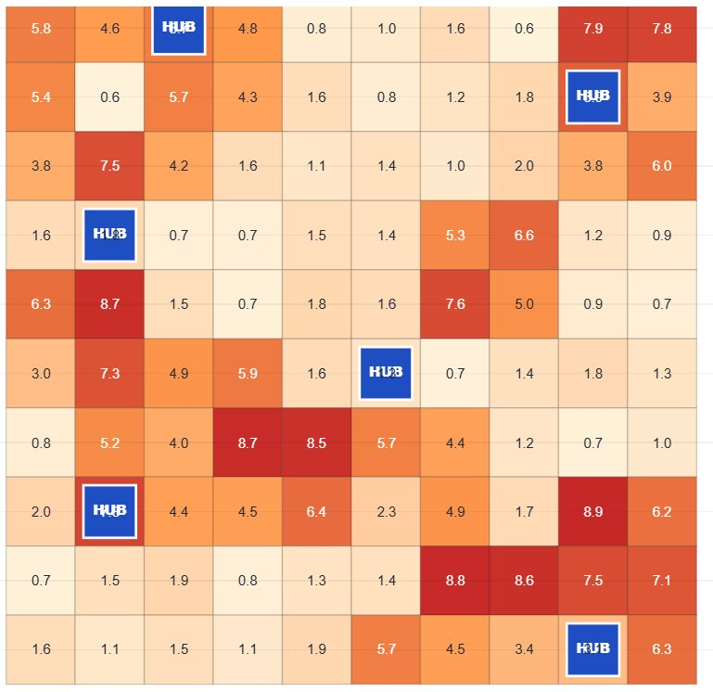
Figure 3: Delivery demand heatmap. Colour intensity indicates demand per cell. Hub locations marked in blue.

Anomaly Detection
The anomaly detection component classifies drone flight telemetry into four categories: Normal, Battery Anomaly, Route Anomaly, and Sensor Spike. Because real UAV telemetry data was not available, a synthetic dataset is generated using generate_synthetic_telemetry() with deliberate overlapping ranges and Gaussian noise to produce realistic classification difficulty. The dataset contains 950 records: 500 normal samples and 150 samples of each anomaly class.
Anomaly Dataset Distribution
[ML] Anomaly dataset: (950, 6), class distribution:
label
Normal 500
Sensor Spike 150
Route Anomaly 150
Battery Anomaly 150

Class | Key Signal | Feature Ranges
Normal | Gradual battery drop, low deviation | battery_drop: 1-5, route_deviation: 0-1
Battery Anomaly | Battery drops faster than expected | battery_drop: 8-20 (overlaps Normal at low end)
Route Anomaly | Drone deviates from planned path | route_deviation: 2-5 (overlaps Normal at low end)
Sensor Spike | Altitude or speed jumps suddenly | altitude_change: 4-12, speed_change: 5-15

Five features are used for training: battery_drop, speed, route_deviation, altitude_change, and speed_change. The data is split 80/20 with stratification to preserve class balance. Two classifiers are trained: a Decision Tree with maximum depth of five, and a Random Forest with 50 trees.
Anomaly Detection Results
[ML] Anomaly Detection Results:
DecisionTree: Accuracy=0.9632
RandomForest: Accuracy=0.9526

Random Forest Classification Report:
precision recall f1-score support
Battery Anomaly 0.93 0.90 0.92 30
Normal 0.94 0.98 0.96 100
Route Anomaly 0.96 0.87 0.91 30
Sensor Spike 1.00 1.00 1.00 30
accuracy 0.95 190
macro avg 0.96 0.94 0.95 190
weighted avg 0.95 0.95 0.95 190

Confusion Matrix:
[[27 3 0 0]
[ 1 98 1 0]
[ 1 3 26 0]
[ 0 0 0 30]]

Model | Accuracy
Decision Tree | 96.32%
Random Forest | 95.26%

The confusion matrix shows that 27 of 30 Battery Anomaly samples were correctly classified with 3 misclassified as Normal; 98 of 100 Normal samples were correctly classified with 1 misclassified as Battery Anomaly and 1 as Route Anomaly; 26 of 30 Route Anomaly samples were correctly classified with 1 misclassified as Battery Anomaly and 3 as Normal; and all 30 Sensor Spike samples were correctly classified with no errors. Sensor Spike achieves perfect scores because its altitude and speed change features are highly distinct from all other classes. Battery Anomaly and Route Anomaly show slightly lower recall due to deliberate overlap with Normal samples at the lower end of the anomaly feature ranges.
During the simulation run, a Battery Anomaly was injected into Drone D1 at step 18, causing its battery to drop from its previous level to 63.1 percent. Since this did not fall below the 20 percent emergency threshold, the drone continued its mission rather than returning to the hub. This reflects the classifier's real-time monitoring role in the simulation.
8. Visualisation Dashboard
The visualisation component in visualization.py builds a Streamlit web dashboard that presents all simulation results interactively. The dashboard is launched by running streamlit run src/visualization.py from the project root. It executes the full pipeline on load and caches the results so subsequent tab switches do not re-run expensive computations.
The dashboard is organised into seven tabs. The Zone Map tab displays the 10x10 city grid with each cell coloured by zone type, with hub, charging pad, medical pickup, and no-fly cells highlighted in distinct colours. The Route Map tab provides an animated step-by-step view using a slider to advance through all 20 simulation steps, showing drone positions, trails, remaining planned routes as dotted lines, and active pickup and dropoff markers per drone in that drone's unique colour. When multiple drones travel through overlapping cells their paths are given a small diagonal offset so every route remains individually visible. The static overview shows all completed routes simultaneously with start, pickup, dropoff, and return markers labelled per drone and delivery. The Demand Heatmap tab renders per-cell demand intensity as shown in Figure 3. The Fleet tab shows the GA-selected fleet and fitness convergence chart. The ML Results tab presents model comparison charts and full confusion matrices. The Anomaly View tab lists all four anomaly classes, any flagged drones, and classifier performance. The Simulation Log tab shows the complete 20-step event log, a drone status table, and a delivery status table.
9. Final Results Summary
The complete system was executed end-to-end and produced the following final output.
======================================================================
FINAL PROJECT SUMMARY
======================================================================
Layout Valid : True
Fleet Selected : 2 Light + 4 Heavy ($9200 / $12000)
Demand Forecast : RF MAE=108.23, RMSE=152.16
Anomaly Accuracy : 95.26%
Deliveries Done : 2/5
Delayed / Failed : 3 / 0
======================================================================

Component | Result
Layout Validation | PASSED — 4/4 CSP rules satisfied
Fleet Selected | 2 Light + 4 Heavy drones at $9,200 out of $12,000 budget
Demand Forecast (RF) | MAE = 108.23, RMSE = 152.16
Anomaly Detection (RF) | Accuracy = 95.26%
Deliveries Completed | 2 out of 5 (Delivery 4 at step 14, Delivery 1 at step 19)
Deliveries Delayed | 3 (Deliveries 2, 3, and 5 not finished within 20 steps)
Deliveries Failed | 0
No-Fly Zone | Activated at (5,3) at step 11, three drones rerouted successfully
Anomaly Injected | Battery Anomaly on Drone D1 at step 18, battery at 63.1%

10. Conclusion
AeroNet Lite successfully implements a multi-module autonomous drone delivery simulation integrating five distinct AI techniques within a unified 20-step console and visual pipeline. The system demonstrated that CSP constraint checking, genetic algorithm optimisation, heuristic search, real-time replanning, regression, and classification can all be combined in a single coherent system of manageable complexity.
The most significant results of this run were that all four CSP rules passed on the first validation, confirming a well-designed city layout; the GA selected a fleet of six drones within budget at a fitness score of 0.5583; all five initial routes were computed successfully using A* search; three out of three rerouting calls at step 11 succeeded in finding alternative paths around the activated no-fly zone; and the Random Forest anomaly classifier achieved 95.26 percent accuracy on the synthetic telemetry dataset. Two out of five deliveries were completed within the 20-step window, with the remaining three marked as Delayed rather than Failed, reflecting a realistic operational model where unfinished missions are rescheduled.
Future extensions could increase the simulation length to allow more deliveries to complete, introduce multiple simultaneous no-fly events, incorporate weather-based routing costs, and connect the anomaly classifier to live telemetry for real-time monitoring during flight.

