**Controller**

**1.frist create controller using artisan command(here you can see)**

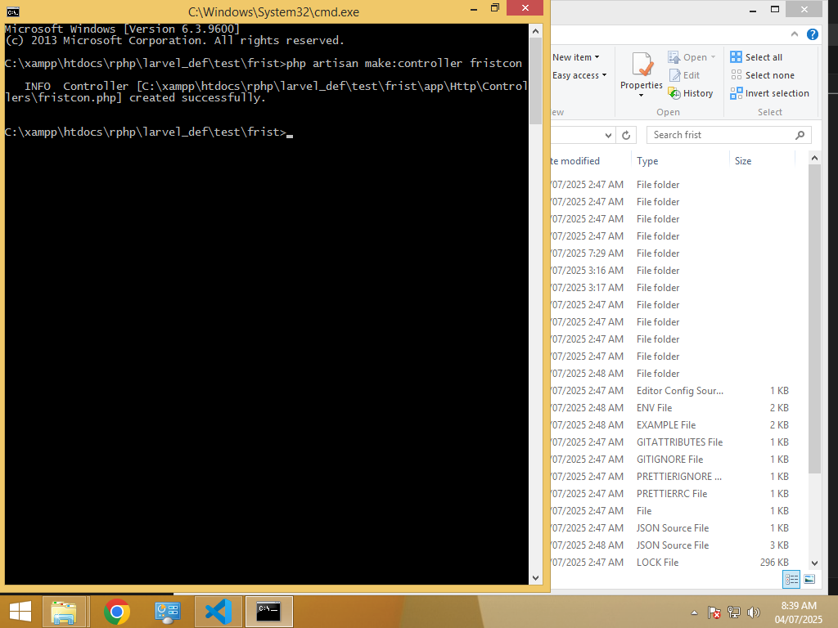

**2.** **Define methods inside the controller to return views or data.**

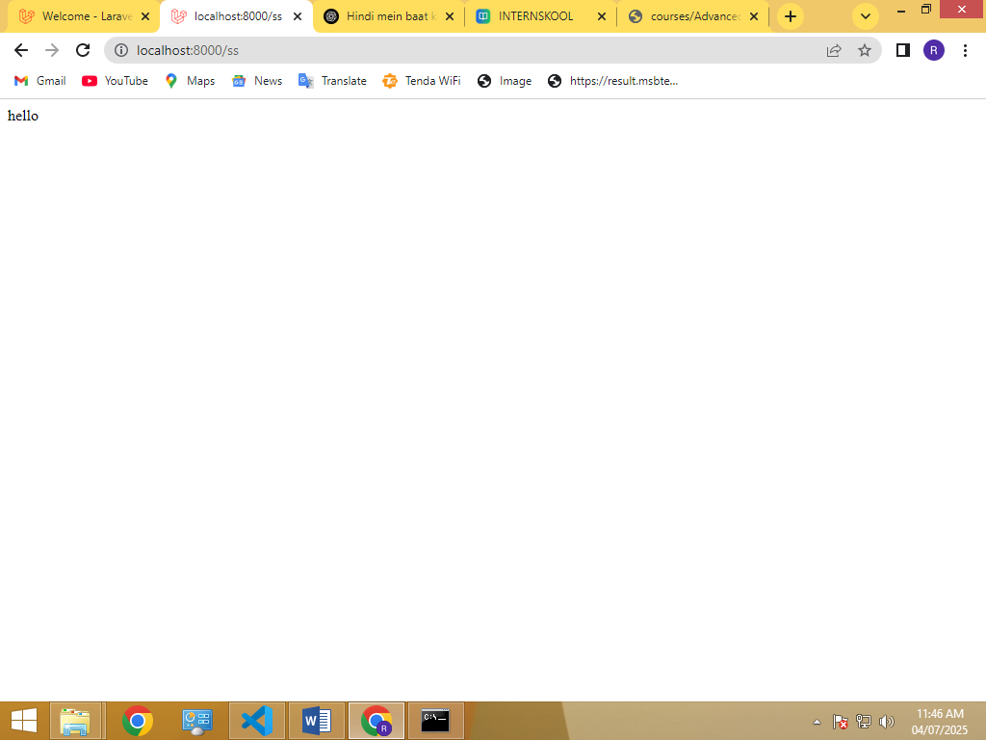

**3.** **Link routes to the controller methods in web.php.**

**4.** . **Pass data from the controller to the view.**

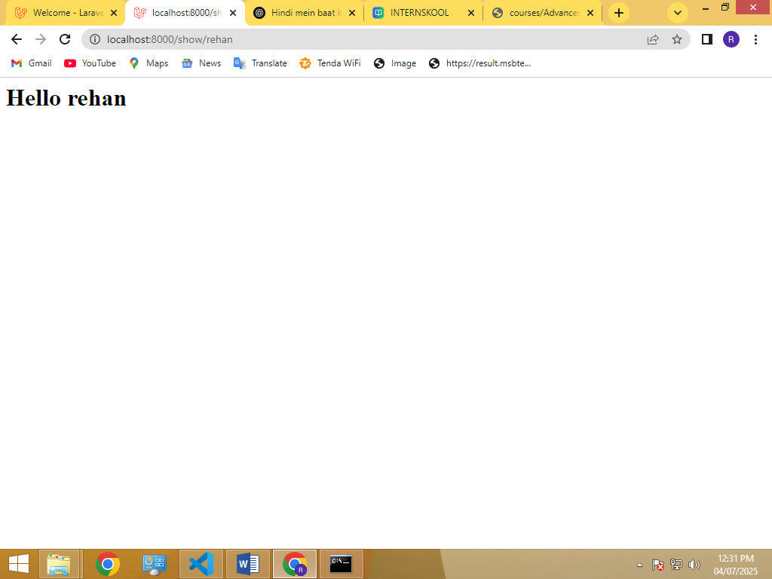

**Controller.php:**

<?php

namespace App\Http\Controllers;

use Illuminate\Http\Request;

class Fristcon extends Controller

{

    function showdata($name){

        return view('app', ['name' => $name]);

    }

}

**App.blade.php:**

<h1>Hello   {{$name}}</h1>

**Web.php:**

<?php

use Illuminate\Support\Facades\Route;

use Inertia\Inertia;

Route::get('/', function () {

    return Inertia::render('welcome');

})->name('home');

Route::middleware(['auth', 'verified'])->group(function () {

    Route::get('dashboard', function () {

        return Inertia::render('dashboard');

    })->name('dashboard');

});

require __DIR__.'/settings.php';

require __DIR__.'/auth.php';

use App\Http\Controllers\Fristcon;

Route::get('show/{name}',[Fristcon::class , 'showdata']);