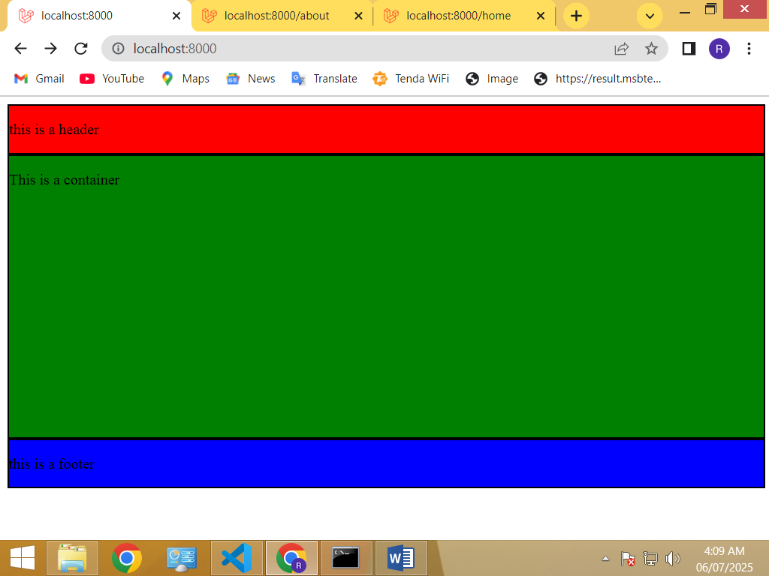

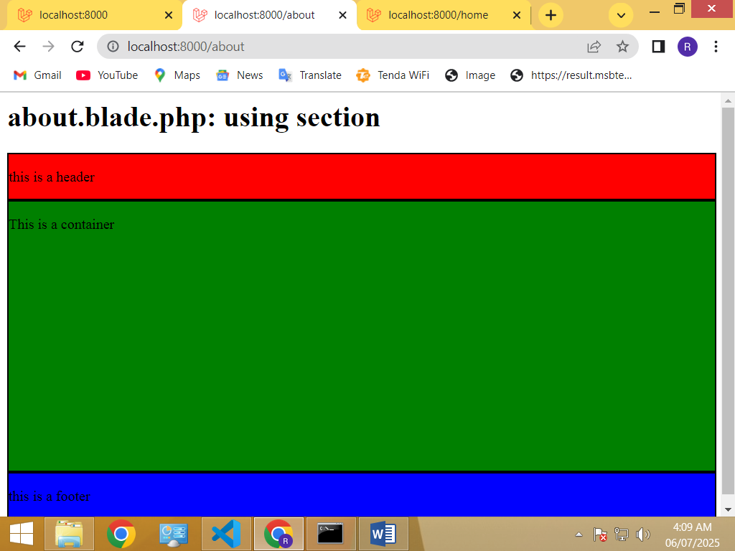

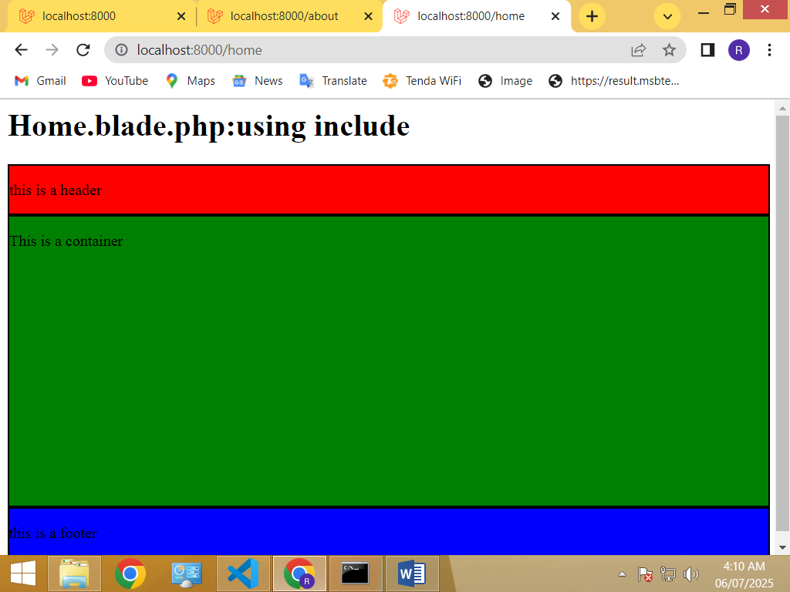

App.blade.php:

<!DOCTYPE html>

<html lang="en">

<head>

    <meta charset="UTF-8">

    <meta name="viewport" content="width=device-width, initial-scale=1.0">

    <title>@yield('sementic tag')</title>

       <style>

       .header {

        border: 2px solid black;

        background-color: red;

        width: 100%;

        height:50px;

        margin:0px;

       }

       .container {

        border: 2px solid black;

        background-color: green;

        width: 100%;

        height:300px;

        margin:0px;

       }

       .footer {

        border: 2px solid black;

        background-color: blue;

        width: 100%;

        height:50px;

        margin:0px;

       }

    </style>

</head>

<body>

    @yield('header')

   <header class = "header">

    <p> this is  a header</p>

</header>

@yield('container')

<div class = "container">

<p>This is a container</p>

</div>

@yield('footer')

<footer class= "footer">

    <p>this is a footer</p>

</footer>

</body>

</html>

[Home.blade.php](http://Home.blade.php):

<h1>Home.blade.php:using include</h1>

@include('app')

About.blade.php:

<h1>about.blade.php: using section</h1>

@extends('app')

@section('header')

@endsection

@section('container')

@endsection

@section('footer')

@endsection

Web.php:

Route::get('home',function(){

return view('home');

});

Route::get('about',function(){

    return view('about');

    });