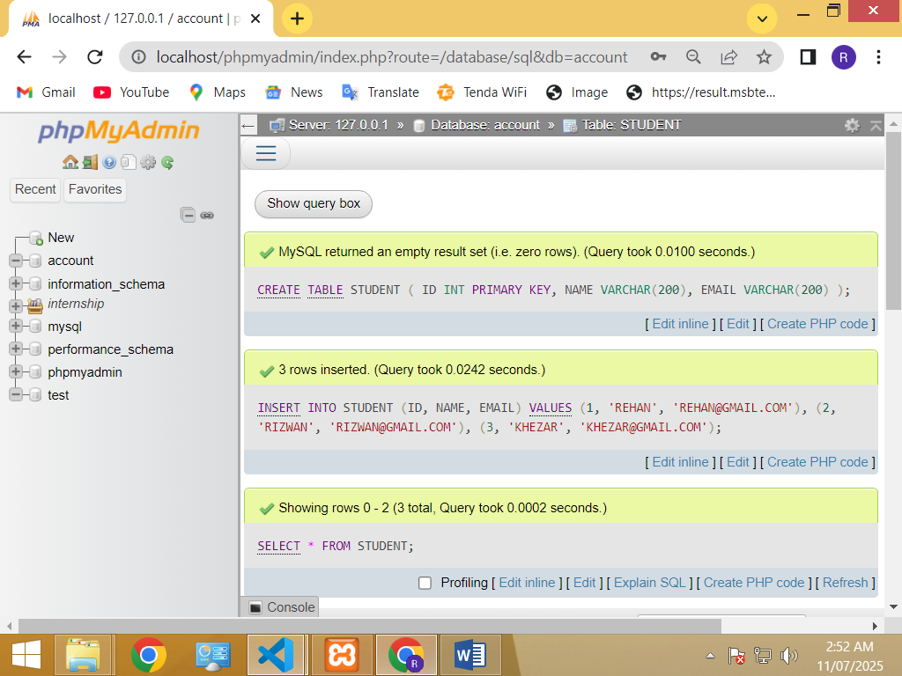

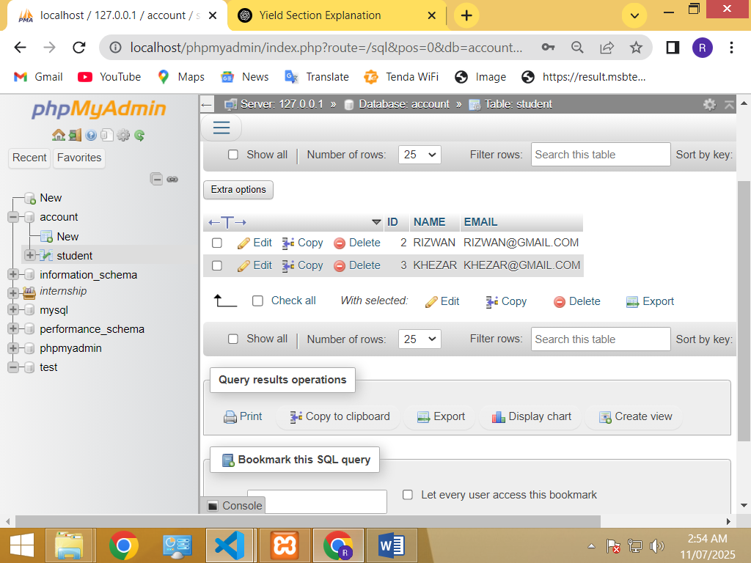

CREATE DATABASE internship_db;

CREATE TABLE STUDENT(ID INT PRIMERY KEY ,

NAME VERCHAR(200),

EMAIL(200)

);

INSERT INTO STUDENT (ID, NAME , EMAIL)VALUES (1 , 'REHAN' , 'REHAN@GMAIL.COM'), (2, 'RIZWAN' , 'RIZWAN@GMAIL.COM') , (3 ,'KHEZAR',' KHEZAR@GMAIL.COM');

SELECT * FROM STUDENT;

UPDATE TABLE STUDENT NAME = 'REHAN ABDU' WHERE ID = 1 ;

DELETE  STUDENT ID = 1 ;