**Ghulam Ishaq Khan**

**Institute of Engineering Sciences & Technology**



CS 313 Project Report

Internet Topology Designing Project

Submitted to:

Engr. Usman Raza

On May 8, 2019

Submitted by:

**Rehan (2016404) FCSE**

**Zeeshan Ul Haq (2016544) FCSE**

**Muhammad Zain ul Abideen bin Zia (2016249) FCSE**

**SECTION: B**

**DEDICATION**

To Our Parents

**Acknowledgement**

We are deeply thankful to Almighty Allah, who is highly Merciful and Graceful, who bestowed us with courage and knowledge to complete this study.

We acknowledge and appreciate the scholarly guidance, valuable suggestions, positive criticism and kind advice given to us by **Mr. Usman Raza** under whose supervision this project has been completed. His guidance on the discussions and suggestions invoked our thinking process. It generated a great deal of interest in the research work, giving us self-believe and feeling of responsibility.

Contents

Objective: 6

Requirements: 6

Requirement Analysis: 6

1. Hostels 6

2. Faculties 7

2.1 FEE 7

2.2 FES 7

2.3 FME 7

2.4 FCME 7

3. Admin 7

4. Residency 8

Major IP Scheme Used: 8

Topology: 8

Main 8

Hostels 9

Faculties 9

Functionalities implemented 10

1. VLAN 10

1.1 Network Security 10

1.2 Waste Traffic 10

2. Telnet 11

3. OSPF 11

4. ACL (Access Control List) 11

5. NAT 11

5.1 Dynamic Nat 12

6. Ether Channel (Link Aggregation) 12

6.1 LACP 12

7. Servers 12

7.1 E-mail Server 12

7.2 DHCP Server 13

7.3 DNS Server 13

Justification 13

1. Less Cost/ Less number of routers 13

2. Efficient Internet Traffic 13

3. Use of Inter VLANS / Link aggregation 13

4. Multiple Level Subnetting 13

5. Admin Faculty Security 14

Summary 14

# Objective:

Objective of the project is to understand and implement all the TCP/IP routing and

Switching concepts learned in the course and lab.

# **Requirements**:

* IPs are assigned by centralized DHCP servers.
* Users in GIK must connect with internet.
* Use any NAT public addresses of your choice from public address range.
* Configure telnet lines for routers so that they can be accessed remotely.
* Each switch and router will need a base configuration, which includes:

1. Hostname
2. Passwords (CON, VTY, Enable) should be set to batch26
3. Logon banner
4. Three-hour console port timeout
5. Synchronous logging on the console port
6. Telnet enabled

* Routing must be done using multi-area OSPF routing protocol and static routing protocol (where needed).
* Routes should not be advertised to user networks for security reasons.
* Students cannot ping Admin or Faculty PCs (use ACLs).

## **Requirement Analysis**:

1. Hostels**:**

|  |  |  |  |  |  |  |  |
| --- | --- | --- | --- | --- | --- | --- | --- |
| Hostel | Floors | Room/Floor | Double | Total Users | +4IP’s[1] |  |  |
| 1 | 3 | 45 | x | 135 | 139 | 256 | 8 |
| 2 | 3 | 45 | x | 135 | 139 | 256 | 8 |
| 3 | 3 | 45 | x | 135 | 139 | 256 | 8 |
| 4 | 3 | 45 | x | 135 | 139 | 256 | 8 |
| 5 | 3 | 45 | x | 135 | 139 | 256 | 8 |
| 6 | 3 | 45 | x | 135 | 139 | 256 | 8 |
| 7 | 3 | 45 | x | 135 | 139 | 256 | 8 |
| 8 | 5 | 50 | x | 250 | 254 | 256 | 8 |
| 9 | 5 | 50 | x | 250 | 254 | 256 | 8 |
| 10 | 5 | 50 | y | 500 | 504 | 512 | 9 |
| 11 | 5 | 50 | y | 500 | 504 | 512 | 9 |
| 12 | 5 | 50 | y | 500 | 504 | 512 | 9 |
|  |  |  |  |  |  | 3840 | 4096 |
|  |  |  |  |  |  |  |  |

1. Faculties**:**

### FEE

|  |  |  |  |  |
| --- | --- | --- | --- | --- |
| FEE | Signal& System | 75 | 78 | 128 |
|  | Offices | 30 | 33 + WAP | 64 |
|  | WAP | 1 |  |  |
|  | +3 IPs | 3 |  |  |
|  | Total | 109 |  | 128 |

### FES

|  |  |  |  |  |
| --- | --- | --- | --- | --- |
| FES | Offices | 15 | 18 + WAP | 32 |
|  | WAP | 1 |  |  |
|  | +3 IPs | 3 |  |  |
|  | Total | 19 |  | 32 |

### FME

|  |  |  |  |  |
| --- | --- | --- | --- | --- |
| FME | ProE | 105 | 108 | 128 |
|  | Offices | 15 | 18 + WAP | 32 |
|  | WAP | 1 |  |  |
|  | 3 Ips | 3 |  |  |
|  | Total | 124 |  | 128 |

### FCME

|  |  |  |  |  |
| --- | --- | --- | --- | --- |
| FCME | Offices | 15 | 18 + WAP | 32 |
|  | WAP | 1 |  |  |
|  | 3 Ips | 3 |  |  |
|  | Total | 19 |  | 32 |

## Admin

|  |  |  |
| --- | --- | --- |
| Admin | 2 IPs |  |
| 30 | 32 | 5 |

## Residency

|  |  |  |  |  |  |  |  |  |  |  |  |
| --- | --- | --- | --- | --- | --- | --- | --- | --- | --- | --- | --- |
| Resedential | Buildings | Floors | Users | Total Users | WAPs | Total WAPs | 3 Ips | Total Ips | Round up | |  |
| A | A1 | x | 20 | 20 | 2 | 2 | 3 | 25 | 32 | | 5 |
| B | B1 | x | 35 | 35 | 2 | 2 | 3 | 40 | 64 | | 6 |
| C | C1-C5 | 2 | 77 | 385 | 8 | 8 | 3 | 396 | 512 | | 9 |
| D | D1-D4 | 3 | 150 | 600 | 3/building | 15 | 3 | 618 | 1024 | | 10 |
| E | E1-E4 | 3 | 120 | 480 | 3/building | 12 | 3 | 495 | 512 | | 9 |
| F | F1-F5 | 3 | 100 | 500 | 3/building | 15 | 3 | 518 | 1024 | | 10 |
|  |  |  |  |  |  |  |  | 3168 | | 4096 |

# Major IP Scheme Used:

**10.0.0.0/18**

# Topology:

Main**:**

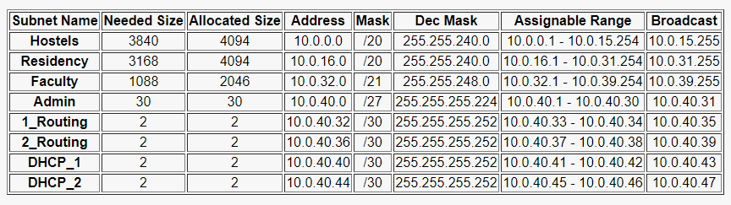

We have submitted the major IP schemes into 8 major subnets. Above table depicting the scenario:

## Hostels

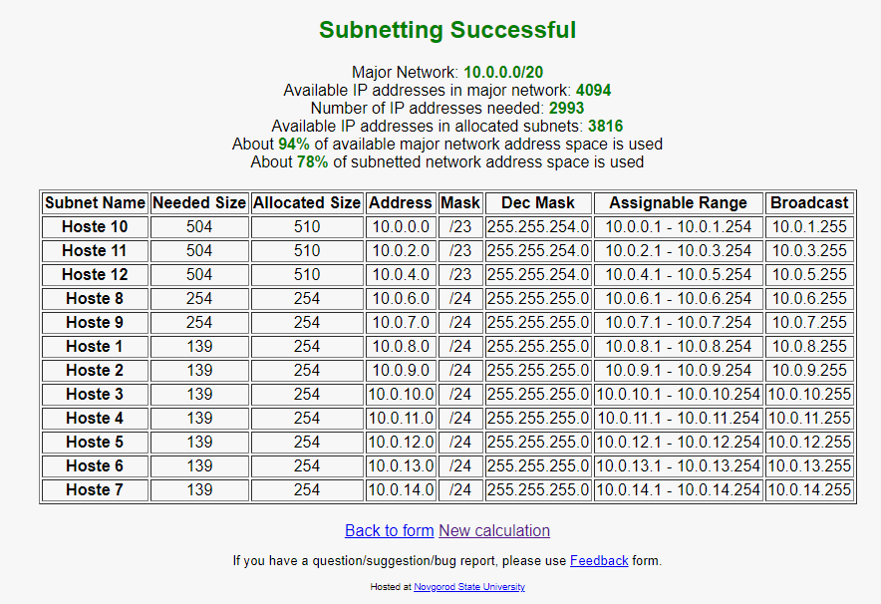

Major Net of Hostels is further Variably subnnetted into different Hostels. . Above table depicting the IP schemes of hostels:

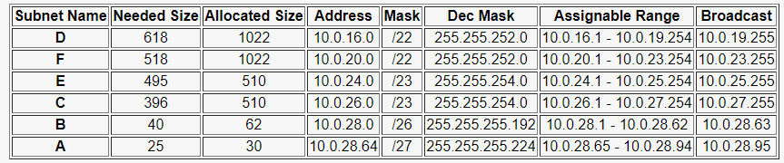**Residency**

## Faculties

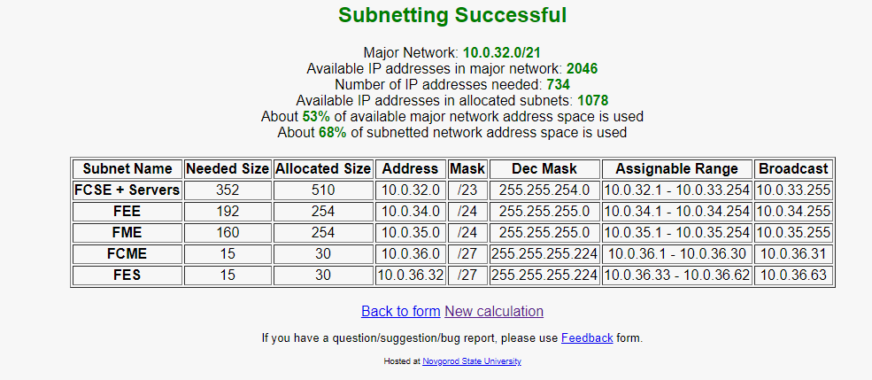

1. **FCSE**

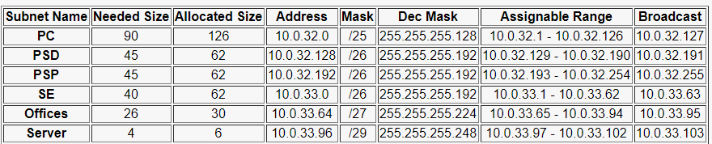

1. **FES**

No sub-netting was required in the given requirement for FES.

1. 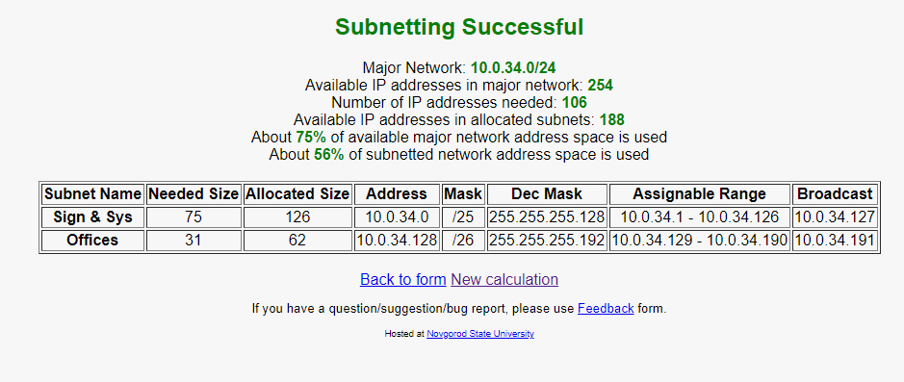**FEE**
2. 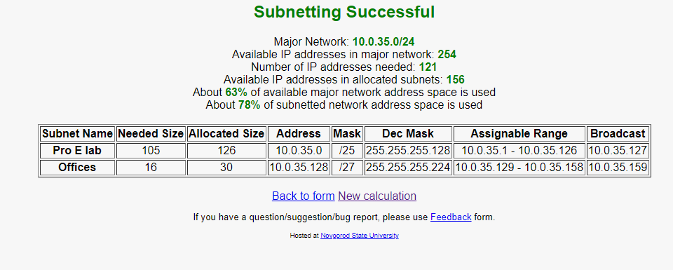**FME**
3. **FCME**

No sub-netting was required in the given requirement for FCME

**Physical Topology**

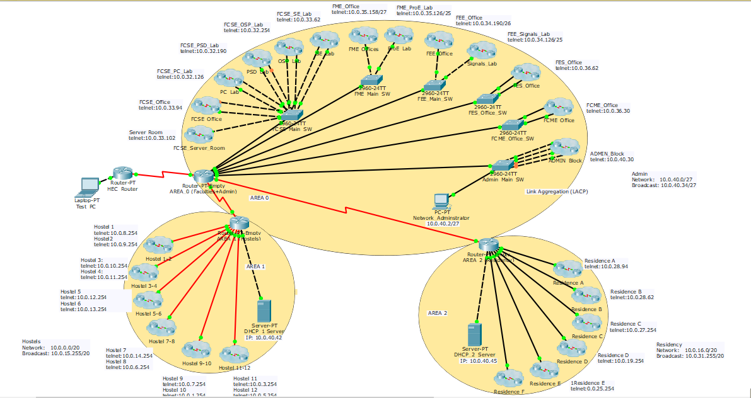

There are 3 OSPF areas. AREA 0 has faculties and admin. Area 1 has hostels and Area 2 has residents. Each area has a single router and its own DHCP server. A backup DHCP server along with Web, Mail and DNS server is present in Area 0.

# Functionalities implemented

We have implemented all the functionalities which were mentioned in Project details. Details of each of them is given below.

## VLAN

A major network, which is connected with an interface of a router, is further broken down to create virtual lanes. Labs and offices within a faculty are separated with the help VLANs to break the broadcast domain. VLAN is implemented because of the following two reasons.

### Network Security

If a device is receiving a packet which it does not require or sending its packet to all the devices in a network then transmission on such network is not safe. To avoid this situation we need to implement VALN.

### Waste Traffic

When a packet is send and received by all the devices on the network where that packet is intended to a single user then it not creates heavy traffic which cause intermediate devices go down but also waste the necessary bandwidth of the network. VLAN is used in such kind of scenarios to avoid network collapse.

## Telnet

Telnet is an Application Layer Protocol of TCP/IP Model. This protocol enables a telnet client to be logged into a telnet host remotely. Telnet host listens for telnet connection request on port 23. A device that runs VRP can act as telnet client and Server. This functionality enables out routers and switches to be accessible remotely from any pc.

## OSPF

Open shortest path first is a standard protocol, implemented by many network devices. This protocol uses Dijkstra’s algorithm in which a shortest path between two nodes is calculated and then it is populated the routing table with the help of these shortest paths. OSPF converges quickly than RIP, therefor it is considered to be most efficient protocol. Another advantage of this protocol is that this protocol works on larger network, RIP does not work properly on a network more than 15 routers. Although our network does not contain not many routers, it is nevertheless we have applied OSPF on the routers in the network to take advantage of its benefits of quick convergence.

## ACL (Access Control List)

A network administrator faces many problems throughout the day. They may need to identify the location of routers, deal with switching issues, ensure that network segments are properly connected, and monitor the traffic on network devices. An access control list (ACL) is a widely used network technology that defines which source and destination IP addresses or subnets can access different areas of a network. ACLs offer great flexibility in controlling access on a network and are often implemented with other technologies such as firewalls. In our Project we have used to ACL to restrict the hostels to ping faculties.

## NAT

ICANN is an organization which manages the uniform distribution of IP addresses to maintain uniqueness of IP address for each network device on the network. IP addresses assigns by ICANN are called Public IP addresses.

However, some devices do not need to connect to internet. These devices do not need public IP addresses to communicate with its own closed network, but they need Private IP addresses for the purpose of communication. Therefore IP addresses exist on a closed network are called private IP addresses. There are three classes of Private IP addresses which can be implemented on a closed network.

Class A: 10.0.0.0 – 10.255.255.255

Class B: 172.16.0.0 – 172.31.255.255

Class C: 192.168.0.0 – 192.168.255.255

Devices on the network do not use private IP addresses to send and receive packets instead they use public IP addresses.

NAT is a technology which translates private IP address into Public address. There are two types of NAT, static and dynamic Nat. in static NAT each public IP address on is mapped to a single private IP address, there exist one-to-one relation between Public and Private IP addresses. We have used Dynamic NAT in our Project.

## PAT

Port addresses translation (PAT) also known as network address port translation is basically translates single public IP into various private IPs. IP's are identified using a specific port address attached with each IP. Thus, it maintains a table.

We have implemented PAT to translate each and every host whenever it tries to communicate with the outside network.

We have implemented PAT to make every pc accessible from internet with a single public IP.

## Ether Channel (Link Aggregation)

Lets’ take a scenario where a switch is connected to 10 users and each link is FEE link and link of the switch with core router/ switch is GE link. In this case number of FEE links and GE link is compatible and no traffic issues will arise. But what if we increase the users’ link up to 20, now the link between core switch is insufficient to provide adequate traffic to all the 20 users and because of heavy load eventually goes down.

To tackle this situation the concept of link aggregation comes in, implementing link aggregation makes the connection between core switch more reliable and meets the need for higher bandwidth in a cost-effective way. If core switches have three GE ports then three links can be created and using link aggregation these three links can be aggregated to a single logical link.

### LACP

We have implemented LACP for the purpose of link aggregation. The Link Aggregation Control Protocol (LACP) is defined in IEEE 802.3ad. LACP provides a high degree of automation and avoid misconceptions.

## Servers

Servers are computing devices that can store and transmit information between different types of clients. Following are the servers that we have used in our project

### E-mail Server

To handle the local email service of GIK institute we have installed a local sever which is located in server room of FCSE.

### DHCP Server

To provide IP addresses to each and every users in the institute we have installed seven DHCP servers. Four dedicated servers, each of them is located in FCSE, Residential area, hostels and admin. Three DHCP servers are configured on three Routers.

### DNS Server

A Domain Naming Server used to convert hosts names into IP addresses and vice Versa is configured and located in Server Room.

# Reasoning

## Less Cost/ Less number of routers

We have used 3 routers. Major reason for using a smaller number of routers is because GIKI have less than 5300 users. It also decreases costs because routers are expensive. Router 1 connects 556 hosts from faculties and admin. Router 2 connects 2993 hosts from hostels. Router 3 connects 1701 hosts from residency. Router 1 also process the traffic for the INTERNET as it is connected with HEC server.

## Efficient Internet Traffic

The design was made as such the router with least number of directly connected hosts is to facilitate the INTERNET traffic. Router 1 is also the best candidate for Internet traffic because after evening and on holidays this router will receive almost no traffic from its directly connected networks. If routers 2 or router 3 were to be used for Internet traffic then they would have been burdened too much. Therefore, usage of 3 routers is ideal for our network as it decreases costs and does not compromise efficiency.

## Use of Inter VLANS / Link aggregation

Our GIKI internet compromises of numerous different networks having small number of hosts. Therefore, we have used concepts on Inter VLAN. It allows us to accommodate numerous small networks on single router. Inter VLAN breaks the broadcast domain. Combination of these inter VLAN provides sufficient traffic for the routers. Otherwise the routers would have very less traffic and we had to use more than 3 routers. Then cost would increase and routers would sit idle.

Less number of routers means increase in number of switches. Efficient use of inter VLAN decreases number of switches. Further link aggregation has been implemented in Admin block. It improves bandwidth and eases traffic through switches. As there are good number of switches so back up loops are also implemented in the network.

## Multiple Level Sub-netting

Sub-netting for inter VLANS is implemented very carefully. Our network subnetting is done at multiple levels so as to provide best efficiency. Multiple level subnetting allow us to do a smaller number of logical divisions in router’s interfaces. Hence traffic is balanced on all interfaces of the routers.

## Security

For security reasons Admin and Faculty networks must not be accessed from the hostels. Hostels were blocked by implementing concepts of Access Control List. Further telnet was enabled on all 3 routers. A special END USER network administrator can only access he routers via telnet. This user I sin the Admin block. All the main switches and all 3 routers are password protected at all levels of enable, console and terminal. OSPF passive facility was used so that the IP routes are not advertised to end user networks.

# **Notes**

Our idea in this project was to analyze critically the problem statement and identify how things are implemented in real life scenario. Where the topology is concern, we have tried our best to implement the design to create a balance between the cost and performance. Designing and Construction is what one learns from experience therefore, the design is our first ever step in this regard.

1. 2 (Network Id + Broadcast Id + Gateway + WAP’s)