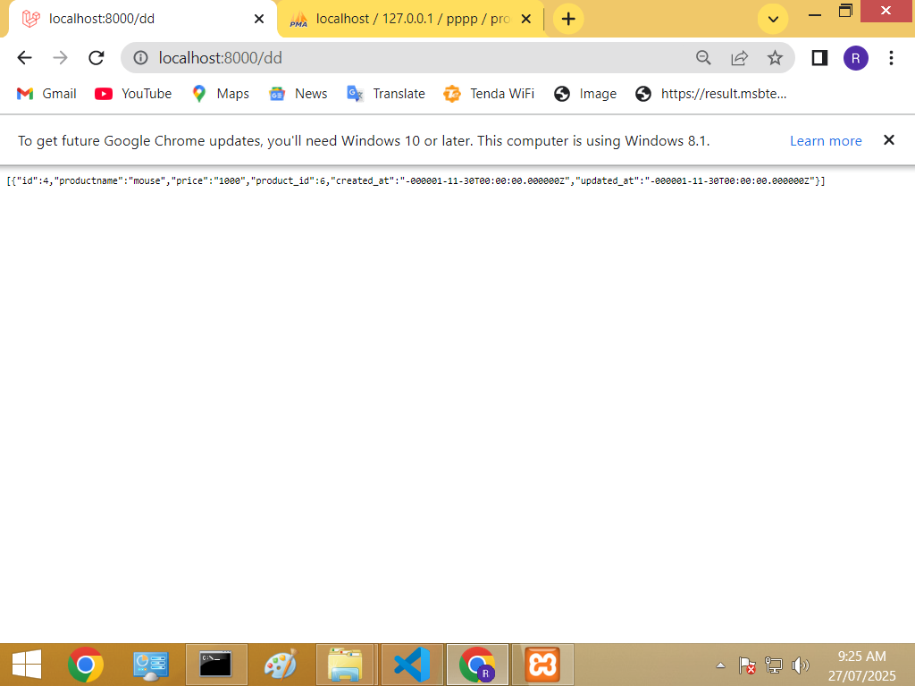

Seller Table:

<?php

use Illuminate\Database\Migrations\Migration;

use Illuminate\Database\Schema\Blueprint;

use Illuminate\Support\Facades\Schema;

return new class extends Migration

{

    /**

     * Run the migrations.

     */

    public function up(): void

    {

        Schema::create('sellerrr', function (Blueprint $table) {

            $table->id();

            $table->string('name',200);

            $table->string('email',200);

            $table->timestamps();

        });

    }

    /**

     * Reverse the migrations.

     */

    public function down(): void

    {

        Schema::dropIfExists('tsellerrr');

    }

};

Product table: <?php

use Illuminate\Database\Migrations\Migration;

use Illuminate\Database\Schema\Blueprint;

use Illuminate\Support\Facades\Schema;

return new class extends Migration

{

    /**

     * Run the migrations.

     */

    public function up(): void

    {

        Schema::create('producttt', function (Blueprint $table) {

            $table->id();

            $table->string('productname',200);

            $table->string('price',200);

            $table->unsignedBigInteger('product_id');<-add column

            $table->foreign('product_id')->references('id')->on('sellerrr')<-make

Foregin key

                   ->cascadeOnDelete();

            $table->timestamps();

        });

    }

    /**

     * Reverse the migrations.

     */

    public function down(): void

    {

        Schema::dropIfExists('tproducttt');

    }

};

Seller model:

<?php

namespace App\Models;

use Illuminate\Database\Eloquent\Model;

class sellerrr extends Model

{

   protected $table = "sellerrr";

   protected $id = "product_id";

   function callfun(){

      return $this->hasMany(Producttt::class, 'product_id', 'id');

   }

}

Product model:

<?php

namespace App\Models;

use Illuminate\Database\Eloquent\Model;

class producttt extends Model

{

    protected $table ="producttt";

    protected $id ="id";

}

Controller:

<?php

namespace App\Http\Controllers;

use Illuminate\Http\Request;

use App\Models\produttt;

use App\Models\sellerrr;

class con1 extends Controller

{

     function data(){

    return sellerrr::find(6)->callfun;

      }

}

Route :

Route::get('dd' , [con1::class,'data']);