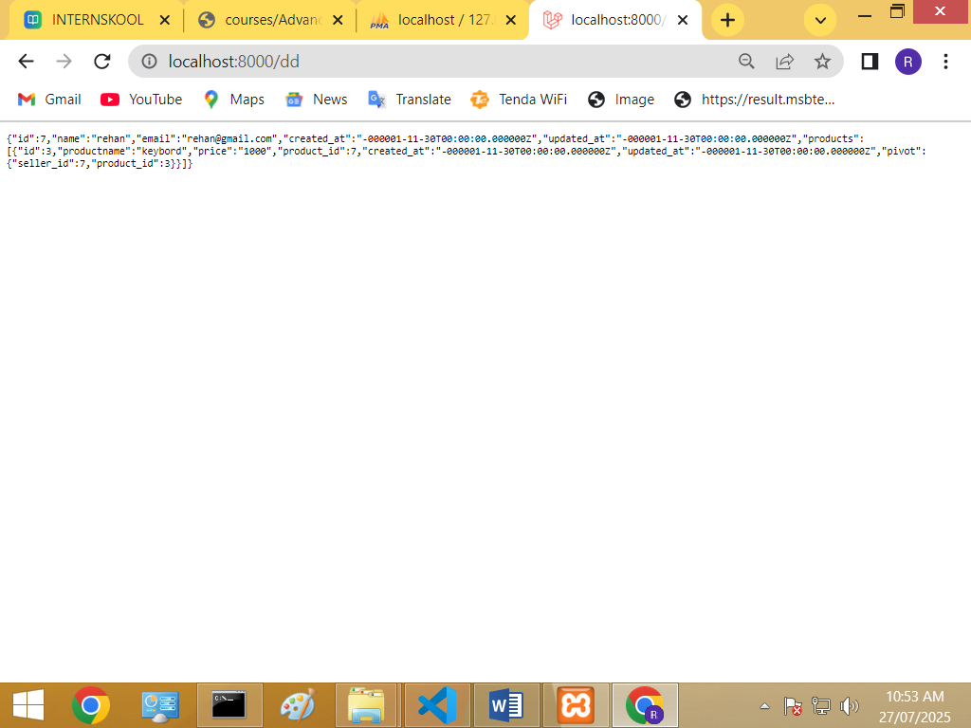

Seller Table:

<?php

use Illuminate\Database\Migrations\Migration;

use Illuminate\Database\Schema\Blueprint;

use Illuminate\Support\Facades\Schema;

return new class extends Migration

{

    /**

     * Run the migrations.

     */

    public function up(): void

    {

        Schema::create('sellerrr', function (Blueprint $table) {

            $table->id();

            $table->string('name',200);

            $table->string('email',200);

            $table->timestamps();

        });

    }

    /**

     * Reverse the migrations.

     */

    public function down(): void

    {

        Schema::dropIfExists('tsellerrr');

    }

};

Product table: <?php

use Illuminate\Database\Migrations\Migration;

use Illuminate\Database\Schema\Blueprint;

use Illuminate\Support\Facades\Schema;

return new class extends Migration

{

    /**

     * Run the migrations.

     */

    public function up(): void

    {

        Schema::create('producttt', function (Blueprint $table) {

            $table->id();

            $table->string('productname',200);

            $table->string('price',200);

            $table->unsignedBigInteger('product_id');<-add column

            $table->foreign('product_id')->references('id')->on('sellerrr')<-make

Foregin key

                   ->cascadeOnDelete();

            $table->timestamps();

        });

    }

    /**

     * Reverse the migrations.

     */

    public function down(): void

    {

        Schema::dropIfExists('tproducttt');

    }

};

<?php

use Illuminate\Database\Migrations\Migration;

use Illuminate\Database\Schema\Blueprint;

use Illuminate\Support\Facades\Schema;

return new class extends Migration

{

    /**

     * Run the migrations.

     */

    public function up(): void

    {

        Schema::create('stock', function (Blueprint $table) {

            $table->id();

            $table->string('quantity');

            $table->string('location',200);

            $table->string('blockno',200);

            $table->foreignId('seller_id')->constrained('sellerrr')->onDelete('cascade');

            $table->foreignId('product_id')->constrained('producttt')->onDelete('cascade');

            $table->timestamps();

        });

    }

    /**

     * Reverse the migrations.

     */

    public function down(): void

    {

        Schema::dropIfExists('stock');

    }

};

Seller model:

<?php

namespace App\Models;

use Illuminate\Database\Eloquent\Model;

class sellerrr extends Model

{

    protected $table = "sellerrr";

//function callfun(){return $this->hasMany(producttt::class, 'product_id', 'id');}

    public function products()

    {

        return $this->belongsToMany(producttt::class, 'stock', 'seller_id', 'product_id');

    }

}

Product model:

<?php

namespace App\Models;

use Illuminate\Database\Eloquent\Model;

class producttt extends Model

{

    protected $table = "producttt";

    public function sellers()

    {

        return $this->belongsToMany(sellerrr::class, 'stock', 'product_id', 'seller_id');

    }

}

Controller:

<?php

namespace App\Http\Controllers;

use Illuminate\Http\Request;

use App\Models\produttt;

use App\Models\sellerrr;

use App\Models\stock;

class con1 extends Controller

{

     function data(){

      $seller = sellerrr::find(7);

      $seller->products;

    return $seller;

      }

}

Route :

Route::get('dd' , [con1::class,'data']);