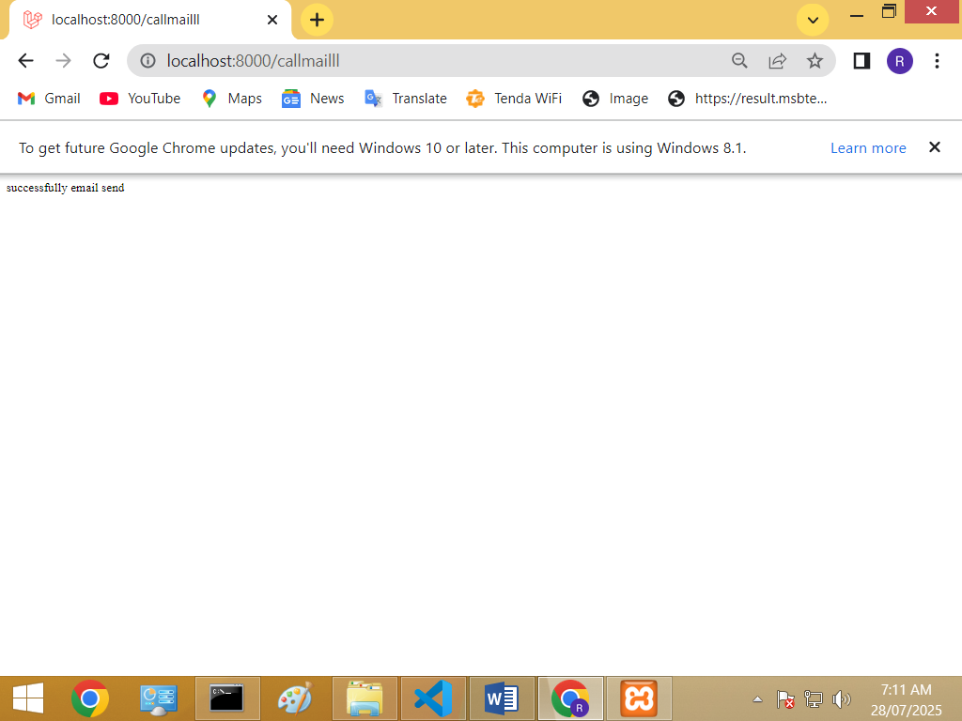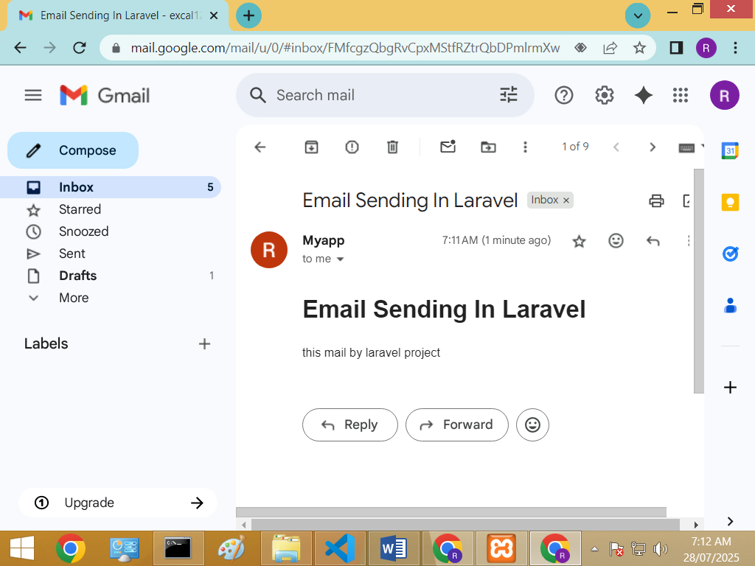

Step1:

Configration:

MAIL_MAILER=smtp

MAIL_HOST=smtp.gmail.com

MAIL_PORT=587

MAIL_USERNAME="jhrrrs760@gmail.com"

MAIL_PASSWORD="yprx osvd ywub euau"

MAIL_ENCRYPTION=tls

MAIL_FROM_ADDRESS="jhrrrs760@gmail.com"

MAIL_FROM_NAME="Myapp"

Step2:controller:

<?php

namespace App\Http\Controllers;

use Illuminate\Http\Request;

use Illuminate\Support\Facades\Mail;

use App\Mail\mymail;

class con3 extends Controller

{

   function fun() {

   $toEmail = " rehanab3824@gmail.com";

   $messageText ="this mail by laravel project";

   $subjectText = "Email Sending In Laravel";

   Mail::to($toEmail)->send(new mymail($messageText, $subjectText));

      return "successfully email send";

      }

}

Step3: run command php artisan make:mail mymail.php :

<?php

namespace App\Mail;

use Illuminate\Bus\Queueable;

use Illuminate\Mail\Mailable;

use Illuminate\Queue\SerializesModels;

use Illuminate\Mail\Mailables\Content;

use Illuminate\Mail\Mailables\Envelope;

class mymail extends Mailable

{

    use Queueable, SerializesModels;

    public $messageText;

    public $subjectText;

    public function __construct($messageText, $subjectText)

    {

        $this->messageText = $messageText;

        $this->subjectText = $subjectText;

    }

    public function envelope(): Envelope

    {

        return new Envelope(

            subject: $this->subjectText,

        );

    }

    public function content(): Content

    {

        return new Content(

            view: 'mailll',

        );

    }

    public function attachments(): array

    {

        return [];

    }

}

Step4:mailll.blade.php:

<h1>{{$subjectText}}</h1>

<p>{{$messageText}}</p>

Step5:

Route::view('callmailll' ,'mailll');

Route::get('callmailll',[con3::class,'fun']);