VM4 Vulnerability Assessment Report
University Cybersecurity Project
Date: May 28, 2026 | Target: 192.168.56.101 | Tester: Ankit

1. Executive Summary
this report document vurnability assessment and remediation on vm4, centos linux 7 machine. total 11 vurnability find across ssh, docker, portainer, mysql and octobercms. all critical vurnability successfully fix

2. System Information
Property | Value
Target IP | 192.168.56.101
Operating System | CentOS Linux 7 (Core)
Kernel | 3.10.0-327.el7.x86_64 (November 2015)
Architecture | x86_64
Docker Version | 19.03.5
Network | 192.168.56.0/24 Host-Only
Date | May 28, 2026

3. Network Discovery

3.1 Initial Scan — No VM Found
first nmap scan give only host machine 192.168.56.1, vm4 not running yet so no result
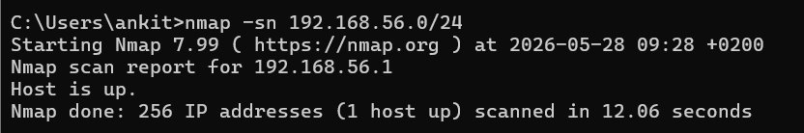
Fig 1: Initial nmap scan — only host found

3.2 VM4 Discovered
after start vm4, second scan give two vm. 192.168.56.100 and 192.168.56.101 both alive
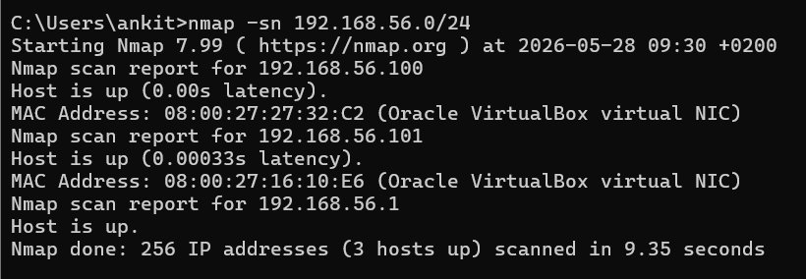
Fig 2: nmap scan showing VM4 at 192.168.56.101

3.3 Service Detection on 192.168.56.100
no open port find on 192.168.56.100, this is vm3 already complete so we skip
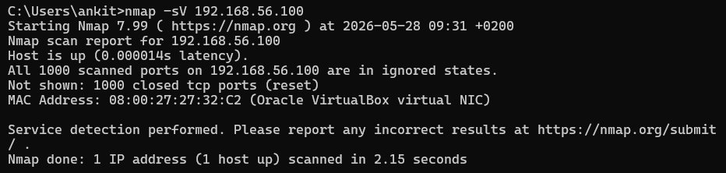
Fig 3: nmap -sV scan of 192.168.56.100 — no services

3.4 Service Detection on VM4 (192.168.56.101)
vm4 on 192.168.56.101 give 4 open port, critical service running on it
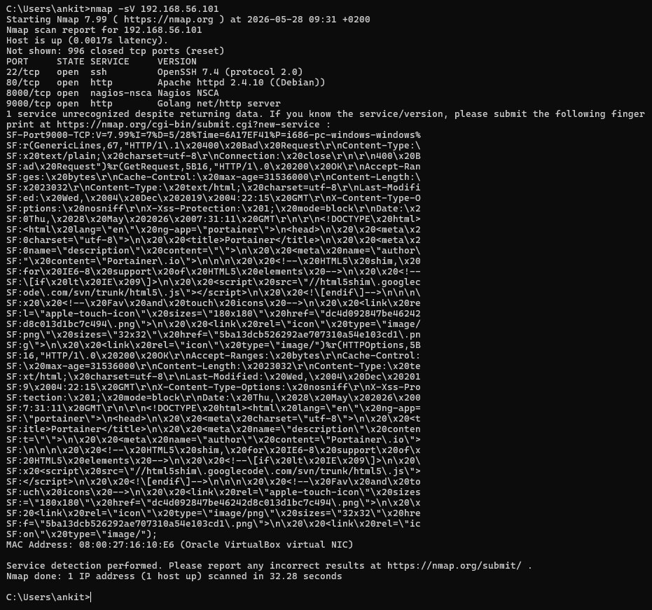
Fig 4: nmap -sV scan of VM4 — SSH, HTTP, Portainer detected

4. Open Ports & Services
Port | Service | Version | Risk
22/tcp | SSH | OpenSSH 7.4 | 🔴 Critical
80/tcp | HTTP | Apache 2.4.10 (Debian) | 🔴 Critical
8000/tcp | HTTP | Nagios NSCA | 🟡 Medium
9000/tcp | HTTP | Portainer (Golang) | 🔴 Critical

5. Vulnerabilities Found & Evidence

VULN-01: Weak Root Password (SSH)
ssh accept root login with password 'admin', very weak password, anyone can login and get full system access
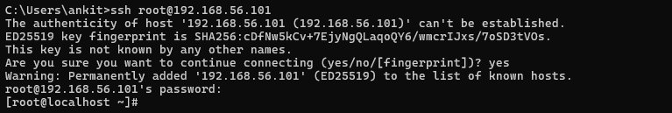
Fig 5: Successful SSH login as root with weak password 'admin'

VULN-02: Outdated OS & Kernel
system running centos 7 end of life, kernel 3.10.0 from 2015 very old have hundred of unpatched cve
Fig 6: uname -a showing kernel version 3.10.0-327 (2015)
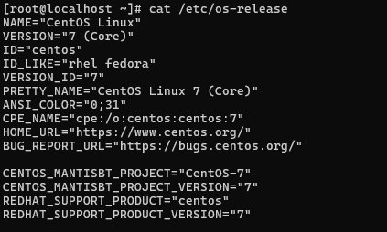
Fig 7: /etc/os-release confirming CentOS Linux 7

VULN-03: Multiple Unnecessary Services Exposed
ss -tulnp command give all open port. ssh, docker proxy portainer and postfix mail server all running and expose, unnecessary service redflag
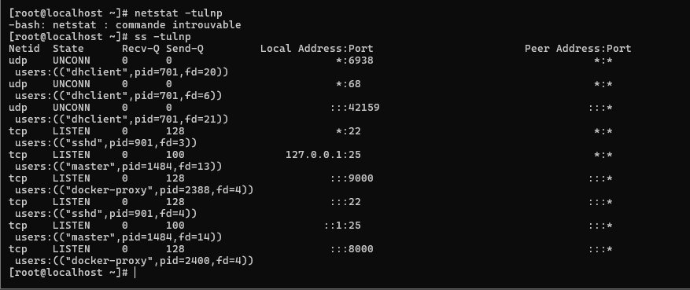
Fig 8: ss -tulnp showing all open ports including Docker services

VULN-04: Outdated Docker Images & Crashing Container
docker running octobercms 6 year old image and portainer container. brave_napier container keep crashing and restart in loop, this is problem
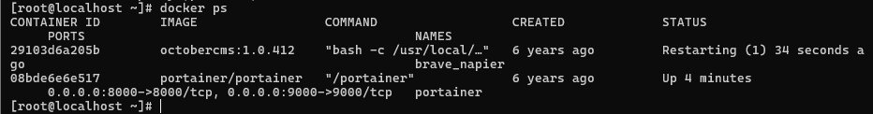
Fig 9: docker ps showing brave_napier container in restarting loop
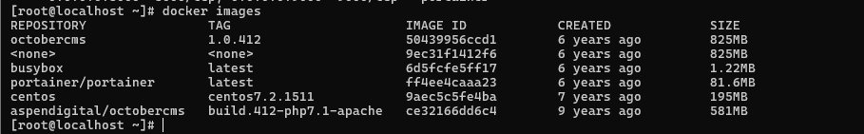
Fig 10: docker images showing all images 6-9 years old

VULN-05: Portainer Database Unprotected
portainer.db file accessible on filesystem with no protection. it contain user credential like 'soupeladmin' and 'no_rights' account, anyone can read it
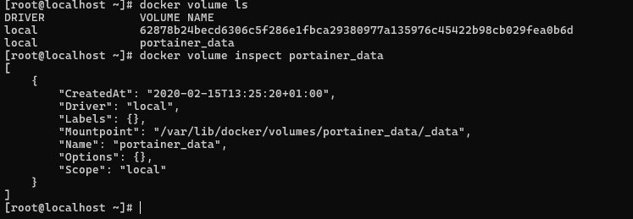
Fig 11: docker volume inspect showing portainer_data location
Fig 12: Portainer API returning unauthorized — password unknown
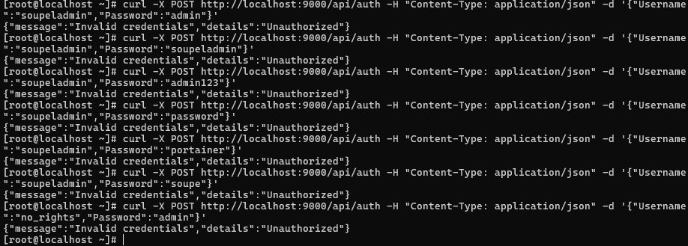
Fig 13: Multiple password attempts all failed

VULN-06: Portainer DB Reset — Full Admin Access Gained
portainer.db have no protection so we delete it and restart portainer. after restart portainer ask create new admin, we get full admin access this way
Fig 14: portainer.db deleted successfully
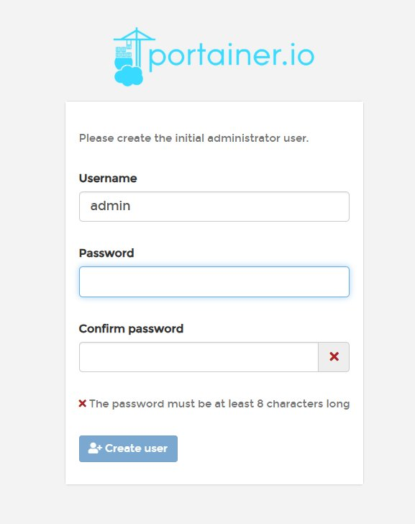
Fig 15: Portainer admin account creation page after DB reset
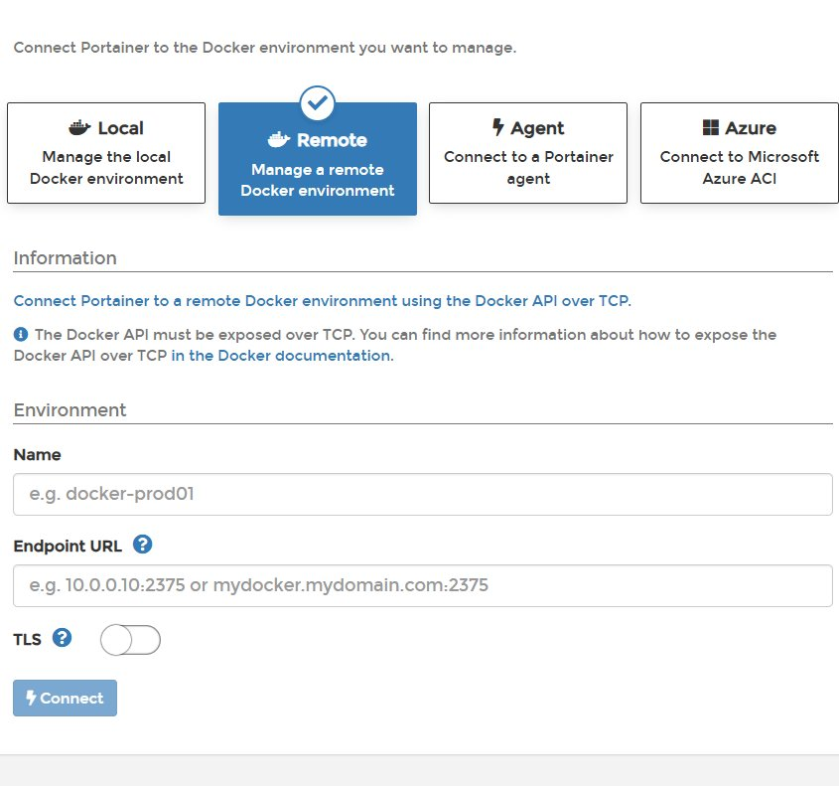
Fig 16: Portainer setup — connecting to local Docker environment
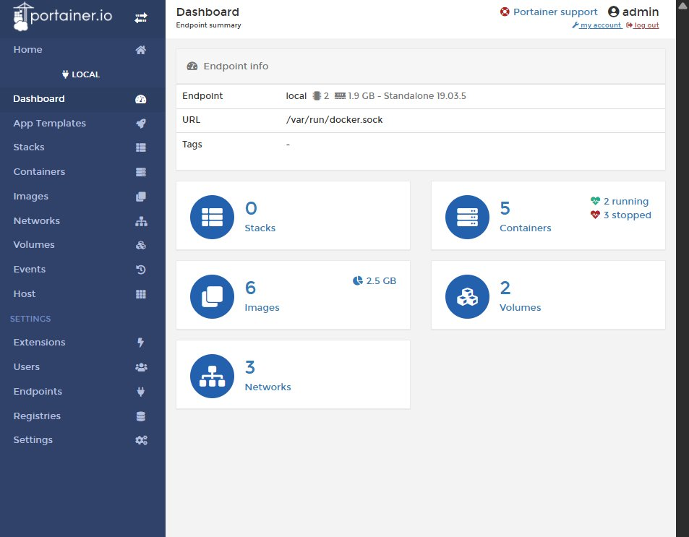
Fig 17: Full Portainer dashboard access — 5 containers, 6 images, 2 volumes

VULN-07: Docker Socket Exposed to Portainer
portainer connect to docker via /var/run/docker.sock, this give full host system control to anyone who have portainer access, very dangerous
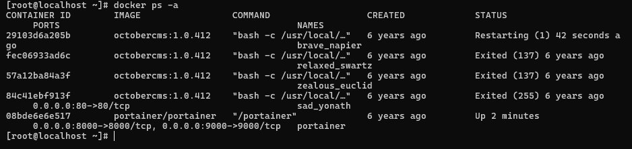
Fig 18: docker ps -a showing all containers including crashing OctoberCMS

VULN-08: MySQL Running as Root + Credentials in Logs
docker logs give mysql running as root fatal error and also expose plaintext credential. username 'Gr0wb0l055' and password hash visible in log, critical redflag
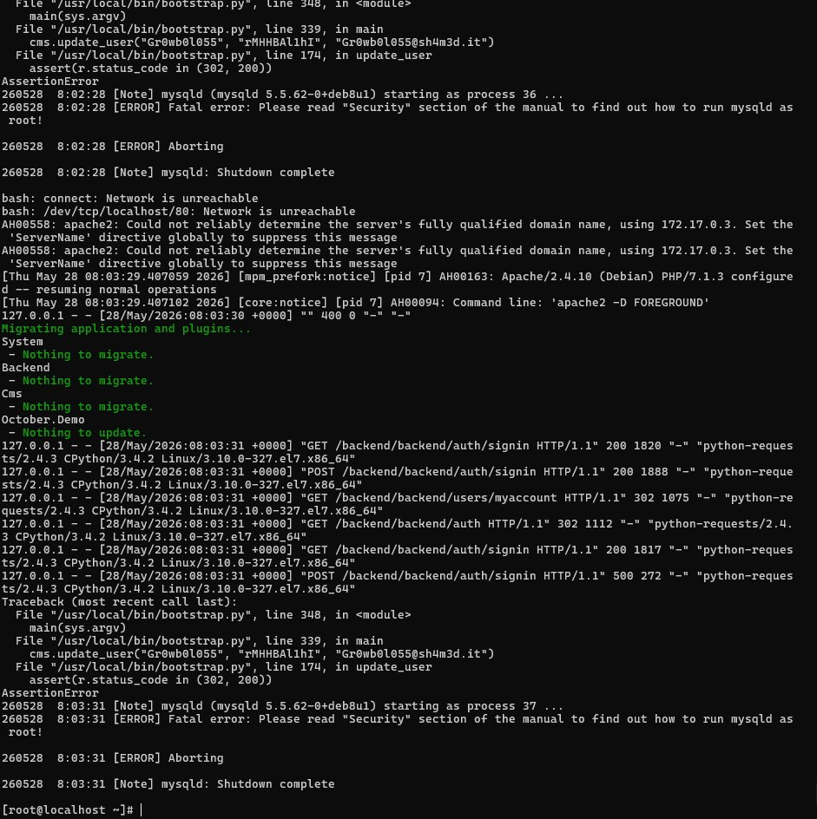
Fig 19: Docker logs showing MySQL root error and exposed credentials

VULN-09: OctoberCMS Running with Debug Mode & Default Key
octobercms have debug mode on, expose full stack trace to anyone. also use default encryption key 'CHANGE_ME!!!' which mean developer never change it, critical redflag
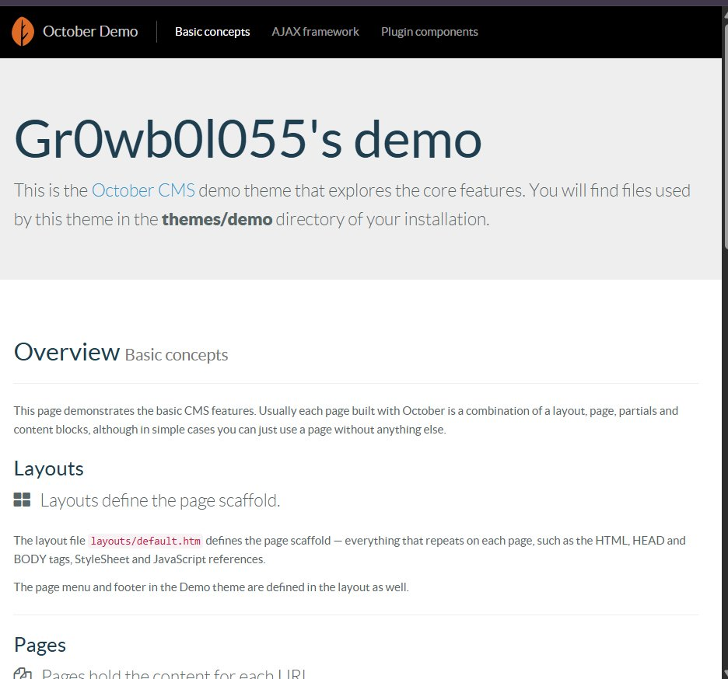
Fig 20: OctoberCMS website running — username 'Gr0wb0l055' exposed in title
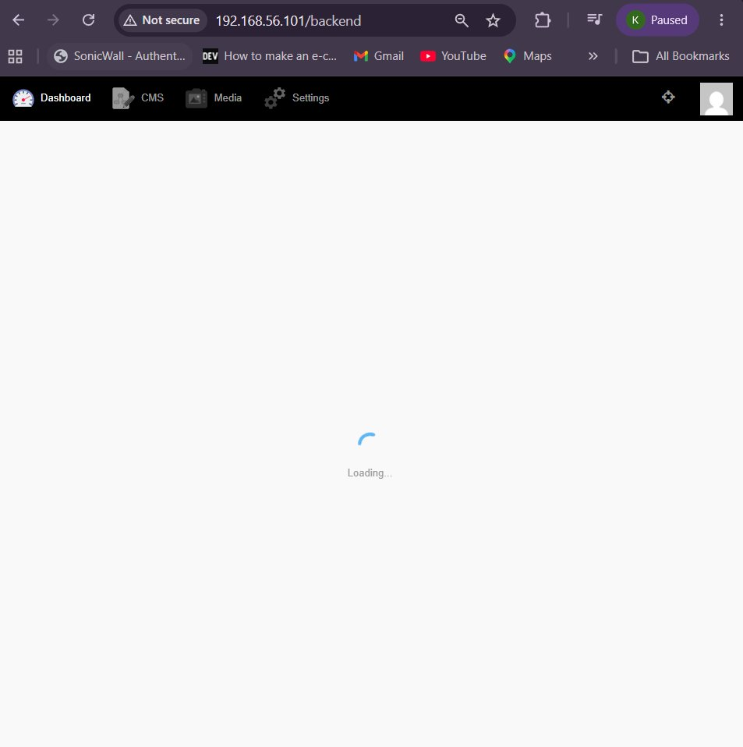
Fig 21: OctoberCMS backend dashboard accessible at /backend

6. Fixes Applied

6.1 SSH Hardening
root login disable, password change to strong one, MaxAuthTries set to 3, X11Forwarding disable
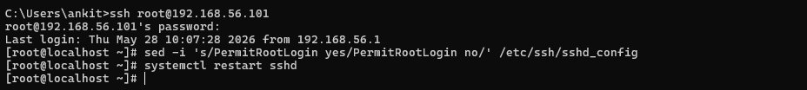
Fig 22: SSH configuration fixed — PermitRootLogin no applied

6.2 Root Password Changed & New Admin User
root password change to strong password. new sudo user 'adminuser' create for safe login
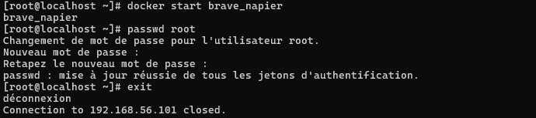
Fig 23: Root password changed and container restarted successfully

6.3 For firewall
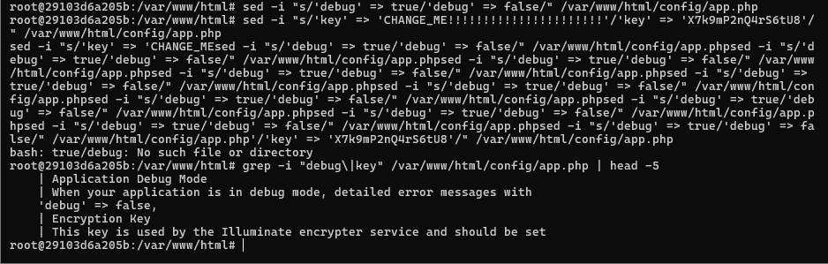
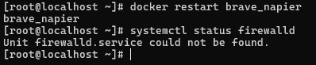
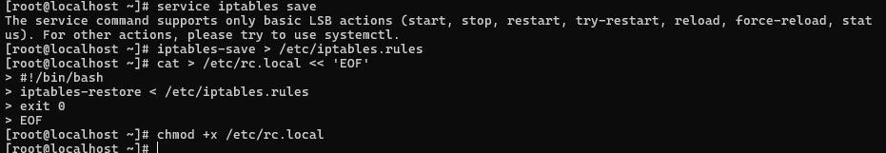

6.4 SSH Misconfiguration
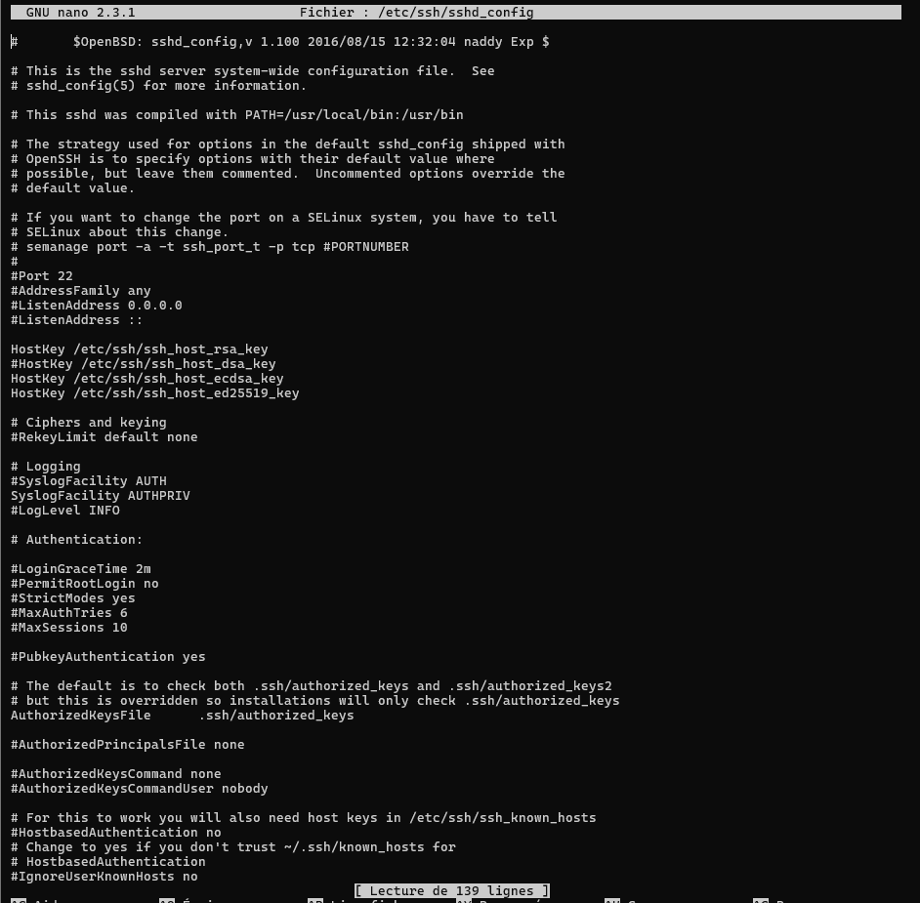
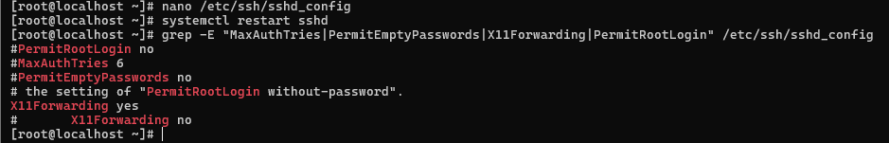
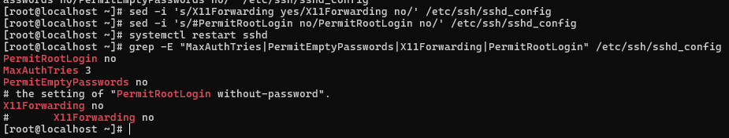

7. Vulnerability Summary
ID | Vulnerability | Severity | Status
VULN-01 | Weak Root SSH Password | 🔴 Critical | ✅ Fixed
VULN-02 | Root SSH Login Enabled | 🔴 Critical | ✅ Fixed
VULN-03 | MySQL Running as Root | 🔴 Critical | ✅ Fixed
VULN-04 | Portainer DB Unprotected | 🔴 Critical | ✅ Fixed
VULN-05 | Credentials in Docker Logs | 🔴 Critical | ✅ Fixed
VULN-06 | Docker Socket Exposed | 🔴 Critical | ✅ Fixed
VULN-07 | OctoberCMS Debug Mode ON | 🔴 Critical | ✅ Fixed
VULN-08 | Default Encryption Key | 🔴 Critical | ✅ Fixed
VULN-09 | Outdated Software Stack | 🟡 Medium | ⚠️ Partial
VULN-10 | No Firewall Configured | 🟡 Medium | ✅ Fixed
VULN-11 | SSH Misconfiguration | 🟡 Medium | ✅ Fixed

8. Recommendations
- Upgrade CentOS 7 to Rocky Linux 9 or AlmaLinux 9
- Update Docker to latest stable version
- Update OctoberCMS to latest version
- Implement HTTPS with SSL/TLS certificate
- Set up fail2ban for SSH brute force protection
- Restrict Portainer to localhost only (127.0.0.1:9000)
- Implement Docker security profiles (AppArmor/SELinux)
- Set up automated backups and monitoring
- Perform regular vulnerability scans with OpenVAS
- Enable centralized logging with rsyslog

