Instructions:
- Go through the problem statement clearly.
- Time limit is 120 minutes.
- Make sure that project is created in eclipse only by the name as <name>_<emp_id>_IM.
- Create all your java files in package “com” within src folder of eclipse project.
- Make sure that exact class outline is followed as you did in previous assignments.
- You need to zip the eclipse project folder and upload the same in LMS once completed. The
project folder will be available in your workspace folder.
- It is mandatory to upload eclipse project and not only java files for your code to be assessed.
- Make sure that there is no compilation error in your code before submission. Even if there is minor error, entire solution could be rejected.
- You may refer previous assignments, course content for any reference.
- You can create a separate test class to contain the main() method.

User input is not required in any of the method described. Prefer to have hard coded values for
method call from main method.

Problem statement:
IRCTC is planning to modify the Booking status of the train and custyomer details. So this project is a prototype for that.

Create the Train table in the database with naming convention as
TBL_TRAIN_<Your Employee Id>

TBL_TRAIN_<Your Employee Id>
Column name | Data Type | Additional Information
Train_id | Number(5) | Primary key
Train_name | Varchar2(200) | Not Null
Start_loc | Varchar2(200) | Not Null
End_loc | Varchar2(200)
Status | Varchar2(10)

Class outline for Train class is as follows :
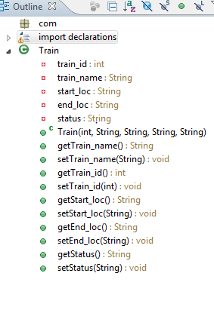

Create the Customer table in the database with naming convention TBL_Customer_<Your Employee Id>

TBL_Customer_<Your Employee Id>
Column name | Data Type | Additional Information
cust_id | Number(5) | Primary key
first_name | Varchar2(100)
last_name | Varchar2(100)
gender | Varchar2(10)
contact | number(10)

Class outline for Customer class is as follows :

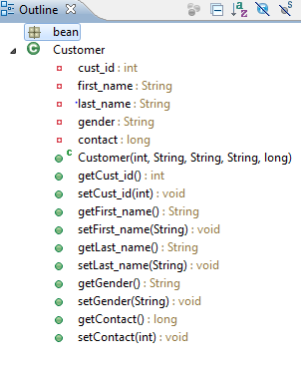

Create the Booking table in the database with naming convention TBL_Customer_<Your Employee Id>

TBL_Customer_<Your Employee Id>
Column name | Data Type | Additional Information
Booking_id | Number(20) | Primary key
cust_id | Varchar2(100) | Foreign key references Customer table
Tarin_id | Number(5) | Foreign key references Train table
price | Number(7,2)
journey_date | Date

Class outline for Booking class is as follows :

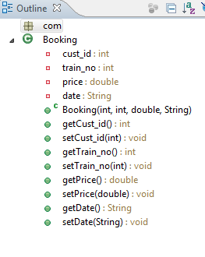
Create Java classes as per below templates and instructions in package com:
DBTransaction class:

This class has attributes – url, tableName,tableName1,tableName2, connection, user and password.

The constructor will take parameters as below sequence:
url, user, password, tableName,tableName1,tableName2

getConnection and closeConnection should be implemented as per code shared at the end of the question.

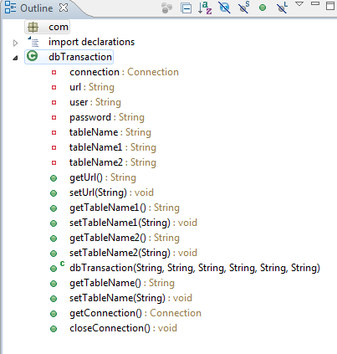

BookingInformation Class: outline for the same has been given below.

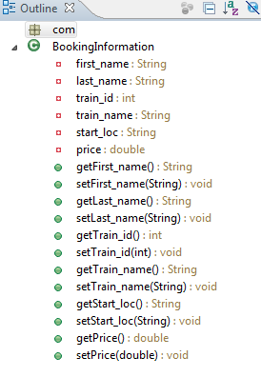

TrainManagementDAO:

This class has below 4 methods

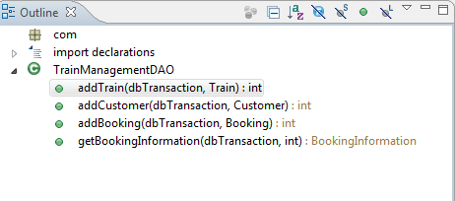

For each of the method result which you are retrieving must be done using SQL queries logic. Also please make sure that Connections are closed in the finally block.

1) int addTrainDbTransaction db,Train t) :
This method will take DbTransaction object & Train as input. This method would be using JDBC to add a new train to Train table. Method will retun 1 after successfully addition and 0 for any failure.

2) addCustomer(DbTransaction db,Customer c) :
This method will take DbTransaction object & Customer as input. This method would be using JDBC to add Customer to Customer table . Method will retun 1 after successfully addition and 0 for any failure.

3) int addTrainDbTransaction db,Booking bd) :
This method will take DbTransaction object & Booking as input. This method would be using JDBC to add a new booking to Booking table. Method will retun 1 after successfully addition and 0 for any failure.

4) BookingInformation getBookingInformation(dbTransaction db,int id):
This method will take DbTransaction object & train id as input. This method will display the first name ,last name,train id,train name,starting location and price of booking.

main method:

Create the main method in the Demo Class

Create DbTransaction class object with all parameters and test above methods (passing
DbTransaction object) from main method.

Also make the following methods in the Demo Class:-

(a) Create method :-This method will take DbTransaction object.This method will create the table
of the required conditions and do the insertion of some random data.
(b) clean up method :-This method will take DbTransaction object.This method will delete the tables through the clean up call.
Note: Call the cleanup() in the finally block of the main method.

Submit all java files in Iascert tool for assessment.

Code for getConnection() method:

public Connection getConnection()
{
try {
closeConnection();
Class.forName("oracle.jdbc.driver.OracleDriver");
connection = DriverManager.getConnection(url,user,password);
} catch (SQLException e) {
// TODO Auto-generated catch block
e.printStackTrace();
} catch (ClassNotFoundException e) {
// TODO Auto-generated catch block
e.printStackTrace();
}

Code for CloseConnection():

public void closeConnection()
{
try
{
if(connection != null && connection.isClosed() == false)
connection.close();
connection = null;
}
catch(SQLException e)
{
e.printStackTrace();
}
}

