High Level Design
Project Name:
Version No.:
Date:

This document contains proprietary information of NEC Technologies India Pvt. Ltd. Unauthorized access, copying and replication are prohibited. This document must not be copied in whole or part by any means, without the written authorization of NEC Technologies India Pvt. Ltd, Noida, India.

Revision History
V. No. | Date | Prepared by / Modified by | Significant Changes

Table of Contents
1 Introduction 5
1.1 Scope 5
1.2 Out of Scope 5
1.3 Intended Audience 5
1.4 Abbreviation 5
1.5 Conventions 6
2 System Environment 6
2.1 Hardware and Software Platforms 6
2.1.1 Hardware 6
2.1.2 Software 7
2.2 System Input and Output 8
3 Architecture 10
3.1 Architecture diagram 10
3.2 Technical Overview 11
3.3 Deployment Model 12
3.4 Data sizing and Performance 14
3.5 Interfaces 14
3.5.1 External Interfaces 15
3.5.2 Internal Interfaces 15
4 Design Description 15
4.1 Static Model 15
4.2 Behavioral Description (This is an optional section, can be removed if not required) 16
4.3 Process Model 16
4.4 Synchronization / threading model 17
4.5 Exception & Signal Handling 18
4.6 Logging & debugging mechanism 18
4.7 Design for Software System Attributes/ Quality Attributes 18
4.8 Design for Performance Requirements 19
4.8.1 List of Time Critical and Periodic Functions 19
5 Design Considerations 19
5.1 Design Constraints 19
5.2 Design Assumptions 19
5.3 Design Limitations 19
5.4 Design Issues 19
5.5 Design Risks 20
5.6 Alternate Design Methods Considered 20
6 Design for special requirements 20
7 Appendix 20
7.1 Standards 20
7.2 References 20
7.3 Construction Strategy 21
7.4 Existing Architecture 21
7.4.1 Architecture diagram 21
7.4.2 Technical Overview 21
7.5 Anticipated Changes 21
7.6 Detailed Decomposition 21
7.6.1 Entity, attributes and their relationships 21

Introduction
<This section should state the introduction of documentation of this document and its relevance development.
e.g. The purpose of the HLD is to identify an unambiguously model and provide a high level view of how the functionality laid out in the SRS will be implemented.>

Scope
<This section lists those parts/areas whose description is included in this document.>

Out of Scope
<This section lists those parts/ areas whose description is specifically excluded in this document.>

Intended Audience
<This section lists the teams which will use HLD document for creating LLD/Code/Testing etc.>

Abbreviation
Abbreviation | Description
API | Application Programmable Interface
BRTM | Business Requirement Traceability Matrix
CBTS | Configurable Bypass TCP Sessions
CLI | Command line Interface
CPU | Central Processing Unit.
CSC | Common Signaling Channel
DFD | Data Flow Diagram

Conventions
Conventions | Description
INET | Ethernet side or User side of the SDC Card.
SAT | Satellite side of the SDC Card.
INET-to-SAT | User side to satellite side connections. This is same as Wired-to-sat.
SAT-to-INET | Satellite to User side connection.
SINET | Refers to SAT-to-INET side

System Environment

Hardware and Software Platforms
<Hardware and software requirement will be documented for all levels as per the need of the project. e.g. production environment.
Note: Development environment (Hardware and Software), Setup, configurations will be part of Build plan. >

Hardware
<The hardware platform, on which the system is going to work, should be specified here. Any hardware related considerations should also be specified here. This section may also lists any hardware simulators / emulators, in-circuit / on-chip debuggers used in this development.>
Table: Production Environment or Final Hardware Description
Item |  | Value | Description
CSC/SDC | CPU | ARM Cortex-A9 Dual core 600MHz | ARM based processor. FPGA with built-in core SoC of the ARM system in CPU is adopted.
CSC/SDC | RAM Size | 1 GB | 512Mbyte x 2, DDR3-400MHz
CSC/SDC | Flash | Flash 1 – 64 MB  Flash 2 – 64 MB  Flash 3 – 32 MB | - Flash 1 is used for system OS.  - Flash 2 is used for Logging and  - Flash 3 is internal and is a FPGA.
CSC/SDC | NIC | 2 NIC each of 100Mbps | - Minimum Number of NIC’s – 2  - Capable of handling Jumbo frames of MTU 9216 bytes
CSC/SDC | Modem Interfaces | 2 Modem Interface.  Max speed of 8Mbps | Modem interface

Software
< This section describes the software development platform used in this development and software platform used in final production environment.>
Table 3: Development platform
Item | Value | Description
OS | x86_64 bit | Fedora 17. File system of the standard Linux distribution.
Kernel | 3.4.34 | Kernel from open source as in sync with WRL 5.0.1
Oracle Virtual box | - | It is used for the Machines preparation for Test environment in the ESX based servers.
Testing tools | - | TC, ftp server, telnet, ssh, http, netstat
Libraries | Libpcap – Version 1.2.1 | library for capturing packets from the interfaces
Libraries | Libnetfilter – version 1.0.2 | Library for Netfilter hook interaction. Multiple libraries are part of this set, including:  Libnetfilter-conntrack - 1.0.2  Libnetfilter-queue  Libnfnetlink
Libraries | Iptables – Version 1.4.12.2 | Tool which manages the Linux Kernel IP Table rules
Libraries | rsyslog – Version 7.2.6 | For logging
 | libpthread | For the thread creation in the TCP-PS

System Input and Output
<Each software system exists because it is used to process a certain amount of information i.e. the input data. The data items, which are used by the system, shall be described to a level of detail that the functional system needs to know. The data item names should be consistent with the data flows of the Design Flow diagram.
Each software system transforms the input data to output data according to the operations of the system. The data items, which are outputs from the system, shall be described. The data item names shall be consistent with the data flows of the DFDs.
For UI based system, outputs should be specified screen wise.>
Example with UI Screen name
Screen Id | Screen Name | Purpose | Input Fields | Output fields | Remark
U001 | BC Login | Screen for BC Login. | BC ID | NA | Screen for BC Login.
U002 | Finger Scan Screen | This Screen will capture the biometric information and BC will Login in the system. | Left/Right Hand  Finger Position (Thumb/Index/Middle/Ring/Little)  Scanned Finger Print | Finger Biometric | This Screen will capture the biometric information and BC will Login in the system.
U003 | BC Post Login | Home Screen/Main Menu Screen | NA | BC Name  BC ID  Banking Services  Transaction Management  Admin | Home Screen/Main Menu Screen

Example for Input and Output for Non GUI. Additional column can be added for more Explanation.
S. no | Input | Output | From | To
1 | INET Side input: Layer 3 IPv4 packets that are received by the system over the user network. All IP except local destined packets. | All kinds of the IPv4 packets. The packets destined at the local will not be considered. | Ethernet Interface – INET side.  Two interfaces as input | IPCL: Sent to the modem interfaces.
2 | Satellite side input: network packets which will be received by the software from IPCL from the satellite side. IPCL will provide the processed IPv4 packets. These IP packets will be IPv4. | All kinds of the IP packets | IPCL: received from the modem interface. | Ethernet Interface – INET side to two Ethernet interfaces
3 | Configuration Files (CBTS and TCPP configuration Files) | - | Command issued by user | TCPP Software

Architecture
<This section provides the overall system architecture. This may be represented in block diagram. In case the system pre-exists and being enhanced, some level of details for existing architecture can be provided in appendix. Reference section should be given in case existing architecture is being provided in appendix section.>

Architecture diagram
<For the proposed architecture, give a block diagram depicting the hardware, software, network components such as servers, connectivity, OS etc. In case system architecture is prepared, this section can be referred there.>
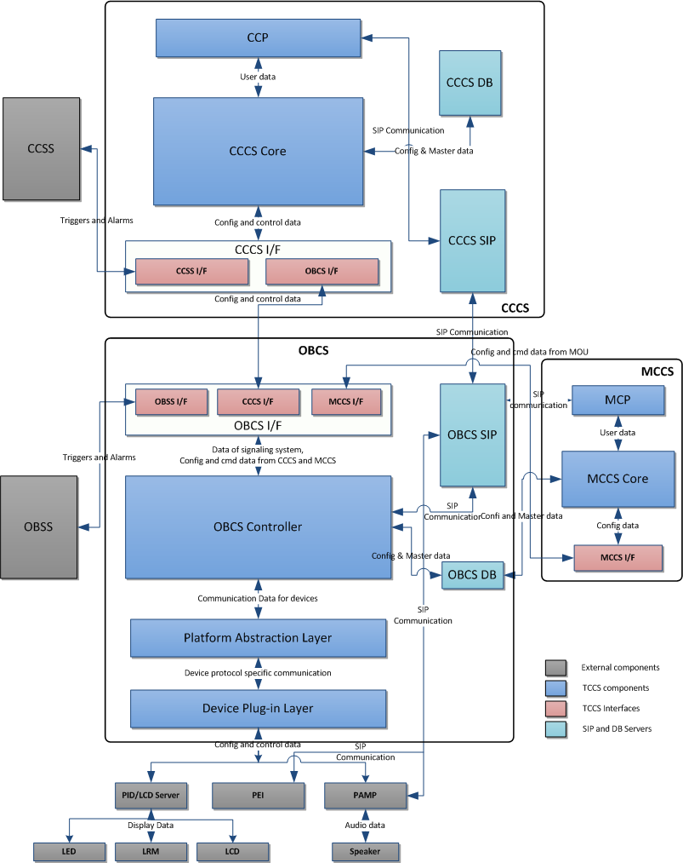

Figure 1 : <Diagram 1>
<This header can be used while inserting a figure. Update field function should be used when there are multiple figures in the document>

Technical Overview
<Give technical overview of the proposed software architecture:
- n-tier architecture components
- database Layer
- client layer
- browser Interface
- Portal Interface
- CRM Package Interface
- message Interface> etc>
Function Decomposition diagram should be provided. Each logical overview should be described in separate sections. Portion of this section can be customized as per the need of the systems.
Example 1
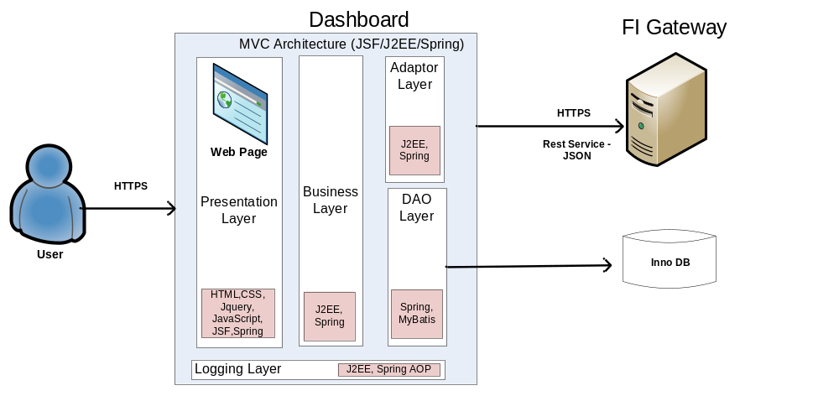
Figure 2 : <Diagram 1>
<This header can be used while inserting a figure. Update field function should be used when there are multiple figures in the document>

Deployment Model
<If applicable, show the deployment perspective of systems showing positioning of various modules / components at various physical entities. Along with the diagram, description of each components description should also be written and mapped against the deployment model. For better understanding the model can also describe of scope context which is part of total deployment model.>
Example of deployment model
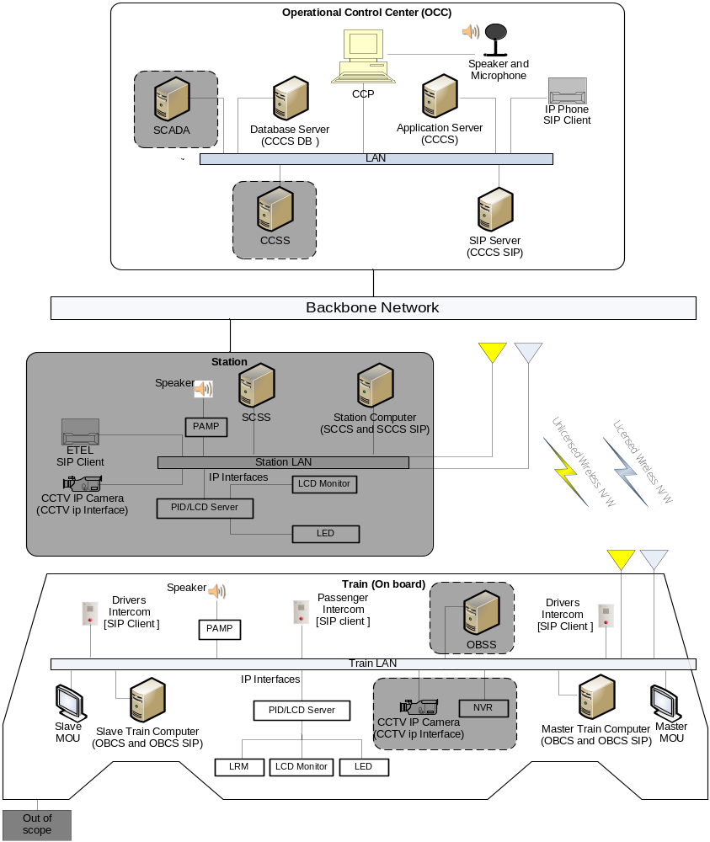
Figure 3 : <Diagram 1>
<This header can be used while inserting a figure. Update field function should be used when there are multiple figures in the document>

<Mapping of component with deployment model must be done.>
Component | Description
Communication Control Panel (CCP) | Provides GUI interface to operator or maintenance officer for doing PA, intercom, and remote management operations.
Central Communication Control System Database Server (CCCS DB) | Provides permanent storage for configuration settings and master data at CCCS system.
Central Communication Control System Application Server (CCCS) | Required for deployment of CCCS software components.  The components are CCCS I/F and OBCS I/F.  CCCS Core: It deals with the communication controls, admin controls and On-board equipment management controls etc.  CCSS I/F: It deals with request and responses for various operations to/from signaling system i.e. CCSS  OBCS I/F: It deals with request and responses for various operations to/from OBCS.

Data sizing and Performance
<This section should list the transaction entries, the growth in the data pattern for the entities/data stores of the software system.
Other critical performance factors like network traffic, usage of hardware devices like juke boxes; optical devices etc. should also be listed.
This section should also specify how the derived timings and performance requirements for the unit processes and the software system are handled as a whole.>

Interfaces
<This section lists the interfaces that will be exposed/used by the system which is being built. Interface specification must describe. >
All data from and to the interfaces shall be defined for the whole range of values defined by the type of the data, including the ranges which are not used when processed by the functions:
a) Definition and description of all equivalence classes for all specified data and each software function using them,
b) Definition of unused or forbidden equivalence classes.
NOTE: The data type includes the following:
- Input parameters and output results of functions and/or procedures;
- Data specified in telegrams or communication packets;
- Data from the hardware.

External Interfaces
<This section lists following type of interfaces:
- Interfaces which will be exposed by the system being built so that external applications/modules can use this system.
- External Interfaces which will be used by the system being built for its functionality.
- Describe interfaces of pre-existing software also
- Boundary conditions >

Internal Interfaces
<This section lists the interfaces required by the internal components of system to work with each other.
If internal interfaces are not given here, then reference to LLD document should be given here to refer the internal interfaces.>

Design Description

Static Model
<Static model represents initial static composition modules / components of system.
Figure out relevant macro level patterns being used, e.g. layering model, MVC, client server architecture etc.>

Behavioral Description (This is an optional section, can be removed if not required)
<State Chart, This section describes the system/module state table, if any. All the states, their transitions and associated events may be detailed here
- State
- Transitions
- Events
The event list is a simple textual listing of the events in the environment to which the system must respond.
Another way to represent the behavior is given in the table below.>
Event Name | Response To Event | Function

Process Model
<Process model consists of the following items:
- Data / Signal Flow Diagram (DFD): The data flow diagram is a modeling tool that allows us to picture a system as a network of functional processes. The data flow diagram (DFD) is a statement of user requirements, which portrays the system in terms of its component pieces with all the interfaces indicated. This diagram consists of terminators, data flows, control flows, data stores and process bubbles.
- Flow charts : Any process specific flow chart may be detailed here
- Context Diagram: Context Diagram defines all the inputs to and the outputs from the software system. This diagram consists of terminators, data flows, control flows, data stores and a single process bubble representing the entire system.>
Example:
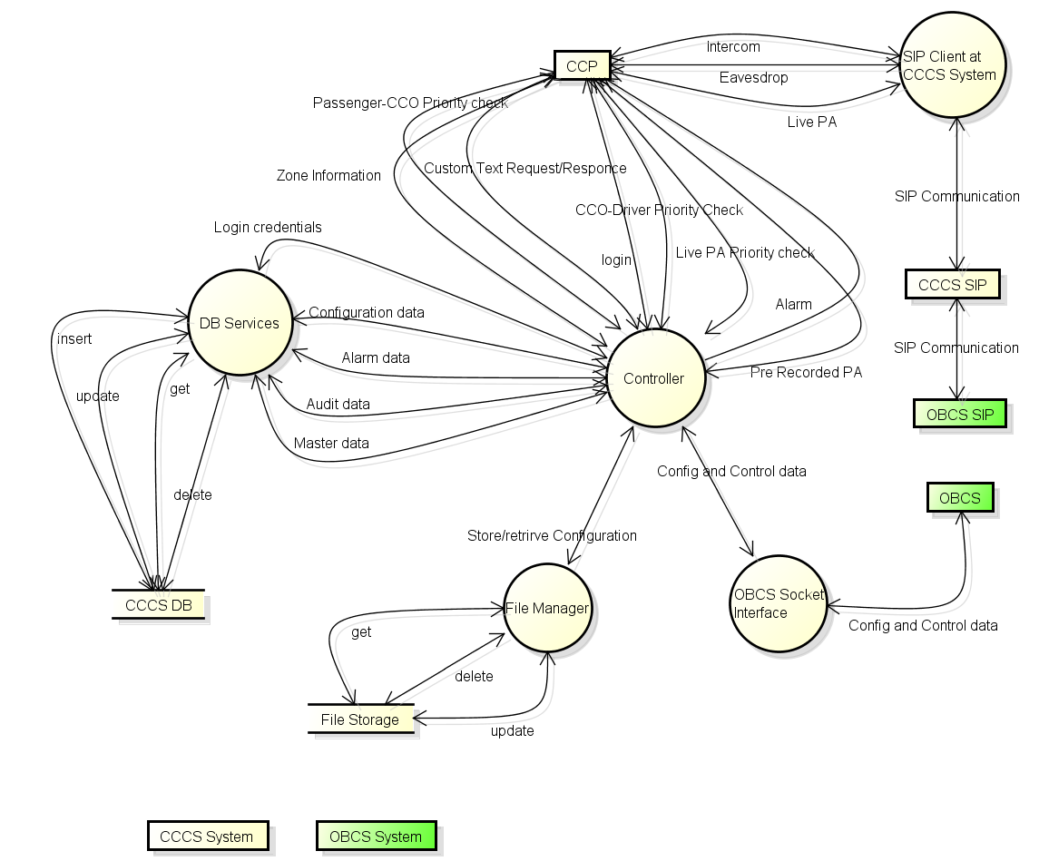
Figure 4 : <Diagram 1>
<This header can be used while inserting a figure. Update field function should be used when there are multiple figures in the document>

Synchronization / threading model
<Explain the strategy for designing multiple components / modules / structures for optimal utilization of system resources and corresponding synchronization strategy.
List of threads can be described as per below reference for more description. Table gives the detailed list of the threads which are running on the system. Description of each column is as follows:
- Component Name– Lists the name of the module of the system
- Total Threads – Signifies total threads that are present in the system including permanent and connection based threads.
- Always running – signifies the permanent running threads.
- Number of Times in system – This column signifies that whether thread will run on each interface of the SDC or only on one interface.
Thread List Table
S. No | Reference section | Component Name | Total Threads | Always running | Number of Times in system | Total on SDC
1 |  | XYZ | 1 | 1 | 2 | 2

Details of the components thread should be detailed down in subsection of 4.4 which will be referred in above table.

Exception & Signal Handling
This section has information about all the errors which will be displayed on the Web Client UI. All the Error messages will be referred from properties file. All the errors received from the external system will be logged and the Dashboard specific errors mentioned in the below table will be thrown depending upon the error received.
Table which can be used for describing exception & Signal Handling are as give below.
S.no | Error Code | Error Message | Remark
1 | DAS_ERR_350001 | User is not found in Database.
2 | DAS_ERR_350002 | Session is not Created

If details of exceptional & Signal handling are defined in LLD this section can be removed. If required high level of detailing can be described here.

Logging & debugging mechanism
Logging: This section will describe about logging approach into the system. It can be explained through diagram too. e.g. “Different components will be sending their log request to log server which will log the info using the syslog service. OBCS will be using syslog service for logging purpose. All the components of OBCS will be sending their log info to log server.
OBCS will be using different log levels for different components and corresponding action of sending audit info to CCCS, will also be determined by evaluating the log level.

Design for Software System Attributes/ Quality Attributes
<This section adds the details w.r.t. technical design required to meet the software system attributes (like availability, reliability etc.) identified in SRS document. Following are the key quality attributes which can be detailed out.
- High Availability and scalability
- Security
- Maintainability
- Portability
- Safety
- Efficiency
- Usability.
Each key attribute can be detailed out in a separate sub sections.>

Design for Performance Requirements
<This section adds the details w.r.t. to technical design required to meet the performance requirements identified in SRS document.>

List of Time Critical and Periodic Functions
<In this section, list out all the time critical and periodic functions for the entire application.>

Design Considerations

Design Constraints
<This section specifies the design constraints on the software being developed. These constraints may include physical memory limitations or the necessity for a specialized external interface, may dictate special requirements for assembling or packaging of software portability, use of system calls, use of specific data structure etc. >

Design Assumptions
<This sections lists down if any assumptions considered by design.>

Design Limitations
<This sections lists down if any limitations are there in the chosen design.>

Design Issues
<This sections lists down if any issues are still there in the chosen design for current/future implementation. These issues should be tracked in PMP too>

Design Risks
<This sections lists down if any risks are associated with the chosen design for current/future implementation. These risks should be tracked in PMP too.>

Alternate Design Methods Considered
<Give the details of the alternate design method considered, evaluation method adopted, rating criteria used and rationale used for selection of chosen design. You can also attach DAR sheet here. If DAR sheet is not followed, refer process and mandatory information (Selected alternatives, critical factors etc.) should be given in project specific template.>

Design for special requirements
Few systems may have some special requirements like installation, system backup/recovery procedure etc. Related design considerations / strategy should be captured in this section.
- Install Procedures
- Backup and Recovery Procedures
<The scope should clearly define whether it is within the purview of the proposed application.
If the client wants something specific to be developed in this regard and it falls within the scope of the application, the details and the specifications for that should be documented.>
- Operating Modes
- Data / object persistence

Appendix
<Appendix is used for additional information which supports HLD. These sections are optional and can be deleted if no such information is required to be documented. Section in appendix can be increased to the extent required by design of the product. >

Standards
<All coding standards and GUI standards should be attached as an appendix. If standards are not given here, then reference to LLD document or standards document should be given here to refer the internal interfaces.>

References
<This section should identify the documents referenced by the HLD, and other documents required to supplement the HLD. The reference should be precise with the document name, version, date, etc.>

S.no | Document Name | Version/Release Date | Remark

Construction Strategy
<In this section, please mention if any of the identified modules / functions will be re-used from the database or bought as third party component. Also mention the verification and validation requirements of such items. These verification and validation should also support PMP>
S. No | Module / Function | Buy / Re-use | Verification / Validation | Remarks

Existing Architecture
<Mention about the existing architecture, if applicable>

Architecture diagram
<For the existing architecture, give a block diagram depicting the hardware, software, network components such as servers, connectivity, OS etc. >

Technical Overview
<As guided above in section 3.2>

Anticipated Changes
<This section specifies the anticipated changes that may occur in the software. Future enhancements from design perspective can also be described here.>

Detailed Decomposition

Entity, attributes and their relationships
<This section is relevant when OOPs (Object Oriented Programming) based design is created for building the prototype.>
<This section should list all the entities, a verbose description of what that entity pertains to and list of all its attributes. Specify For each of the attributes, the data type, the data size, specific constraints and a verbose description for each of the attribute should be specified.>

