High Level Design
Project Name: Web Talk
Version No.: 1.0
Date: 08 Sep 2016

This document contains proprietary information of NEC Technologies India Pvt. Ltd. Unauthorized access, copying and replication are prohibited. This document must not be copied in whole or part by any means, without the written authorization of NEC Technologies India Pvt. Ltd, Noida, India.

Revision History
V. No. | Date | Prepared by / Modified by | Significant Changes

Table of Contents
1 Introduction 5
1.1 Scope 5
1.2 Out of Scope 6
1.3 Intended Audience 6
1.4 Abbreviation 6
2 System Environment 7
2.1 Hardware and Software Platforms 7
2.1.1 Hardware 7
2.1.2 Software 8
2.2 System Input and Output 8
3 Architecture 10
3.1 Architecture diagram 10
3.2 Technical Overview 11
3.3 Deployment Model 15
3.4 Data sizing and Performance 16
3.5 Interfaces 17
3.5.1 External Interfaces 17
3.5.2 Internal Interfaces 18
4 Design Description 20
4.1 Static Model 20
4.2 Process Model 22
4.3 Synchronization / threading model 23
4.4 Exception & Signal Handling 23
4.5 Logging & debugging mechanism 23
4.6 Design for Software System Attributes/ Quality Attributes 24
5 Design Considerations 25
5.1 Design Constraints 25
5.2 Design Assumptions 25
5.3 Design Limitations 25
5.4 Design Issues 25
5.5 Design Risks 25
5.6 Alternate Design Methods Considered 25
6 Design for special requirements 26
Operations 26
7 Appendix 27
7.1 Standards 27
7.2 References 27
7.3 Existing Architecture 28
7.3.1 Architecture diagram 28
7.3.2 Technical Overview 28

1 Introduction

The purpose of this document is to present a detailed description of the peer-to-peer multimedia broadcast which specify how to deal with real time communication. WebRTC (Web Real-Time Communications) is a technology which enables Web applications and sites to capture stream audio and/or video media, as well as to exchange arbitrary data between browsers without requiring an intermediary. The set of standards that comprises WebRTC makes it possible to share data and perform peer-to-peer, without requiring that the user install plug-ins or any other third-party software. WebRTC (Web Real-Time Communication) is a standard that defines a collection of API’s and application programming interfaces that enable real-time communication over peer-to-peer connections. This allows web browsers to not only request resources from backend servers, but also real-time information from browsers of other users.
WebRTC has mainly three API namely
- RTCPeerConnection, which sets up connection audio/video calls between two peers.
- RTCDataChannel, which allow browsers to share data via peer-to-peer.
- GetUserMedia, which allows a web browser to access the camera and microphone and to capture media.

Also in this document we give the overview of the implementation details using code and Diagram representation i.e. Data flow diagram, architecture etc. Overall it provides the high level view of how the functionality laid out in Requirements\SRS\Webrtc-Software-Requirements-Specification.docx will be implemented.

1.1 Scope

This Document contains requirements for Web Talk which is a web based Real time Audio and Text Communication Application using WebRTC technology. It also contains working principle, requirements for Web Talk Application and use case analysis of the application.

This application is a browser-based method of broadcasting media using peer-to-peer technologies. Its purpose is to allow users to stream audio, text, files easily, quickly, and free of cost.

1.2 Out of Scope
In this document we are not implementing the video streaming, conference talk and hence these are the parts which may be further implemented.

1.3 Intended Audience

NAME
MONIKA SHARMA
SOUMYA
SAQUIB AZAD
REHAN RAZA

1.4 Abbreviation

Abbreviation | Description
API | Application Programmable Interface
SDP | Session Description Protocol (SDP) is a set of rules that describe media communication sessions.
Signaling | A process to exchange data and Coordinate communication between two end users.
SRS | Software Requirements Specification.
Stream | A sequence of data.
STUN | Session Traversal Utilities for NAT (STUN) is a protocol that uses a third-party STUN server to allow peers to discover each other’s IP Address and helps to identify each users and find a good connection between them.
TURN | Traversal Using Relays around NAT (TURN) is a protocol.
UDP | The User Datagram Protocol (UDP) is a transport layer protocol defined for use with the IP network layer protocol.
ICE Framework | ICE is a framework used to connect users. First tries UDP, then TCP with HTTP, then TCP with HTTPS, then TURN servers.
ICE Candidate | ICE candidate provides the information about the IPad dress and port from where the data is going to be exchanged.
WebRTC | A WebRTC is a technology based on Real-Time Communications (RTC) that provides peer to peer connection without using any plugin and third party software.
Web Browser | A software application for retrieving, presenting and traversing information resources Over

2 System Environment

2.1 Hardware and Software Platforms

2.1.1 Hardware

Item | Value | Description
RAM | 2 GB RAM will be required with at least 200 MB free space. | Normal RAM in which OS and other software can be installed.
Processor | 1 gigahertz (GHz) or faster 32-bit (x86) or 64-bit (x64) processor will be required to run the application. | Any processor which is capable of running web applications and basic software.
Hard Disk | 150 MB free space to install the application | Normal Hard Disk to store the OS programs.
Microphone | NA

2.1.2 Software

Item | VALUES
OS | x86_64 bit
Kernel | 3.4.34
Node.Js | V 6.0.0

Software interfaces | Specification | Description
Operating System | Linux(UBUNTU or DEBIAN) | OS on which application will be installed.
Tools | Chromium Depot Tools. | It is a package of scripts that is used to manage checkouts and code reviews.
Tools | Node Js | Node.Js is a very powerful framework used to develop I/O intensive web applications like video streaming sites, single-page applications, and other web applications
2.2 System Input and Output

Screen Id | Screen Name | Purpose | Input Fields | Output fields | Remark
U001 | Main Screen | Screen for giving user name to sign in. | User Name | NA | This screen contain a text field where a user give his user name to join.
U002 | Menu Screen | This Screen contains Choice for audio and text communication. | Buttons. | NA | This Screen contains Choice for audio and text communication.
U003 | Audio Screen | This screen contain a text field where the user will give the name of that person whom he wants to call and two buttons call and hang up. Call button establish connection and hang up button disconnects them. | User Name of the receiver and buttons. | The voice of the receiver. | This screen contain a text field where the user will give the name of that person whom he wants to call and two buttons call and hang up. Call button establish connection and hang up button disconnects them.
U004 | Text Screen | This screen contain a text field where the user will give the name of that person whom he wants to chat and two buttons chat and hang up. Chat button establish connection and hang up button disconnects them. Also this screen contain two panel login members and chat area. | User Name of the receiver and buttons. | The message sent by the receiver. | This screen contain a text field where the user will give the name of that person whom he wants to chat and two buttons chat and hang up. Chat button establish connection and hang up button disconnects them. Also this screen contain two panel login members and chat area.

3 Architecture

Architecture diagram

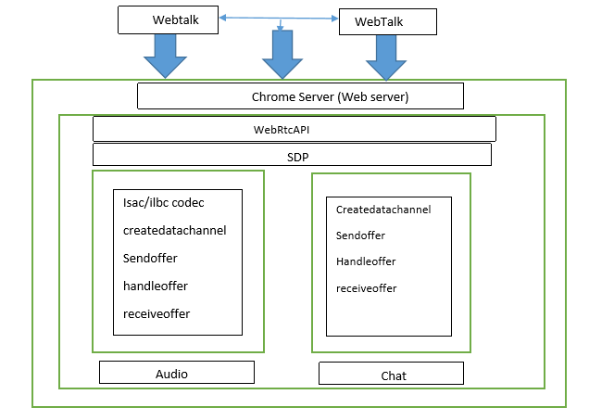

3.2 Technical Overview
EventHandler Function/API Description

1.loginBtn.addEventListener  2. chatBtn.addEventListener  3. audioBtn.addEventListener  4. CallBtn.addEventListener  5.hangUpBtn.addEventListener  6.sendMsgBtn.addEventListener | handle Login(success)  1.Create.datachannel()  2.getUserMedia  3. dataChannel.onerror()  4.datachannel.onclose()  1.getUserMedia  2.handleoffer()  3.handlecandidate()  1.handleoffer()  2.send(offer)  3.handlecandidate()  4.handleAnswer()  1.handleleave()  1.datachannel.send() | This event handler enables the login button calling the handle login () function. If login is success then the user go to the next page.  This event handler created the channel for data transfer using create.datachannel () function.  Gives the error message.  Describe the closing status of data channel.  This event calls the getUserMedia API using navigator.webkitGetUserMedia().  In this event the given function are called and the given username to call the connection is established and information displayed on the server console.  This event handler disconnected the data channel and close the connection using handle Leave () function.  After clicking this button the messages (text/audio) data are transferred.

N-tier architecture components
There are many components to the WebRTC architecture they are as follows.
Webserver: The Webserver used in this project is mainly the chrome STUN server and for establishing connection we used the signaling server or socket server as Node Js. There is a server.js file which have the main connection with the chrome server and Node server is installed on the system which behaves as running server for the project.
Web Application: In the application there are files namely client.js server.js, index.html and some authentication and certification files. The peer connection established when the client send the request to server using signaling server and server response using the RTCpeerconnection API after the connection is established the client is ready to use the two modules namely Audio and Chat for Voice and text communication on same or different machine. The web pages correspond to this are depicted in the section 3.3 Deployment Model.
Web API: The Web API is used to create Web applications, which has video and audio chat capabilities. The Web API is used by the developers to develop Web based video chat-like applications.
WebRTC Internal API: The WebRTC Native API layer enables browser developers to easily implement the Web API proposal. This is used by browser developers to create WebRTC compatible browsers.
Voice engine: This sets the framework for the audio media connection, which includes the iSAC (Internet Speech Audio Codec), the iLBC (Internet Low Bitrate Codec), the Opus codec, the NetEqualizer for Voice, the acoustic echo canceller and noise reduction technologies.
The NetIQ for Voice is a dynamic jitter buffer and error concealment algorithm used for concealing the negative effects of network jitter and packet loss, which keeps ltency as low as possible while maintaining the highest voice quality.
The acoustic echo canceller is a software based signal processing component that removes the acoustic echo resulting from the voice being played out coming into the active microphone. The noise reduction component is a software based signal processing component that removes certain types of background noise usually associated with VoIP, such as fan noises and other background disturbances.

Video engine: This is the framework for the video media connection for video, from the camera to the network, and from the network to the screen and back. It includes the VP8 (video compression format owned by Google) codec, dynamic jitter buffer and image enhancement technology. The VP8 codec by the WebM Project (an open media file format designed for the Web) is well suited for RTC as it is designed for low latency. The dynamic jitter buffer for video helps conceal the effects of jitter and packet loss on overall video quality, and image enhancements remove video noise from the image capture by the webcam.

Transport session: Transport session components are built by re-using components from libjingle, without using or requiring the Extensible Messaging and Presence Protocol (XMPP) or Jingle Protocol. The Real Time Protocols (RTP) network stack and the STUN and ICE components allow calls to establish connections across various types of networks.

- Client layer
This layer is present between the browser and client and provides an interface to interact with the browser using native WEBRTC APIs.
- Browser Interface
This interface is responsible for providing webrtc facility which helps the user to interact using real time communications.
- message Interface

3.3 Deployment Model
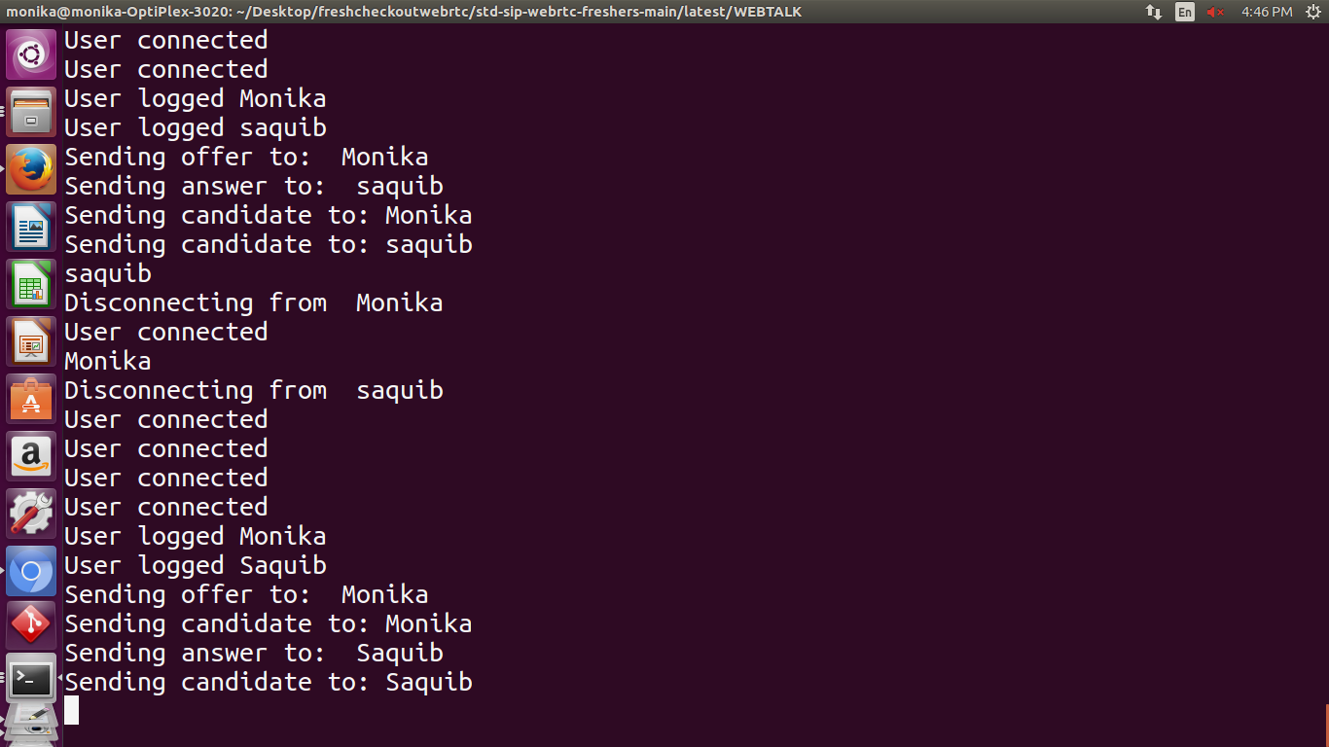

Figure 1 : <Server Screen.>

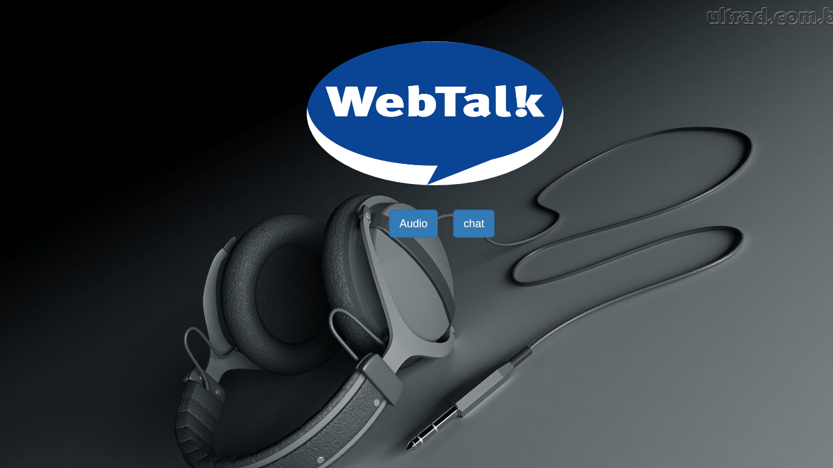

Figure 2 : <Main Screen.>

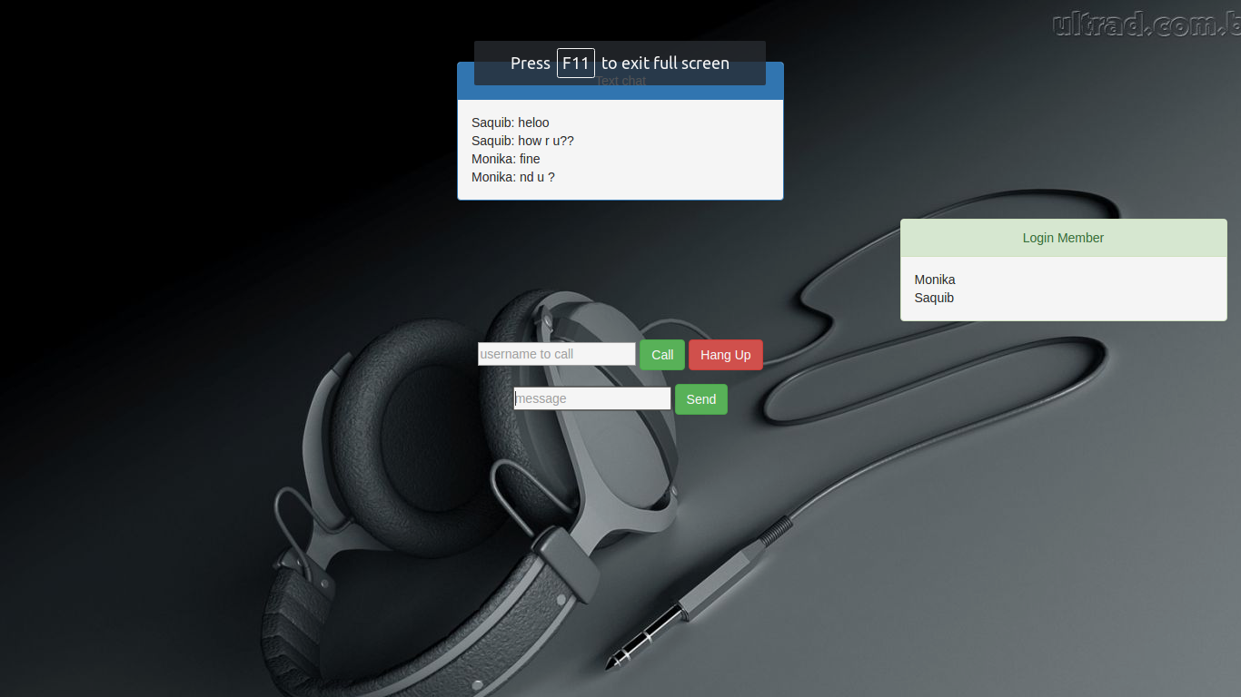

Figure 3 : <Call Screen.>

3.4 Data sizing and Performance

TBD

3.5 Interfaces

3.5.1 External Interfaces

Webrtc have mainly 3 parts.
- Media stream
- RTC peer connections
- RTC data channel

Media Stream () API is used to receive data from a user's microphone. Media Stream () API abstracts the microphone complexities from the user.

Communication interfaces will be abstracted by the Webrtc API mainly by the RTCPeerConnection () which is created by RTCPeerConnectionFactory () interface. This allows peer to peer communication between two users with a high level approach without worrying about the lower level implementation. With RTCPeerConnection () users exchange SDP (Session Protocol Description) packets which contain many of the network and user information i.e. ip address, port number, transport layer protocol used etc. RTCPeerConnection () also contain method for the encryption of the data to be sent and it also maintain the signaling mechanism.

Webrtc also focuses on the ICE framework for connecting two peers directly. ICE framework first try to connect the peers using UDP protocol with the most minimum latency. If UDP fails the ICE framework try to connect the peers with TCP with HTTP protocol and later with TCP with HTTPS. Finally when a direct connection does not work ICE will try to use TURN server.

Boundary Handling

- Browser Incompatibility: Webrtc application is applicable only for those browser which supports webrtc. So if the browser does not support webrtc then the program will not run and nothing will be displayed on the browser.

- Hardware Not Found: If the microphone is not plug in then user will get a message that “audio device is not found”.

- Connection Problem: If the system is not connected with internet then the user will not able to open the web browser to run the application.

- Poor Connection: If suddenly the connection become slow then it will try to reconnect the peer to peer connection for a particular time period.

Below table represents and give the basic input/output of the External API

S. no | Input | Output | From | To
1 | Sender initialize the call by using navigator.usermedia () method  . | Stream | Sender | RTCPeer Connection Method.
2 | RTCPeerConnection.CreateOffer () is called which create a SDP offer and send this offer via signaling. | Offer | Sender | Receiver
3 | Receiver receives the offer from the Sender and use navigator.getUSerMedia method to create a stream and adds this stream to RTCPeer Connection. Then he creates answer with the help of the offer sent by the sender and sends the answer to the caller. | answer | Receiver | Sender

3.5.2 Internal Interfaces

- RTCPeerConnection: Represents a WebRTC connection between the local computer and a remote peer.

- RTCSessionDescription: Represents the parameters of a session. Each RTCSessionDescription consists of a description type indicating which part of the offer/answer negotiation process it describes and of the SDP descriptor of the session.

- RTCIceCandidate: Represents a candidate internet connectivity establishment (ICE) server for establishing an RTCPeerConnection.

- RTCPeerConnectionIceEvent: Represents events that occurs in relation to ICE candidates with the target, usually an RTCPeerConnection.

- RTCRtpReceiver: Manages the reception and decoding of data through a MediaStreamTrack for a RTCPeerConnection.

- RTCRtpSender: Manages the encoding and transmission of data through a MediaStreamTrack for an RTCPeerConnection.

- RTCDataChannel: Represents a bi-directional data channel between two peers of a connection.
- RTCDataChannelEvent: Represents events that occur while attaching an RTCDataChannel to an RTCPeerConnection. The only event sent with this interface is data channel.

4 Design Description

4.1 Static Model

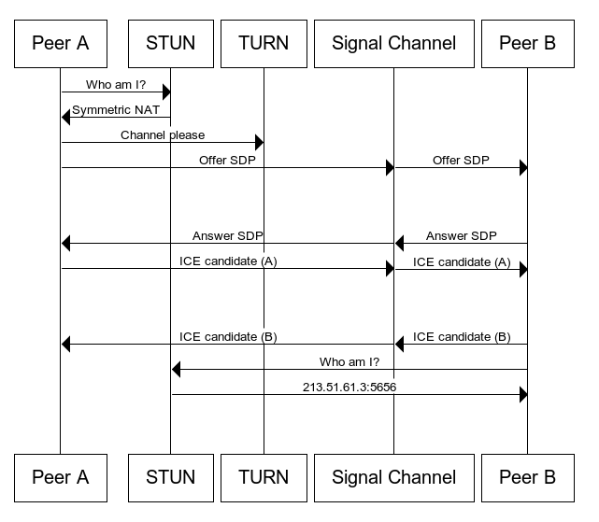

 | On. Message ()  Receives the new-ice-candidate and forward it to caller Soumya  On. Message ()  Receives the new-ice-candidate and forward it to caller | Web Talk Web Browser  Callee (Soumya)
  WebTalk
  HandleIcecandidate ()
  Receives the candidate and send it to Soumya client using signaling server as a new ice candidate message
  Caller (Saquib)
  HandlenewIcecandidateMsg ()
  1. Create and RTCIcecandidate object using the SDP provided in the candidate.
  2. Deliver the candidate to Saquib and pass it to RTCpeerconnection.addIcecandidate ()
  Web Browser
  Generate an ice candidate represented by an SDP string
  Signaling Server
  Generate an ice candidate represented by an SDP string
  HandlenewIcecandidateMsg ()
  1. Create and RTCIcecandidate object using the SDP provided in the candidate.
  2. Deliver the candidate to saquib and pass it to Soumya RTCpeerconnection.addIcecandidate ()
  HandleIcecandidate ()
  Receives the candidate and send it to Saquib client using signaling server as a new ice candidate message

Class diagram of Web Talk
The above class diagram represents the peer to peer connection using signaling server with two client a caller and caller .Here the Web App is our Web Talk application.

4.2 Process Model

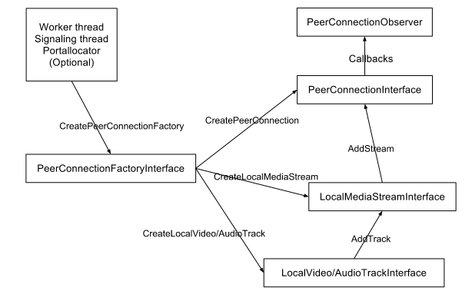
Process diagram
In this process model the part of stream can be called as media stream which can be divided into audio, video etc. Mainly used parts are audio and video tracks.PeerconnectionFactoryinterface local video audio track interface local media stream interface PeerConnectionInterface and PeerConnectionObserver.

4.3 Synchronization / threading model

WebRTC Native APIs use two globally available threads: the signaling thread and the worker thread. Depending on how the Peer Connection factory is created, the application can either provide those two threads or just let them be created internally.
Calls to the Stream APIs and the Peer Connection APIs will be proxies to the signaling thread, which means that an application can call those APIs from whatever thread.
All callbacks will be made on the signaling thread. The application should return the callback as quickly as possible to avoid blocking the signaling thread. Resource-intensive processes should be posted to a different thread.
The worker thread is used to handle more resource-intensive processes, such as data streaming.
- Stream APIs (mediastream.h)
- Peer Connection APIs (peerconnection.h)

4.4 Exception & Signal Handling
- Hardware Issue Microphone is not used by any user.

- Browser Issues User using Browser not supported by webRTC.

- Handling the situation when the receiver does not receive or disconnect the call.

- Time out Exception when the receiver does not receive the call within the Set time frame.

4.5 Logging & debugging mechanism

- Working with a WebRTC API.

- Debugging with Browser.

- Debugging with Networking.

4.6 Design for Software System Attributes/ Quality Attributes

1 Reliability

The server should make sure a peer is always having a connection to another peer in the network.

2 Availability

- Any user may access the service to broadcast or view broadcasts via the website.

- Server-side software will not have any unusual requirements allowing for deployment in many environments.

3 Security
- Security can be achieved by the encryption followed by decryption between sender and receiver.

- Communications between peers is encrypted with DTLS-SRTP as defined in WebRTC.

4 Maintainability
- The host shall be competent in the administration of common web application software and techniques

- The host must make sure that web application is accessible to end-users

- The end-user will not need to download or install any software to make use of this application.

5 Portability
The service should be able to run on any latest version of Google Chrome browser with no additional plugins or software on a desktop or laptop.

6 Install ability
There is no requirement of installing any software or plugins to use this application.

5 Design Considerations

5.1 Design Constraints
Web Talk is an application that can run in browser and through which two user can communicate in real time scenario. So it is highly dependent on browser. This application can run only those browser which support this WebRTC technology like Chrome, Mozilla, Opera etc.

5.2 Design Assumptions
We assume here that the browser in which the application is deployed supports WebRTC technology.

5.3 Design Limitations
This program cannot be able to run in every browser.

5.4 Design Issues
Through this application two users using different browser cannot communicate with each other. They have to use one particular WebRTC enabled browser.

5.5 Design Risks
<This sections lists down if any risks are associated with the chosen design for current/future implementation. These risks should be tracked in PMP too.>

5.6 Alternate Design Methods Considered
<Give the details of the alternate design method considered, evaluation method adopted, rating criteria used and rationale used for selection of chosen design. You can also attach DAR sheet here. If DAR sheet is not followed, refer process and mandatory information (Selected alternatives, critical factors etc.) should be given in project specific template.>

6 Design for special requirements

- Install Procedures
- Backup and Recovery Procedures
- Operating Modes

There are two operating modes available in this requirement namely
- Real time chat
- Audio call

Operations
- Real time chat:

In this mode the registered user is applicable to send or receive instant messaging .There is a login page after which the user gets a random generated number and a URL corresponding to that generated number. On clicking the URL other user which is active on that time will be connected. After connection is established the data is transferred with the help of RTC- Data channel.

- Audio call:

In this mode users are allowed to communicate with each other using TCP UDP. In this application two users on separate devices to communicate using WebRTC audio streams. Our application will have two pages. One for login and the other for making an audio call to another user. Here we use SDP handshaking

- Data / object persistence

7 Appendix

7.1 Standards

<All coding standards and GUI standards should be attached as an appendix. If standards are not given here, then reference to LLD document or standards document should be given here to refer the internal interfaces.>

7.2 References
- Web real-time communications working group charter. W3C. Dec.2010.
- http://www.w3.org/2010/12/webrtc-charter.html
- RTC-Web IETF working charter proposal. Mar.2011, http://rtc web.alvestrand.com/ietf-activity
- J. Rosenberg et al. “An architectural framework for browser based real-time communications.
- IETF Internet draft. “Work in progress”, Feb.2011.
- J. Rosenberg, et al., “SIP: Session Initiation protocol”, IETF RFC 3261, June 2002
    - http://www.tutorialspoint.com/webrtc/webrtc_browser_support.htm

    - https://webrtc.org/native-code/development/prerequisite-sw/

    - https://webrtc.org/

    - https://en.wikipedia.org/wiki/WebRTC

7.3 Existing Architecture

7.3.1 Architecture diagram

7.3.2 Technical Overview
Web API: The Web API is used to create Web applications, which has video and audio chat capabilities. The Web API is used by the developers to develop Web based video chat-like applications.
WebRTC Internal API: The WebRTC Native API layer enables browser developers to easily implement the Web API proposal. This is used by browser developers to create WebRTC compatible browsers.
Voice engine: This sets the framework for the audio media connection, which includes the iSAC (Internet Speech Audio Codec), the iLBC (Internet Low Bitrate Codec), the Opus codec, the Net Equalizer for Voice, the acoustic echo canceller and noise reduction technologies.
Video engine: This is the framework for the video media connection for video, from the camera to the network, and from the network to the screen and back. It includes the VP8 (video compression format owned by Google) codec, dynamic jitter buffer and image enhancement technology

