**Godrej Report**



**Name**: Rehan Samirkhan Attar

**Class:** TY-Computer

**College:** Sanjivani College of Engineering

**Elevating My Data Analytics Journey**

I am immensely grateful to Sanjivani College of Engineering and Godrej for the incredible opportunity to participate in the **Godrej | Online | Data Analytics with Cloud Computing & AI Features Training Program (6 Jan – 3 Mar 2025)**. This program has been instrumental in expanding my knowledge of **data analytics, cloud computing, and AI-driven solutions**.

Starting with **Python fundamentals**, the training gradually progressed to **NumPy, Pandas, and Matplotlib**, enhancing my ability to manipulate and visualize data efficiently. The exploration of **Power BI and Advanced Power BI** allowed me to master the creation of interactive dashboards and extract meaningful insights. Additionally, diving into **Machine Learning algorithms** strengthened my understanding of predictive analytics and AI-powered decision-making.

This experience has been transformative, equipping me with the practical expertise needed to bridge the gap between **theory and real-world industry applications**. I extend my sincere appreciation to **Sanjivani College of Engineering and Godrej** for organizing such a valuable program. Excited to leverage these learnings in upcoming projects!

**Key Learnings from the Training**

This training provided in-depth knowledge of essential **data analytics tools, techniques, and technologies**, including:

* **Python for Data Analytics:** Hands-on experience with **Pandas, NumPy, and Matplotlib** for efficient data manipulation and visualization.
* **Power BI & Data Visualization:** Mastered **interactive dashboard creation, data visualization techniques, and report publishing** using Power BI.
* **Machine Learning Concepts:** Explored **Linear Regression, predictive modeling, and Principal Component Analysis (PCA)** to enhance analytical capabilities.
* **Cloud-Based Analytics:** Gained insights into **Big Data processing, Hadoop, and cloud computing applications** in data analytics.
* **Interactive Learning with Kahoot!:** Reinforced knowledge through **engaging quizzes and assessments** to test understanding.
* **Analytical Thinking & Decision-Making:** Developed the ability to **interpret data-driven insights** for informed decision-making.

**Activities Led by Mr. Yogesh Murumkar**

* **Interactive Hands-on Training** for practical application of concepts.
* **Real-World Case Studies** to understand industry scenarios.
* **Collaborative Discussions & Problem-Solving** sessions.
* **Live Implementation Demos** of Python and Power BI tools.
* **Gamified Learning Approaches** for an engaging experience.
* **Task-Based Assessments & Assignments** to solidify knowledge.

**Power BI Dashboard Assignments :**

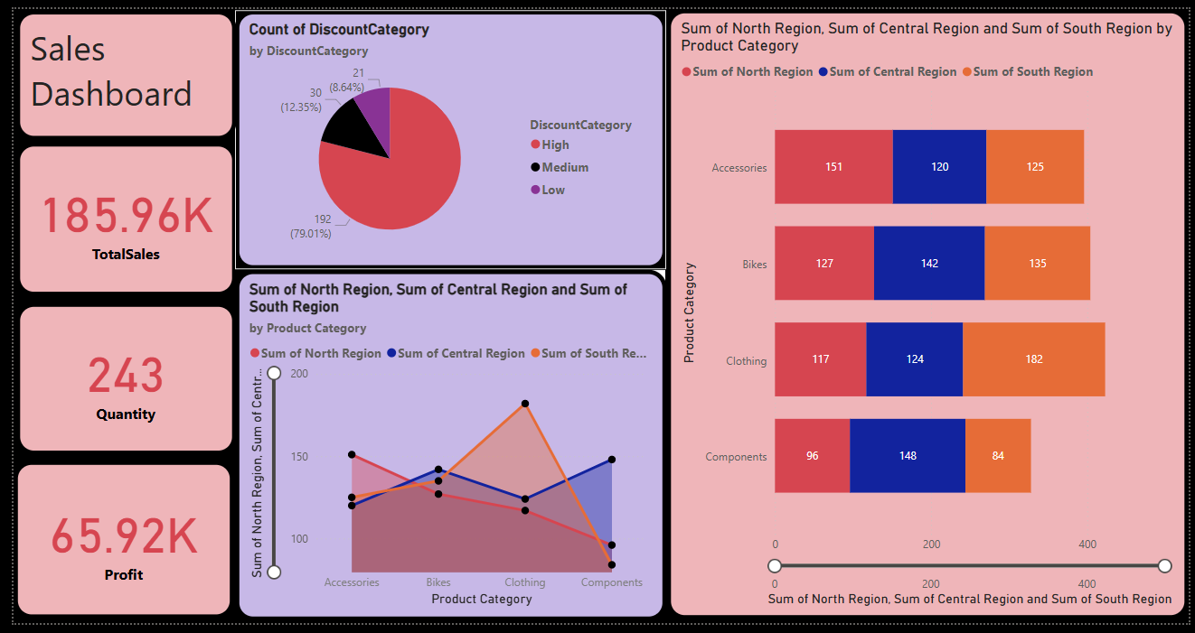 **:**

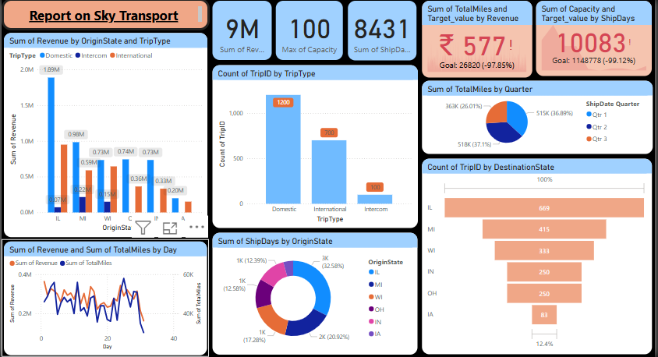

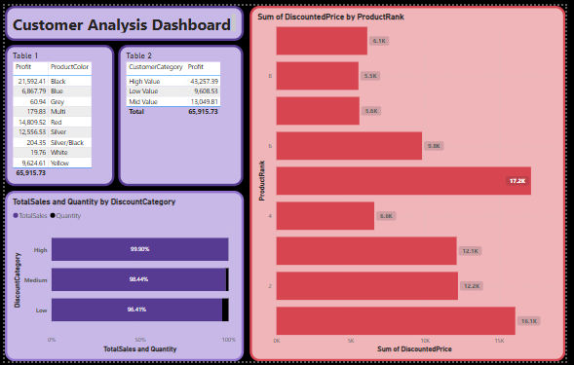

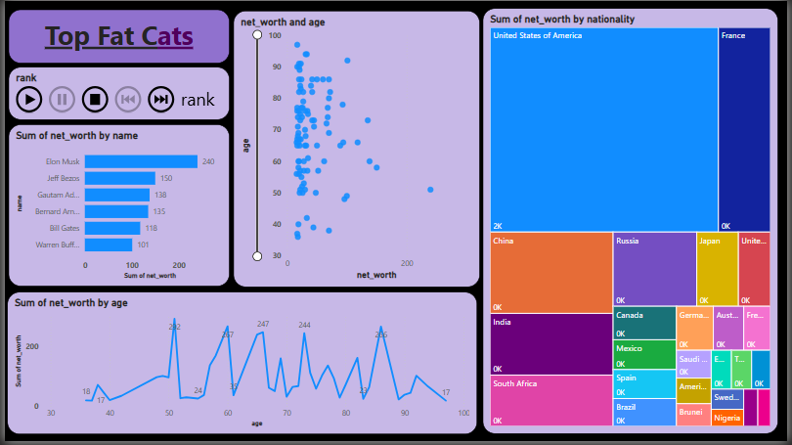

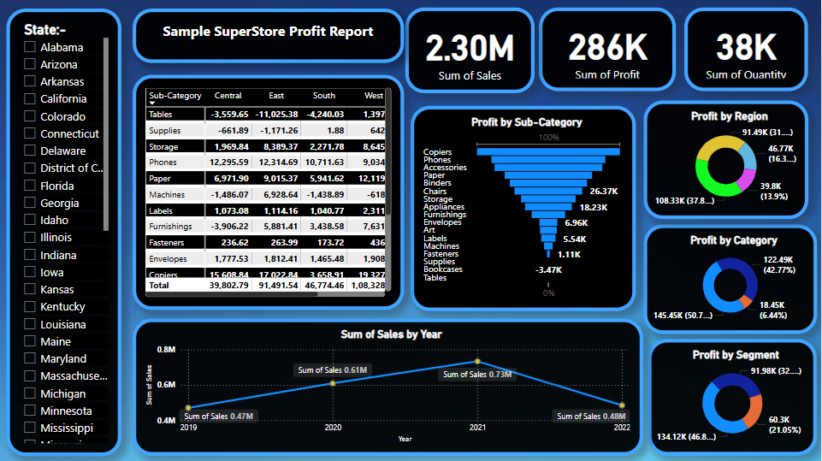

Mr. Murumkar reviewed these assignments during the online sessions, where students were required to share their screens and present their work.

I am sincerely grateful to Sanjivani College of Engineering and Godrej Infotech for the amazing opportunity to participate in the **Godrej | Online | Data Analytics with Cloud Computing & AI Features Training Program (January 6 – March 3, 2025)**. This program provided a comprehensive understanding of Data Analytics, allowing me to develop both core and advanced skills in the field.