**Task 1: Understanding Power Query Editor (Data Cleaning & Transformation)**

**Remove missing values & duplicates.**

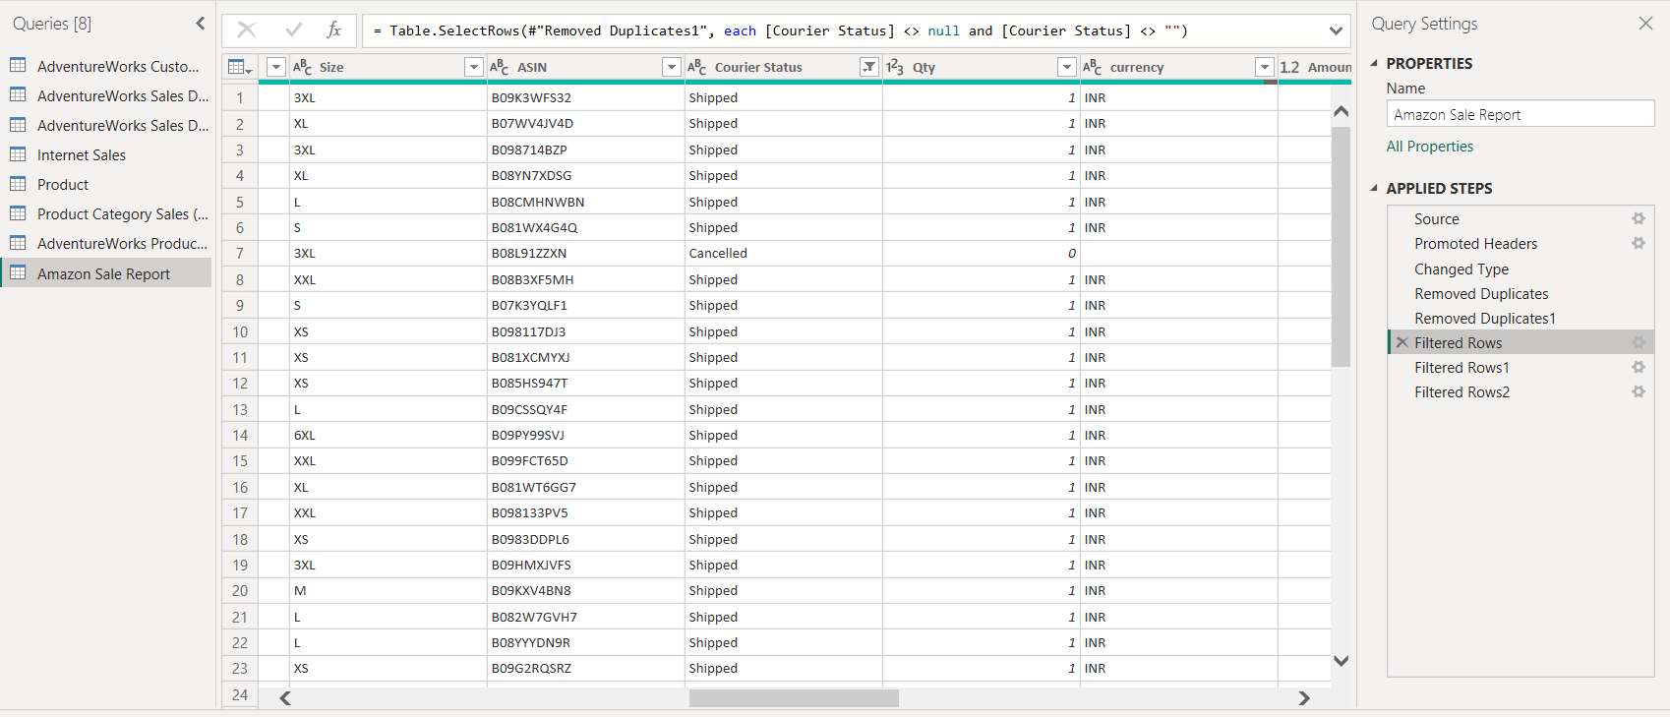

**Change data types (e.g., Date, Currency, Categories).**

**Merge tables based on keys (e.g., Orders & Customers).**

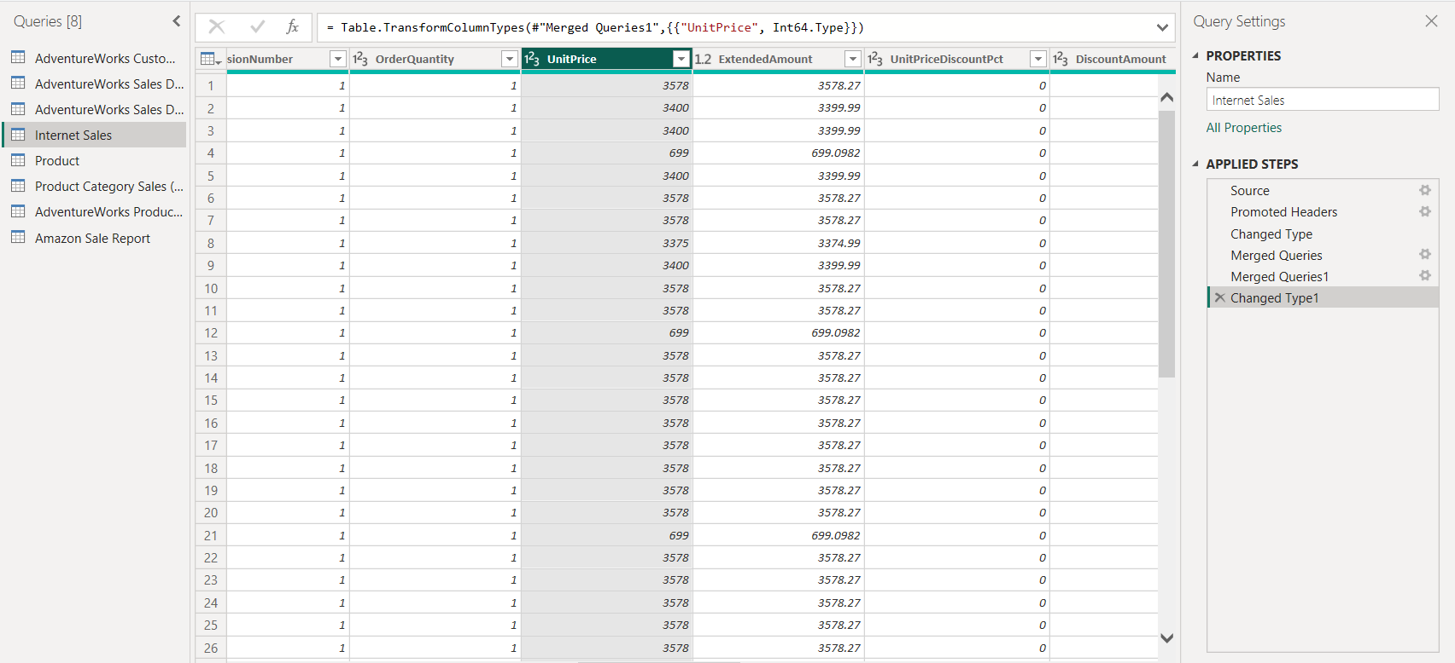

**Split full names into first and last names.**

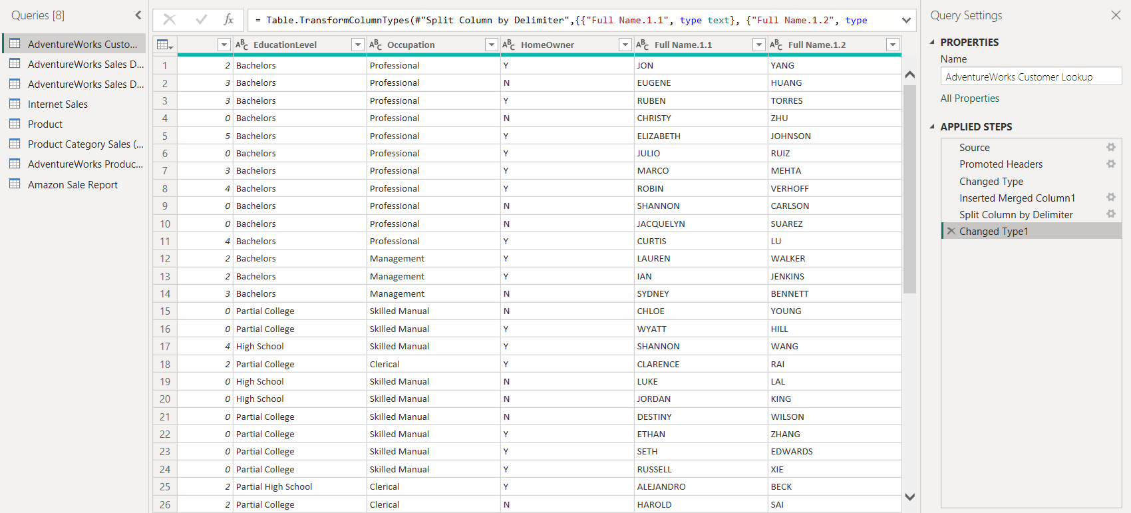

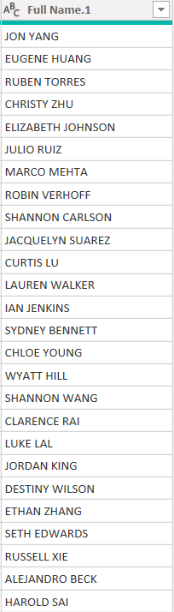

**Task 2: Understanding Data & Data Modeling**

**Star Schema for better performance.**

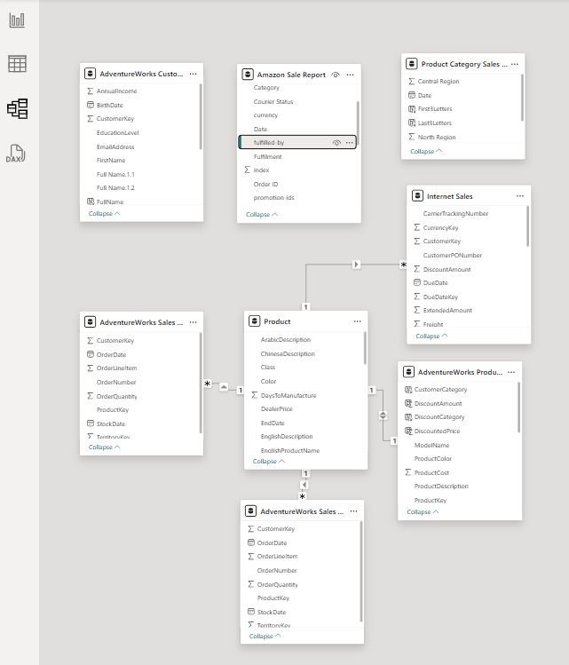

**Task 3: Implementing DAX Functions A)**

**Text Functions**

**Extract the first 3 letters of Product Category:**

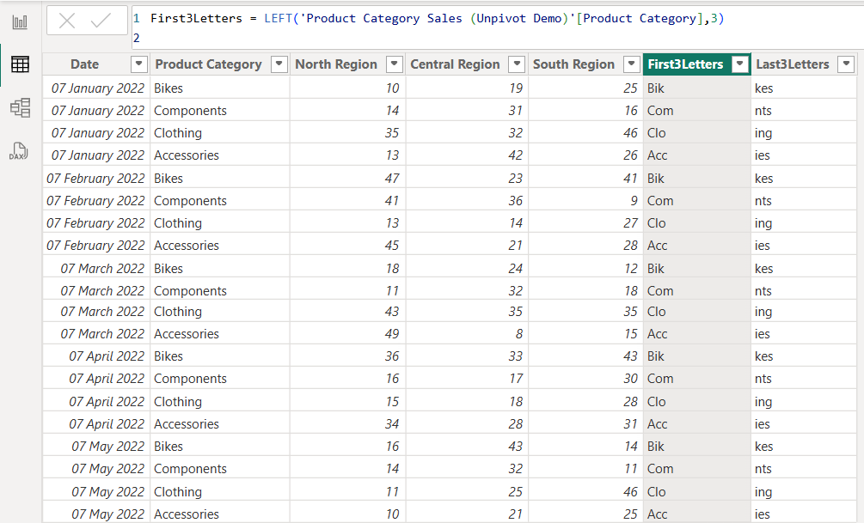

**First3Letters = LEFT('Product Category Sales (Unpivot Demo)'[Product Category],3)**

**Create a full name column from First & Last Names:**

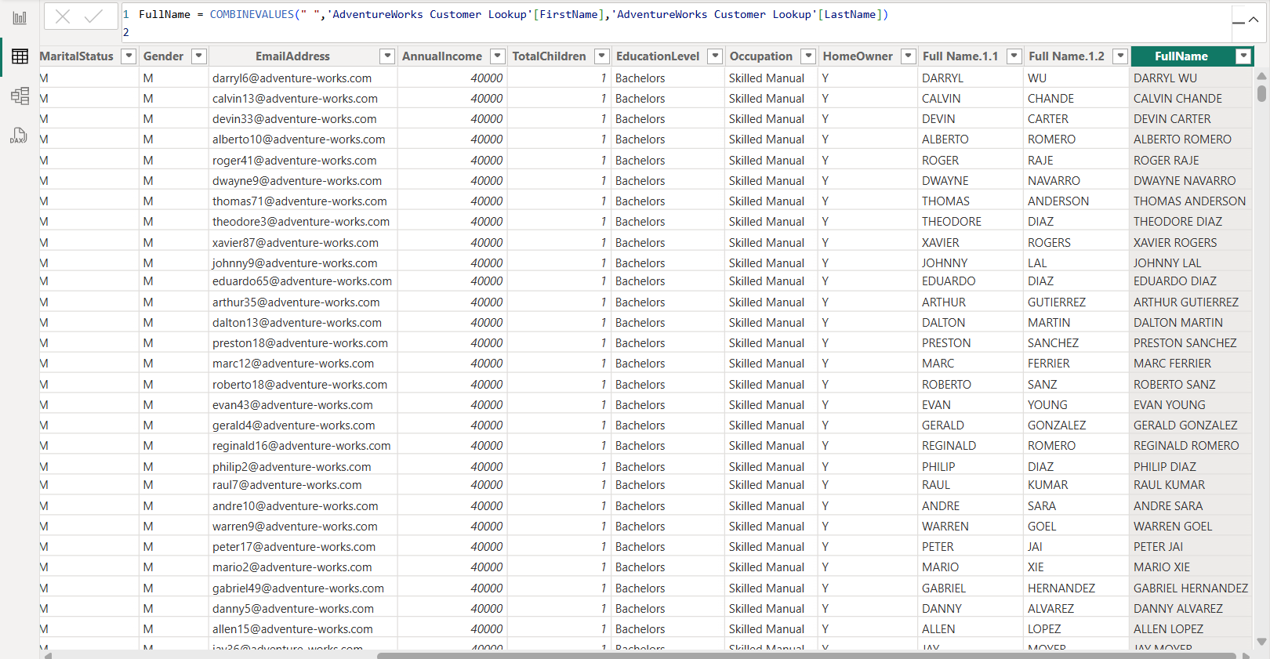

**FullName = COMBINEVALUES(" ",'AdventureWorks Customer Lookup'[FirstName],'AdventureWorks Customer Lookup'[LastName])**

**B) Logical Functions**

**1. Discount Category: Create a calculated column to categorize discounts**

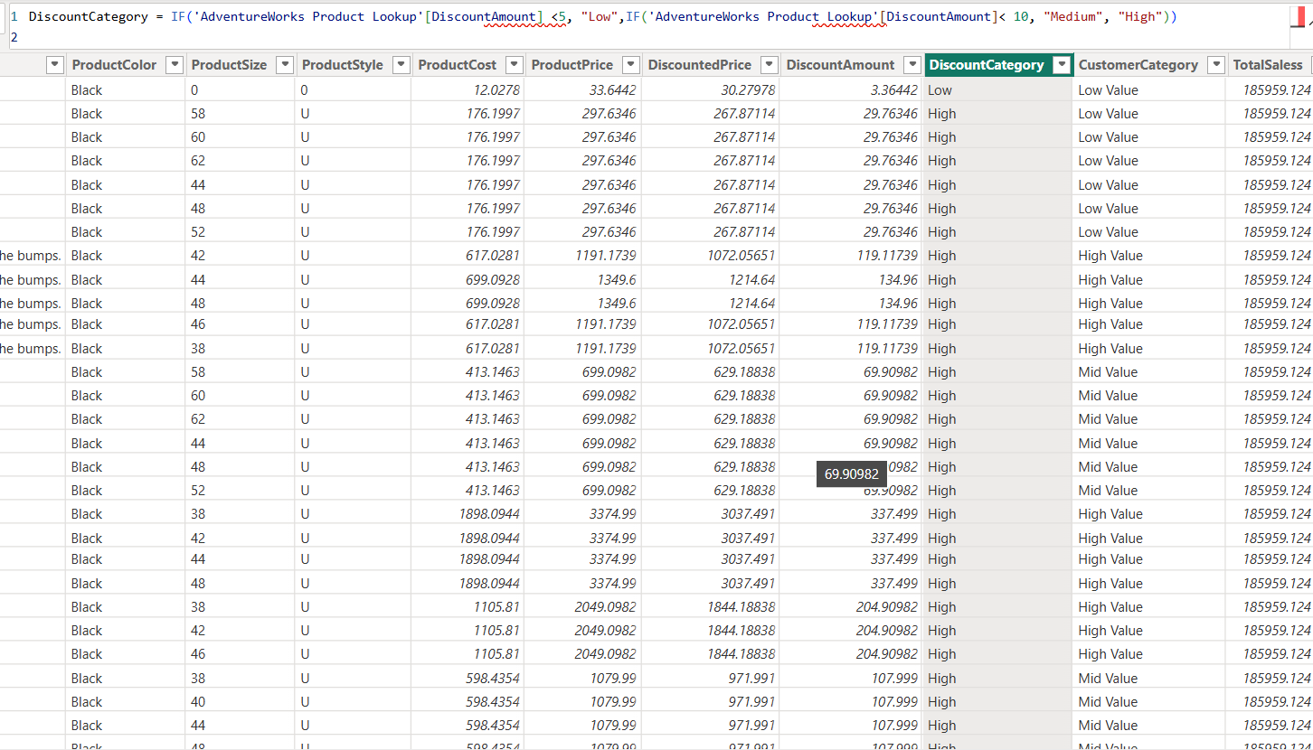

**DiscountCategory = IF('AdventureWorks Product Lookup'[DiscountAmount] <5, "Low",IF('AdventureWorks Product Lookup'[DiscountAmount]< 10, "Medium", "High"))**

**2. High-Value Customers:**

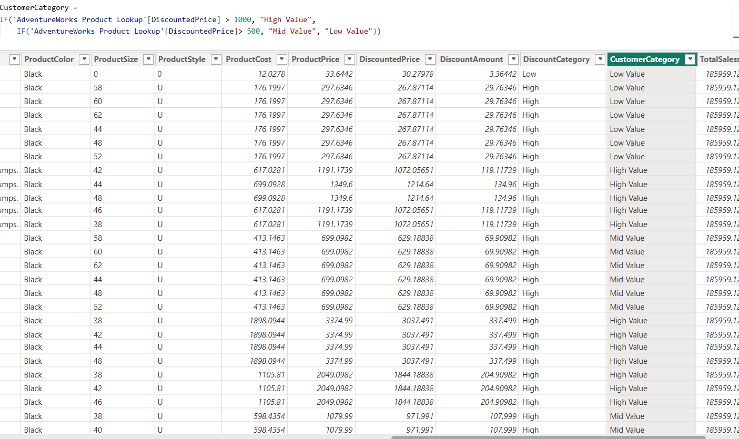

**CustomerCategory = IF('AdventureWorks Product Lookup'[DiscountedPrice] > 1000, "High Value",**

**IF('AdventureWorks Product Lookup'[DiscountedPrice]> 500, "Mid Value", "Low Value"))**

**C) Time & Intelligence Functions**

1. **Calculate Total Sales Last Year:**

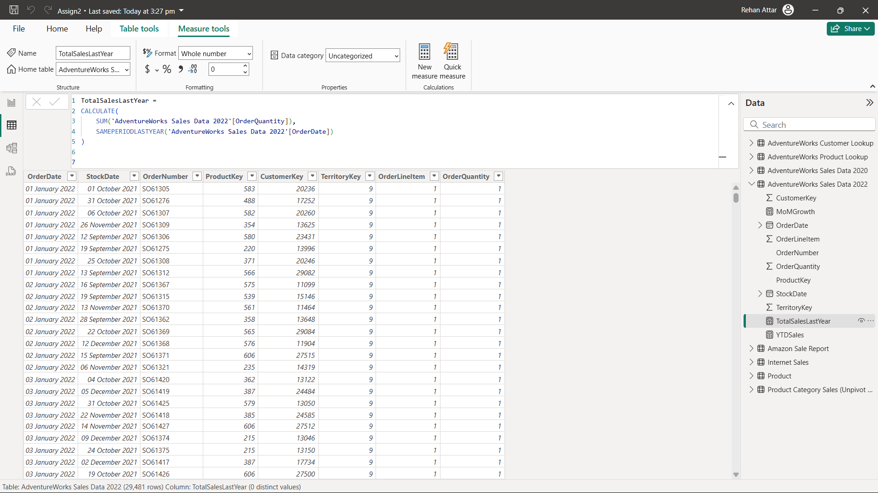

**TotalSalesLastYear = CALCULATE( SUM('AdventureWorks Sales Data 2022'[OrderQuantity]),**

**SAMEPERIODLASTYEAR('AdventureWorks Sales Data 2022'[OrderDate]))**

**2.Find Year-to-Date (YTD) Sales:**

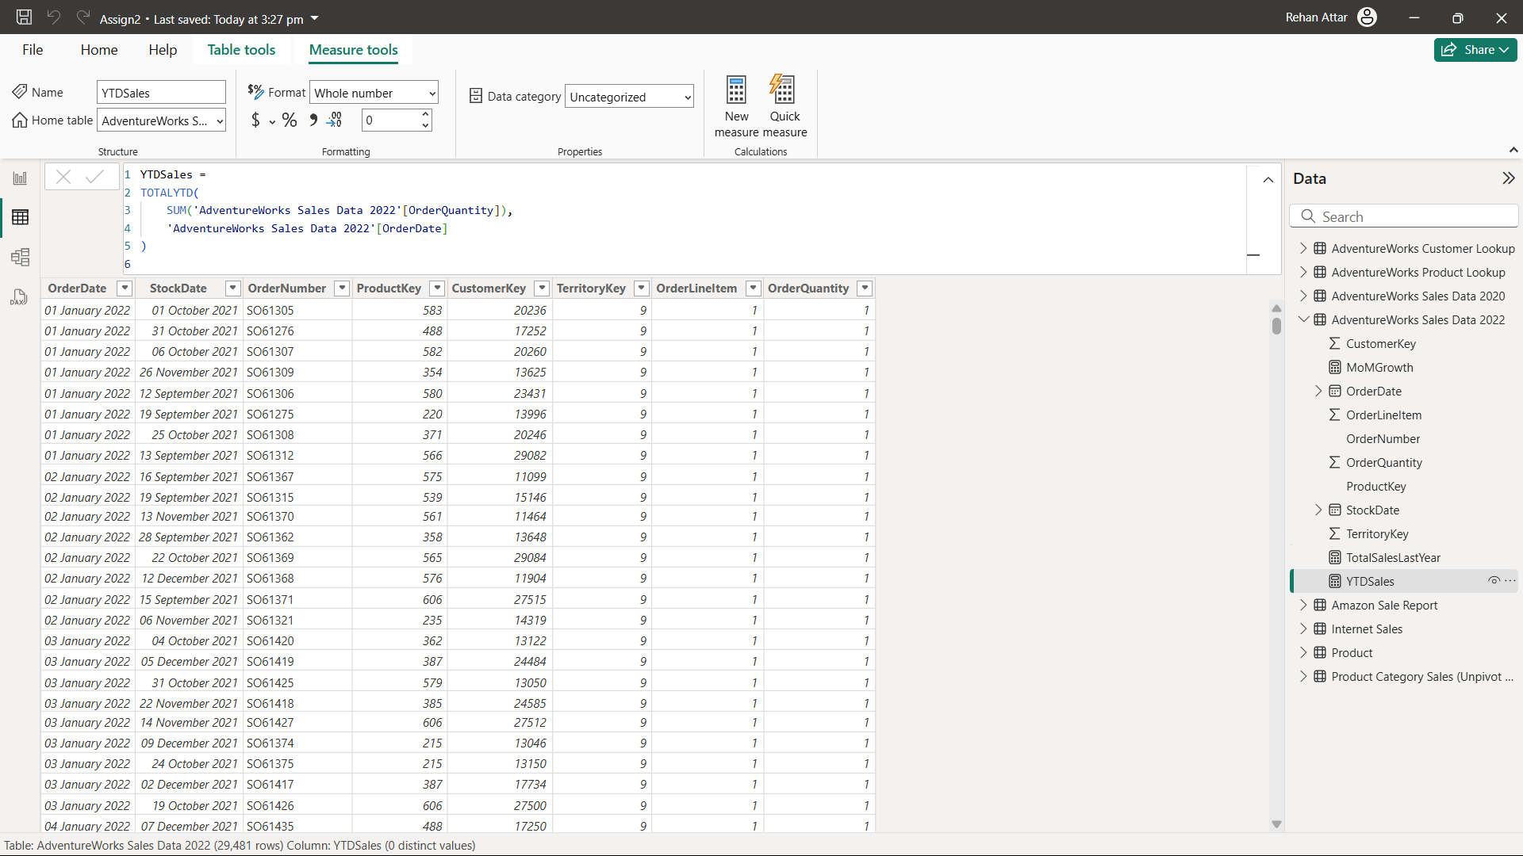

**YTDSales = TOTALYTD(SUM('AdventureWorks Sales Data 2022'[OrderQuantity]),**

**'AdventureWorks Sales Data 2022'[OrderDate])**

**3.Calculate Month-over-Month Growth**

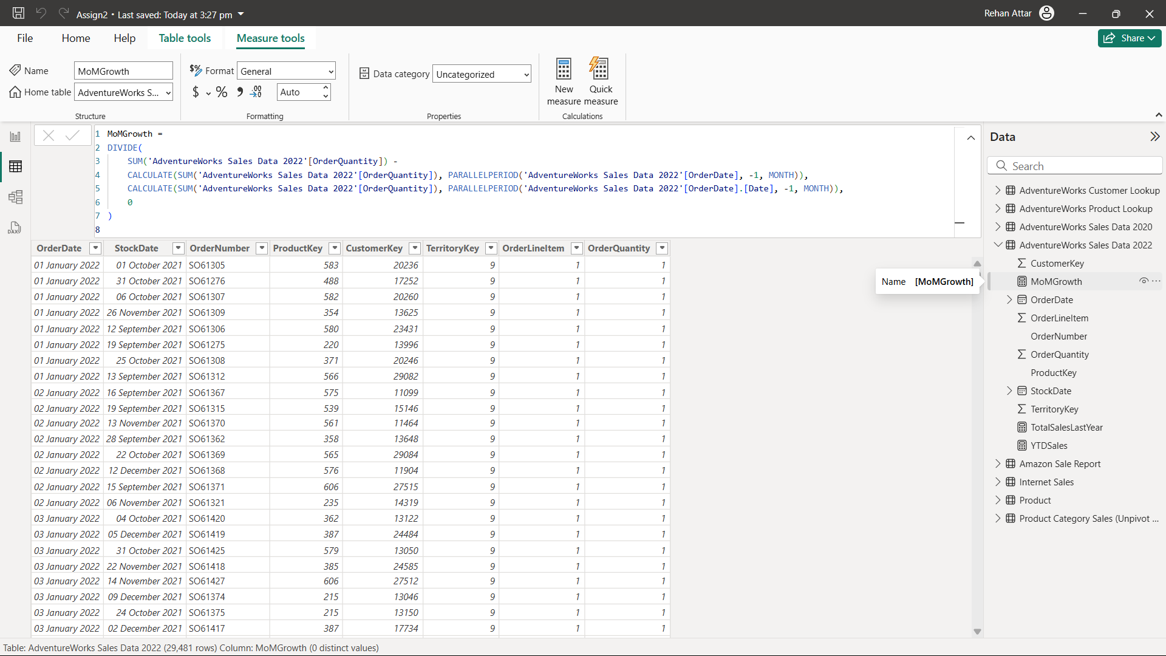

**MoMGrowth =**

**DIVIDE(**

**SUM('AdventureWorks Sales Data 2022'[OrderQuantity]) -**

**CALCULATE(SUM('AdventureWorks Sales Data 2022'[OrderQuantity]), PARALLELPERIOD('AdventureWorks Sales Data 2022'[OrderDate], -1, MONTH)),**

**CALCULATE(SUM('AdventureWorks Sales Data 2022'[OrderQuantity]), PARALLELPERIOD('AdventureWorks Sales Data 2022'[OrderDate].[Date], -1, MONTH)),**

**0**

**)**

**Task 4: Data Visualization & Report Creation**

**Create a Sales Dashboard:**

**• Total Sales, Profit, and Quantity (Cards)**

**• Sales Trends over time (Line Chart)**

**• Sales by Region & Product Category (Bar Chart)**

**• High-Value vs Regular Customers (Pie Chart)**

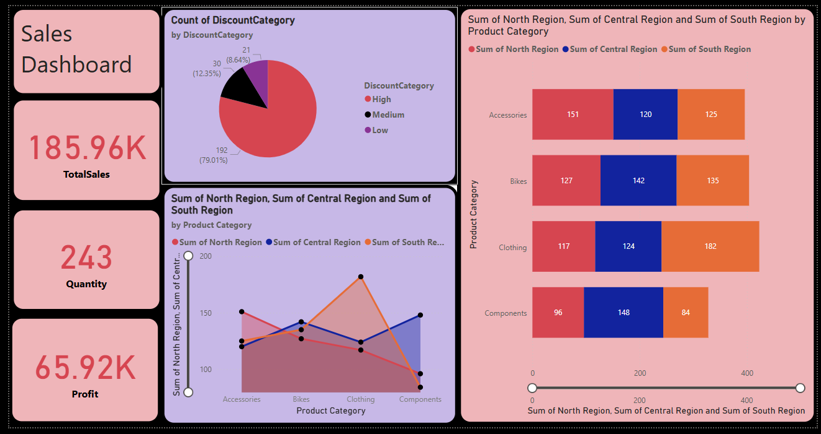

**Create Customer Analysis Dashboard**

**: • Customer-wise sales & profits (Table)**

**• Top 10 Customers (Bar Chart)**

**• Discount Categories (Stacked Bar Chart)**

