Task 1: Understanding Power Query Editor (Data Cleaning & Transformation)
Remove missing values & duplicates.
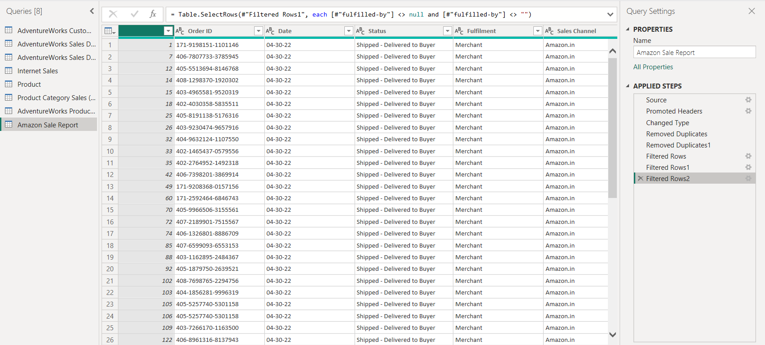

Change data types (e.g., Date, Currency, Categories).
Merge tables based on keys (e.g., Orders & Customers).
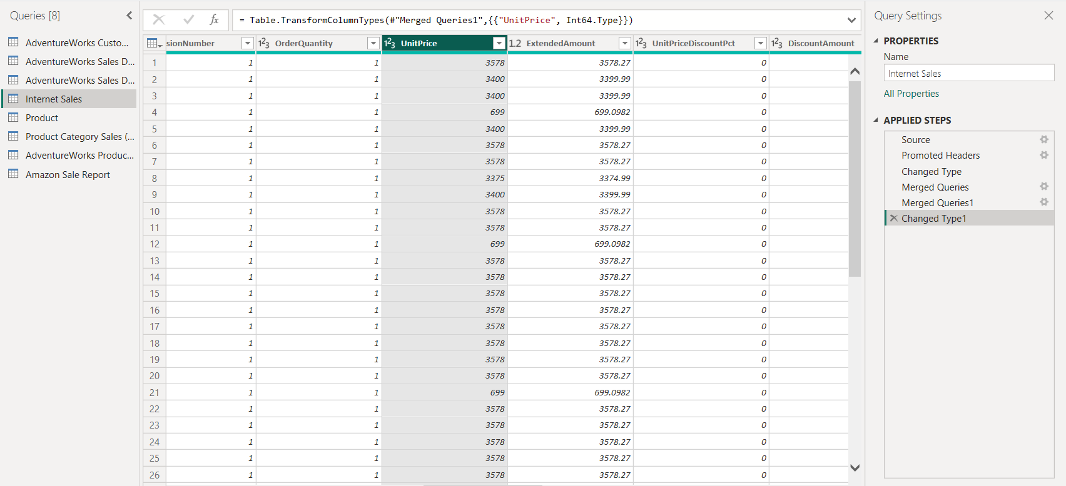

Split full names into first and last names.
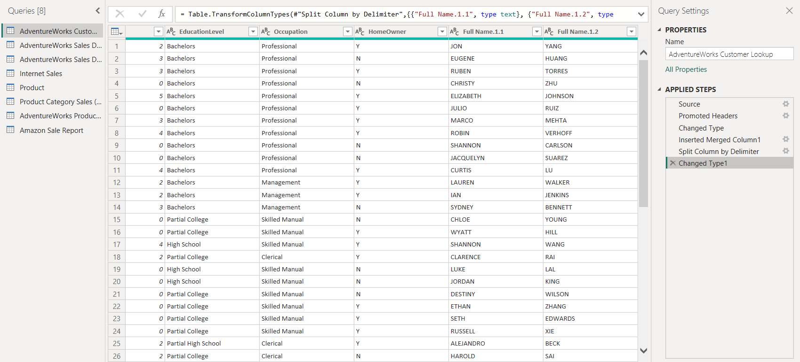

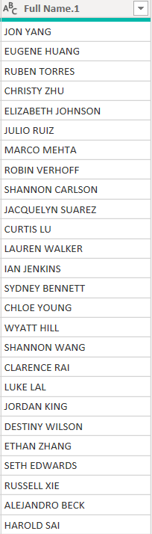

Task 2: Understanding Data & Data Modeling
Star Schema for better performance.
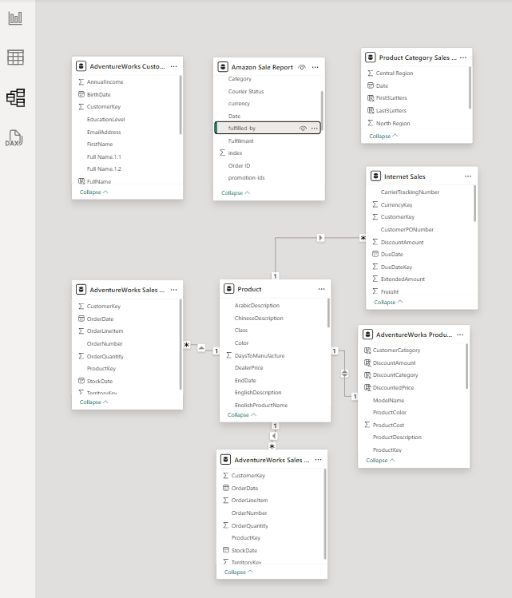

Task 3: Implementing DAX Functions A)
Text Functions
Extract the first 3 letters of Product Category:
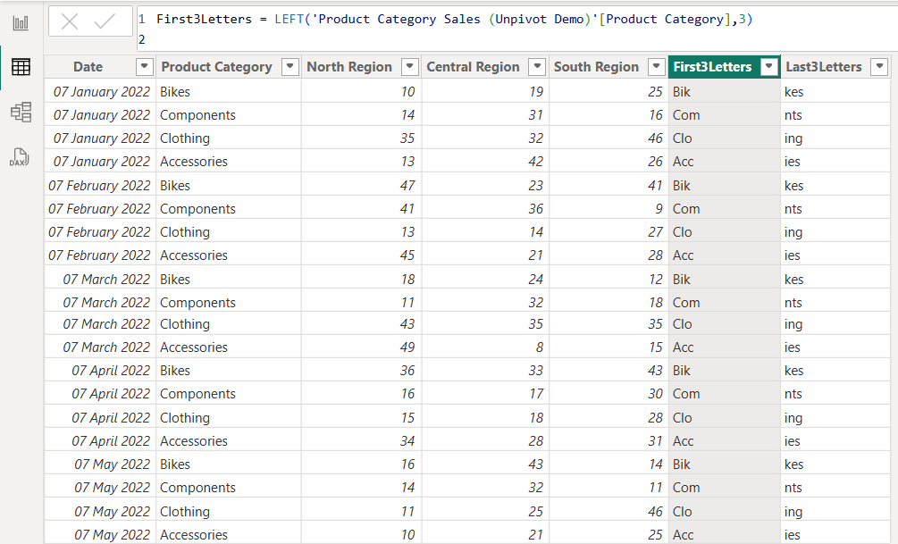
First3Letters = LEFT('Product Category Sales (Unpivot Demo)'[Product Category],3)

Create a full name column from First & Last Names:
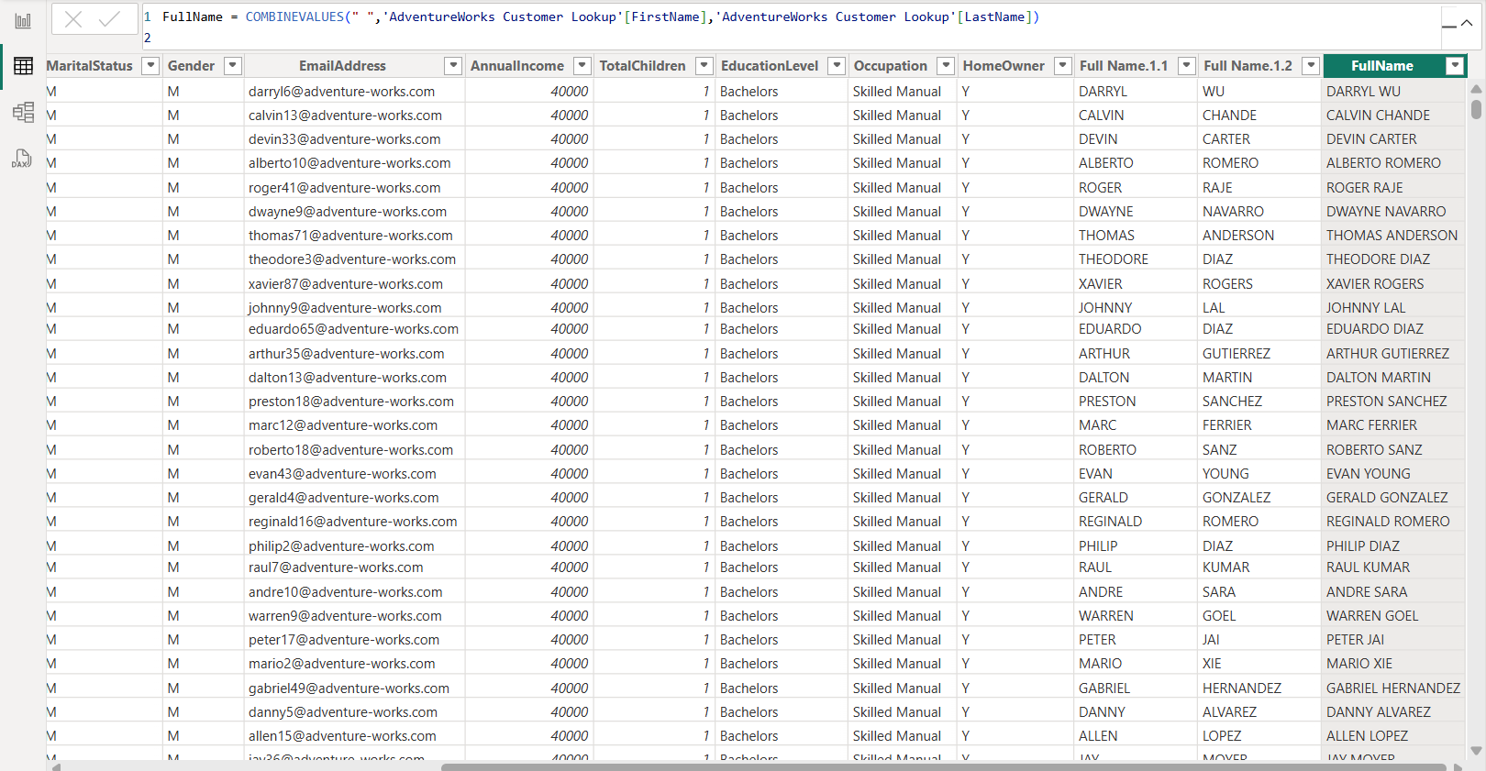
FullName = COMBINEVALUES(" ",'AdventureWorks Customer Lookup'[FirstName],'AdventureWorks Customer Lookup'[LastName])
B) Logical Functions
1. Discount Category: Create a calculated column to categorize discounts
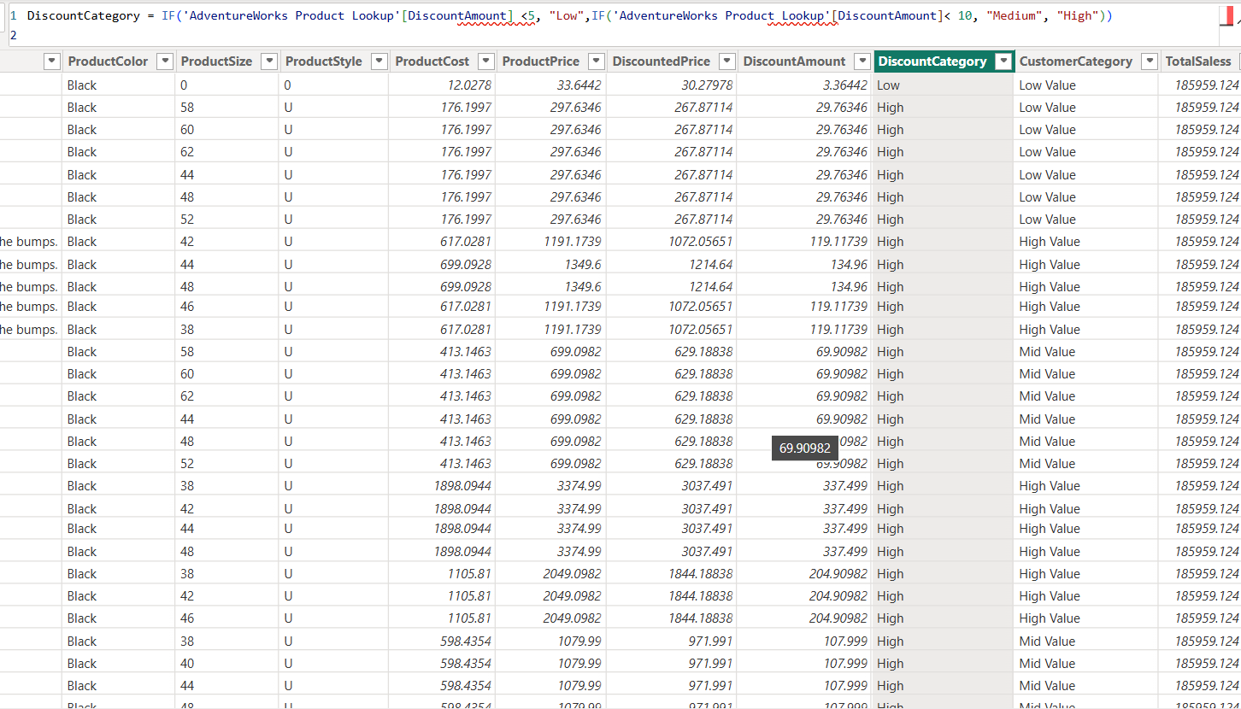
DiscountCategory = IF('AdventureWorks Product Lookup'[DiscountAmount] <5, "Low",IF('AdventureWorks Product Lookup'[DiscountAmount]< 10, "Medium", "High"))
2. High-Value Customers:
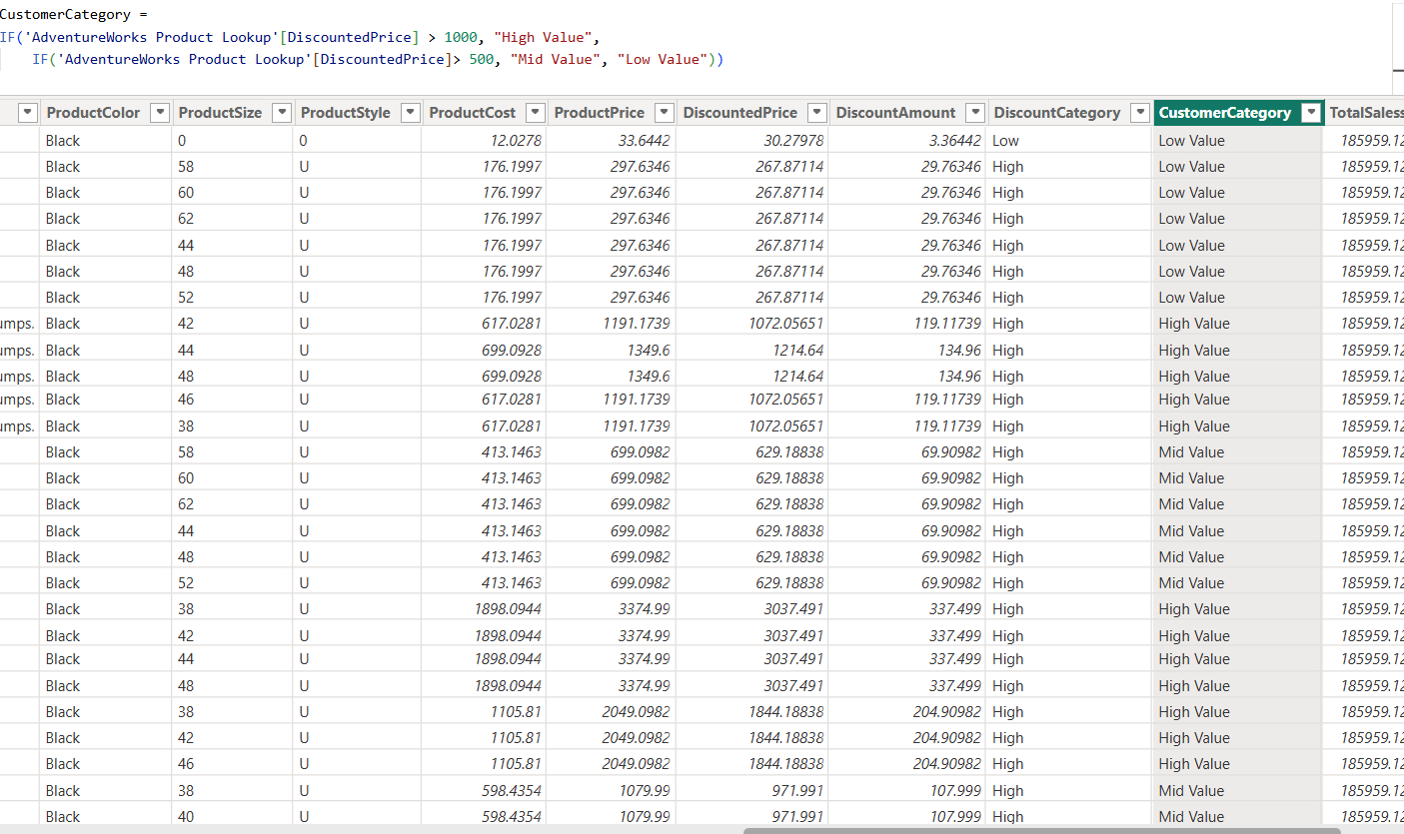
CustomerCategory = IF('AdventureWorks Product Lookup'[DiscountedPrice] > 1000, "High Value",
IF('AdventureWorks Product Lookup'[DiscountedPrice]> 500, "Mid Value", "Low Value"))

Task 4: Data Visualization & Report Creation
Create a Sales Dashboard:
• Total Sales, Profit, and Quantity (Cards)
• Sales Trends over time (Line Chart)
• Sales by Region & Product Category (Bar Chart)
• High-Value vs Regular Customers (Pie Chart)

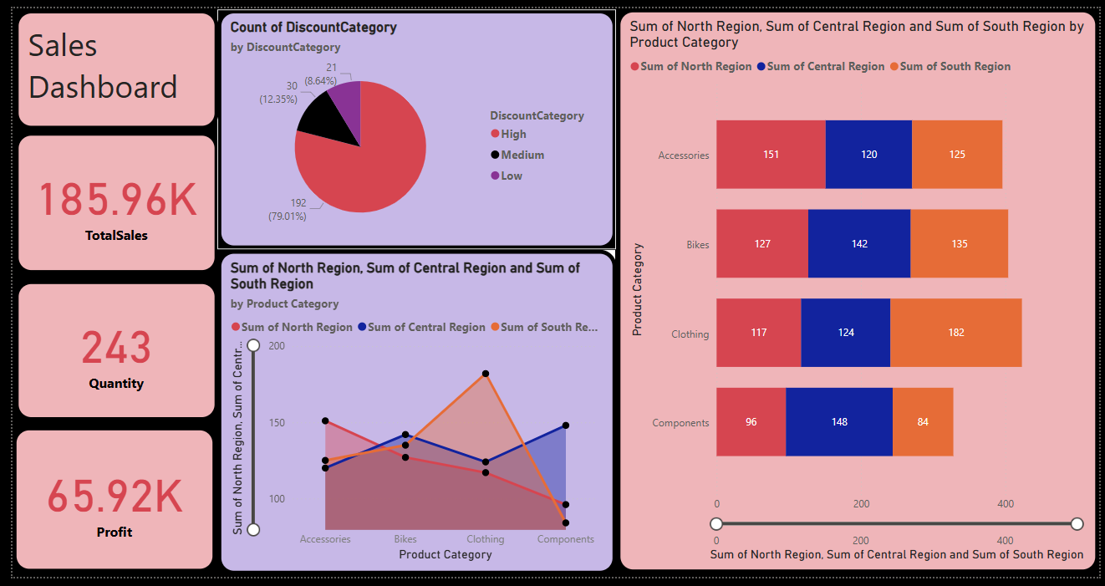

Create Customer Analysis Dashboard
: • Customer-wise sales & profits (Table)
• Top 10 Customers (Bar Chart)
• Discount Categories (Stacked Bar Chart)
