

Project Title:
AI-Powered Personalized Study Planner

Group Members:
- Rehan Asif - 70147344
- Khudija Kashif - 70147016

Submitted to: DR. HAMEDOON
Introduction:
The AI-Powered Personalized Study Planner is a Jupyter Notebook application designed to help students organize and optimize their study schedules using data-driven predictions and automated planning. The system trains a Linear Regression model on historical or synthetic data—including subject difficulty, target marks, and hours studied—to estimate how much time is required for each subject.
Users interact with the planner through an interface built using ipywidgets, where they can add subjects, set goal marks, select difficulty levels, and define their available study hours for each day of the week. Once the inputs are provided, the application breaks the predicted study time into one-hour blocks and distributes them across a 14-day schedule based on the user’s availability.
To support real-world usage, the planner includes Google Calendar integration, allowing users to export the generated study schedule directly into their calendar as individual events.

Technologies Used
The project is built using a Python-based data science stack. Scikit-learn is used to implement the Linear Regression model, while Pandas and NumPy handle data processing and synthetic dataset generation. The interactive interface is created using ipywidgets, enabling sliders, buttons, and input fields within the notebook.
For calendar synchronization, the project uses the Google APIs Client Library along with Google Auth to manage OAuth2 authentication and event creation. Scheduling logic is handled using Python’s datetime module, and Matplotlib and Seaborn are included for optional data visualization.
- AI-Based Study Time Prediction
Estimates required study hours based on subject difficulty and performance goals.
- Personalized Weekly Scheduling
Allows users to define daily study start times and available hours.
- Interactive Notebook Dashboard
Enables subject management and schedule generation without manual coding.
- Google Calendar Synchronization
Automatically exports study sessions as calendar events.
- Automatic Data Generation
Creates dummy training data when no prior dataset is available.

Flow Diagram:
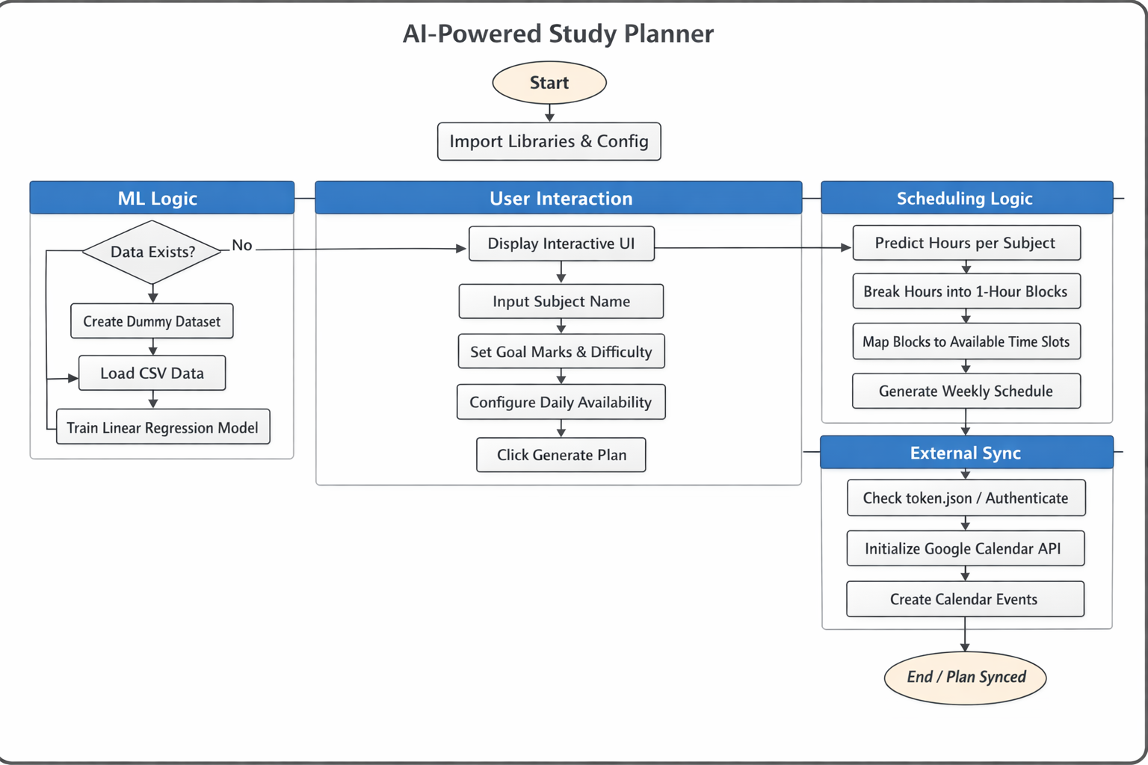

Project Code:
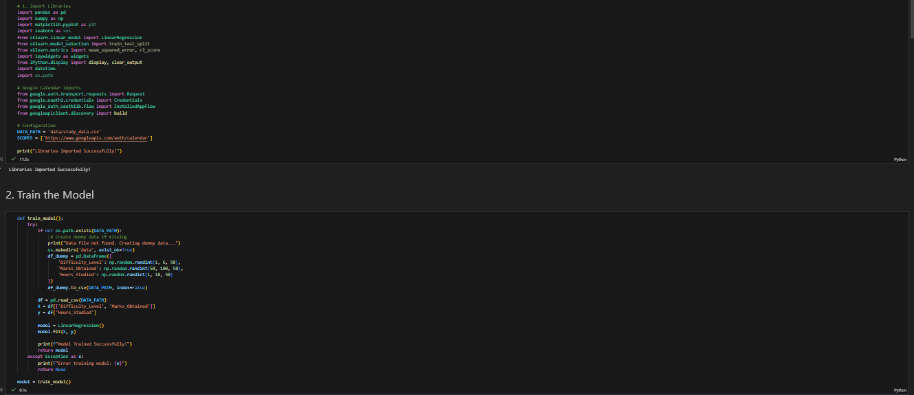

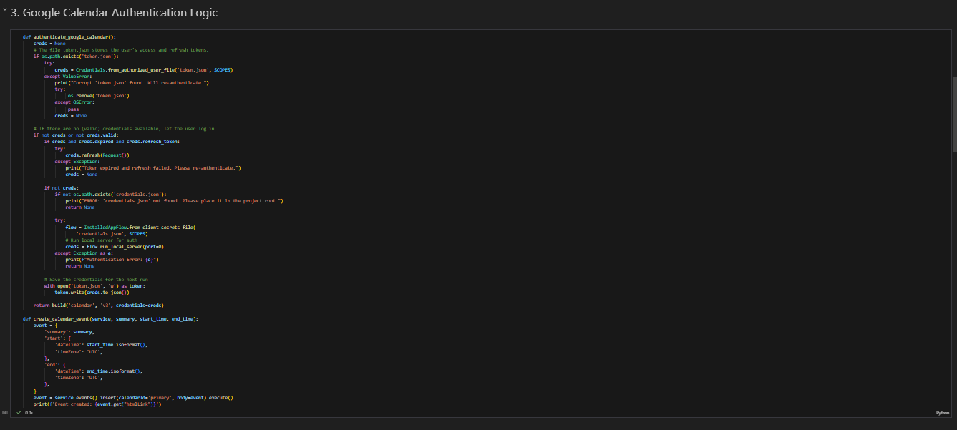

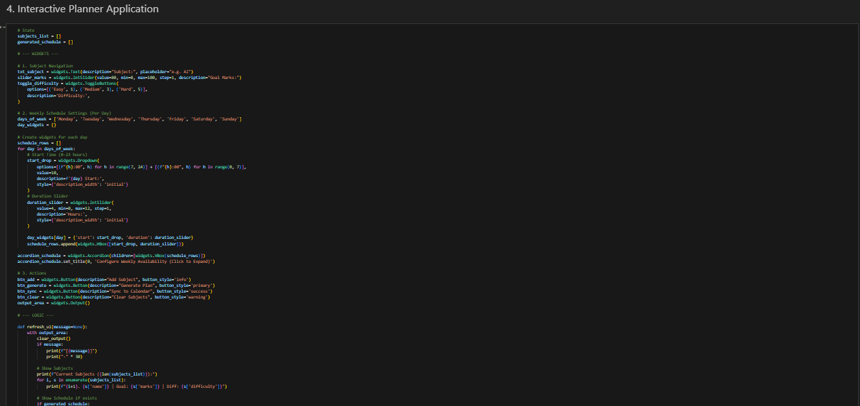

Output panel:
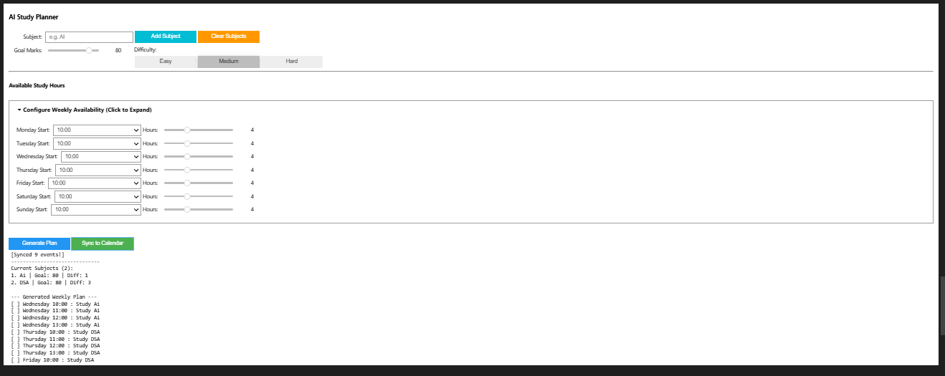

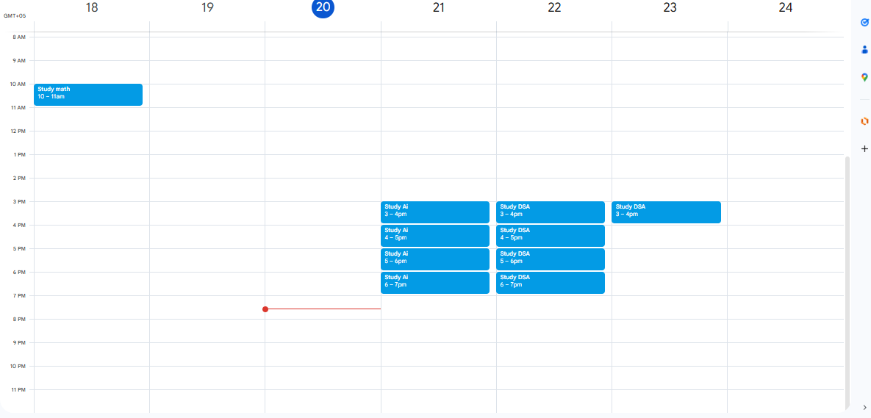

Scope of Work
The scope of this project focuses on designing and implementing an AI-assisted study planning system within a Jupyter Notebook environment. The system aims to convert academic goals into a structured and realistic study schedule using machine learning and automation.
The project includes the following components:
- Development of a Linear Regression–based machine learning model to predict required study hours based on subject difficulty, target marks, and past study data.
- Automatic generation of synthetic training data when historical data is unavailable to ensure the system remains functional.
- Creation of an interactive user interface using ipywidgets for subject input, goal setting, and weekly availability configuration.
- Implementation of study schedule generation logic that breaks predicted study hours into one-hour blocks and allocates them across a 14-day period based on user availability.
- Integration with Google Calendar using OAuth2 authentication to export generated study sessions as calendar events.
- Handling of capacity limitations, including alerts when the total study load exceeds the user’s available time.
GitHub repository Link:
https://github.com/RehanAsif02/AI-Powered-Personalized-Study-Planner.git

