Object Oriented Programming Project

Rehan Ayub 24I-0631
Raja Moiz Khalid 24I-0674
Section CS-B

The Galaxy War

Overview and motivation
In an era where space exploration captures our collective imagination, we present Galaxy Wars, a thrilling 2D space survival game that merges the excitement of arcade-style combat with the elegance of object-oriented design. This project is the true representation of our skills and journey into the vast universe of C++ programming language where every class, every object and every single line of code is true definition of structured programming, thinking and creative problem-solving.

Its main core is that Galaxy Wars creates a challenging environment for players to defend their spaceship against relentless waves of enemies and deadly asteroids and while collecting the resources you may risk you life and in that process you can have the use to loss your life as well. The game intensity is increased to such an extent through three distinct difficulty levels, each testing the player’s reflexes, strategy, and also the determination to be shown that how to survive in an unending space of death.
What motivated us to embark on this ambitious project was the opportunity to transform abstract programming concepts into tangible, interactive experiences. We wanted to demonstrate that Object-Oriented-Programming is not merely theoretical framework- it is a powerful too that gives birth to the digital worlds. Through this game, we have implemented inheritance to show the chain of the enemies and their family system, polymorphism that handles dynamic combat scenarios, and encapsulation that protects the integrity of game mechanics.

Beyond the technical achievements, Galaxy Wars also represents our passion for game development and also our dedication to create a competitive environment and pressure that can felt to every player. Every powerup collected, every enemy defeated, and every level conquered reflects countless hours of design decisions, debugging sessions and creative iterations. This project is not just an assignment, it is a testament to what can be achieved when programming principles meet creative vision and we are excited to share this interstellar adventure with you.

Class diagram
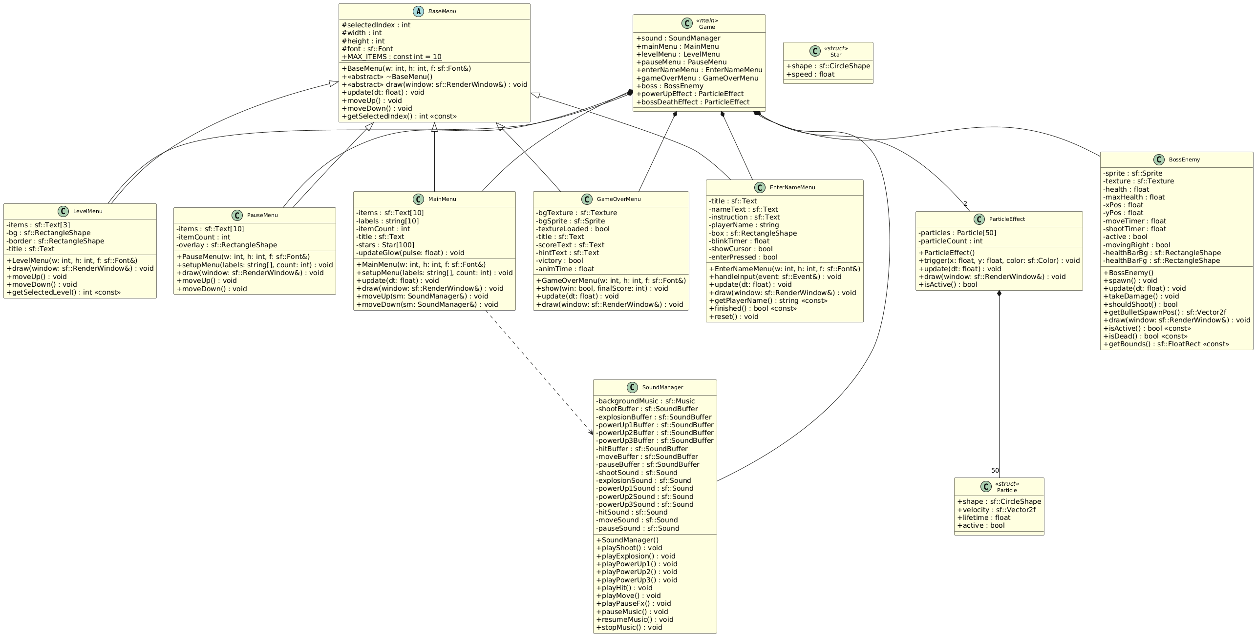

Mapping of OOP concepts to implemented features
This project uses many core object-oriented programming concepts to structure the Galaxy War game. The code is divided into logical classes that each handle a specific responsibility, and these classes work together to create the full gameplay experience.
Classes, Objects and Encapsulation
The game is built around several main classes: ParticleEffect, BossEnemy, SoundManager, BaseMenu, MainMenu, LevelMenu, PauseMenu, GameOverMenu, EnterNameMenu, Score, Score Manager, and File Exception. Each of these classes represents a real component of the game, such as the boss enemy, the sound system, the different menus, or the file handling system. Inside each class, the important data is kept private and is only accessible through public functions. For example, Boss Enemy keeps its health, position, timers, and active status as private variables, and provides functions like spawn(), update(), take Damage(), is Active(), and get Bounds() to interact with it. Similarly, the Score class encapsulates player name, points, and date as private members, exposing only what's needed through public methods. This use of classes and encapsulation makes the code easier to manage and protects the internal state of each game component.
Inheritance, Abstraction and Polymorphism
The different menus in the game are a clear example of inheritance and abstraction. There is a base class called Base Menu that stores common information such as the window width and height, the selected item index, and the font. It also declares virtual functions like update(float dt) and a pure virtual draw(sf::RenderWindow& window). This makes Base Menu an abstract class which defines the general idea of a menu but does not know how each specific menu looks. Classes like Main Menu, Level Menu, Pause Menu, Game Over Menu, and Enter Name Menu inherit from Base Menu and override the draw() function, and some also override update() and movement functions. Thanks to virtual functions, the correct draw() and update() methods are called at runtime depending on which specific menu object is being used. This is an example of dynamic polymorphism: the same interface (like draw) behaves differently for each derived class, while the main game code can still treat them as menus.
Composition and Aggregation
Composition is used heavily to build complex objects from simpler pieces. Boss Enemy contains its own sprite, texture, health bar background and foreground rectangles, and all related data needed to represent the boss on screen. Particle Effect contains an array of 50 Particle structs, where each particle has a shape, velocity, lifetime, and active flag. The menus also contain multiple SFML objects such as sf::Text, sf::RectangleShape, sf::Sprite, and even starfield data in the case of Main Menu. The Score Manager class aggregates Score objects and file handling functionality. At a higher level, the main game function creates and owns objects like Sound Manager, all the menu classes, Boss Enemy, Score Manager, and multi-Particle Effect instances. The game loop then coordinates all of these objects. This "has-a" relationship between objects is composition when the lifetime is tightly bound, and aggregation when the game simply uses an object like Sound Manager without it logically being part of one specific menu or entity.
Operator Overloading
The Score class demonstrates practical operator overloading for comparing and outputting score data. We implemented the greater-than operator (operator>) and less-than operator (operator<) to compare two Score objects based on their point values, which makes sorting the high score list intuitive and natural. Instead of writing separate comparison functions, we can directly use expressions like score1 > score2 in our sorting logic. Additionally, we overloaded the output stream operator (operator<<) to allow Score objects to be written directly to file streams using the familiar syntax file << score Object. This operator formats the score data into a properly delimited string that can be saved to the high scores file. This use of operator overloading makes the code more readable and expressive while maintaining the object-oriented principle of encapsulating score-related behavior within the Score class itself.
Friend Functions
The implementation of operator<< for the Score class required the use of friend functions. Since this operator needs to access the private member variables (player name, points, and date) to write them to an output stream, we declared it as a friend function of the Score class. Friend functions have special permission to access private and protected members even though they are not member functions themselves. This is a standard C++ pattern for implementing stream operators: the function maintains the natural stream << object syntax while still respecting encapsulation by keeping Score's data members private. Without friend functions, we would have to either make all Score data public (breaking encapsulation) or create verbose getter methods just for file output purposes.
Exception Handling with Custom Exception Class
To handle file operation errors gracefully, we created a custom File Exception class that inherits from or wraps standard exception behavior. This class stores descriptive error messages specific to file operations in our game, such as "high scores file not found" or "corrupted save data detected". Throughout the file handling code in Score Manager, we use try-catch blocks to protect against runtime errors. When opening files for reading or writing, if an operation fails, we throw a File Exception with a meaningful message. The catch blocks handle these exceptions by logging errors, notifying the player if appropriate, and allowing the game to continue with default values or by creating new files. This demonstrates both the creation of custom exception classes and the practical application of exception handling to make the program more robust and fault-tolerant.
File Handling (Text and Binary)
The game implements both text-based and binary file handling for different purposes. For high scores, we use a text file (highscores.txt) that stores the top fifty player scores in a human-readable format. Each line contains a player name, score, and date separated by delimiters. The Score Manager class provides methods to read this file into memory, add new scores, sort them using the overloaded comparison operators, trim the list to fifty entries, and write it back. Text files are easy to debug and can be opened in any text editor, making them suitable for high score tables. For game save/load functionality, we optionally implemented binary file handling which writes the complete game state (level, score, lives, active powerups) directly to disk in binary format using write() and read() operations. Binary files are more compact and faster to process than text files, though they are not human-readable. Both implementations include exception handling to deal with missing files, permission errors, and corrupted data.
Function Overloading
Function overloading is demonstrated in several places throughout the code. The Score Manager class provides multiple versions of the save Scores() function: one that takes a filename parameter, and another that uses a default filename. Similarly, the Score class constructor is overloaded to accept different combinations of parameters, allowing scores to be created with or without a date value. Menu classes also use overloaded constructors that can accept different initialization parameters. This demonstrates how function overloading allows us to provide flexible interfaces while keeping function names meaningful and consistent.
Static Members and Persistent Game State
The project uses static members in multiple ways. First, the Base Menu class defines a static const int MAX_ITEMS = 10, which is shared by all menus derived from Base Menu and represents the maximum number of menu items. Second, inside the main game section of Game.cpp, many variables are declared as static so that they keep their values between frames. These include static bool loaded, static int lives, static int score, static textures and sprites, and large arrays for bullets, enemies, boss bullets, wingmen, and powerup sprites. Timer such as fire Timer, spawn Timer, double Fire Timer, shield Timer, slow Motion Timer, wingmen Timer, and boss Death Timer are also static, which lets them smoothly accumulate time across the game loop. This use of static variables gives persistent state without global variables or a separate Game class.
Const Correctness
Const correctness is applied to clearly separate "read-only" functions from those that modify objects. For example, the Boss Enemy class has methods like bool is Active() const, bool is Dead() const, and sf::FloatRect get Bounds() const. These functions are marked const, which means they do not change any internal member variables. Similarly, menu classes use const in getter functions like int get Selected Index() const, int get Selected Level() const, std::string get Player Name() const, and bool finished() const. The Score class comparison operators are also declared const since they only read values for comparison. This makes the code safer and clearer because it is obvious which functions are just reading state and which ones can change it.
Dynamic Behavior Through Arrays and Object Pooling
Because STL containers are not allowed, the project uses fixed-size arrays combined with Boolean flags to manage many game objects. For example, bullets are stored in Sprite bullets[MAX_BULLETS] with a matching bool bullet Active[MAX_BULLETS], and the same pattern is repeated for enemies, boss bullets, and wingmen bullets. When the game needs a new bullet or enemy, it looks for an inactive slot in the array, initializes it, and marks it active. When the object goes off-screen or collides, it is marked inactive again. This pattern is a manual form of object pooling and shows careful handling of multiple objects without dynamic containers. A similar idea appears in Particle Effect, where an array of particles is reused every time the effect is triggered instead of creating and destroying particles each time. The Score Manager also uses a fixed array to store the top fifty scores, managing them manually without vectors or lists.
Menus, Game States and Event-Driven Design
The design of Game.cpp works like a state machine using simple Boolean flags such as in Main Menu, in Level Menu, in Enter Name, in Game, is Paused, and in Game Over. Depending on which flags are true, different menu objects are updated and drawn, and different event-handling logic is active. For example, in the main menu state, keyboard arrows move the selection and Enter chooses a menu item; in the name entry state, text input events update the player name; in the game state, the same keys control the ship and fire bullets. This event-driven structure, combined with menus implemented as separate classes, demonstrates how object-oriented design can organize complex screen flows and user interactions in a clear way.
Use of Namespaces and Virtual Destructors
The code uses the sf namespace from SFML to simplify types like sf::Sprite, sf::Render Window, and sf::Text, and in Game.cpp it brings this into scope with using namespace sf;. The Base Menu class defines a virtual ~Base Menu() = default;, which is a virtual destructor. This is an important OOP practice when using inheritance, because it ensures that if a menu is ever deleted through a base class pointer, the correct derived destructor will be called. Even though dynamic allocation is not used here for menus, this shows awareness of safe polymorphic destruction.
Visual Effects and Behavior Encapsulation
The Particle Effect and Boss Enemy classes are good examples of encapsulating complex behavior inside a single object. Particle Effect hides all the details of generating random directions, speeds, sizes, lifetimes, and fading alpha values when an explosion or powerup effect is triggered. The rest of the game only needs to call trigger(x, y, color), then update(dt) and draw(window). Similarly, Boss Enemy encapsulates its own horizontal movement logic, health updates, shooting timer, death state, and health bar rendering. The Score Manager encapsulates all file I/O logic and exception handling, so the main game loop doesn't need to know about file formats or error recovery. From the game loop's point of view, interacting with these systems is as simple as calling high-level methods. This is a practical use of encapsulation and abstraction to keep the main loop readable while still supporting rich behavior.

Screenshots of gameplay all levels and GUI

Main Menu
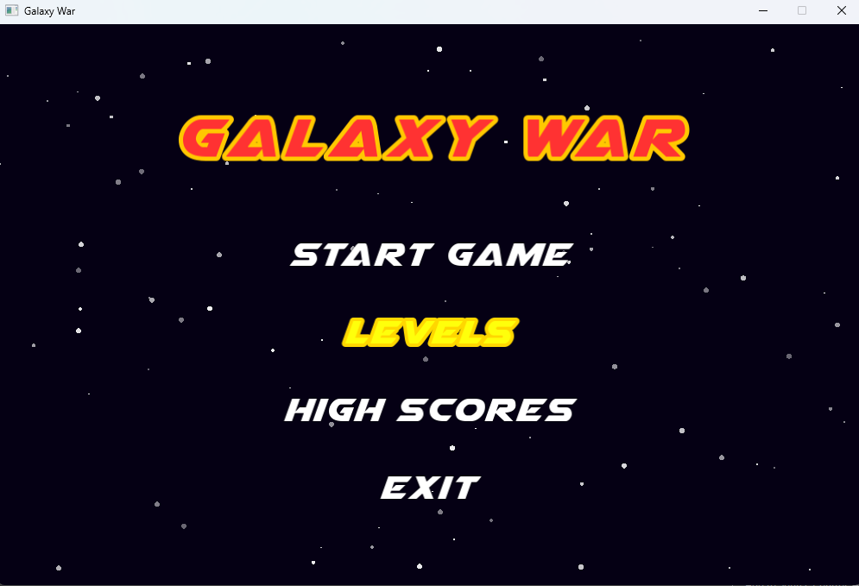
Level Menu
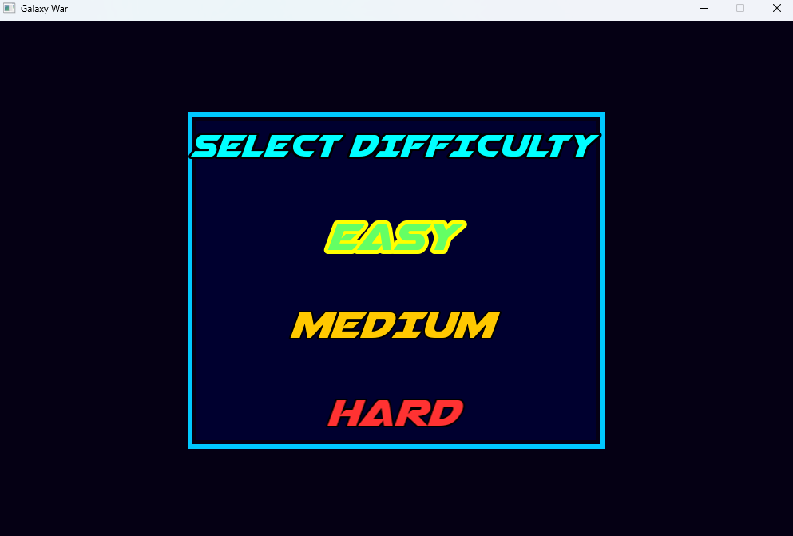
Pause Menu
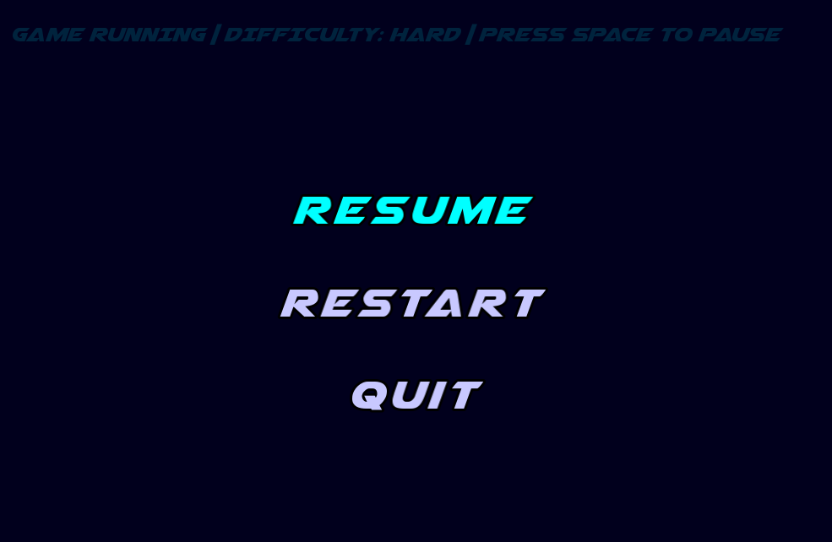

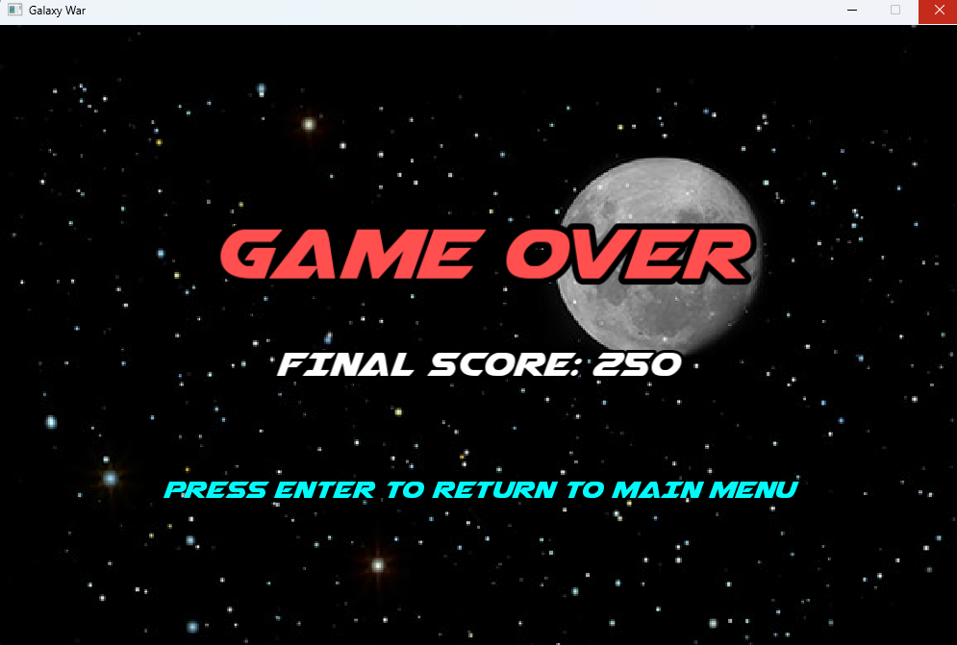

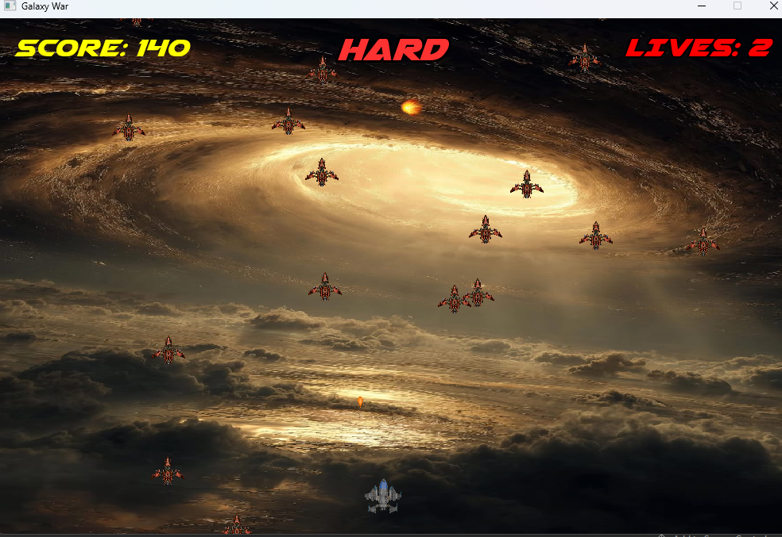

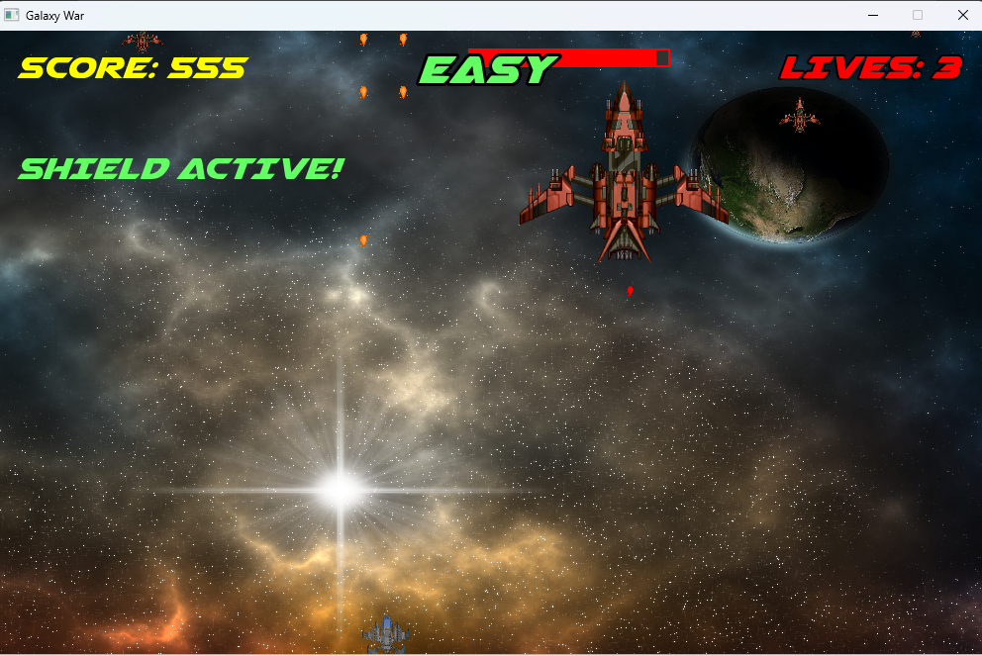

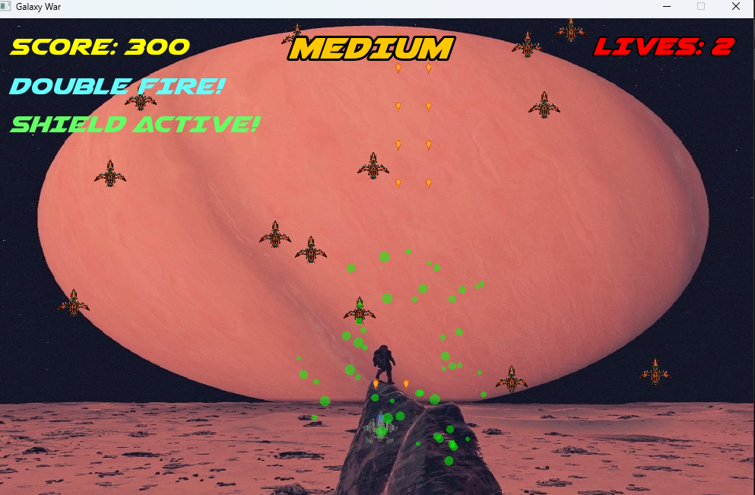

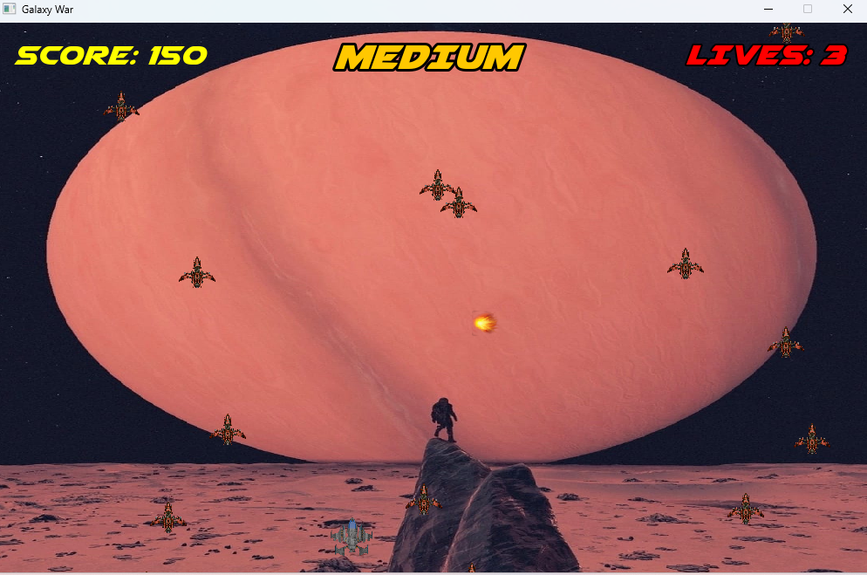

Challenges faced and how they were solved
Throughout the development of Galaxy Wars, we encountered several technical and design challenges that required careful problem-solving and iterative refinement. Each challenge taught us valuable lessons about game architecture and object-oriented design.
Challenge 1: Managing Multiple Power-Up Systems with Timed Effects
One of the earliest challenges was implementing three different power-ups (double fire, shield, and wingmen squadron) that each had different durations and visual effects. The difficulty was keeping track of which power-ups were active, how long they had been running, and ensuring they deactivated at the right time without interfering with each other. We solved this by creating separate Boolean flags and timer variables for each power-up: doubleFireActive with doubleFireTimer, shieldActive with shieldTimer, and wingmen Active with wingmen Timer. Each power-up spawns at specific score milestones (100, 200, and 300 points respectively), and during the game loop we increment the timers using delta time and check if they exceed their duration limits. When a timer expires, we simply set the corresponding active flag to false. This clean separation of state made the system manageable and easy to debug.
Challenge 2: Creating a Dynamic Health Bar for the Boss Enemy
Displaying the boss's health in real-time required more than just a number. We wanted a visual health bar that moved with the boss and accurately reflected damage taken. The solution involved using two sf::RectangleShape objects inside the Boss Enemy class: one for the background bar and one for the foreground that shrinks as health decreases. Every time update() is called, we recalculate the health percentage by dividing current health by maximum health, then adjust the foreground bar's width accordingly. The bars are also repositioned relative to the boss sprite's position so they move smoothly with the boss across the screen. To add more visual feedback, we implemented a red flashing effect when the boss health drops below thirty percent, which uses a simple timer-based modulo calculation to toggle the sprite color between red and white.
Challenge 3: Implementing the Wingmen Squadron Feature
The third power-up, wingmen squadron, was particularly complex because it required spawning ten allied ships that needed to stay positioned around the player and fire their own bullets independently. The positioning challenge was solved by calculating horizontal spacing based on the wingman sprite width and arranging five ships on the left and five on the right of the player. We update their positions every frame to follow the player's movement. For the firing system, we created separate arrays wingmenBullets[] and wingmenBulletActive[], similar to the player's bullets but with their own fire timer. Every 0.4 seconds, all ten wingmen fire simultaneously by looping through each wingman and finding an inactive bullet slot. Collision detection for wingmen bullets works the same way as player bullets, checking intersections with enemies and the boss, which keeps the code consistent and maintainable.
Challenge 4: Handling Different Backgrounds for Each Difficulty Level
We wanted each difficulty level (Easy, Medium, Hard) to have its own unique background image to give visual variety and reinforce the difficulty setting. The challenge was that backgrounds couldn't simply be loaded once at startup because the player can switch difficulty levels from the level menu. Our solution uses a variable last Bg Difficulty to remember which background is currently loaded. Every frame, we check if selected Difficulty has changed compared to last Bg Difficulty. If it has, we load the new background texture file, reset the sprite's texture, and recalculate the scale to fit the window dimensions properly. We also added error handling: if a background file fails to load, the game falls back to the default background and prints a console warning rather than crashing. This ensures the game remains playable even if an image file is missing.
Challenge 5: Resetting Game State When Restarting or Changing Levels
One of the trickiest bugs we encountered was that restarting the game or changing difficulty levels would carry over old bullets, enemies, scores, and power-up states from the previous session. This created confusing gameplay where enemies appeared immediately or the score started at a random value. To fix this, we introduced a resetGameState flag that gets set to true whenever the player starts a new game or restarts. When this flag is true, we reset all critical variables: lives, score, all active flags for bullets, enemies, boss bullets, wingmen bullets, power-ups, timers, and the boss state. We also reset the player's position and force the background to reload by setting last Bg Difficulty to negative one. Only after everything is cleaned up do we set reset Game State back to false. This centralized reset logic ensures every new game starts from a completely clean slate.
Challenge 6: Synchronizing Sound Effects with Gameplay Events
We wanted sound effects to play exactly when actions happened, like shooting, hitting enemies, collecting power-ups, or taking damage. The challenge was avoiding redundant sound playback and ensuring sounds didn't overlap annoyingly. We solved this by creating the Sound Manager class that loads all sound buffers once at startup and provides simple methods like playShoot(), playExplosion(), playPowerUp1(), etc. The game loop calls these methods at the exact moment an event occurs: when a bullet is fired, when a collision is detected, or when a power-up is collected. For movement sounds, we added a static moving flag to prevent the move sound from restarting every frame while the key is held down. This gave us precise control over audio timing and made the game feel much more responsive and polished.

Explanation of exception handling and file I/O
To ensure robust data persistence and error management in Galaxy Wars, we implemented a comprehensive file handling system with custom exception handling. This system manages high score storage and provides graceful error recovery when file operations fail.
Custom Exception Class
We created a custom File Exception class to handle file-related errors in a structured way. This class encapsulates error messages and provides a clean interface for reporting what went wrong during file operations. The exception stores a descriptive message string that explains the specific nature of the error, such as "file not found," "permission denied," or "corrupted data format." By defining our own exception class rather than relying on generic system exceptions, we can provide more meaningful error messages that are specific to our game's file handling needs and make debugging much easier during development.
Exception Handling Implementation
Throughout the file handling code, we use try-catch blocks to protect against runtime errors. When attempting to open a file for reading or writing, the operation is wrapped in a try block. If the file cannot be accessed—perhaps because it doesn't exist yet, the path is incorrect, or the system denies permission—a File Exception is thrown with an appropriate error message. The corresponding catch block then handles this exception gracefully: instead of crashing the game, we log the error to the console, notify the player if necessary, and allow the game to continue running with default values or by creating a new file. This defensive programming approach ensures that file errors never interrupt gameplay or cause the application to terminate unexpectedly.
Text File Handling for High Scores
The game stores the top fifty high scores in a plain text file called highscores.txt. Each line in this file contains a player's name, their score, and the date they achieved it, separated by delimiters for easy parsing. When a player finishes a game, the system reads all existing scores from the file into memory, adds the new score to the collection, sorts the scores in descending order (highest to lowest), keeps only the top fifty entries, and writes the updated list back to the file. This sorting mechanism uses operator overloading on the Score class: we defined comparison operators like operator> and operator< so that Score objects can be compared directly based on their point values. This makes the sorting logic clean and intuitive.
Operator Overloading in the Score System
The Score class demonstrates several types of operator overloading. The greater-than operator (operator>) compares two scores by checking if one player's points exceed another's, which is essential for sorting the high score list. We also implemented the output stream operator (operator<<) as a friend function, allowing Score objects to be written directly to file streams using the familiar << syntax. This operator formats the score data into a single line with proper delimiters, making file writing code much simpler and more readable. Without operator overloading, we would need separate comparison functions and manual formatting logic scattered throughout the code, but with overloaded operators, the sorting and file writing operations look natural and expressive.
Friend Functions for File I/O
The operator<< for the Score class is declared as a friend function because it needs access to the private member variables (player name, points, date) to write them to the output stream. Friend functions are allowed to access private and protected members of the class, which is necessary here since we want to keep the Score data encapsulated but still allow convenient file output. This is a standard C++ idiom for implementing stream operators: the function is not a member of the Score class itself, but it has special permission to access its internals. This design maintains encapsulation while providing clean syntax for file operations.
Error Recovery and Graceful Degradation
When the high scores file cannot be read—perhaps on the first launch of the game when the file doesn't exist yet—the exception handling system creates a new empty file instead of failing. Similarly, if the file contains corrupted data that cannot be parsed correctly, we skip the invalid entries and load whatever scores are readable, then write back a corrected version of the file. This ensures that the game always has valid high score data available and that one bad entry doesn't invalidate the entire file. The console logs all file operations and any errors encountered, which helps with debugging during development and troubleshooting if players report issues.
Binary File Handling for Save/Load (Optional Extension)
As an optional enhancement, we also implemented binary file handling for saving and loading game progress. Unlike text files, binary files store data in a compact format that matches the exact memory representation of our game state variables. When saving, we write the player's current level, score, lives, active powerups, and other state information directly to a binary file using write() operations on an of stream opened in binary mode. When loading, we read these bytes back and reconstruct the game state exactly as it was. Binary files are faster to read and write than text files, and they are harder for players to manually edit (which prevents cheating), but they are also less human-readable and more sensitive to changes in data structure. We included exception handling here as well to detect corrupted save files and prevent the game from loading invalid state.
Integration with the Game Loop
The file handling system integrates seamlessly with the rest of the game. When the Game Over screen appears, the system automatically checks if the player's score qualifies for the high score list, and if so, it updates the file. Players can view the high scores from the main menu, which triggers a file read operation. All of these operations happen in the background without blocking gameplay or causing delays, and thanks to the exception handling, any file errors are handled invisibly so the player experience remains smooth. This demonstrates how file I/O and exception handling work together to create a robust and professional game system that manages persistent data reliably.

