WEEK 4 TASK
Predictive Modeling and Optimization in Logistics Systems
Forecasting last-mile delivery time and using the forecasts to cut fleet time and SLA risk

1. Executive Summary
This report builds a machine-learning model that predicts delivery time in minutes for last-mile routes, then uses the predictions to drive three operational optimizations. Because no real company data was provided, the data is simulated (Section 3) with realistic relationships between distance, stops, vehicle type, weather and traffic. All numbers below come from code that was actually run on that data.
Headline result | Value
Best model (tuned Gradient Boosting): test RMSE | 9.5 min
Test MAE / R-squared | 7.1 min / 0.895
Predictions within 10 minutes of the actual time | 76.4%
Two biggest drivers (distance + number of stops) | 77.3% of importance
Optimization A: predictive driver-job matching | 7.3% less total fleet time
Optimization B: shifting flexible departures | 6.8% less predicted time (4.7 min per job)
Optimization C: SLA risk flagging (120 min promise) | 91.1% of breaches caught

2. Problem Definition
A regional courier runs three warehouses (North, South, East) and dispatches bikes, vans and trucks on multi-stop delivery routes. Dispatchers currently estimate route duration by rule of thumb, which leads to three recurring problems:
- Drivers and vehicles are matched to routes without regard to how long each pairing will actually take.
- Flexible deliveries are sent out during peak traffic when a nearby off-peak slot would be faster.
- Customers are given delivery promises that are too tight or too loose, causing SLA breaches or wasted buffer.
Prediction target: delivery_time_min, the total time in minutes from the vehicle leaving the warehouse until the last stop on the route is completed. This is a continuous regression problem.
Why this metric: route duration feeds directly into labour cost, vehicle utilisation and on-time performance, so an accurate forecast supports every downstream decision in this report.

3. Dataset Description (Simulated)
The dataset contains 6,000 historical routes. The target averages 67.6 minutes (standard deviation 29.0, range 6.6 to 296.5). About 120 traffic readings were deliberately removed to mimic sensor gaps.
Feature | Type | Description
distance_km | Numeric | Total route distance
num_stops | Numeric | Number of delivery stops (1 to 25)
package_weight_kg | Numeric | Total package weight, right-skewed
hour_of_day | Numeric | Departure hour (07 to 20)
traffic_index | Numeric | Congestion score 1 to 10 (higher is worse); has missing values
driver_experience_yrs | Numeric | Years of driver experience (0 to 12)
weather | Categorical | clear, rain or storm
vehicle_type | Categorical | bike, van or truck
warehouse | Categorical | WH_North, WH_South or WH_East (differ in loading delay)
day_of_week | Numeric | Used to derive is_weekend
delivery_time_min | Target | Route duration in minutes

The target is generated as driving time (distance divided by a speed that falls with traffic and bad weather and rises with experience) plus service time at stops (scaled by package weight and vehicle type), plus a warehouse delay and noise that grows with route length. This gives the data realistic non-linear interactions, for example, bad weather hurts long routes far more than short ones.
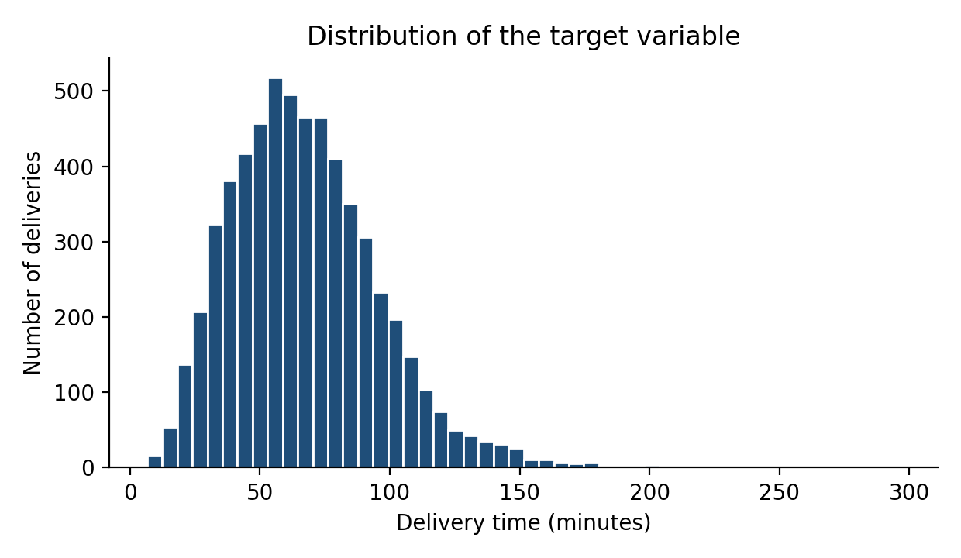
Figure 1. The target is right-skewed: most routes take 40 to 90 minutes, with a long tail of multi-hour routes.

Simulation code (excerpt)
def simulate(n=6000):
df = pd.DataFrame({
"distance_km": RNG.gamma(3.0, 3.0, n).clip(0.5, 45),
"num_stops": RNG.integers(1, 26, n),
"package_weight_kg": RNG.lognormal(1.2, 0.7, n).clip(0.2, 60),
"hour_of_day": RNG.integers(7, 21, n),
"weather": RNG.choice(["clear","rain","storm"], n, p=[.70,.24,.06]),
"vehicle_type": RNG.choice(["bike","van","truck"], n, p=[.30,.50,.20]),
"driver_experience_yrs": RNG.uniform(0, 12, n),
"warehouse": RNG.choice(["WH_North","WH_South","WH_East"], n),
# day_of_week omitted here for brevity
})
peak = (df.hour_of_day.between(8,10) | df.hour_of_day.between(17,19)).astype(int)
df["traffic_index"] = (3 + 4*peak + RNG.normal(0, .9, n)).clip(1, 10)

speed = df.vehicle_type.map({"bike":17, "van":28, "truck":24}).astype(float)
speed *= (1 - 0.055*(df.traffic_index - 1))
speed *= df.weather.map({"clear":1.0, "rain":0.85, "storm":0.62})
speed *= (1 + 0.012*df.driver_experience_yrs)
drive = df.distance_km / speed * 60
service = df.num_stops * (2.2 + 0.03*df.package_weight_kg)
df["delivery_time_min"] = drive + service + warehouse_delay + noise
return df

4. Data Preparation
Preparation follows four steps. Missing traffic values are imputed with the median inside a scikit-learn pipeline, so the median is learned from training data only and never leaks from the test set. Categorical variables are one-hot encoded. Numeric variables are standardised only for linear regression, since tree models do not need scaling. Three engineered features capture domain knowledge: is_peak (rush-hour flag), is_weekend, and stops_per_km (route density). Finally, the data is split 80/20 into 4,800 training and 1,200 test rows; the test set is untouched until the final evaluation.
df["is_peak"] = (df.hour_of_day.between(8,10) | df.hour_of_day.between(17,19)).astype(int)
df["is_weekend"] = (df.day_of_week >= 5).astype(int)
df["stops_per_km"] = df.num_stops / df.distance_km

num_cols = ["distance_km","num_stops","package_weight_kg","hour_of_day",
"traffic_index","driver_experience_yrs","is_peak","is_weekend","stops_per_km"]
cat_cols = ["weather","vehicle_type","warehouse"]

X_train, X_test, y_train, y_test = train_test_split(
df[num_cols + cat_cols], df["delivery_time_min"], test_size=0.2, random_state=42)

def prep(scale):
num = [("imp", SimpleImputer(strategy="median"))]
if scale: num.append(("sc", StandardScaler()))
return ColumnTransformer([("num", Pipeline(num), num_cols),
("cat", OneHotEncoder(handle_unknown="ignore"), cat_cols)])

5. Model Selection and Rationale
Four models were compared, ordered from simplest to most flexible. Starting with a simple baseline shows how much value extra complexity actually adds.
Model | Why it was included | Main limitation
Linear Regression | Transparent baseline; coefficients are easy to explain to dispatchers | Cannot capture interactions such as weather x distance
Decision Tree | Interpretable rules; handles non-linearity without scaling | A single tree has high variance and predicts in coarse steps
Random Forest | Averages many trees to cut variance; robust to outliers | Larger and slower; less sharp than boosting on smooth relationships
Gradient Boosting | Builds trees sequentially to correct earlier errors; typically best accuracy on tabular data | Needs tuning; can overfit if unconstrained

6. Training, Validation and Tuning

6.1 Evaluation metrics
- RMSE (minutes): the primary metric. It squares errors before averaging, so it penalises large misses, which matter most when a route runs hours over plan.
- MAE (minutes): the average absolute miss, easy for operations staff to interpret.
- R-squared: the share of variation in delivery time explained by the model; useful for comparing against the baseline.

6.2 Cross-validation
Each model was scored with 5-fold cross-validation on the training set only. The folds are shuffled and every observation is used for validation exactly once. The standard deviation across folds shows how stable a model is.
kf = KFold(n_splits=5, shuffle=True, random_state=42)
scoring = {"rmse": "neg_root_mean_squared_error",
"mae": "neg_mean_absolute_error",
"r2": "r2"}

for name, pipe in models.items():
cv = cross_validate(pipe, X_train, y_train, cv=kf, scoring=scoring)
print(name, -cv["test_rmse"].mean(), -cv["test_mae"].mean(), cv["test_r2"].mean())
Model | CV RMSE | CV RMSE std | CV MAE | CV R-squared
Linear Regression | 10.77 | 0.32 | 7.94 | 0.861
Decision Tree | 13.06 | 0.16 | 9.44 | 0.795
Random Forest | 10.38 | 0.43 | 7.62 | 0.871
Gradient Boosting | 9.43 | 0.23 | 7.04 | 0.893
Table 1. Five-fold cross-validation results on the training set.
Gradient Boosting leads in cross-validation, so it was carried forward to hyperparameter tuning.

6.3 Hyperparameter tuning
Randomized search with 5-fold cross-validation sampled 10 hyperparameter combinations, scoring on RMSE. Randomized search was chosen over an exhaustive grid because it explores a wide space at a fraction of the cost. The search covered the number of trees, learning rate, tree depth, minimum samples per leaf and subsample fraction.
param_dist = {
"m__n_estimators": randint(100, 300),
"m__learning_rate": uniform(0.02, 0.13),
"m__max_depth": randint(2, 6),
"m__min_samples_leaf": randint(5, 40),
"m__subsample": uniform(0.6, 0.4),
}
search = RandomizedSearchCV(models["Gradient Boosting"], param_dist, n_iter=10, cv=kf,
scoring="neg_root_mean_squared_error", random_state=42)
search.fit(X_train, y_train)
best = search.best_estimator_
Best settings found: 150 trees, learning rate 0.1221, max depth 4, minimum leaf size 7, subsample 0.8721. Cross-validated RMSE improved from 9.43 to 9.19 minutes.

7. Test-Set Performance
All models were refit on the full training set and evaluated once on the held-out test set.
Model | RMSE (min) | MAE (min) | R-squared
Linear Regression | 11.02 | 8.34 | 0.859
Decision Tree | 13.18 | 9.38 | 0.798
Random Forest | 10.26 | 7.55 | 0.878
Gradient Boosting | 9.67 | 7.16 | 0.891
Tuned Gradient Boosting | 9.50 | 7.11 | 0.895
Table 2. Held-out test results.
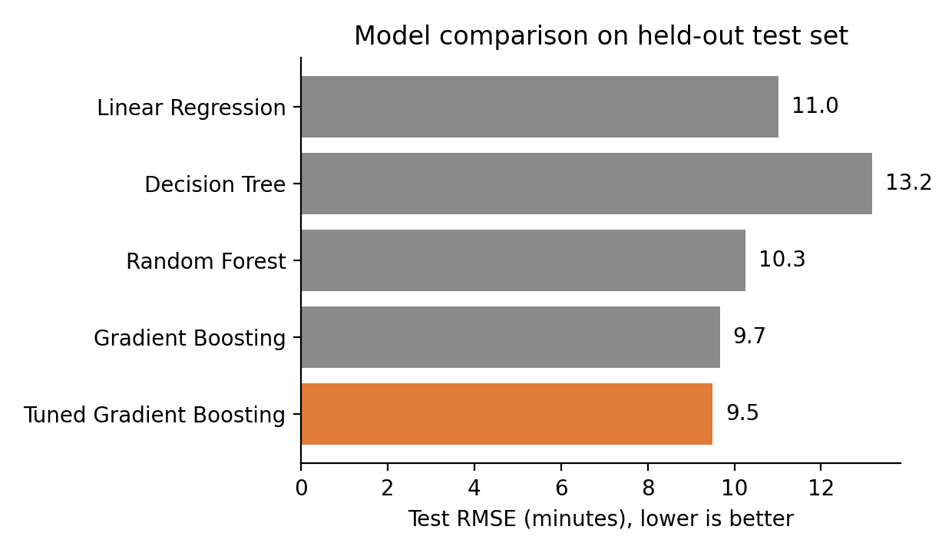
Figure 2. Tuned Gradient Boosting has the lowest error.

What the results tell us
- The linear baseline is already strong (R-squared 0.859) because route time is largely additive in distance and stops. Boosting still removes about 1.5 minutes of RMSE by learning interactions such as weather x distance and vehicle x stops.
- The single decision tree is weakest, as expected: it predicts in coarse steps and is sensitive to the training sample.
- No sign of overfitting: cross-validated RMSE (9.19) and test RMSE (9.50) are close.
- Practical accuracy: 76.4% of test predictions land within 10 minutes of the actual time, and the mean absolute percentage error is 11.4%.
pred = best.predict(X_test)
rmse = np.sqrt(mean_squared_error(y_test, pred))
mae = mean_absolute_error(y_test, pred)
r2 = r2_score(y_test, pred)
resid = y_test - pred
within_10 = (resid.abs() <= 10).mean()
q_lo, q_hi = np.quantile(resid, [0.05, 0.95]) # 90% prediction interval
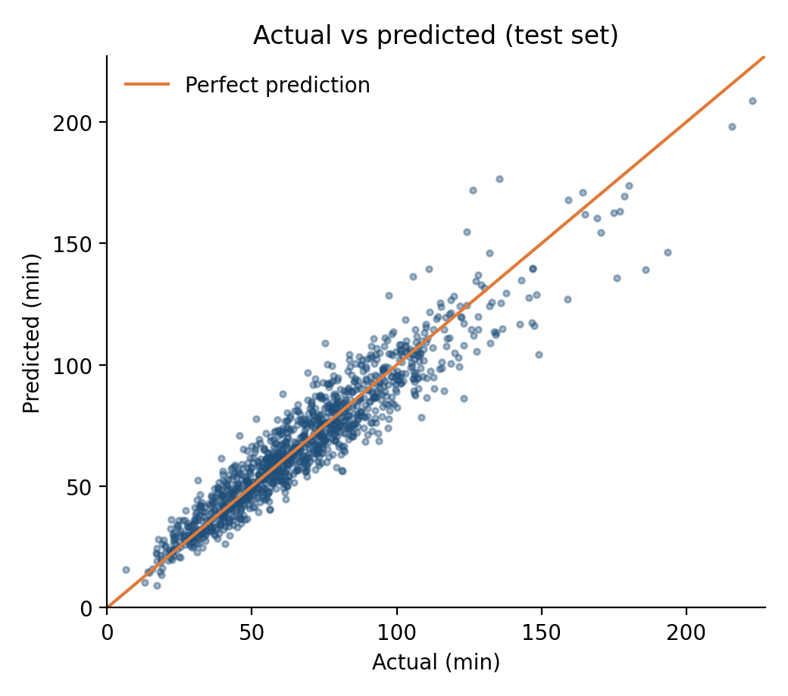
Figure 3. Predictions track actual values closely; scatter widens on longer routes.
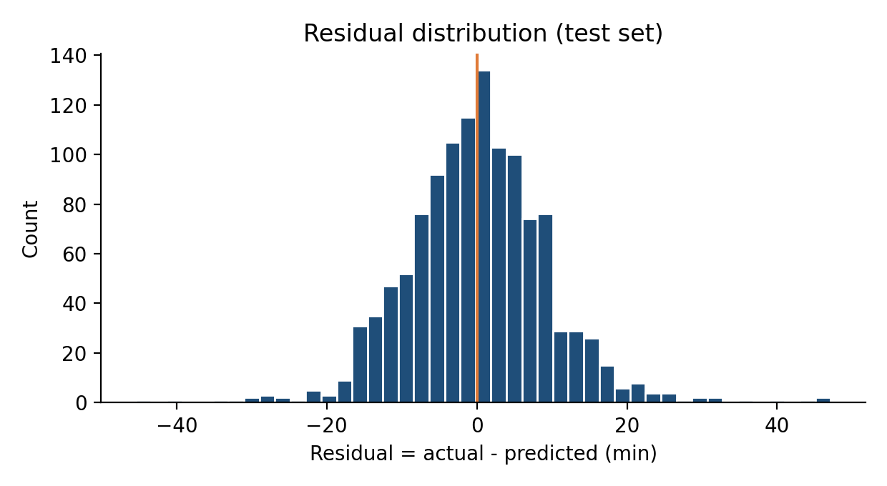
Figure 4. Residuals are centred on zero (mean 0.08 min, std 9.5 min). Roughly 90% of errors fall between -14.6 and +14.9 minutes, which is used later as an uncertainty band.

8. Insights from the Model
Permutation importance measures how much test RMSE worsens when a single feature is shuffled. It is model-agnostic and evaluated on unseen data.
pi = permutation_importance(best, X_test, y_test, n_repeats=10, random_state=42,
scoring="neg_root_mean_squared_error")
imp = pd.Series(pi.importances_mean, index=X_test.columns).sort_values(ascending=False)
imp_pct = imp / imp.sum() * 100
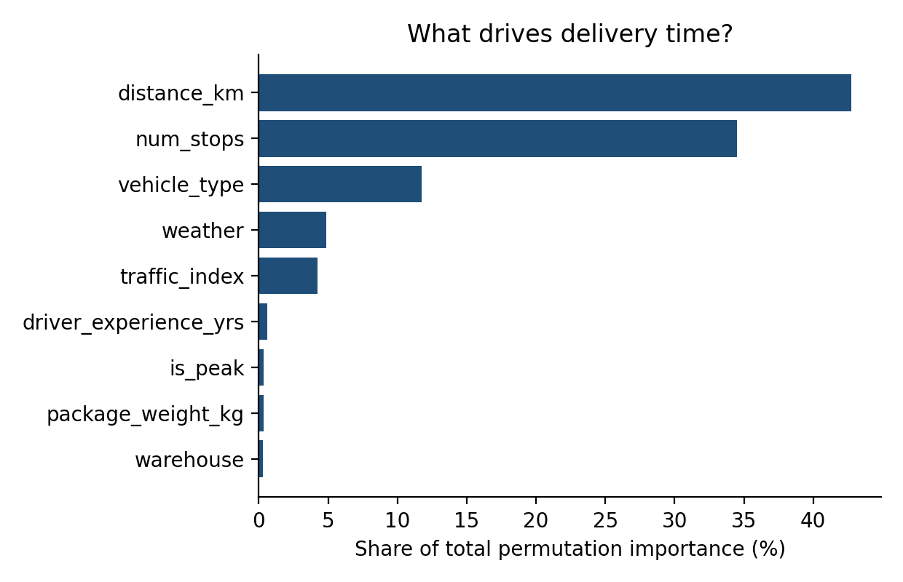
Figure 5. Distance and number of stops dominate.
- Route structure drives time. Distance (42.8%) and number of stops (34.5%) together explain about three-quarters of the model's predictive signal. Route design is therefore the biggest lever.
- Vehicle choice matters (11.7%), and conditions add a smaller but real effect: weather (4.9%) and traffic (4.2%).
- Hour of day and weekend show near-zero importance, but this should not be read as 'timing does not matter'. Their effect reaches the model through traffic_index and is_peak, which are correlated with them, so permuting hour alone changes little. Section 9.2 tests timing directly.
- Driver experience has a small effect (0.6%) in this data. Real-world effects are often larger, so this should be re-checked on actual records.

9. Optimization Strategies Based on the Model
The model is used here as a cost estimator. Instead of asking only 'how long will this route take?', we ask 'how long would it take under each possible decision?' and pick the best option. Three strategies were implemented and measured; a fourth set of extensions is proposed.

9.1 Predictive driver-vehicle assignment
Problem: 30 routes must be matched one-to-one with 30 available driver-vehicle combinations. For every route and every driver-vehicle pair, the model predicts the delivery time, which gives a 30 x 30 cost matrix. The Hungarian algorithm (a linear assignment solver) then finds the matching with the lowest total predicted time. A random matching is the baseline, averaged over 5,000 random draws.
cost = np.zeros((n_jobs, n_jobs))
for i in range(n_jobs): # job i
batch = jobs.iloc[[i] * n_jobs].copy()
batch["vehicle_type"] = fleet.vehicle_type.values # every driver-vehicle
batch["driver_experience_yrs"] = fleet.driver_experience_yrs.values
cost[i] = best.predict(batch) # predicted minutes, job i x each driver

rows, cols = linear_sum_assignment(cost) # minimise total predicted time
opt_total = cost[rows, cols].sum()
rand_total = np.mean([cost[np.arange(n_jobs), rng.permutation(n_jobs)].sum()
for _ in range(5000)])
Strategy | Total predicted fleet time
Random matching (average of 5,000) | 30.5 hours
Model-optimised matching | 28.3 hours
Saving | 2.2 hours (7.3%)

Interpretation: the optimiser puts heavy, stop-dense and long routes on the vehicles best suited to them. Because the saving repeats every dispatch cycle, it compounds into significant labour and fuel savings over time.

9.2 Off-peak departure shifting
For deliveries that have scheduling flexibility, the model scores each possible departure hour within two hours of the planned time and selects the lowest predicted duration. Traffic for each candidate hour is set to the typical level for that hour (peak or off-peak).
for h in range(7, 21):
t = flex.copy()
t["hour_of_day"] = h
t["is_peak"] = int(8 <= h <= 10 or 17 <= h <= 19)
t["traffic_index"] = 3 + 4 * t["is_peak"] + 0.8 * (1 - flex.is_weekend)
p = best.predict(t)
ok = np.abs(h - flex.hour_of_day.values) <= 2 # allowed shift window
better = ok & (p < best_pred)
best_pred[better], best_hour[better] = p[better], h
Across 400 flexible routes, 60.8% were moved to a different hour, cutting predicted time by 6.8% overall (4.7 minutes per route on average). This estimate depends on the assumption that traffic at each candidate hour follows the usual pattern. It should be validated with live traffic feeds before use.

9.3 Risk-aware delivery promises (SLA flagging)
The residual distribution gives an uncertainty band around each forecast. A route is flagged as at risk when its upper bound (prediction + 14.9 min) exceeds a 120-minute SLA. Flagged routes can be given extra buffer, re-planned, or assigned a better vehicle.
upper = pred + q_hi # 95th-percentile residual added to forecast
flag = upper > 120 # at-risk routes
breach = y_test.values > 120 # actual SLA breaches
recall = (flag & breach).sum() / breach.sum()
precision = (flag & breach).sum() / flag.sum()
Measure | Result
Routes that actually breached 120 min | 4.7%
Routes flagged as at risk | 8.8%
Breaches caught (recall) | 91.1%
Flagged routes that really breached (precision) | 48.6%

The flag is deliberately cautious: it catches nearly all breaches at the price of about one false alarm per true breach. For SLA protection, where a missed delivery costs more than a precautionary buffer, that trade-off is sensible. The threshold can be adjusted to match the cost of each error type.

9.4 Proposed extensions (not implemented here)
- Route planning: feed model-predicted travel and service times into a vehicle-routing solver (for example Google OR-Tools) instead of static averages, so routes are built around conditions-aware times.
- Resource allocation: aggregate predicted route durations by warehouse and day to size driver shifts and vehicle pools, and shift capacity toward warehouses with the highest predicted load.
- Cost minimisation: combine predicted time with labour rate, fuel and SLA-penalty costs in one objective: minimise the sum of (cost per hour x predicted time + expected penalty), subject to vehicle capacity and driver shift limits.

10. Recommendations
# | Action | Evidence from this analysis | Effort
1 | Use model-predicted times when matching drivers and vehicles to routes | 7.3% lower predicted fleet time vs random matching | Low
2 | Move flexible deliveries out of peak windows using predicted time | 6.8% saving on flexible routes | Medium
3 | Quote delivery promises with a risk-based buffer; review flagged routes | 91.1% of 120-min breaches flagged in advance | Low
4 | Focus route design effort on distance and stop count | 77.3% of predictive importance | Medium
5 | Add weather-aware planning: extra time or earlier dispatch in rain and storms | Weather is the largest condition-related factor in the model | Low
6 | Retrain monthly and track MAE by warehouse and vehicle type for drift | CV and test errors are close, so refreshes should keep the model stable | Medium

Suggested rollout: start with recommendations 1 and 3, which need no change to field operations. Pilot recommendation 2 on one warehouse with an A/B comparison, and expand once realised savings are confirmed.

11. Limitations and Next Steps
- Simulated data. Results reflect the structure built into the simulator. Real data will be noisier, so expect a lower R-squared; the workflow itself transfers directly.
- Predicted, not realised, savings. Optimization gains are measured with the model's own predictions. A live pilot is needed to confirm them.
- Generous baseline. Random matching is easier to beat than an experienced dispatcher's heuristics, so real-world gains over current practice may be smaller.
- Timing assumption. The departure-shifting analysis assumes typical traffic by hour; live traffic data would sharpen it.
- Next steps. Add GPS and live-traffic features, compare against LightGBM or XGBoost, use quantile regression for direct prediction intervals, and integrate predictions into a full vehicle-routing solver.

Appendix: Model Definitions and Environment
models = {
"Linear Regression": Pipeline([("prep", prep(True)),
("m", LinearRegression())]),
"Decision Tree": Pipeline([("prep", prep(False)),
("m", DecisionTreeRegressor(
max_depth=8, min_samples_leaf=10,
random_state=42))]),
"Random Forest": Pipeline([("prep", prep(False)),
("m", RandomForestRegressor(
n_estimators=100, min_samples_leaf=3,
random_state=42))]),
"Gradient Boosting": Pipeline([("prep", prep(False)),
("m", GradientBoostingRegressor(
random_state=42))]),
}
Environment: Python 3, pandas 3.0, scikit-learn 1.8, NumPy, SciPy (linear_sum_assignment), Matplotlib. All random seeds are fixed (42) so results are reproducible.

