SUPPLY CHAIN ANALYTICS | PERFORMANCE REVIEW
Logistics Delivery Performance and Cost Analysis
Evidence from 10,324 health-commodity shipment lines delivered to 43 countries, 2006 to 2015

Document | Detail
Report type | Advanced data analysis and visualization (Week 3 assignment), corporate performance review
Dataset | SCMS Supply Chain Shipment Pricing Data (Kaggle: sawandikirby/supply-chain-shipment-pricing-data), file Raw_Data.csv
Audience | Supply chain leadership, logistics operations, procurement and finance
Analyst | [Insert name]
Tools | Python 3 (pandas, NumPy, SciPy, scikit-learn, matplotlib, seaborn)
Classification | Internal / for management review

Contents
1. Executive Summary 3
Key findings 3
2. Business Context and Objectives 4
3. Data and Methodology 4
3.1 Data source 4
3.2 Variables used 4
3.3 Data cleaning log 4
3.4 Derived metrics and KPI definitions 5
3.5 Analytical approach 6
4. Exploratory Data Analysis 6
4.1 Central tendency and spread 6
4.2 Distribution of delivery performance 6
4.3 Correlation analysis 7
4.4 Statistical tests 8
5. Delivery Performance Analysis 8
5.1 Volume and reliability over time 8
5.2 Value at risk 9
5.3 Purchase-order-to-delivery lead time 9
6. Freight Cost Analysis 10
6.1 Mode scorecard 10
6.2 Freight cost distribution by mode 11
6.3 Weight as the cost driver 11
6.4 Product group economics 12
7. Network Analysis: Route, Country and Supplier 13
7.1 Fulfilment route: Direct Drop versus RDC 13
7.2 Destination countries 14
7.3 Country and mode interaction 14
7.4 Supplier concentration and performance 15
8. Drivers of Late Delivery 16
9. Consolidated Insights 17
9.1 Operational efficiency 17
9.2 Cost drivers 17
9.3 Bottlenecks 17
10. Risk Register 18
11. Recommendations and Implementation Roadmap 19
11.1 Prioritised actions 19
11.2 Phased roadmap 19
11.3 Indicative opportunity 19
11.4 Proposed KPI scorecard 20
12. Limitations and Data Caveats 20
Appendix A: Country and Supplier Summary Tables 21
Appendix B: Reproducing the Analysis 22

1. Executive Summary
This review analyses 10,324 real shipment lines from the SCMS delivery history, a public dataset covering health commodities (antiretroviral drugs, HIV test kits and related products) delivered to 43 countries between 2006 and 2015. Together the lines represent USD 1.63 billion of delivered commodity value and 189 million units. The aim is to establish how reliably the network delivers, what drives freight cost, and where the bottlenecks sit.
10,324  Shipment lines analysed | $1.63 billion  Delivered commodity value | 88.5%  Delivered on or before schedule | 7.4%  Delivered more than 7 days late
101 days  Median PO-to-delivery lead time (Direct Drop) | $7.26  Median freight cost per kg | 5.8%  Freight as % of commodity value (weighted) | 15.9%  Share of value delivered late

Key findings
- Overall on-time performance is high, but lateness has become a structural problem. 88.5% of lines arrive on or before the scheduled date, yet the late rate rose from about 2% in 2007 to 2009 to between 8.5% and 23.8% every year from 2010 onwards. Late lines carry USD 259.0 million of value (15.9%); the typical late line is 12 days behind and the 90th percentile is 51 days.
- The Regional Distribution Centre (RDC) route is the single largest source of lateness. Deliveries from RDC stock make up 52.3% of lines and 66.7% of value, but 78% of all late lines. The RDC late rate is 17.2% against 5.3% for Direct Drop. Trucking from the RDC is the worst lane: 23.2% late, compared with 1.2% for trucked Direct Drop lines.
- Lead times are lengthening. Median purchase-order-to-delivery time rose from about 55 to 70 days (2007 to 2009) to between 98 and 133 days from 2012 onwards. Ocean freight is slowest at 167 days and has the worst severity profile (9.7% of lines more than 30 days late).
- Freight cost is driven by weight, mode and destination, and shows clear economies of scale. Freight tracks shipment weight with an elasticity of 0.439: doubling weight cuts freight cost per kg by roughly 32%. Median freight is $10.0/kg by air, $2.5/kg by truck and $1.7/kg by ocean. Remote or low-volume destinations (DRC, South Sudan, Haiti, Guyana) pay a median of 26% to 88% of commodity value in freight.
- Supplier performance is polarised and concentration is high. Three suppliers (Orgenics, Aurobindo and Cipla) deliver 13% to 14% of lines late, while Mylan and Hetero are below 1%. The RDC and two suppliers (Orgenics and Aurobindo) account for 81% of value, and eight countries account for 80% of value.

Management decision requested
Approve a 12-month RDC outbound reliability programme (carrier SLAs on RDC trucking, lane-level root-cause review, and an RDC stock buffer for the six highest-volume corridors), together with a freight consolidation and mode policy and a supplier scorecard. If the RDC late rate reached the Direct Drop level of 5.3%, about 640 fewer lines per period would arrive late, which is more than half of all late lines in the dataset.

Section 11 sets out six prioritised actions with owners, KPIs and a phased roadmap. Sections 3 and 12 document the data treatment and the limitations of the evidence, which management should read before relying on the quantified estimates.

2. Business Context and Objectives
The dataset records the delivery history of a global health supply chain. Commodities are bought from manufacturers and either shipped directly from the supplier to the country (Direct Drop) or issued from stock held in a Regional Distribution Centre in South Africa (From RDC). Because the products are antiretroviral medicines and diagnostics, delivery reliability has a direct service consequence: late deliveries raise the risk of stock-outs at treatment sites, and excess freight cost reduces the volume of commodities the same budget can buy.
The assignment brief asks for exploratory analysis, multiple justified visualizations, interpretation of operational efficiency, cost drivers and bottlenecks, and a documented Python workflow. The analysis is organised around four business questions:
- Delivery reliability: how often, how late, and where do deliveries miss schedule?
- Lead time: how long does it take from purchase order to delivery, and is it changing?
- Cost drivers: what explains freight cost, and where is freight most expensive relative to the goods?
- Bottlenecks and risk: which routes, modes, countries and suppliers concentrate the problems?

3. Data and Methodology

3.1 Data source
The source file (Raw_Data.csv, 3.8 MB) holds 10,324 rows and 35 columns. Each row is a shipment line item. Delivered-to-client dates run from 2006-05-02 to 2015-09-14. The file is raw and minimally processed: costs and weights contain text codes, several date fields contain placeholders, and text fields contain encoding artefacts. These issues are typical of operational logistics extracts and are treated explicitly in Section 3.3.

3.2 Variables used
Variable | Group | Use in the analysis
Scheduled / Delivered / Recorded date | Timing | Delay in days = delivered minus scheduled; recording lag
PO Sent to Vendor Date | Timing | PO-to-delivery lead time (Direct Drop lines only)
Country, Vendor, Fulfill Via | Network | Destination, supplier and route (Direct Drop or From RDC)
Shipment Mode | Transport | Air, Air Charter, Truck, Ocean (360 lines not recorded)
Product Group, Sub Classification | Product | ARV, HRDT (test kits), plus small ACT, ANTM, MRDT groups
Line Item Quantity, Line Item Value | Volume / value | Units shipped and commodity value in USD
Weight (Kilograms) | Volume | Shipment weight, used as the main freight cost driver
Freight Cost (USD) | Cost | Direct freight charge; analysed per kg and as % of line value
Vendor INCO Term | Commercial | Incoterm; who carries freight responsibility

3.3 Data cleaning log
Every transformation is applied in code and logged below so that the figures in this report can be reproduced from the raw file.
Issue found | Lines | Treatment
Text encoding corruption (country and site names, file header) | 1,083 + 1 | Repaired, for example Côte d'Ivoire; header marker removed
Two metadata columns (Load_Date, Source_System) populated on one row only | 1 | Dropped as non-analytical
Freight cost stored as text codes instead of a number | 4,126 | Split into four statuses: Direct (6,198), Referenced to another line of the same shipment (2,445), Included in commodity cost (1,442), Invoiced separately (239)
Weight stored as text (see another line / captured separately) | 3,952 | Set to missing; excluded from per-kg metrics
Insurance values with thousands separators | 576 | Converted to numbers
PO date and PQ date contain placeholders ("Date Not Captured", "N/A - From RDC", "Pre-PQ Process") | 5,732 | Converted to missing; lead time computed only where a valid PO date exists
PO date on or after delivery date (impossible lead time) | 357 | Excluded from lead-time statistics
Shipment mode blank | 360 | Labelled "Not recorded"; kept in totals, excluded from mode comparisons
Zero line value / zero weight | 17 / 1 | Kept in delivery analysis; excluded from ratios that divide by value or weight
Near-identical rows (all fields equal except ID) | 4 | Flagged, retained (distinct IDs, possibly split shipments); impact on results is negligible
Delivered more than 30 days before the scheduled date | 903 | Retained and labelled "Early"; reported separately as a data-quality caution

df = pd.read_csv("Raw_Data.csv")
df.columns = [c.replace("Ã¯Â»Â¿", "").strip() for c in df.columns] # repair BOM artefact
df["Country"] = df["Country"].str.replace(r"^C.{1,4}te d'Ivoire$",
"Côte d'Ivoire", regex=True)

# Dates: delivery fields are d-Mon-yy, PO/PQ fields are m/d/yy with text placeholders
df["sched"] = pd.to_datetime(df["Scheduled Delivery Date"], format="%d-%b-%y")
df["deliv"] = pd.to_datetime(df["Delivered to Client Date"], format="%d-%b-%y")
df["po_date"] = pd.to_datetime(df["PO Sent to Vendor Date"], format="%m/%d/%y", errors="coerce")

# Numerics: non-numeric codes become NaN, and a status column keeps the reason
df["freight_usd"] = pd.to_numeric(df["Freight Cost (USD)"], errors="coerce")
df["weight_kg"] = pd.to_numeric(df["Weight (Kilograms)"], errors="coerce")
df["insurance_usd"] = pd.to_numeric(df["Line Item Insurance (USD)"].astype(str).str.replace(",", ""), errors="coerce")

3.4 Derived metrics and KPI definitions
Metric | Definition
Delay (days) | Delivered to Client Date minus Scheduled Delivery Date. Negative = early, zero = on schedule, positive = late
On-time rate | Share of lines with delay of 0 days or less
Late rate / severity | Share with delay > 0 days; severity bands > 7, > 14 and > 30 days
Value at risk | Commodity value of late lines divided by total commodity value
PO-to-delivery lead time | Delivered date minus PO sent date, valid positive values only (Direct Drop lines)
Freight per kg | Direct freight cost (USD) divided by weight (kg), lines with both present and positive
Freight % of value | Direct freight cost divided by line item value; the median is reported because a few tiny-value lines produce extreme ratios

3.5 Analytical approach
Analysis proceeded in four layers. First, descriptive statistics and distribution checks established the shape of each variable. Second, grouped KPIs compared performance across mode, route, product, country, vendor and year. Third, hypothesis tests (Kruskal-Wallis, chi-square, Mann-Whitney, Spearman) confirmed whether differences are statistically meaningful; non-parametric tests were chosen because delay, weight and cost are heavily skewed. Fourth, two multivariate models separated the effects of correlated factors: a log-log regression for freight cost and a logistic regression for late delivery. The models describe association, not proof of cause.

4. Exploratory Data Analysis

4.1 Central tendency and spread
Variable | n | Mean | Median | Std dev | 5th pct | 95th pct
Quantity (units) | 10,324 | 18,333 | 3,000 | 40,035 | 17.0 | 90,952
Line value (USD) | 10,324 | 157,651 | 30,471 | 345,292 | 193 | 702,831
Weight (kg) | 6,372 | 3,424 | 1,047 | 13,527 | 18.0 | 12,958
Freight cost (USD) | 6,198 | 11,103 | 5,870 | 15,813 | 641 | 36,680
Unit price (USD) | 10,324 | 0.61 | 0.16 | 3.28 | 0.01 | 1.60
Delay (days) | 10,324 | -6.0 | 0.0 | 27.2 | -52.0 | 14.0
PO-to-delivery (days) | 4,235 | 115 | 101 | 76.2 | 21.0 | 280
Freight per kg (USD) | 6,174 | 38.93 | 7.26 | 581.78 | 0.82 | 67.65

Almost every business variable is strongly right-skewed: the mean of line value is USD 157,651 but the median is only USD 30,471, and the mean freight cost per kg (USD 38.93) is more than five times the median (USD 7.26) because a small number of tiny, expensive shipments dominate the average. Medians and percentiles are therefore used for comparisons throughout. Delay has a median of 0 days and a mean of -6.0 days, reflecting a long left tail of early deliveries and a long right tail of late ones. Direct freight cost is available for 6,174 lines with usable weight; PO dates are valid for 4,235 lines.

4.2 Distribution of delivery performance
Why this chart. A histogram on a log count axis shows the whole shape of the delay distribution, including rare but serious late deliveries that a table of averages would hide. The companion bar chart gives the three-way outcome split for executive reporting.
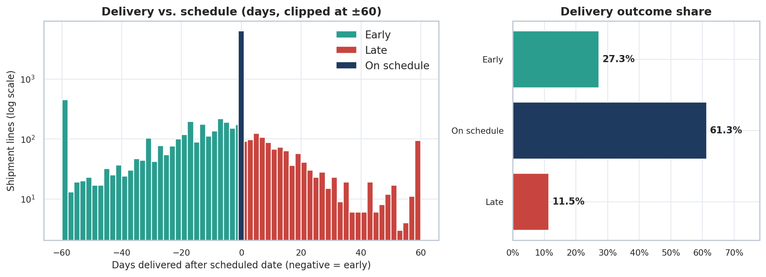
Figure 1. Distribution of delivery delay (left, clipped at ±60 days) and overall outcome shares (right).
df["delay_days"] = (df["deliv"] - df["sched"]).dt.days
df["outcome"] = np.select([df.delay_days < 0, df.delay_days == 0], ["Early", "On schedule"], "Late")
ax[0].hist(df.delay_days.clip(-60, 60)[df.delay_days < 0], bins=np.arange(-60, 62, 2), color=TEAL)
ax[0].hist(df.delay_days.clip(-60, 60)[df.delay_days > 0], bins=np.arange(-60, 62, 2), color=RED)
ax[0].set_yscale("log")

Interpretation. 61.3% of lines are delivered exactly on the scheduled date, 27.3% early and 11.5% late (1,186 lines). Lateness is skewed: the median late line is 12 days behind, the mean is 21.4 days, and 230 lines (2.2%) are more than 30 days late. The spike at exactly zero is unusually tall. In 53.2% of lines the delivery and recording dates also coincide, which suggests that for many records the delivered date may have been entered as the scheduled date. This does not change the conclusions about late lines, but it means the on-time rate should be treated as an upper bound.

4.3 Correlation analysis
Why this chart. A heatmap compresses a full correlation matrix into one view and exposes both strong relationships and multicollinearity before modelling. Spearman rank correlation is used instead of Pearson because the variables are skewed and contain extreme values.
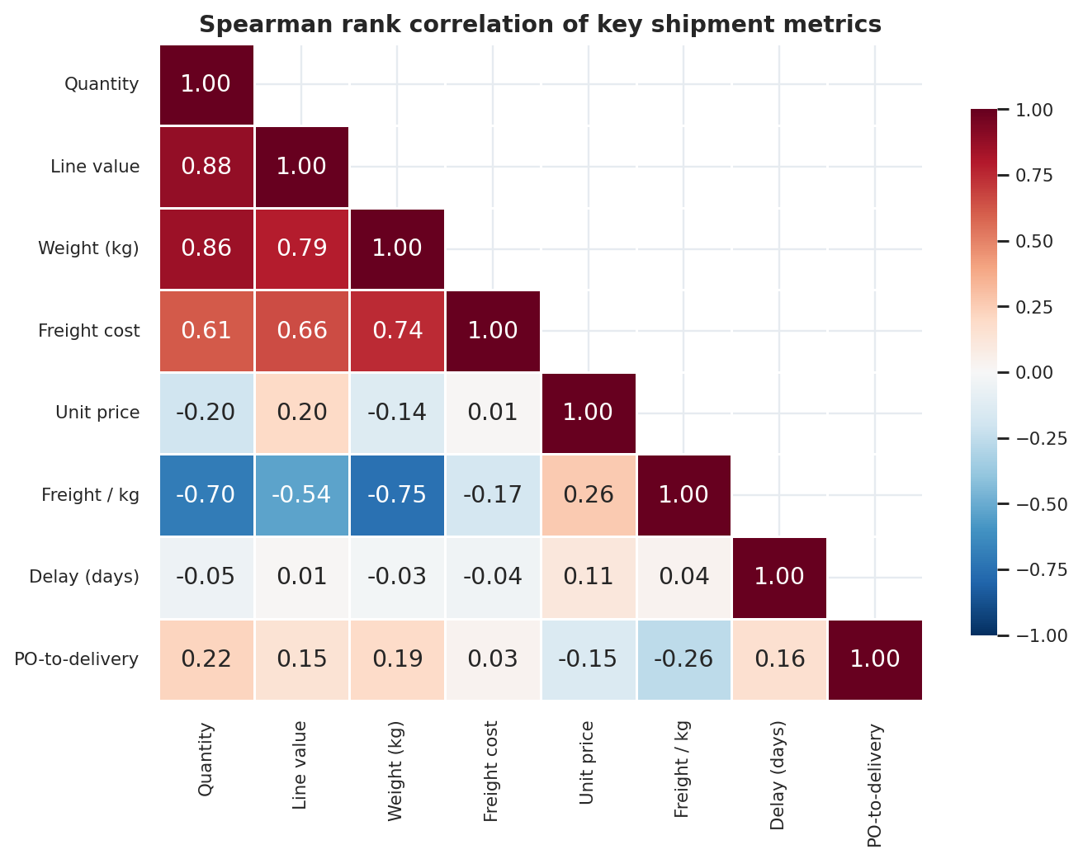
Figure 2. Spearman rank correlation of key shipment metrics.
cols = ["quantity", "line_value", "weight_kg", "freight_usd", "unit_price",
"freight_per_kg", "delay_days", "po_to_delivery_days"]
corr = df[cols].corr(method="spearman")
sns.heatmap(corr, mask=np.triu(np.ones_like(corr, bool), k=1), annot=True, fmt=".2f",
cmap="RdBu_r", center=0, vmin=-1, vmax=1)

Interpretation. Quantity, value and weight move together (quantity-weight ρ = 0.857), so only one of them should enter a regression. Weight is the strongest correlate of total freight cost (ρ = 0.742), while freight per kg falls sharply as weight rises (ρ = -0.75), the signature of economies of scale. The delay variable is almost uncorrelated with any size or cost measure (all |ρ| ≤ 0.16), which tells us that lateness is not a function of shipment size or price; it is driven by route, mode, supplier and period, which the next sections examine.

4.4 Statistical tests
With more than 10,000 observations almost any difference is statistically significant, so the effect size and the business meaning matter more than the p-value. Cramér's V is reported for the chi-square tests.
Test | Question | Statistic | p-value | Reading
Kruskal-Wallis | Does delay differ by transport mode? | H = 613.8 | < 0.001 | Yes
Chi-square | Is late status related to mode? | χ² = 89.4 (3 df) | < 0.001 | Small effect, V = 0.095
Chi-square | Is late status related to fulfilment route? | χ² = 356.9 (1 df) | < 0.001 | V = 0.19, stronger than mode
Mann-Whitney U | Is delay different for RDC vs Direct Drop? | U = 10.3 million | < 0.001 | Yes
Chi-square | Does late rate change across years? | χ² = 504.9 (9 df) | < 0.001 | Yes
Kruskal-Wallis | Does freight per kg differ by mode? | H = 1282.3 | < 0.001 | Yes
Kruskal-Wallis | Does freight per kg differ across the top 10 countries? | H = 759.1 | < 0.001 | Yes
Spearman | Weight vs freight cost | ρ = 0.742 | < 0.001 | Strong positive

from scipy import stats
core = df[df["mode"].isin(["Air", "Air Charter", "Truck", "Ocean"])]
stats.kruskal(*[g.delay_days.values for _, g in core.groupby("mode")])
stats.chi2_contingency(pd.crosstab(df.fulfill_via, df.late))
stats.mannwhitneyu(df.loc[df.fulfill_via == "From RDC", "delay_days"],
df.loc[df.fulfill_via == "Direct Drop", "delay_days"])
stats.spearmanr(fa.weight_kg, fa.freight_usd)

5. Delivery Performance Analysis

5.1 Volume and reliability over time
Why this chart. Bars show scale (delivered value) and lines show reliability on a second axis, so the reader can test whether performance deteriorates as the programme grows. This is the standard capacity-versus-service view for a control tower. 2006 is omitted because it has only 65 lines.
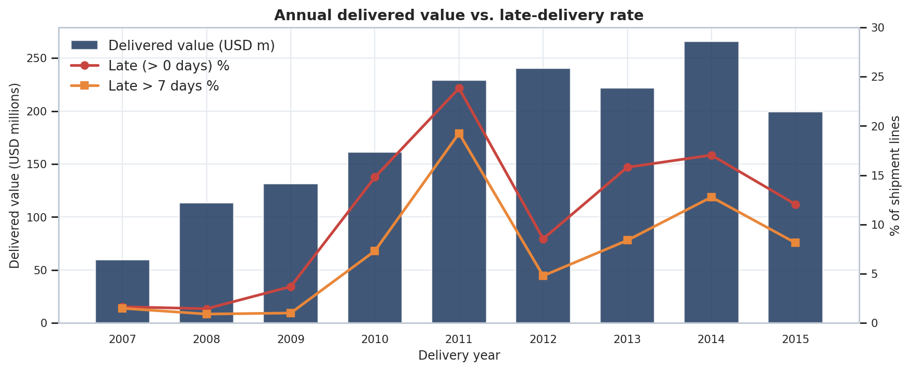
Figure 3. Annual delivered value (bars) and late-delivery rates (lines).
yr = df.groupby("year").agg(value=("line_value", "sum"), late=("late", "mean"),
late7=("late_gt7", "mean")).reset_index()
ax1.bar(yr.year, yr.value / 1e6, color=NAVY)
ax2 = ax1.twinx()
ax2.plot(yr.year, yr.late * 100, color=RED, marker="o")
ax2.plot(yr.year, yr.late7 * 100, color=ORANGE, marker="s")

Interpretation. Delivered value grew from USD 59.6 million in 2007 to a peak of USD 265.7 million in 2014. Reliability did not keep pace. The late rate was 1.6%, 1.4% and 3.7% in 2007 to 2009, jumped to 14.8% in 2010 and peaked at 23.8% in 2011 when 19.3% of lines were more than a week late. After a recovery to 8.5% in 2012 it settled in a 12.0% to 17.0% range. The step change after 2009 and the repeat in 2013 to 2014 look like capacity or process shocks rather than gradual drift, and they warrant a root-cause review of what changed in 2010 and 2013.

5.2 Value at risk
Why this chart. Counting late lines treats a USD 500 order and a USD 5 million order equally. Weighting by value shows how much of the programme's spend arrived late, which is the relevant measure for financial and service-level reporting.
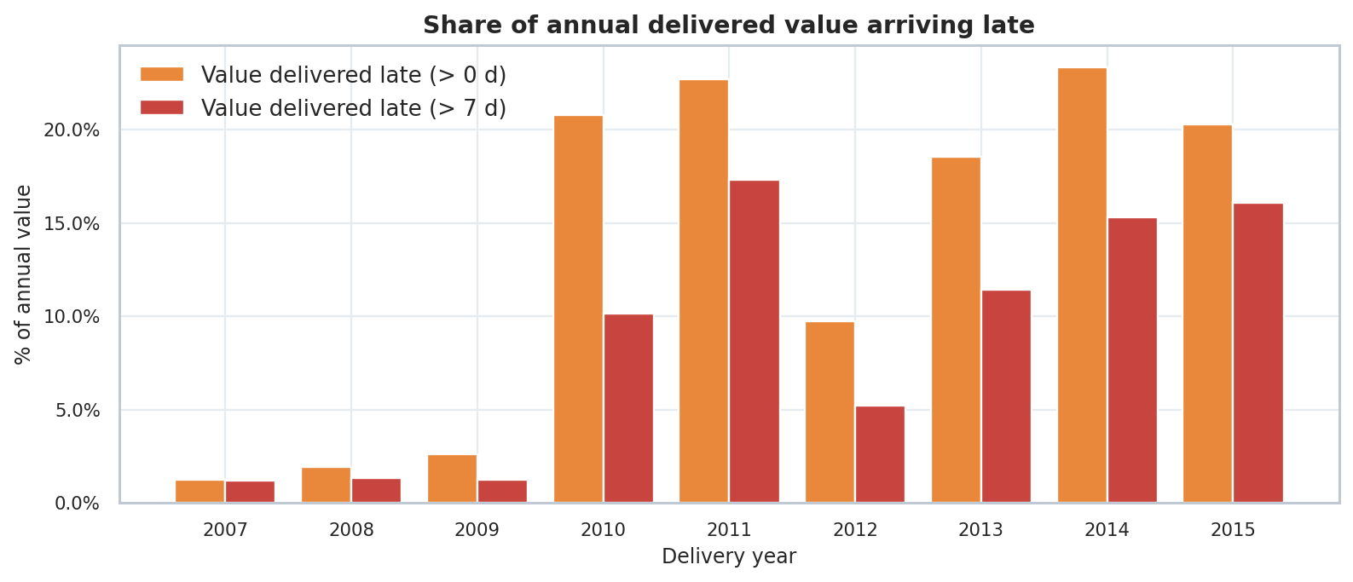
Figure 4. Share of annual delivered value arriving late, by year.
Interpretation. Across the full period 15.9% of delivered value (USD 259.0 million) arrived late and 10.5% (USD 170.4 million) arrived more than a week late. In 2011 and 2014 more than 22% of annual value was late. Because value-weighted lateness is close to line-count lateness, large orders are no safer than small ones, and the problem is not confined to low-value consignments.

5.3 Purchase-order-to-delivery lead time
Why this chart. Box plots show median, spread and extremes of lead time per mode, which a mean cannot. The trend line shows whether the end-to-end cycle is lengthening. Lead time is only available for Direct Drop lines with valid PO dates, because RDC lines draw on existing stock.
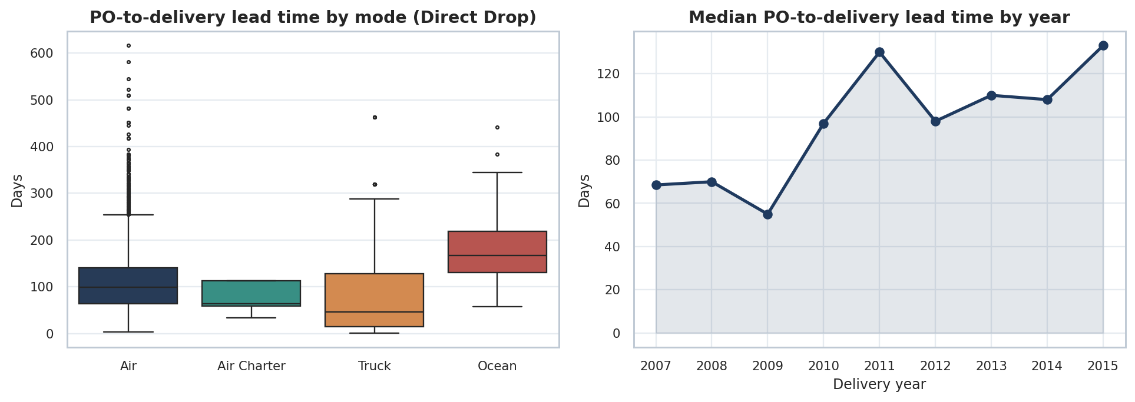
Figure 5. PO-to-delivery lead time by mode (left) and median lead time by year (right).
ld = df[df.po_to_delivery_days.notna() & df["mode"].isin(MODE_ORDER)]
sns.boxplot(data=ld, x="mode", y="po_to_delivery_days", order=MODE_ORDER, ax=ax[0])
ax[1].plot(ld.groupby("year").po_to_delivery_days.median())

Interpretation. Median lead time is 101 days overall (mean 114.6, 90th percentile 217 days). Ocean is slowest at a median of 167 days, air at 99 days and trucking at 46 days (trucked Direct Drop lines are a small, regional sample). The yearly trend rose from roughly 55 to 70 days in 2007 to 2009 to 130 days in 2011 and 133 days in 2015. A longer cycle forces earlier ordering and more safety stock and makes the schedule less credible, so this trend deserves the same management attention as the late rate.

6. Freight Cost Analysis
Direct freight cost is reported for 6,174 lines with a usable weight, totalling USD 68.7 million. The remaining lines carry freight inside the commodity price, on another line of the same shipment, or on a separate invoice, so the cost analysis describes this directly-reported 60% of lines and should not be read as total programme freight. Across these lines freight averages USD 3.24 per kg (weight-weighted) and 5.8% of commodity value.

6.1 Mode scorecard
Why this chart. Three small panels with a shared mode axis let the reader compare what each mode contributes (value share), how it performs (late rate) and what it costs (freight per kg) in one glance, which is how mode policy is normally discussed.
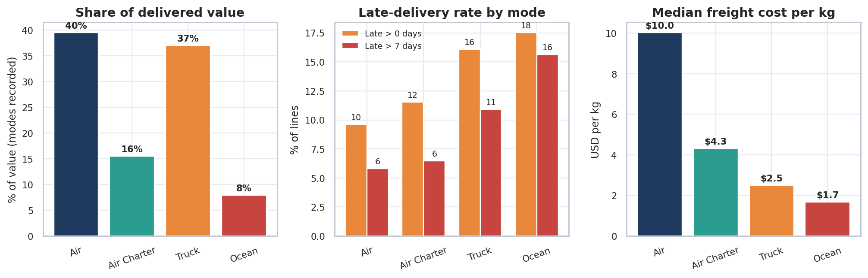
Figure 6. Mode scorecard: value share, late rate and median freight per kg.
mm = core.groupby("mode").agg(value=("line_value", "sum"), late=("late", "mean"),
late7=("late_gt7", "mean")).loc[MODE_ORDER]
fpk = fa.groupby("mode").freight_per_kg.median().loc[MODE_ORDER]
ax[0].bar(MODE_ORDER, mm.value / mm.value.sum() * 100)
ax[2].bar(MODE_ORDER, fpk)

Interpretation. Among lines with a recorded mode, air and truck carry about 40% and 37% of value, air charter 16% and ocean 8%. A clear cost-speed gradient exists: median freight is $10.0/kg by air, $4.3 by air charter, $2.5 by truck and $1.7 by ocean. Reliability does not follow the price gradient in a simple way. Ocean is cheapest but least reliable (17.5% late, 15.6% more than 7 days late), and truck is cheap but 16.1% late, whereas standard air is 9.6% late. Section 7.1 shows that truck lateness is largely a route effect rather than a mode effect.

6.2 Freight cost distribution by mode
Why this chart. Box plots on a log scale show the spread of cost per kg within each mode; the second panel normalises freight by commodity value, which shows whether freight is proportionate to what is being shipped.
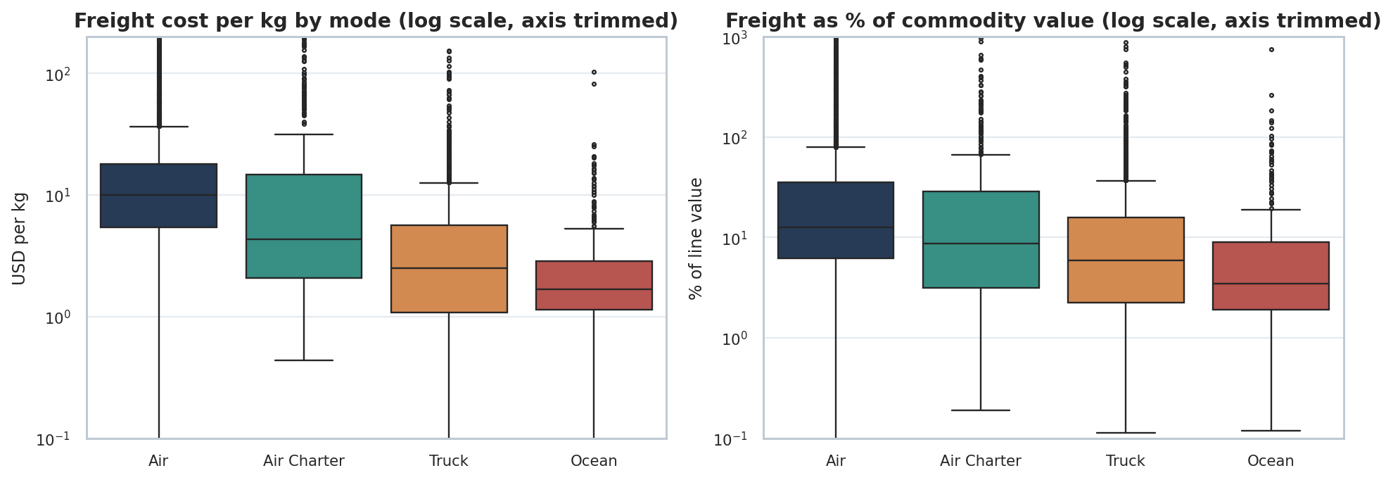
Figure 7. Freight per kg and freight as % of commodity value by mode (log axes, trimmed).
sns.boxplot(data=fa[fa["mode"].isin(MODE_ORDER)], x="mode", y="freight_per_kg", order=MODE_ORDER, ax=ax[0])
ax[0].set_yscale("log"); ax[0].set_ylim(0.1, 200)
sns.boxplot(data=fa[fa["mode"].isin(MODE_ORDER)], x="mode", y="freight_pct_value", order=MODE_ORDER, ax=ax[1])

Interpretation. The mode ordering holds in the spread as well as the median, but the boxes overlap widely: a heavy air shipment can cost less per kg than a light truck shipment. Median freight is 12.6% of commodity value by air, 8.7% by air charter, 5.9% by truck and 3.5% by ocean. Air carries about 63% of directly reported freight spend, so it is the main lever for cost control.

6.3 Weight as the cost driver
Why this chart. A scatter plot is the appropriate tool for the relationship between two continuous variables. Both axes are logarithmic because weight and cost span five orders of magnitude; on log axes a power-law relationship appears as a straight band, and its slope is the elasticity.
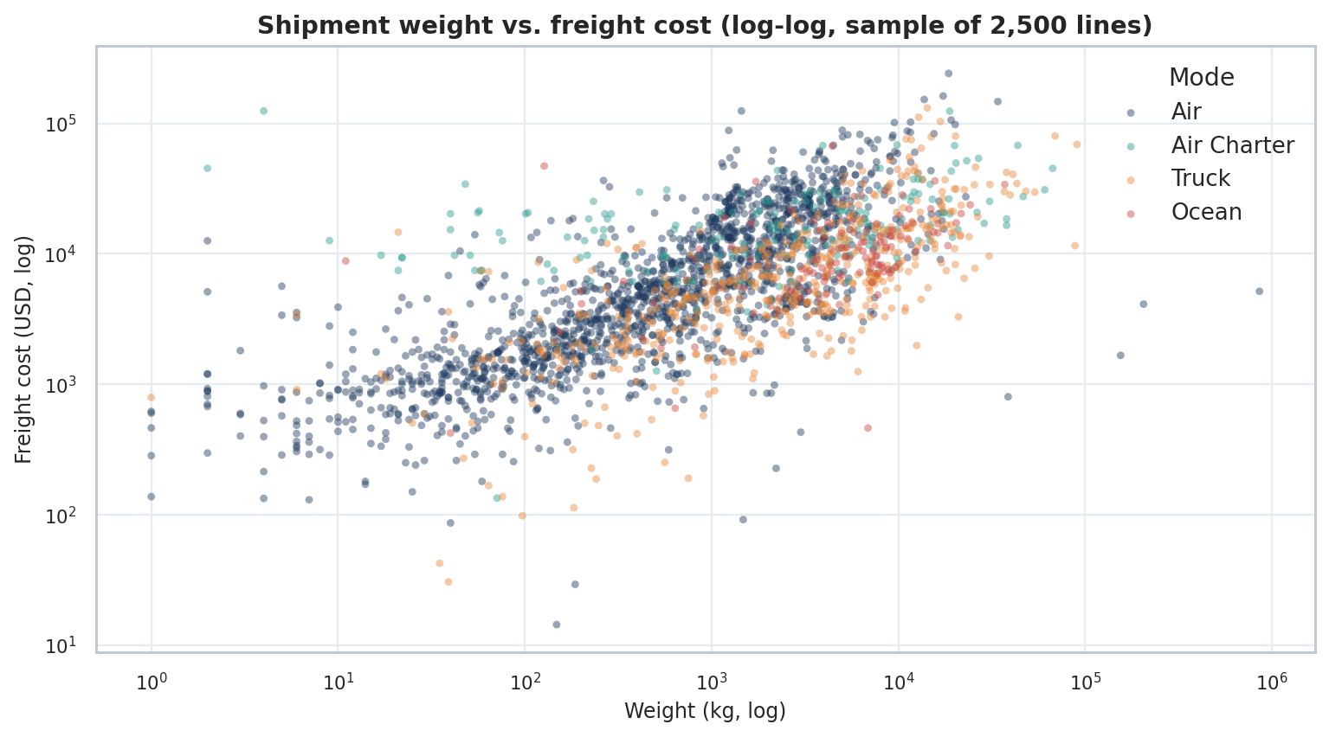
Figure 8. Weight versus freight cost on log axes, coloured by mode.
X = pd.DataFrame({"ln_weight": np.log(m.weight_kg)})
for lvl in ["Air Charter", "Truck", "Ocean"]: X["mode_" + lvl.replace(" ", "_")] = (m["mode"] == lvl).astype(float)
X["from_RDC"] = (m.fulfill_via == "From RDC").astype(float)
X["ln_value"] = np.log(m.line_value.clip(lower=1)); X["year_trend"] = m.year - 2006
X.insert(0, "const", 1.0)
beta, *_ = np.linalg.lstsq(X.values, np.log(m.freight_usd).values, rcond=None)

Interpretation. The cloud rises steadily from lower left to upper right, with Air (navy) spread across the whole range and Truck (orange) concentrated at higher weights. The regression below quantifies the pattern.
Term | Coefficient | Std error | t | Effect on freight cost (holding others constant)
ln(weight) | 0.439 | 0.009 | 49 | Elasticity 0.439: +10% weight gives about +4.4% cost; doubling weight cuts cost per kg by about 32%
Air Charter (vs Air) | 0.429 | 0.048 | 8.9 | About 54% higher cost for the same weight
Truck (vs Air) | -0.515 | 0.036 | -14.3 | About 40% lower cost
Ocean (vs Air) | -0.494 | 0.055 | -9 | About 39% lower cost
From RDC (vs Direct Drop) | -0.097 | 0.029 | -3.3 | About 9% lower cost
ln(line value) | 0.065 | 0.008 | 8.3 | Higher-value goods carry slightly higher freight
Year trend (per year) | 0.025 | 0.005 | 4.9 | About +2.5% per year
Model fit: R² = 0.578 on 5,963 lines (dependent variable ln freight cost). Weight, mode, route and time explain a little over half of the variation, so destination and lane-specific factors (Section 7) account for much of the rest.

6.4 Product group economics
Why this chart. Product group determines handling requirements and density. Comparing reliability and freight intensity for the two material groups (ARV medicines and HRDT test kits, which are 99.9% of lines) shows whether freight policy should differ by product. The three very small groups (ACT, ANTM, MRDT, 46 lines) are excluded because they are too small for reliable comparison.
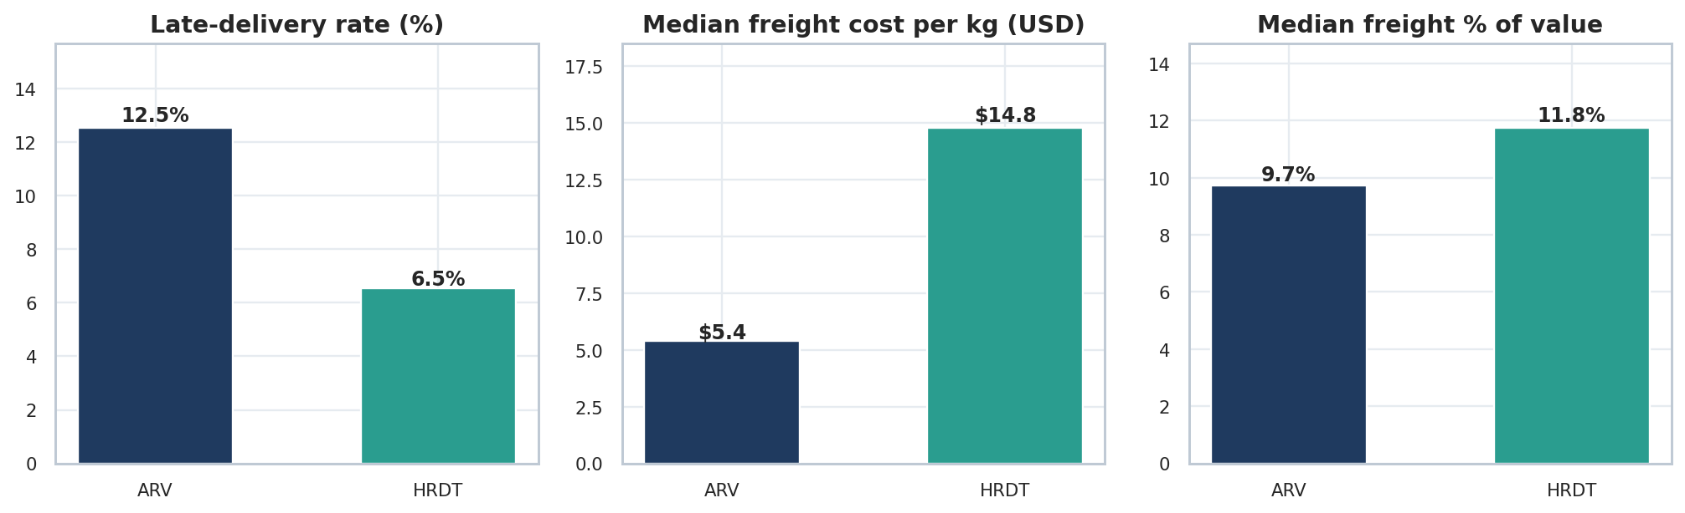
Figure 9. ARV vs HRDT: late rate, median freight per kg and median freight as % of value.
Interpretation. ARVs make up 86.8% of value and 82.8% of lines, with a late rate of 12.6% and median freight of $5.4/kg. Test kits (HRDT) are 13.1% of value, are late less often (6.5%) but cost nearly three times as much to move per kg ($14.8) and carry a higher freight burden relative to value (11.8% vs 9.7%). The higher per-kg cost is consistent with lower weight density and possibly special handling; this should be validated with operations before it is used for decisions.

7. Network Analysis: Route, Country and Supplier

7.1 Fulfilment route: Direct Drop versus RDC
Why this chart. Grouped bars compare the two supply routes side by side, both overall by severity band and within each transport mode. Splitting by mode separates a route effect from a mode effect; cells with fewer than 30 lines are suppressed.
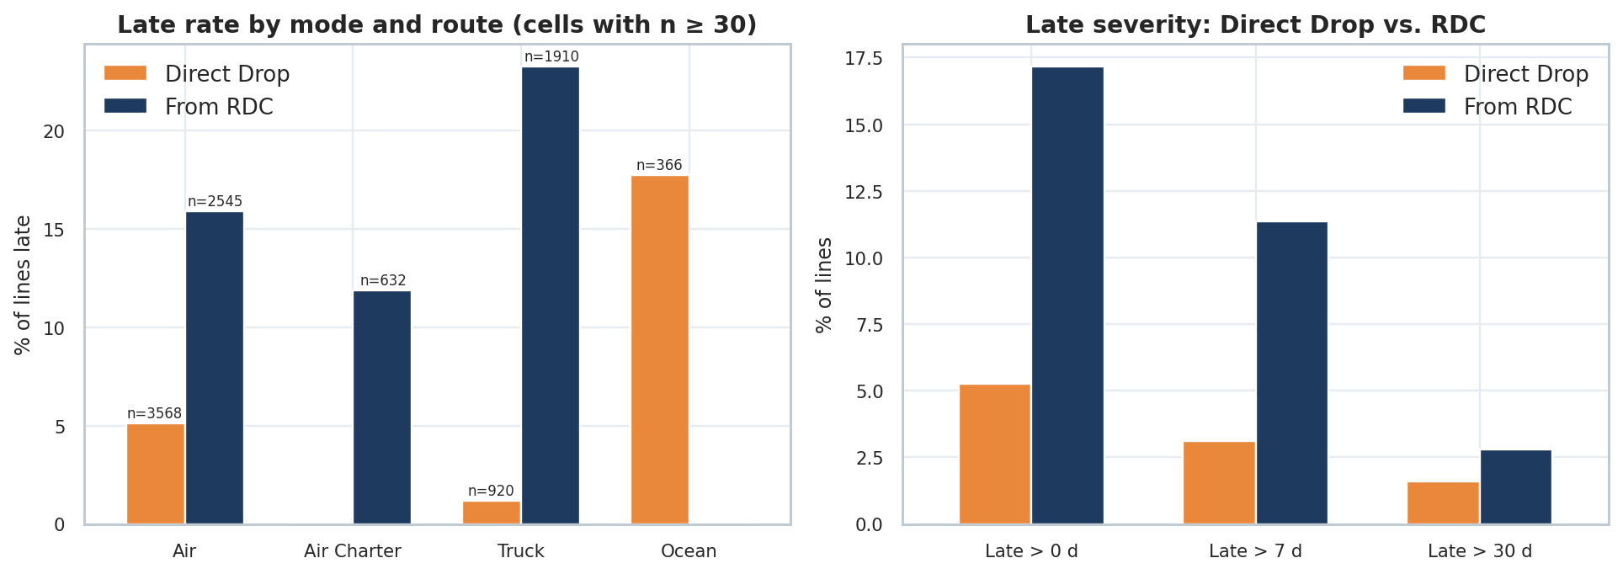
Figure 10. Late rate by mode and fulfilment route (left) and late severity by route (right).
fm = core.groupby(["mode", "fulfill_via"]).agg(lines=("ID", "count"), late=("late", "mean")).reset_index()
pv = fm.pivot(index="mode", columns="fulfill_via", values="late") * 100
pv = pv.where(fm.pivot(index="mode", columns="fulfill_via", values="lines") >= 30)
pv.plot(kind="bar", ax=ax[0])

Interpretation. This is the clearest finding in the data. RDC deliveries are 17.2% late versus 5.3% for Direct Drop (chi-square 356.9, p < 0.001). Within the same mode the gap persists: standard air is 15.9% late from the RDC and 5.1% for Direct Drop, and trucking is 23.2% late from the RDC but only 1.2% for Direct Drop. The RDC route accounts for 78% of all late lines and 78% of all late value, and 80% of lines more than 7 days late. The apparent weakness of trucking in Section 6.1 is therefore a route effect: nearly all trucking (1,910 of 2,830 lines) is RDC outbound.

7.2 Destination countries
Why this chart. The left panel ranks countries by delivered value, which shows concentration. The bubble chart on the right plots cost against reliability for the top 15 countries, with bubble size showing value, so a leader can see which large markets are both costly and unreliable.
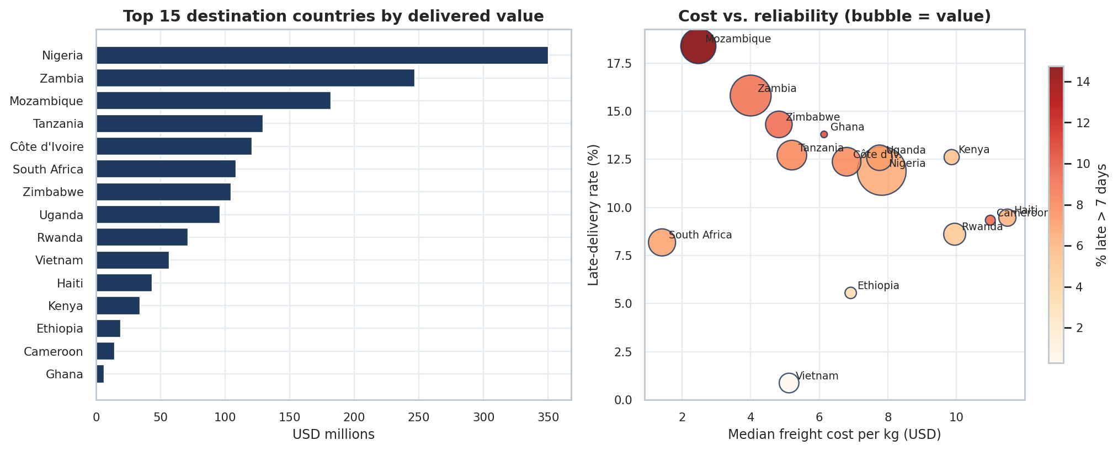
Figure 11. Top 15 countries by value (left) and cost versus reliability (right).
cc = df.groupby("country").agg(value=("line_value", "sum"), late=("late", "mean"),
fpk=("freight_per_kg", "median")).sort_values("value", ascending=False)
top = cc.head(15)
ax[1].scatter(top.fpk, top.late * 100, s=top.value / 1e6 * 4, c=top.late7 * 100, cmap="OrRd")

Interpretation. Delivered value is concentrated: the top five countries account for 63.3% of value, the top ten for 90.1%, and eight countries make up 80%. Nigeria is the largest market at USD 350.3 million. Mozambique, Zambia and Zimbabwe combine high value with the highest late rates among major markets (18.4%, 15.8% and 14.3%), though their freight per kg is relatively low ($2.5 to $4.8), consistent with proximity to the South African RDC. Haiti, Rwanda and Nigeria sit at the opposite corner, with high cost per kg and moderate lateness. Vietnam stands out as a model: 0.9% late at mid-range cost.

7.3 Country and mode interaction
Why this chart. A heatmap of a country-by-mode pivot reveals interaction effects that single-variable charts hide, and identifies specific lanes for corrective action. Cells with fewer than 15 lines are blank.
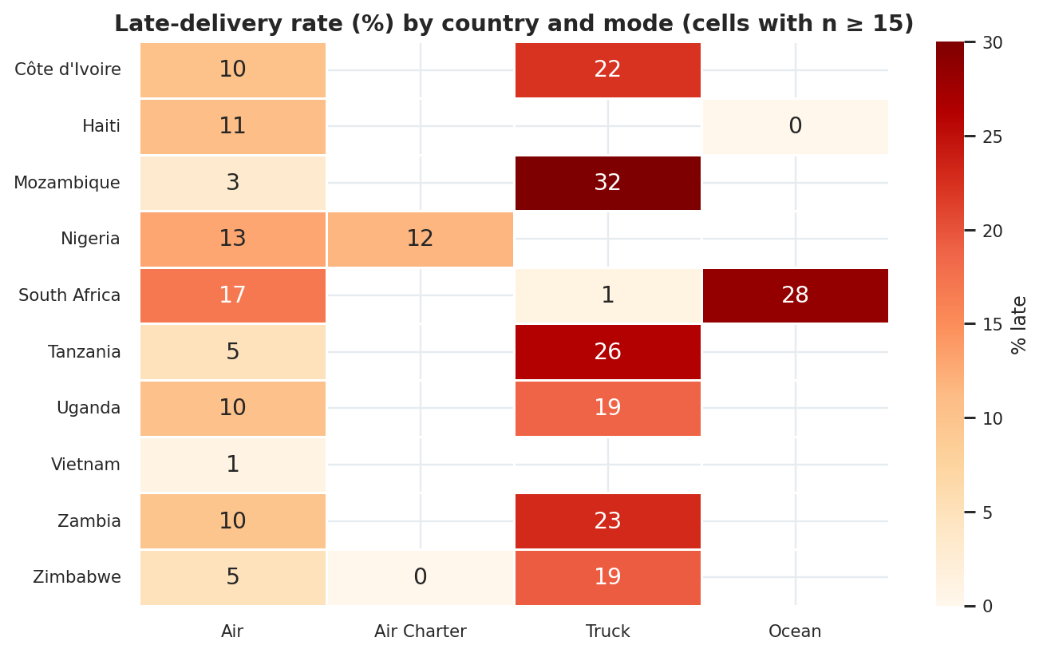
Figure 12. Late-delivery rate (%) by country and mode, top 10 countries.
hm = core[core.country.isin(top10)].pivot_table(index="country", columns="mode",
values="late", aggfunc="mean") * 100
sns.heatmap(hm.where(counts >= 15), annot=True, cmap="OrRd", vmin=0, vmax=30)

Interpretation. The hottest cells are truck lanes into neighbouring countries: Mozambique 32%, Tanzania 26%, Zambia 23%, Côte d'Ivoire 22%, Uganda 19% and Zimbabwe 19%, against 1% to 17% for air into the same countries. South African ocean shipments (28%) also stand out. By contrast, Direct Drop deliveries into the same markets are only 1% to 9% late across all modes, which points to the RDC outbound process (for example consolidation, dispatch, customs or carrier handover) rather than road transport itself; the dataset cannot say which step is responsible. These corridors are the logical pilot lanes for the reliability programme.

7.4 Supplier concentration and performance
Why this chart. A Pareto chart is the standard tool for concentration: it shows how few suppliers carry most of the value. The adjacent bar chart pairs concentration with performance so procurement can see whether the largest suppliers are also reliable.
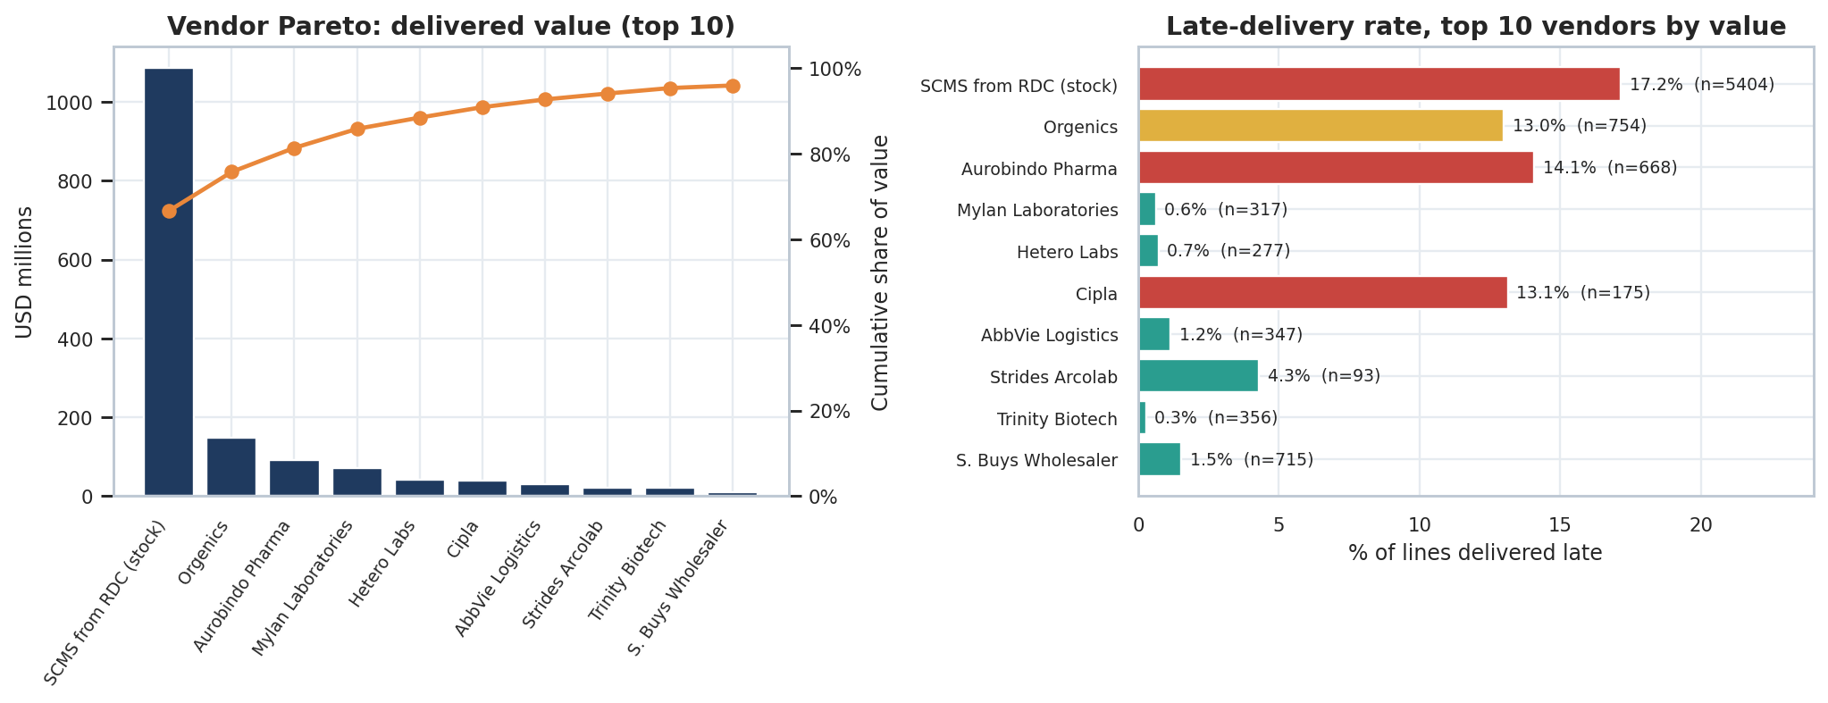
Figure 13. Supplier Pareto by value (left) and late rate for the top 10 (right).
vv = df.groupby("vendor").agg(value=("line_value", "sum"), late=("late", "mean"), lines=("ID", "count"))
vv = vv.sort_values("value", ascending=False)
vv["cum"] = vv.value.cumsum() / vv.value.sum() * 100
ax[0].bar(range(10), vv.value.head(10) / 1e6); axp.plot(range(10), vv.cum.head(10))

Interpretation. The RDC ("SCMS from RDC") is the largest single source at 66.7% of value; with the next two suppliers it reaches 81.4%. Among the 72 external suppliers, the top three supply 57.4% of external value and seven supply 80%. Reliability is sharply polarised: Orgenics (13.0% late, 754 lines), Aurobindo Pharma (14.1%, 668 lines) and Cipla (13.1%, 175 lines) are the weakest high-volume suppliers, while Mylan (0.6%), Hetero Labs (0.7%), AbbVie Logistics (1.2%) and Trinity Biotech (0.3%) are consistently on time. Supplier lateness can be partly due to lane or mode, so scorecards should compare suppliers on like-for-like lanes.

8. Drivers of Late Delivery
Why this chart. Mode, route, product, size and period are all correlated with each other, so one-at-a-time comparisons can mislead. A logistic regression estimates the effect of each factor while holding the others constant, and an odds-ratio chart ranks them on one scale.
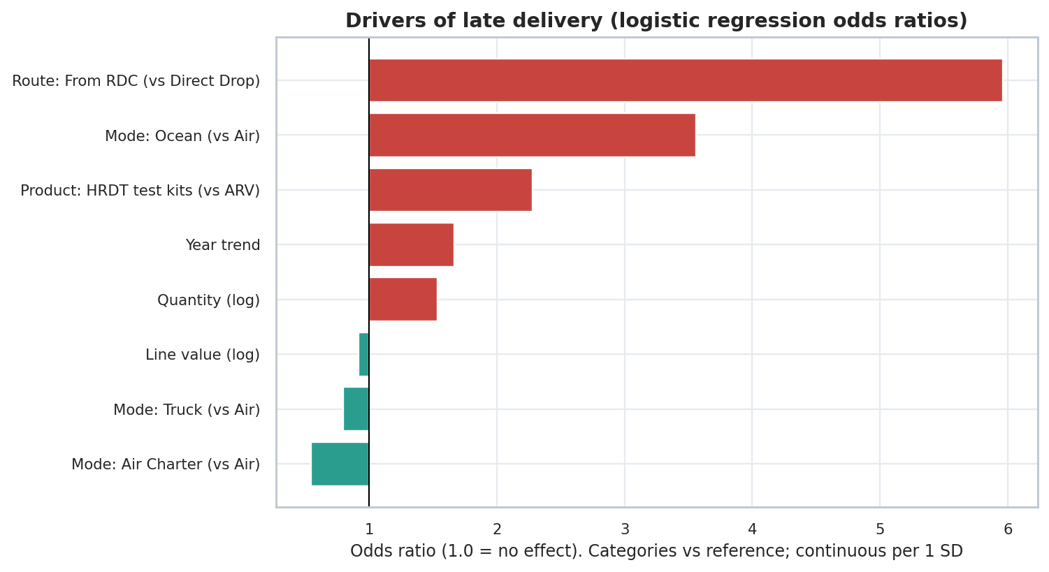
Figure 14. Odds ratios for late delivery (categorical variables versus their reference group; continuous variables per 1 SD).
from sklearn.linear_model import LogisticRegression
from sklearn.metrics import roc_auc_score
feat = pd.DataFrame({"mode_Truck": (d["mode"] == "Truck"), "mode_Ocean": (d["mode"] == "Ocean"),
"fulfill_via_From RDC": (d.fulfill_via == "From RDC"), ...}).astype(float)
lr = LogisticRegression(max_iter=2000, class_weight="balanced").fit(Xtr, ytr)
roc_auc_score(yte, lr.predict_proba(Xte)[:, 1]) # hold-out AUC
odds = np.exp(lr.coef_[0])

Factor | Odds ratio | Meaning
Fulfilment route: From RDC (vs Direct Drop) | 5.96 | Roughly six times the odds of lateness, after controlling for mode, product, size and year
Mode: Ocean (vs Air) | 3.56 | About 3.6 times the odds
Product: HRDT test kits (vs ARV) | 2.28 | About 2.3 times the odds once route and mode are held constant
Year trend (per SD, about 2.4 years) | 1.67 | Lateness has become more likely over time
Quantity (log, per SD) | 1.54 | Larger quantity lines are somewhat more likely to be late
Mode: Truck (vs Air) | 0.80 | Not a driver once the RDC route is controlled for
Mode: Air Charter (vs Air) | 0.54 | Lower odds than standard air
The model was fitted on 9,919 lines (ARV and HRDT with a recorded mode) and achieves a hold-out AUC of 0.781, which indicates useful but not exhaustive explanatory power. Important operational factors such as carrier, customs clearance and order timing are not in the dataset.
Interpretation. Controlling for the other factors changes the picture from the raw comparison. Truck is no longer a risk factor; the route is. Ocean remains a genuine risk because of long transit and a higher chance of severe delays. The upward time trend remains after controlling for route and mode, which supports a capacity or process explanation rather than a mix-shift explanation. Test kits are more likely to be late than ARVs once route and mode are accounted for, even though their raw late rate is lower; this is because HRDT shipments are mostly Direct Drop, which masks the underlying effect.

9. Consolidated Insights

9.1 Operational efficiency
- Headline reliability is good; the tail is not. 88.5% on or before schedule, but 766 lines were more than a week late and 230 more than 30 days.
- Performance deteriorated after 2009 and has not recovered. The late rate moved from about 2% to a 8.5% to 23.8% annual range.
- Lead time is lengthening. Median PO-to-delivery roughly doubled between 2009 and 2015.
- Reliability depends on route, not size. Delay is uncorrelated with value, weight or price; it is strongly associated with route (RDC), mode (ocean) and period.

9.2 Cost drivers
- Weight and mode explain most freight cost. Elasticity 0.439 on weight; truck and ocean are about 40% cheaper than air at equal weight.
- Scale pays. Doubling shipment weight cuts freight per kg by about 32%, so frequent small shipments are structurally expensive.
- Destination geography drives the rest. DRC, South Sudan, Haiti and Guyana pay 26% to 88% of commodity value in freight (median), compared with 3% to 6% for South Africa, Mozambique and Zambia.
- Air dominates spend. About 63% of directly reported freight spend is air.

9.3 Bottlenecks
- RDC outbound trucking corridors. Mozambique, Tanzania, Zambia, Côte d'Ivoire, Uganda and Zimbabwe are 19% to 32% late.
- Ocean freight. The longest lead time (167 days) and 9.7% of lines more than 30 days late.
- Three high-volume suppliers. Orgenics, Aurobindo and Cipla run 13% to 14% late.
- Data visibility. Freight cost is reported directly for only 60% of lines, mode is blank for 360 lines, and delivery dates show signs of default-filling.

10. Risk Register
Risks are rated on the evidence in this dataset. Likelihood is based on observed frequency; impact on the value or service consequence.
# | Risk | Likelihood | Impact | Evidence and mitigation direction
1 | RDC outbound delays | High | High | 17.2% late, 78% of all late value; address through carrier SLAs, dispatch cut-offs and corridor root-cause review
2 | Lengthening lead times | High | High | Median PO-to-delivery at 133 days in 2015; introduce lead-time targets and supplier milestone tracking
3 | Ocean shipment failure | Medium | High | 17.5% late, 9.7% more than 30 days; earlier booking, buffer stock and mode fallback rules
4 | Supplier concentration | Medium | High | RDC plus two suppliers hold 81% of value; qualify alternate sources for the top lines
5 | Weak supplier performance | Medium | Medium | Three suppliers at 13% to 14% late; scorecards and service-level clauses
6 | Freight cost in remote markets | High | Medium | Freight at 26% to 88% of value in DRC, South Sudan, Haiti, Guyana; consolidation and regional hubs
7 | Air spend dependence | Medium | Medium | 63% of direct freight spend is air; mode policy by urgency and weight
8 | Data quality and visibility | High | Medium | 40% of lines without direct freight, 61% of deliveries exactly on schedule; standardise data capture

11. Recommendations and Implementation Roadmap

11.1 Prioritised actions
# | Action | Evidence | Owner (role) | Target KPI
1 | RDC outbound reliability programme: lane-level root cause on late RDC lines, carrier SLAs, dispatch and handover controls, pilot on six truck corridors | RDC 17.2% late vs 5.3% Direct Drop; truck from RDC 23.2% late; 78% of late value | Head of Distribution / RDC manager | RDC late rate from 17.2% to 10% or less in 12 months; late > 7 days from 11.3% to 5%
2 | Lead-time governance: milestone tracking from PO to delivery, supplier lead-time targets, early-warning alerts | Median lead time 55 to 70 days (2007 to 2009) to 133 days (2015) | Procurement Director | Median PO-to-delivery 90 days or less
3 | Ocean freight controls: earlier booking windows, buffer stock for ocean-sourced lines, defined air fallback | 17.5% late, 9.7% more than 30 days, 167-day median lead time | Logistics Manager | Lines > 30 days late from 9.7% to 3%
4 | Freight consolidation and mode policy: minimum shipment weights, consolidate small air shipments, mode by urgency, regional rate negotiation for high-cost destinations | Elasticity 0.44 (doubling weight cuts cost per kg about 32%); air is 63% of freight spend | Freight and Finance Lead | Median freight per kg from $7.26 toward $6; freight below 5% of value
5 | Supplier scorecard and service-level clauses, starting with Orgenics, Aurobindo and Cipla; qualify second sources for top lines | Late rates 13% to 14% vs below 1% for peers; top 3 = 81% of value | Supplier Relationship Manager | Each top-10 supplier below 5% late
6 | Data and visibility: mandatory freight, weight and mode fields, audit of date capture, control-tower dashboard | Freight direct for 60% of lines; 61% of deliveries on the scheduled date | Supply Chain Analytics Lead | Freight and mode populated for 95% of lines

11.2 Phased roadmap
Phase | Activities | Outputs
0 to 3 months | Root-cause review of late RDC lines (2010, 2013, 2014 peaks); fix data fields (mode, freight, weight); publish baseline KPI dashboard | Baseline scorecard; list of top 20 problem lanes; data standard
3 to 9 months | Pilot RDC truck corridor improvements; supplier scorecards live; ocean booking rules; minimum shipment weight and consolidation trial | Pilot results on six corridors; supplier quarterly reviews; consolidation business case
9 to 18 months | Scale successful pilots network-wide; renegotiate freight rates and supplier SLAs; qualify second sources | Network-wide SLA framework; rate card by destination; supplier diversification plan

11.3 Indicative opportunity
If the RDC late rate fell from 17.2% to the Direct Drop level of 5.3%, about 640 fewer of the 5,404 RDC lines would have been late, which is 54% of all 1,186 late lines. Closing half of that gap would remove roughly 320 late lines. These are illustrative upper bounds based on historical data, and actual results depend on whether the RDC route can match the conditions of Direct Drop deliveries (for example, RDC lines are mostly trucked and serve urgent top-up demand).

11.4 Proposed KPI scorecard
KPI | Baseline | Target (12 months) | Definition / source
On-time or early delivery | 88.5% | 93% or more | Delivered date <= scheduled date
Late > 7 days | 7.4% | 4% or less | Delivered more than 7 days after schedule
Late > 30 days | 2.2% | 1% or less | Severe delay indicator
RDC late rate | 17.2% | 10% or less | From RDC lines late / RDC lines
Median PO-to-delivery (days) | 101.0 | 90 or less | Direct Drop lines with valid PO date
Median freight per kg (USD) | 7.26 | 6.00 | Direct freight lines
Value delivered late | 15.9% | 8% or less | Late value / total value

12. Limitations and Data Caveats
- Delivery dates. Over 61% of lines show delivery exactly on the scheduled date, and many also have identical recording dates. Delivered dates may in places have been filled from schedule, so the on-time rate is likely an upper bound.
- Freight coverage. Direct freight cost and weight are present for about 60% of lines. Lines with freight included in the commodity price or referenced to another line are excluded from cost analysis; results may not generalise to those lines.
- Association, not causation. Regression and test results show association. Route, mode and corridor are correlated, and unobserved factors (carrier identity, customs, order urgency, stock availability) are not in the data.
- Lead-time scope. PO-to-delivery time is available only for Direct Drop lines with valid dates (4,235 lines); RDC lead times cannot be assessed from this file.
- Historical period. The data covers 2006 to 2015. Conclusions describe that period and should be revalidated with current data before operational targets are fixed.
- Small groups. Product groups ACT, ANTM and MRDT (46 lines) and several small countries are too small for reliable comparison and are excluded from inference.

Appendix A: Country and Supplier Summary Tables

A.1 Top 12 destination countries by delivered value
Country | Lines | Value (USD m) | Late % | Late > 7 d % | Median freight / kg
Nigeria | 1,194 | 350.3 | 11.9 | 6.5 | 7.82
Zambia | 683 | 247.0 | 15.8 | 8.9 | 4.00
Mozambique | 631 | 182.0 | 18.4 | 14.7 | 2.47
Tanzania | 519 | 129.5 | 12.7 | 7.9 | 5.20
Côte d'Ivoire | 1,083 | 120.9 | 12.4 | 7.9 | 6.80
South Africa | 1,406 | 108.7 | 8.2 | 6.8 | 1.41
Zimbabwe | 538 | 104.4 | 14.3 | 9.1 | 4.82
Uganda | 779 | 96.2 | 12.6 | 6.9 | 7.76
Rwanda | 430 | 71.1 | 8.6 | 4.9 | 9.95
Vietnam | 688 | 57.0 | 0.9 | 0.3 | 5.12
Haiti | 655 | 43.5 | 9.5 | 6.1 | 11.49
Kenya | 111 | 33.9 | 12.6 | 5.4 | 9.86

A.2 Top 10 suppliers by delivered value
Supplier | Lines | Value (USD m) | Value share % | Late % | Late > 7 d %
SCMS from RDC (stock) | 5,404 | 1085.4 | 66.7 | 17.2 | 11.3
Orgenics | 754 | 147.7 | 9.1 | 13.0 | 5.2
Aurobindo Pharma | 668 | 91.4 | 5.6 | 14.1 | 10.2
Mylan Laboratories | 317 | 72.2 | 4.4 | 0.6 | 0.0
Hetero Labs | 277 | 42.9 | 2.6 | 0.7 | 0.0
Cipla | 175 | 39.7 | 2.4 | 13.1 | 12.0
AbbVie Logistics | 347 | 29.4 | 1.8 | 1.2 | 1.2
Strides Arcolab | 93 | 22.5 | 1.4 | 4.3 | 2.2
Trinity Biotech | 356 | 20.8 | 1.3 | 0.3 | 0.3
S. Buys Wholesaler | 715 | 9.9 | 0.6 | 1.5 | 0.7

A.3 Mode summary
Mode | Lines | Value (USD m) | Late % | Late > 7 d % | Late > 30 d % | Median freight / kg
Air | 6,113 | 627.3 | 9.6 | 5.8 | 1.9 | 10.02
Air Charter | 650 | 246.4 | 11.5 | 6.5 | 0.8 | 4.32
Truck | 2,830 | 587.4 | 16.1 | 10.9 | 2.5 | 2.50
Ocean | 371 | 126.2 | 17.5 | 15.6 | 9.7 | 1.68
Not recorded | 360 | 40.4 | 1.1 | 0.6 | 0.3 | 4.65

Appendix B: Reproducing the Analysis
The complete Python script (scms_analysis.py) cleans the raw file, computes every KPI and statistic quoted in this report, fits both models and writes the 14 figures and the cleaned dataset (scms_cleaned.csv). The core structure is shown below.
import numpy as np, pandas as pd, matplotlib.pyplot as plt, seaborn as sns
from scipy import stats
from sklearn.linear_model import LogisticRegression

df = load_clean("Raw_Data.csv") # cleaning steps in Section 3.3

# KPIs
on_time = df.on_time.mean() * 100 # 88.5
late7 = df.late_gt7.mean() * 100 # 7.4
value_late = df.loc[df.late == 1, "line_value"].sum() / df.line_value.sum() * 100 # 15.9

# Segment KPI table
seg = df.groupby("fulfill_via").agg(lines=("ID", "count"), late=("late", "mean"),
late7=("late_gt7", "mean"), fpk=("freight_per_kg", "median"))

# Run: python scms_analysis.py -> figs/*.png, stats.json, scms_cleaned.csv

