
JOINT MILITARY TRAINING

Introduction to Computing and Computers

Department of Computer Science

Chief Editor
Brig Raza Muhammad Khan

Editor
Lt Col Shakir Ali Khan

Sub Editor
Maj Rehan
Capt Waqas Abbasi

Pakistan Military Academy Kakul, Abbottabad

TABLE OF CONTENTS
Ser | Topic | Page No
Chapter 1: Introduction to Computer |  | 1-17
 | Characteristics of Computer
 | Evolution of Computers
 | Classification of Computers
 | Basic Computer Organization
Chapter 2: Number System |  | 18-26
 | Binary Number System
 | Octal and Hexadecimal Number System
 | Converting from Decimal to Binary, Octal and Hexadecimal
 | Computer Coding Systems
 | Logic Gates
Chapter 3: Operating System |  | 27-40
 | Intro and Main functions of OS
 | Types of OS
 | Mobile OS
 | Latest OS and their comparison
Chapter 4: Introduction to Programming |  | 41-51
 | Machine, Assembly and Algorithmic Languages
 | Business Oriented Languages
 | Education Oriented and Object Oriented Languages
 | Characteristics of Languages
 | Generations of Languages
 | Language Translators
Chapter 5: Introduction to Networks |  | 52-56
 | Importance of Computer Networks
 | Basic Networking Terminologies
Chapter 6: Introduction to Databases |  | 57-64
 | Data and its Importance in Organization
 | Database and Database Management System
 | Overview of Structured Query Language
Chapter 7: Internet and Web Publishing |  | 65-75
 | WWW and Web Browser
 | Downloading and Uploading
 | HTML
 | Hacking, Cloud Computing, IOT and Block Chain
 | Artificial Intelligence, Machine learning and Big Data
Chapter 8: Microsoft Word |  | 76-86
 | Brief History of MS Word
 | Difference Between Word 2003 and Word 2010
 | How to Create, Open and Save a New Document
 | Cut, Copy, Paste and Formatting Text.
 | Formatting Documents
 | Table
 | Print Preview
Chapter 9: Microsoft PowerPoint |  | 86-102
 | Intro to MS PowerPoint
 | Design Ribbon Toolbar
 | Inserting and adding objects in Presentation
 | Animating Text and Objects
 | Transitions
 | Master Slides
 | Hyperlink
 | Customizing Slide Show
 | Packaging a Presentation on a CD
Chapter 10: Microsoft Excel |  | 103-125
 | Brief History of MS Excel
 | How to Create, Open and Save a New Document
 | Select Cells or Ranges
 | Modifying Spreadsheets
 | Formulas in MS Excel
 | Charts in MS Excel
 | Conditional Formatting
 | Sorting in MS Excel
 | Data validation
 | MS Excel keyboard shortcuts
Chapter 11: CI Awareness |  | 126-146
 | Virus and Antivirus
 | The Intelligence Threat
 | Glossary of terminologies
 | Hostile Espionage Effort
 | Preventive Measures against Hostile Espionage Effort

FOREWORD
In today’s rapidly evolving military landscape, the integration of computer science plays a pivotal role in enhancing operational effectiveness, decision-making and strategic planning. As technology continues to advance, armed forces around the globe are increasingly reliant on sophisticated systems that leverage data analysis, cyber security and network communications.
The intersection of computer science and military operations not only transforms traditional warfare but also enables new forms of deterrence and defense. As we navigate these complex challenges, it is essential for military personnel and policy makers to understand the foundational principles of computer science. This knowledge empowers Gentlemen Cadets to effectively implement technological innovations, optimize resource allocation and enhance mission readiness. The future of military operations will undoubtedly hinge on the successful integration of computer science, making it imperative for all levels of command to embrace this transformative discipline.
The compilation of this book would certainly help Gentlemen Cadets meet minimum required standards of most essential official work. I feel delighted to express my deep appreciation to the Computer Science Department for compiling useful reference material in the form of this valuable book.

Kakul  October 2025 | Major General  Commandant  (Iftikhar Hassan Chaudhary)

PREFACE
In an era where collaboration and shared learning are increasingly recognized as vital components of educational success, we are pleased to present a syllabus designed to cater for the needs of three distinct academies, each bringing unique strengths to the table. This syllabus is crafted to serve sister academies who will be joining PMA for their 1st term, fostering a unified approach to learning and promoting a sense of harmony among cadets and educators alike.
The primary goal of this syllabus is to ensure a smooth transition for all cadets, allowing them to adapt to a new learning environment while benefiting from the diverse expertise that each academy offers. By studying a common syllabus, cadets will not only gain the essential knowledge required for their academic progression but also mutual support.
This syllabus is a product of careful consideration of the educational needs of all three academies, ensuring that it meets the highest standards of academic excellence while also encouraging the sharing of best practices. It is our belief that this collaborative approach will enhance the learning experience for all cadets of three academies, helping them to develop a broader perspective and a deeper understanding of the subjects they study.
At the Computer Science Department, we pride ourselves on fostering an environment that nurtures innovation, critical thinking and collaboration. As a discipline that sits at the intersection of theory and practice, computer science is at the heart of technological advancement, impacting industries ranging from healthcare to finance, entertainment to education.
We are confident that this initiative will not only benefit the cadets academically but also foster a spirit of cooperation and mutual respect that will serve them well beyond the halls of study.

Kakul  October 2025 | Brigadier  Director of Studies  (Raza Muhammad Khan)

INTRODUCTION TO COMPUTERS
- The word “computer” comes from the word “compute”, which means, “to calculate”. Hence, people usually consider a computer to be a calculating device that can perform arithmetic operations at high speed. In fact the original objective for inventing the computer was to create a fast calculating machine. However, more than 80% of work done by computers today is of non-mathematical or non-numerical nature. Hence, to define a computer merely as a calculating device is to ignore 80% of its functions. More accurately, we can define a computer as a device that operates upon data. Data can be anything like bio-data of applicants when computer is used for short-listing candidates for recruiting; marks obtained by students in various subjects when used for preparing results; details (name, age, gender, etc.) of passengers when used for making airline or railway reservations; or number of different parameters when used for solving scientific research problems, etc.
- Hence, data comes in various shapes and sizes depending upon the type of computer application. A computer can store, process, and retrieve data as and when desired. The fact that computers process data is so fundamental that many people have started calling it a data processor. The name data processor is more inclusive because modern computers not only compute in the usual sense but also perform other functions with data that flows to and from them. For example, data processors may gather data from various incoming sources, merge them all, sort them in the desired order, and finally print them in desired format. Notice that none of these operations involves arithmetic computations in the usual sense but a computer is the most suitable device for performing them.
- The activity of processing data using a computer is called data processing. Data processing consists of three sub activities: capturing input data, manipulating the data, and managing output results. As used in data processing, information is data arranged in an order and form that is useful to people receiving it. Hence, data is raw material used as input to data processing and information is processed data obtained as output of data processing.
Characteristics of Computers
- Increasing popularity of computers has proved that it is a very powerful and useful tool. The power and usefulness of this popular tool are mainly due to its following characteristics:
a. Automatic. An automatic machine works itself without human intervention. Computers are automatic machines because once started on a job, they carry out the job until it is finished. However, computers being machines cannot start themselves and cannot go out and find their own problems and solutions. We need to instruct a computer using coded instructions that specify exactly how it will do a particular job. Some of the other characteristics of computers (such as speed and accuracy) are because they are automatic, and work on a problem without any human intervention.
b. Speed. A computer is a very fast device. It can perform in a few seconds, the amount of work that a human being can do in an entire year – if he/she worked day and night and did nothing else. In other words, a computer can do in a few minutes what would take a man his entire lifetime.
c. Accuracy. In addition to being very fast, computers are very accurate. Accuracy of a computer is consistently high and the degree of its accuracy depends upon its design. A computer performs every calculation with the same accuracy. However, errors occur in computer. These errors are mainly due to human rather than technological weaknesses. For example, errors may occur due to imprecise thinking by a programmer or incorrect input data.
d. Diligence. Unlike human beings, a computer is free from monotony, tiredness, and lack of concentration. It can continuously work for hours without creating any error and without grumbling. Hence, computers score over human beings in doing routine types of jobs that require great accuracy. If ten million calculations have to be performed, a computer will perform the last one with exactly the same accuracy and speed as the first one.
e. Versatility. Versatility is one of the most wonderful things about the computer. One moment it is preparing results of an examination, next moment it is busy preparing electricity bills, and in between, it may be helping an office secretary to trace an important letter in seconds. All that is required to change its talent is to slip in a new program into it. In brief, a computer is capable of performing almost any task, if the task can be reduced to a finite series of logical steps.
f. Power of Remembering. As a human being acquires new knowledge, his/her brain subconsciously selects what it feels to be important and worth retaining in memory. The brain relegates unimportant details to back of mind or just forgets them. This is not the case with computers. A computer can store and recall any amount of information because of its secondary storage capability. It can retain a piece of information as long as a user desires and the user can recall the information whenever required.
g. No Feelings. Computers are devoid of emotions. They have no feelings and no instincts because they are machines. Although men have succeeded in building a memory for computer, but no computer possesses the equivalent of a human heart and soul. Based on our feelings, taste, knowledge, and experience we often make certain judgments in our day-to-day life whereas, computers cannot make such judgments on their own. They make judgments based on the instructions given to them in the form of programs that are written by human beings.
Evolution of Computer
- The history of computer development is often referred to in reference to the different generations of computing devices. A generation refers to the state of improvement in the product development process. This term is also used in the different advancements of new computer technology. With each new generation, the circuitry has gotten smaller and more advanced than the previous generation before it. As a result of the miniaturization, speed, power, and computer memory has proportionally increased. New discoveries are constantly being developed that affect the way we live, work and play.
- Each generation of computers is characterized by major technological development that fundamentally changed the way computers operate, resulting in increasingly smaller, cheaper, and more powerful and more efficient and reliable devices. Overview of the major developments and technologies during the five generations of computer is as follows:
  - First Generation (1940-1956: Vacuum Tubes). The first computers used vacuum tubes for circuitry and magnetic drums for memory, and were often enormous, taking up entire rooms. They were very expensive to operate and in addition to using a great deal of electricity, generated a lot of heat, which was often the cause of malfunctions. First generation computers relied on machine language, the lowest-level programming language understood by computers, to perform operations, and they could only solve one problem at a time. Input was based on punched cards and paper tape, and output was displayed on printouts. The UNIVAC and ENIAC computers are examples of first-generation computing devices. The UNIVAC was the first commercial computer delivered to a business client, the U.S. Census Bureau in 1951.
b. Second Generation (1956-1963: Transistors). Transistors replaced vacuum tubes and ushered in the second generation of computers. The transistor was invented in 1947 but did not see widespread use in computers until the late 1950s. The transistor was far superior to the vacuum tube, allowing computers to become smaller, faster, cheaper, more energy-efficient and more reliable than their first-generation predecessors. Though the transistor still generated a great deal of heat that subjected the computer to damage, it was a vast improvement over the vacuum tube. Second-generation computers still relied on punched cards for input and printouts for output.
c. Third Generation (1964-1971: Integrated Circuits). The development of the integrated circuit was the hallmark of the third generation of computers. Transistors were miniaturized and placed on silicon chips, called semiconductors, which drastically increased the speed and efficiency of computers. Instead of punched cards and printouts, users interacted with third generation computers through keyboards and monitors and interfaced with an operating system, which allowed the device to run many different applications at one time with a central program that monitored the memory. Computers for the first time became accessible to a mass audience because they were smaller and cheaper than their predecessors.
d. Fourth Generation (1971-Present: Microprocessors). The microprocessor brought the fourth generation of computers, as thousands of integrated circuits were built onto a single silicon chip. What in the first generation filled an entire room could now fit in the palm of the hand. The Intel 4004 chip, developed in 1971, located all the components of the computer—from the central processing unit and memory to input/output controls—on a single chip. In 1981 IBM introduced its first computer for the home user, and in 1984 Apple introduced the Macintosh. Microprocessors also moved out of the realm of desktop computers and into many areas of life as more and more everyday products began to use microprocessors. As these small computers became more powerful, they could be linked together to form networks, which eventually led to the development of the Internet. Fourth generation computers also saw the development of GUIs, the mouse and handheld devices.
e. Fifth Generation (Present and Beyond: Artificial Intelligence). Fifth generation computing devices, based on artificial intelligence, are still in development, though there are some applications, such as voice recognition, that are being used today. The use of parallel processing and superconductors is helping to make artificial intelligence a reality. Quantum computation and molecular and nanotechnology will radically change the face of computers in years to come. The goal of fifth-generation computing is to develop devices that respond to natural language input and are capable of learning and self-organization.
Classification of Computers
- Computers may be classified based on the following:-
- Operating principles (based on their construction and working)
- Applications
- Size and capability (or classification into micro, mini, mainframe and supercomputers)
- Number of Microprocessors
- Word length
- Number of users
- Classification Based on Operating Principles. Based on the operating principles, computers can be classified into one of the following types:
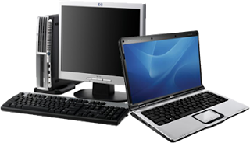
a. Digital Computers. Operate essentially by counting. All quantities are expressed as discrete or numbers. Digital computers are useful for evaluating arithmetic expressions and manipulations of data (such as preparation of bills, ledgers, solution of simultaneous equations etc.)
b. Analog Computers. An analog computer is a form of computer that uses the continuously changeable aspects of physical phenomena such as electrical and mechanical quantities to model the problem being solved. In contrast, digital computers represent varying quantities symbolically, as their numerical values change.
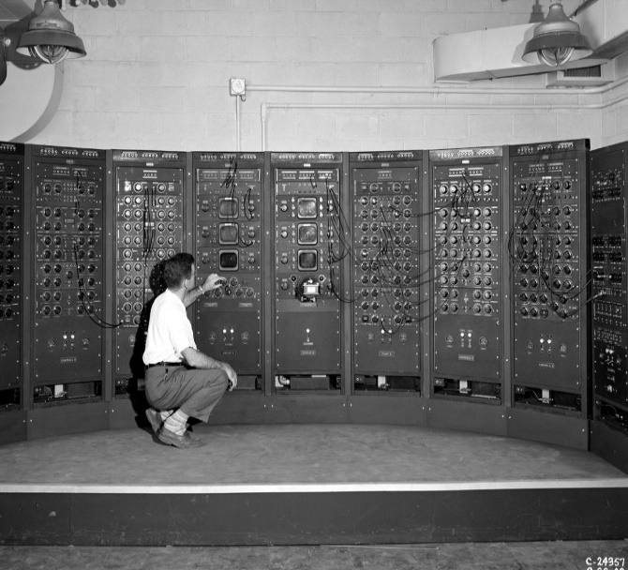

c. Hybrid Computers. Hybrid computers are computers that exhibit features of analog computers and digital computers. The digital component normally serves as the controller and provides logical operations, while the analog component normally serves as a solver of differential equations.
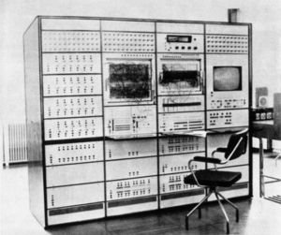

- Classification Based on Area of Applications. Modern computers depending upon their applications are classified as:-
- Special Purpose Computers. A special purpose computer is designed only to meet the requirements of a particular task or application. The instructions needed to perform a particular task are permanently stored into the internal memory, so that it can perform the given task on a single command. It therefore doesn’t possess unnecessary options and is less expensive.
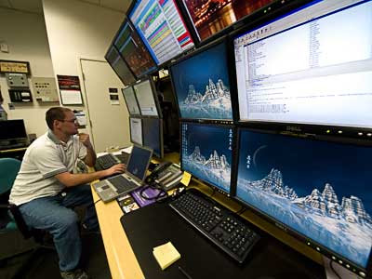

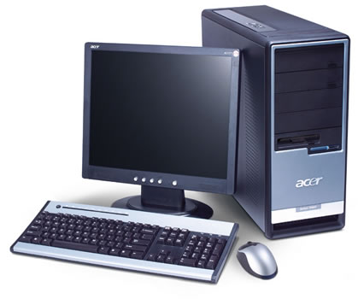
b. General Purpose Computers. General Purpose computers are designed to meet the needs of many different applications. In these computers, the instructions needed to perform a particular task are wired permanently into the internal memory. When one job is over, instructions for another job can be loaded into the internal memory for processing. This machine can be used to prepare pay-bills, manage inventories, and print sales report and so on.
10. Classification Based on Size and Capability. Based on size and capability, computers are broadly classified into following:
a. Microcomputers (Personal Computer). A microcomputer is the smallest general purpose processing system. The older pc started 8bit processor with speed of 3.7MB and current pc 64bit processor with speed of 4.66 GB. Microcomputer can be classified into 2 types:
(1) Desktop. The difference is portable can be used while travelling whereas desktop computer cannot be carried around.
(2) Portable. The different portable computers are:
(a) Laptop. This computer is similar to a desktop computers but the size is smaller. They are expensive than desktop. The weight of laptop is around 3 to 5 kg.
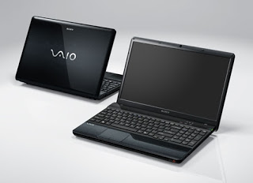

(b) Notebook. These computers are as powerful as desktop but size of these computers are comparatively smaller than laptop and desktop. They weigh 2 to 3 kg. They are more costly than laptop.
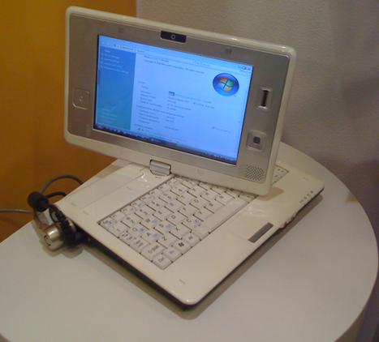
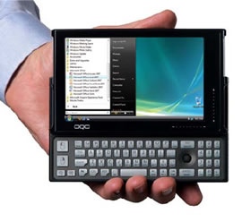
(c) Palmtop (Hand held). They are also called as personal Digital Assistant (PDA). These computers are small in size. They can be held in hands. It is capable of doing word processing, spreadsheets and hand writing recognition, game playing, faxing and paging. These computers are not as powerful as desktop computers.

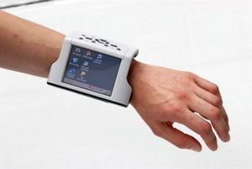
(d) Wearable Computer. The size of this computer is very small so that it can be worn on the body. It has smaller processing power. It is used in the field of medicine. For example, pacemaker to correct the heart beats. Insulin meter to find the levels of insulin in the blood.
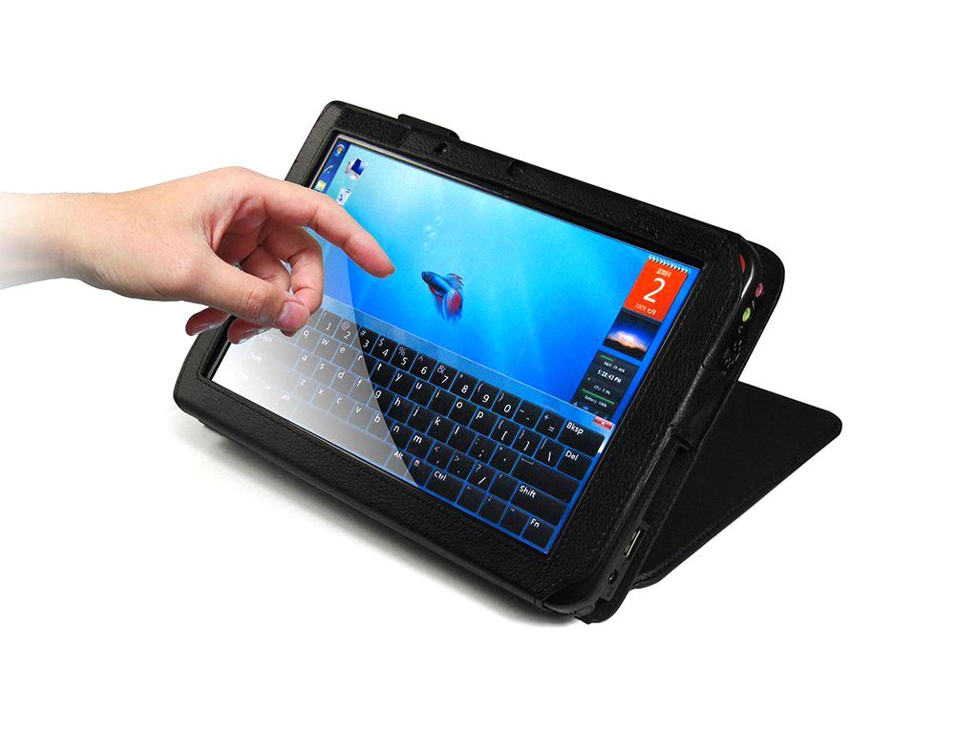
- Minicomputers. A minicomputer is a medium-sized computer. That is more powerful than a microcomputer. These computers are usually designed to serve multiple users simultaneously (Parallel Processing). They are more expensive than microcomputers. Examples: Digital Alpha, Sun Ultra.

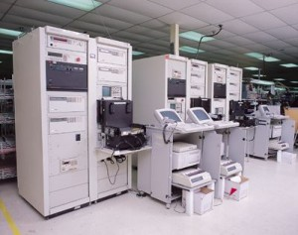
c. Mainframe Computers. Computers with large storage capacities and very high speed of processing (compared to mini- or microcomputers) are known as mainframe computers. They support a large number of terminals for simultaneous use by a number of users like ATM transactions. They are also used as central host computers in distributed data processing system Examples:- IBM 370, S/390.
d. Supercomputer. Supercomputers have extremely large storage capacity and computing speed, many times faster than other computers. A supercomputer is measured in terms of tens of millions Instructions per second (mips). The supercomputer is mainly used for large scale numerical problems in scientific and engineering disciplines such as Weather analysis.
Examples: - IBM Deep Blue
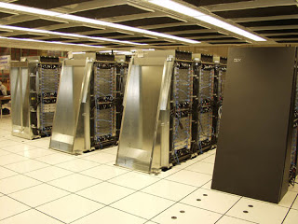

11. Classification Based on Number of Microprocessor. Based on the number of microprocessors, computers can be classified into following:
a. Sequential Computers. Any task complete in sequential computers is with one microcomputer only. Most of the computers (today) we see are sequential computers where in any task is completed sequentially instruction after instruction from the beginning to the end.
b. Parallel Computer. The parallel computer is relatively fast. New type of computers that use a large number of processors. The processors perform different tasks independently and simultaneously thus improving the speed of execution of complex programs dramatically. Parallel computers match the speed of supercomputers at a fraction of the cost.
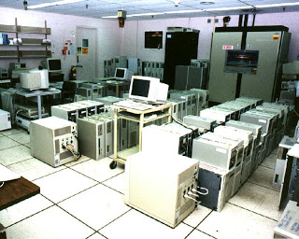

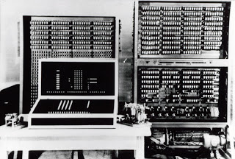
12. Classification Based on Word-Length. A binary digit is called “BIT”. A word is a group of bits that is fixed for a computer. The number of bits in a word (or word length) determines the representation of all characters in these many bits. Word length lies in the range from 16-bit to 64-bits of most computers of today.
13. Classification Based on Number of Users. Based on number of users, computers are classified into following:
a. Single User. Only one user can use the resource at any time.
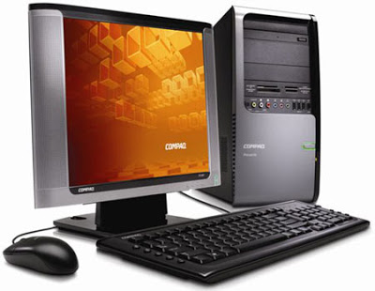

b. Multi User. A Multi User computer shared by a number of users at any time
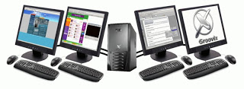

c. Network. A number of interconnected autonomous computers shared by a number of users at any time.
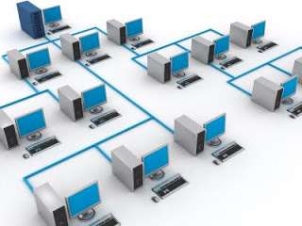

Basic Computer Organization
14. Even though the size, shape, performance, reliability, and cost of computers have been changing over the years, the basic logical structure, as proposed by Von Neumann, has not changed. No matter what shape and size of computer we are talking about, all computer systems perform the following five basic operations for converting raw input data into useful information and presenting it to a user:
a. Input. Process of entering data and instructions into a computer system.
b. Storing. Saving data and instructions to make them readily available for initial or additional processing as and when required.
c. Processing. Performing arithmetic operations (add, subtract, multiply, divide, etc.), or logical operations (comparisons, like equal to, less than, greater than, etc.) on data to convert them into useful information.
d. Output. Process of producing useful information or results for a user, such as printed report or visual display.
e. Controlling. Directing the manner and sequence in which the above operations are performed.
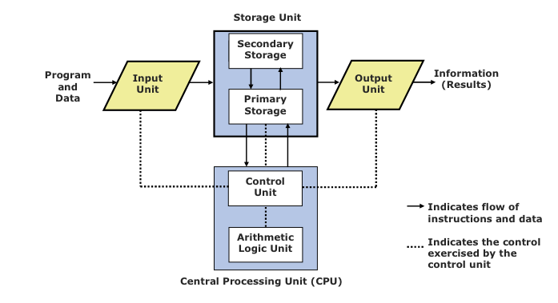
15. Internal architecture of computers differs from one system model to another. However, basic organization remains the same for all computer system.

16. Input Unit. Data and instructions must enter a computer system before the computer can perform any computations on the supplied data. The input unit that links a computer with its external environment performs this task. Data and instructions enter a computer through an input unit in a form that depends upon the input device used. For example, data can be entered using a keyboard in a manner similar to typing and this differs from the way in which data is entered through a scanner, another type of input device. However, a computer’s memory is designed to accept input in binary code and hence, all input devices must transform input signals to binary codes. In short, an input unit performs following functions:-
a. It accepts (or reads) instructions and data from outside world.
b. It converts these instructions and data in computer acceptable form.
c. It supplies the converted instructions and data to computer system for further processing.
17. Output Unit. An output unit performs the reverse operation of that of an input unit. It supplies information obtained from data processing to output world. Hence, it links a computer with its external environment. As computers work with binary code, results produced are also in binary form. Therefore, before supplying the results to outside world, the system must convert them to human acceptable (readable) form. In short, an output unit performs following functions:
a. It accepts the results produced by a computer, which are in coded form and hence, we cannot easily understand them.
b. It converts these coded results to human acceptable (readable) form.
c. It supplies the converted results to outside world.
18. Storage Unit. Data and instructions entered into a computer system through input units have to be stored inside the computer before actual processing starts. Similarly, results produced by a computer system before being passed on to an output unit. Moreover, a computer must also preserve intermediate results for ongoing processing. Storage unit of a computer system caters to all these needs. It provides space for storing data and instructions, intermediate results, and results for output. In short, a storage unit holds (stores):
a. Data and instructions required for processing (received from input devices).
b. Intermediate results of processing.
c. Results for output, before they are released to an output device.
19. Storage unit of all computers is comprised of following two types of storage:
a. Primary Storage. Primary storage of a computer, also known as its main memory, is used to hold pieces of program instructions and data, intermediate results of processing, and recently produced results of those job(s) on which the computer is currently working. These pieces of information are represented electronically in the main memory chip’s circuitry and while it remains in the main memory, central processing unit can access it directly at a very fast speed. However, primary storage can hold information only while computer system is on. As soon as the computer system switches off or resets, the information held in primary storage is erased. Moreover, primary storage normally has limited storage capacity because it is very expensive. Primary storage of modern computer systems is made of semiconductor devices.
b. Secondary Storage. Secondary storage of a computer, also known as its auxiliary storage, is used to take care of the limitations of primary storage. That is, it supplements the limited storage capacity and the volatile characteristics of primary storage. This is because secondary storage is much cheaper than primary storage and it can retain information even when a computer system switches off or resets. Secondary storage holds the program instructions, data, and information of those jobs on which the computer system is currently not working but needs to hold them for processing later. Magnetic disk is the most commonly used secondary storage medium.
20. Arithmetic Logic Unit. Arithmetic logic unit (ALU) of a computer system is the place where actual execution of instructions takes place during processing operation. To be more precise, calculations are performed and all comparisons (decisions) are made in the ALU. Data and instructions stored in primary storage before processing and transferred as and when needed to the ALU where processing takes place. Intermediate results generated in the ALU are temporarily transferred back to primary storage until needed later. Hence, data may move from primary storage to ALU and back again to storage many times before processing is over.
21. Control Unit. How does an input device know that it is time for it to feed data to storage unit? How does the ALU know what should be done with the data once they are received? Moreover, how it is that only results for output are sent to an output device and not the intermediate results? All this is possible due to the control unit of the computer system. Although, it does not perform any actual processing on data, the control unit acts as a central nervous system for other components of a computer system. It manages and coordinates the entire computer system. It obtains instructions from the program stored in main memory, interprets the instructions, and issue signals causing other units of the system to execute them.
22. Central Processing Unit. Control unit (CU) and arithmetic logic unit (ALU) of a computer system are together known as the central processing unit (CPU). The CPU is the brain of a computer system. In a human body, the brain takes all major decisions and other parts of the body function as directed by the brain. Similarly, in a computer system, all major calculations and comparisons take place inside the CPU and the CPU is responsible for activating and controlling the operations of other units of the computer system.
NUMBER SYSTEMS
1. A computer stores data internally in a format that is not easily readable by human beings. This is the reason why input and output (I/O) interfaces are required. Every computer stores numbers, letters, and other special characters in coded form. Before doing into the detail of these codes it is essential to have a basic understanding of number system.
Binary Number System
2. Binary number system is like decimal number system, except that the base is 2, instead of 10. We can only use two symbols or digits (0 or 1) in this number system. Each position in a binary number represents a power of the base (2). Hence, in this system, the rightmost position is units (2⁰) position, the second position from the right is 2’s (2¹) position, and proceeding in this way, we have 4’s (2²) position, 16’s (2⁴) position, and so on. Therefore, decimal equivalent of binary number 10101 (written as 10101₂) is:
(1 x 2⁴) + (0 x 2³) +(1 x 2²) + (1 x 2¹) + (1 x 2⁰) = 16 + 0 + 4 + 0 + 1 = 21
3. In order to be specific about which system we are referring to, it is a common practice to indicate the base as a subscript. Hence, we write:
10101₂ = 21₁₀
4. The short form of “binary digit” is bit. Hence, a bit in computer terminology means either a 0 or 1. An n-bit number is a binary number consisting of ‘n’ bits. Remember that we have only two digits, 0 and 1, in binary number system and hence, binary equivalent of decimal number 2 has to be stated as 10 (read as one, zero). Another important point to note is that with 3 bits (positions), only 8 (2³) different patterns of 0s and 1s are possible. In fact, any decimal number in the range 0 to 2 ^{n-1} can be represented in binary form as an n-bit number.
Octal Number System
5. In octal number system, the base is 8. Hence, there are only eight digit symbols or digits: 0, 1, 2, 3, 4, 5, 6, and 7 (8 and 9 do not exist in this system). The largest single digit is 7 (one less than the base 8). Each position in an octal number represents a power of the base (8). Therefore, decimal equivalent of octal number 2057 (written as 2057₈) is:
(2 x 8³) + (0 x 8²) + (5 x 8¹) + (7 x 8⁰) = 1024 + 0 + 40 + 7 = 1071
Hence, 2057₈ = 1071₁₀
Converting from One Number System to Another
7. Numbers expressed in decimal number system are much more meaningful to us, than are numbers expressed in any other number system. This is because we have been using decimal numbers in our day-to-day life, right from childhood. However, we can represent any number system in any other number system. Because the input and final output values are to be in decimal, computer professionals are often required to convert numbers in other number systems to decimal and vice-versa. Many methods can be used to convert numbers from one base to another. A method of converting from another base to decimal, and a method of converting from decimal to another base are described below:
8. Converting from Another Base to Decimal. Following steps are used to convert a number in any other base to base 10 (decimal) number:
a. Step 1. Determine the column (positional) value of each digit (this depends on the position of the digit and the base of the number system.
b. Step 2. Multiply the obtained column values (in step 1) by the digits in the corresponding columns.
c. Step 3. Sum up the products calculated in step 2. The total is the equivalent value in decimal.
9. Example. 11001 = ?₁₀
Solution:
- Step 1. Determine column values
Column Number Column Value
(from right)
- 2⁰ = 1
- 2¹ = 2
- 2² = 4
- 2³ = 8
- 2⁴ = 16
- Step 2. Multiply the column values by the corresponding column digits.
16 8 4 2 1
x1 x1 x0 x0 x1
____________________________________
16 8 0 0 1
____________________________________
- Step 3. Sum up the products
16 + 8 + 0 + 0 + 1 = 25
Hence, 11001₂ = 25₁₀
11. Converting from Decimal to Another Base. Following steps are used to convert a base 10 (decimal) number to a number in another base:
a. Step 1. Divide the decimal number by the value of the new base.
b. Step 2. Record the remainder from Step 1 as the rightmost digit (least significant digit) of the new base number.
c. Step 3. Divide the quotient of the previous division by the new base.
d. Step 4. Record the reminder from Step 3 as the next digit (to the left) of the new base number.
12. Repeat steps 3 and 4, recording remainders from right to left, unit the quotient becomes zero in step 3. Note that the last remainder, thus obtained, will be the most significant digit of the new base number.
13. Example. 25₁₀ = ?₂
Step 1 and 2. 25/2 = 12 and remainder 1
Step3 and 4. 12/2 = 6 and remainder 0
Step 3 and 4. 6/2 = 3 and remainder 0
Step 3 and 4. 3/2 = 1 and remainder 1
Step 3 and 4. 1/2 = 0 and remainder 1
The remainders are now arranged in the reverse order, making the first remainder the least significant digit (LSD) and the last remainder the most significant digit (MSD).
Hence, 25₁₀ =11001₂
14. Example. 42₁₀ = ?₂
2 | 42 | Remainders
 | 21 | 0
 | 10 | 1
 | 5 | 0
 | 2 | 1
 | 1 | 0
 | 0 | 1
Hence, 42₁₀ = 100101₂
15. Example. 952₁₀ = ?₈
8 | 952 | Remainders
 | 119 | 0
 | 14 | 7
 | 1 | 6
 | 0 | 1
Hence, 952₁₀ = 1670₈
Computer Coding Systems
17. To represent numeric, alphabetic, and special characters in a computer's internal storage and on magnetic media, we must use some sort of coding system. In computers, the code is made up of fixed size groups of binary positions. Each binary position in a group is assigned a specific value; for example 8, 4, 2, or 1. In this way, every character can be represented by a combination of bits that is different from any other combination. In this section you will learn how the selected coding systems are used to represent data. The coding systems included are:
a. Binary Coded Decimal Numbers (BCD). BCD is one of the early computer codes. The idea of this coding scheme is to convert each digit of a decimal number into its binary equivalent instead of converting the entire decimal value in to a binary number. This makes the conversion process easier.
DECIMAL DIGITS | BCD EQUIVALENT
0 | 0000
1 | 0001
2 | 0010
3 | 0011
4 | 0100
5 | 0101
6 | 0110
7 | 0111
8 | 1000
9 | 1001
Above table shows BCD equivalent of each decimal digit. Since 8 and 9 requires 4 bits, all decimal digits are represented in BCD by 4 bits. As 42₁₀ is equal to 101010₂, converting 42₁₀ into BCD, however, produces the following result:
42₁₀ = 0100 0010 or 01000010 in BCD
4 2
Note that each decimal digit is independently converted to a 4-bit binary number, and hence, the conversion is very easy. Also note that when four bits are used, altogether 16 (2⁴) combinations are possible. However, from the above table you can see that only the first ten of these combinations are used to represent decimal digits. The remaining six arrangements (1010, 1011, 1100, 1101, 1110, and 1111) have decimal values from 10 to 15. These arrangements are not used in BCD coding. That is, 10₁₀ does not represent 1010 in BCD. Instead,
10₁₀ = 0001 0000 or 00010000 in BCD
1 0
Similarly,
15₁₀ = 0001 0101 or 00010101 in BCD
1 5
In the discussion above, we have used a group of four bits to represent a digit (character) in BCD. 4-bit BCD coding system can be used to represent only decimal numbers because four bits are insufficient to represent the various characters used by a computer. Hence, instead of using four bits with only 16 possible characters, computer designers commonly use six bits to represent characters in BCD code. In 6-bit BCD code, the four BCD numeric place positions are retained but two additional zone positions are added. With six bits, it is possible to represent 64 (26) different characters. This is sufficient to code the decimal digits (10), alphabetic letters (26), and other special characters (28).
b. Extended Binary-Coded Decimal Interchange Code (EBCDIC). The major problem with BCD code is that it can represent only 64 (2⁶) different characters. This is not sufficient for providing decimal numbers (10), lowercase letters (26), uppercase letters (26), and a large number of other special characters (28+).
Hence, BCD code was extended from 6-bit code to an 8-bit code. The added two bits are used as additional zone bits, expanding the zone to 4 bits. The resulting code is called EBCDIC. In this code, it is possible to represent 256 (28) different characters, instead of 64 (26). In addition to the various character requirements mentioned above, this also allows large variety of printable characters and several non-printable control characters. The control characters are used to control such activities as printer vertical spacing, movement of cursor on terminal screen, etc. All of the 256 combinations have not been assigned characters. Hence, the code can still grow, as new requirements develop.
Since EBCDIC is an 8-bit code, it can be easily divided into 4-bit groups. Each of these 4-bit groups can be represented by one hexadecimal digit. Hence, hexadecimal number system is used as shortcut notation for memory dump by computers that use EBCDIC for internal representation of characters. This results in a one-to-four reduction in volume of memory dump.
c. American Standard Code for Information Interchange (ASCII). Another widely used computer code is the American Standard Code for information Interchange. Several American manufactures have adopted ASCII as their computer’s internal code. This code is popular in data communications, is used almost exclusively to represent data internally in microcomputers, and is frequently found in larger computers produced by some vendors.
American National Standards Institute (ANSI) published ASCII standard in 1963. However, the standard lacked lowercase letters and ANSI subsequently revised ASCII in 1967. Later, revisions in 1968. 1977, and finally in 1986 brought it in its present form. Today, ASCII is one of the most popular and widely supported character-encoding standards.
ASCII is of two types:
(1) ASCII-7. ASCII-7 is a 7-bit code that can represent 128 (2⁷) different characters; computers using 8-bit byte (group of 8 bits for 1 byte) and the 7-bit ASCII either set the 8th bit (leftmost bit) of each byte as zero or use it as a parity bit.
(2) ASCII-8. ASCII-8 is an extended version of ASCII-7. It is an 8-bit code that can represent 256 (2⁸) different characters. The additional bit is added to the left of the 7th bit (leftmost bit) of ASCII-7 codes.
Logic Gates
18. Logic gates are the basic building blocks of any digital system. It is an electronic circuit having one or more than one input and only one output. The relationship between the input and the output is based on a certain logic. Based on this, logic gates are named as AND gate, OR gate, NOT gate.
a. AND Gate. A circuit which performs an AND operation is shown below It has n input (n >= 2) and one output.
Y = A AND B AND C …… N
Y = A.B.C ……. N
Y = ABC ……. N
(1) Logic Diagram
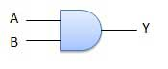
(2) Truth Table
Inputs |  | Output
A | B | AB
0 | 0 | 0
0 | 1 | 0
1 | 0 | 0
1 | 1 | 1
b. OR Gate. A circuit which performs an OR operation is shown below It has n input (n >= 2) and one output.
Y = A OR B OR C …… N
Y = A+B+C ……. N
(1) Logic Diagram
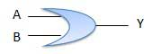
(2) Truth Table
Inputs |  | Output
A | B | A+B
0 | 0 | 0
0 | 1 | 1
1 | 0 | 1
1 | 1 | 1
c. NOT Gate. NOT gate is also known as Inverter. It has one input A and one output Y.
Y = NOT A
Y = A
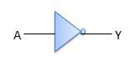
(1) Logic Diagram

(2) Truth Table
Inputs | Output
A | B
0 | 1
1 | 0

OPERATING SYSTEMS
Introduction
- An operating system (OS) is the software component of a computer system that is responsible for the management and coordination of activities and the sharing of the resources of the computer. The OS acts as a host for application programs that are run on the machine. As a host, one of the purposes of an OS is to handle the details of the operation of the hardware. This relieves application programs from having to manage these details and makes it easier to write applications. Almost all computers use an OS of some type
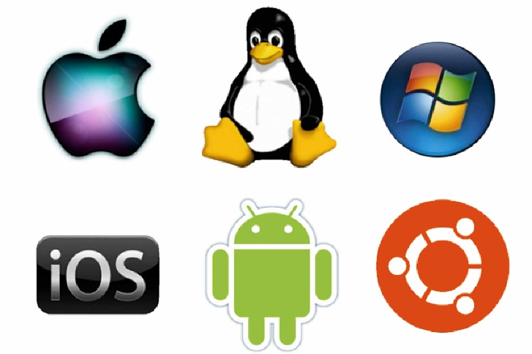
- An OS performs basic tasks, such as recognizing input from the keyboard, sending output to the display screen, keeping track of files and directories on the disk, and controlling peripheral devices such as printers. OS offers a number of services to application programs and users. Applications access these services through application programming interfaces (APIs) or system calls. By using these interfaces, the application can request a service from the OS, pass parameters, and receive the results of the operation. Users may also interact with the OS by typing commands or using a graphical user interface (GUI). Below are the few services provided by the OS.
a. Program Execution. OS provides an environment where the user can conveniently run programs. The user does not have to worry about memory allocation.
b. I/O Operations. Each program requires input and produces output. The OS hides some of the details of the underlying hardware for such I/O. All the user sees is that the I/O has been performed, without those details.
c. Communications. There are instances where processes need to communicate with each other to exchange information. It may be between processes running on the same computer or running on different computers. The OS provides these services to application programs, making inter-process communication possible, and relieving the user of having to worry about how this accomplished.
- Main Functions of Operating Systems
- Booting. Booting is a process of starting the computer operating system starts the computer to work. It checks the computer and makes it ready to work.
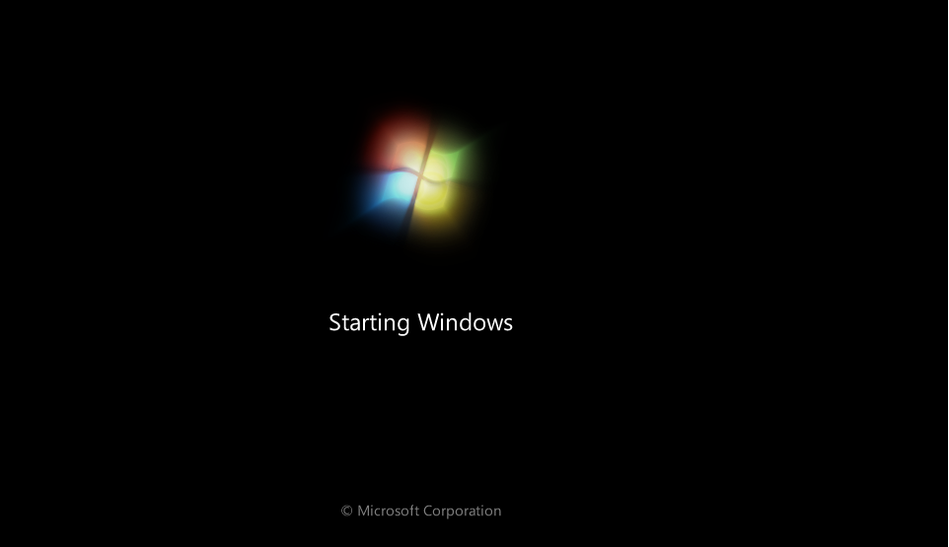
- Memory Management. It is also an important function of operating system. The memory cannot be managed without operating system. Different programs and data execute in memory at one time. If there is no operating system, the programs may mix with each other. The system will not work properly.
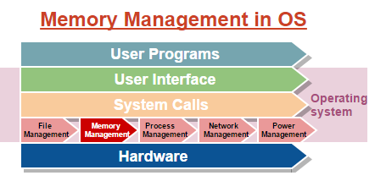
- Loading and Execution. A program is loaded in the memory before it can be executed. Operating system provides the facility to load programs in memory easily and then execute it.
- Data Security. Data is an important part of computer system. The operating system protects the data stored on the computer from illegal use, modification or deletion.

- Disk Management. Operating system manages the disk space. It manages the stored files and folders in a proper way.
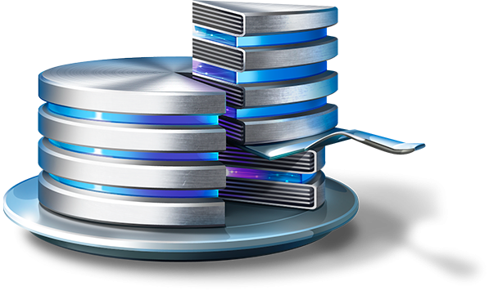
- Process Management. CPU can perform one task at one time. If there are many tasks, operating system decides which task should get the CPU.
- Device Controlling. Operating system also controls all devices attached to computer. The hardware devices are controlled with the help of small software called device drivers.
- Printing Controlling. Operating system also controls printing function. If a user issues two print commands at a time, it does not mix data of these files and prints them separately.
- Providing Interface. It is used in order that user interface acts with a computer mutually. User interface controls how you input data and instruction and how information is displayed on screen. The operating system offers two types of the interface to the user.
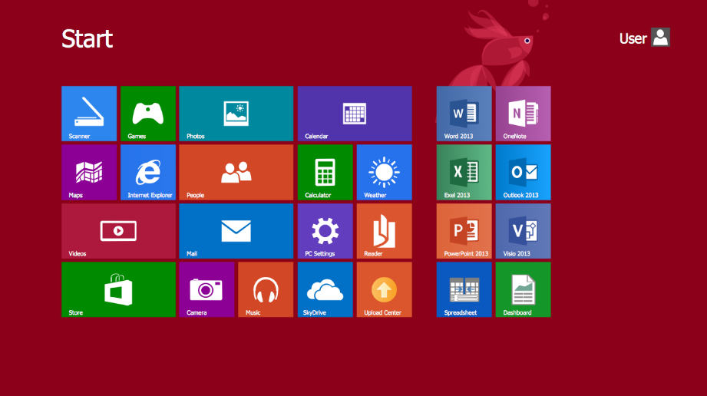
            - Graphical-line Interface. It interacts with of visual environment to communicate with the computer. It uses windows, icons, menus and other graphical objects to issues commands.

            - Command-line Interface. It provides an interface to communicate with the computer by typing commands.
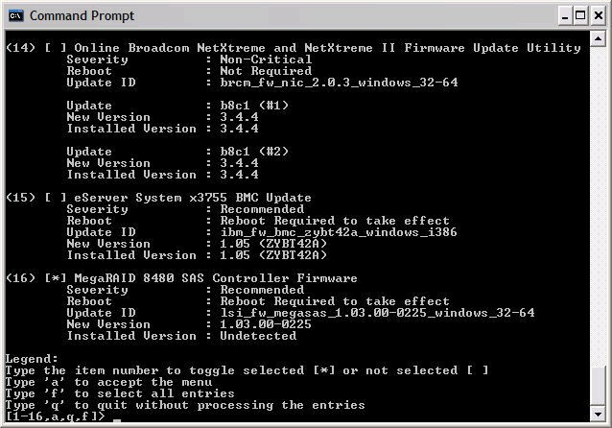

Types of Operating System
4. Following are some of the most widely used types of Operating system.
a. Simple Batch System. In this type of system, there is no direct interaction between user and the computer. The user has to submit a job (written on cards or tape) to a computer operator. Then computer operator places a batch of several jobs on an input device. Jobs are batched together by type of languages and requirement. Then a special program, the monitor, manages the execution of each program in the batch. The monitor is always in the main memory and available for execution.
b. Multiprogramming Batch System. In this the operating system, picks and begins to execute one job from memory. Once this job needs an I/O operation operating system switches to another job (CPU and OS always busy). Jobs in the memory are always less than the number of jobs on disk (Job Pool). If several jobs are ready to run at the same time, then system chooses which one to run (CPU Scheduling). In Non-multi programmed system, there are moments when CPU sits idle and does not do any work. In Multiprogramming system, CPU will never be idle and keeps on processing. Time-Sharing Systems are very similar to Multiprogramming batch systems. In fact, time sharing systems are an extension of multiprogramming systems. In time sharing systems the prime focus is on minimizing the response time, while in multiprogramming the prime focus is to maximize the CPU usage.
c. Multiprocessor System. A multiprocessor system consists of several processors that share a common physical memory. Multiprocessor system provides higher computing power and speed. In multiprocessor system, all processors operate under single operating system. Multiplicity of the processors and how they do act together are transparent to the others.
d. Distributed Operating Systems. The motivation behind developing distributed operating systems is the availability of powerful and inexpensive microprocessors and advances in communication technology. These advancements in technology have made it possible to design and develop distributed systems comprising of many computers that are inter connected by communication networks. The main benefit of distributed systems is its low price/performance ratio.
e. Real-Time Operating System. It is defined as an operating system known to give maximum time for each of the critical operations that it performs, like OS calls and interrupt handling. The Real-Time Operating system which guarantees the maximum time for critical operations and complete them on time are referred to as Hard Real-Time Operating Systems. While the real-time operating systems that can only guarantee a maximum of the time, i.e. the critical task will get priority over other tasks, but no surety of completing it in a defined time. These systems are referred to as Soft Real-Time Operating Systems.
Mobile Operating Systems
5. Over the past decade, smartphones have taken the world by storm and recently, tablets have entered into the arena as well. These mobile devices are having a significant impact on our lives and are in fact redefining the way we access information and communicate with others. This is due to not only the hardware but the specialized software that these devices run and most importantly, their operating systems.
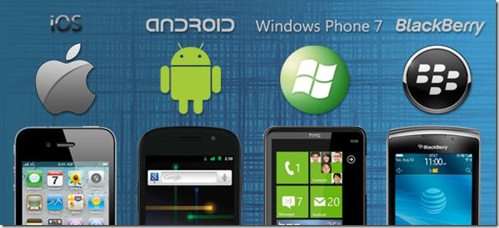
Just like a PC can run different operating systems (like Windows, Linux, BSD etc.) or different versions of the same operating system (like Windows XP, Windows Vista, Windows 7 etc.), most smartphones can also run different versions of the operating system they were made for and in exceptional cases, they might even be able to run operating systems they weren’t made for. In general however, an Android phone will only run a version of Android while an iPhone will only run an iOS version.
Some popular mobile phone operating systems are as follows
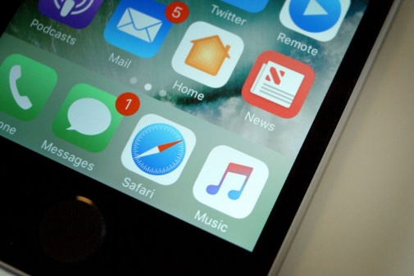
a. Apple iOS. iOS is the operating system used by Apple in all variants of iPod Touch, iPhone and iPad. While smartphones have been around since the 90’s, it was Apple that successfully managed convincing masses to switch to them with the release of the first iPhone in 2007 running the first version of iOS. At the time of its release, iOS wasn’t even capable of performing what most other smartphones operating systems had been doing for almost a decade – things such as true multitasking, data connection tethering, task switching, Bluetooth pairing, PC-like application installation using installer files, and dozens others – yet the first iPhone was received with immense enthusiasm by the masses, perhaps for not knowing any better. Other factors contributing to the success of iOS included smooth graphics, consistent user interface elements across apps, built-in iPod application, iTunes integration, an App Store for buying and installing apps and perhaps most importantly, a multi-touch finger-friendly capacitive touch screen that eliminated the use of a stylus while offering finger based gestures such as pinch-to-zoom, twist-to-rotate etc. These, coupled with the similarity with the hugely popular iPod Touch, resulted in the iPhone going viral and ended up in most people buying it as more of a status symbol of owning an iPhone, than for the utility of having a smartphone. The introduction of the iPad in 2010 only added to the popularity of iOS. Much like the case of smartphones, tablets had been widely available for over a decade but it was again Apple that built upon the success of iPhone to bring them to the masses in form of the iPad, creating a modern tablet boom and leading to other competitors joining the market. With the iPad and the iPad 2, Apple still leads the tablet market share by a huge margin. Due to its restricted nature, iOS limited users to only the features Apple decided appropriate. That is when the development community decided to intervene and came up with Jailbreaking. This allowed power users to install additional apps not available in the official App Store and customize their iPhones beyond the standard features provided by Apple. By now, iOS has improved a lot and as of the current version 4.3.3, it supports multi-tasking, audio and video playback to AirPlay devices, data tethering and several other enhancements, in addition to the above-mentioned features. Jailbreaking continues to play an important role in iOS devices and enables users to take their iPhones beyond the often ridiculous limitations set by Apple.
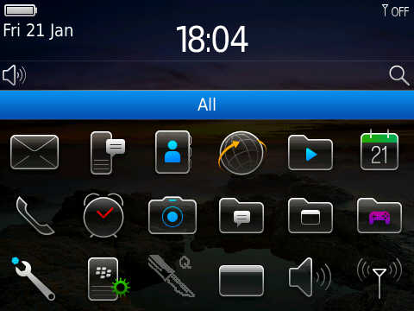
b. RIM BlackBerry OS. This is the operating system used in all BlackBerry devices. Despite having been popular in corporate sector, BlackBerry devices are losing market share to Android and iPhone. However, they still have a loyal following of users who are used to the signature hardware keyboard of BlackBerry devices and the convenience of the built-in corporate features of BlackBerry OS. RIM’s attempts at entering the touch screen smartphone market haven’t been too successful due to the limited number of quality apps available, though their recently released tablet called BlackBerry Playbook appears promising.

Playbook is the first BlackBerry device to ship with their latest OS called QNX which is set to replace the older BlackBerry OS. Future phones by BlackBerry are also expected to ship with QNX. A recent development that might change things for the better for RIM is the Android App Player that promises to bring support for running hundreds of thousands of Android apps on BlackBerry OS devices, as demoed at the recent BlackBerry World 2011 keynote.
c. HP WebOS (Previously Palm WebOS). Palm – despite being one of the initial players of the smartphone market – experienced declining market share and dropping revenues due to their old PalmOS devices not being able to keep up with iOS and Android. Palm tried to counter it by replacing its dying PalmOS with an entirely new operating system built from scratch – WebOS. Although WebOS was built by Palm as a pretty solid and feature-rich operating system having a killer interface to match, it wasn’t enough to keep the company’s lost reputation. Eventually, at the verge of bankruptcy, Palm ended up getting acquired by HP in 2010. The acquisition was followed by HP’s announcement of continuing development of the Palm devices as well as WebOS under HP’s brand name. At its core, WebOS derives heavily from Linux and uses several open source components, maintained at the Palm Open Source website. HP is heavily promoting Palm OS and releasing several devices running it, including HP Veer & HP Pre 3 smartphones and HP TouchPad tablet. While WebOS doesn’t have a prominent market share at the moment, things seem promising for this platform’s future.
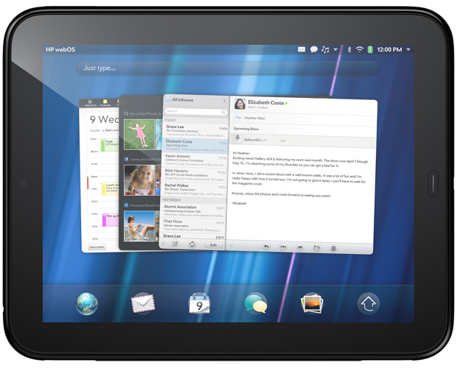
d. Microsoft Windows Mobile. Windows Mobile devices were called Pocket PCs and were true to their name! The operating system had true multitasking, installation of apps using cab files, full file system access, registry access, options for replacing the entire user interface with another, integrated data tethering support, personal information synchronization and a complete office suite.
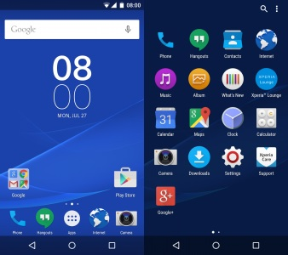
e. Android. When an operating system is open source, based on Linux, owned by Google, backed by all major mobile device manufacturers including HTC, Samsung, Motorola, Dell, Sony Ericsson, LG and countless more, and allows for endless customization, it is bound to make an impact. Initially developed by Android Inc. and purchased by Google in 2005, Android has become the leading smartphone OS in the world today, and is our smartphone platform of choice here at Addictive Tips. While it appeals more to the techies amongst us, Android has been received well by the non-techies as well, and with an app market boasting over 200,000 apps, there’s plenty to do with it as well. With multiple new releases each year, the operating system is continuously evolving. Android has already beaten iOS to become the most widely used smartphone OS in the world, though its app Market still lags behind the Apple App Store in terms of the number of apps by roughly 100,000 apps, plus iOS apps in general tend to be more refined than Android apps, and this is the only reason we can see for any rational person to choose an iOS device over an Android device, but that’s our personal opinion.
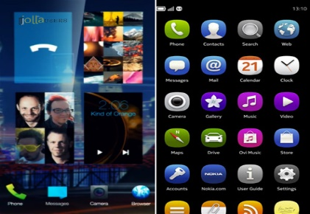
f. MeeGo. Few years back, Nokia and Intel decided to merge their Linux-based Maemo and Moblin operating systems to form MeeGo, and several other high-profile companies also joined in to contribute to the open source project. Things seemed to be promising, smartphone and tablet enthusiasts were eagerly anticipating developments to bear fruit in form of another Android to bring competition to the market and provide a further incentive for innovation, when all of a sudden a key player i.e. Nokia decided to abandon it and switch over to Windows Phone 7 as its primary smartphone platform.
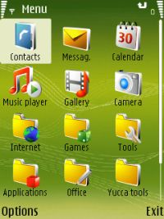
g. Symbian. Symbian – in its various forms – has been the operating system of thousands of devices by dozens of manufacturers but despite its commercial success, it has failed to achieve any critical acclaim in the smartphone arena despite Nokia’s repeated efforts of trying to get it right. We are including it here only due to the number of smartphones running Symbian globally, despite a negligible share in the United States. In all other aspects, it doesn’t even come close to any of the other smartphone operating systems mentioned in this guide. The future of Symbian in the smartphone world is practically over. With Nokia’s abandonment and more and more users switching to Android, iOS and Windows Phone 7 globally, it is safe to conclude that Symbian no longer has a place in the smartphone world.
Latest OS and their Comparison
6. Windows. With almost 90% of the operating system market share, you can't miss Windows. It's in commercial buildings, industrial facilities, as well as home computers. Windows, having been introduced in 1985, is a very mature and complete piece of software.
a. Pros
- Compatibility. Almost every application, driver or game will work on Windows.
- Technical Support. Having so many users, you can always find someone (either online or offline) who can help you with Windows.
- Huge Quantity of Function. When you get to know Windows well, you'll find out that there are so many functions that you can do almost anything quite easily.
- Cons
- Viruses. You may need to buy an antivirus program, although free ones exist.
- Slow. Windows, especially Vista and 7, requires a lot of computer resources (memory, processor, disk space), and thus, runs slower.
- Price. It easily costs over a hundred dollars.
7. Macintosh. Apple's Macintosh OS is even older than Windows. It is the first ever successful graphical-based operating system, being released one year before it's Microsoft counterpart.
  - Pros
    - Viruses. Apple Macs get almost no viruses. This is mostly due to Window's superior market share.
    - Reliability. Macs only run on Apple computers, and are thus less prone to hardware and software crashing.
    - GUI. GUI of Mac looks better than Windows.
  - Cons
- Expensive: Mac costs even more than Windows.
- Only available on Apple computers: If you already have a computer, you cannot install MAC on it unless it's an Apple. Otherwise, you must buy a new computer.
- Compatibility: Only a few programs will run on Mac, and almost no games.
8. Linux. Linux is GNU's answer to Mac and Windows. Yes, this means that Linux is FREE! By free, you can download, modify and redistribute it without spending a dime. Linux is a younger player in the OS world, having been written in 1991, and is optimized for modern use (well, more than Windows and Mac).
a. Pros
- Price. Linux is absolutely free and it can be downloaded from the Internet.
- Variety. Linux is not a full operating system. It is just a kernel. To use the kernel, additional software needs to be bundled with Linux. Several hundreds of these bundles (called "distributions" or simply "distros") exist. The most popular ones include Ubuntu, Mint and Fedora. The good thing is, with so many different flavours of Linux, there is always one to suit your needs!
- Viruses. Although being more vulnerable to viruses than Mac (because it is open source), Linux still has very, very, very few viruses.
  - Cons
- Complicated. Although some distributed OS are quite easy to use, most of them will required a good deal of computer knowledge in order to get them to work.
- Compatibility. Like Mac, representing only few percent of the market share, Linux does not have as many programs and games as Windows.
- Vendors. You won't find a lot of vendors selling Linux computers. Usually, you'll just end up having to buy Windows computer, reformatting the hard drive, and installing Linux yourself.

INTRODUCTION TO PROGRAMMING LANGUAGES
1. A program is a set of instructions that tell the computer to do various things; sometimes the instruction it has to perform depends on what happened when it performed a previous instruction. This section gives an overview of the two main ways in which you can give these instructions or “commands” as they are usually called. As human languages are too difficult for a computer to understand in an unambiguous way, commands are usually written in one or other languages specially designed for the purpose.
2. Language Types
a. Machine Language. A machine language consists of the numeric codes for the operations that a particular computer can execute directly. The codes are strings of 0s and 1s, or binary digits (“bits”), which are frequently converted both from and to hexadecimal (base 16) for human viewing and modification. Machine language instructions typically use some bits to represent operations, such as addition, and some to represent operands, or perhaps the location of the next instruction. Machine language is difficult to read and write, since it does not resemble conventional mathematical notation or human language, and its codes vary from computer to computer.
b. Assembly Language. Assembly language is one level above machine language. It uses short mnemonic codes for instructions and allows the programmer to introduce names for blocks of memory that hold data. One might thus write “add pay, total” instead of “0110101100101000” for an instruction that adds two numbers.
Assembly language is designed to be easily translated into machine language. Although blocks of data may be referred to by name instead of by their machine addresses, assembly language does not provide more sophisticated means of organizing complex information. Like machine language, assembly language requires detailed knowledge of internal computer architecture. It is useful when such details are important, as in programming a computer to interact with input/output devices (printers, scanners, storage devices, and so forth).
c. Algorithmic Languages. Algorithmic languages are designed to express mathematical or symbolic computations. They can express algebraic operations in notation similar to mathematics and allow the use of subprograms that package commonly used operations for reuse. They were the first high-level languages.
(1) FORTRAN. The first important algorithmic language was FORTRAN (for trans), designed in 1957 by an IBM team led by John Backus. It was intended for scientific computations with real numbers and collections of them organized as one- or multidimensional arrays. Its control structures included conditional IF statements, repetitive loops (so-called DO loops), and a GOTO statement that allowed non sequential execution of program code. FORTRAN made it convenient to have subprograms for common mathematical operations, and built libraries of them. FORTRAN was also designed to translate into efficient machine language. It was immediately successful and continues to evolve.
(2) ALGOL. ALGOL (Algorithmic Language) was designed by a committee of American and European computer scientists during 1958–60 for publishing algorithms, as well as for doing computations. Like LISP (described in the next section), ALGOL had recursive subprograms, procedures that could invoke themselves to solve a problem by reducing it to a smaller problem of the same kind. ALGOL introduced block structure, in which a program is composed of blocks that might contain both data and instructions and have the same structure as an entire program. Block structure became a powerful tool for building large programs out of small components. ALGOL contributed a notation for describing the structure of a programming language, Backus–Naur Form, which in some variation became the standard tool for stating the syntax (grammar) of programming languages. ALGOL was widely used in Europe, and for many years it remained the language in which computer algorithms were published. Many important languages, such as Pascal and Ada (both described later), are its descendants.
(3) LISP. LISP (list processing) was developed about 1960 by John McCarthy at the Massachusetts Institute of Technology (MIT) and was founded on the mathematical theory of recursive functions (in which a function appears in its own definition). A LISP program is a function applied to data, rather than being a sequence of procedural steps as in FORTRAN and ALGOL. LISP uses a very simple notation in which operations and their operands are given in a parenthesized list. For example, (+ a (* b c)) stands for a + b*c. Although this appears awkward, the notation works well for computers. LISP also uses the list structure to represent data, and, because programs and data use the same structure, it is easy for a LISP program to operate on other programs as data.
(4) C Language. The C programming language was developed in 1972 by Dennis Ritchie and Brian Kernighan at the AT&T Corporation for programming computer operating systems. Its capacity to structure data and programs through the composition of smaller units is comparable to that of ALGOL. It uses a compact notation and provides the programmer with the ability to operate with the addresses of data as well as with their values. This ability is important in systems programming, and C shares with assembly language the power to exploit all the features of a computer’s internal architecture. C, along with its descendant C++, remains one of the most common languages.
Let us look at a simple code that would print the words "Hello World"
#include <stdio.h>
int main()
{
/* my first program in C */
printf("Hello, World! \n");
return 0;
}
Let us take a look at the various parts of the above program:
(a) The first line of the program #include <stdio.h> is a preprocessor command, which tells a C compiler to include stdio.h file before going to actual compilation.
(b) The next line int main() is the main function where the program execution begins.
(c) The next line /*...*/ will be ignored by the compiler and it has been put to add additional comments in the program. So such lines are called comments in the program.
(d) The next line printf(...) is another function available in C which causes the message "Hello, World!" to be displayed on the screen.
(e) The next line return 0; terminates the main() function and returns the value 0.
d. Business Oriented Languages
(1) COBOL. COBOL (Common Business Oriented Language) has been heavily used by businesses since its inception in 1959. A committee of computer manufacturers and users and U.S. government organizations established CODASYL (Committee on Data Systems and Languages) to develop and oversee the language standard in order to ensure its portability across diverse systems. COBOL uses an English-like notation—novel when introduced. Business computations organize and manipulate large quantities of data, and COBOL introduced the record data structure for such tasks. A record clusters heterogeneous data such as a name, ID number, age, and address into a single unit. This contrasts with scientific languages, in which homogeneous arrays of numbers are common. Records are an important example of “chunking” data into a single object, and they appear in nearly all modern languages.
(2) SQL. SQL (Structured Query Language) is a language for specifying the organization of databases (collections of records). Databases organized with SQL are called relational because SQL provides the ability to query a database for information that falls in a given relation. For example, a query might be “find all records with both last name Smith and city New York.” Commercial database programs commonly use a SQL-like language for their queries.
e. Education Oriented Languages
(1) BASIC. BASIC (Beginner’s All-Purpose Symbolic Instruction Code) was designed at Dartmouth College in the mid-1960s by John Kemeny and Thomas Kurtz. It was intended to be easy to learn by novices, particularly non-computer science majors, and to run well on a time-sharing computer with many users. It had simple data structures and notation and it was interpreted: a BASIC program was translated line-by-line and executed as it was translated, which made it easy to locate programming errors. Its small size and simplicity also made BASIC a popular language for early personal computers. Its recent forms have adopted many of the data and control structures of other contemporary languages, which makes it more powerful but less convenient for beginners.
(2) Pascal. About 1970 Niklaus Wirth of Switzerland designed Pascal to teach structured programming, which emphasized the orderly use of conditional and loop control structures without GOTO statements. Although Pascal resembled ALGOL in notation, it provided the ability to define data types with which to organize complex information, a feature beyond the capabilities of ALGOL as well as FORTRAN and COBOL. User-defined data types allowed the programmer to introduce names for complex data, which the language translator could then check for correct usage before running a program.
f. Object-Oriented Languages. Object Oriented languages help to manage complexity in large programs. Objects package data and the operations on them so that only the operations are publicly accessible and internal details of the data structures are hidden. This information hiding made large-scale programming easier by allowing a programmer to think about each part of the program in isolation. In addition, objects may be derived from more general ones, “inheriting” their capabilities. Such an object hierarchy made it possible to define specialized objects without repeating all that is in the more general ones.
(1) C++. The C++ language, developed by Bjarne Stroustrup at AT&T in the mid-1980s, extended C by adding objects to it while preserving the efficiency of C programs. It has been one of the most important languages for both education and industrial programming. Large parts of many operating systems, such as the Microsoft Corporation’s Windows 98, were written in C++.
(2) Java. In the early 1990s, Java was designed by Sun Microsystems, Inc., as a programming language for the World Wide Web (WWW). Although it resembled C++ in appearance, it was fully object-oriented. In particular, Java dispensed with lower-level features, including the ability to manipulate data addresses, a capability that is neither desirable nor useful in programs for distributed systems. In order to be portable, Java programs are translated by a Java Virtual Machine specific to each computer platform, which then executes the Java program. In addition to adding interactive capabilities to the Internet through Web “applets,” Java has been widely used for programming small and portable devices, such as mobile telephones.
(3) Visual Basic. Visual Basic was developed by Microsoft to extend the capabilities of BASIC by adding objects and “event-driven” programming: buttons, menus, and other elements of graphical user interfaces (GUIs). Visual Basic can also be used within other Microsoft software to program small routines.
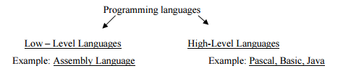
3. Characteristics of Languages

4. Characteristics of Low Level Languages
a. They are machine oriented: an assembly language program written for one machine will not work on any other type of machine unless they happen to use the same processor chip.
b. Each assembly language statement generally translates into one machine code instruction, therefore the program becomes long and time-consuming to create.
5. Characteristics of High Level Languages
a. They are not machine oriented: in theory they are portable, meaning that a program written for one machine will run on any other machine for which the appropriate compiler or interpreter is available.
b. They are problem oriented: most high level languages have structures and facilities appropriate to a particular use or type of problem. For example, FORTRAN was developed for use in solving mathematical problems. Some languages, such as PASCAL were developed as general-purpose languages.
c. Statements in high-level languages usually resemble English sentences or mathematical expressions and these languages tend to be easier to learn and understand than assembly language.
d. Each statement in a high level language will be translated into several machine code instructions.
6. Generations of Languages
a. Machine Language – 1st Generation. In the early days of computer programming all programs had to be written in machine code.
For example a short (3 instruction) program might look like this:
0111 0001 0000 1111
1001 1101 1011 0001
1110 0001 0011 1110
Machine code has several significant disadvantages associated with it:
(1) It is not intuitively obvious what a machine code instruction does simply from its encoding, consequently it is very difficult to read and write machine code.
(2) The writing of machine code is extremely time consuming and error prone.
(3) Many different machine codes exist (one for each make and type of computer). Machine code executes directly without translation since it is the actual pattern of 0s and 1s understood by the computer’s memory.
b. Assembly Language – 2nd Generation. Assembler languages were initially developed to address the disadvantages associated with machine code programming. They used symbolic codes instead lists of binary instructions. Consequently programming became more "friendly". An example of assembly code is given below:
MOV AX 01
MOV BX 02
ADD AX BX
In assembler language each line of the program corresponds to one instruction in machine code. For a program written in assembler language to be executable it must be translated into machine code using a translating program called an assembler. Although use of assembly languages offers some advantages there are still a number of significant disadvantages associated with their use:
(1) Each model of computer has its own assembly language associated with it.
(2) Assembler programming still requires great attention to detail and hence remains both time consuming and tedious.
(3) Because of the risk of program error is not significantly reduced.
c. High Level Languages – 3rd Generation. High Level languages are so-called because they are independent of the particular computer. They are not machine oriented.
d. Fourth Generation Languages. 4GLs are the most modern high level languages today. The user must concentrate more on what is to be done to solve the problem while the how part is entirely (or most of it) left in the hands of the 4GL.
Language Translators
7. A computer language translator is a program that translates a set of code written in one programming language into a functional equivalent of the code in another programming language. The different types of computer translators are interpreters, source-to-source compilers, standard compilers, decompiles, assemblers and disassemblers. A computer can only understand programs defined using machine code. Consequently a program written for example in a high level language such as Java cannot be run directly. To execute a computer program written in high or low level language, it must be first be translated. There are 3 types of system software used for translating the code that a programmer writes into a form that the computer can execute (i.e. machine code). These are:-
a. Assembler. An assembler is a program that takes basic computer instructions and converts them into a pattern of bits that the computer's processor can use to perform its basic operations. Some people call these instructions assembler language and others use the term assembly language.
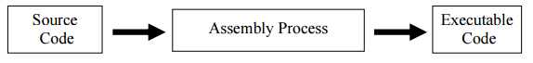

b. Compiler. A Compiler is a program that translates a high level language into machine code. The Turbo Pascal compiler, for example, translates a program written in Pascal into machine code that can be run on a PC.
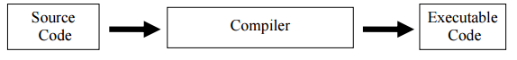
(
1) Advantages of a Compiler
(a) Fast in execution
(b) The object/executable code produced by a compiler can be distributed or executed without having to have the compiler present.
(c) The object program can be used whenever required without the need to of recompilation.
(2) Disadvantages of a Compiler
(a) Debugging a program is much harder. Therefore not so good at finding errors
(b) When an error is found, the whole program has to be re-compiled
  - Interpreter. An Interpreter is also a program that translates high-level source code into executable code. However the difference between a compiler and an interpreter is that an interpreter translates one line at a time and then executes it: no object code is produced, and so the program has to be interpreted each time it is to be run. If the program performs a section code 1000 times, then the section is translated into machine code 1000 times since each line is interpreted and then executed. 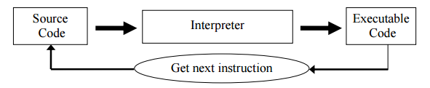
(1) Advantages of an Interpreter
(a) Good at locating errors in programs
(b) Debugging is easier since the interpreter stops when it encounters an error.
(c) If an error is deducted there is no need to retranslate the whole program
(2) Disadvantages of an Interpreter
(a) Rather slow
(b) No object code is produced, so a translation has to be done every time the program is running.
(c) For the program to run, the Interpreter must be present.
INTRODUCTION TO NETWORKS
Introduction
1. A computer network is a set of computers sharing resources located on or provided by network nodes. Computers use common communication protocols over digital interconnections to communicate with each other. These interconnections are made up of telecommunication network technologies based on physically wired, optical and wireless radio-frequency methods that may be arranged in a variety of network topologies. Computer networks may be classified by many criteria, including the transmission medium used to carry signals, bandwidth and communications protocols to organize network traffic, the network size, the topology, traffic control mechanisms and organizational intent.

What is a Computer Network?
- Computer networking is what allows all our devices to connect and communicate with one another. From day-to-day activities to business operations, networks responsibilities are pivotal in providing the ability to undertake and complete tasks involving technology, smoothly and efficiently. A network comprises of two or more devices communicating to share information. Businesses use networks to make their employees’ devices work together smoothly. They can share things like files and printers. Networks deal with creating, managing and keeping these lines of communication and connection secure and accessible to those who use it.

How do Computer Networks work?
- For devices to communicate with one another, they follow a set of rules, so that they may understand each other’s messages. These rules are called protocols. Whenever your phone or computer is connected to Wi-Fi, you are connected to a network where a router is sending messages to and from your device. From there, the router is connected to the internet, which allows a larger scale of communication between devices and in turn, people and businesses.
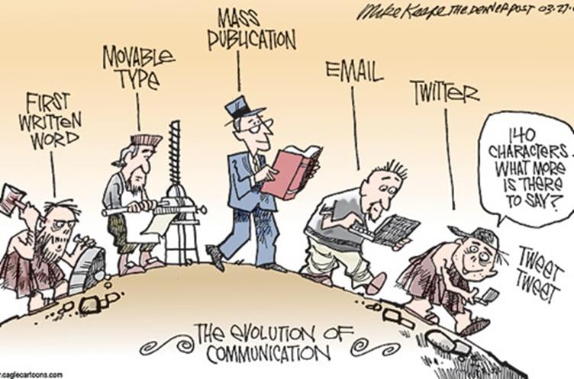
Importance of Computer Networking
- Businesses rely heavily on computer networking to stay competitive and efficient. Computer networking is the backbone of a company’s communication and operations. While it may seem like a technical concept, getting computer networking right is essential for businesses, no matter their size.
- Efficient Communication and Collaboration. Within a business, the ability to communicate and collaborate efficiently is extremely important as without it, the services provided, projects being undertaken and internal management would be of a poor and suboptimal standard. A well-designed network allows employees to talk to each other, share files and collaborate on projects seamlessly. This leads to better teamwork and more productive outcomes.
- Sharing Resources. Every business needs to save costs wherever possible. Computer networking allows the sharing of devices among employees in the office, like printers and servers. This means resources such as servers can be shared as opposed to having one for each department. It creates a communal technology-based toolbox, where everyone can access the tools, they need.
- Fast and Easy Data Transfer. Data within a business is extremely important and often is required to be accessed by multiple employees quickly and securely. A well-functioning network ensures that information can travel from one department to another in a flash. This can make decision-making faster, decrease time wasted waiting for data to be delivered and improve overall efficiency.
- Reliable Internet Connectivity. Internet connectivity can be extremely frustrating when not complying, resulting in loss of productivity. A strong network ensures that the internet connection is stable and reliable, subsequently producing less to no interruptions in business practices, accessing cloud-based services and communication, all of which are vital for modern businesses.
- Keeping Information Safe. Businesses deal with sensitive information, such as customer details and financial data. A properly secured network acts like a fortress, protecting this valuable information from hackers and cyber-attacks.
- Easy Scalability. Every business dreams of growth and success. As a company expands, so do its networking needs. A well-designed network allows for easy expansion without major disruptions.
- Cost Savings. Getting networking right can save business money in the long run. By reducing downtime, streamlining processes and optimizing resource usage, a well-implemented network can lead to cost savings over time.
- Staying Ahead of the Competition. In a world where technology is constantly evolving, having the right network can give a business a competitive advantage. It enables a company to adapt quickly to market changes, adopt new technologies and stay ahead of the competition.
- Happy Customers. Providing excellent customer service is crucial for any business. A reliable network enables faster response times, smoother online transactions and uninterrupted communication, making customers happy and satisfied.
Basic Network Terminologies
- To stay ahead of the curve in the world of networking, individuals need to keep abreast of the latest terminologies. With the ever-changing technology landscape, new words and phrases are added to the dictionary all the time. Basic networking terminologies are:-
Terms | Definition
2G | The radio signals used by the 1G network were analog, while 2G networks were digital. 2G capabilities were achieved by allowing multiple users on a single channel via multiplexing. During 2G, cellular phones were used for data along with voice. Data speeds of up to 64 kbps.
3G | 3G network combines aspects of the 2G network with new technologies and protocols to deliver a significantly faster data rate. By using packet switching, the original technology was improved to allow speeds up to 14 Mbps. It used Wide Band Wireless Network that increased clarity. Speed of up to 2 Mbps.
4G | 4G LTE is a “fourth generation long term evolution”, capable of delivering a very fast and secure internet connection. The main difference between 3G and 4G is the data rate. High speed, high capacity and low cost per bit (Speeds of up to 20 Mbps or more).
5G | 5G networks operate on rarely used radio millimeter bands in the 30 GHz to 300 GHz range. Low latency is one of 5G’s most important features. 5G is estimated to be 60 to 120 times faster than the average 4G latency.
Administrator | User with full control over a network or individual computer.
Bandwidth | Amount of data that can be transferred over a given period of time.
Cluster | Group of computers that work together to provide high availability.
Data Center | Facility used to house networking equipment and other computer systems.
Dedicated Line | Physical connection between two devices that is not shared with any other devices.
Denial of Service (DoS) | Attack that prevents legitimate users from accessing a network or individual device.
Extranet | It is a controlled, private network that includes external parties such as clients, partners, suppliers, colleague or vendors.
Ethernet | Popular type of physical network that uses twisted pair or fiber optic cables to connect devices.
Firewall | Device or software application that filters traffic between two networks or between a device and a network.
Host | A host is any hardware device that has the capability of permitting access to a network via a user interface, specialized software, network address, protocol stack or any other means.
Infrastructure as a Service (IaaS) | Form of cloud computing that delivers computer infrastructure on an as-a-service basis. e.g., Amazon Web Services, Oracle Cloud.
Internet | The internet is a vast global network connecting millions of computers and devices worldwide.
Intranet | It is a private extension of the internet confined to an organization.
Jitter | Variation in delay between data packets sent across a network.
Latency | Network latency is the delay in network communication. It shows the time that data takes to transfer across the network.
Media | Communication channels are the medium that connect two or more workstations. Workstations can be connected by either wired media or wireless media.
Modem | Device that converts digital signals to analog signals and vice versa.
Node | The connection point among network devices such as routers, printers or switches that can receive and send data from one endpoint to the other.
Packet | Unit of data that is sent over a network.
Platform as a Service (PaaS) | Form of cloud computing that delivers a computing platform and/or solution stack as a service. e.g., Google App Engine, Windows Azure.
Receiver | It is a device that receives messages. It can be a computer, telephone mobile, workstation, etc.
Sender | Sender is a device that sends message. The message can consist of text, numbers, pictures etc. it is also called source or transmitter.
Server | Device or software application that provides services to other devices or software applications.
Software as a Service (SaaS) | Form of cloud computing that delivers software as a service. e.g., Dropbox, Google Apps, Microsoft Office 365.
Voice over IP (VoIP) | Technique used to transmit voice traffic over a data network.
Wireless Access Point (WAP) | Device that connects wireless devices to a wired network.

INTRODUCTION TO DATABASES
Introduction
1. Databases are structured collections of data stored and managed electronically, designed to facilitate easy access, management and updating of information. They employ a Database Management System (DBMS), a software application that allows users to interact with the data efficiently. Databases can be relational, where data is organized into tables linked by relationships, or non-relational, accommodating various data models like key-value, document, or graph formats. Modern databases are integral to numerous applications, from managing business records to supporting complex data-driven services. They enable quick data retrieval, support transactions and ensure data integrity. Understanding databases involves grasping concepts like data models, schemas, queries and normalization. They are crucial in fields like data analytics; software development and system administration, helping organizations make informed decisions and streamline operations.
Understanding the Concept of Data and its Importance in Organization
What is Data?
- Data refers to raw facts, figures and statistics collected for analysis and used to make decisions. It becomes meaningful when processed into information.
Nadra
- In the context of the National Database and Registration Authority (NADRA) in Pakistan, data is of paramount importance. NADRA collects, stores and manages personal information of Pakistani citizens, such as biometric data, national identity card details and more. This data is crucial for maintaining accurate national records, facilitating governmental services and ensuring security. The importance of data in context of NADRA or any other organization can be summarized as:-
- Identity Verification. Ensuring accurate identification of citizens through biometric data helps prevent identity theft and fraud.
- Service Delivery. Reliable data allows the government to provide services efficiently, such as issuing identity cards, passports and verifying eligibility for social programs.
- Security and Law Enforcement. Data helps in tracking and monitoring activities for national security purposes, aiding law enforcement agencies in investigations.
- Economic Planning. Accurate data collection supports effective policy-making and resource allocation based on demographic information.
- Transparency and Accountability. Data-driven processes in NADRA enhance transparency and reduce the potential for corruption.
Military
- In military organizations, data is a strategic asset that is essential for achieving operational success, improving decision-making and maintaining national security. The importance of data in military contexts can be broken down into several key areas:-
- Enhanced Decision-Making. Data provides military leaders with accurate, real-time information, enabling them to make informed decisions. For example, predictive analytics can forecast potential threats or logistical needs, allowing for proactive measures. This capability is vital for maintaining operational readiness and gaining a tactical advantage in various scenarios.
- Operational Efficiency. Data is used to streamline military operations, from resource allocation to mission planning. For instance, by analyzing logistical data, military organizations can optimize the deployment of personnel and equipment, ensuring that resources are used efficiently and effectively.
- Data-Driven Defense Strategies. Military organizations use data to enhance their defense strategies. For example, data analytics can help identify patterns in enemy behavior or potential security breaches, enabling preemptive actions to be taken to mitigate risks.
- Secure Data Management. The secure storage and management of data are crucial in the military to protect sensitive information. Military databases store vast amounts of critical data, including operational files, personnel records and intelligence data, which must be securely managed to prevent unauthorized access and potential security breaches.
- Real-Time Situational Awareness. By leveraging big data and analytics, military leaders can maintain real-time situational awareness. For example, integrating data from various sensors and intelligence sources allows for a comprehensive operational picture, facilitating better decision-making on the battlefield.
Database and Database Management System

What is Database?
- A database is a collection of interrelated data that facilitates efficient retrieval, insertion and deletion of data. It organizes data into tables, views, schemas, reports and other structures that enable efficient data management. There are several types of databases like Hierarchical databases, Network databases, Object-oriented databases, Relational databases, Non-Relational databases, Cloud Database, Centralized Database and Operational Database.
Relational Databases
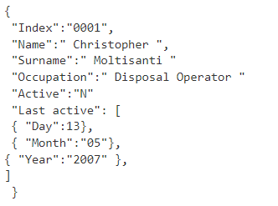
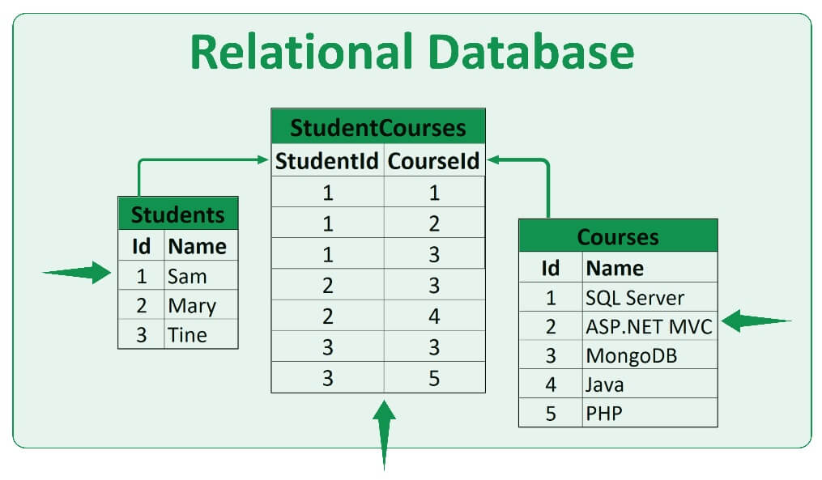
- The relational database model is the most used database model today. A relational database is like a digital version of a well-organized filing cabinet. Imagine you have several folders (called tables), each containing a list of related items. Each folder might have a list of people, products, or orders. Inside each folder, the information is neatly organized into rows and columns, much like a spreadsheet. Big industries like E-commerce, Finance, Social media and more use relational database.
Non-Relational / NoSQL Databases
- Non-relational databases, on the other hand, don't use rows and tables, but instead use data models such as key-value pairs, graphs and column families to store and organize data. Netflix uses Non-Relational databases to store and manage massive amounts of data, including customer profiles, viewing histories and content recommendations.
Key-value pairs
What is a Database Management System (DBMS)?
- Database software is sometimes also referred to as a “database management system” (DBMS).A DBMS serves as an interface between the database and its end users or programs, allowing users to retrieve, update and manage how the information is organized and optimized. Examples of relational database management software include Microsoft SQL Database, Amazon RedShift, Oracle Database, MongoDB, MariaDB and more.
Advantages of Using a DBMS
- DBMS offers numerous advantages, which have contributed to its widespread adoption:-
- Improved Data Organization. DBMS allows for structured data organization, making it easier to retrieve and query data.
- Data Integrity. DBMS enforces data integrity constraints, ensuring data accuracy and consistency.
- Concurrent Access. DBMS provides mechanisms for controlling concurrent access, enabling multiple users to work with the data simultaneously.
- Data Security. DBMS offers tools for managing data security, including access controls and data encryption.
- Backup and Recovery. DBMS includes mechanisms for backing up and recovering data, reducing the risk of data loss.
- Data Sharing. DBMS allows multiple users to access and share the same data, supporting collaborative work environments.
Disadvantages of Using a DBMS
- The shift from file systems to DBMS was driven by the challenges posed by file systems, including:-
- Complexity. DBMS can be complex to set up and maintain, requiring specialized knowledge and skills.
- Performance Overhead. The use of a DBMS can introduce performance overhead, especially in highly concurrent scenarios.
- Scalability. DBMS may limit the scalability of an application due to the need for synchronization mechanisms to maintain data consistency.
- Cost. The cost of purchasing, maintaining and upgrading a DBMS can be high, particularly for large or complex systems.
- Limited Use Cases. Not all applications require the high reliability, consistency and security provided by a DBMS. Some solutions may be better served by other types of data storage.
Overview of Structured Query Language
- The term SQL is pronounced ess-kew-ell or sequel. Structured Query Language (SQL) is a standardized programming language that is used to manage relational databases and perform various operations on the data in them. Initially created in the 1970s, SQL is regularly used not only by database administrators but also by developers writing data integration scripts and data analysts looking to set up and run analytical queries.

What Can SQL do?
- SQL basic operations are:-
- SQL can execute queries against a database.
- SQL can retrieve data from a database.
- SQL can insert records in a database.
- SQL can update records in a database.
- SQL can delete records from a database.
- SQL can create new databases.
- SQL can create new tables in a database.
- SQL can create stored procedures in a database.
- SQL can create views in a database.
- SQL can set permissions on tables, procedures and views.
Using SQL in Your Web Site
- To build a web site that shows data from a database, you will need:-
- An RDBMS database program (i.e. MS Access, SQL Server, MySQL).
- A server-side scripting language, like PHP or ASP.
- SQL to get the data you want.
- HTML / CSS to style the page.
SQL Queries
- Some of the most commonly used SQL queries are:-
Query | Function
SELECT * FROM table_name; | Retrieve all columns and rows from the specified table.
SELECT column1, column2 FROM table_name; | Retrieve specific columns from the specified table.
SELECT DISTINCT column FROM table_name; | Retrieve unique values from a specific column in the table.
WHERE condition; | Filter rows based on a specified condition in the WHERE clause.
INSERT INTO table_name (column1, column2) VALUES (value1, value2); | Insert new records into a table with specified column values.
UPDATE table_name SET column1 = value1 WHERE condition; | Update existing records in a table based on a specified condition.
DELETE FROM table_name WHERE condition; | Delete rows from a table based on a specified condition.
CREATE TABLE table_name (column1 datatype, column2 datatype, …); | Create a new table with specified columns and data types.
ALTER TABLE table_name ADD column_name datatype; | Add a new column to an existing table.
DROP TABLE table_name; | Delete an entire table along with its data.
Database Tables
- A database most often contains one or more tables. Each table is identified by a name (e.g. "Customers" or "Orders") and contains records (rows) with data. The table below contains three records (one for each customer) and six columns (CustomerID, ContactName, Address, City, PostalCode and Country).
CustomerID | CustomerName | Address | City | PostalCode | Country
1 | Rehan | St 12 PK | ISB | 45654 | Pakistan
2 | Sufyan | 120 ISB | LHR | 49280 | Pakistan
3 | Waqas | BR 202 | ATD | 24543 | Pakistan
Different Keys in SQL
- SQL offers several types of Keys, each serving a distinct purpose in the database system:-
- Primary Key. It is an identifier for each record in a table. It ensures data uniqueness and serves as a reference for establishing relationships.
- Unique Key. Like a Primary Key, a Unique Key enforces uniqueness but allows null values. It's used for columns that must be unique but might contain missing information.
- Foreign Key. A Foreign Key establishes a link between two tables based on a standard column. It maintains referential integrity and enforces relationships between tables.
- Composite Key. A Composite Key uses multiple columns to create a unique identifier. It's useful when a single column cannot ensure uniqueness.
- Candidate Key. Candidate Keys are potential options for Primary Keys. They share the properties of uniqueness and minimal redundancy.
- Alternate Key. An Alternate Key is a candidate key that isn't chosen as the Primary Key. It provides additional options for uniquely identifying records.
- Super Key. It is a set of attributes that, taken together, uniquely identify records. It can include more details than necessary for a primary key.

INTERNET AND WEB PUBLISHING
Introduction
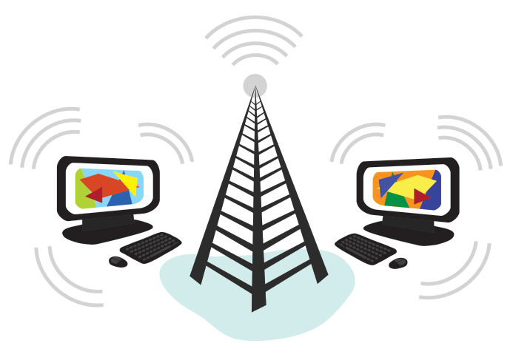
- The Internet is a global network of billions of computers and other electronic devices. With the Internet, it's possible to access almost any information, communicate with anyone else in the world, and do much more. You can do all of this by connecting a computer to the Internet, which is also called going online. When someone says a computer is online, it is just another way of saying it's connected to the Internet.
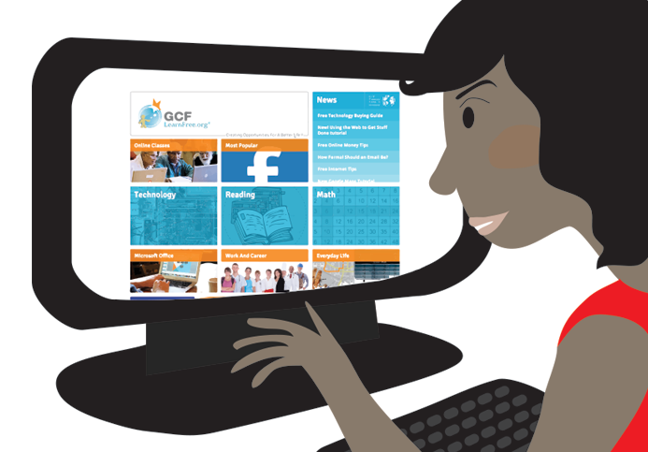
- World Wide Web. The World Wide Web, usually called the Web for short is a collection of different websites you can access through the Internet. A website is made up of related text, images, and other resources. Websites can resemble other forms of media like newspaper articles or television programs or they can be interactive in a way that is unique to computers. The purpose of a website can be almost anything: a news platform, an advertisement, an online library, a forum for sharing images, or an educational site. Once you are connected to the Internet, you can access and view websites using a type of application called a web browser. Just keep in mind that the web browser itself is not the Internet; it only displays websites that are stored on the Internet.
Web Browser
- A web browser is a type of software that allows you to find and view websites on the Internet. There are many different web browsers, but some of the most common ones include Google Chrome, Internet Explorer, Safari, and Mozilla Firefox. Some of the important terminologies related to web browsers are discussed below.
  - URLs and the Address Bar. Each website has a unique address, called a URL (short for Uniform Resource Locator). It's like a street address that tells your browser where to go on the Internet. When you type a URL into the browser's address bar and press Enter on your keyboard, the browser will load the page associated with that URL. In the example below, we've typed www.bbc.com/travel into the address bar.
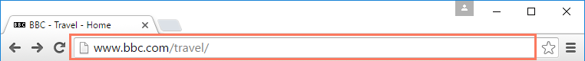

  - Links. Links are used to navigate the Web. When you click a link, it will usually take you to a different webpage. You may also notice that your cursor changes into a hand icon whenever you hover over a link.


  - Navigation Buttons. The Back and Forward buttons allow you to move through websites you've recently viewed. You can also click and hold either button to see your recent history.
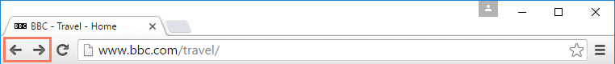

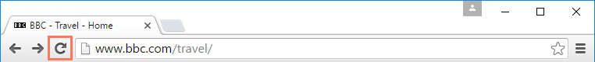
  - Refresh Button.The Refresh button will reload the current page. If a website stops working, try using the Refresh button.

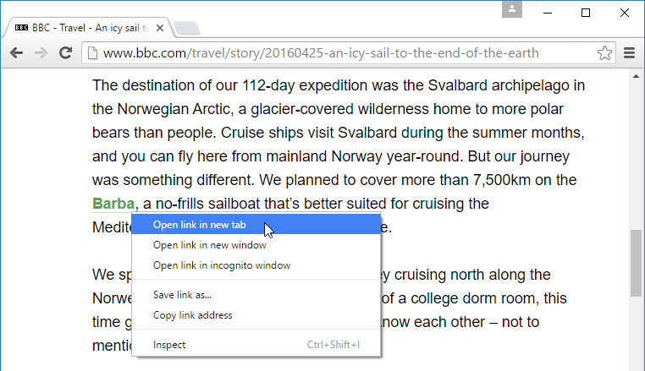
  - Tabbed Browsing. Many browsers allow you to open links in a new tab. You can open as many links as you want, and they'll stay in the same browser window instead of cluttering your screen with multiple windows. To open a link in a new tab, right-click the link and select Open link in new tab (the exact wording may vary from browser to browser)

  - Plug-ins. Plug-ins are small applications that allow you to view certain types of content within your web browser. For example, Adobe Flash and Microsoft Silverlight are often used to play videos, while Adobe Reader is used to view PDF files. If you don't have the correct plug-in for a website, your browser will usually provide a link to download it. There may also be times when you need to update your plug-ins.
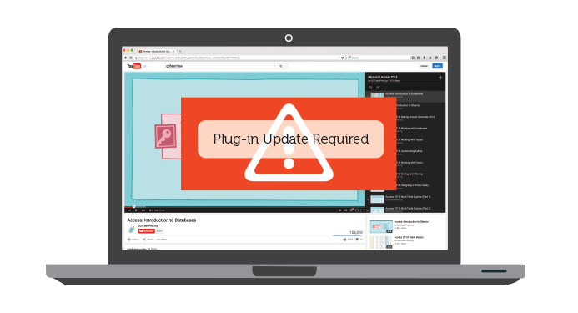
Downloading and Uploading
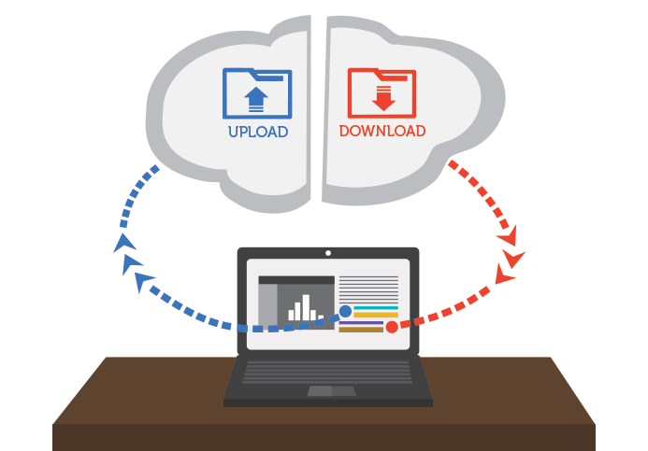
- While exploring the Internet, you have probably encountered the terms downloading and uploading. Downloading means receiving data or a file from the Internet on your computer. Uploading means sending data or a file from your computer to somewhere on the Internet.

  - Downloading. Usually, when you download a file you will start the download by clicking a link to that file. If you click the link, your browser should prompt you to select one of two methods for downloading the file
    - Open with will download the file and load it immediately in the specified program
    - Save File will download it and save it to your hard drive

b. Uploading. If a site allows uploads, it will have an upload utility to help perform the file transfer. Many sites have an upload button that opens a dialog box. For example, Facebook has a camera icon that begins the upload process.


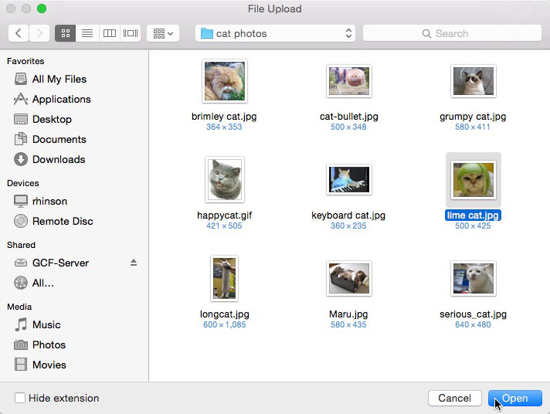
A dialog box will appear, prompting you to select a file. Browse to the location where your file is stored, select it, and then click the Open button. Afterward, a progress bar tracking the upload process will appear on the page.

Some sites support a drag-and-drop interface. For example, when logged in to Dropbox you can drag the files from a folder on your computer and drop them into the browser window.
HTML
- HTML is the standard markup language for creating Web pages.
  - HTML stands for Hyper Text Markup Language.
  - HTML describes the structure of Web pages using markup.
  - HTML elements are the building blocks of HTML pages
  - HTML elements are represented by tags.
  - HTML tags label pieces of content such as "heading", "paragraph", "table", and so on.
  - Browsers do not display the HTML tags, but use them to render the content of the page.
  - A Simple HTML Document

Example
<!DOCTYPE html>
<html>
<head>
<title>PageTitle</title>
</head>
<body>
<h1>My First Heading</h
<p>My first paragraph</p>
</body>
</html>
  - Example Explained
- The <!DOCTYPE html> declaration defines this Document to be HTML5
- The <html> element is the root element of an HTML page
(3) The <head> element contains meta information about the Document
- The <title> element specifies a title for the Document
- The <body> element contains the visible page content
- The <h1> element defines a large heading
- The <p> element defines a paragraph
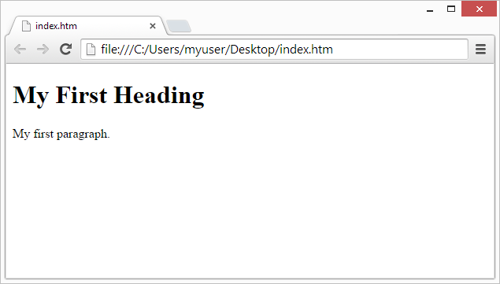
  - Output of the Example

  - HTML Page Structure. Below is a visualization of an HTML page structure
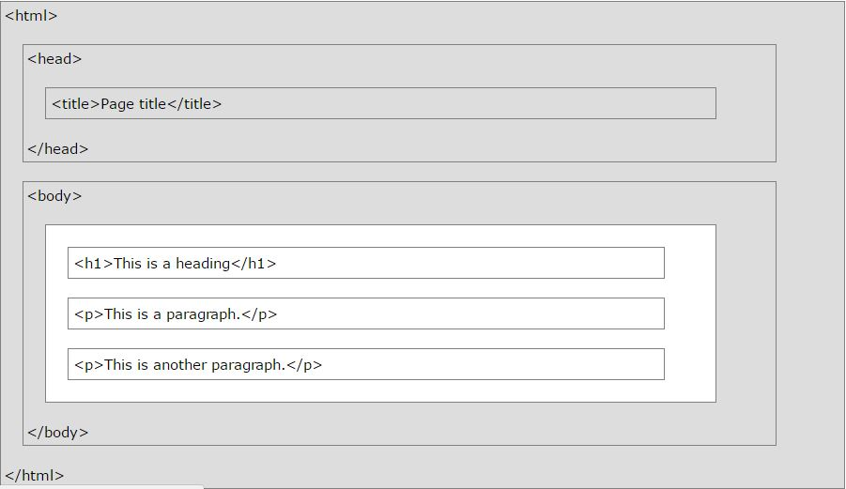
Designing of a Simple Web Page
- Web pages can be created and modified by using professional HTML editors. However, for learning HTML we recommend a simple text editor like Notepad (PC) or Text Edit (Mac).We believe using a simple text editor is a good way to learn HTML.Follow the four steps below to create your first web page with Notepad or Text Edit.
  - Open the Start Screen (the window symbol at the bottom left on your screen). Type Notepad
  - Open Finder > Applications > Text Editor.
  - Write or copy some HTML into Notepad
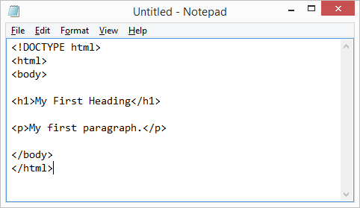
  - Save the file on your computer. Select File > Save as in the Notepad menu. Name the file "index.htm" and set the encoding to UTF-8 (which is the preferred encoding for HTML files)
  - Open the saved HTML file in your favorite browser (double click on the file, or right-click - and choose "Open with").The result will look much like this.
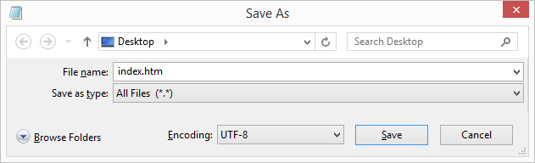



Hacking
- Hacking is the act of gaining unauthorized access to computer systems, networks, or data. It can be ethical (legal, for security testing) or malicious (illegal, for theft or damage).
Types of Hacking
  - White Hat Hacking. Ethical hacking done to find and fix security flaws.
  - Black Hat Hacking. Malicious hacking for personal gain or harm.
  - Grey Hat Hacking. In-between; may break rules but not for harmful intent.
Cloud Computing
- Cloud Computing is a technology that delivers on demand computing services such as servers, storage, databases, networking, software, and analytics over the internet (“the cloud”) rather than relying on a local computer or physical infrastructure. It allows users and organizations to access, store, and process data anytime and anywhere without owning or managing physical hardware. Cloud computing works on a pay-as-you-go model, meaning you only pay for the resources you use, making it cost-effective, scalable, and flexible.
IOT
- Internet of Things (IoT) is a network of physical objects such as devices, vehicles, appliances, and sensors that are connected to the internet and can collect, exchange, and process data without human intervention. These “smart” devices use embedded sensors, software, and communication technologies to interact with each other and with users, creating an intelligent system that improves efficiency, automation, and decision making.
Block Chain
- Block chain is a decentralized and distributed digital ledger technology that records transactions across multiple computers in a secure, transparent, and tamper-proof way. Instead of being controlled by a single authority, the data is stored in “blocks” that are linked together in a “chain.” Each block contains transaction data, a timestamp, and a cryptographic hash of the previous block, ensuring integrity and immutability.
Artificial Intelligence
- Artificial Intelligence (AI) is a branch of computer science that focuses on creating machines and systems capable of performing tasks that normally require human intelligence. These tasks include learning, reasoning, problem-solving, decision making, speech recognition, image processing, and natural language understanding. AI systems use algorithms, data, and computational power to simulate human-like intelligence and improve performance over time.
Machine Learning
- Machine Learning (ML) is a subset of Artificial Intelligence (AI) that enables computers to learn and improve automatically from data and past experiences without being explicitly programmed. Instead of following fixed rules, ML systems use algorithms and statistical models to identify patterns, make predictions, and improve decision-making as more data is provided.
Big Data
- Big Data refers to extremely large and complex sets of data structured, semi-structured, and unstructured that are too vast for traditional data processing software to handle efficiently. It requires advanced tools and technologies to store, manage, and analyze in order to extract valuable insights for decision-making.

MICROSOFT WORD
Definition
            - Microsoft Word is the word processing component of the Microsoft Office Suite. It is used primarily to enter, edit, format, save, retrieve and print documents.
            - MS Word can also be used for creating documents such as letters, brochures, learning activities, tests, quizzes and students' homework assignments.
MS Word is a popular word-processing program used primarily for creating documents such as
- Letters
- Minute sheets
- Brochures
- Learning activities
- Tests
- Quizzes
- Students' homework assignments

Brief History of MS Word
            - The first version of Microsoft Word was developed by Charles Simonyi and Richard Brodie, former Xerox programmers hired by Bill Gates and Paul Allen in 1981. Both programmers worked on Xerox Bravo, the first WYSIWYG (What You See Is What You Get) word processor. The first Word version, Word 1.0, was released in October 1983 for Xenix and MS-DOS; it was followed by four very similar versions that were not very successful. The first Windows version was released in 1989, with a slightly improved interface. When Windows 3.0 was released in 1990, Word became a huge commercial success. Word for Windows 1.0 was followed by Word 2.0 in 1991 and Word 6.0 in 1993. Then it was renamed to Word 95 and Word 97, Word 2000 and Word for Office XP (to follow Windows commercial names). With the release of Word 2003, the numbering was again year-based. Since then, Word 2007, Word 2010, Word 2013, and most recently, Word 2016 have been released for Windows.
            - Word 2010. Microsoft Word 2010 is a word-processing program, designed to help you create professional-quality Documents. With the finest document-formatting tools, Word helps you organize and write your docments more efficiently. Word also includes powerful editing and revising tools so that you can collaborate with others easily.
            - Difference Between Word 2003 and Word 2010. Understanding the Ribbon is a great way to help understand the changes between Microsoft 2003 to Microsoft 2010. The ribbon holds all of the information in previous versions of Microsoft Office in a more visual stream line manner through a series of tabs that include an immense variety of program features.
              - Home Tab. This is the most used tab; it incorporates all text formatting features such as font and paragraph changes
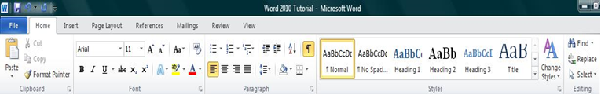
              - Insert Tab. This tab allows you to insert a variety of items into a Document from pictures, clip art, tables and headers and footers.
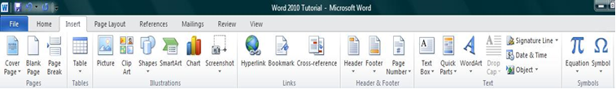
              - Page Layout Tab. This tab has commands to adjust page elements such as margins, orientation, inserting columns, page backgrounds and themes.
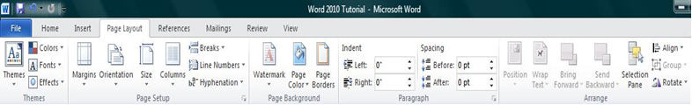
              - Reference Tab. This tab has commands to use when creating a Table of Contents and citation page for a paper. It provides you with many simple solutions to create these typically difficult to produce Documents.
              - Mailing Tab. This tab allows you to create Documents to help when sending out mailings such as printing envelopes, labels and processing mail merges
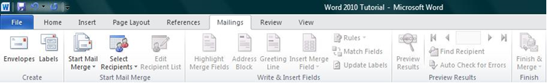

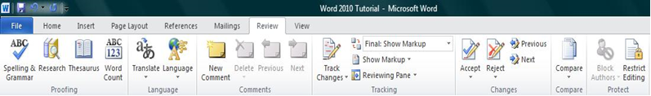
  - Review Tab. This tab allows you to make any changes to your Document due to spelling and grammar issues. It also holds the track changes feature which provides people with the ability to make notes and changes to a Document of another person.
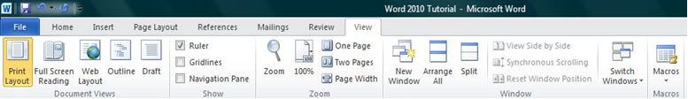
  - View Tab. This tab allows you to change the view of your documents to a different two page document or zoom.

- How to Create a New Document
  - Click the File tab and then click New.
  - Under Available Templates, click Blank Document.
  - Click Create.
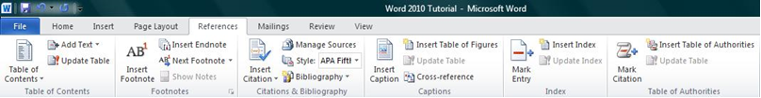

- Using Templates. Word 2010 allows you to apply built-in templates from a wide selection of popular Word templates, including resumes, agendas, business cards, and faxes. To find and apply a template in Word, do the following:
  - On the File tab, click New.
  - Under Available Templates, do one of the following
    - To use one of the built-in templates, click Sample Templates, click the template that you want, and then click Create.
    - To reuse a template that you’ve recently used, click Recent Templates, click the template that you want, and then click Create.
    - To find a template on Office.com, under Office.com Templates, click the template category that you want, click the template that you want, and click Download to download the template from Office.com to your computer
  - Once you have selected your template you can modify it in any way to create the Document you want.
- How to Open a Document. To open a Document follow the following steps.
  - Click the File tab, and then click Open.
  - In the left pane of the Open dialog box, click the drive or folder that contains the Document.
  - In the right pane of the Open dialog box, open the folder that contains the Document that you want.
  - Click the Document and then click Open.
- Saving a Document. we can save a Document in different formats of the word i.e 2007 and 2003 compatible
  - To save a Document in the format used by Word 2010 and Word 2007, do the following:-
    - Click the File tab.
    - Click Save As.
    - In the File name box, enter a name for your Document.
    - Click Save.
  - To save a Document so that it is compatible with Word 2003 or earlier, do the following:-
    - Click the File tab.
    - Click Save As.
    - In the Save as type list, click Word 97-2003 Document. This changes the file format to .doc.
    - In the File name box, type a name for the Document.
    - Click Save.
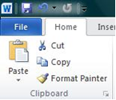
- Cut, Copy and Paste. If you would like to remove text from your Document you can copy or cut the text from the Document. Simply highlight the text and go to the Home tab in the Clipboard group and click Cut or Copy. You can also right click on your mouse and select Cut or Copy.
  - Pasting Text. If you Copy text, you typically need to Paste it somewhere. The Paste feature in 2010 is much more detailed than in previous versions of Word. When you paste content, the Paste Options button provides different options, depending on the source of the content
    - Keep source formating.This option preserve the look of the original text
    - Keep Text Only. This option removes all the original formation of the text.
    - Link & Keep Source Formatting. This option preserves the look of the original text, and it maintains a link to the source file and updates the pasted text with any changes that are made to the source file.
    - This option inserts the text as an image.
- Formatting Text. Formatting a document can range from modifying text size to adding graphics. It is easy to add creative touches to any document with the options Microsoft Word has to offer.
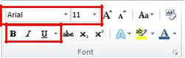
  - Modifying Fonts. The Font Group allows you to change your text font style, size, color and many other elements.
    - Highlight the text you would like to modify.
    - Click on the drop down arrow of font style and font size and select the changes you would like to make.
    - While text is highlighted you can also click on the color, bold, italics or underline commands to modify the text even more.
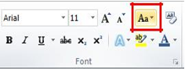
  - Change Text Case. You can change the case of selected text in a Document by clicking a single button called Change Case on the ribbon.
    - Highlight the text for which you want to change the case.
    - On the Home tab, in the Font group, click Change Case.
    - Choose an option from the dropdown list, which includes Sentence case, lowercase, UPPERCASE, Capitalize Each Word, and tOGGLE cASE.
  - Adding Text Effects
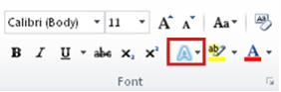
    - Select the text that you want to add an effect to.
    - On the Home tab, in the Font group, click Text Effect.
    - Click the effect that you want.
    - For more choices, point to Outline, Shadow, Reflection, or Glow, and then click the effect that you want to add.

  - Remove Text Effects
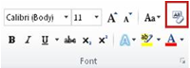
    - Select the text that you want to remove an effect from.
    - On the Home tab, in the Font group, click Clear Formatting.
  - Format Painter. The Format Painter feature allows you to quickly copy a format that you have applied to text already in your Document.
    - Select the text or graphic that has the formatting that you want to copy.
    - On the Home tab, in the Clipboard group, single click Format Painter. The pointer will change to a paintbrush icon.
    - Bring your cursor to the text or graphic that you want to format and click on the text.

    - To stop formatting, press ESC or click on the Format Painter command again
- Formatting Documents. In word 2010 we have a lot of options for Document formatting in which some are as follow:-
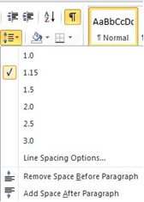
  - Adjusting Line Spacing. The default spacing is 1.15 line spacing and 10 points after each paragraph. The default spacing in Office Word 2003 Documents is 1.0 between lines and no blank line between paragraphs
    - On the Home tab, in the Paragraph group, click Line Spacing
    - Click the number of line spaces that you want
    - For example, click 1.0 to single-space with the spacing that is used in earlier versions of Word. Click 2.0 to double-space the selected paragraph. Click 1.15 to single-space with the spacing that is used in Word 2010.
  - Page Orientation. You can choose either portrait (vertical) or landscape (horizontal) orientation for all or part of your Document.
    - On the Page Layout tab, in the Page Setup group, click Orientation.
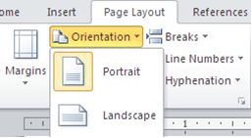
    - Click Portrait or Landscape

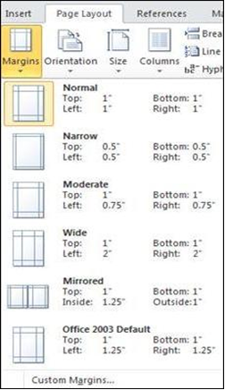
  - Page Margins. Page margins are the blank space around the edges of the page. In general, you insert text and graphics in the printable area inside the margins. When you change a Document’s page margins, you change where text and graphics appear on each page. You can change the page margins either by choosing from one of Word’s predefined settings in the Margins gallery or by creating custom margins
    - On the Page Layout tab, in the Page Setup group, click Margins. The Margins gallery drop down menu will appear.
    - Click the margin type that you want to apply.
  - Page Breaks. Word automatically inserts a page break when you reach the end of a page. If you want the page to break in a different place, you can insert a manual page break.
    - Click where you want to start a new page.
    - On the Insert tab, in the Pages group, click Page Break
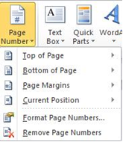
  - Add Page Numbers. If you want a page number on each page, you can quickly add a page number from the gallery.
    - On the Insert tab, in the Header & Footer group, click Page Number.
    - Click the page number location that you want.
    - In the gallery, scroll through the options, and then click the page number format that you want.
  - Add Header or Footer
    - On the Insert tab, in the Header & Footer group, click Header or Footer.
    - Click the header or footer that you want to add to your Document and your header or footer area will open.
    - Type text in the header or footer area.
    - To return to the body of your Document, click Close Header and Footer on the Design tab (under Header & Footer Tools).
Table
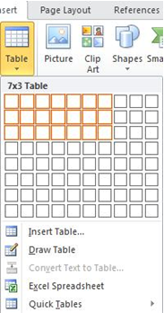
- Using tables in Word can provide you with additional elements to any Document. Tables can be used to create lists or format text in an organized fashion.
- Inserting Table
  - Click where you want to insert a table.
  - On the Insert tab, in the Tables group, click Table
  - A drop down box will appear; click and hold your mouse then drag to select the number of rows and columns that you want inserted into your Document. You will see your table appearing in your Document as you drag on the grid.
  - Once you have highlighted the rows and columns you would like let go of your mouse and the table will be in your Document
  - Add Row/Column to Table
    - Click on the table.
    - Under Table Tools, go to the Layout tab
    - Click on the Insert Above or Insert Below to add a row, Click on
    - Insert Left or Insert Right to insert a column.
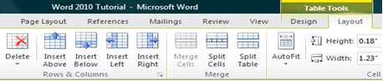

  - Deleting a Table
    - Rest the pointer on the table until the table move handle appears, and then click the table move handle.
    - Press BACKSPACE on your keyboard.
- Finalizing a Document
  - Using the "Spell Check" Feature. As you type your Document, red wavy lines will appear under any word that is spelled incorrectly. The fastest way to fix spelling errors is to
    - Put your cursor over the misspelled word and right click.
    - A drop down box will appear with correct spellings of the word.
    - Highlight and left click the word you want to replace the incorrect word with
  - To complete a more comprehensive Spelling and Grammar check, you can use the Spelling and Grammar feature.
    - Click on the Review tab
    - Click on the Spelling & Grammar command (a blue check mark with ABC above it).
    - A Spelling and Grammar box will appear.
    - You can correct any Spelling or Grammar issue within the box.
- Print Preview. Print Preview automatically displays when you click on the Print tab. Whenever you make a change to a print-related setting, the preview is automatically updated
  - Click the File tab, and then click Print. To go back to your Document, click the File tab.
  - A preview of your Document automatically appears. To view each page, click the arrows below the preview
  - The Print tab is the place to go to make sure you are printing what you want
  - Click the File tab.
  - Click the Print command to print a Document.
  - Click the Print button to print your Document.
  - This dropdown shows the currently selected printer. Clicking the dropdown will display other available printers.
  - These dropdown menus show currently selected Settings. Rather than just showing you the name of a feature, these dropdown menus show you what the status of a feature is and describes it. This can help you figure out if you want to change the setting from what you have

MICROSOFT POWERPOINT
Definition
            - PowerPoint is a presentation program developed by Microsoft. It is included in the standard Office suite along with Microsoft Word and Excel. The software allows users to create anything from basic slide shows to complex presentations.
            - PowerPoint is often used to create Military presentations, but can also be used for educational or informal purposes.
MS PowerPoint is a popular presentation making software used primarily for
- Present information in office meetings
- Present seminar
- Present lectures
- Amplification of message
- Visual Impacts
- Collaboration

Brief History of MS Powerpoint
            - Software developers Robert Gaskins and Dennis Austin created the original PowerPoint application under the Forethought, Inc. it was originally called the ‘Presenter’. The Presenter was later called PowerPoint 1.0 when it was released for use for Apple Macintosh in April of 1987. During that time the PowerPoint 1.0 only function in black and white, and text and graphics generated pages only for overhead transparencies. The PowerPoint full color version came out the year 1987. On July 31st of the year 1987, the Forethought Inc. and its PowerPoint product software was bought by Microsoft Corporation in a staggering amount of Fourteen Million dollars ($14 million). In the year 1990 the first ever version of Windows was created for Windows 3.0 and it has included the PowerPoint application as part of the Microsoft Office suite. The current version for the Windows platform is Microsoft Office PowerPoint 2016.

PowerPoint 2010
            - PowerPoint 2010 is a system in the Microsoft Office Suite that enables you to present information in office meetings, lectures and seminars to create maximum impact in a minimal amount of time. PowerPoint presentations can amplify your message, accelerate the information being absorbed and assist with comprehension enabling faster decision making.
            - The Design Ribbon Toolbar. The Design Ribbon toolbar contains several categories for formatting the design and elements of your presentation. These include: Home, Insert, Design, Transitions, Animations, Slide Show, Review and View. These icons are convenient but will not bring up dialogue boxes that allow you to change the settings of these actions. You should use whichever method works the best for you.
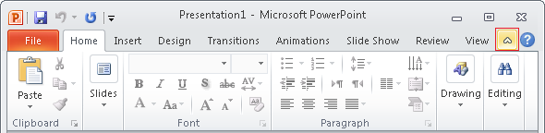
- Home Tab. This tab has features that allow you to edit Slides, Fonts, Paragraph, Drawing and Editing.
- Insert Tab. This tab has features that allow you to add Tables, Images, Illustrations, Links, WordArt, and Media Clips.
- Design Tab. This tab allows you to edit how your presentation will look. It includes features such as Page Setup, Themes, and Background Styles.
- Transition Tab. This tab allows you to edit Slide Transitions, Effects, and Transition Timing.
- Animations Tab. This tab allow you to add custom animations to your presentation. You can select from Preview, Animations, Advance Animation, and Animation timing.
- Slide Show Tab. This tab has features that allow you to select how your presentation will be displayed. From here, you can start your Slide Show, Set Up your Slide Show, and Adjust Monitor Settings.
- Review Tab. This tab allows you to Proofread, Translate Languages, Comment Slides, and Compare your Presentation.
- View Tab. This tab has features that allow you to set the View of your Presentation, Create Master Views, Show/Hide Features, Zoom, Switch from Color to Grayscale, Adjust Windows, and Add Macros.
            - How to open PowerPoint Presentation
  - Start Menu
  - All Programs
  - Microsoft Office
  - Microsoft PowerPoint.

            - Inserting and Adding Objects in Presentation. we can insert different objects in PowerPoint presentation such as pictures, videos, audios, tables and clip Art etc. The steps to add these objects are as follow:-
              - Clip Art. When trying to enhance your word Document you may want to include Clip Art and/or Word Art. Microsoft PowerPoint comes with a Clip Gallery that contains a large variety of images including pictures, borders, and backgrounds. To find a desired image, you can either click on topics or type in the search box to find exactly what you are looking for. To insert clip Art follow the following steps.
    - Click on the insert bar
    - Click on the Clip Art
    - Select the Clip Art of your choice
    - Click OK

  - Word Art. WordArt is inserted similar to Clip Art. To insert WordArt, go to Insert > WordArt (WordArt). Afterwards, you will be prompted to insert your text. To select your WordArt, click on it, and small boxes will appear in the corners. Moving the small boxes will allow you to resize the WordArt. You can also change the effects of the WordArt by clicking the options in the design ribbon toolbar.

  - Pictures. To insert a picture into your presentation select Insert > Picture. You can choose either to get the photo from a browser, or from a file or then locate the image that you want to put into your Document and click Insert.

  - Inserting a Table. To create a table within your Document, go to the Insert > Table. Choose the desired table size by moving your cursor over the grid and until you have the appropriate amount of rows and columns and then click to insert the table into the Document. To navigate within your table, use the arrow keys.

  - Inserting Videos
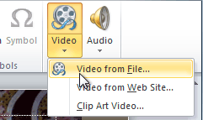
    - From the Insert tab, click the Video drop-down arrow and select Video from File
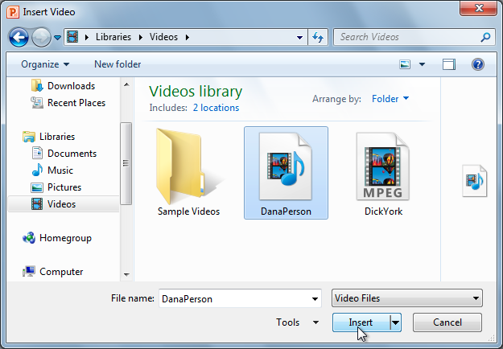
    - Locate and select the desired video file, then click Insert

            - Animating Text and Objects. PowerPoint offers a variety of animations you can use to enhance your presentation. Animations can be used to make text or objects appear on a slide, exit a slide, or emphasize the text or objects already on a slide. You can even use motion paths to create a customized animation. Following are the four types of animations available in PowerPoint.

  - Entrance. These control how the object enters the slide. For example, with the Bounce animation, the object will drop onto the slide and then bounce several times.


  - Emphasis. These animations occur while the object is on the slide and are often triggered by a mouse click. For example, you can set an object to spin when you click the mouse.

  - Exit. These control how the object exits the slide. For example, with the Fade animation, the object will simply fade away
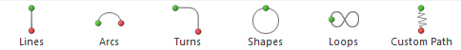

  - Motion Paths. These are similar to Emphasis effects, except the object moves within the slide along a predetermined path, like a circle.
            - How to Apply an Animation to an Object. To apply animation on the object follow the following steps
  - Select an object.
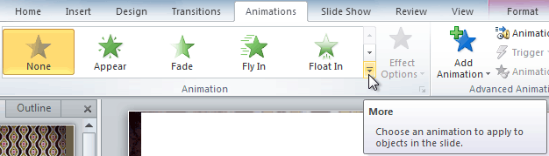
  - Click the Animations tab.

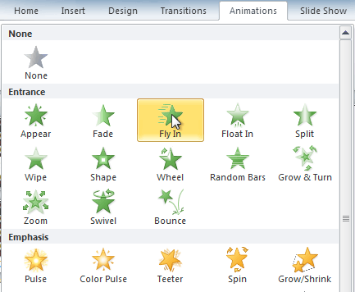
  - In the Animation group, click the more drop-down arrow to view the available animations. Select the desired animation effect

d. The object will now have a small number next to it to show that it has an animation. Also, in the Slide pane, the slide will now have a star symbol next to it.
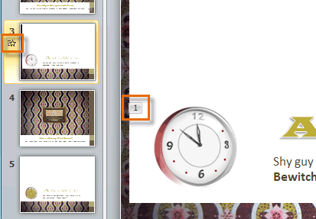

            - To Copy Animations with the Animation Painter. Sometimes you may want to apply the same effects to more than one object. You can do this by copying the effects from one object to another using the Animation Painter.
  - Click the object that has the affects you want to copy.
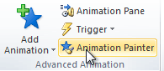
  - From the Animations tab, click the Animation Painter command.
  - Click the object you want to copy the effects to. The effects will be applied to the object.
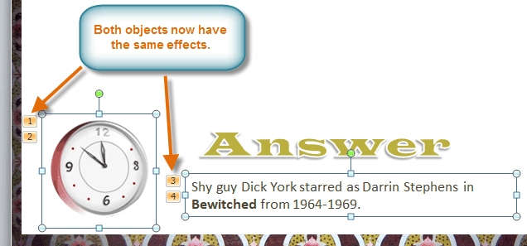

            - Transitions. Transitions are motion effects that when in Slide Show view add movement to your slides as you advance from one slide to another. There are many transitions to choose from, each one of which allows you to control the speed and even add sound. Following are the three categories of transitions.
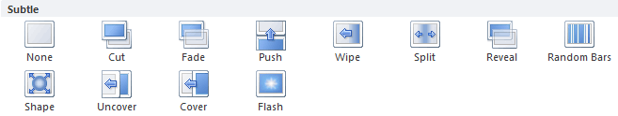
              - Subtle (Slight Transitions)

              - Exciting (Strong Transitions)
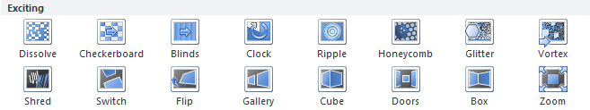

              - Dynamic Content (Strong Transitions that Affect only the Content, such as Text or Images)
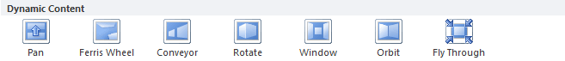

            - How to Apply a Transition. To apply animation on the object follow the following steps
  - Select the slide you want to modify.
  - Click the Transitions tab.
  - Locate the Transition to This Slide group. By default, None is applied to each slide.
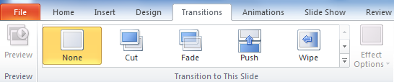
  - Click the More drop-down arrow to display all of the transitions.
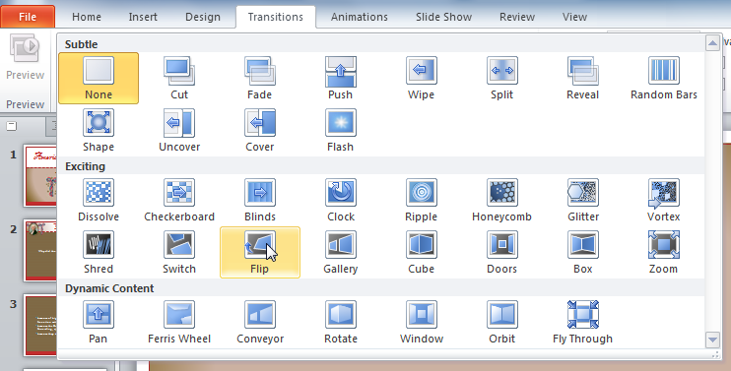
  - Click a transition to apply it to the selected slide. This will automatically preview the transition as well.

Master Slides
            - Slide masters are designed to help you create great looking presentations in less time, without a lot of effort. When you want all your slides to contain the same fonts and images (such as logos), you can make those changes to the Slide Master, and they'll be applied to all your slides.
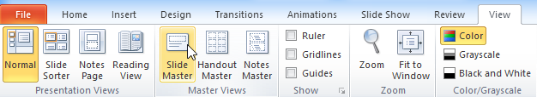
  - Select the View tab, then click the Slide Master command

  - The presentation will switch to Slide Master View, and the Slide Master tab will be selected on the Ribbon.
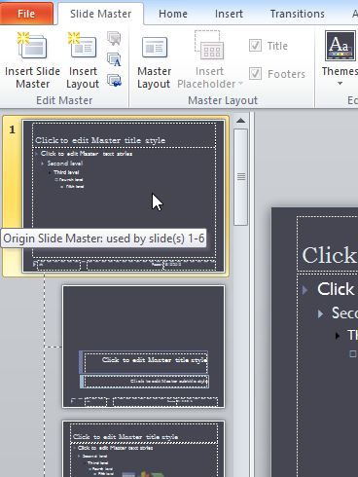
  - In the left navigation pane, scroll up and select the first slide. This is the slide master

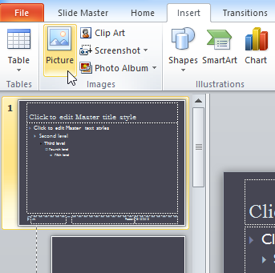
  - Use the desired tabs on the Ribbon to make changes to the slide master. In our example, we'll insert a picture in the upper- left corner of the slide

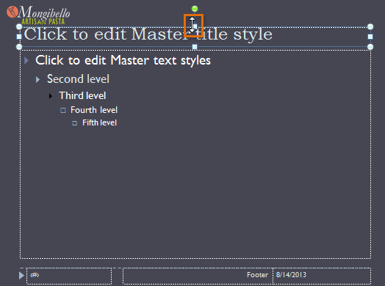
  - Move, resize, or delete other slide objects as needed. In our example, we'll resize the title placeholder to fit below our newly inserted logo


  - When you are finished, click the Close Master View command on the Slide Master tab

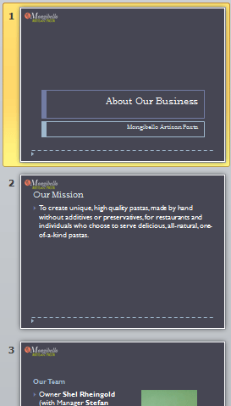
  - The change will appear on all slides of the presentation

Hyperlink
- When you are online, you are using hyperlinks to navigate from one webpage to another. If you want to include a web address or email address in your PowerPoint presentation, you can choose to format them as clickable hyperlinks. It's also possible to link to files and other slides within a presentation. It's easy to do all of this using two tools: hyperlinks and action buttons. To insert hyperlink follow the following steps.
  - Select the image or text you want to make a hyperlink.
  - Right-click the selected text or image, then click Hyperlink

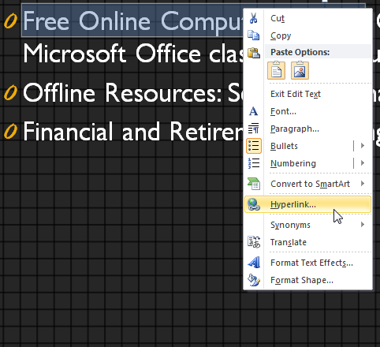

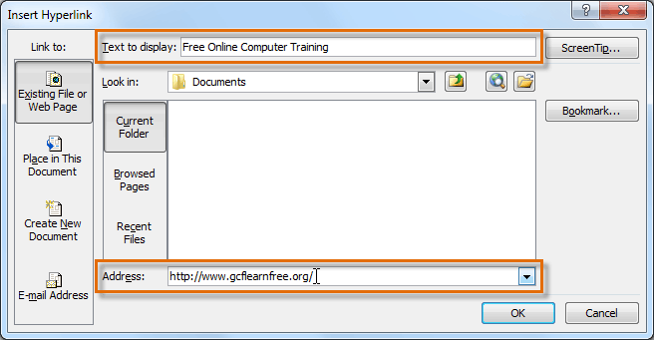
  - The Insert Hyperlink dialog box will open. You can also get to this dialog box from the Insert tab by clicking Hyperlink

  - If you selected text, the words will appear in the Text to display field at the top. You can change this text if you want.
  - Type the address you want to link to in the Address field.
  - Click OK. The text or image you selected will now be a hyperlink to the web address

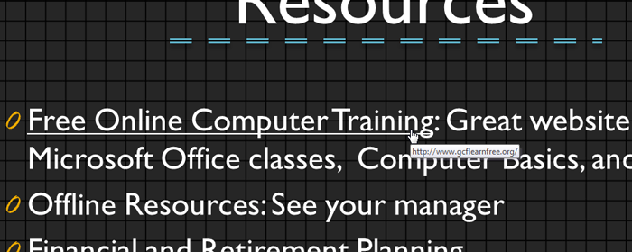

Customizing Slide Show
- Sometimes you might want to hide a slide while still keeping it in your presentation. For instance, if you are presenting a slide show to more than one group of people, hiding or even rearranging certain slides can help you tailor your slide show to each group you present it to. You could also choose to create a shortened version of your slide show to present when you are short on time. The Custom Slide Show feature allows you to create and name different versions of your slide show with hidden or rearranged slides. Following are the steps to arrange custom slide show.
  - Select the Slide Show tab, and locate the Start Slide Show group.
  - Click the Custom Slide Show command.
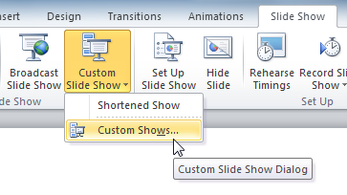

  - Select Custom Shows the Custom Shows dialog box will appear.
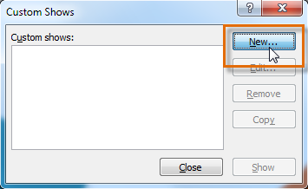
  - Click New. The Define Custom Show dialog box will appear Locate the Slide show name box, and type a name for your custom show.
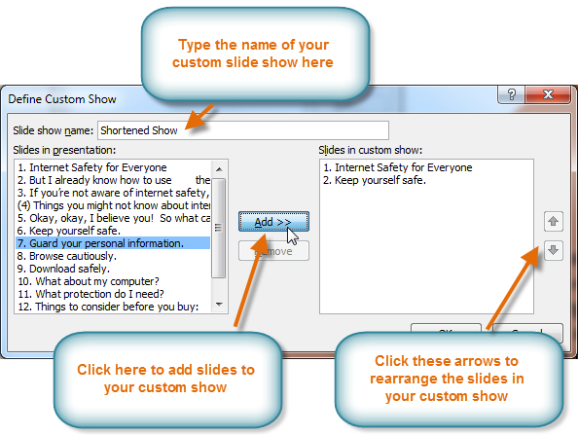
  - Select the slides in the Slides in presentation: box that you want to include in your custom show, then click Add>> to add them to the Slides in custom show: box. If necessary, use the up and down arrows to reorder the added slides

  - Click OK.
  - Select Close to exit or Show to view your custom show.
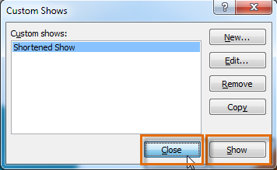

Packaging a Presentation on a CD
- If you are going to display a presentation on a computer other than your own, you should use the Package for CD feature in PowerPoint. This allows you to package the presentation along with all necessary PowerPoint files so you can view the presentation on any computer, regardless of whether the computer has PowerPoint 2007 installed. Steps are:-
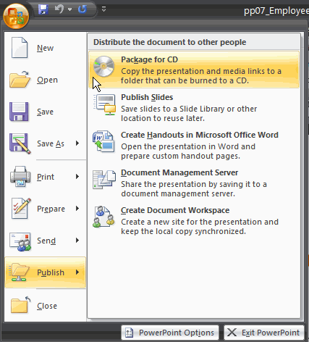
  - Open the presentation you want to save on the CD.
  - Insert a CD into the CD drive. Be sure to use a CD that is able to have data burned—or stored—on it.
  - Click the Microsoft Office button.
  - Select Publish.
  - Select Package for CD.
  - If you link to files from slides in your presentation, a PowerPoint message will appear notifying you that the files may be updated. Click OK.
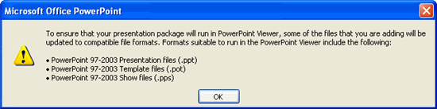
  - The Package for CD dialog box appears.

  - Enter a name in the Name the CD field.
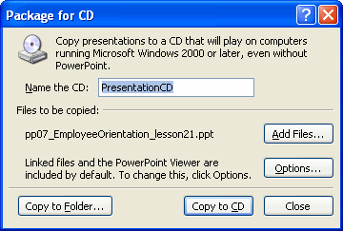

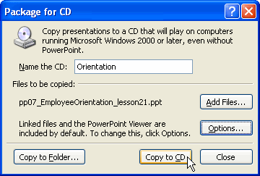
  - Click Copy to CD.

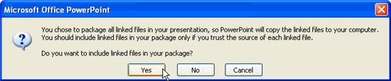
  - If you have linked to other files, a warning message may appear asking you to confirm that you want to include the linked files in your presentation. Click yes, and PowerPoint will copy the files to the CD.

MICROSOFT EXCEL
Definition
            - Microsoft Excel is a spreadsheet (an electronic Document in which data is arranged in the rows and columns of a grid and can be manipulated and used in calculations) program included in the Microsoft Office suite of applications. Spreadsheets present tables of values arranged in rows and columns that can be manipulated mathematically using both basic and complex arithmetic operations and functions.
            - You can use Excel to create and format workbooks (a collection of spreadsheets) in order to analyze data and make more informed business decisions.
MS Excel is a popular data management program used primarily for
- Tracking of data
- Analysis of data
- Performing calculations on that data
- Pivoting the data in numerous ways
- Presenting data in a variety of professional looking charts.

Brief History of MS Excel
            - Microsoft originally marketed a spreadsheet program called Multiplan in 1982, which was very popular on CP/M systems, but on MS-DOS systems it lost popularity to Lotus 1-2-3.This promoted development of a new spreadsheet called Excel which started with the intention to 'do everything 1-2-3 does and do it better. The first version of Excel was released for the Mac in 1985 and the first Windows version was released in November 1987. Lotus was slow to bring 1-2-3 to Windows and by 1988 Excel had started to outsell 1-2-3 and helped Microsoft achieve the position of leading PC software developer. This accomplishment, dethroning the king of the software world, solidified Microsoft as a valid competitor and showed its future of developing graphical software. Microsoft pushed its advantage with regular new releases, every two years or so. The current version for the Windows platform is Microsoft Office Excel 2016. The current version or the Mac OS X platform is Microsoft Excel 2016.
EXCEL 2010
            - Excel 2010 is a spreadsheet program in the Microsoft Office system. You can use Excel to create and format workbooks (a collection of spreadsheets) in order to analyze data and make more informed business decisions. Specifically, you can use Excel to track data, build models for analyzing data, write formulas to perform calculations on that data, pivot the data in numerous ways, and present data in a variety of professional looking charts.
            - Difference Between EXCEL 2003 and EXCEL 2010. Understanding the Ribbon is a great way to help understand the changes between Microsoft 2003 to Microsoft 2010. The ribbon holds all of the information in previous versions of Microsoft Office in a more visual stream line manner through a series of tabs that include an immense variety of program features
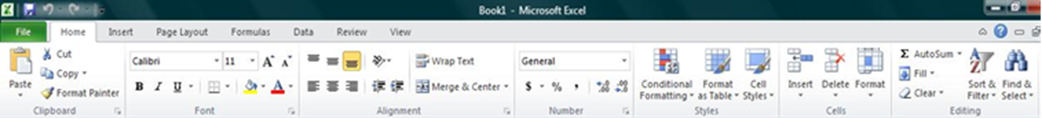
              - Home Tab. This is the most used tab; it incorporates all text and cell formatting features such as font and paragraph changes. The Home Tab also includes basic spreadsheet formatting elements such as text wrap, merging cells and cell style.

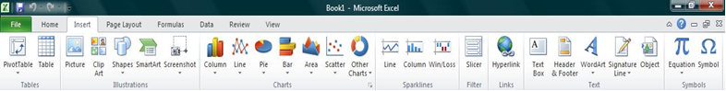
              - Insert Tab. This tab allows you to insert a variety of items into a Document from pictures, clip art, and headers and footers.

              - Page Layout Tab. This tab has commands to adjust page such as margins, orientation and themes.
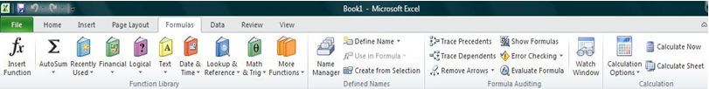
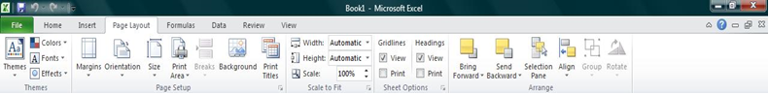
              - Formula Tab. This tab has commands to use when creating Formulas. This tab holds an immense function library which can assist when creating any formula or function in your spreadsheet

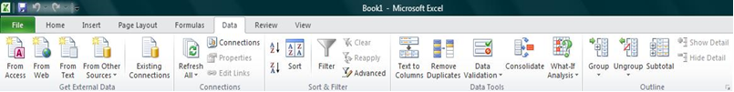
              - Data Tab. This tab allows you to modifying worksheets with large amounts of data by sorting and filtering as well as analyzing and grouping data.

              - Review Tab. This tab allows you to correct spelling and grammar issues as well as set up security protections. It also provides the track changes and notes feature providing the ability to make notes and changes someone’s Document.
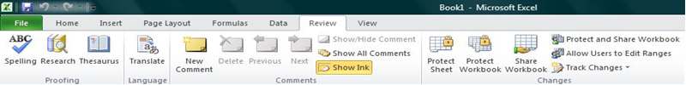

              - View Tab. This tab allows you to change the view of your Document including freezing or splitting panes, viewing gridlines and hide cells.
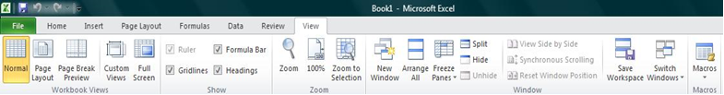

            - How to Create a New Workbook
              - Click the File tab and then click New.
              - Under Available Templates, double click Blank Workbook or Click Create.
            - Using Templates. Excel 2010 allows you to apply built-in templates and to search from a variety of templates on Office.com. To find a template in Excel 2010, do the following:
              - On the File tab, click New.
              - Under Available Templates, do one of the following
                - To use one of the built-in templates, click Sample Templates, click the template that you want, and then click Create
                - To reuse a template that you’ve recently used, click Recent Templates, click the template that you want, and then click Create.
                - To find a template on Office.com, under Office.com Templates, click the template category that you want, click the template that you want, and click Download to download the template from Office.com to your computer
                - Once you have selected your template you can modify it in any way to create the Document you want.
            - How to Open a Document. To open a Document follow the following steps.
              - Click the File tab, and then click Open.
              - In the left pane of the Open dialog box, click the drive or folder that contains the Document.
              - In the right pane of the Open dialog box, open the folder that contains the Document that you want.
              - Click the Document and then click Open.
            - Saving a Document. we can save a Document in different formats of the excel i.e 2007 and 2003 compatible
              - To save a Document in 2010 and 2007 Excel format, do the following:
                - Click the File tab.
                - Click Save As.
                - In the File name box, enter a name for your Document.
                - Click Save.
              - To save a Document so that it is compatible with Excel 2003 or earlier, do the following:
                - Click the File tab.
                - Click Save As.
                - In the Save as type list, click Excel 97-2003 Document. This changes the file format to .doc.
                - In the File name box, type a name for the Document.
                - Click Save.
            - Enter Data in a Worksheet
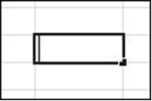
              - Click the cell where you want to enter data.
              - Type the data in the cell.
              - Press enter or tab to move to the next cell
            - Select Cells or Ranges. In order to complete more advanced processes in Excel you need to be able to highlight or select cells, rows and columns. There are a variety of way to do this, see the table below to understand the options.

To select | Do this
A single cell | Click the cell, or press the arrow keys to move to the cell.
A range of cells | Click the first cell in the range, and then drag to the last cell, or hold down SHIFT while you press the arrow keys to extend the selection
A large range of cells | Click the first cell in the range, and then hold down SHIFT while you click the last cell in the range. You can scroll to make the last cell visible
All cells on a worksheet | Click the Select All button or press CTRL+A.
Nonadjacent cells or cell Ranges | Select the first cell or range of cells, and then hold down CTRL while you select The other cells or ranges.
 | NOTE: You cannot cancel the selection of a cell or range of cells in a Nonadjacent selection without canceling the entire selection
An entire row or column | Click the row or column heading.
Adjacent rows or columns | Drag across the row or column headings. Or select the first row or column; then hold down SHIFT while you select the last row or column.
Nonadjacent rows or  Columns | Click the column or row heading of the first row or column in your selection;  then hold down CTRL while you click the column or row headings of other rows  or columns that you want to add to the selection.
Cells to the last used cell | Select the first cell, and then press CTRL+SHIFT+END to extend the selection

            - Modifying Spreadsheets. In order to create an understandable and professional Document you will need to make adjustments to the cells, rows, columns and text. Use the following processes to assist when creating a spreadsheet.
              - Cut, Copy, and Paste Data . You can use the Cut, Copy, and Paste commands in Microsoft Office Excel to move or copy entire cells or their contents. NOTE: Excel displays an animated moving border around cells that have been cut or copied. To cancel a moving border, press ESC
              - Move/Copy Cells. When you move or copy a cell, Excel moves or copies the entire cell, including formulas and their resulting values, cell formats, and comments
                - Select the cells that you want to move or copy.
                - On the Home tab, in the Clipboard group, do one of the following
                - To move cells, click Cut .
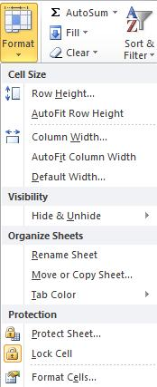
                - To copy cells, click Copy
                - Click in the center of the cell you would like to Paste the information too.
                - On the Home tab, in the Clipboard group, click Paste
                - NOTE: Excel replaces existing data in the paste area when you cut and paste cells to move them. When you copy cells, cell references are automatically adjusted. If the selected copy or paste area includes hidden cells, Excel also copies the hidden cells. You may need to temporarily unhide cells that you don't want to include when you copy information.
              - Column Width and Row Height. On a worksheet, you can specify a column width of 0 to 255 and a row height of 0 to 409. This value represents the number of characters that can be displayed in a cell that is formatted with the standard font. The default column width is 8.43 characters and the default row height is 12.75 points. If a column/row has a width of 0, it is hidden. To Set Column/Row Width/Height follow the steps
                - Select the column(s) or row(s) that you want to change.
                - On the Home tab, in the Cells group, click Format.
                - Under Cell Size, click Column Width or Row Height.
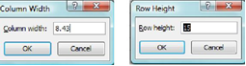
                - A Column Width or Row Height box will appear.
                - In the Column Width or Row Height box, type the value that you want your column or row to be.
              - Merge or Split Cells. When you merge two or more adjacent horizontal or vertical cells the cells become one larger cell that is displayed across multiple columns or rows. When you merge multiple cells, the contents of only one cell appear in the merged cell
              - Merge and Center Cells
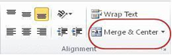
                - Select two or more adjacent cells that you want to merge.
                - On the Home tab, in the Alignment group, click Merge and Center.
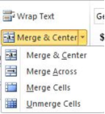
                - The cells will be merged in a row or column, and the cell contents will be centered in the merged cell
                - Merge Cells. To merge cells only, click the arrow next to Merge and Center, and then click Merge Across or Merge Cells.
                - Split Cells
                - Select the merged cell you want to split
                - To split the merged cell, click Merge and Center .The cells will split and the contents of the merged cell will appear in the upper-left cell of the range of split cells.
              - Automatically Fill Data. To quickly fill in several types of data series, you can select cells and drag the fill handle. To use the fill handle, you select the cells that you want to use as a basis for filling additional cells, and then drag the fill handle across or down the cells that you want to fill.
                - Select the cell that contains the formula that you want to be brought to other cells.

                - Move your curser to the small black square in the lower-right corner of a selected cell also known as the fill handle. Your pointer will change to a small black cross.
                - Click and hold your mouse then drag the fill handle across the cells, horizontally to the right or vertically down, that you want to fill.
                - The cells you want filled will have a gray looking border around them. Once you fill all of the cells let go of your mouse and your cells will be populated.
              - Formatting Spreadsheets. To further enhance your spreadsheet you can format a number of elements such as text, numbers, coloring, and table styles. Spreadsheets can become professional Documents used for company meetings or can even be published
              - Wrap Text. You can display multiple lines of text inside a cell by wrapping the text. Wrapping text in a cell does not affect other cells
                - Click the cell in which you want to wrap the text.
                - On the Home tab, in the Alignment group, click Wrap Text.
                - The text in your cell will be wrapped
              - Cell Borders. By using predefined border styles, you can quickly add a border around cells or ranges of cells. If predefined cell borders do not meet your needs, you can create a custom border.
NOTE: Cell borders that you apply appear on printed pages. If you do not use cell borders but want worksheet gridline borders for all cells to be visible on printed pages, you can display the gridlines
- Apply Cell Borders
- On a worksheet, select the cell or range of cells that you want to add a border to, change the border style on, or remove a border from.
- Go to the Home tab, in the Font group
- Click the arrow next to Borders
- Click on the border style you would like
- The border will be applied to the cell or cell range
- Remove Cell Borders
                - Go to the Home tab, in the Font group
                - Click the arrow next to Borders
                - Click No Border .
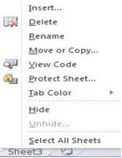
- Customize Worksheet Tab
                - On the Sheet tab bar, right-click the sheet tab that you want to customize
                - Click Rename to rename the sheet or Tab Color to select a tab color.
                - Type in the name or select a color you would like for your spreadsheet.
                - The information will be added to the tab at the bottom of the spreadsheet
Formulas in MS Excel
13. Formulas are the Bread and butter of worksheet. Without formula, worksheet will be just simple tabular representation of data. A formula consists of special code, which is entered into a cell. It performs some calculations and returns a result, which is displayed in the cell. Formulas use a variety of operators and worksheet functions to work with values and text. The values and text used in formulas can be located in other cells, which makes changing data easy and gives worksheets their dynamic nature. For example, you can quickly change the data in a worksheet and formulas works.
14. Elements of Formulas. A formula can consist of any of these elements:
              - Mathematical operators, such as + (for addition) and *(for multiplication) Example =A1+A2 Adds the values in cells A1 and A2.
              - Values or text Example: o =200*0.5 Multiplies 200 times 0.15. This formula uses only values, and it always returns the same result as 100. Cell references (including named cells and ranges). Example: =A1=C12 Compares cell A1 with cell C12. If the cells are identical, the formula returns TRUE; otherwise, it returns FALSE.
              - Worksheet functions (such as SUM or AVERAGE) Example: =SUM (A1:A12) Adds the values in the range A1:A12.
15. Create Simple Formulas
              - Click the cell in which you want to enter the formula.
              - Type = (equal sign).
              - Enter the formula by typing the constants and operators that you want to use in the calculation.
              - Press ENTER.

EXAMPLE  FORMULA | WHAT IT DOES
=5+2 | Adds 5 and 2
=5-2 | Subtracts2 from 5
=5/2 | Divides 5 by 2
=5*2 | Multiplies 5 times 2
=5^2 | Raises 5 to the 2nd power

16. Create a Formula with Cell References
- Click the cell in which you want to enter the formula.
- In the formula bar, at the top of the Excel window that you use, type = (equal sign).
- Click on the 1st cell you want in the formula.
- Enter an Operator such as +, or *.
- Click on the next cell you want in the formula. Continue steps 3 – 5 until the formula is complete
- Hit the ENTER key on your keyboard
17. Create a Formula with Function
  - Click the cell in which you want to enter the formula.
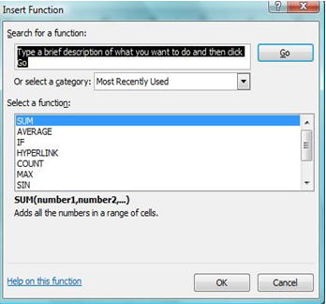
  - Click Insert Function on the formula bar. Excel inserts the equal sign (=) for you.
  - Select the function that you want to use.
NOTE: If you are not sure which function to use, type a question that describes what you want to do in the Search for a function box (for example, "add numbers" returns the SUM function), or browse from the categories in the Or Select a category box.
  - Enter the arguments.
  - After you complete the formula, press ENTER
  - Avoid common errors with formulas The following table summarizes some of the most common errors that you can make when entering a formula and how to correct those errors
Make sure | Description
Match all open and close parentheses | Make sure that all parentheses are part of a matching pair. When you create a formula, Excel displays parentheses in color as they are entered
Use a colon to indicate a range | When you refer to a range of cells, use a colon (:) to separate the reference to the first cell in the range and the reference to the last cell in the range. For example, A1:A5
Enter numbers without formatting | Do not format numbers as you enter them in formulas. For example, even if the value that you want to enter is $1,000, enter 1000 in the formula

Charts in MS-Excel
18. A chart is a visual representation of numeric values. Charts (also known as graphs) have been an integral part of spreadsheets. Charts generated by early spreadsheet products were quite crude, but thy have improved significantly over the years. Excel provides you with the tools to create a wide variety of highly customizable charts. Displaying data in a well-conceived chart can make your numbers more understandable. Because a chart presents a picture, charts are particularly useful for summarizing a series of numbers and their interrelationships.
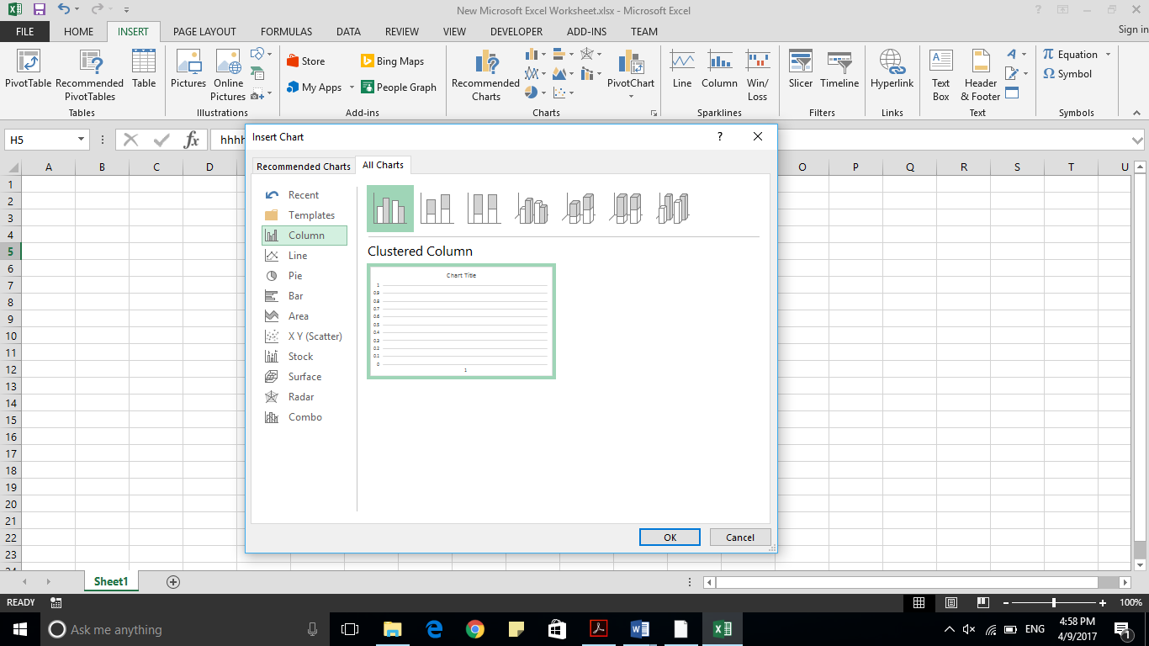
19. Types of Charts. There are various chart types available in MS Excel as shown in the below screen-shot.
    - Column. Column chart shows data changes over a period of time or illustrates comparisons among items.
    - Bar. A bar chart illustrates comparisons among individual items.
    - Pie. A pie chart shows the size of items that make up a data series, proportional to the sum of the items. It always shows only one data series and is useful when you want to emphasize a significant element in the data.
    - Line. A line chart shows trends in data at equal intervals.
    - Area. An area chart emphasizes the magnitude of change over time
    - X Y Scatter. A xy (scatter) chart shows the relationships among the numeric values in several data series, or plots two groups of numbers as one series of xy coordinates.
    - Stock. This chart type is most often used for stock price data, but can also be used for scientific data (for example, to indicate temperature changes).
    - Surface. A surface chart is useful when you want to find the optimum combinations between two sets of data. As in a topographic map, colors and patterns indicate areas that are in the same range of values.
    - Doughnut. Like a pie chart, a doughnut chart shows the relationship of parts to a whole; however, it can contain more than one data series.
    - Bubble. Data that is arranged in columns on a worksheet, so that x values are listed in the first column and corresponding y values and bubble size values are listed in adjacent columns, can be plotted in bubble chart.
    - Radar. A radar chart compares the aggregate values of a number of data series.
20. Creating Chart. To create charts for the data by below mentioned steps.
- Select the data for which you want to create the chart.
- Choose Insert Tab » Select the chart or click on the Chart group to see various chart types.
- Select the chart of your choice and click OK to generate the chart.
21. Editing Chart. You can edit the chart at any time after you have created it.
- You can select the different data for chart input with Right click on chart » Select data. Selecting new data will generate the chart as per the new data, as shown in the below screen-shot.
- You can change the X axis of the chart by giving different inputs to X-axis of chart.
- You can change the Y axis of chart by giving different inputs to Y-axis of chart.
22. Conditional Formatting. MS Excel 2010 Conditional Formatting feature enables you to format a range of values so that the values outside certain limits, are automatically formatted. Choose Home Tab » Style group » Conditional Formatting dropdown.
- Various Conditional Formatting Options
      - Highlight Cells Rules. It opens a continuation menu with various options for defining the formatting rules that highlight the cells in the cell selection that contain certain values, text, or dates, or that have
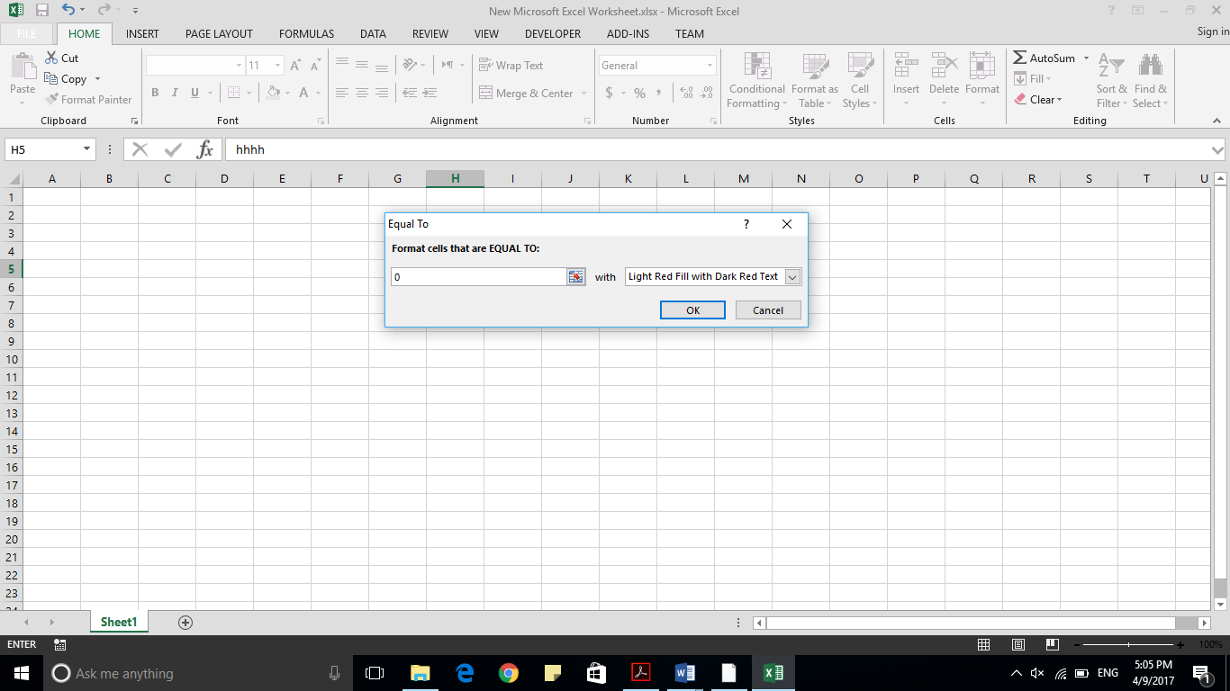

values greater or less than a particular value, or that fall within a certain ranges of values. Suppose you want to find cell with Amount 0 and Mark them as red. Choose Range of cell » Home Tab » Conditional Formatting Dropdown »Highlight Cell Rules » Equal To.
      - After Clicking ok, the cells with value zero are marked as red.
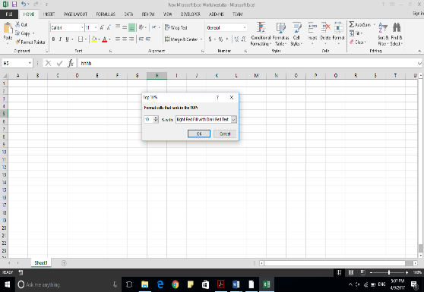
  - Top/Bottom Rules. It opens a continuation menu with various options for defining the formatting rules that highlight the top and bottom values, percentages, and above and below average values in the cell selection. Suppose you want to highlight the top 10% rows, you can do this with these Top/Bottom rules.
  - Data Bars. It opens a palette with different color data bars that you can apply to the cell selection to indicate their values relative to each other by clicking the data bar thumbnail. With this conditional Formatting, data Bars will appear in each cell.
  - Color Scales. It opens a palette with different three- and two-colored scales that you can apply to the cell selection to indicate their values relative to each other by clicking the color scale thumbnail.
  - Icon Sets. It opens a palette with different sets of icons that you can apply to the cell selection to indicate their values relative to each other by clicking the icon set.
  - New Rule. It opens the New Formatting Rule dialog box, where you define a custom conditional formatting rule to apply to the cell selection.
  - Clear Rules. It opens a continuation menu, where you can remove the conditional formatting rules for the cell selection by clicking the Selected Cells option, for the entire worksheet by clicking the Entire Sheet option, or for just the current data table by clicking the This Table option.
  - Manage Rules. It opens the Conditional Formatting Rules Manager dialog box, where you edit and delete particular rules as well as adjust their rule precedence by moving them up or down in the Rules list box.
23. Sorting in MS Excel. Sorting data in MS Excel rearranges the rows based on the contents of a particular column. You may want to sort a table to put names in alphabetical order. Or, maybe you want to sort data by Amount from smallest to largest or largest to smallest. To Sort the data follow the steps mentioned below.
- Select the Column by which you want to sort data.
- Choose Data Tab » Sort Below dialog appears.
24. Sort Data in Multiple Columns or Rows. You may want to sort by more than one column or row when you have data that you want to group by the same value in one column or row, and then sort another column or row within that group of equal values
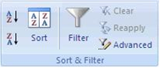
- Select a range of cells with two or more columns of data.
- On the Data tab, in the Sort & Filter group, click Sort.
- The Sort dialog box will appear.
- Under Column, in the Sort by box, select the first column that you want to sort.
- Under Sort On, select the type of sort.
- To sort by text, number, or date and time, select Values.
- To sort by format, select Cell Color, Font Color, or Cell Icon.
- Under Order, select how you want to sort.
- For text values, select A to Z or Z to A.
- For number values, select Smallest to Largest or Largest to Smallest.
- For date or time values, select Oldest to Newest or Newest to Oldest.
- To sort based on a custom list, select Custom List.
- To add another column to sort by, click Add Level, and then repeat steps four through six.
- To copy a column to sort by, select the entry and then click Copy Level.
- To delete a column to sort by, select the entry and then click Delete Level.
- To change the order in which the columns are sorted, select an entry and then click the Up or Down arrow to change the order.
- Apply a sort after you change the data, click a cell in the range or table and then, on the Data tab, in the Sort & Filter group, click Reapply
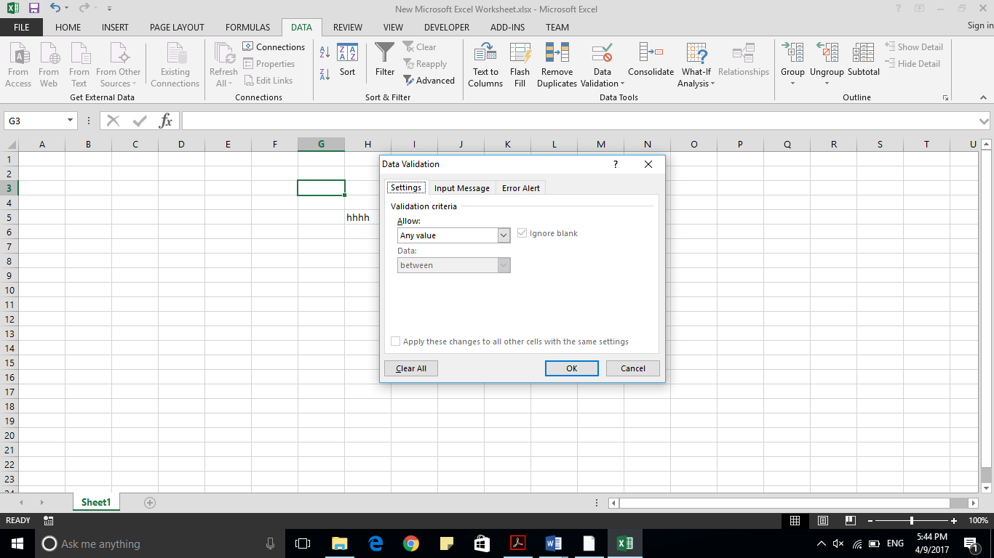
25. Data Validation. MS Excel data validation feature allows you to set up certain rules that dictate what can be entered into a cell. For example, you may want to limit data entry in a particular cell to whole numbers between 0 and 10. If the user makes an invalid entry, you can display a custom message as shown below.
- Validation Criteria To specify the type of data allowable in a cell or range, follow the steps below, which shows all the three tabs of the Data Validation dialog box.
    - Select the cell or range
    - Choose Data » Data Tools » Data Validation. Excel displays its Data Validation dialog box having 3 tabs settings, Input Message and Error
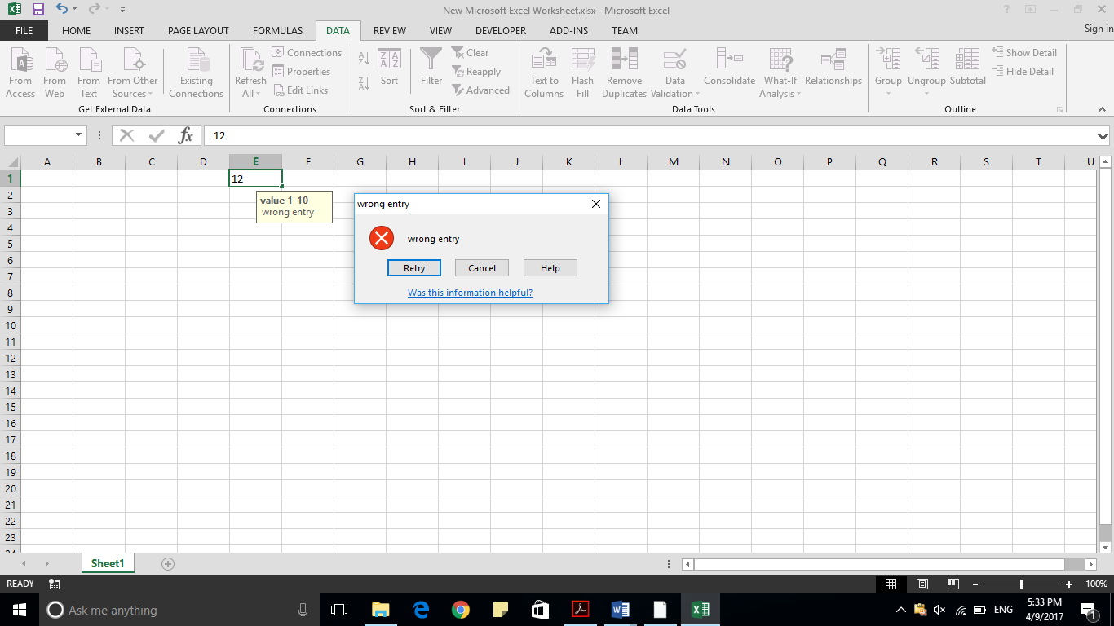
alert.

    - Settings Tab. Here you can set the type of validation you need. Choose an option from the Allow drop-down list. The contents of the Data Validation dialog box will change, displaying controls based on your choice.
    - Any Value. Selecting this option removes any existing data validation.
    - Whole Number. The user must enter a whole number. For example, you can specify that the entry must be a whole number greater than or equal to 50.
    - Decimal. The user must enter a number. For example, you can specify that the entry must be greater than or equal to 10 and less than or equal to 20.
    - List. The user must choose from a list of entries you provide. You will create drop-down list with this validation. You have to give input ranges then those values will appear in the drop-down.
    - Date. The user must enter a date. You specify a valid date range from choices in the Data drop-down list. For example, you can specify that the entered data must be greater than or equal to January 1, 2013, and less than or equal to December 31, 2013.
    - Time. The user must enter a time. You specify a valid time range from choices in the Data drop-down list. For example, you can specify that the entered data must be later than 12:00 p.m.
    - Text Length. The length of the data (number of characters) is limited. You specify a valid length by using the Data drop-down list. For example, you can specify that the length of the entered data be 1 (a single alphanumeric character).
    - Custom. To use this option, you must supply a logical formula that determines the validity of the user’s entry (a logical formula returns either TRUE or FALSE).
- Input Message Tab. You can set the input help message with this tab. Fill the title and Input message of the Input message tab and the input message will appear when the cell is selected.
- Error Alert Tab. You can specify an error message with this tab. Fill the title and error message. Select the style of the error as stop, warning or Information as per you need.
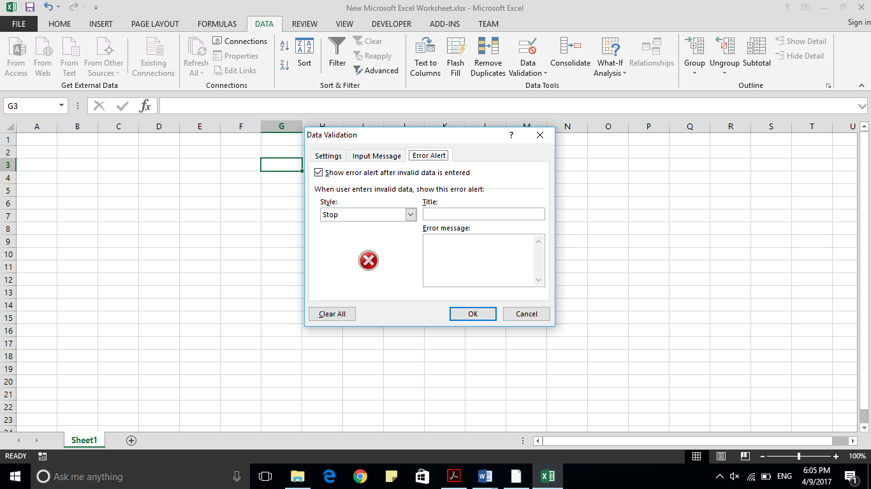

MS Excel Keyboard Shortcuts
26. MS Excel offers many keyboard short-cuts. If you are familiar with windows operating system, you should be aware of most of them. Below is the list of all the major shortcut keys in Microsoft Excel.
  - Ctrl + A. Selects all contents of the worksheet.
  - Ctrl + B. Bold highlighted selection.
  - Ctrl + I. Italicizes the highlighted selection.
  - Ctrl + K. Inserts link.
  - Ctrl + U. Underlines the highlighted selection.
  - Ctrl + 1. Changes the format of selected cells.
  - Ctrl + 5. Strikethrough the highlighted selection.
  - Ctrl + P. Brings up the print dialog box to begin printing.
  - Ctrl + Z. Undo last action.
  - Ctrl + F3. Opens Excel Name Manager.
  - Ctrl + F9. Minimizes the current window.
  - Ctrl + F10. Maximizes the currently selected window.
  - Ctrl + F6. Switches between open workbooks or windows.
  - Ctrl + Page up. Moves between Excel work sheets in the same Excel Document.
  - Ctrl + Page down. Moves between Excel work sheets in the same Excel Document.
  - Ctrl + Tab. Moves between Two or more open Excel files.
  - Alt + =. Creates a formula to sum all of the above cells
  - Ctrl + '. Inserts the value of the above cell into cell currently selected.
  - Ctrl + Shift + !. Formats the number in comma format.
  - Ctrl + Shift + $. Formats the number in currency format.
  - Ctrl + Shift + #. Formats the number in date format.
  - Ctrl + Shift + %. Formats the number in percentage format.
  - Ctrl + Shift + ^. Formats the number in scientific format.
  - Ctrl + Shift + @. Formats the number in time format.
  - Ctrl + Arrow key. Moves to the next section of text.
  - Ctrl + Space. Selects the entire column.
  - Shift + Space. Selects the entire row.
  - Ctrl + -. Deletes the selected column or row.
  - Ctrl + Shift + =. Inserts a new column or row.
  - Ctrl + Home. Moves to cell A1.
  - Ctrl + ~. Switches between showing Excel formulas or their values in cells.
  - F2. Edits the selected cell.
  - F3. After a name has been created F3 will paste names.
  - F4. Repeat last action. For example, if you changed the color of text in another cell pressing F4 will change the text in cell to the same color.
  - F5. Goes to a specific cell. For example, C6.
  - F7. Spell checks the selected text or Document.
  - F11. Creates chart from the selected data.
  - Ctrl + Shift + ;. Enters the current time.
  - Ctrl + ;. Enters the current date.
  - Alt + Shift + F1. Inserts New Worksheet.
  - Alt + Enter. While typing text in a cell pressing Alt + Enter will move to the next line allowing for multiple lines of text in one cell.
  - Shift + F3. Opens the Excel formula window.
  - Shift + F5. Brings up the search box. When you paste content, the Paste

CI Awareness
Virus
- A computer virus is a type of malicious software program designed to disrupt system operations, steal data, or damage files. It attaches itself to files or programs and spreads when those files are shared or executed. Viruses can slow down systems, corrupt data, and even cause total system failure.
Types of Computer Viruses
  - File Infector Virus – Attaches to executable files.
  - Macro Virus – Targets documents (e.g., Word, Excel).
  - Boot Sector Virus – Infects the system’s startup files.
  - Polymorphic Virus – Changes its code to avoid detection.
  - Ransomware – Locks files and demands payment.
Antivirus
- Antivirus software is a security program designed to detect, prevent, and remove computer viruses and other malicious software (worms, trojans, spyware). It scans files, monitors system behavior, and provides real-time protection against threats.
Functions of Antivirus
  - Scanning files and emails for malware
  - Quarantining or deleting infected files
  - Real-time monitoring of system activity
  - Providing security updates and patches
Examples: Avast, Kaspersky, Norton, Windows Defender, McAfee.
THE INTELLIGENCE THREAT
- The past few decades have brought about a paradigm shift in the nature and methods of conflicts. This change in the characteristic of conflicts is direct outcome of cumulative effects of different phenomena like globalization, polarity, resource wars, hegemony of international financial institutions, unilateralism of authoritative countries and alliances, asymmetry in cutting edge technology, exploitive media and non-state actors etcetera. In this Non-Traditional Threat Spectrum, "War has Lost its Boundaries" and Indirect Strategy in connotation of Non-Kinetic and Hybrid Warfare, is thus emerged as preferred alternative to meet desired ends.
- It is in this Indirect Application that INTELLIGENCE figures out so prominently in Nation's Power Struggle. Intelligence thus seeks to undermine the strength of adversary through host of means which includes Espionage, Subversion, Sabotage, Special Operations (Black, Covert, False Flag and Assassinations), Economic Hitman, Cyber Wars and Information Operations, Sponsoring Proxies/ Terrorism, Overthrowing Governments, Regime Change and Rebalancing Strategy. No sphere of nation is safe from Intelligence Targeting. Intelligence Threat is not restricted to Enemy/ Adversary States, it also includes so called Friendly Nations/ Countries "There are Friendly Countries however, there are No Friendly Intelligence Agencies in the World"¹
- "Espionage" in Context is The Oldest Profession; obtaining and/ or stealing information of intelligence value used to incept, plan and execute one's policy and objective. Hence, Counter Intelligence is an intelligence function which seeks to deny enemy vital information and prevent a range of hostile activities directed against nation and/or country. The objective of counter intelligence is thus to enhance security of all those aspects, compromise of which may jeopardize own national security interests. Counter Intelligence also provides critical intelligence support by identifying capabilities, intentions and potential threats to own operations/ intelligence efforts. It also assists in deceiving the adversary as to own capabilities, vulnerabilities and intentions.
- Counter Intelligence also helps in identification of own security vulnerabilities. monitoring exploitable avenues proffered to hostile intelligence agencies, security 22 measures required and implementation of appropriate security plans/ corrections. It is in this disciple of counter intelligence, this handout will endevours to develop understanding and enhance awareness about the threat looming in our daily personal and professional life, alike.
GLOSSARY OF TERMINOLOGIES
- Agent. Agent refers to that person who is involved in clandestine operations. He usually operates from third or target country (Talent Spotter) under hostile environment Agents may be nationals of target, base or third country.
- Clandestine Operation (CN Ops). An operation sponsored or conducted by Governmental Departments/ Agencies in such a way as to assure secrecy or concealment. Clandestine operation differs from covert operation as in clandestine operation emphasis is placed on concealment of the operation rather than on concealment of identity of sponsor or allow plausible denial by the sponsor
- Code Injection. Attack that injects malicious code, which then trick Operating System (OS) or legitimate application misinterpreting malicious code as its integral part and executed, giving complete control to attacker
- Counter Intelligence (CI). Counter Intelligence refers to activities conducted to identify, detect, prevent and neutralize the threats of espionage, sabotage, subversion, terrorism, assassination or any other anti-state activity by hostile, foreign or domestic0bBor elements, intelligence agencies, organizations, outfits or non-state actors (NSAS)
- Cover. In intelligence, it is the assumed identity of a person, organization, installation through which it disguises its true identity, nature, activity and / or mission.
- Cyber Intelligence. Intelligence involving exploitation of cyber space to acquire information of intelligence value. It is use or targeting of computers, online control systems and networks of target country against her interest and/ or with the intent to fulfill own objectives.
- Cyber Space. A global domain within the information environment consisting of the interdependent networks of Information Technology infrastructures and resident data, including the internet, telecommunication networks, computer systems, and embedded processors and controllers. Cyber space is nothing more than a symbolic and figurative space that exists within scope of internet
- Cyber Security. Cyber security is branch of technology concerned with protecting electronic and smart devices like cell phones, smart watches, smart televisions, tablets, ipads and dongles etcetera. Its objectives vary and can include protection of information and data from theft or corruption, or the preservation of availability, unauthorized access or exposure of which could have negative consequences.
- Cultivation. Process/ procedure undertaken by intelligence officials to lure in a spotted prospect by exploiting different/ applicable motives.
- Disinformation. Disinformation aims at misleading target government's policy making groups and population so as to activate events favourable and conducive to sponsoring state/ agency. It entails distribution of fabricated documents, photographs letters, rumours and misleading intelligence from known and projected sources.
- Dumpster Diving Attack. Practice of searching through trash, recycle bins, physical or digital waste for gaining sensitive information.
- Entrapment. The action of luring in an individual into committing action and/or abuse of process for desired action.
- Espionage. Espionage is clandestine collection and retrieval of information about target country in violation to the laws of target or third country, e.g, information about armed forces, nuclear installations and terrain infrastructure etcetera.
- Foreign Intelligence Services and Entities (FISE). The term refers to a known Or suspected foreign state or non-state organization or person conducting clandestine/non clandestine intelligence activities to acquire information about a target country.
- Hacking. Gaining of unauthorized access to data in a system or computer.
- Honey Trap. An investigative practice directed to trick, lure and individual or prospect using a sweet substance into relationship or situation of romance and/or sex.
- Hostile Intelligence. It refers to the combination of clandestine, covert/ overt operations undertaken for intelligence gathering, planning and preparation by state or non-state actors against the law of country. It usually aimed at exploiting the fault lines of target country by the sponsoring country/nation or on behalf of any other country/nation.
- Hostile Intelligence Agencies (HIA). Intelligence agencies of adversarial state(s).
- Human Intelligence (HUMINT). Intelligence derived from information collected through clandestine means by employing human sources.
- Hybrid Warfare. The term 'Hybrid Warfare' refers to the use of a combination of conventional and unconventional tactics and tools to achieve strategic objectives, often falling short of traditional armed conflict. It includes non-state actors, information technology, economic manipulation, disinformation, proxies and insurgencies, diplomatic coercion and cyber attacks.
- Informant. A person, who provides information of intelligence value to own Intelligence agencies undertaking cis-frontier operations.
- Information. It is the unevaluated detail or data pertaining to a target which could be True or False.
- Information Operation. Information operations capitalize on the growing sophistication, connectivity and reliance on Information Technology and, are defined as actions taken to affect adversary's information and information systems while defending one's own information and information systems.
- Information Security. It involves protection of sensitive information and/ or safety and protection of critical data from unauthorized activities, including inspection, recording, modification, any disruption or destruction.
- Intelligence. Information about actual or potential threat, area of operation and/or activity collected, collated, evaluated and furnished to meet known, perceived or impromptu requirements of a nation/ country.
- Internet. Internet is a network of networks ie it is a global network that is created by linking smaller networks of computers and servers.
- Investigation. It is the process/ procedure adopted to establish suitability of an individual for use by intelligence setup.
- Motive. It is the personal or inner compulsion of an individual which makes him accept the employment as clandestine operative, agent or informant.
- Open Source Intelligence (OSINT). It is also known as overt intelligence. In this, information is collected from public or open sources such as Internet, Print Media (newspapers, magazines, books) and electronic media (Radio, Television) etcetera.
- O.MG Cable. Sophisticated hacking tool indistinguishable from an ordinary mobile charging cable with an implant hidden inside to execute hacking attack.
- Plus Addressing Method. Also known as sub-addressing or tag-addressing is a method of adding a suffix to an email address using plus (+) symbol and word. These are unique receive-only email address. Email received with plus addressing will be received just like any other email but will contain suffix indicating source of an email ID abc123@gmail.com will become abc123+Netflix@gmail.com or abc123+twitter@gmail.com.
- Recruitment. The process of enrollment of potential agent or informant after spotting, investigation and cultivation is called recruitment.
- Sabotage. Sabotage is a covert act with intent to injure, interface with, obstruct or destroy the national defense of a country by willfully injuring or destroying or attempting to injure or destroy any national defense material, installation or utility. Besides aiding subversive warfare by the enemy to demoralize and impair the will of a common man to resist, Sabotage is also directed to infect policies' formulation of a country.
- Seduction. It is a process of enticing or persuading someone to engage in a desired behavior, often with a subtle or charming approach including romantic/ sexual attraction and/or manipulation.
- Smart Device. A smart device is any electronic device, generally connected to other devices or networks via different wireless protocols such as Wi-Fi, Bluetooth, Mirroring or 3G/4G etcetera
- Source. Anything from which information can be obtained, may it be a person, book, document, record, writing, photograph, drawing, print and electronic media and internet etcetera.
- Social Media. Social media is the collection of online communication channels dedicated to community based input, interaction, content sharing and collaboration. Websites and applications dedicated to forums, micro blogging, social networking, collaborative projects, social bookmarking, social curation, social gaming, virtual worlds and wikis are among the different types of social media.
- Social Engineering. Social Engineering in the context of security is the art of psychological manipulation of people into performing actions or divulging confidential information. While it is similar to a confident trick or simple fraud, it is typically trickery or deceptive for the purpose of information gathering, fraud or computer system access. It can simply be described as "any act that influences a person to take an action that may or may not be in his best interest. Life Cycle of Social Engineering in clandestine domain is explained in given picture for guideline
- Spotting. Spotting is directed at locating and/ or finding an appropriate individual who can obtain or assist in obtaining desired information/intelligence.
- Stealer. Malicious software that steals passwords, cookies and information from browser and can be embedded inside infected downloaded file.
- Subversion. An act or activity with the intent to change the loyalties of people, to meet one's objective ranging from undermining the writ, to change or overthrow an established government or system in the target country.
- Target Audience. It implies specific group of people/ onlookers towards which intelligence activity is directed.
- Technical Intelligence (TECHINT). Intelligence derived from technical means usually machines, electronics and instruments.
- Telephone Probe. Telephone probe or telephone penetration is means of acquiring intelligence through use of telephone from unsuspecting targets. Taking full advantage of loopholes in our communication systems, our principal adversary is actively pursuing its tele-probe operations against our Armed Forces, while taking effective measures to deny the same to intelligence agencies hostile to her.
- Terrorism. Terrorism is the systematic use of calculated violence and intimidation against the target individual, group, authority government or state by an individual or a group in furtherance of its ideology or political aims.
- 3rd Party Apps. 3rd party softwares and applications refer to virtual programs and tools created by individuals or organizations outside of the original manufacturer developer of a particular system, platform and/ or device.
HOSTILE ESPIONAGE EFFORT
- Armed Forces of Pakistan continue to remain under intense hostile attempts to trap and cultivate uniformed personnel and civilians paid out of defence budget as espionage agents. The ongoing trend indicates methodical entrapment of all ranks by employing seductive means by spotting vulnerable individuals through social media or by exploiting already acquired information from hacked devices.
- In contemporary social media environment, applications like Facebook (Meta), Snapchat and LinkedIn etcetera, provided easy avenues for spotting. Moreover, chat applications like WhatsApp, Telegram, Instagram, imo, Facebook (Meta) Messenger, Signal and Tinder etcetera have become preferred option for spotting/ cultivation of desired prospects by foreign agencies. Methods being used by these agencies for conducting espionage against Pakistan Armed Forces include following –
- On-line Recruitment
  - Sexual Seduction
    - Hostile Intelligence Agencies exploit online tools to target armed forces personnel by adopting a typical cycle (Figure). Social Engineering (SE) is used as primary medium to accomplish intended objectives. Normally, such attempts are made through female clients (hired), who are professionals in trapping the targeted individual through various SE tricks. Usual target cycle includes five stages as:-
      - Spotting
        - Initial spotting of Armed Forces Personal is carried our over social media, especially at Facebook (Meta), Instagram, Tik Tok and Bigo Live etcetera, where uniformed personnel usually leave military signature.
        - Spotting by Hostile Intelligence Agencies is also carried out through leaked mobile numbers and exploiting hacked mobiles/social media accounts under the guise of armed forces personnel.
        - In most of the cases, female agents are employed for spotting usually posing as residents of Pakistan or Illegally Indian Occupied Jammu and Kashmir (IIOJK).
        - At this stage, hostile agent may gather as much information of spotted target as possible including interests, likes/ dislikes, religious/ political affiliation/preference and family details to appear more appealing to target in next stage of online honey trapping.
      - Online Honey Trapping
        - After spotting, initial contact is established directly over WhatsApp or similar platform under different pretexts, inciting to start conversation. Target is then persuaded to share his pictures in uniform. In some cases, hostile agent also demands video of office / unit etcetera.
        - After development of intimacy, target is sexually seduced usually in uniform through exchange of nude pictures and videos.
        - During the process, target is persuaded to install 3rd chat application on pretext of secrecy, which results in hacking of victim's mobile.
        - Normally such applications are installed through sources other than Google Play Store; however some times, such malicious applications are made to be installed from Google Play Store, which are not dubious initially. Afterwards, the same application becomes malicious in garb of updation through sources other than Google Play Store. Such technique is resorted to normally against unwitting targets.
        - Given are the few infamous malicious applications identified so far, and being used by Indian agencies to hack the mobiles. Use of new malicious applications by Foreign Intelligence Services and Entities (FISE) is an ongoing process, warrants timely awareness of various advisories issued from time to time; latest list is being periodically updated on OAS Portal.
        - Upon hacking of mobile, HIA clandestinely retrieve personal data from compromised mobiles including contacts, call log, call data record and picture gallery. They also bug the mobile so as to gain permanent access / control of mic, camera & global positioning system etcetera.
        - Off-late, hostile agency has placed few chatting applications over Playstore. Upon installation, said applications get legal access to the cell phone on similar lines as of malicious application
        - Further verification of targeted individuals is carried out through various freeware applications like eyecon, true caller etcetera.
      - Coercion under False Flag
        - Honey trapped individuals are then pressurized coerced under the guise of fake MI, ISI, Police or IB representative and threatened regarding disciplinary action for sharing obscene pictures / videos with females
        - Trapped individuals are coerced to cooperate, threatening them of sharing pictures/videos/messages or leaked contents of the cell phone with colleagues, family members, seniors and friends, leading to spoiled social life and professional career.
      - Tasking. Coerced individuals are then tasked to perform acts of espionage as relevant to their rank and appointment. Initially, easier tasks are assigned to develop confidence and establish financial trail.
      - Payment. In the final stage, payments are made through Hawala / Hundi, bank accounts/microfinance accounts from within Pakistan or from abroad to complete and formalize the recruitment process. Once payment is received by the targeted individual, its digital signature is also logged in on web. The same record of digital signature is then used as coercive mean to blackmail the targeted individual
  - Financial Entrapment. For financial entrapment, HIAs send WhatsApp messages for earning easy money through freelancing. Targets of this technique are usually clerks, soldiers and civilians paid out of defense budget, procedure followed by HIAs is as under: -
    - Message to earn Pakistan Rupees 1000-5000 by working for hours or to earn money under pandemic is sent
    - Msg may contains a link like i.e https://cut.ly/yRTOuUx. Detail is as under:-
      - Upon clicking the link, the user is directed to an insecure website/ server i.e. http://www.wsid.me.
      - It displays a WhatsApp number for establishing contact.
      - Upon clicking the link. HIAs get access to IP Address location) and browser details (type of mobile).
      - WhatsApp number displayed is randomly selected from multiple international countries, which are changed intermittently.
      - Interested individuals are asked to share their Name, Father's Name, Address, Education, Account number and CNIC etcetera,
      - Initially targets are asked to share pictures of surrounding areas including HQ/units' premises etcetera.
      - Targets are also persuaded to install Auto Geo Tagging App "Notecam" (available over Google Play Store) to share pictures/videos of sensitive areas. The purpose of asking to use Notecam application is to get Lat/Long of the intended targets for subsequent exploitation.
      - Upon receipt of pictures, targets are paid.
      - Subsequently, targets are coerced, threatened & blackmailed and asked to share the pictures of classified documents.
  - Fake WhatsApp Groups. Hostile agencies have also created number of fake WhatsApp Groups to lure new targets. In said process: -
    - Hostile agencies usually use Pakistani numbers to create WhatsApp group, usually comprising maximum of 6-8 members.
    - HIA's official and target are actual members of the group
    - HIA's official himself generates a conversation and using other numbers (part of the WhatsApp group), shares already acquired classified documents and demands money.
    - In response, HIA's official using another number send the picture of money transfer inciting the target to do the same to eam easy money Meanwhile HIA's official confirms receipt of money in his account using impersonated number.
    - Compromised individuals considering that other uniformed personal/civilian paid out of defense budget are making easy money by sharing classified documents, also starts doing the same and fall prey to the hostile trap:
  - Dubious WhatsApp Communities. These have emerged as a new phenomenon where users are lured in to join various communities via text messages on pretext of buying gadgets. Cheap infotainment and online jobs etcetera. Besides giving away personal data, downloading files and phishing links may expose you (device) to malwares, spyware and stealing of data
  - Taxi/Rent a Car Services. in another method, taxi or rent a car services are also being used to lure in new targets, usually by adopting technique as-
    - Taxi or rent a car service are contacted by hostile agency's officials over WhatsApp by impersonating themselves as Pakistan Army or Government Official and ask them to bring car to a particular location.
    - Driver is then asked to share live location and move on intended/assigned route
    - Upon reaching the intended destination, driver is persuaded to share video or picture of the area or a particular place as dictated.
    - In such cases, either the payment is made in advance in micro-finance account or service provider is informed that payment will be made upon reaching the destination.
- Mobile Hacking
  - As per Edward Snowdon, UK's Government Communication HQ has capability to intrude and fully control any mobile (iPhone/Android) With this capability, they can switch on/off a mobile, switch on the mic and carryout ambient recording and get precise location of target's mobile phone.
  - Other intelligence agencies in the world hack mobiles through different means including: -
    - Installing viruses through fake/malicious links.
    - Use of 3rd party malicious applications.
    - Unsafe/immoral browsing websites.
    - Injection/ installation of virus through malicious SD Card, USB or OMG Cable.
  - Upon hacking of mobile, HIAs gain access to following: -
    - Personal information including emails, passwords and security patterns.
    - Financial information
    - Contact list and call logs.
    - Gallery including stored photographs, videos and audios
    - Messages/chats on different Social Media Networks.
    - Control of mobile's camera and speaker
  - Upon hacking the mobile, HIAs gain access to following data, which helps them prepare personality profiling: -
    - You and your family's personal data.
    - Profession including duty station.
    - Whereabouts including native city.
    - Likes and dislikes.
    - Religions, politics and social leanings.
  - Few indicators of mobile hacking are: -
    - Quick battery drainage.
    - Heating up of mobile.
    - Unusual behaviour of applications.
    - Mobile restarts automatically.
    - Hanging up of mobile.
    - Unusual shutter sound
    - Occupation of mic by applications which are not in use.
- Computer Hacking. Casual use of computers results in leakage of information. Same is attributable to following: -
  - Directly connecting standalone computers with internet.
  - Connecting mobile phone with standalone computer either via physical connection, Wi-Fi or Bluetooth etcetera.
  - Use of USBs/O.MG Cables for transfer of data between internet and stand-alone computers:-
    - Once internet computers get infected, virus travels to stand-alone computers via USB.
    - Same USB once reconnected with internet computers, the data which is copied by the virus in USB, gets leaked/uploaded to HIA's server.
- Use of Talent Spotters/ Female Clients. Talent spotters/ Female Clients are being used to spot new prospects for FISE. In the said process:
  - HIAs are using both civil and uniformed personal as talent spotters/ female clients to spot new targets by making them work on payroll.
  - Talent spotters are being offered upto Rs. 50,000/- for each new target.
  - New targets are initially assigned easier tasks i.e. sharing of the sketch of cantonment, ORBAT information etcetera, however, subsequently, they are asked to share documents and activities of units/formations
- Use of Illegal Resident Agent (IRA)
  - In some cases, foreigners including residents of IIOJK, Afghan and Bengali nationals manage to get enrolled in different government departments (including armed forces) to undertake espionage for hostile agencies.
  - In other cases, illegal resident agents operate under different covers and perform their tasks for hostile agencies.
- Use of Border Crossers
  - Despite advent of modern technologies, border crossers continue to important tasks for hostile agencies.
  - Usually they undertake spotting of uniformed personals especially clerks to seek critical information.
  - Usually they undertake spotting of uniformed personals normally hailing from border belt areas to seek critical information.
  - Most of the targets are natives of their villages serving in armed forces including civilians paid out of defence budget
- Telephone Probe. To learn about real time activities of formations/units/senior officers etcetera, HIAs endeavor to extract sensitive and classified information through telephone probe as under-
  - Telephone Exchange
    - HIAS officials using cover of some senior official posted in higher HQ make calls on landline PTCL numbers and 9 persuade the operators to transfer their call to desired PASCOMS number through exchange, wherein interconnectivity between PTCL PASCOMS and DEFCOM numbers can be made through exchange.
    - Operators inadvertently transfer the call without cross checking the identity of the caller
    - Since recipient receives the call on PASCOMS, therefore, he considers it a legitimate call and usually divulges desired information.
  - Mobile. Exploiting spillover of Pakistani mobile tower signals or using Voice over Internet Protocol (VoIP), hostile intelligence operators, using various covers make calls to officers and soldiers over GSM and extract valuable information regarding ongoing training or administrative activities of units / HQs. In certain instances, sometimes, call is made while displaying contact numbers familiar to the targeted individual, as the VOIP protocols afford options for caller to display no of their choice.
  - Text Msg Probe. HIA officials impersonating as Pakistani Armed Forces official try to extract classified information through text messages usually over WhatsApp.
- Drugs/Brothels and Abuse Networks near Cantonments
  - Drugs. Almost every cantonment houses street level bazars either in immediate or general vicinity, where various drugs peddlers/ suppliers roam around and function through low social strata like beggars, rickshaw drivers and hawkers Trends of hash. Crystal and ice is increasingly penetrating into our society particularly youth. Such networks are often found to be associated with trans-frontier espionage networks especially around cantonments which are in near vicinity of border belt areas.
  - Brothels/ Keeps, Gay Keeps. Such activities are also on hike near cantonments wherein uniformed personnel are lured in and entrapped in opportunity attempts for immoral activities. For this purpose, different accommodation facilities are used including various cheap hotels at transit places of respective cities like bus terminals/ Adda. Various instances have surfaced where videos have been made during undesired activities for subsequent blackmailing for espionage
- Embassy Based Operations. Cover officials of Foreign intelligence Entities, working in embassies, undertake spotting/recruitment of armed forces personals through various means. They usually cultivate the prospects during visa interviews, visit to foreign countries courses, assignments abroad etcetera. Moreover, they also recruit individuals of their interest through talent spotters.
- Non-Embassy Based Operations. In non-embassy based operations, cultivation by foreign intelligence entities is carried out through different platforms including business, trade, media, educational and intellectual exchange programs, symposiums, NGOs INGOs etcetera.
PREVENTIVE MEASURES AGAINST HOSTILE ESPIONAGE EFFORT
- Anonymity and gravity of hostile effort directed against we, men in uniform is extremely detrimental however, in contrast, can simply be disrupted by strict implementation of SOPs on use of smart devices (computers, mobile phones, ipads) and cyber security instructions in true letter and spirit. Moreover, there is a need to regularly enhance awareness of all ranks regarding exploitable vulnerabilities vis preventive measures
- Preventive Measures. In order to counter hostile espionage effort, specific guidelines may be followed as under:-
  - Online Recruitment
    - Never post pictures in military signature/ uniform or share any information related to military service over Social Media
    - Never respond to any unknown message/call/email/ friend request.
    - Never install 3rd party applications: ensure enabling of 'Google Play Protect when using Android based Smart Phones.
    - Other than WhatsApp, do not install chatting applications even if hosted over App Store. In that, NEVER join any WhatsApp group
    - Educate colleagues, subordinates and family members.
    - If trapped, immediately report the matter to Counter Intelligence Reporting Cell - CIRC (Hamraz Cell³) or in chain of command of getting blackmailed.
    - Do not fall prey to online financial entrapment offers, as there is no free money in the world.
    - Beware of taxi / rent a car services. Possibility of drivers unwittingly working for hostile agency cannot be ruled out.
  - Talent Spotters. Never share military information or grant access to any stranger or accept incentives from anyone. Such individuals can be talent spotters, undertaking cultivation attempts on behest of hostile agencies.
  - Illegal Resident Agents. Always ensure timely initiation of security clearances. Never employ anyone at any appointment without requisite security clearance.
  - Border Crossers. Adhere to the Army instructions regarding maintenance of data of border belt areas and cyber security data. Keep special watch ono1e5 clerical, intelligence and regimental police staff of units/ installations and ensure periodic security clearance through concerned tentacles like Field Security Sections and respective Corps Intelligence Battalions.
  - Telephone Probe
    - Do not host landline civil and PASCOMS number over same exchange.
    - Do not divulge any information on mobile instead force the caller to call on PASCOM or DEFCOM.
    - Do not transfer calls without establishing the identity of the caller.
  - Embassy Based Operations (EBOS)
    - Never visit diplomatic missions without prior permission.
    - Never share classified or undesirable personal information with visa officials of diplomatic missions.
    - Always go through process of Cl briefing, prior to visiting foreign countries in connection with official visits.
    - Be conscious of likely hostile entrapment attempts during stay in foreign countries.
    - Always report unusual happenings on occurrence or repatriation.
  - Non-Embassy Based Operations (NEBOs). Be conscious of hostile attempts and do not allow un-authorized interaction of domestic international organizations with armed forces personnel.
  - Mobile Hacking
    - Ten Commandments for safe use of mobile phones are as under: -as
      - Conduct yourself in Cyber Space as responsibly as you behave in real world, maintain decent social behaviour.
      - Using social media without precautions is dangerous, educate yourself and family, especially kids.
      - Cyber space is infested with predators and enemies; remain invisible or conceal your military identity
      - Consider mobile phone a snake in the courtyard; handle with care and keep it for communication only, not as a computer
      - Cyber violations are like an epidemic, if you are adhering to all precautions and your family and near ones are not, everyone is in danger.
      - Every cell phone activity is recorded and analyzed; guard your personal and family secrets.
      - Treading unknown spaces/routes over cyber space are risky: practice safe browsing.
      - Secrecy and privacy are alien to cyber world; never keep official or personal secrets in mobiles.
      - Non-verified stuff in cyber world is deceitful; never install 3rd party applications.
      - Nothing is free in the cyber world; all free service providers access your privacies, Stay Away!
    - Five Golden Rules for Handling of Mobile Phones by Armed Forces Personnel and Families
      - Always keep your personal and official mobiles separate and updated.
      - Do not save your personal family photographs, personal details in mobile. Never keep photos of military installations in your mobile phone; use separate cameras and Laptop /computers.
      - Frequently change mobiles and more frequently reset to Factory settings. With new mobile, never transfer ciata or contacts through pairing / from old device through data cable; instead, do it manually, though difficult, but it will prevent you from old viruses / malicious applications that might have infected old device.
      - Never save names with ranks, appointments, correct spellings or related descriptions; keep it hazy
      - Your mobile carries retrievable personal information, no matter how many times it is reset, never sell it in market
    - General Precautions
      - Do not give family members access to your official mobile phones.
      - Never leave your official phone un-attended
      - Do not click on unverified / suspicious/forwarded links.
      - Do not install or trust free VPN / proxy applications to browse internet anonymously. Use well-reputed VPN / Proxy applications, if required.
      - Do not connect to public/free/ insecure wifi networks (available at restaurants/transport/airports etcetera).
      - Never connect to unknown hotspot nor create one without password.
  - Computer Hacking
    - Restrict connection of external storage devices (mobile phones, USBs, SD Cards and external drives) with computers.
    - Keep OS, anti-virus and other installed applications updated standalone computers. on internet and
    - Transfer data between internet and standalone computers using CDs.
  - Indicators of Human Entrapment. Enhancement of self-awareness level is of utmost importance. Always keep a watch around routine social interactive circles. However, this does not merit being over suspicious or raising unnecessary alarms.

