

**Name:** Muhammad Rehan

**Reg No:** 4404-FOC/BSSE/F22-A

**Subject:** OPERATING SYSTEMS

**Submitted To:** SIR NIAZ MUHAMMAD

**Lab No:** 01

**Title:** Create Account on WebMinal

**Objective:** This lab is about registering in webminal and login on it. Webminal is an online terminal.

## Description:

In this step we will register on webminal. Webminal is an online terminal where you can learn about linux.

## Task 01:

Registering at webminal

## Steps to Perform the Lab

First , give the user name.  
Second, I put my email in email box.  
Third, I give the password to webminal.

Then webminal send the link at my email. And then I click on the email to login.

## Screenshots:

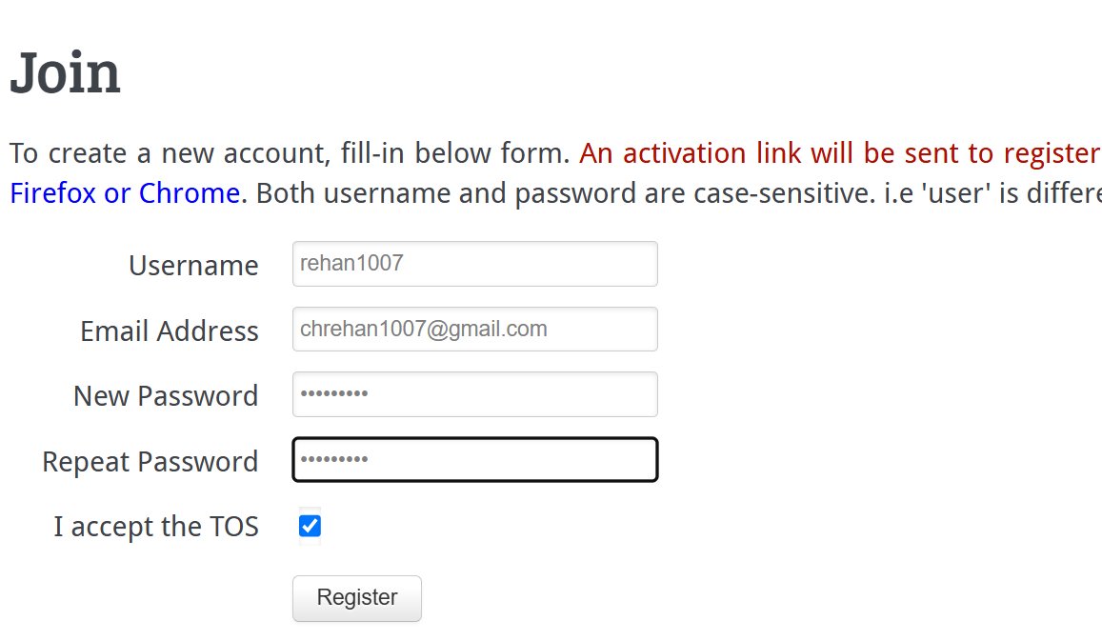

## Description:

Login with the account from which we Register.

## Task 02:

Login at webminal

## Steps to Perform the Lab

First, I used my login name and password to login at webminal.

## Screenshots:

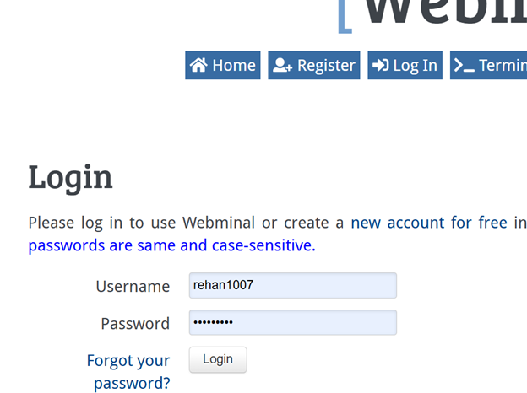  
  
  
  
  
  
  
  
  
  
  
  
  
  
  
  
  
  
  
  
  
  
  
**Lab No:** 02

**Title:** Runing Basic commands

**Objective:** This lab is about performing the basic command on webminal, such as, date command, cal, touch, cat and man .

## Description:

whoami command is used to display user name in the terminal.

## Task 01:

whoami

## Steps to Perform the Lab

I’ve used this command to show my user name.

## Screenshots:

## Description:

Date command is used to display the current date.

## Task 02:

Date

## Steps to Perform the Lab

I run this command to show the current data, time and year.

## Screenshots:

## Description:

Date +%A command is used to display the full day name.

## Task 03:

Date +%A

## Steps to Perform the Lab

I’ve used this command to display the current day.

## Screenshots:

## Description:

Date +%a command is used to display the day name in short form.

## Task 04:

Date +%a

## Steps to Perform the Lab

I’ve used this command to display the current day in short form.

## Screenshots:

## Description:

Date +%B command is used to display the full month name.

## Task 05:

Date +%B

## Steps to Perform the Lab

I’ve used this command to display the name of current in full form.

## Screenshots:

## Description:

Date +%b command is used the month name in short form

## Task 05:

Date +%b

## Steps to Perform the Lab

I’ve used this command to display the current name in short form.

## Screenshots:

## Description:

Date +%C command is used to display century of current year.

## Task 06:

Date +%C

## Steps to Perform the Lab

I’ve used this command to display the current century.

## Screenshots:

## Description:

Date +%c command is used to display the current day, month, year and time.

## Task 08:

Date +%c

## Steps to Perform the Lab

I’ve used this command to display the current day, month, year and time and time zone.

## Screenshots:

## Description:

Date +%h command is used to display the month name in short form.

## Task 09:

Date +%h

## Steps to Perform the Lab

I’ve used this command to display the current month name in short word.

## Screenshots:

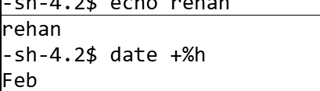

## Description:

Cal command is used to display the complete current month.

## Task 01:

Cal

## Steps to Perform the Lab

I’ve used this command to display the whole current month of the current year.

## Screenshots:

## Description:

Cal 2020 command is used to display the complete calender of the 2020

## Task 10:

Cal 2020

## Steps to Perform the Lab

I’ve used this command to display to display the specific calender.

## Screenshots:

## Description:

Touch abc.txt command is used to create file and enter ls for saving file.

## Task 11:

Touch bcd.txt

## Steps to Perform the Lab

I’ve used this command to create a dummy file.

## Screenshots:

## Description:

Touch abc.mp3 command is used to create empty file name abc.mp3 if it does not already exist

## Task 13:

Touch abc.mp3

## Steps to Perform the Lab

I’ve used this command to create an abc.mp3 file.

## Screenshots:

## Description:

Ls command is used to display all the files in the directory.

## Task 14:

ls

## Steps to Perform the Lab

I’ve used this command to display all the file in the directory.

## Screenshots:

## Description:

Man cal command is used to display manual page for the cal command.

## Task 15:

Man cal

## Steps to Perform the Lab

I’ve used this command to display all the option releated to the cal command.

## Screenshots:

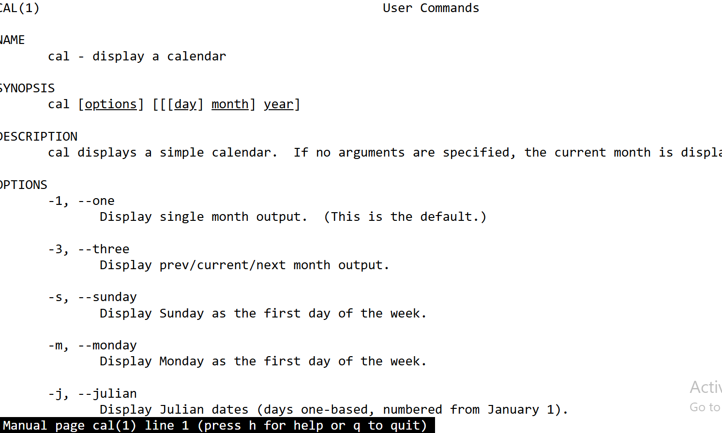

## Description:

This command is used to create new file named abc.txt and write content into it like user name roll no and class. Click on controle D to close file.

## Task 16:

Cat >mahi.txt

## Steps to Perform the Lab

I’ve used this command to create a writable file mahi.txt.

## Screenshots:

## 

**Lab No:** 03

**Title: Linux Commands**

**Objective:** In this lab, we have run some general command for linux such as, cat , cd , mkdri, rm, rmdir, cp and mv.

## Description:

mkdir command is used to create an empty directory.

## Task 01:

mkdri command

## Steps to Perform the Lab:

I’ve used this command to create a new empty directory name IIUI in home directory.

## Screenshots:





## Description:

cd dir name command is to move in a directory if it exist.

## Task 02:

cd IIUI command

## Steps to Perform the Lab:

I used this command to move into a directory IIUI.

## Screenshots:

  
  
  
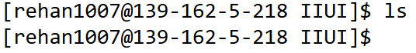

## Description:

cd BSSE command is used to create the BSSE Directory

## Task 03:

cd BSSE command

## Steps to Perform the Lab:

I’ve used this command to move to previous directory which is BSSE.

## Screenshots:



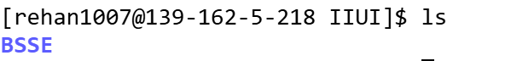

## Description:

cd .. command is used to go back to the parent directory is the current directory.

## Task 04:

cd .. command

## Steps to Perform the Lab:

I’ve used this command to move to previous directory which is IIUI.

## Screenshots:





## Description:

cd ~ command is used to move back in to the top most parent directory in other word to move in parent directory.

## Task 05:

cd .. command

## Steps to Perform the Lab:

I’ve used this command to move to my parent directory.

## Screenshots:



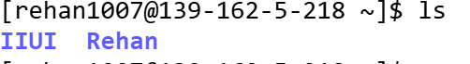

## Description:

This command is used to create new file named abc.txt and write content into it like user name roll no and class. Click on controle D to close file.

## Task 06:

Cat >abc.txt

## Steps to Perform the Lab

I’ve used this command to create a writable file.

## Screenshots:

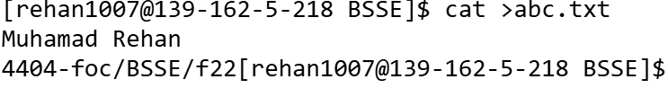

## Description:

cat abc.txt command is used to display the contents of the current file.

## Task 07:

cat abc.txt command

## Steps to Perform the Lab:

I’ve used this command to display the content of the file abc.txt

## Screenshots:

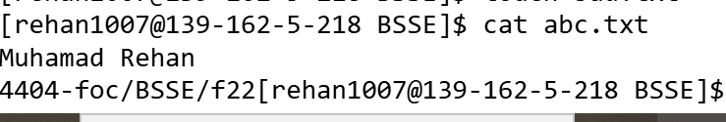

## Description:

Executing **cd /** takes you to the very top of the directory tree, which contains all other directories .

## Task 08:

cd / command

## Steps to Perform the Lab:

I’ve used this command to move me to the very top directory of the root tree.

## Screenshots:





## Description:

The **cp** command is used to copy files or directories.

## Task 09:

cp command

## Steps to Perform the Lab:

I’ve used this command to copy abc.txt file content to bcd.txt.

## Screenshots:

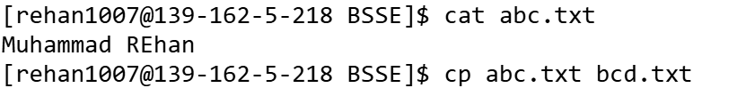

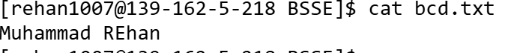

## Description:

The **mv** command is used to move or rename the files and directories.

## Task 10:

mv command

## Steps to Perform the Lab:

I’ve used this command to move my abc.txt file to rehan.txt file.

## Screenshots:

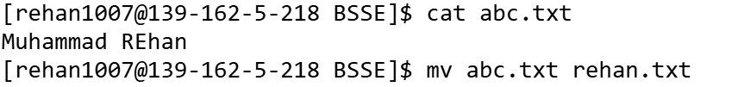



## Description:

The **rm bcd.txt is used to remove the file completely.**

## Task 11:

rm command

## Steps to Perform the Lab:

I’ve used this command to remove my bcd.txt file.

## Screenshots:

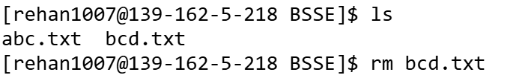

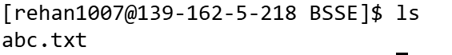

## Description:

The **rmdir** command is used to remove directories.

## Task 12:

rmdir command

## Steps to Perform the Lab:

I’ve used this command to remove my Mahi directory.

## Screenshots:

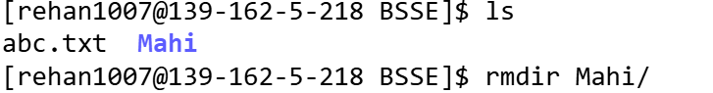

## Description:

Touch abc.txt command is used to create file and enter ls for saving file.

## Task 13:

Touch bcd.txt

## Steps to Perform the Lab

I’ve used this command to create a dummy file.

## Screenshots:

## Description:

Ls command is used to display all the files in the directory.

## Task 14:

ls

## Steps to Perform the Lab

I’ve used this command to display all the file in the directory.

## Screenshots:

## Task 15:

cat >hello.txt

## Steps to Perform the Lab

I’ve used this command to create a writable file.

## Screenshots:

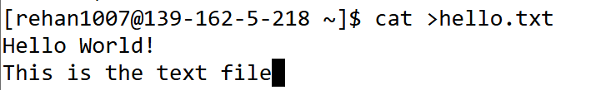

## Description:

ls command is used to display all the file and directory

## Task 16:

Ls command

## Steps to Perform the Lab

I’ve used this command to display the files and dir

## Screenshots:



## Description:

Ctrl D command is used to move out of file

## Task 17:

Ctrl D

## Steps to Perform the Lab

I’ve used this command to move out of file.

## Screenshots:

## 

## Description:

I have used the upper keyboard button to display the above command.

## Task 18:

Upper key

## Steps to Perform the Lab

I’ve used this command to display the upper command.

## Screenshots:

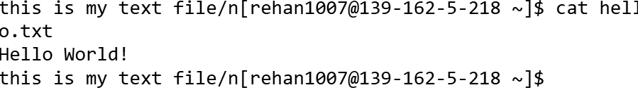

**Lab No:** 04

**Title:** Runing Basic commands

**Objective:** This lab is about performing the basic command on webminal, such as pwd, cd absolute path, and other commands .

## Description:

pwd command used to display the path of current dir.

## Task 01:

pwd bcd.txt

## Steps to Perform the Lab

I’ve used this command to display the current path.

## Screenshots:

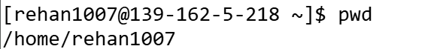

## Description:

cd IIUI/BSSE/ is used to move to the path dir.

## Task 02:

## cd IIUI/BSSE/

## Steps to Perform the Lab

I’ve used this command to move to the dir from current dir.

## Screenshots:

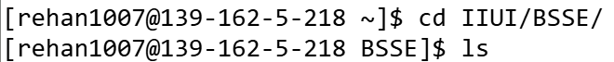

## Description:

Ls IIUI/BSSE/ is used to display the files and dir in the path.

## Task 03:

Ls IIUI/BSSE/

## Steps to Perform the Lab

I’ve used this command to diplay the directory at the path .

## Screenshots:

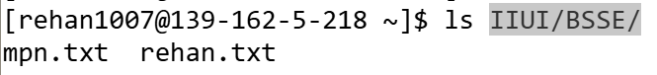

## Description:

Cd absolute pathis used to create file and enter ls for saving file.

## Task 04:

Cd /home/rehan1007/IIUI/BSSE

## Steps to Perform the Lab

I’ve used this command to move to the absolute path /home/rehan1007/IIUI/BSSE.

## Screenshots:

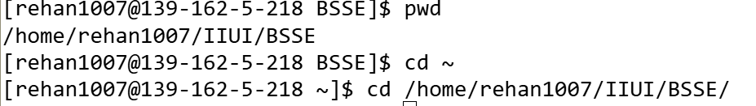

## Description:

ls absolute_path is used to display the files at absolute path.

## Task 05:

ls /home/rehan1007/IIUI/BSSE

## Steps to Perform the Lab

I’ve used this command to display the content of /home/rehan1007/IIUI/BSSE.

## Screenshots:



## Description:

Cat path is used to display the file at that path.

## Task 06:

Cat path

## Steps to Perform the Lab

I’ve used this command to display the file content at that path.

## Screenshots:



## Description:

Ls –l hello.txt is used to display when this file was created.

## Task 07:

Ls -l

## Steps to Perform the Lab

I’ve used this command to display when my file was created.

## Screenshots:



## Description:

Cat >.abc.txt is used to create a hidden file.

## Task 08:

Cat >.abc.txt

## Steps to Perform the Lab

I’ve used this command to create a hidden file.

## Screenshots:

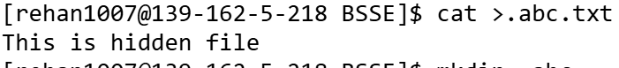

## Description:

mkdir .abc is used to create a hidden directory.

## Task 09:

mkdri .abc

## Steps to Perform the Lab

I’ve used this command to create .abc hidden dir.

## Screenshots:

## 

## Description:

rmdir .abc command is used to delete dir.

## Task 10:

rmdir .abc command

## Steps to Perform the Lab

I’ve used this command to remove the empty dir.

## Screenshots:

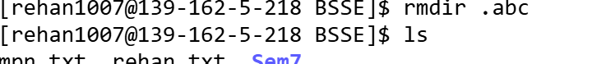

## Description:

ls –a is used to display the hidden files.

## Task 11:

ls –a command

## Steps to Perform the Lab

I’ve used this command to display the hidden files.

## Screenshots:



## Description:

mkdir qcy is used to create a new dir qcy .

## Task 12:

mkdir qcy

## Steps to Perform the Lab

I’ve used this command to make a dir name qcy.

## Screenshots:



## Description:

Cat >rehan.txt is used to create file.

## Task 13:

Cat >rehan.txt

## Steps to Perform the Lab

I’ve used this command to create a file in qcy dir.

## Screenshots:

  
  
  
Description:

Cd .. command is used to move back to the previous dir.

## Task 14:

Cd ..

## Steps to Perform the Lab

I’ve used this command to move back to previous dir.

## Screenshots:



## Description:

rm –r qcy is used to create delete the non-empty dir.

## Task 15:

rm –r qcy

## Steps to Perform the Lab

I’ve used this command to remove the non empty dir name qcy.

## Screenshots:

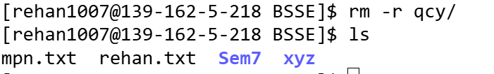

**Lab No:** 05

**Title:** Runing Basic commands and Editing File

**Objective:** This lab is about performing the basic command on webminal, such as ls *, editing files on Vim and nano editor.

## Description:

rm –r * Deletes all files and directories (including non-empty ones) in the current directory recursively.

## Task 01:

rm –r *

## Steps to Perform the Lab

I’ve used this command is used to delete all the non-empty directory as well as empty directory.

## Screenshots:

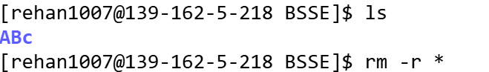

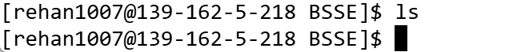

## Description:

touch rehan.txt | ls command Creates a file named rehan.txt and lists the contents of the directory. However, the | (pipe) operator is used incorrectly here. To run two commands one after another, use ; or && instead.

## Task 02:

touch rehan.txt | ls

## Steps to Perform the Lab

I’ve used this command is used when we want to use two command at same time .

## Screenshots:

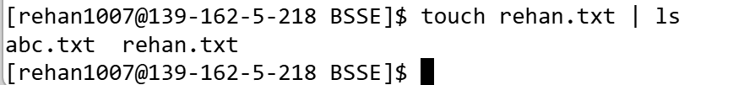

## Description:

cat abc.txt | wc command Displays the number of lines, words, and characters in abc.txt. The cat command outputs the file contents, which is then passed to wc (word count) using a pipe.

Task 03:

cat abc.txt | wc

## Steps to Perform the Lab

I’ve used this command is used to show how many line, word in the abc.txt file.

## Screenshots:

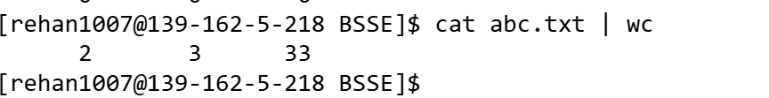

## Description:

Ctrl k is used this command to cut the line in the file, from the insert cursor to the start of the line.

## Task 04:

Ctrl k

## Steps to Perform the Lab

I’ve used this command to cut the line in the file.

## Screenshots:





## Description:

Ctrl A command is used to move the insert cursor at the start of the line.

## Task 05:

Ctrl a

## Steps to Perform the Lab

I’ve used this command to move the insert cursor at the start of the line.

## Screenshots:

.

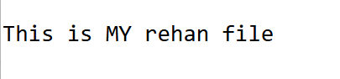

## Description:

vim abc.txt command will open an editor where, we can edit our file and this’ll create the file if it doesn’t exit.

## Task 06:

vim abc.txt

## Steps to Perform the Lab

* Firstly I ran the above command then text Editor opened up.
* Secondly, I edited my file then press esc button.
* Thirdly, I entered :wq to close the file and editor.

## Screenshots:



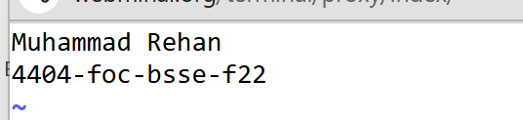

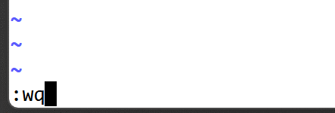

## Description:

nano rehan.txt command will open an editor where, we can edit our file and this’ll create the file if it doesn’t exit.

## Task 07:

nano rehan.txt

## Steps to Perform the Lab

* Firstly, when I’ve written this command a text editor opened up.
* Secondly, I wrote in the file and saved changes with ctrl o.
* Thirdly, I pressed ctrl E to escape from the editor

## Screenshots:



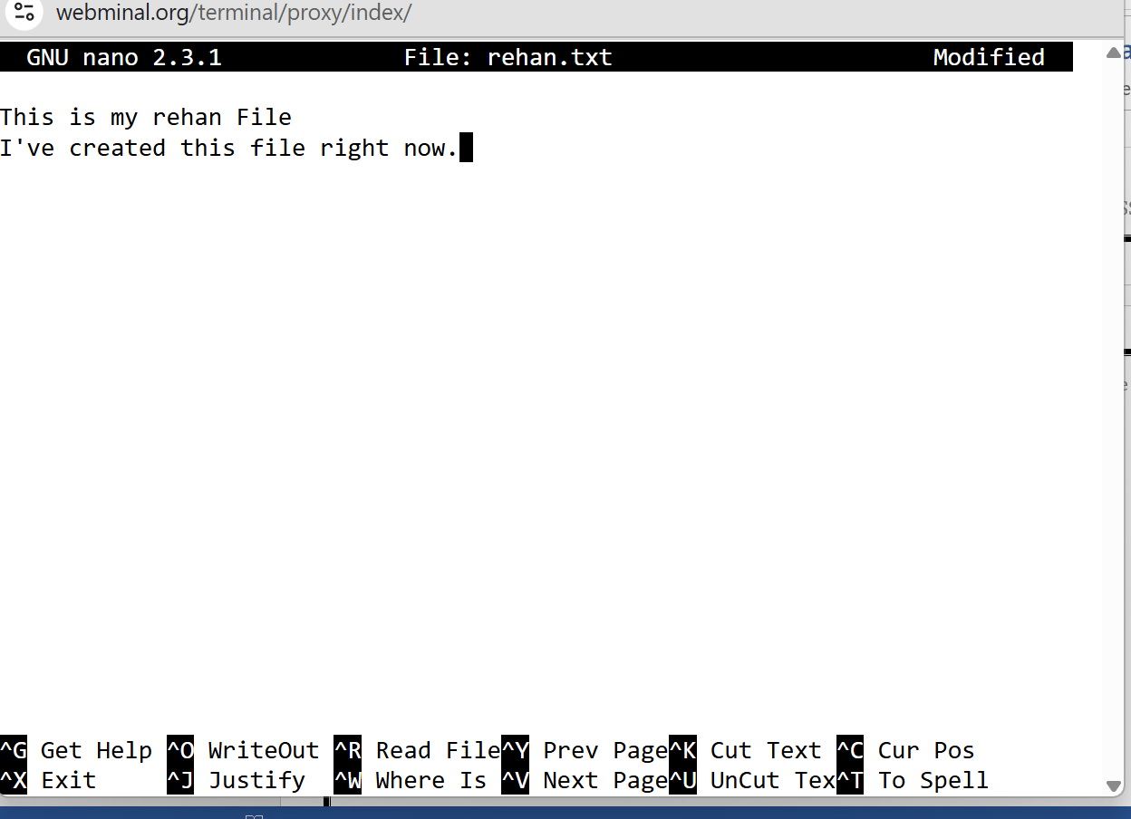

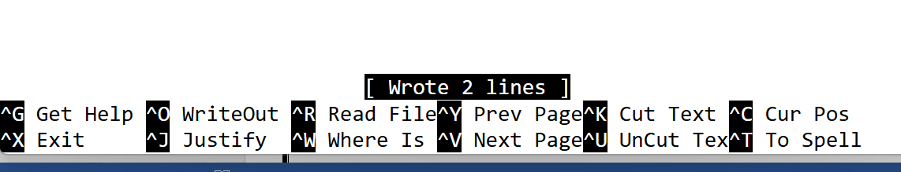



## Description:

ls –l abc.txt mahi.txt Displays detailed information (permissions, ownership, size, and modification date) for the files abc.txt and mahi.txt.

Task 08:

ls –l abc.txt mahi.txt

## Steps to Perform the Lab

I’ve used this command to show the information about these two files.

## Screenshots:

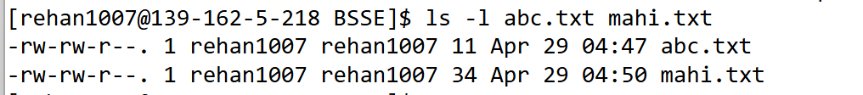

## Description:

ls *.txt command Lists all files in the current directory that have a .txt extension..

## Task 09:

ls *.txt

## Steps to Perform the Lab

I’ve used this command to display all the files in the current directory.

## Screenshots:

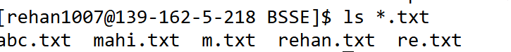

## Description:

ls –la *.txt command Displays detailed information about all .txt files in the current directory, including hidden .txt files (those starting with a dot), if any.

Task 10:

ls –la *.txt

## Steps to Perform the Lab

I’ve used this command to show information about the file that ends with .txt including hidden files.

## Screenshots:

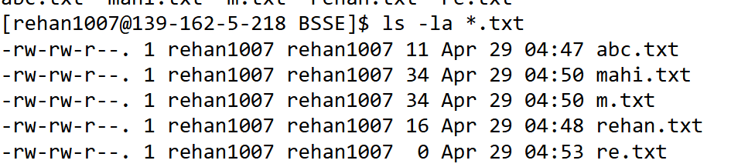

## Description:

ls –la abc.* Displays detailed information about all files that start with abc. (like abc.txt, abc.sh, etc.), including hidden files that match the pattern.

## Task 11:

ls –la abc.*

## Steps to Perform the Lab

I’ve used this command to show information about the file that starts with abc. including hidden files.

## Screenshots:

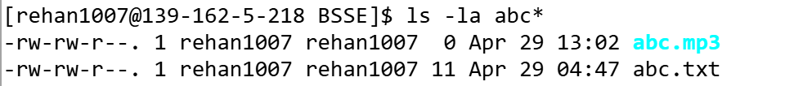

## Description:

rm * command delete all the files in the current directory but it won’t delete the directories

## Task 12:

rm *

## Steps to Perform the Lab

I’ve used this command to delete all the files in the current directory

## Screenshots:

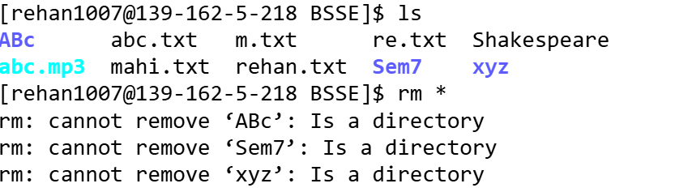

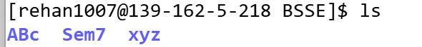

## Description:

rmdir * command delete all the empty directories in the current directory.

## Task 13:

rmdir *

## Steps to Perform the Lab

I have used this command delete all the empty directories in the current directory.

## Screenshots:

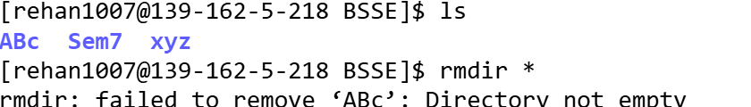

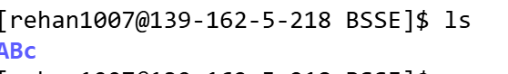

## Description:

This command *Counts the total number of lines, words, and characters in all .txt files in the current directory.*

## Task 14:

*.txt | wc

## Steps to Perform the Lab

I’ve used this command to show the detail of my files

## Screenshots:

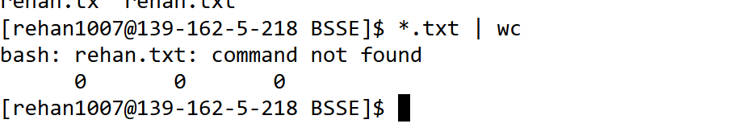

## Description:

I’ve used this command in nano text editor to show the current contents of the file.

## Task 14:

Ctrl O

## Steps to Perform the Lab

I’ve used this command to show save the data in nano editor

## Screenshots:

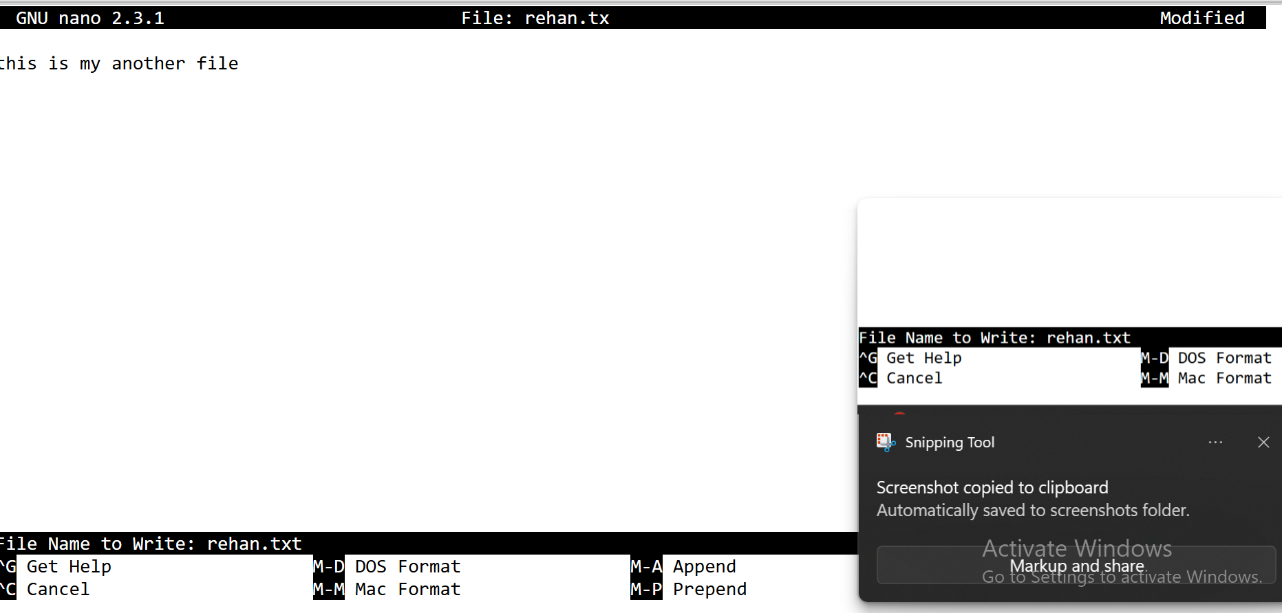

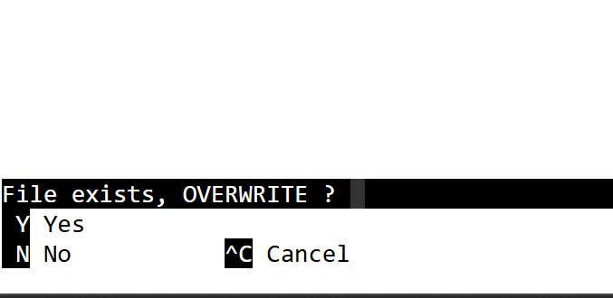

**Lab No:** 06

**Title:** Execute some commands WebMinal

**Objective:** In this lab work we worked on shell variables, environmental variable , operator and for loops.

## Description:

• Defines (or updates) the environment variable abc with the given value for the current shell and its children.

## Task 01:

export abc=”this is my file”

## Steps to Perform the Lab

I define an environment variable named abc with the value “this is my file” by running export abc="this is my file".

## Screenshots:



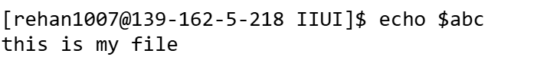

## Description:

Prints the value of the variable abc to standard output.

## Task 02:

Echo $abc

## Steps to Perform the Lab

I display whatever’s stored in abc by typing echo $abc.

## Screenshots:



## Description:

Sets an environment variable named path (note: this is case-sensitive and different from the special PATH).

## Task 03:

Export path=”any path”

## Steps to Perform the Lab

I set a custom variable called path (distinct from the system PATH) to “any path” using export path="any path".

## Screenshots:

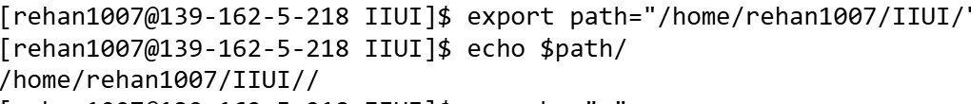

## Description:

Launches a new command with abc set to that value, but does *not* modify the parent shell’s environment

## Task 04:

Env abc=”this is rehan”

## Steps to Perform the Lab

I launch a one‐off command environment where abc equals “this is rehan” by prefacing my command with env abc="this is rehan" (for example, env abc="this is rehan" printenv abc).

## Screenshots:

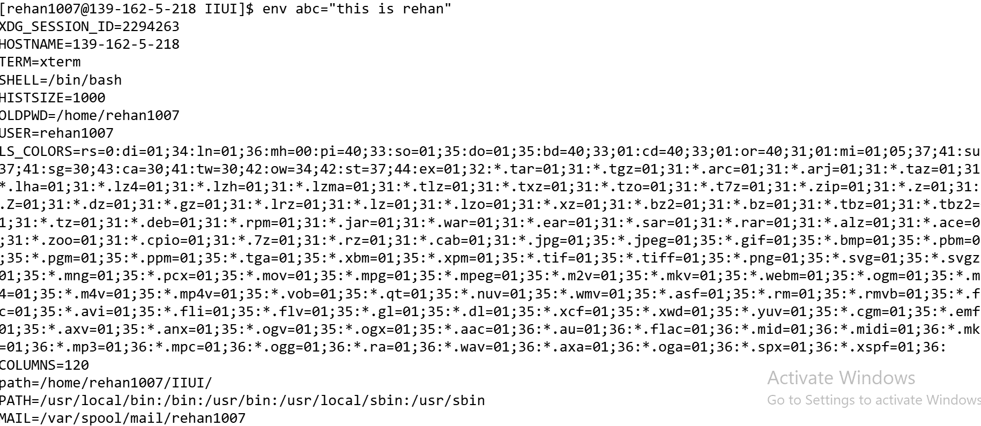

## Description:

Displays the current value of the environment variable abc

## Task 05:

printenv abc

## Steps to Perform the Lab

I check the current value of abc in my shell environment by typing printenv abc.

## Screenshots:



## Description:

Shows a numbered list of the commands you’ve run in this shell session.

## Task 06:

history

## Steps to Perform the Lab

I review all the commands I’ve entered in this session by simply running history.

## Screenshots:

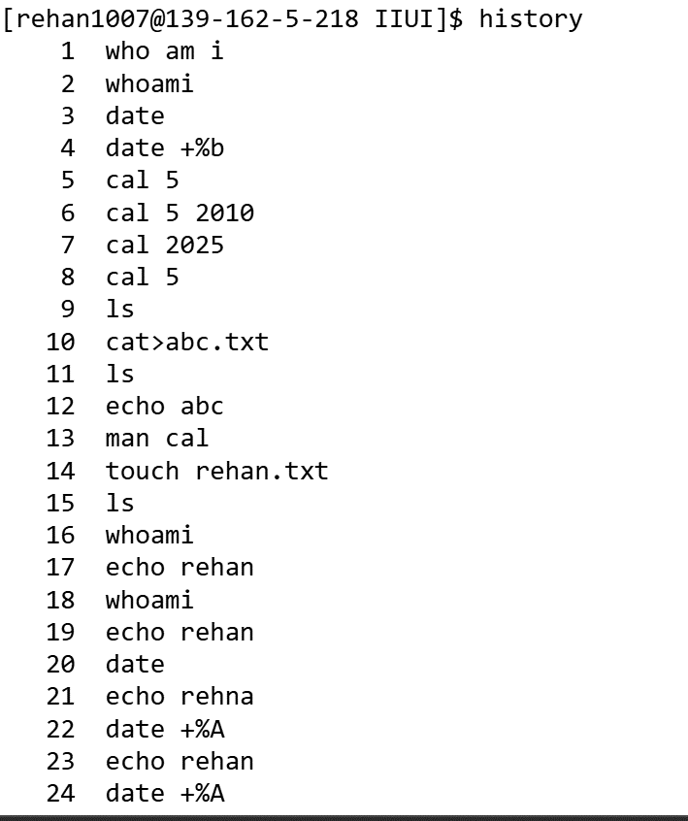

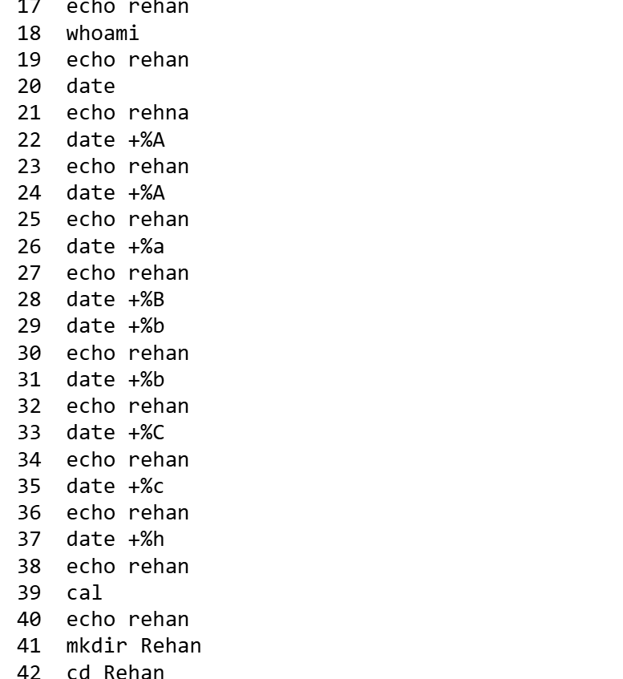

## Description:

In many shells, recalls and runs the most recent command beginning with cd.

## Task 07:

!cd

## Steps to Perform the Lab

I recall and rerun the last command I issued that began with “cd” by typing !cd.

## Screenshots:



## Description:

Executes the last command you ran that started with ls.

## Task 08:

!ls

## Steps to Perform the Lab

I repeat the most recent “ls…” command from my history by entering !ls.

## Screenshots:

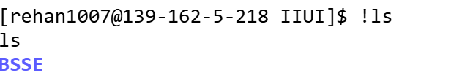

## Description:

• Loops once, setting $i to the literal string 12345 and prints it.

## Task 09:

for i in 12345; do echo "num: " $i; done

## Steps to Perform the Lab

I loop once with $i set to the literal string “12345” and print “num: 12345” by executing for i in 12345; do echo "num: " $i; done.

## Screenshots:



## Description:

Iterates over the list 1,2,3,4,5 and prints each with the prefix “num:”.

## Task 10:

for i in {1,2,3,4,5}

> do

> echo "num: " $i

> done

## Steps to Perform the Lab

I iterate over the list 1 2 3 4 5 and output “num: ” followed by each number by running that loop.

## Screenshots:

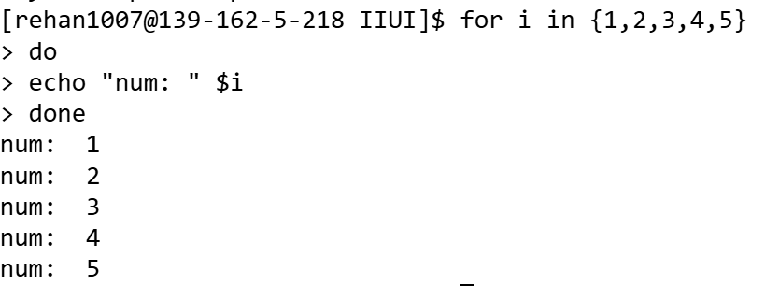

## Description:

Counts from 1 to 20, printing each number prefixed by “num:”.

## Task 11:

for i in {1..20}; do echo "num: " $i; done

Steps to Perform the Lab

I count from 1 through 20, printing “num: <n>” for each, with for i in {1..20}; do echo "num: " $i; done.

## Screenshots:

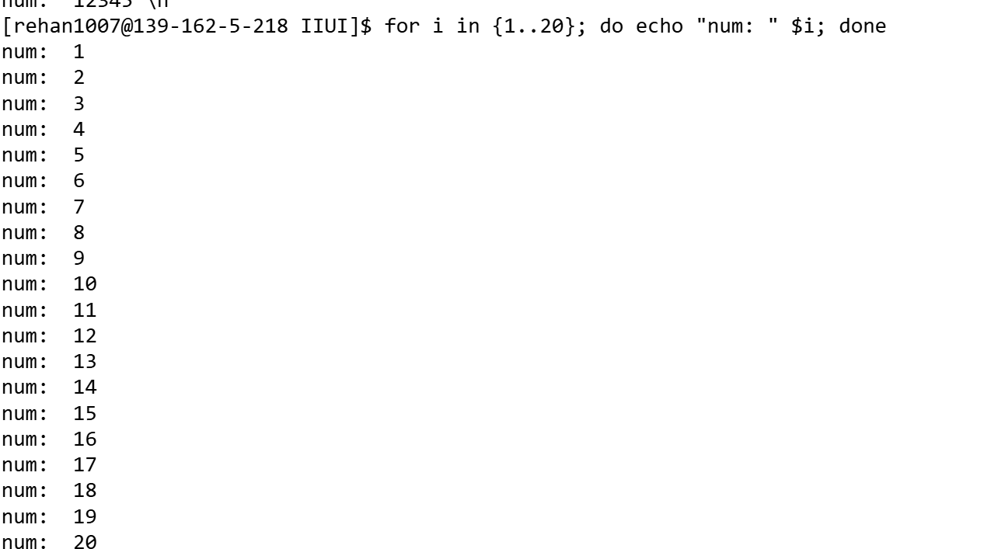

## Description:

oops i = 1, 6, 11, 16, 21 (until >20), printing the number then pausing (sleep defaults to 1 s).

## Task 12:

for i in {1..20..5}; do echo "num: " $i; sleep; done

## Steps to Perform the Lab

I step through 1, 6, 11, 16 (incrementing by 5), printing each as “num: <n>” and pausing one second between by using for i in {1..20..5}; do echo "num: " $i; sleep; done.

## Screenshots:

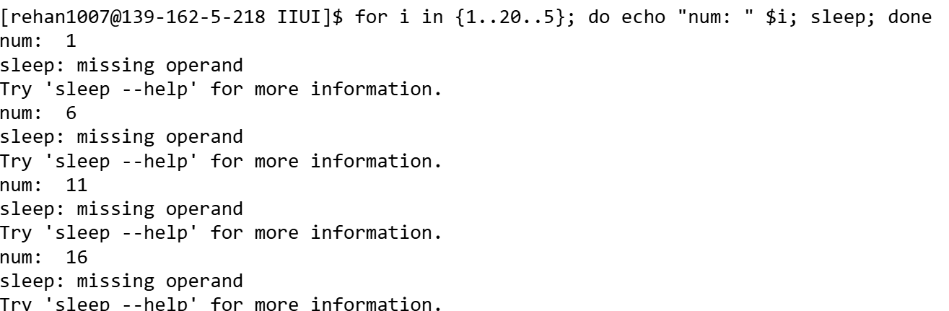

## Description:

Creates a directory named Rehan; if that succeeds, displays the contents of rehan.txt.

## Task 13:

mkdir Rehan && cat rehan.txt

## Steps to Perform the Lab

I create a directory named Rehan and, if successful, immediately display the contents of rehan.txt by chaining mkdir Rehan && cat rehan.txt.

## Screenshots:

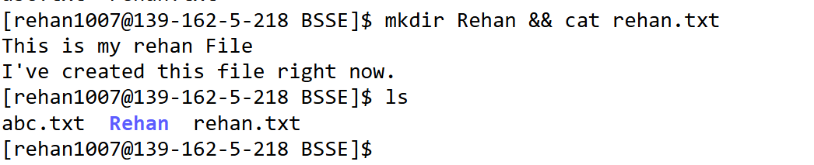

## Description:

Prints rehan.txt’s contents; then, if successful, lists files in the current directory.

## Task 14:

cat rehan.txt && ls cat rehan.txt && ls

## Steps to Perform the Lab

I output the content of rehan.txt first, then list the files in my current directory by running cat rehan.txt && ls.

## Screenshots:

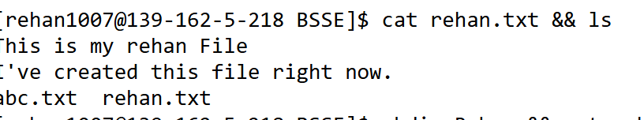

**Lab No:** 07

**Title:** Running Command for finding.

**Objective:** This lab is about performing the basic command on webminal, such as find, locate and other commands.

## Description:

Lists the contents of the directory or file paths mentioned inside the file.

## Task 01:

ls $(cat mahi.txt)

## Screenshots:

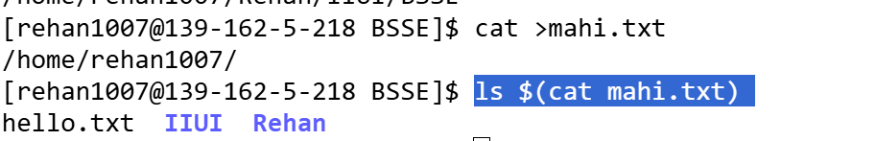

## Description:

This command is used to find the file in the directory heriarichy.

## Task 02:

find mahi.txt

## Screenshots:

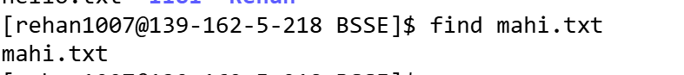

## Description:

This command finds the file and lists its details .

## Task 03:

ls -l $(find mahi.txt)

## Screenshots:

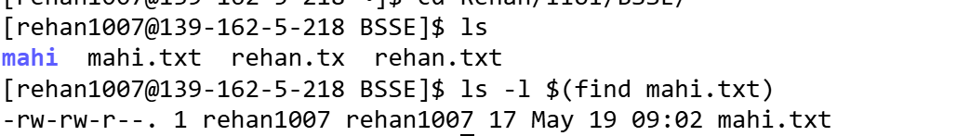

## Description:

This command quickly find paths to files without scanning the filesystem. This command only work on linux as OS but not on the webminal website.

## Task 04:

locate hello.txt

## Screenshots:

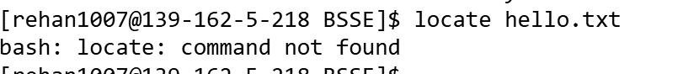

## Description:

This command is useful if file contains a list of filenames and you want to open the last one.

## Task 05:

vi $(mahi.txt | tail -1)

## Screenshots:

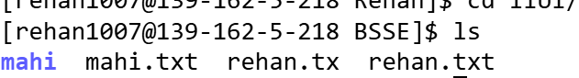 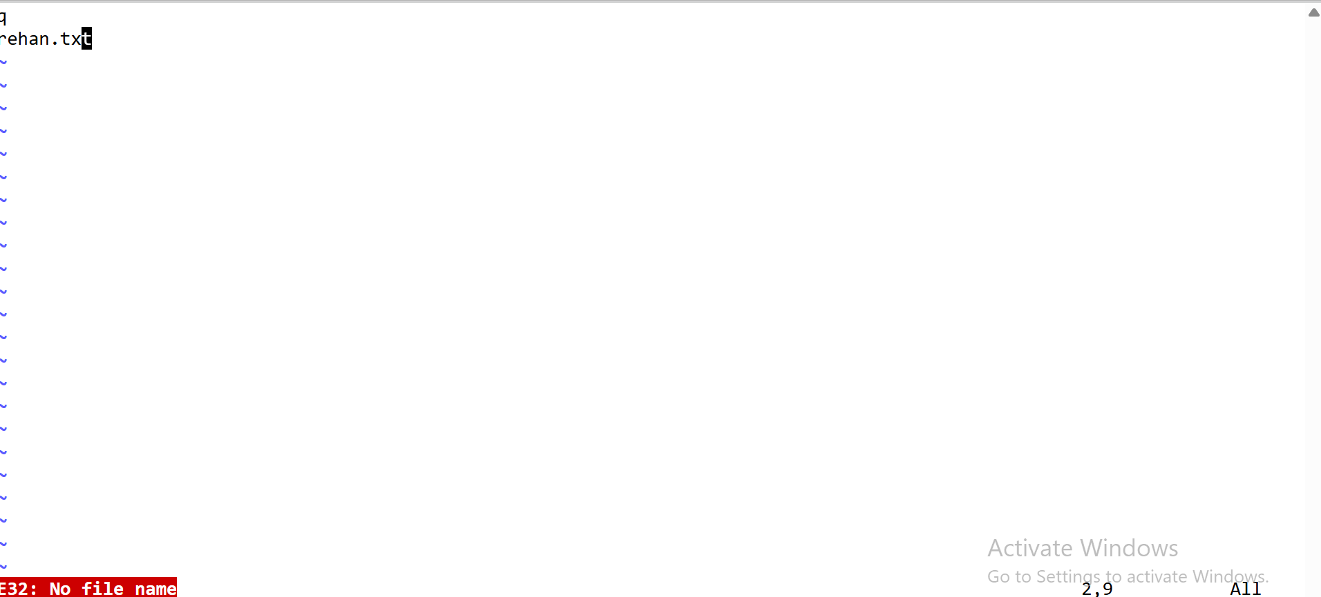

## Description:

This command is used to display the path of the file that is being searched.

## Task 06:

find -name mahi.txt

## Screenshots:

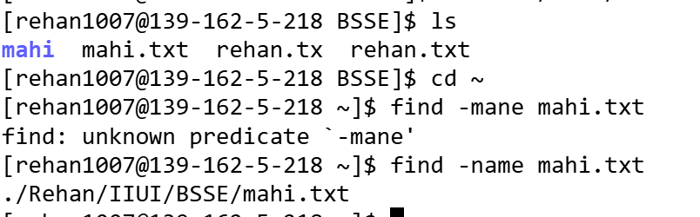

## Description:

Searches for a file named rehan in the current directory and subdirectories.

## Task 07:

find -name rehan*

## Screenshots:

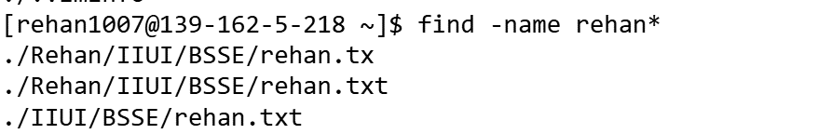

## Description:

Finds all files.

## Task 08:

find -type f

## Screenshots:

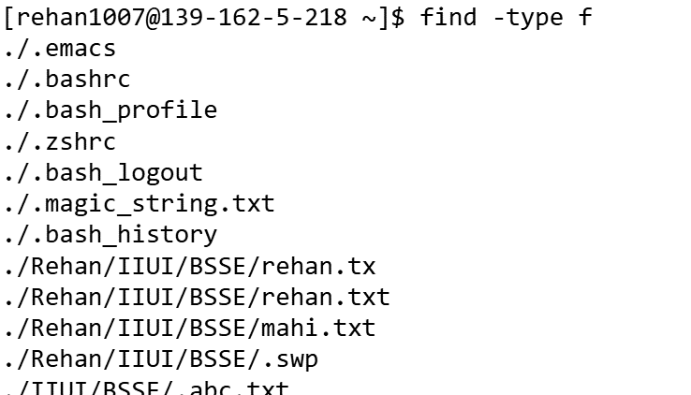

## Description:

Finds all **directories** starting from the current directory.

## Task 09:

find -type d

## Screenshots:

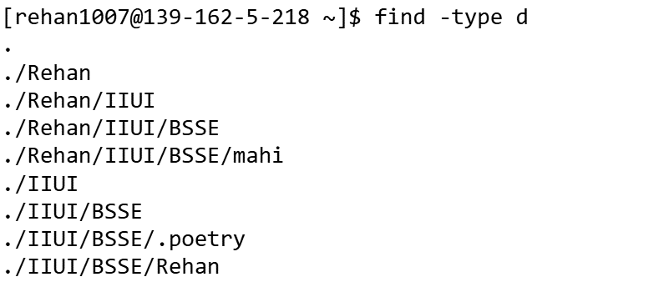

## Description:

Lists detailed information for all files/directories starting with rehan found by find command .

## Task 10:

find name rehan* -exec ls -l '{}' \;

## Screenshots:

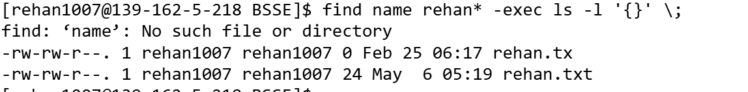

**a: Commands ls –a and ls –A and the difference b/w them.**

## Description:

This command shows ALL files, including (current directory) and (parent directory)

## Task 11:

ls -a

## Screenshots:



## Description:

This command shows almost all files, excluding . and ..

## Task 12:

ls -A

## Screenshots:



## Difference between ls -a and –A options in ls

The ls -a and -A options both show hidden files, but there's a small difference.

ls -a shows everything, including the current (.) and parent (..) directories.

ls -A skips those two and just shows the rest.

**b: Write a command that goes through all file in dir and print their name using echo command.**

## Description:

I’ve used for loop that’ll goes through all the files in current directory and print the file name using echo.

## Task 13:

for file in *; do echo $file; done

## Screenshots:

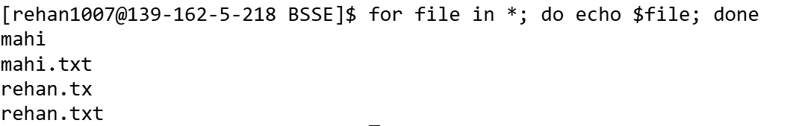

**c: Write a for loop that’ll go through all the names and print greeting for their name using echo command.**

## Description:

* Firstly I created a variable name which contains name.
* Secondly, I wrote a for loop that goes through all the name in name variable.
* Thirdly, I wrote an echo command that print a greeting for each name.

## Task 14:

for n in "${name[@]}"; do echo "Hello $n , how was your day"; done

## Screenshots:

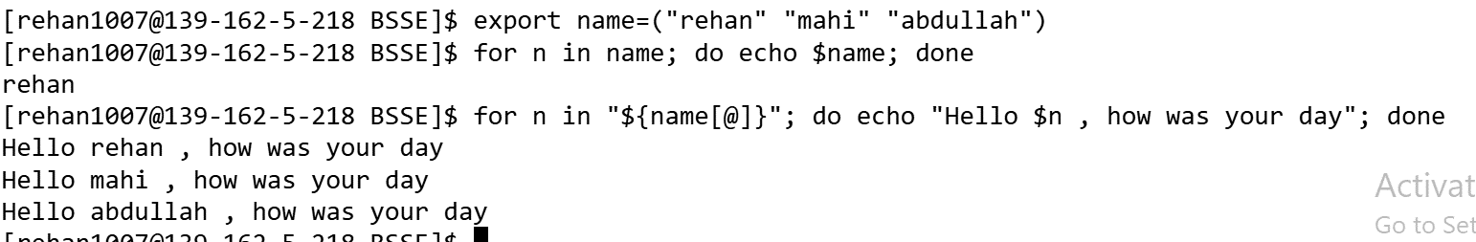

**d: Write why echo * might be useful instead of ls command**

## Description:

This command is simpler and faster than ls, when you just want plain filenames in one line—great for quick copy-paste or scripts.

## Task 15:

echo *

## Screenshots:

