Object Oriented Programming Spring-2026

DUNGEON SIEGE
Project Report


Submitted By:
Muhammad Rehan Ilyas (2025-CS-65)

Submitted to:
Miss Rimsha Afzal

Department of Computer Science
University of Engineering and Technology, Lahore
Dated: 06/10/2026
Table of Contents
1. ACKNOWLEDGEMENT: 3
2. ABSTRACT: 3
1. Project Idea: 3
2. Technologies Used: 3
3. OOP Concepts Implemented: 3
CHAPTER 1: INTRODUCTION 4
1. Introduction: 4
2. Project Overview: 4
3. Problem Statement: 4
CHAPTER 2: DESIGN AND ARCHITECTURE: 4
1. Architecture Overview: 4
2. Class Hierarchy : 4
CHAPTER 3: IMPLEMENTATION: 5
1. Core File Structure: 5
2. Game Loop and Update Cycle: 5
3. Enemy Behavior: 5
4. Component-Based Design: 6
CHAPTER 4: TESTING AND RESULTS 6
1. Test Cases: 6
2. Gameplay Testing Results: 6
3. OOP Principle Verification: 6
CHAPTER 5: CONCLUSION 7
Key Achievements: 7
Future Enhancement: 7
Final Thoughts 7

ACKNOWLEDGEMENT:
I would like to express my sincere gratitude to the following individuals and institutions whose support and guidance made the completion of this project possible:
- Allah Almighty for providing me with knowledge and strength.
- My parents for their support and encouragement.
- Ms. Rimsha Afzal, my course instructor, for providing guidance and positive feedback.

ABSTRACT:
Dungeon Siege is a top-down action game developed using C# and Windows Forms as part of an Object-Oriented Programming course.

Project Idea:
Dungeon Siege places the player in a walled dungeon arena where they must defeat waves of enemies to achieve victory. The game features three difficulty levels that scale enemy behavior and spawn rates, multiple enemy types with distinct attack patterns, and real-time action gameplay mechanics.

Technologies Used:
The project is implemented using C# programming language with the .NET Framework. Windows Forms provides the graphical user interface and event handling, while GDI+ handles all graphics rendering and sprite drawing.

OOP Concepts Implemented:
- Encapsulation separates concerns between game logic in Game Manger, user interface in Form1, and entity behavior in Player and Enemy classes.
- Inheritance creates a class hierarchy where Entity serves as an abstract base class for both Player and Enemy. This hierarchy allows code reuse for common functionality like health management and drawing while enabling specialized behavior in subclasses
- Polymorphism enables flexible entity behavior through abstract methods like Move() and SpecialAbility() that each subclass implements uniquely.
- Abstraction hides complex implementation details behind clean public interfaces. Players interact with high-level concepts like Move, Attack, and TakeDamage without understanding internal mechanics.

CHAPTER 1: INTRODUCTION

Introduction:
Game development provides an excellent real-world platform for learning Object-Oriented Programming principles. Complex interactive systems require careful design with proper separation of concerns, code reuse through inheritance, and flexible behavior through polymorphism.

Project Overview:
Dungeon Siege is a top-down action game where the player spawns in the center of a walled dungeon arena and must defeat waves of enemies. The player controls movement with WASD keys, fires projectiles with Space, restores shields with Shift, and performs melee attacks with mouse clicks.

Problem Statement:
The primary objective was to create a game that demonstrates mastery of Object-Oriented Programming principles while delivering an engaging player experience. The challenge involved designing a flexible class hierarchy that could accommodate multiple entity types, implement varying behaviors through polymorphism, and maintain clean separation between game logic and user interface.

CHAPTER 2: DESIGN AND ARCHITECTURE:

Architecture Overview:
The game architecture follows a layered design pattern that separates concerns into distinct responsibilities. The presentation layer in Form1 handles user input processing, screen rendering, and menu management. The game logic layer in Game Manger manages gameplay rules, enemy spawning, collision detection, and win condition checking.

Class Hierarchy :
- The project employs a carefully designed class hierarchy rooted in the IDamageable interface. This interface defines a contract that any entity capable of taking damage must implement. The Entity abstract class serves as the base for all characters, providing common properties like health, position, and sprite along with methods for taking damage and checking alive status.
- The Player class extends Entity with specific player mechanics including shield and stamina management, fire projectile functionality, and melee attack range. The Enemy abstract class extends Entity and adds properties like level and difficulty scaling. Three concrete enemy classes extend Enemy with unique implementations: Goblin for simple melee behavior, Orc for armored combat, and DarkMage for ranged intelligence.

UML Class Diagram:

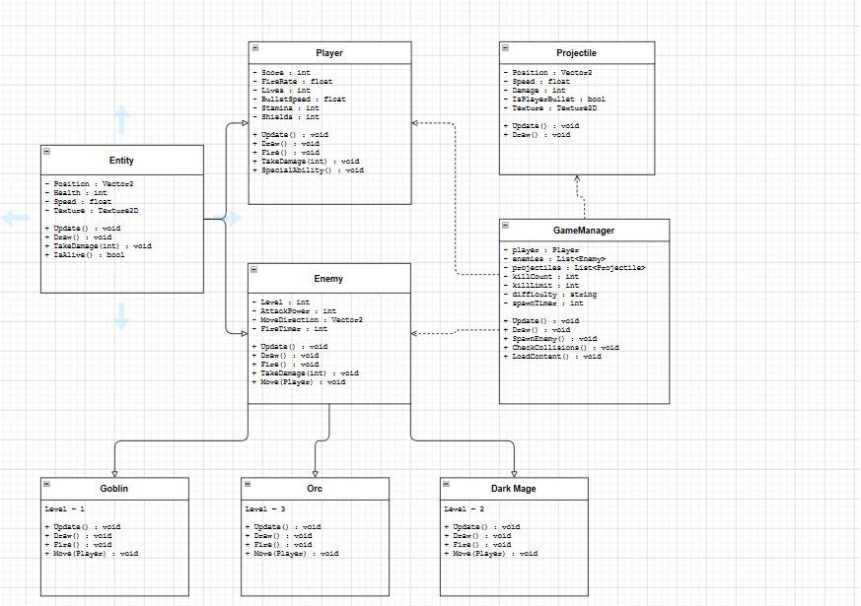

CHAPTER 3: IMPLEMENTATION:

Core File Structure:
The implementation consists of nine core C# files organized into logical folders that reflect the architectural design. Form1.cs serves as the main game window and UI layer, handling input processing, screen rendering, and menu state management. GameManger.cs contains all game logic including enemy spawning, collision detection, and win condition checking. The Entities folder contains the class hierarchy with Entity.cs as the abstract base, Player.cs for the player character, Enemy.cs as an abstract enemy base, and three concrete enemy types: Goblin.cs, Orc.cs, and DarkMage.cs. The Components folder contains reusable functionality with HealthBar.cs for rendering health and shield bars, and ProjectileManager.cs for managing bullet lists. The Core folder contains supporting systems including Projectile.cs for individual bullet behavior, Utils.cs for helper methods, and TextureManager.cs for image loading.

Game Loop and Update Cycle:
The game operates on a fixed update cycle using a Windows Forms timer that fires every 16 milliseconds, achieving approximately 60 frames per second. Each frame, the timer calls GameTimer_Tick() which updates the game state and triggers a screen repaint. UpdateGame() first checks if the game is over by examining whether the player is dead or has reached the kill limit. It then updates the player position and projectiles based on input. All active enemies are updated in sequence, moving toward or away from the player and attacking when in range. The system checks for collisions between player projectiles and enemies, applying damage and incrementing the kill counter.

Enemy Behavior:
Each enemy type implements distinct behavior patterns that provide varied gameplay challenges. Goblins implement simple aggressive behavior, moving directly toward the player at medium speed and attacking with close-range melee strikes. Orcs add armor mechanics to the melee fighter achetype. DarkMages implement intelligent kiting behaviour, moving away from the player when too close to minimize the damage.

Component-Based Design:
The HealthBar component provides a reusable visual representation of an entity's health or shields. It is composed into the Entity class rather than inherited, preventing tight coupling and allowing the health bar to be used independently if needed.

CHAPTER 4: TESTING AND RESULTS

Test Cases:

Test Case | Expected Result | Actual Result | Status
Game Initialization | Application launches and main menu displays | Main menu appears with difficulty and game options | Passed
Player Movement | Player moves in all directions with WASD keys | Player responds smoothly to movement input in all directions | Passed
Enemy Spawning | Enemies spawn at screen edges at proper intervals | Enemies spawn correctly on all four edges with appropriate timing | Passed
Projectile Collision | Projectiles damage enemies and are removed on impact | Projectiles correctly detect collision and damage enemies | Passed
Win Condition | Victory screen displays after reaching kill limit | Victory screen displays after reaching kill limit | Passed

Gameplay Testing Results:
Gameplay testing confirmed that all core mechanics function as intended. Player controls respond smoothly with immediate feedback to keyboard input. The camera follows the player appropriately, and collision boundaries prevent movement outside the playable area.

OOP Principle Verification:
Testing confirmed successful implementation of all OOP principles. Encapsulation properly protects data integrity through appropriate access control. Inheritance verification confirmed that Player and Enemy classes properly inherit common Entity functionality while implementing their own specialized behavior. Polymorphism testing confirmed that abstract methods are properly overridden in subclasses and that the correct implementation is called at runtime Abstraction testing verified that complex implementation details are properly hidden. Players interact with clean game concepts without needing to understand underlying mechanics like collision mathematics or projectile trajectory calculations.

Game ScreenShots:

Main Menu:

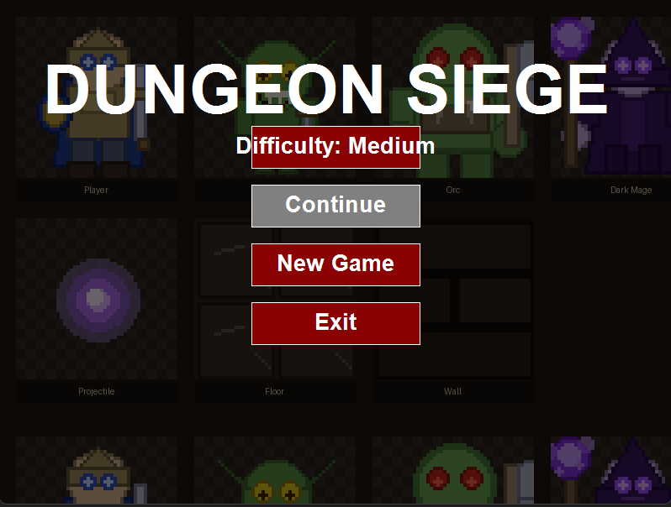

Gameplay:
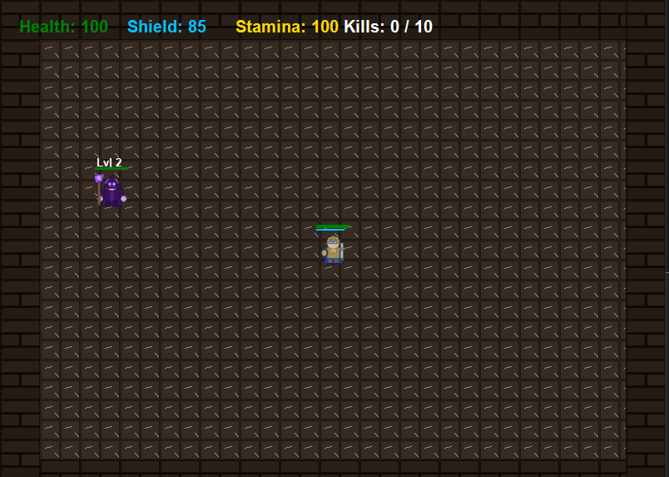

Winning Screen:

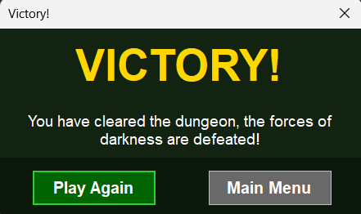

CHAPTER 5: CONCLUSION
Dungeon Siege successfully demonstrates the practical application of Object-Oriented Programming principles in game development. Through careful design and systematic implementation, the project showcases how encapsulation, inheritance, polymorphism, and abstraction combine to create flexible, maintainable, and extensible code. The game provides an engaging player experience across three difficulty levels while maintaining clean architecture and separation of concerns. The class hierarchy effectively models the problem domain. Polymorphism enables flexible entity behavior without tight coupling.

Key Achievements:
- Successfully implemented a functional action game with real-time gameplay mechanics.
- Demonstrated mastery of class hierarchy design with a clear Entity system.
- Implemented both static and dynamic polymorphism through abstract methods and interfaces.
- Created three distinct enemy types with unique behaviors and mechanics.
- Developed reusable components that reduce code duplication and improve maintainability.

Future Enhancement:
- Additional enemy types with unique abilities and attack patterns.
- Power-up system providing temporary player boosts like increased damage or invulnerability.
- Multiple levels or maps with increasing complexity and different environmental layouts.
- Sound effects, background music, and audio feedback for game events.

Final Thoughts
This project has provided valuable hands-on experience in applying OOP concepts to solve real problems. The process of designing the class hierarchy, implementing abstract methods, and creating reusable components has deepened understanding of software design principles. The structured approach to development has resulted in clean, understandable code that can serve as a foundation for learning advanced game development concepts and software architecture pattern.

