**Title: Multi-Level FAQ Chatbot for a Hospital Using X-State and Python**

**Introduction**

The Multi-Level FAQ Chatbot for a Hospital is a Python application that utilizes the FastAPI framework and X-State library to create an interactive chatbot for hospitals. The chatbot provides users with information on various topics, including general information, services, and appointments. The chatbot features multi-level button interactions, allowing users to navigate through different topics and subtopics efficiently.

Design The chatbot's design consists of a state machine that manages user interactions based on button clicks. The state machine is implemented using the X-State library, and the user interface is created using FastAPI and HTML.

**State Diagram**

The following state diagram depicts the chatbot's states, substates, transitions, and button labels:

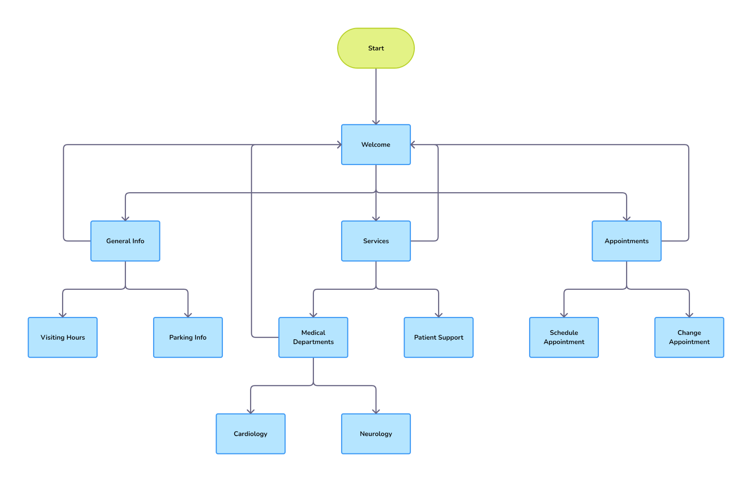

**State Descriptions**

**Start** (Welcome): Displays a welcome message and offers buttons for main categories: General Info, Services, and Appointments.

**General Info State:**

**Buttons**: Visiting Hours, Parking Info, and Return to Start.

**Services State**:

Buttons: Medical Departments, Patient Support, and Return to Start.

Appointments State:

Buttons: Schedule Appointment, Change Appointment, and Return to Start.

Nested States (example within "Medical Departments"):

Cardiology Info

Neurology Info

Return to Services

Transition Descriptions

Each button click triggers a transition to a new state or substate.

The "Return to Start" button in any state transitions the chatbot back to the Start state.

In the "Medical Departments' ' substate, clicking on "Cardiology Info' ' or "Neurology Info" transitions to the respective substrate. Clicking on "Return to Services" transitions back to the Services state.

**Implementation and Testing:** The chatbot is implemented using Python, FastAPI, and X-State. The backend server is established using FastAPI, and the state machine is implemented using X-State. The user interface is created using basic HTML, and button clicks are handled using FastAPI.

The chatbot is tested using simple tests to verify that state transitions are handled correctly based on user button interactions. The tests are implemented using Python's unittest library and are available in the tests directory.

**Evaluation Criteria:** The evaluation of the chatbot will be based on the following criteria:

Accuracy and clarity of the state diagram.

Functionality of the chatbot, especially in managing nested states and handling button interactions.

Code quality, encompassing organization, readability, and adherence to best practices.

Quality of documentation, emphasizing the ease of setup and understanding of the chatbot's operation.

**Conclusion:** The Multi-Level FAQ Chatbot for a Hospital is an efficient and user-friendly application that provides hospital-related information using multi-level button interactions. The chatbot's design and implementation are based on the X-State library and Python's FastAPI framework, ensuring a robust and maintainable solution.