Software Requirements Specification
SRS



Al-Seena Medical Data Hub
(AMDH)

September 30, 2016
Comsats institute of information technology ATD
Team Members

FA13-BSE-161 KHALID
FA13-BSE-138 ABEEL
FA13-BSE-021 ONEES

Contents

1. Introduction
1.1 Purpose 5
1.2 Scope 5
1.3 Definitions, Acronyms, and Abbreviations 7
1.3.1 Definitions 7
1.4 References 8
2. Overall description 9
2.1 Product Perspective 9
2.2 Product Funtions 10
2.3 User Characteristics 11
2.4 Assumptions and Dependencies 11
3. Specific Requirements 12
3.1 Functional Requirements 12
3.1.1 Domain Model 12
3.1.2 Use case model 13
3.2 Performance Requirements 26
3.2.1 Static Requirements 26
3.2.2 Dynamic Requirements 26
3.3 Logical Database Requirements 26
3.4 Design Constraints 26
3.5 Security Requirements 27
3.6 Software System Attributes 27y

1. Introduction
The Software Requirements and Specifications document (SRS) collects, analyzes, and defines high-level needs and features of the AL-SEENA MEDICAL DATA HUB (AMDH). Hospitals, clinics and other medical facilities will use AMDH to manage all aspects of management for their patients. This software replaces the tasks that would normally be given to a receptionist or secretary by allowing patients to schedule their own appointments, check their lab tests result and by allowing doctors to manage their appointments and patients records. A significant part of the operation of any hospital involves the acquisition, management and timely retrieval of great volumes of information. This information typically involves; patient personal information and medical history, staff information, room and ward scheduling, staff scheduling, operating theater scheduling and various facilities waiting lists. All of this information must be managed in an efficient and cost wise fashion so that an institution's resources may be effectively utilized AMDH will automate the management of the hospital making it more efficient and error free. It aims at standardizing data, consolidating data ensuring data integrity and reducing inconsistencies. The document will describe the product functions, requirements and constraints of the web-based AL-SEENA MEDICAL DATA HUB.
The details of how the web-based AL-SEENA MEDICAL DATA HUB fulfills these needs are explained in the use-cases. More details will be available in the upcoming system design phase report.

1.1 Purpose
The purpose of this document is to define the requirements and the specifications of the web-based AL-SEENA MEDICAL DATA HUB. It will describe the product functions, specific requirements, constraints and an analysis model. The analysis model will include use-case diagrams, class diagrams, sequence diagrams and state transition diagrams. This document is intended primarily for the modeling and design team developers of the web-based Al-Seena Medical Data Hub and the project co-coordinator and shall serve as a basis for the upcoming phases of the project.

1.2 Scope
This web-based Al-Seena Medical Data Hub shall enable patients, system admin and doctors to schedule and manage their appointments, manage patient record, manage medicine record with the latest software technology from the comfort of their homes and offices. AMDH is capable of many interdependent tasks, some of which relate to patients, and some of which relate to doctors. AMDH consists of three user interfaces: the patient interface, the doctor interface, and the administrator interface.
There are three user levels for this software, namely:
- Patient
- Doctor
- Administrator
- Staff
The scope of the patient is limited to:
- Logging into the patient interface of the system using a username and password: This applies to returning patients only.
- Entering their personal information: New patients are required to fill in a form in order to enter their personal information. The patient’s personal information will be stored in a database. The patient’s personal information includes their name, address, telephone number, e-mail address, SIN, Medicare card number, username, password, etc.
- Modifying their personal information: Once a returning patient is logged in, they will be able to update their personal information if necessary.
- Scheduling their appointment(s): Patients can schedule their own appointments via the Internet. The patient will be able to choose the type of appointment he/she needs, for example, the appointment could be for a regular check-up, a blood test, an operation, etc. Each of these appointment types will require a different amount of time, for example, a regular check-up can be half an hour while an operation can be three hours. Also, each appointment type will be associated with a different doctor. Once the patient has chosen their appointment type, they will be able to choose a date and time for their appointment. The time slots will depend on the time that is needed for the appointment type that was chosen and the availability of the doctor that is associated with that appointment type.
- Modifying their appointment(s): Returning patients will be able to modify their appointments if necessary.
- Canceling their appointment(s): Returning patients will be able to cancel their appointments if necessary.
- Viewing or printing their schedule: Once the patient has made their schedule, they will be able to view it on their screen, print it.
- Viewing or printing their Lab Tests: Patient can view and print their lab results and send them to specific doctors.
- Check for required medicine: Patient(s) also can check for required medicine from medical store module, if medicine is not available patient can order medicine.

The scope of the doctor is limited to:
- Logging into the doctor interface of the system using a username and password: This applies to returning doctors only.
- Entering their personal information: New doctors are required to fill in a form in order to enter their personal information. The doctor’s personal information will be stored in the database. The doctor’s personal information consists of their name, address, telephone number, social security number, etc.
- Modifying their personal information: Once a returning doctor is logged in, they will be able to update their personal information if necessary.
- Scheduling the time(s) that they will not be available to meet with patients: For example, they can set their lunch hour from 12:00 to 1:00 so that patients will not be able to schedule appointments during this time.
- Modifying the time(s) that they will not be available to meet with patients: Returning doctors will be able to modify their availability if necessary.
- Canceling the time(s) that they will not be available to meet with patients: Returning doctors will be able to cancel their unavailable times if necessary.
- Viewing, printing or emailing their schedule: Once the doctor has made their schedule, they will be able to view it on their screen, print it or email it. Their schedule will also contain information about their patients.
- Viewing or printing patient’s Lab Tests: Doctor also can view and print patient’s lab results and sends them to specific department or patient.
- Check Medicine stock: Doctor also can check for any medicine from medical store module, if medicine is not available patient can order medicine.
- Medical Stock management: Doctor can also manage medical store stock, reporting stock, and order for new medicine.

Overall Description

In this software there will be some main forms. The brief description about them is as

Follow.

    - Reception

The reception module handles various enquiries about the patient's admission and discharge details, bed census, and the patient's movements within the hospital. The system can also handle fixed-cost package deals for patients as well as Doctor Consultation and Scheduling, Doctor Consultancy Fees and Time Allocation.

- Doctor visit schedule

- Doctor Appointment Scheduling

- Enquiry of Patient

- Find History of Patient Enquired.

    - Administration

This module handles all the master entry details for the hospital requirement such as consultation detail, doctor specialization, consultancy fee, and service charges.
- Employee Detail Recording.

- Doctor Type

- Doctor Master

- Referral Doctor

    - Pharmacy
This module deals with all medical items. This module helps in maintaining Item Master, Receipt of Drugs/consumables, issue, handling of material return, generating retail bills, stock maintenance. It also helps in fulfilling the requirements of both IPD and OPD Pharmacy.

    - Laboratory
This module enables the maintenance of investigation requests by the patient and generation of test results for the various available services, such as clinical pathology, X-ray and ultrasound tests. Requests can be made from various points, including wards, billing, sample collection and the laboratory receiving point. The laboratory module is integrated with the in-patient/ outpatient registration, wards and billing modules.
    - Registration
This module helps in registering information about patients and handling both IPD and OPD patient’s query. A unique ID is generated for each patient after registration. This helps in implementing customer relationship management and also maintains medical history of the patient.
    - Abbreviations
- SRS – Software Requirements Specifications
- A.M.D.H - Al-Seena Medical Data Hub
- Dr – Doctor
- Admin – Administrator
- SIN – Social Insurance Number
- OS – Operating System
- DB – Database
- DBMS – Database Management System
- HTML – HyperText Markup Language
- HTTP – HyperText Transfer Protocol
- ASP – Active Server Pages

    - References
[1] Wikipedia, http://www.wikipedia.org/ (current September 22, 2005).

2. Overall description

2.1 Product Perspective
AMDH is intended to be used in Hospitals in order to help improve medical services. There already exists a wide variety of similar products on the market. Most of these commercial applications are intended to be very general and try to cover any possible business. Although these products exist, Hospitals still exhaust a great deal of time and money for management of patient data and appointments scheduling etc. This is because Hospitals have very specific needs that differ from other businesses. AMDH is a web-based application that is tailored to a Hospital’s needs.

2.1.1 System Interfaces
Not required.

2.1.2 User Interfaces
AMDH contains three different types of users, and can be seen from different perspectives:
- Patients. Patients will be able to:
  - Edit Personal information
  - Create his/her account
  - Consult his/her appointments
  - Book an appointment
  - Cancel an appointment
  - Search medicine
  - Order new medicine

- Doctors. Doctor shall be able to:
  - Create his/her account
  - Edit Personal information
  - Add new patient
  - Add or remove patient medical record
  - Manage medicine stock
  - Add or remove Lab tests record
  - Cancel appointments
  - Schedule special appointments
  - Edit his/her profile. Meaning s/he will be able to change his/her address, etc. S/he can also make changes to his/her schedule, for example, set vacations, days off, etc.

- Administrators. Administrator will be able to:
  - Activate or deactivate a doctor
  - Configure employee catalogs
  - Configure departments
  - Configure employees in a department
  - Create an doctor’s account
  - Manage medicine record
  - Add, remove or update medicine and lab test

2.1.3 Hardware Interfaces
Not required

2.1.4 Software Interfaces
Not required

2.1.5 Communication Interfaces
Not required

2.1.6 Memory Constraints
AMDH is supported by any web browser and can be accessed by any computer with internet access.
The following is needed for the architecture of our web browser:
Pentium IV
1 GB RAM
80 GB HDD

3. Specific Requirements

Functional Requirements

3.1.1 Domain Model
Figure 1 in Appendix A.1.1 lists the candidate concept classes and describes the relationship types and the attributes of AMDH.

3.1.1.1 Concept Classes
- Doctor: The user who uses this system to manage the schedule and appointment.
- Patient: The user who makes an online appointment with the doctor.
- Agenda: Exactly the same concept as an agenda in real life. It is used by a doctor to manage his or her schedule. Each day in the agenda has the following attribute: Date, weekday, and status. The status shows whether the day is a holiday, or weekend, or vocation day, or work day.
- Appointment: Patient can book or cancel an appointment with the doctor.
- Appointment Type: Appointment reason is grouped into some appointment type. Appointment Type such as blood test, health examination, is defined by the doctor.
- Time Slot: One day is split into many small pieces of time slots with equal length. For example, if we set the minimum measure unit of the appointment duration as 10 minutes, then one day consists of many time slots: 8:00, 8:10, 8:20 etc.

USECASE DIAGRAM

A Use case is a description of set of sequence of actions graphically it is rendered as an ellipse with solid line including only its name. Use case diagram is a behavioral diagram that shows a set of use cases and actors and their relationship. It is an association between the use cases and actors. An actor represents a real-world object.

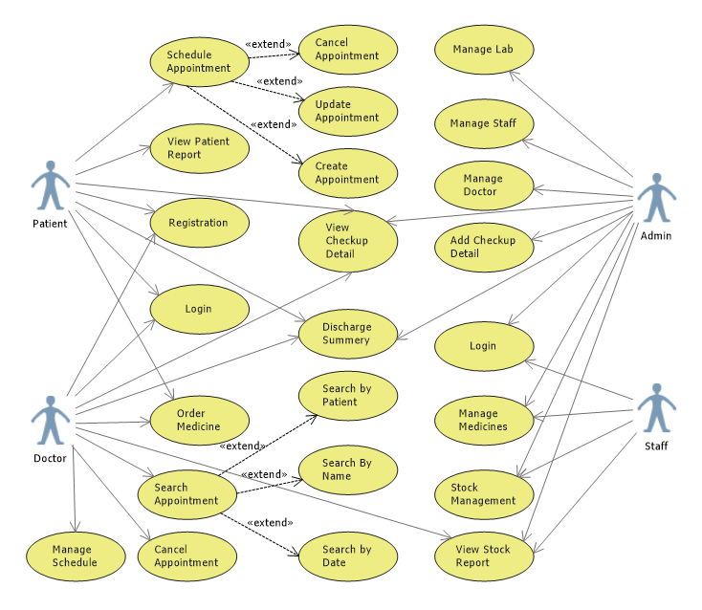

Performance Requirements

3.2.1 Static Requirements
- The System should be able to service multiple terminal connections simultaneously. At least 50 internet users should be able to use the system without any connection delay issues
- The system should process textual and numerical data

3.2.2 Dynamic Requirements
- The software should be able to process more that 90% of the user queries in a fraction of 1 second.
- No Restriction is applied on the number of queries performed be a user as long as he is authorized to do perform them.
- The time needed to display information of users’ queries on a web client, varies according to the system load and users’ internet connection speed.
- For a specific time in a specific date, all users have same priority to reserve that slot. Users are served in a First-Come First-served fashion.

Logical Database Requirements
- The database should store different data types of information like integers, time formats, date format, real numbers and strings.
- A fault tolerance and crash recovery plan should be implemented on the system by configuring automatic backup in the DBMS.
- The database should be able to handle up to 50 simultaneous user queries.
- The database design and relationships should be in a BCNF normal form to guarantee maximum space usage efficiency and a response time of less than three seconds.

Design Constraints
- The system should work on any internet browser with GUI whether the underlying Operating System is Windows.

3.5 Security Requirements
- User authentication is needed to use the system. Users should not be able to create or delete reservations for other users. Thus, a track of each user’s reservations is needed in order to apply these constraints.
- Personal information collected upon registration should not be revealed for the sake of privacy. A user needs only to know whether a certain time slot is reserved or not, without the need to reveal the patient’s name.

Software System Attributes

Usability
The System’s interface should be user-friendly:
- All web pages used by the users should consistent with standardized colors and fonts.
- The presentation of the web pages should be made friendly be provided the users with on-the-spot instructions concerning the step they are.
- In case of errors, help links should be provided or instructions for correct use.
- An HTML online documentation should be available and accessible to the users on all pages and steps of system usage.

Reliability
The system should insure that the user actions are performed correctly as the user requires:
- The system’s database should handle the maximum number of users (50) without failure.
- If the user entered invalid data, the system should be able to recover and react robustly with the error, by sending a message back to the user
- The System should be set up on a dedicated computer machine for s 24-hours a day and 7-days a week availability.
- The system’s backup plan should support the protection of the DB data and assure the functioning of the system after recovery of a crash

Portability
- Because the appointment scheduler is a web based system, it can be accessed by users having any operating system with GUI internet browser installed; thus insuring high portability and minimum system requirements.
- 100% of the client code is host independent.
- The C# language used at the hosting machine is system independent.
- System can be work under Windows or Linux.

Correctness
- All algorithms implemented in the system should be correct; meaning they should be performed as required. The testing phase insures correctness of the software by trying all possible case and matching their output with the documentation.

Interoperability
- Since the system relies on the web agents (browsers) in its interoperability, and all web agents interoperates with other software packages, then the system can work with other software. For example, it can provide an Acrobat Reader version of the documentation.

Maintainability
- The client side scripting is of the system can be easily fixed and enhanced due to simplicity. The server side scripting is well maintainable also as all models and code is preceded by related design and this requirements document.

