## Question 2

**A)**

**Code:**

**#include <iostream>**

**using namespace std;**

**class Publications**

**{**

**};**

**class Staff**

**{**

**};**

**class Library**

**{**

**private:**

**Staff* stf[5];**

**Publications* pub[5];**

**string publishDate;**

**int staffId;**

**public:**

**void addStaff(Staff *stff, int staffId) {**

**if (staffId >= 0 && staffId <= 15) {**

**stf[staffId] = stff;**

**}**

**}**

**Staff* getStaff(int staffId) {**

**if (staffId >=0 && staffId <=20) {**

**return stf[staffId];**

**}**

**else {**

**return NULL;**

**}**

**}**

**void setStaffId(int id) {**

**staffId = id;**

**}**

**int getStaffId() {**

**return staffId;**

**}**

**void addPublications(Publications *pubb, int pubNo)**

**{**

**if (pubNo >= 0 && pubNo <= 20) {**

**pub[pubNo] = pubb;**

**}**

**}**

**Publications* getPublications(int pubNo) {**

**if (pubNo >=0 && pubNo <=20) {**

**return pub[pubNo];**

**}**

**else {**

**return NULL;**

**}**

**}**

**void setPublishDate(string date) {**

**publishDate = date;**

**}**

**string getPublishDate() {**

**return publishDate;**

**}**

**};**

**int main()**

**{**

**cout<<"\tName :\tRehan Mumtaz \n\tRoll #:\tSE-19036";**

**Staff s[20];**

**Publications p[20];**

**Library l1;**

**for (int i = 0; i <= 5; i ++)**

**{**

**l1.addStaff(&s[i], i);**

**cout << "Staff with staff id: " << i << " added"<< endl;**

**}**

**cout << endl;**

**for (int i = 0; i <= 5; i ++)**

**{**

**l1.addPublications(&p[i], i);**

**cout << "Publicatoin with publication number: " << i << " added" << endl;**

**}**

**return 0;**

**}**

**Output:**

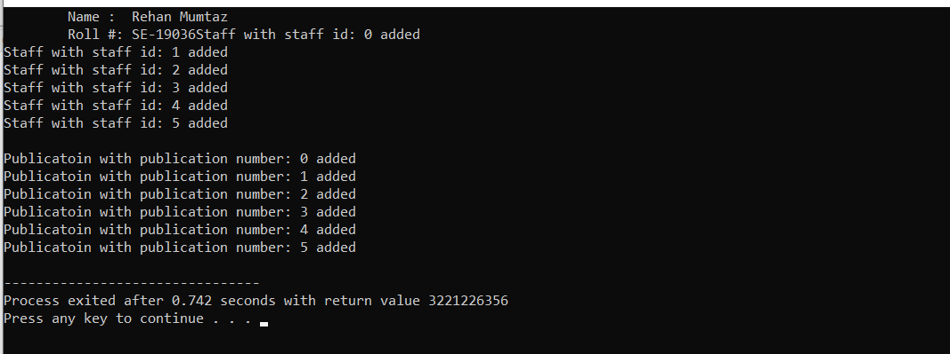

**B)**

**CODE:**

#include <iostream>

#include <string.h>

#include <math.h>

#include <cmath>

using namespace std;

class triangle{

protected:

double base;

double altitude;

double angle;

public:

triangle(){};

triangle(double a,double ang){

base=a;

angle=ang;

}

triangle(double b,double a,double ang){

base=b;

altitude=a;

angle=a;

}

double getbase(){

return base;

}

void setbase(double b){

base=b;

}

double getaltitude(){

return altitude;

}

void setaltitue(double b){

altitude=b;

}

double getangle(){

return angle;

}

void setangle(double b){

angle=b;

}

double area(){

return (base*altitude)/2;

}

};

class isoceles:public triangle{

isoceles(int a,double ang):triangle(a,ang)

{

}

virtual double area(){

return (base*altitude)/2;

}

};

class rightangle:public triangle{

public:

rightangle(int a,int b){

angle=90;

base=a;

altitude=b;

}

virtual double area(){

return base*altitude/2;

}

};

class Equilateral:public triangle{

public:

Equilateral(int a){

base=a;altitude=a;

angle=60;

}

virtual double area(){

return (sqrt(3)*pow(base,2))/4;

}

double parameter(){

return 3*base;

}

};

int main(){

cout<<"\tName :\tRehan Mumtaz \n\tRoll #:\tSE-19036";

cout<<"\n\t The Equilateral Triangle applied area and perimeter are given as\n";

Equilateral e1(5);

cout<<"\n\tArea is "<<e1.area()<<endl;

cout<<"\n\tParameter is "<<e1.parameter();

}

**Output:**

