## **Question 3**

A)

Code:

#include <iostream>

#include <string.h>

#include <math.h>

#include <cmath>

using namespace std;

class publication

{

protected:

string title;

float price;

public:

publication(string t,float p):title(t), price(p)

{

};

void putData()

{

cout<<"\n\tTitle of book is "<<title<<endl;

cout<<"\n\tPrice is"<<price <<endl;

}

void getData()

{

cout<<"\n\tEnter title of publication"<<endl;

cin>>title;

cout<<"\n\tEnter price "<<endl;

cin>>price;

}

};

class book: public publication

{

private:

int pagecount;

public:

book(string t,float p):publication(t,p)

{

}

void getData(int pc)

{

pagecount = pc;

}

void putData()

{

cout<<"\n\t Welcome !\n";

cout << "\n\tBook NAME : " << title << endl;

cout<<"\n\tTotal pages are "<<pagecount<<endl;

cout << "\n\tBook price: " << price << endl;

}

};

class tape:public publication

{

private:

float playingtime;

public:

tape(string t,float p):publication(t,p)

{

}

void getData(float pt)

{

playingtime=pt;

}

void putData()

{

cout<<"\n\t We alse deals with the DVDS\n";

cout << "\n\tDvd name is: " << title << endl;

cout<<"\n\tPlaying time is "<<playingtime<<endl;

cout << "\n\tDvd price is: " << price << endl;

}

};

int main() {

cout<<"\tName :\tRehan Mumtaz \n\tRoll #:\tSE-19036";

cout << "\n\tInfo of Books:" << endl;

book bb1("Pride and Prejudice", 1900);

bb1.getData(900);

bb1.putData();

cout << "\n\tInfo of DVDs : " << endl;

tape dvd1("Michael Jackson wheelers", 250);

dvd1.getData(100);

dvd1.putData();

}

**Output:**

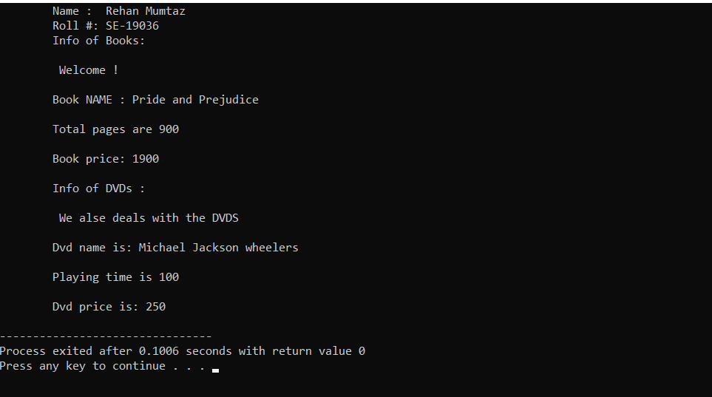

**B)**

**Code:**

#include <iostream>

#include <conio.h>

#include <string.h>

#include <math.h>

#include <cmath>

using namespace std;

class publication

{

private:

string title;

float price;

public:

void getdata()

{

cout << "\nEnter title:" ;

cin >> title;

cout << " Enter price: ";

cin >> price;

}

void putdata() const

{

cout << "\nTitle: " << title;

cout << "\n Price: " << price;

}

};

class sales

{

private:

float ttlsale[3];

public:

void returndata(){

cout << " Enter sales for 3 months\n";

for(int k=0; k<3; k++)

{

cout << " Month " <<k+1 << ": ";

cin >> ttlsale[k];

}

}

void outputdata() const{

for(int k=0; k<3;k++)

{

cout << "\n Sales for month "<< k+1 << ": ";

cout << ttlsale[k];

}

};

class book : private publication, private sales

{

private:

int pages;

public:

void getdata()

{

publication::getdata();

cout << " Enter number of pages: "; cin >> pages;

sales::returndata();

}

void putdata() const

{

publication::putdata();

cout << "\n Pages: " << pages;

sales::outputdata();

}

};

class tape : private publication, private sales

{

private:

float time;

public:

void getdata()

{

publication::getdata();

cout << " Enter playing time: "; cin >> time;

sales::getdata();

}

void putdata() const

{

publication::putdata();

cout << "\n Playing time: " << time;

sales::putdata();

}

};

int main()

{

cout<<"\tName :\tRehan Mumtaz \n\tRoll #:\tSE-19036";

book bk;

tape tp;

bk.getdata();

tp.getdata();

bk.putdata();

tp.putdata();

return 0;

}

**Output:**

