Procedural Paradigm:

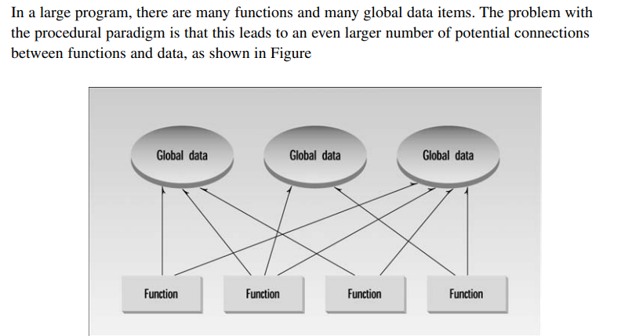

Object Oriented Paradigm:

The fundamental idea behind object-oriented languages is to combine into a single unit both data and the functions that operate on that data. Such a unit is called an object. You can’t access the data directly. The data is hidden, so it is safe from accidental alteration. Data and its functions are said to be encapsulated into a single entity. Data encapsulation and data hiding are key terms in the description of object-oriented languages. A C++ program typically consists of a number of objects, which communicate with each other by calling one another’s member functions.

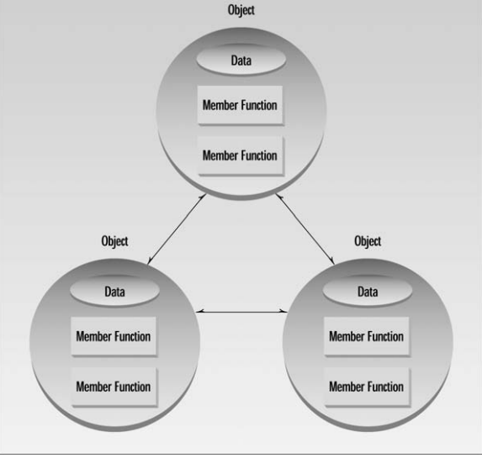

Corporate Paradigm:

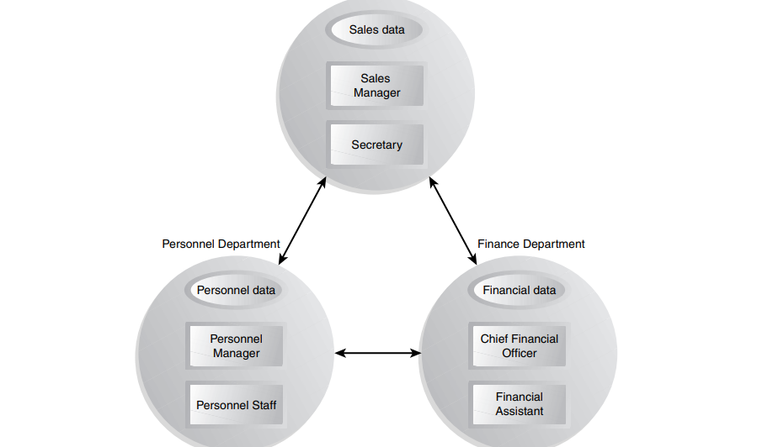

Inheritance(Class and its Objects)

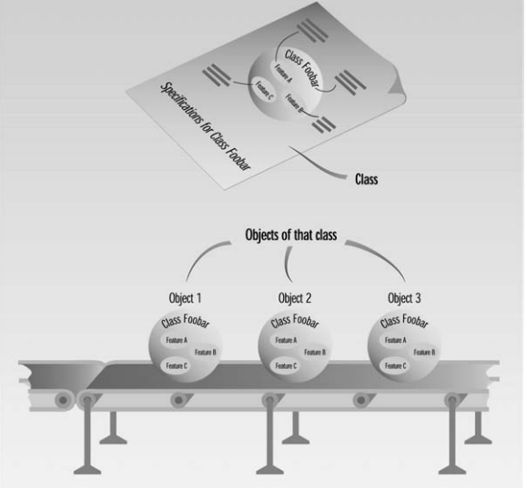

Inheritance

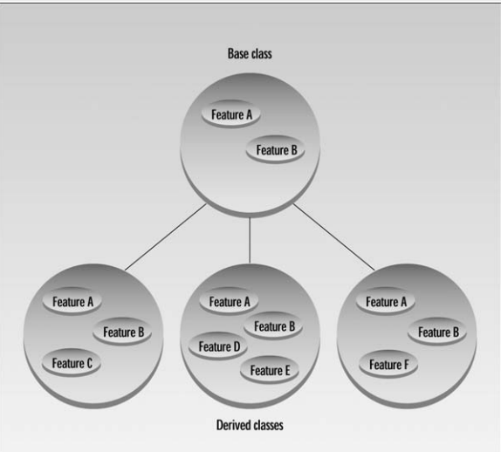

Relationship between C and C++

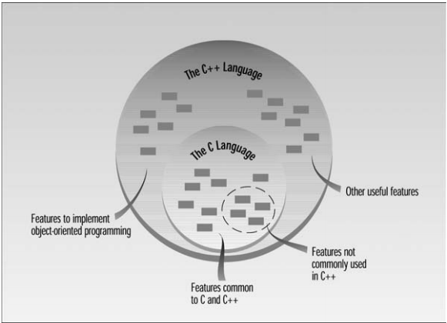

Use of Cout and Cin

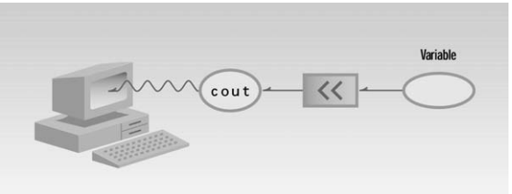

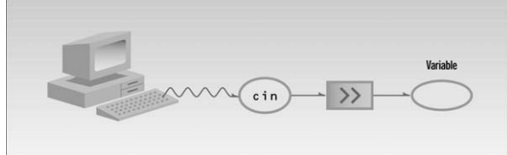

Polymorphism

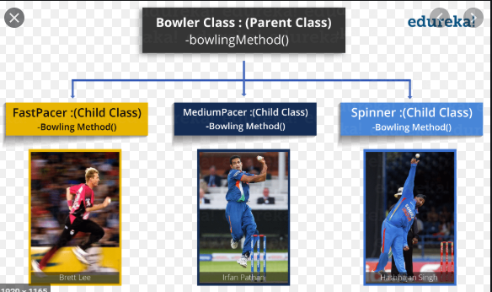

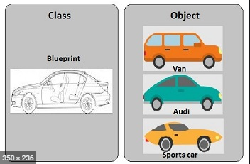

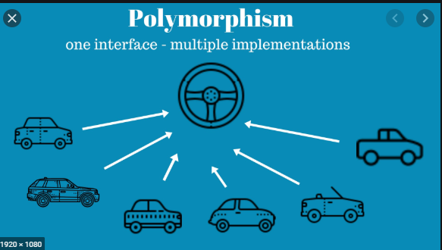-

Generalization:

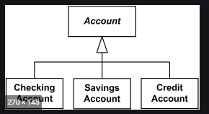

Specialization:

