Day 1 – Day 10 : 01/08/2024

Inverted Search Project

Introduction :
An inverted index is an index data structure storing a mapping from content, such as words or numbers, to its locations in a database file, or in a document or a set of documents. The purpose of an inverted index is to allow fast full text searches, at the cost of increased processing when a document is added to the database.

The term "inverted index" is used because this type of index inverts the typical relationship between documents and terms. In a standard index, each document lists the words it contains. An inverted index flips this around: for each term, it lists the documents that contain that term. This inversion is what makes the retrieval process efficient.

It is the most popular data structure used in document retrieval systems, used on a large scale for example in search engines.

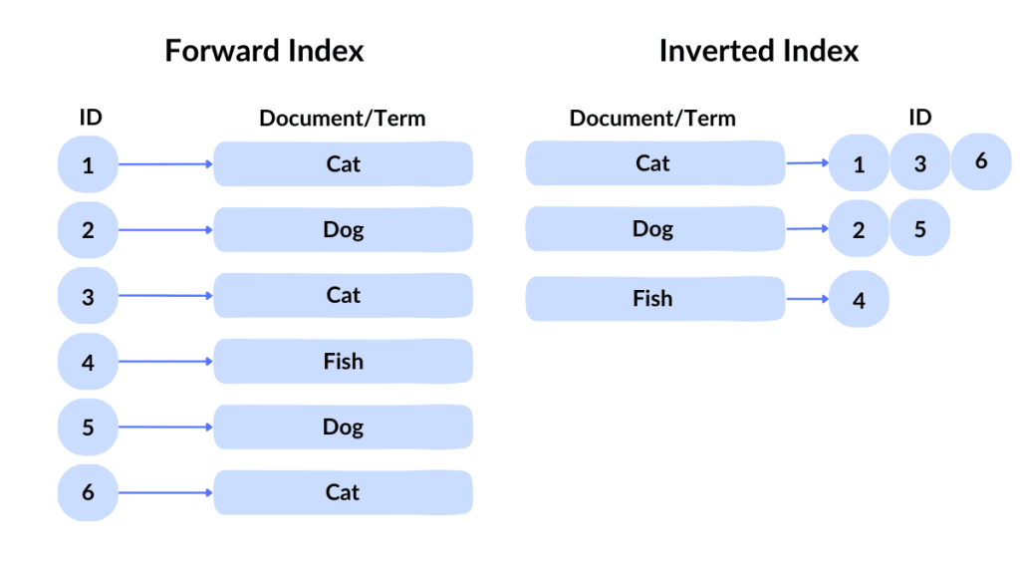

Concepts Used :
Single linkedlist + file io + dynamic memory, all in C programming language.

Requiremnets :
Implementing this search program mainly consists two important functions.
1. Indexing.
2. Querying.

1) Indexing :

By Indexing, we are creating a database file which contains the index of all words. So this can be termed as Database Creation also. All the files whose index are to be created are selected and inputed to this function. All the files are parsed and words are separated and indexed. They are arranged in sorted order. For this a sorted Linked List is used which will store the words and the related file details. The index thus created is then stored in the file as database. This file is later used in Querying. While the files are removed or added this index file is updated.

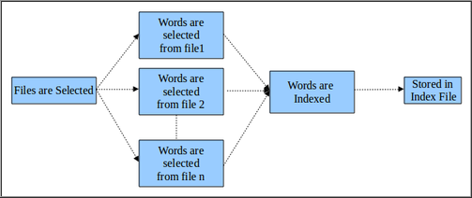

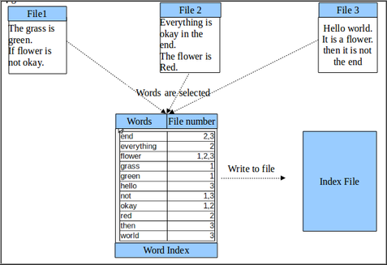

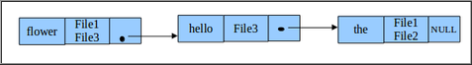

2) Searching :

Once the Indexing is over we have the Querying or Searching. The text to be searched is inputed which is parsed into words and those words are searched in the index file. To avoid the overhead of
reading the file again, the file is converted back to a linkedList, in which the words are searched. The information about the files which contain the words are collected. The ones
with more matches are filtered and produced as the result.

