Name : Rehan Shakoor
Data : 03/07/2024 (4 Days)

Steganographer Project

Steganography :
A practice of concealing a file, message, image, or video within another file, message, image, or video.

Requirements:
The application accept an image file say .bmp along with the a text file which contains the message to be steged.

Analize the size of the message file and the data part of the .bmp file to check whether the messsage could fit in the provided .bmp image. The current project expects us to implement LSB (Least
Significant Bit) Image Steganography on a .bmp file.

Provide a option to steg a magic string (kind of password) which could be usefull to identify whether the image is steged or not.

The appliaction should provide a option to decrpt the file.

This has to be an command line apliaction and all the options has to be passed as an command line argument

Concepts used:
File I/O
Pointers and Structures
Dynamic memory

What is a BMP image?

The BMP file format (Windows bitmap) handles graphic files within the Microsoft Windows OS.
Typically, BMP files are uncompressed, and therefore large and lossless; their advantage is their simple structure and wide acceptance in Windows programs.

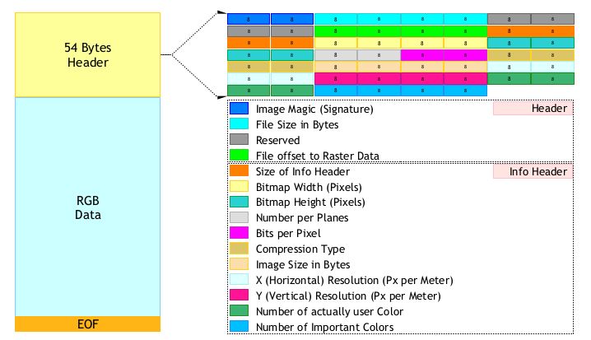

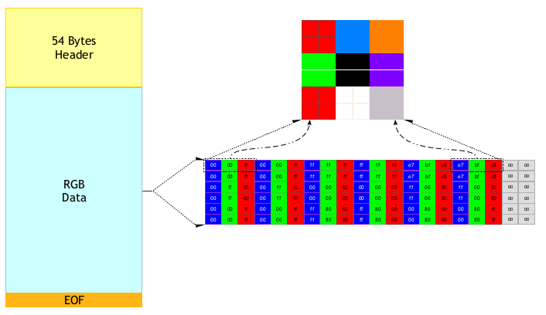

Imformation is stored in the lsb (bit) of each pixel of RGB data. Lsb is used because it makes the least changes in the colour and therefore the final image.

Code Design :

