Shallow feels

**Short description**: An view of making organic clothes using natural dyes and natural fabrics.

**Problem:** As the synthetic dyes are harmful for natural water bodies and causes undesirable changes in lakes and rivers

**Idea:** To create sustainable , environment friendly fabrics which does not cause much damage to the society.

**Long description:**

**Types of Fabric to Use**

Not all fabric can be easily dyed with natural materials. The best ones to use are those made from natural materials themselves. Cotton, silk, wool, and linen will take the dye the best.

## Natural Dyes for Fabric

We use natural dyes for fabric because we want something non-carcinogenic and not harmful to our environment.

#### Natural Dyes

* **Orange:** carrots, gold lichen, onion skins
* **Brown:** dandelion roots, oak bark, walnut hulls, tea, coffee, acorns
* **Pink:** berries, cherries, red and pink roses, avocado skins and seeds (really!)
* **Blue:** indigo, red cabbage, elderberries, red mulberries, blueberries, purple grapes, dogwood bark
* **Red-brown:** pomegranates, beets, bamboo, hibiscus (reddish colour flowers), bloodroot
* **Grey-black:** Blackberries, walnut hulls, iris root
* **Red-purple:** red sumac berries, basil leaves, daylilies, pokeweed berries, huckleberries
* **Green:** artichokes, sorrel roots, spinach, peppermint leaves, snapdragons, lilacs, grass, nettles, plantain, peach leaves
* **Yellow:** bay leaves, marigolds, sunflower petals, dandelion flowers, paprika, turmeric, celery leaves, lilac twigs, Queen Anne’s Lace roots, barberry roots, yellow dock roots

## The Process for Natural Dyes for

#### The Process

1. Place the plant material in a large non-reactive pot (like stainless steel or glass). Remember the dye could stain some pots and spoons, so use these only for dyeing.
2. Fill the pot with twice as much water as plant material.
3. Simmer for an hour or so, until you get a nice dark color.
4. Strain out the plant material and return the liquid to the pot.
5. Carefully place the fabric in the dye bath and bring to a slow boil. Simmer for an hour or so, stirring once in a while.
6. Check your fabric. Remember, it will be lighter when it dries. An hour should produce nice color, but darker hues can be achieved by allowing to sit longer, even overnight. Turn the pot off after an hour and allow the fabric to sit in the warm water as long as needed.
7. When you get the color you want, take the fabric out and wash in cold water. Expect the color to run some as the excess dye is washed out
8. Dry as usual.

#### Sustainable Natural and Vegan Fabrics

* [Organic Cotton](https://www.sustainablejungle.com/sustainable-fashion/sustainable-fabrics/#item-1)
* [Recycled Cotton](https://www.sustainablejungle.com/sustainable-fashion/sustainable-fabrics/#item-2)
* [Organic Hemp](https://www.sustainablejungle.com/sustainable-fashion/sustainable-fabrics/#item-3)
* [Organic Linen](https://www.sustainablejungle.com/sustainable-fashion/sustainable-fabrics/#item-4)
* [Organic Bamboo (Bamboo Linen)](https://www.sustainablejungle.com/sustainable-fashion/sustainable-fabrics/#item-5)
* [Cork](https://www.sustainablejungle.com/sustainable-fashion/sustainable-fabrics/#item-6)

#### Vegan, Synthetic Fabrics

* [ECONYL](https://www.sustainablejungle.com/sustainable-fashion/sustainable-fabrics/#item-7)
* [Recycled polyester](https://www.sustainablejungle.com/sustainable-fashion/sustainable-fabrics/#item-8)

#### Animal Derived Natural Fabrics (sustainable depending on source)

* [Sheep Wool](https://www.sustainablejungle.com/sustainable-fashion/sustainable-fabrics/#item-22)
* [Merino Wool](https://www.sustainablejungle.com/sustainable-fashion/sustainable-fabrics/#item-23)
* [Alpaca Wool](https://www.sustainablejungle.com/sustainable-fashion/sustainable-fabrics/#item-24)
* [Cashmere](https://www.sustainablejungle.com/sustainable-fashion/sustainable-fabrics/#item-25)
* [Camel](https://www.sustainablejungle.com/sustainable-fashion/sustainable-fabrics/#item-26)
* [Yak Wool](https://www.sustainablejungle.com/sustainable-fashion/sustainable-fabrics/#item-27)
* [Vegetable Tanned Leather](https://www.sustainablejungle.com/sustainable-fashion/sustainable-fabrics/#item-28)
* [Down](https://www.sustainablejungle.com/sustainable-fashion/sustainable-fabrics/#item-29)
* [Silk](https://www.sustainablejungle.com/sustainable-fashion/sustainable-fabrics/#item-30)

**Demo video:**

**Architecture:**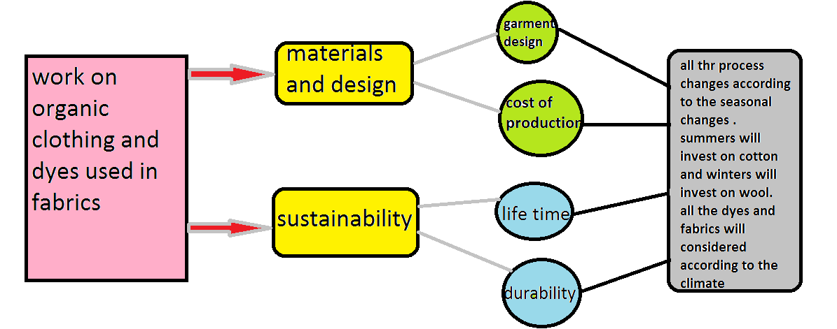

**Project roadmap:**