

Sales Portal
User Guide
Ittehad Automotive Dealership Management System
Hyundai Islamabad · Jetour Ittehad · CSM Ittehad

For: Salespeople, Assistant Managers, Sales Managers, Sales Admins and the Delivery Team
Version 1.0 · October 2026

How to use this guide
Each chapter is for one role. Find your role, then the task you want to do. Every task has a heading, a short explanation, and numbered steps. Each step has one line of instruction and a screenshot of the portal: the red circles and arrows show exactly where to click or type. When a screenshot has several red circles, they are numbered in the order you use them.
Everyone should read Chapter 1 (Getting started) first. The Assistant Manager and Sales Manager can also do everything in the Salesperson chapter.
The screenshots use sample customers and the Hyundai Islamabad dealership. Jetour Ittehad and CSM Ittehad work the same way; only the logos, car models and document formats differ.

Who does what
Role | Main tasks
Salesperson / CRO | Logs leads, records follow-ups and appointments, issues quotations and PPF vouchers, converts customers who book, follows their own orders.
Assistant Manager | Sees every lead of the dealership, logs leads for salespeople, decides duplicate customers, reassigns leads, approves leave, schedules deliveries, maintains document formats.
Sales Manager | Everything the Assistant Manager does, plus approving sales orders, the team report and track record, and managing staff logins.
Sales Admin | Raises the sales order for each converted lead, records payments, submits orders for approval, clears cars for delivery.
Delivery Team | Registers cars in open stock, allocates them to orders, moves them through logistics, requests clearance and hands cars over.

The order of a sale
- Salesperson logs the lead and follows it up (quotation, appointment).
- Salesperson converts the lead when the customer books (payment, CNIC, address).
- Sales Admin raises the sales order with the PBO number and records payments, then submits it.
- Sales Manager approves the order.
- Delivery Team allocates a car, marks it in transit, received and ready for delivery.
- Sales Admin clears the car once all payments are in; the delivery date is scheduled.
- Delivery Team hands the car over (Mark as delivered): the order and the lead are completed.

Contents
Right-click here and choose “Update field” to show the table of contents.

1. Getting started (all users)
These tasks are the same for every user: logging in, the dashboard, notifications, leave applications and logging out.
- 1.1 Log in to the portal
- 1.2 Read your dashboard
- 1.3 Check notifications and pending actions
- 1.4 Apply for leave
- 1.5 Sign out

1.1 Log in to the portal
Open the portal in your browser (Google Chrome recommended) and sign in with the email and password given to you by your Manager.
Step 1: Type your email address and password, then click Log In.
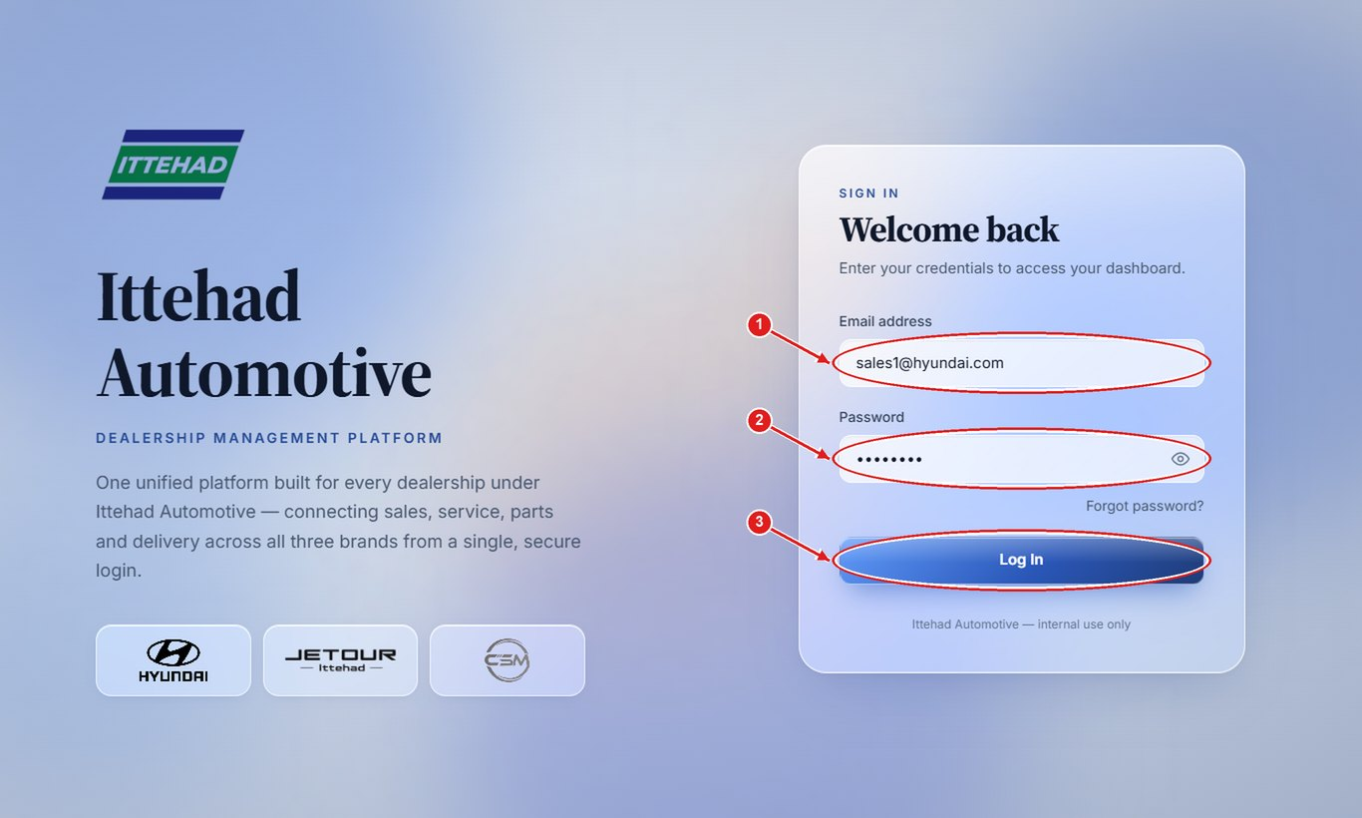
Note: Forgot your password? Ask your Manager to reset it; you will be asked to choose a new password at your next login.

1.2 Read your dashboard
The dashboard opens after you log in. It shows today’s appointments, what needs your action, and your figures.
Step 1: “Today at a glance” lists today’s appointments; “Action needed” lists the work waiting for you, click Open → to go to it.
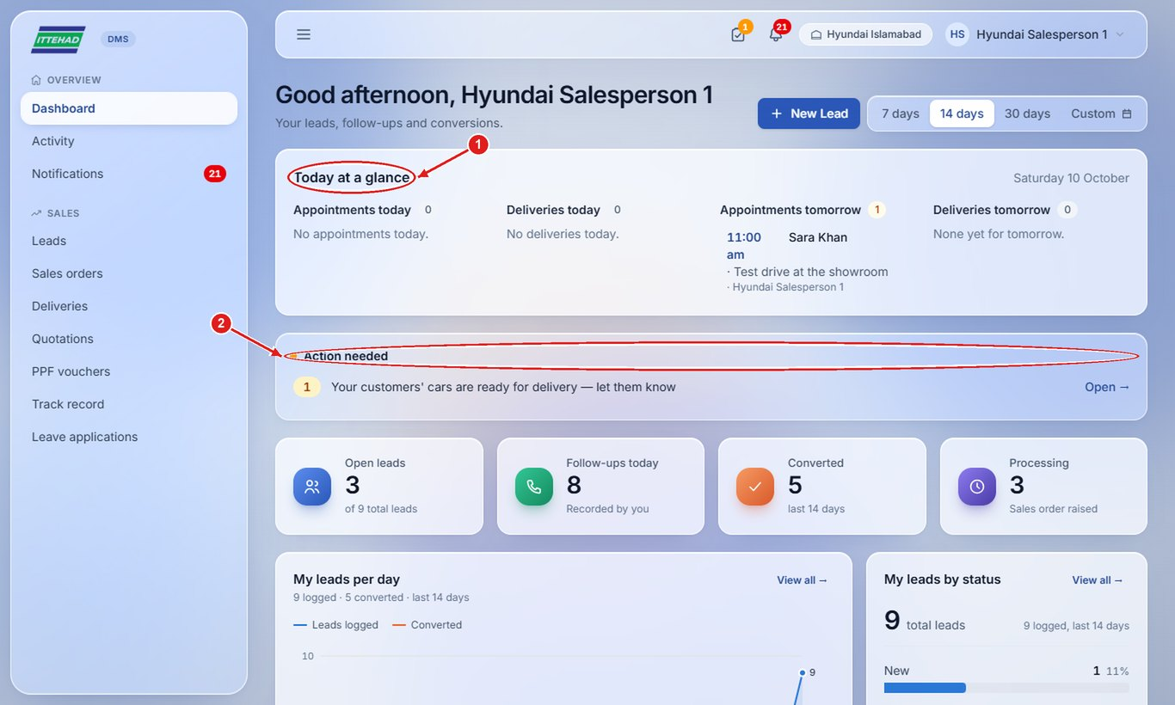
Step 2: Scroll down for your leads per day, leads by status and your monthly record. Pick 7, 14 or 30 days at the top to change the period.
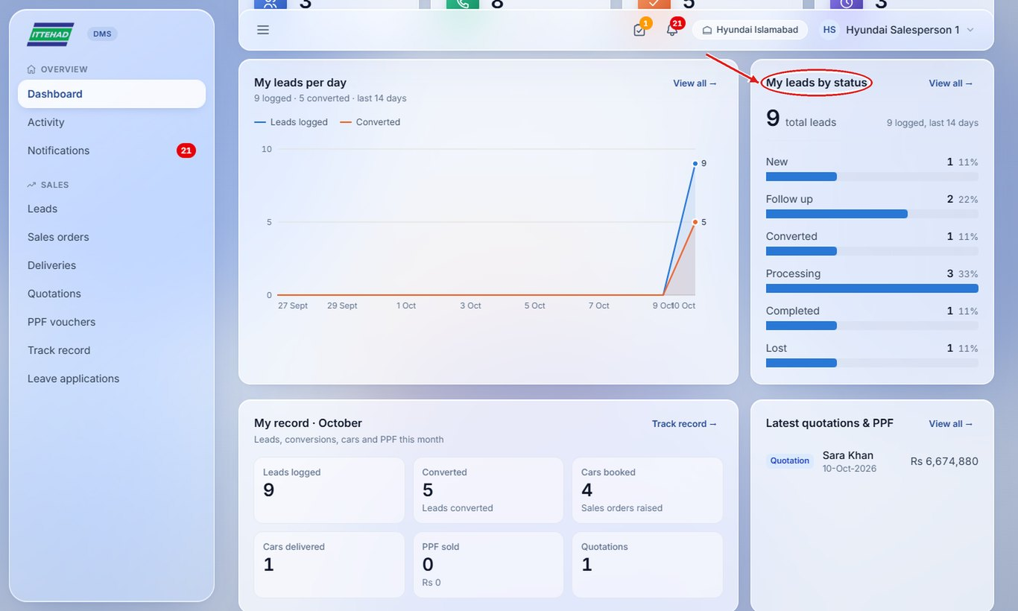

1.3 Check notifications and pending actions
The bell shows new notifications (new leads, approvals, cars received and so on). The tick icon shows how many actions are waiting for you.
Step 1: Click the bell to see the latest notifications, or the tick icon to see your pending actions.
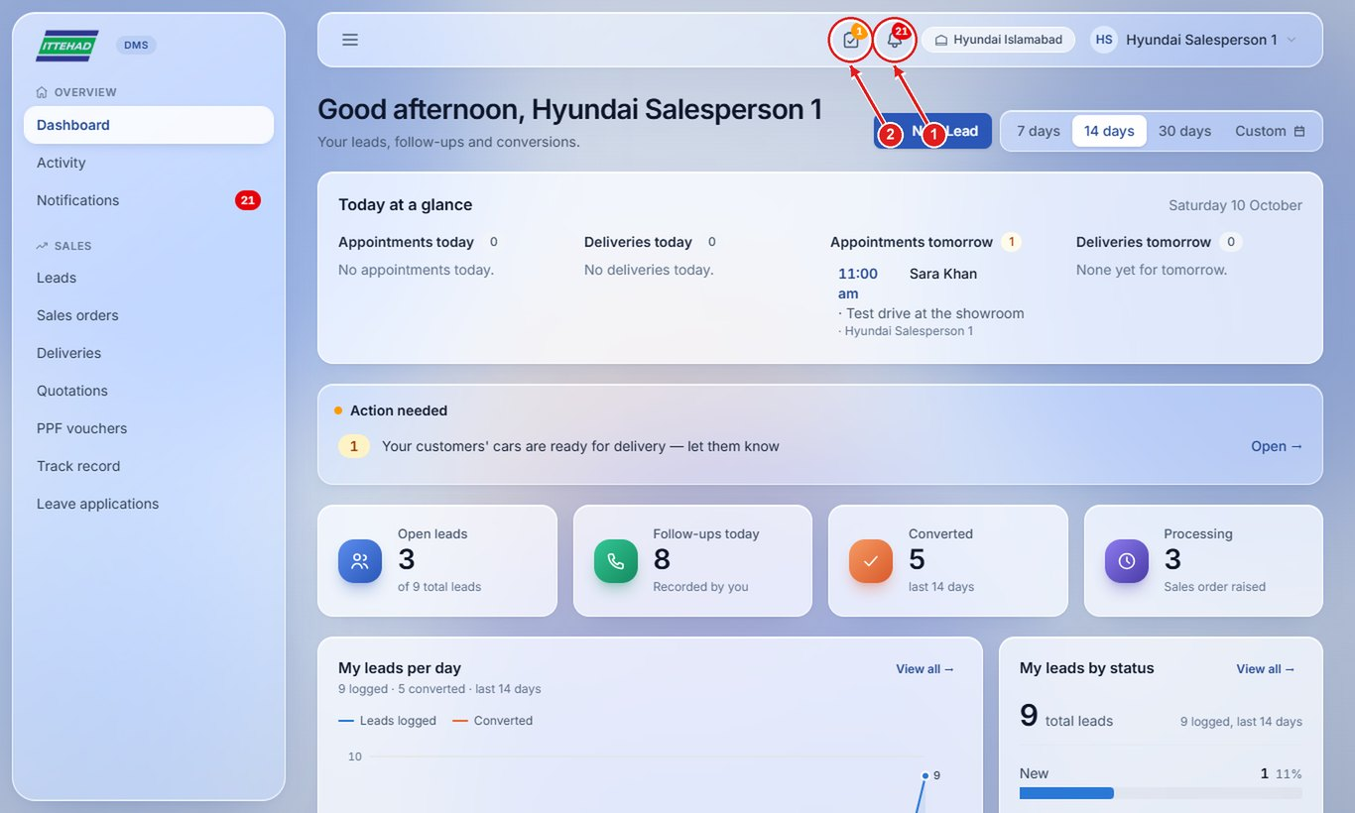
Step 2: Click Notifications in the menu to see all of them; click one to open the lead, order or delivery it is about.
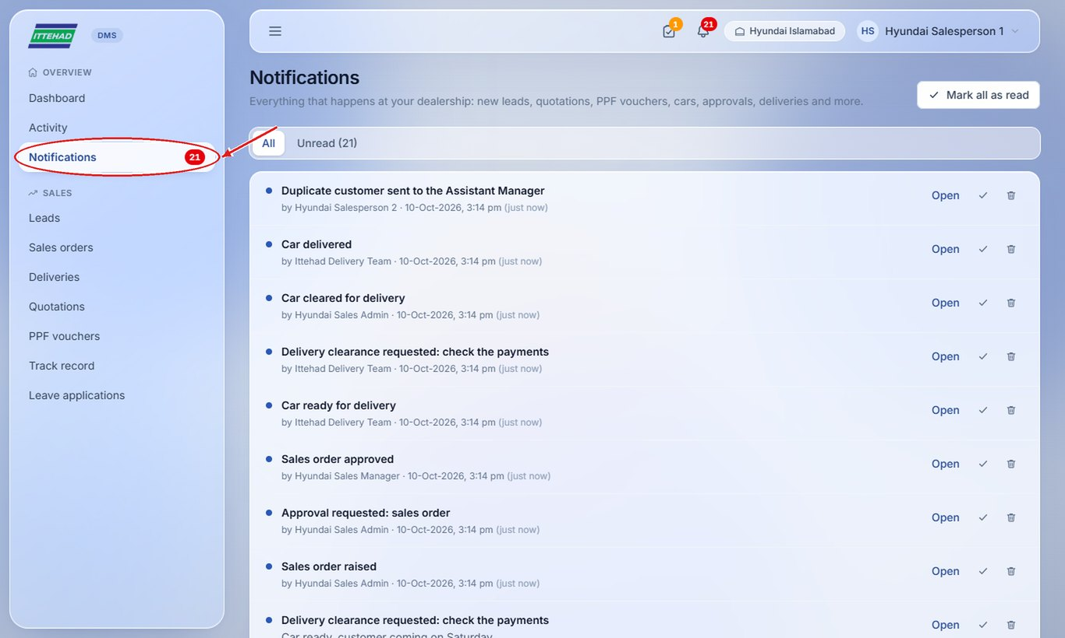

1.4 Apply for leave
Every member of the sales department applies for sick or emergency leave in the portal. The Assistant Manager or Manager approves it.
Step 1: Click Leave applications in the menu, then + Apply for leave.
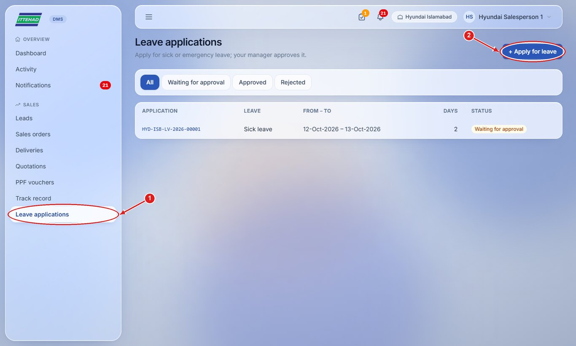
Step 2: Choose the type of leave, the dates and the reason, then click Submit application.
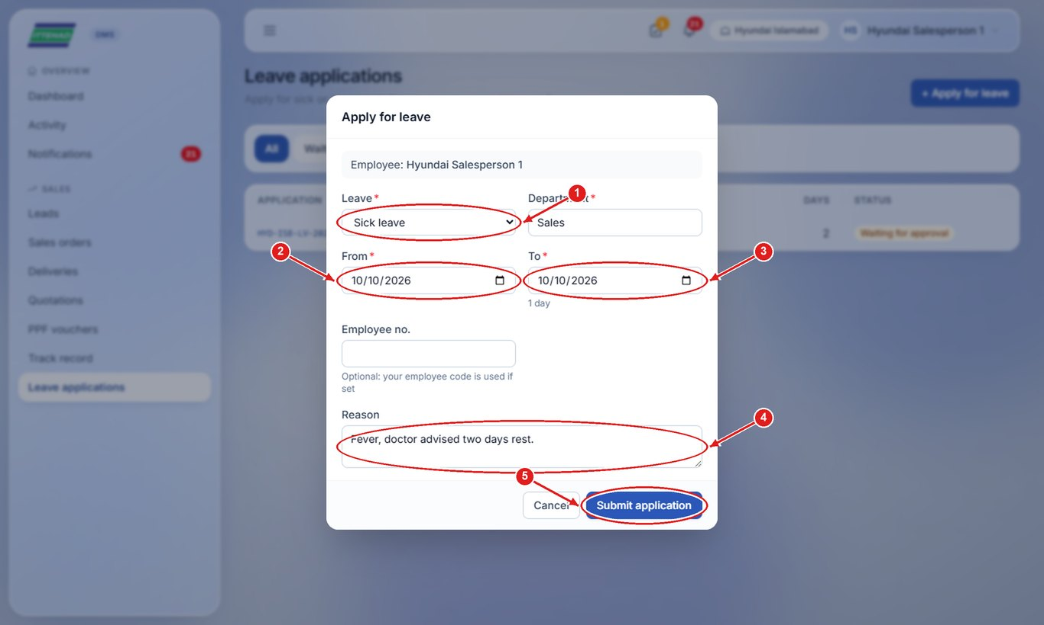
Note: You get a notification when your leave is approved or rejected. Open the application to download the leave form (English and Urdu) as a PDF.

1.5 Sign out
Always sign out when you leave a shared computer. “My account” in the same menu lets you change your password.
Step 1: Click your name at the top right, then click Sign out.
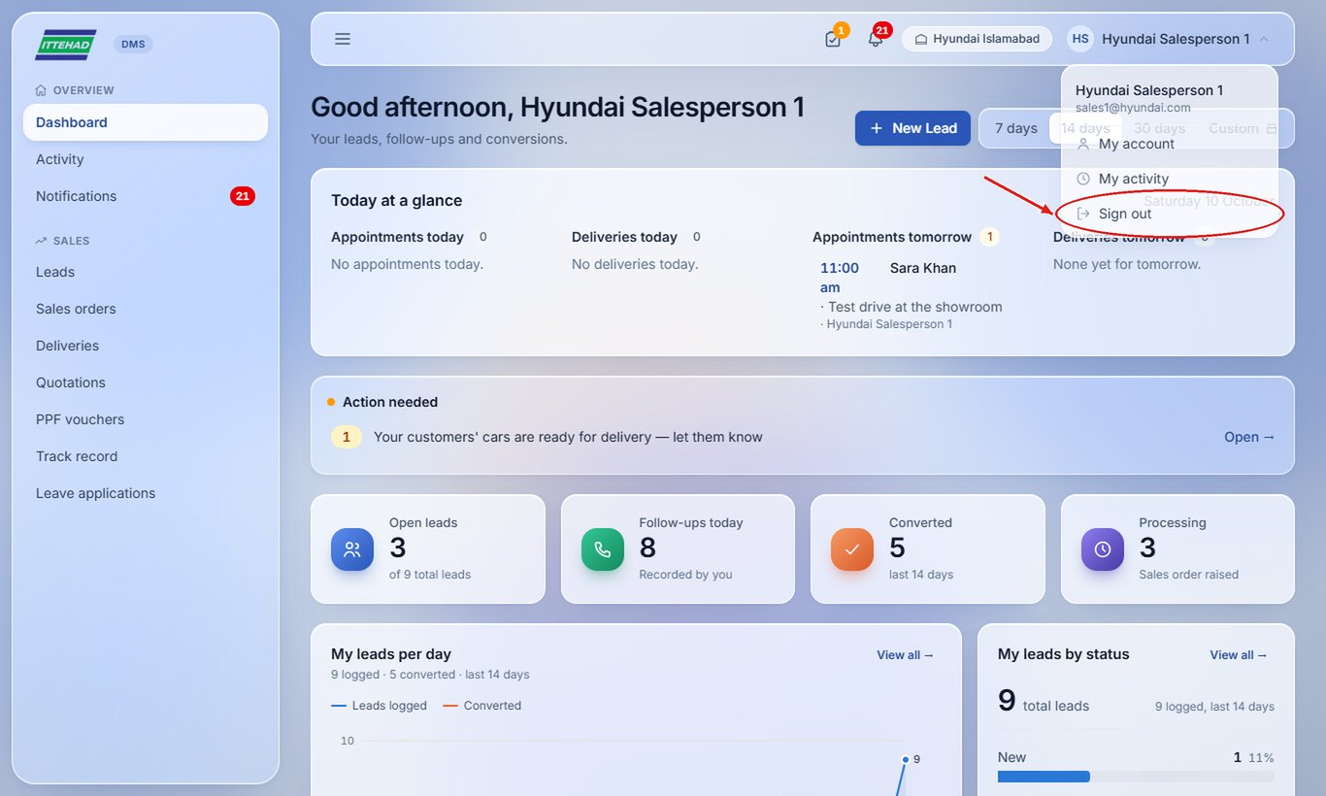

2. Salesperson
A salesperson logs walk-in and phone customers as leads, follows them up, issues quotations and PPF vouchers, and converts the customers who book. A salesperson sees only their own leads and orders.
Example login used in the screenshots: sales1@hyundai.com
- 2.1 Create a new lead
- 2.2 Duplicate customer: send to the Assistant Manager
- 2.3 Find a lead
- 2.4 Record a follow-up
- 2.5 Mark a lead lost
- 2.6 Set an appointment
- 2.7 Issue a vehicle quotation
- 2.8 Print, download or send a quotation on WhatsApp
- 2.9 Issue a PPF voucher
- 2.10 Quotation or PPF voucher without a lead
- 2.11 Convert a lead (customer booked)
- 2.12 Follow your sales orders
- 2.13 Download your track record and export your leads

2.1 Create a new lead
Log every walk-in or call as a lead, so it is followed up and counted in your record.
Step 1: Click + New Lead (on the dashboard or the Leads page).
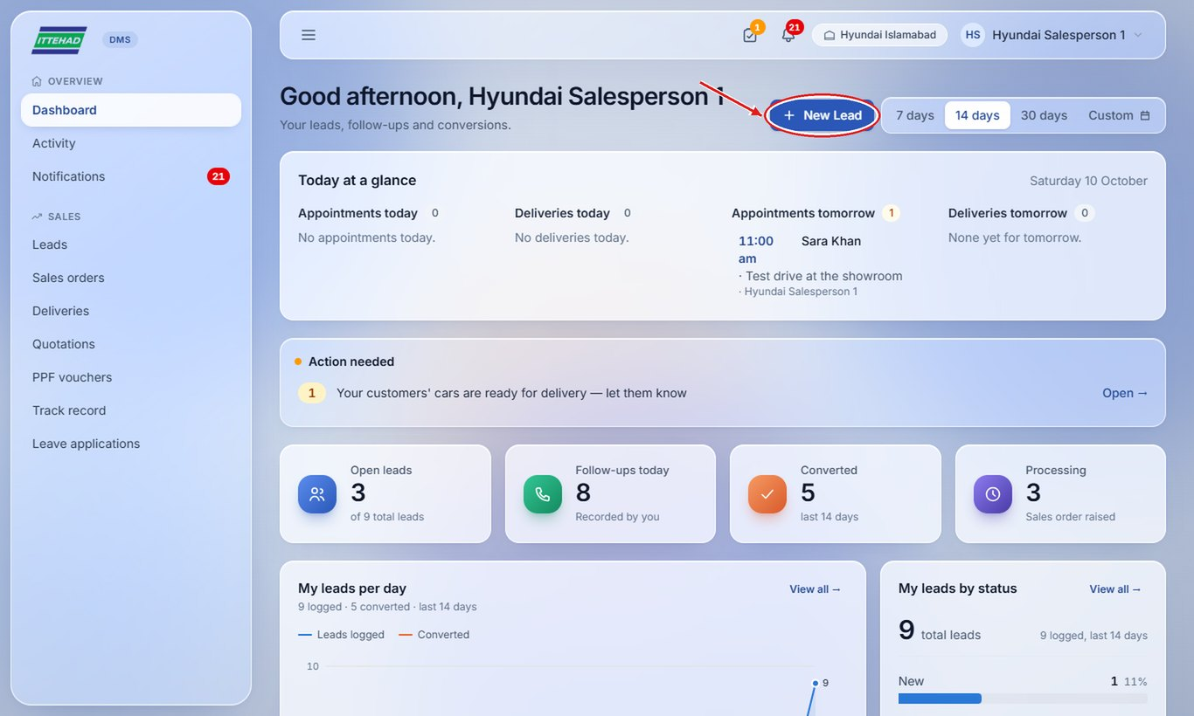
Step 2: Fill in the customer’s name, phone (digits only, e.g. 03001234567), source and the model they want.
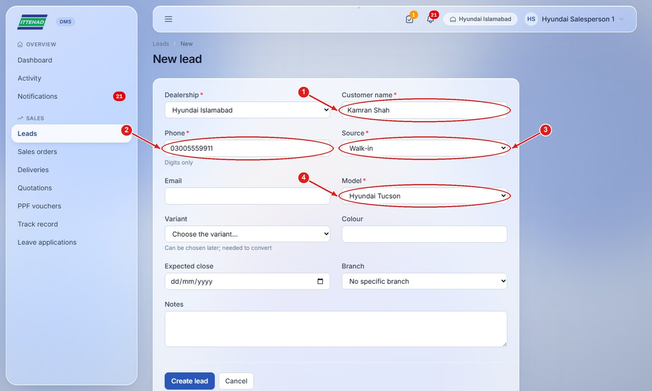
Step 3: Add the variant, colour and notes if known, then click Create lead.
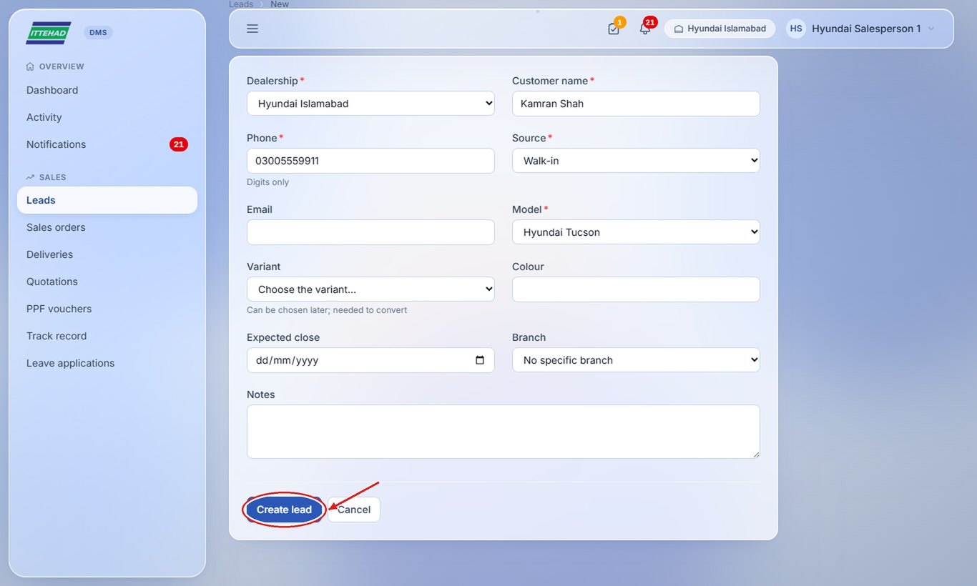
Note: If the phone number is already a lead, the portal tells you and does not create a second one (see the next task).

2.2 Duplicate customer: send to the Assistant Manager
A phone number can have only one open lead. If your customer is already someone else’s lead, send it to the Assistant Manager, who decides who handles it.
Step 1: If the customer belongs to another salesperson, this message appears: click Send to Assistant Manager.
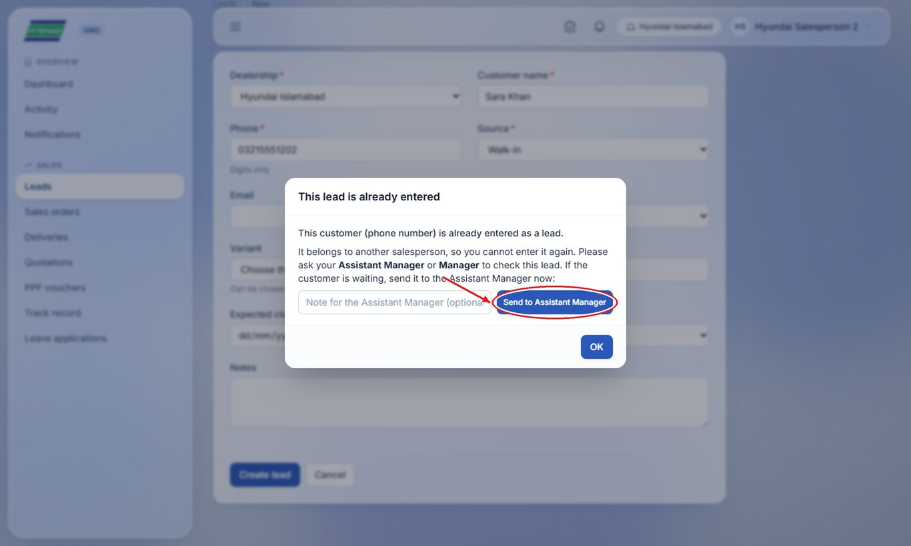
Note: If the lead is already yours, the message instead offers “Open the existing lead”.

2.3 Find a lead
The Leads page lists your open leads. Leads whose order is approved, and completed leads, move to Sales orders.
Step 1: Search by name, phone, PBO, CNIC or chassis number; click a status box to see only those leads.
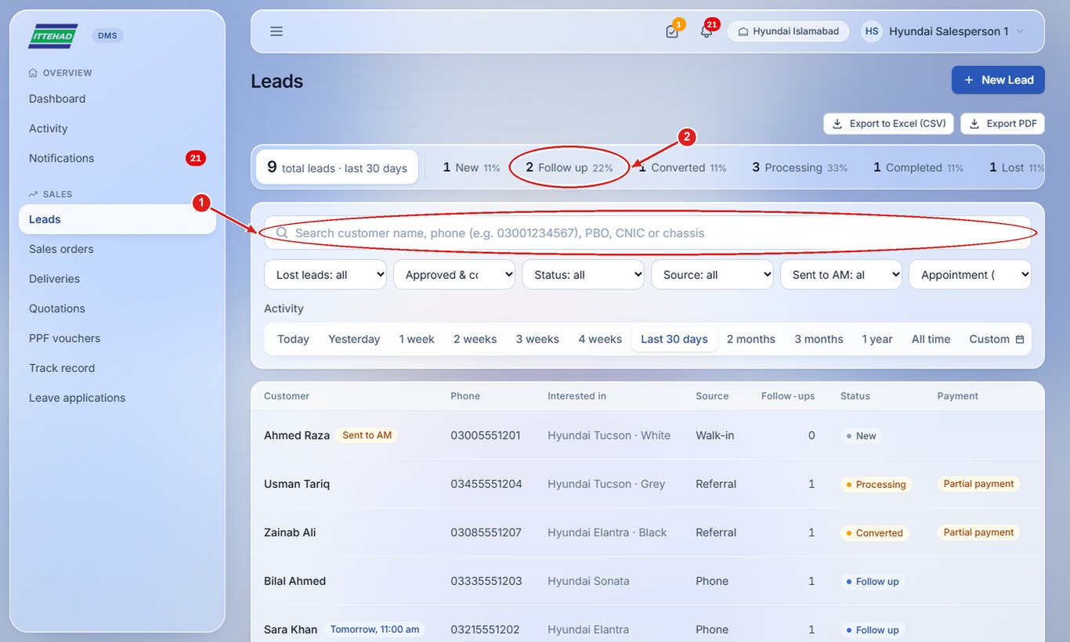
Step 2: Pick the period (Today, 1 week, Last 30 days, All time…) and use the filters to narrow the list.
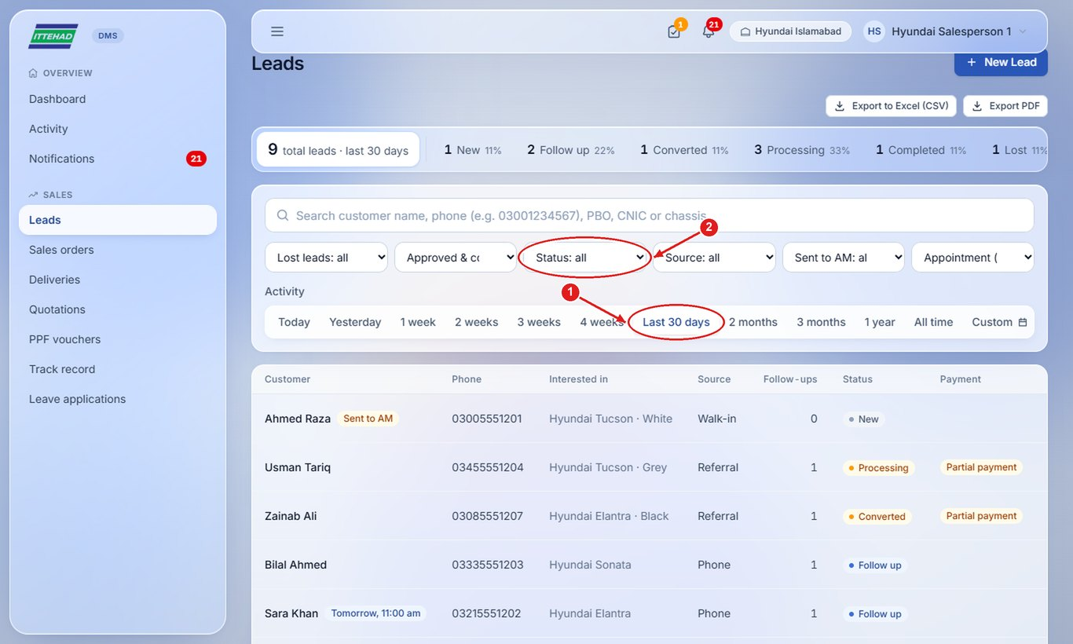
Step 3: Click a customer’s name to open the lead.
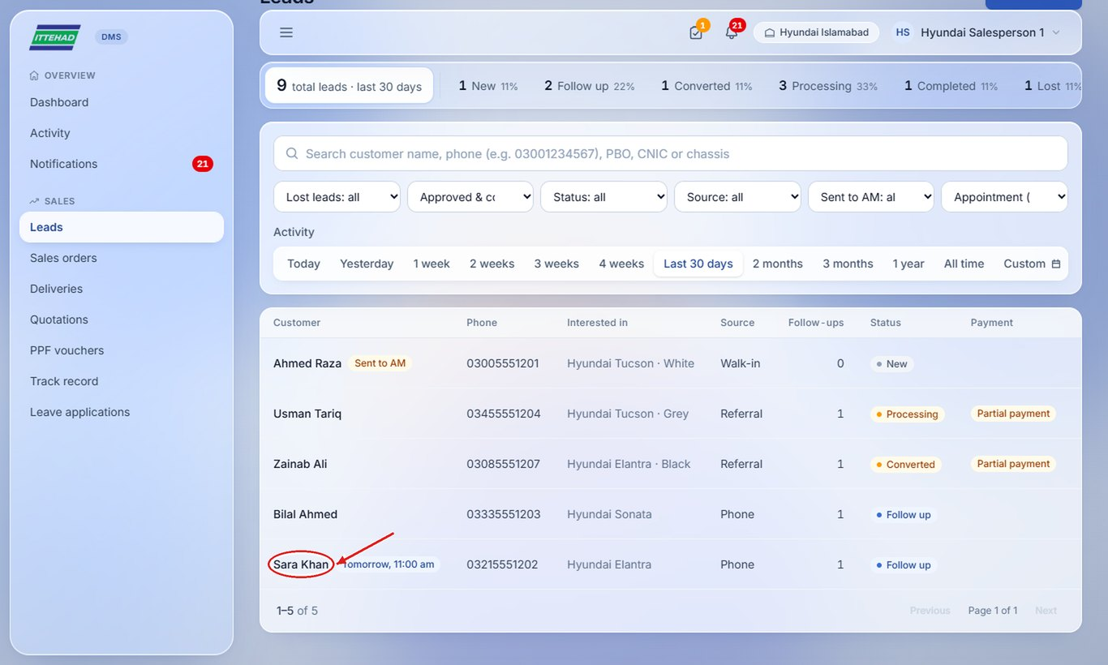

2.4 Record a follow-up
After every call or meeting, record what the customer said. Three follow-ups are needed before a lead can be marked exhausted.
Step 1: Open the lead, scroll to Follow-ups, choose the outcome, write your remarks and click Record.
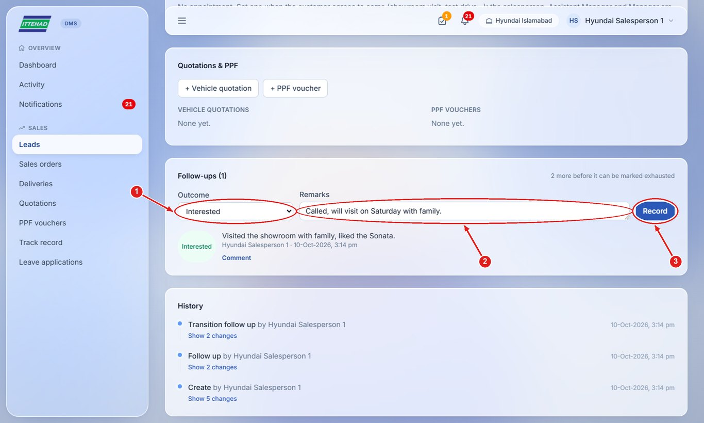

2.5 Mark a lead lost
When the customer is not interested any more, record it so the lead leaves your open list.
Step 1: Choose “Not interested”, tick the box to mark the lead lost, write the reason and click Record.
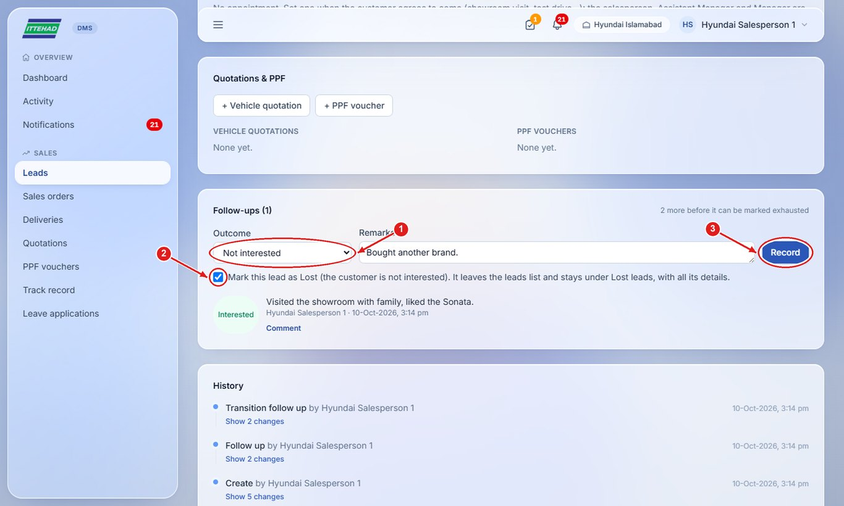
Note: Lost leads are hidden from the list; choose “Lost leads: Show lost leads” in the filters to see them again.

2.6 Set an appointment
Book a showroom visit or test drive. It appears in “Today at a glance” on the day, and you get a reminder.
Step 1: On the lead, click Set appointment, pick the date and time, add a note and click Save.
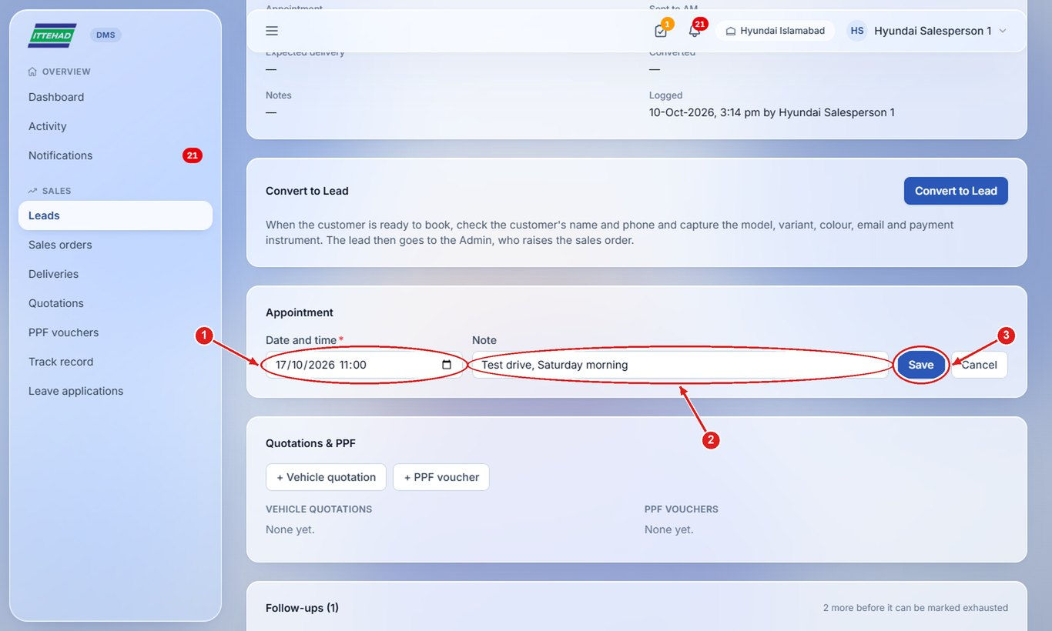

2.7 Issue a vehicle quotation
Quotations are issued from the lead, in the dealership’s own format, with the variant code in the Ref.
Step 1: On the lead, under Quotations & PPF, click + Vehicle quotation.
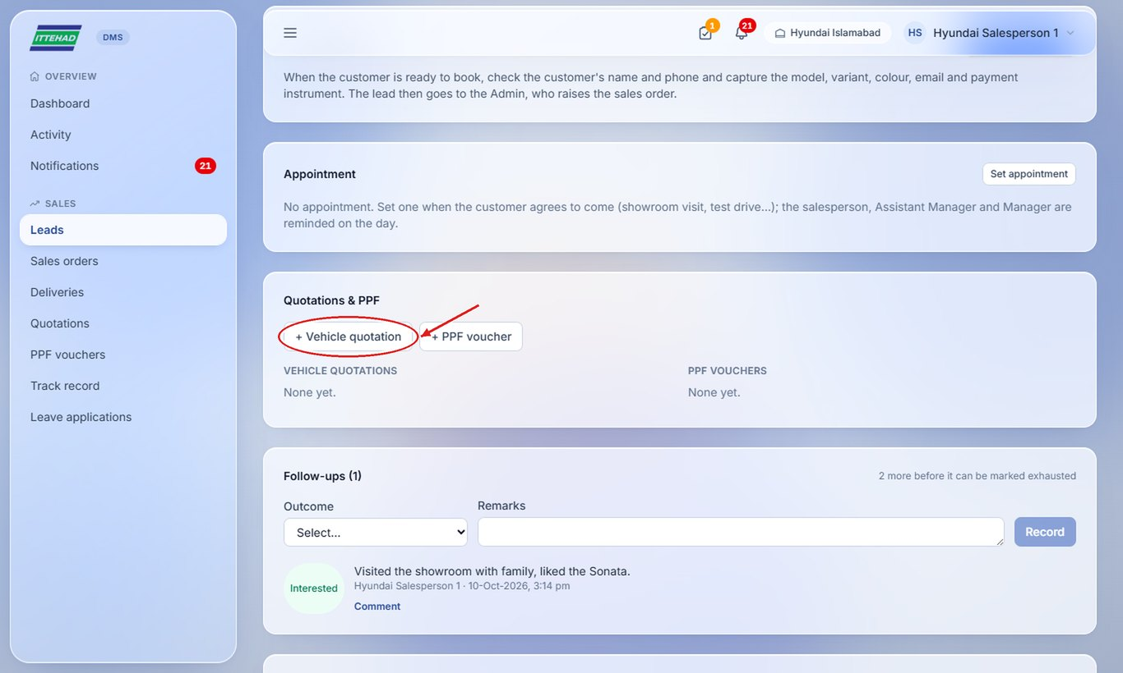
Step 2: Choose the variant code and check the price, freight and withholding tax.
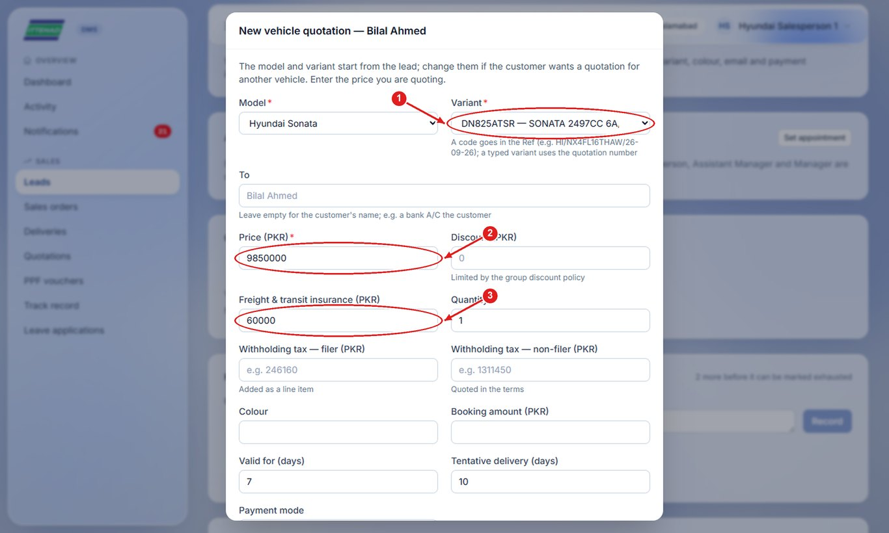
Step 3: Fill the colour, validity and delivery period if needed, then click Save & preview.
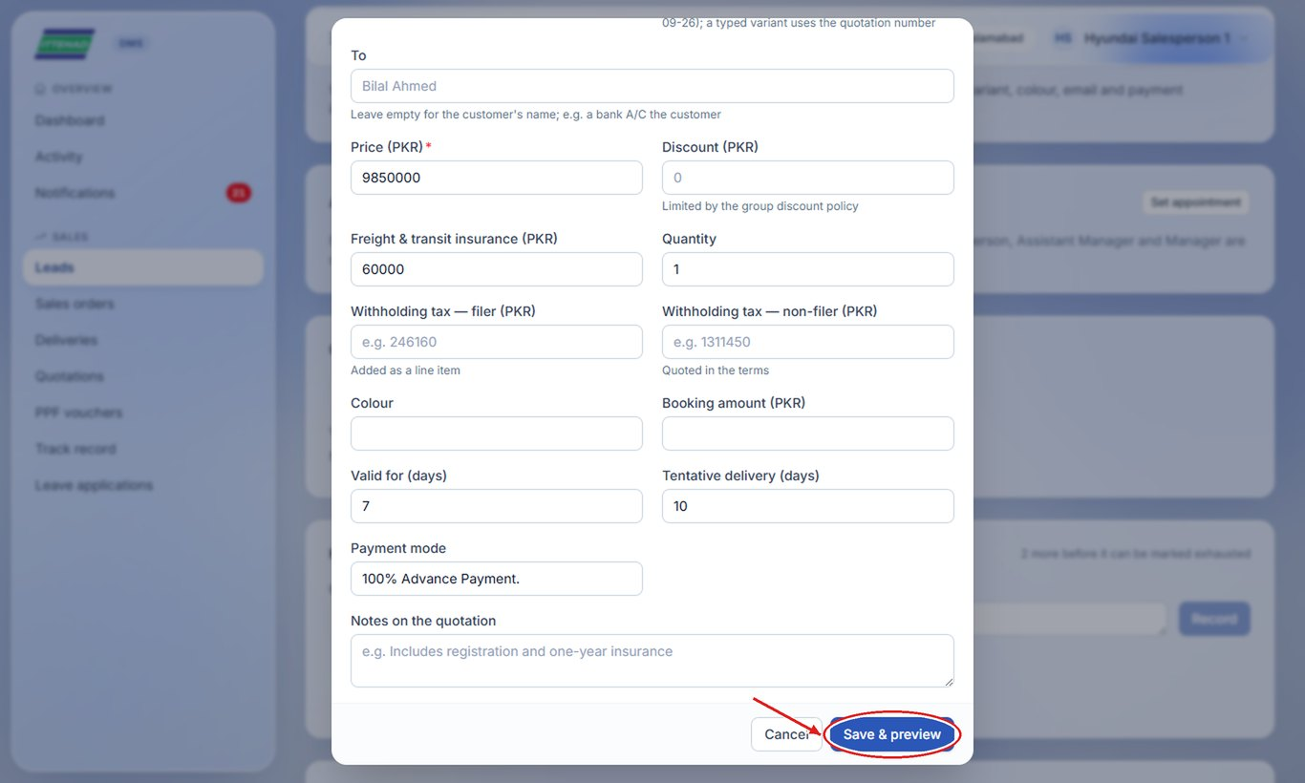

2.8 Print, download or send a quotation on WhatsApp
Every quotation can be printed on the letterhead paper, or sent as a full page with the logos, stamp and signature.
Step 1: Open the quotation from the lead (or from Quotations in the menu).
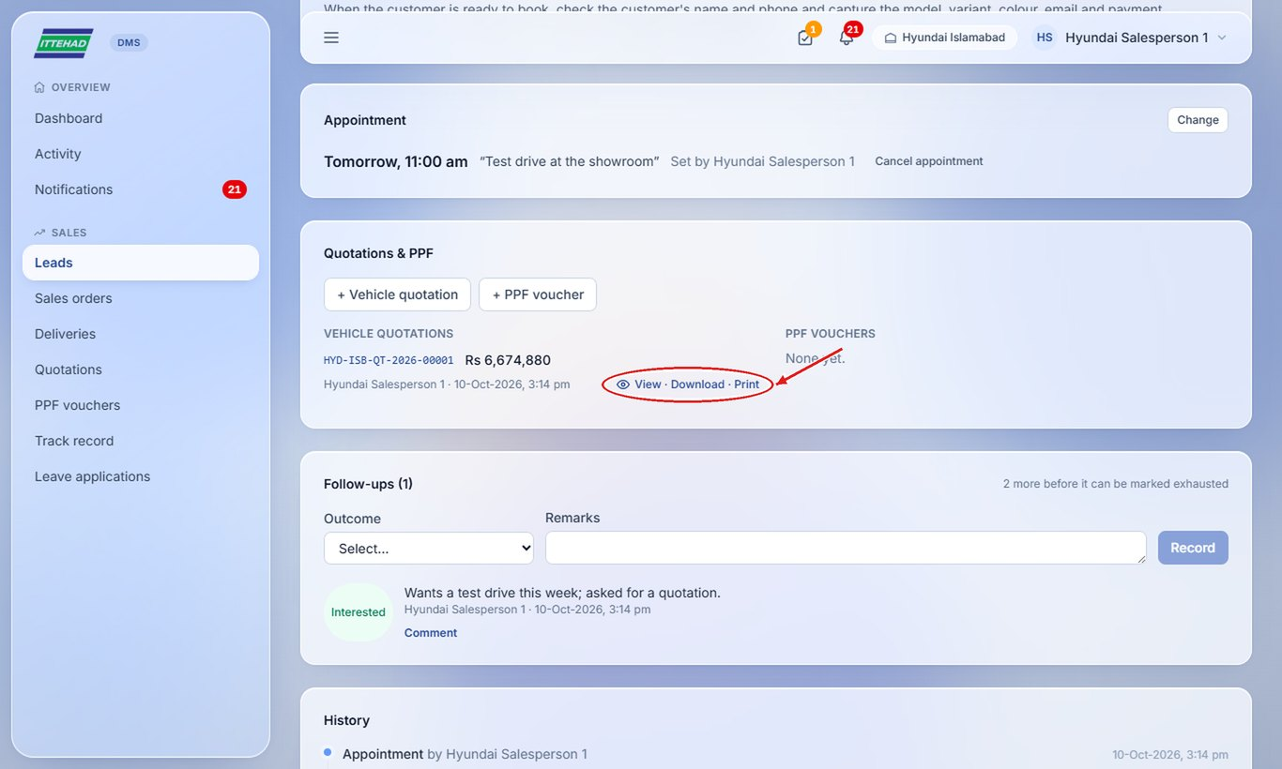
Step 2: Choose “Letterhead paper (print)” to print on the pre-printed paper, or “Full page (WhatsApp / email)” for a complete page.
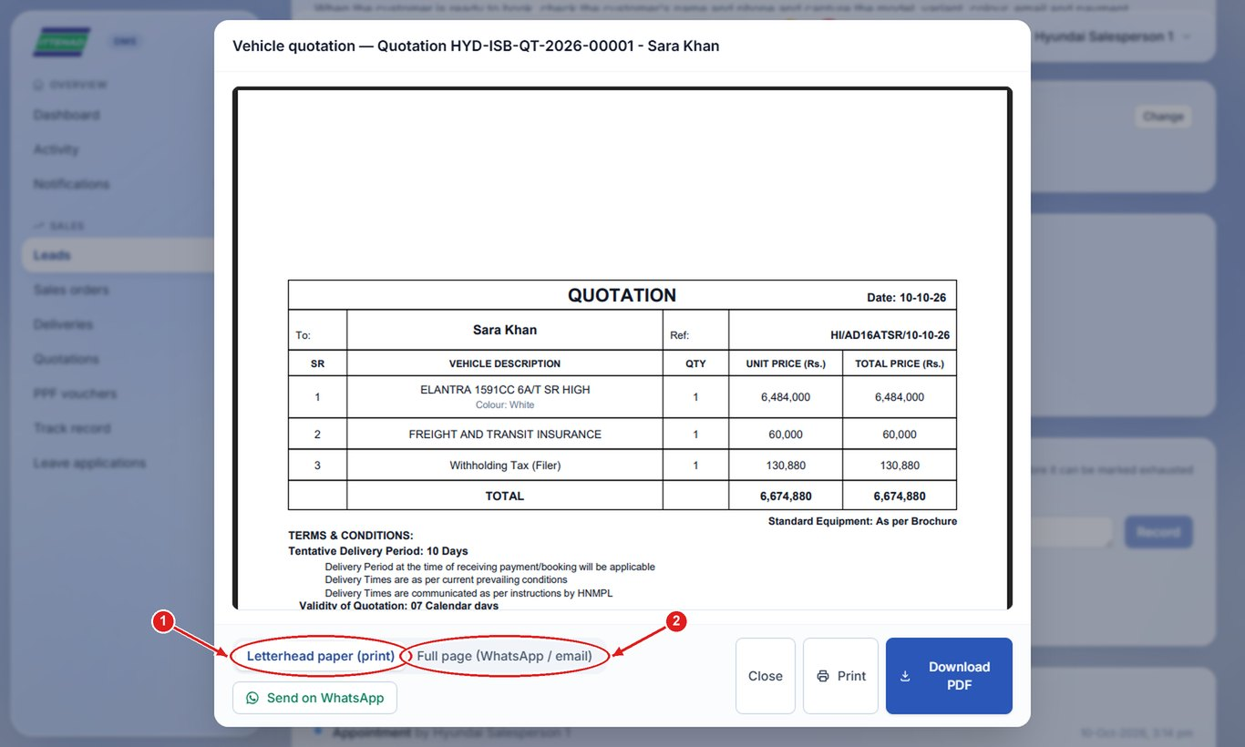
Step 3: Click Send on WhatsApp to share it with the customer, or Print / Download PDF.
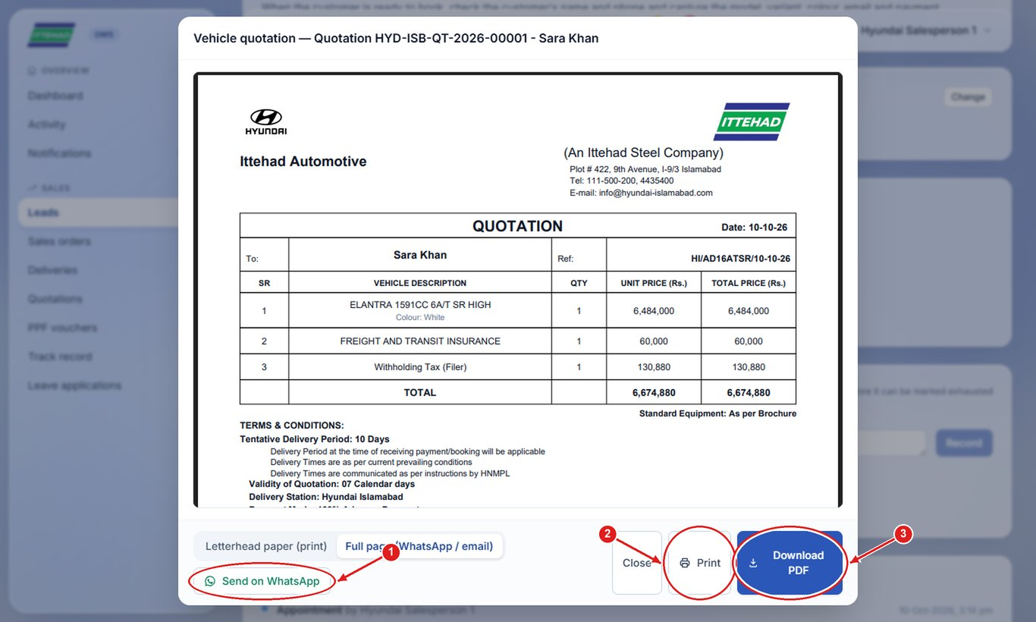
Note: On a phone, WhatsApp opens with the PDF attached. On a computer, the PDF downloads and the customer’s WhatsApp chat opens: attach the downloaded file and send.

2.9 Issue a PPF voucher
Record the Paint Protection Film the customer bought, with its price and what was paid.
Step 1: On the lead, click + PPF voucher, then choose the coverage, protection package and price.
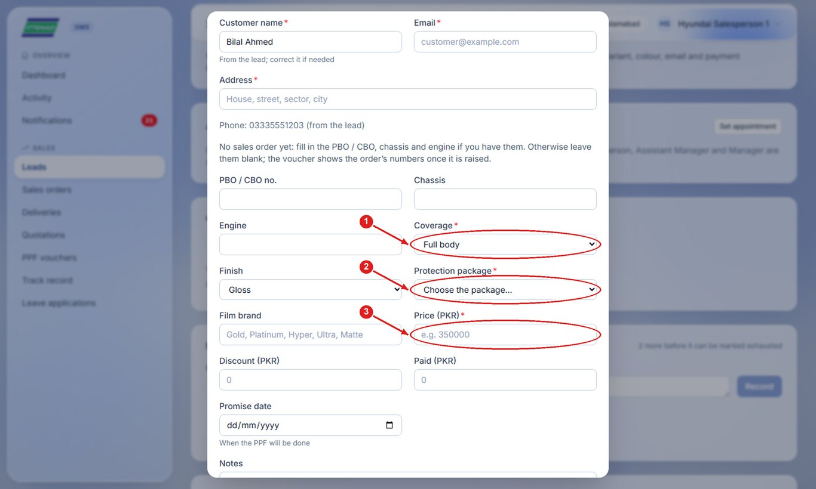
Step 2: Fill the amount paid and the promise date, then click Save & preview.
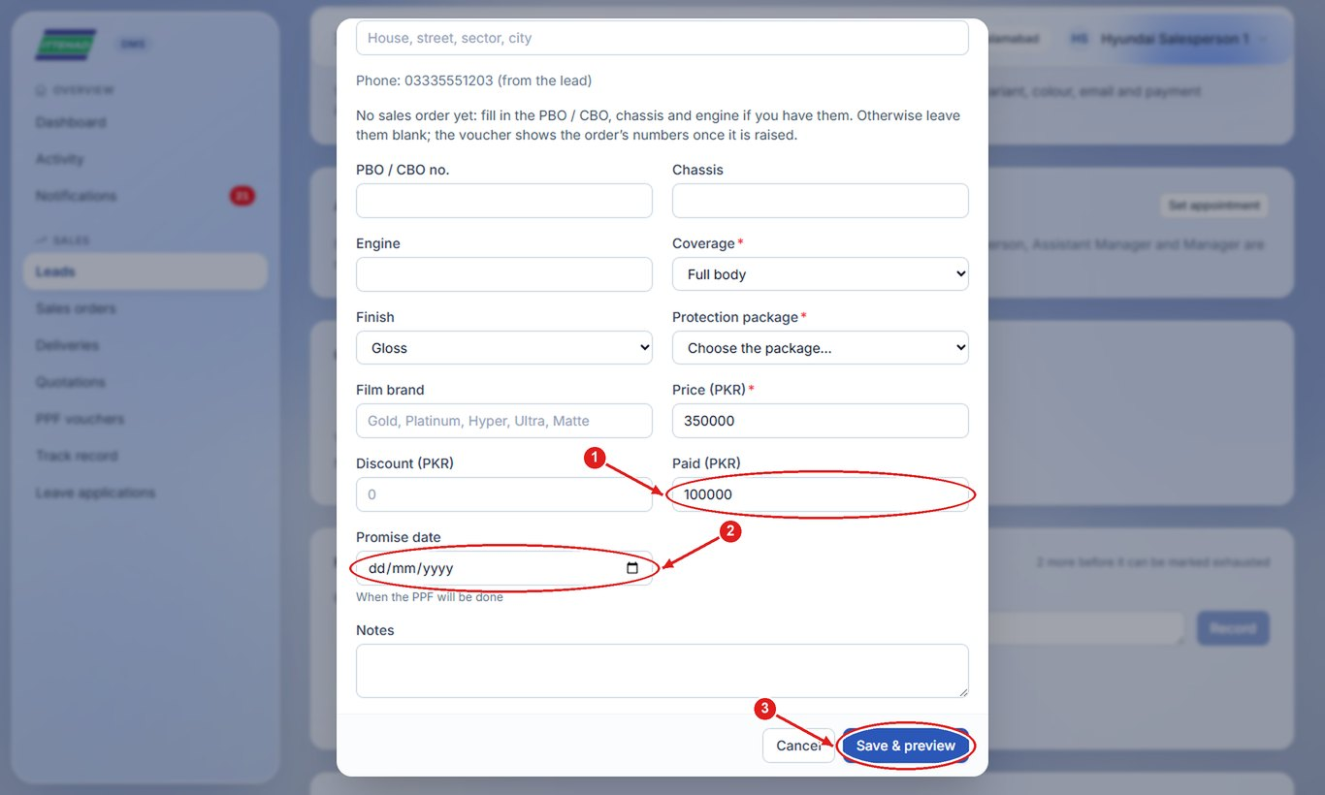

2.10 Quotation or PPF voucher without a lead
For a customer who only wants a price, issue a quotation (or PPF voucher) without creating a lead.
Step 1: Click Quotations in the menu, then Create quotation.
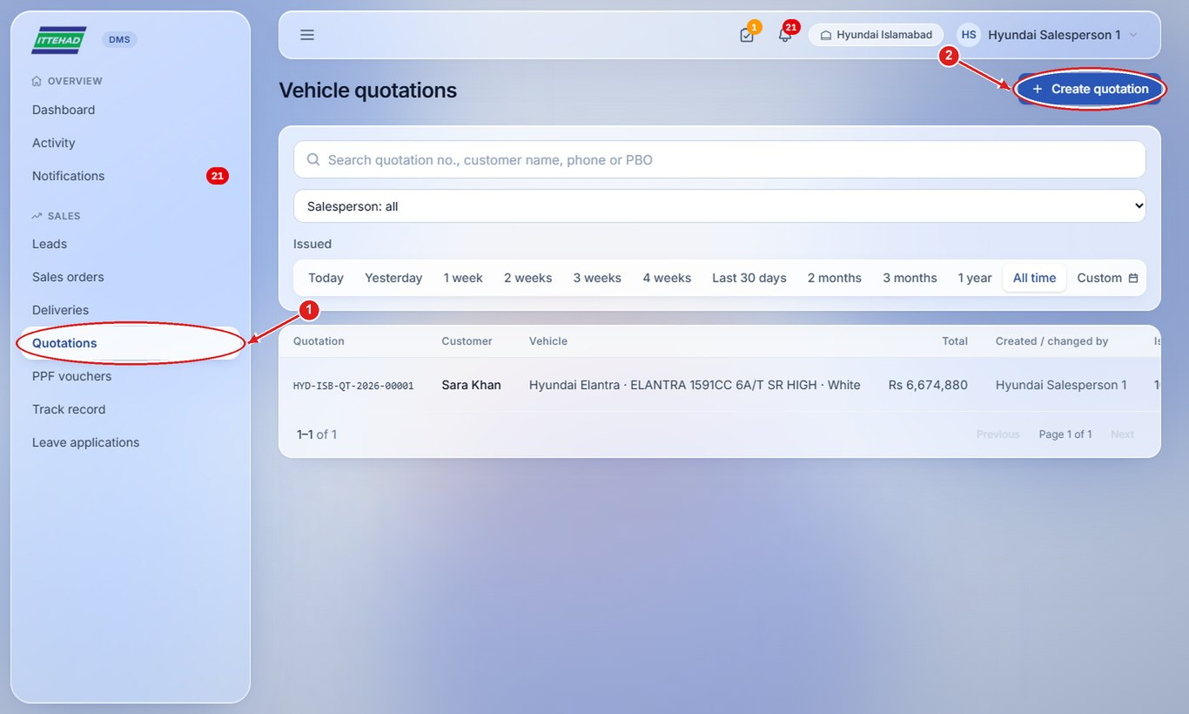
Step 2: Enter the customer’s name and phone, choose the model and variant and fill the price.
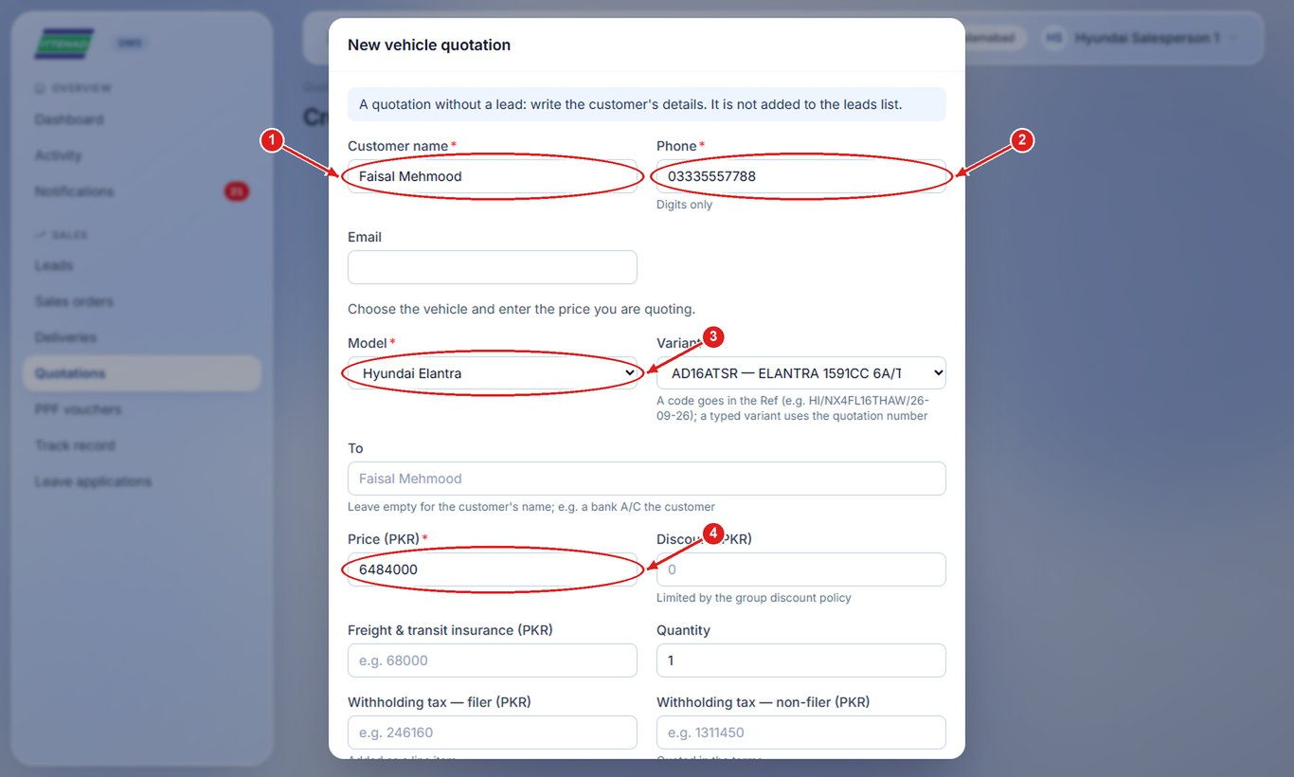
Step 3: Click Save & preview; the quotation opens ready to print, download or send.
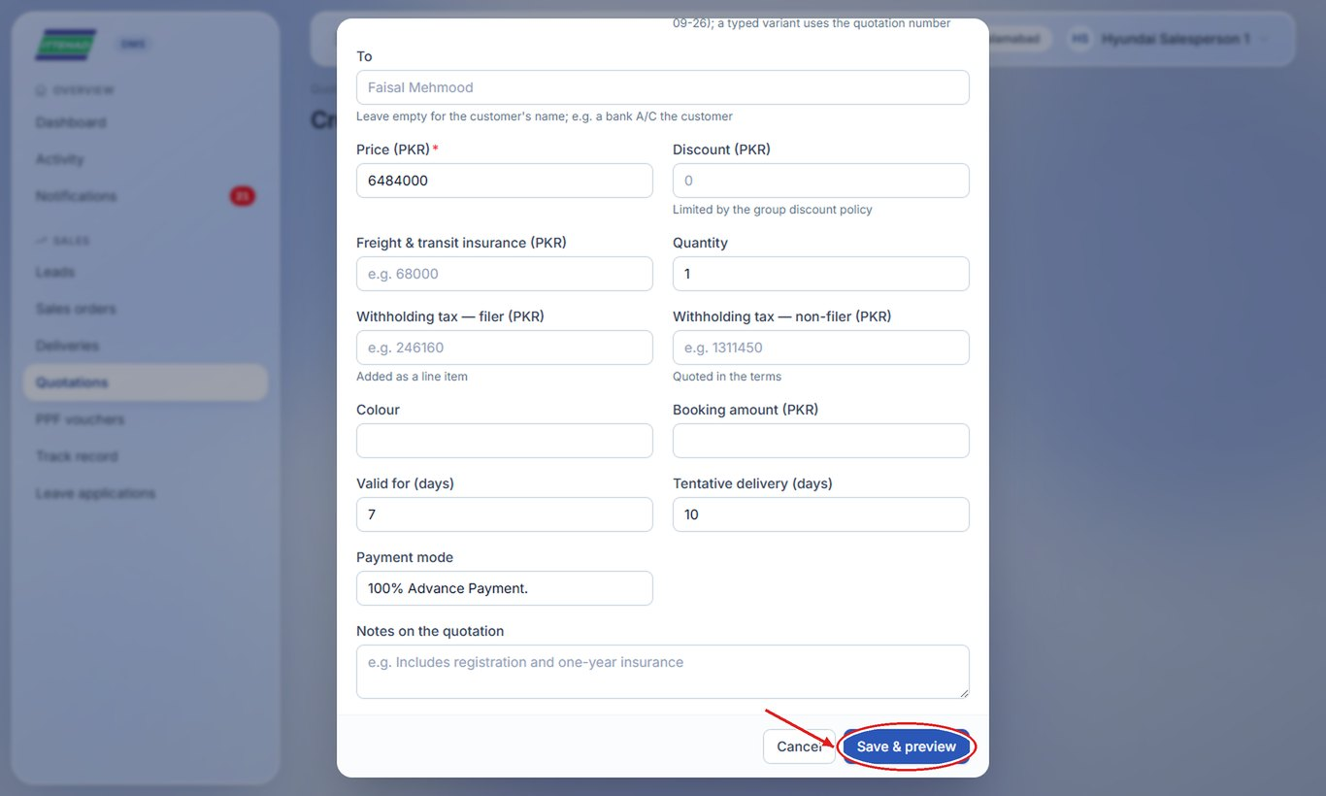
Note: PPF vouchers work the same way: PPF vouchers in the menu → Create PPF voucher.

2.11 Convert a lead (customer booked)
When the customer books, convert the lead with their details and the payment. The Sales Admin then raises the sales order.
Step 1: Click Convert to Lead. Choose Individual or Corporate (company) and fill in the address.
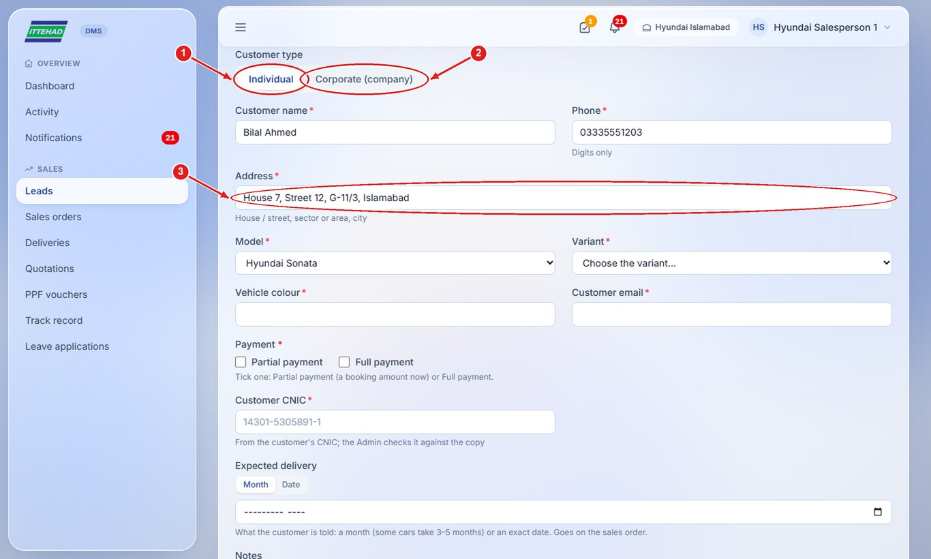
Step 2: Choose the variant and fill the colour and the customer’s email.
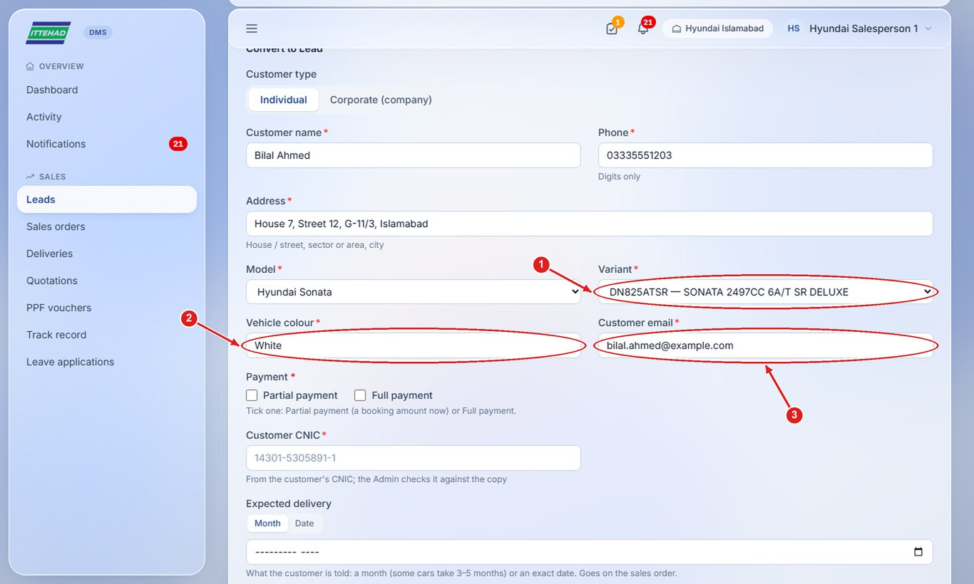
Step 3: Tick Partial payment or Full payment. For a partial payment, enter the total amount of the car and the amount paid now.
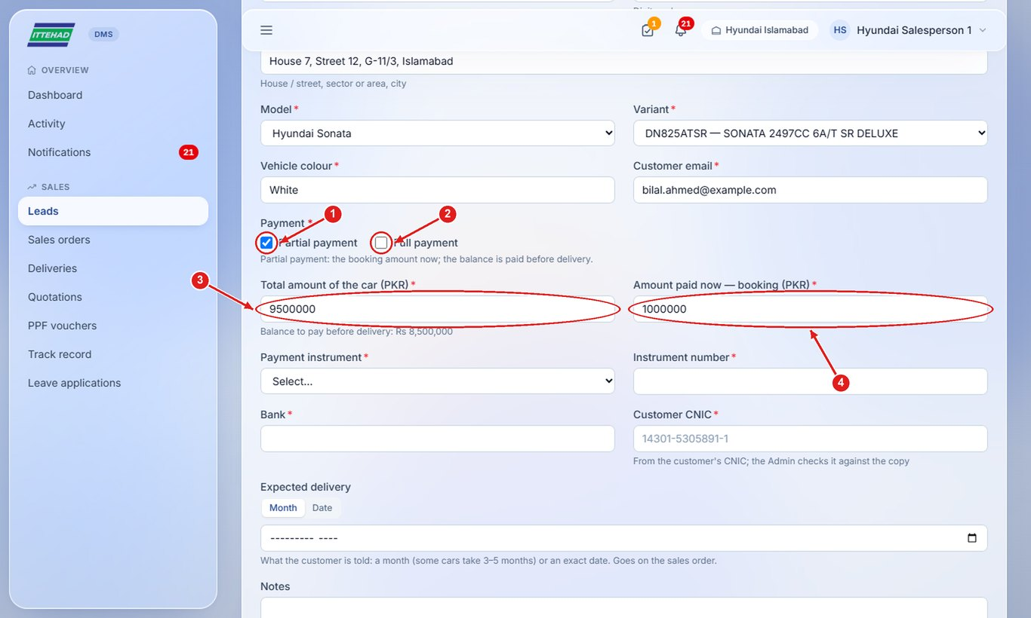
Step 4: Enter how it was paid (pay order, cheque…), its number and bank and the customer’s CNIC, then click Confirm conversion.
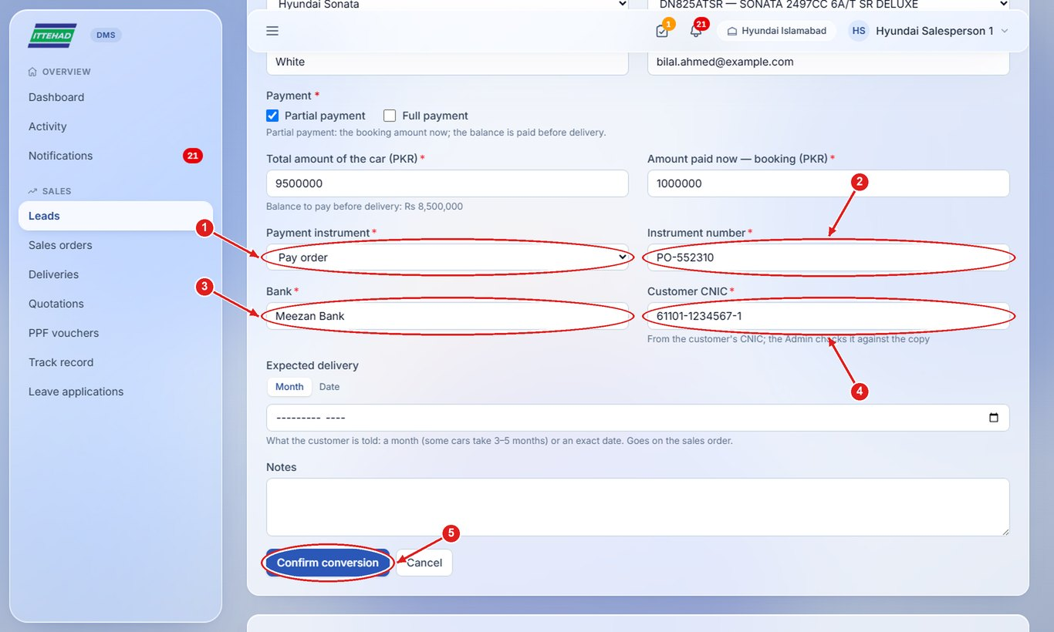
Note: After conversion the lead shows “Converted”. When the Admin raises the order it becomes “Processing”, and “Completed” once the car is delivered.

2.12 Follow your sales orders
Once the Admin raises the order, it appears under Sales orders. “Processing” means raised and not delivered yet.
Step 1: Click Sales orders. The boxes at the top show how many orders are Processing, awaiting approval and approved.
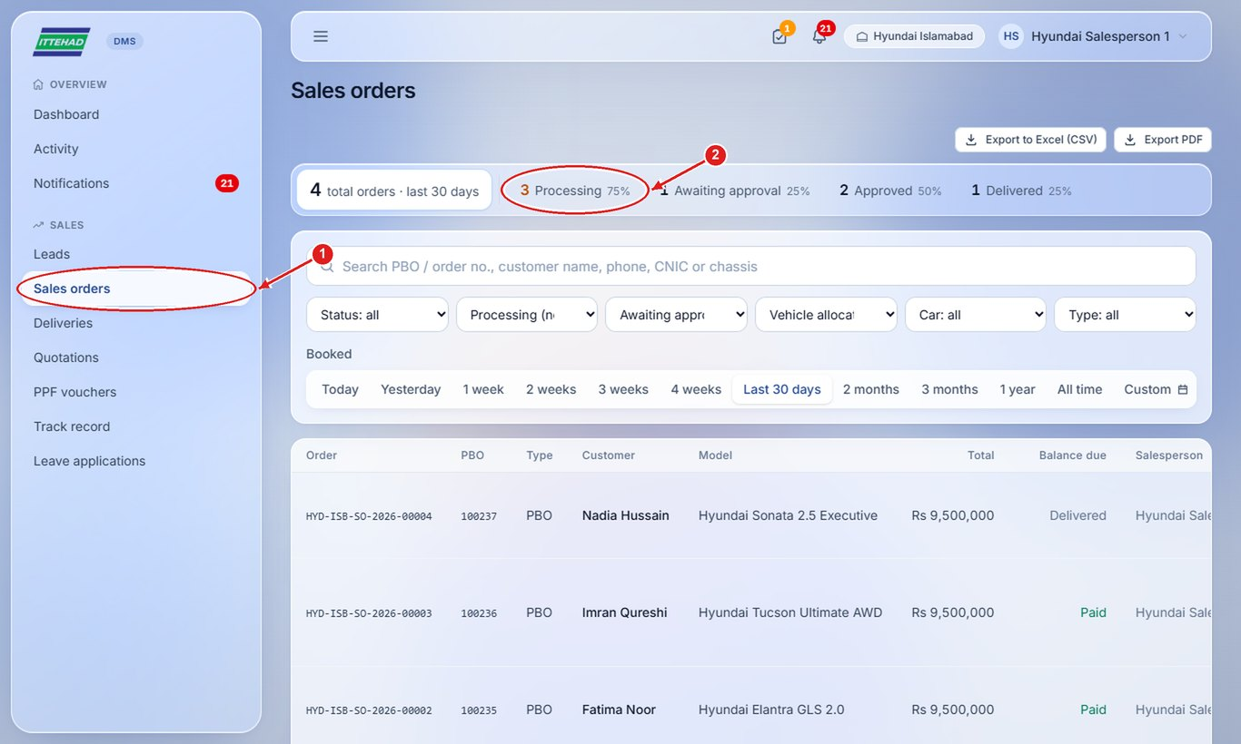
Step 2: Click Deliveries to see where each customer’s car is: waiting, in transit, received, scheduled or delivered.
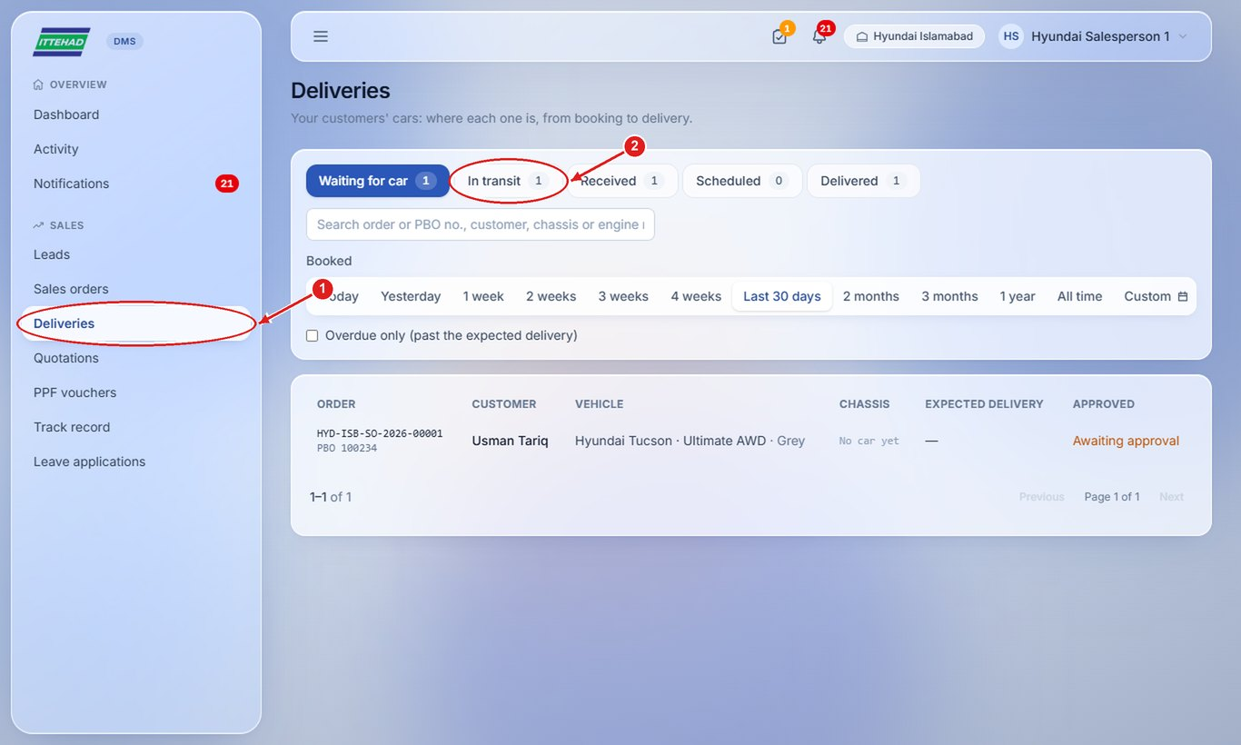

2.13 Download your track record and export your leads
Download your monthly record, or export your leads to Excel.
Step 1: Click Track record, choose the year and month, then Download PDF or Download CSV (Excel).
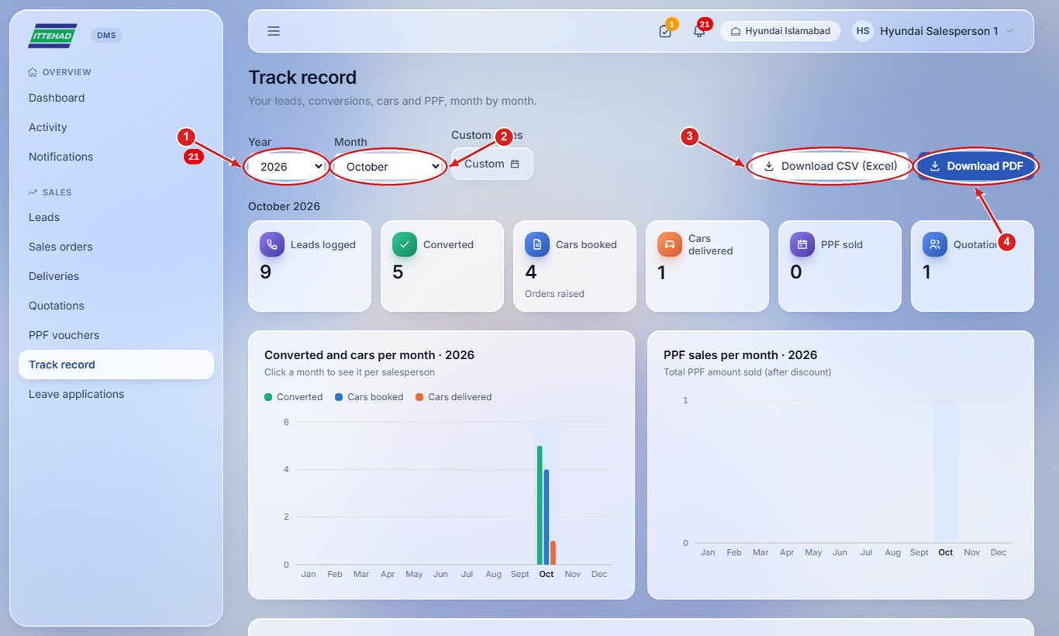
Step 2: On the Leads page, Export to Excel (CSV) or Export PDF saves the leads of the period on screen.
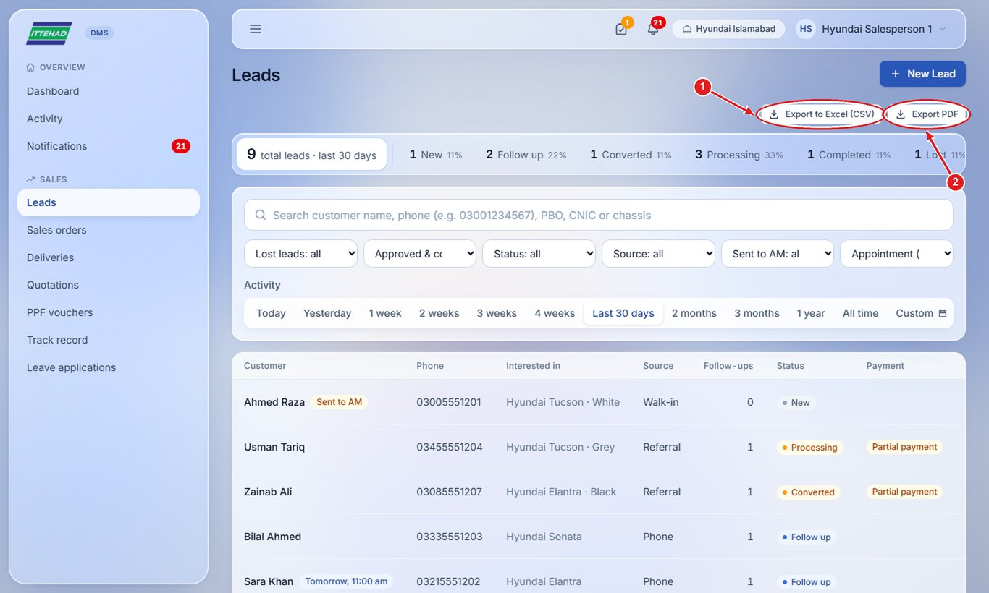

3. Assistant Manager
The Assistant Manager oversees every lead of the dealership: logs leads for salespeople, decides duplicate customers, reassigns leads, approves leave, follows orders to delivery and keeps the document formats up to date. Everything a salesperson can do, the Assistant Manager can do too.
Example login used in the screenshots: am@hyundai.com
- 3.1 Your dashboard
- 3.2 See every salesperson’s leads
- 3.3 Log a lead for a salesperson
- 3.4 Handle a duplicate customer
- 3.5 Reassign a lead
- 3.6 Approve or reject a leave application
- 3.7 Schedule a delivery
- 3.8 See the dealership’s customers
- 3.9 Update the quotation format, stamp and signature

3.1 Your dashboard
The dashboard shows the whole dealership: leads per day, leads by status, each salesperson’s record, duplicate customers and leave waiting for you.
Step 1: Action needed shows duplicate customers sent to you and leave applications waiting for approval; click Open → to handle them.
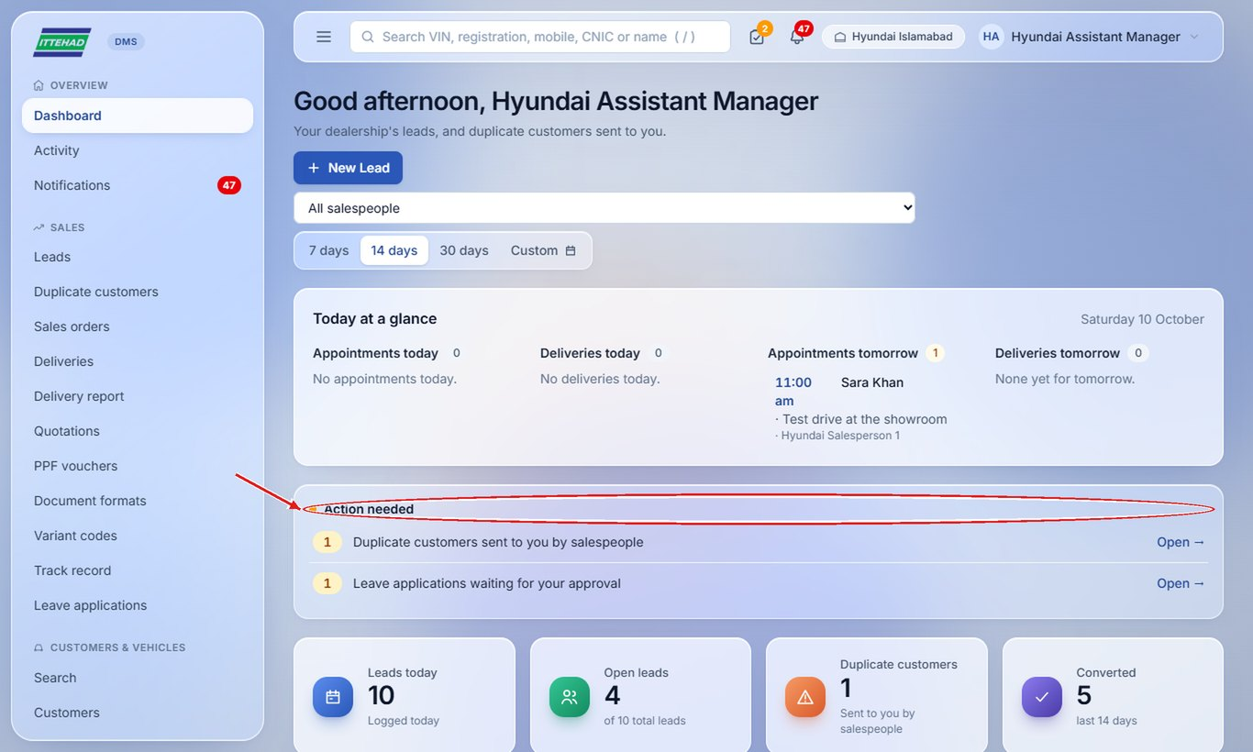

3.2 See every salesperson’s leads
The Leads page shows all leads of the dealership.
Step 1: Use the Salesperson filter to see one person’s leads, and the status boxes to see a stage.
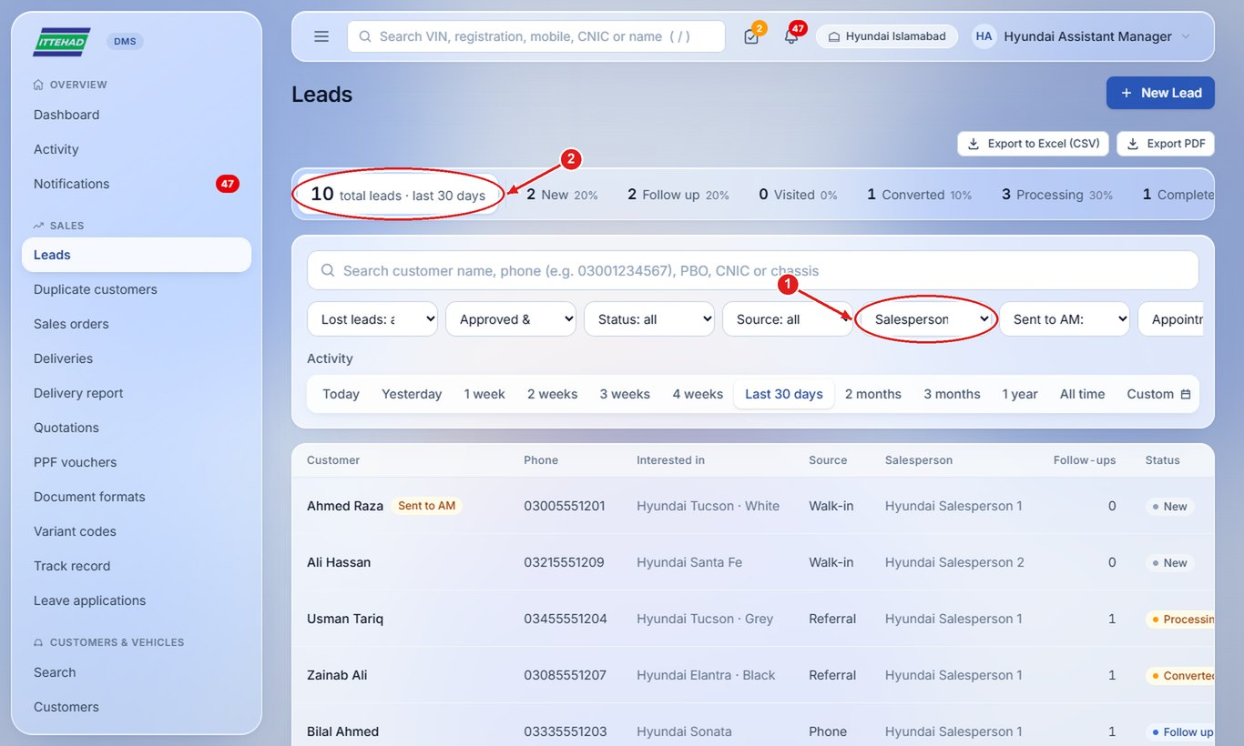

3.3 Log a lead for a salesperson
When a customer calls you directly, log the lead for the salesperson who will handle it.
Step 1: Click + New Lead and choose the Salesperson (leave it empty to keep the lead yourself), then fill the customer’s details and click Create lead.
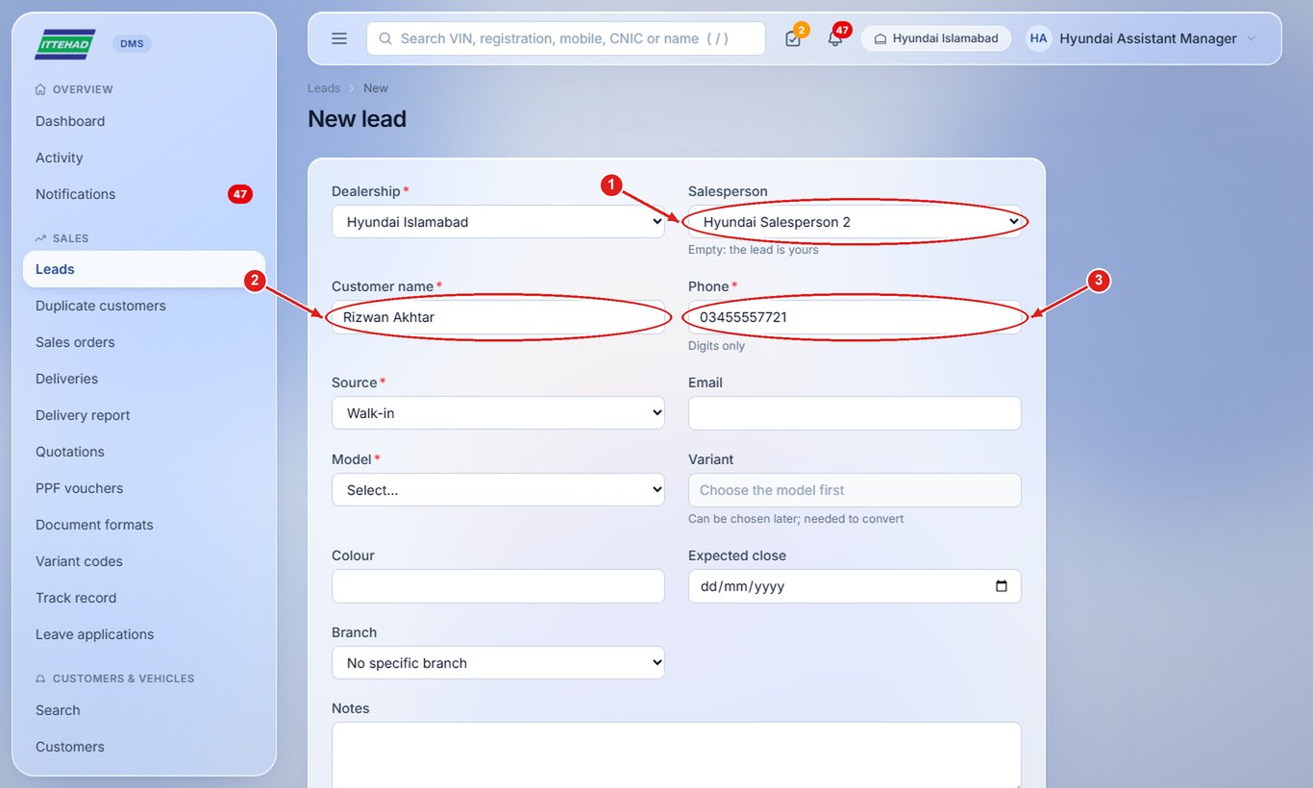

3.4 Handle a duplicate customer
When a salesperson finds that their customer is already someone else’s lead, it comes to you under “Duplicate customers”.
Step 1: Click Duplicate customers in the menu and open the lead. The amber “Sent to AM” badge shows it was sent to you.
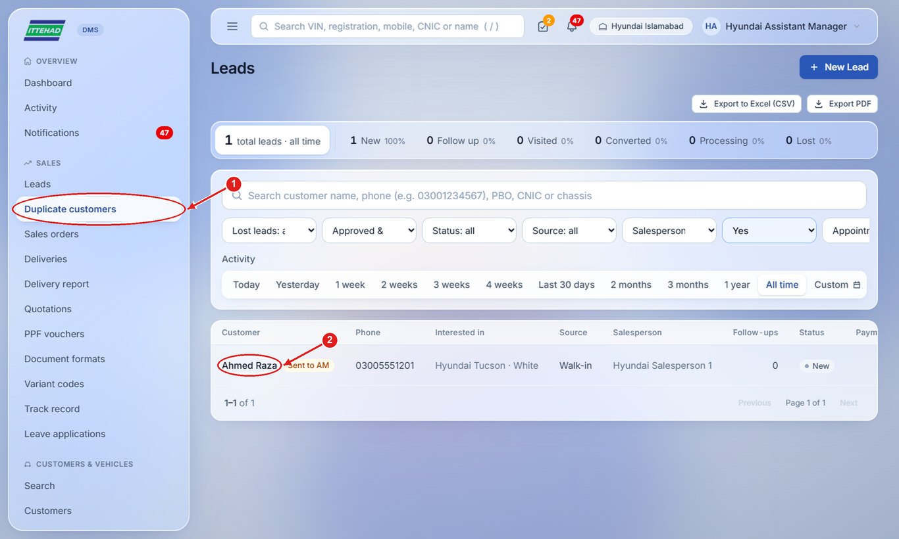
Step 2: Decide who keeps the customer: Reassign the lead to the other salesperson, or Convert it yourself if the customer has booked.
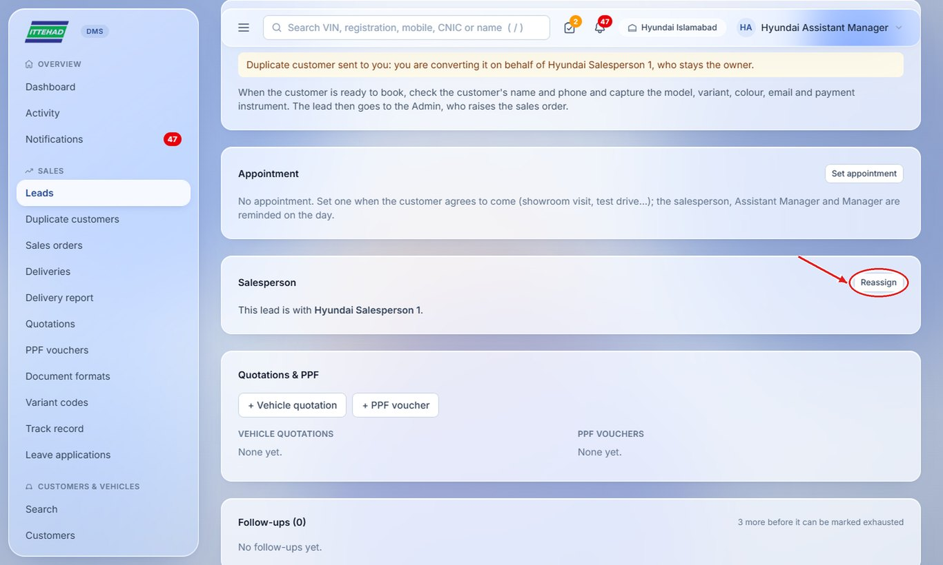

3.5 Reassign a lead
Give a lead to another salesperson (for example when someone is on leave).
Step 1: On the lead, click Reassign, choose who to give it to, write the reason and click Reassign.
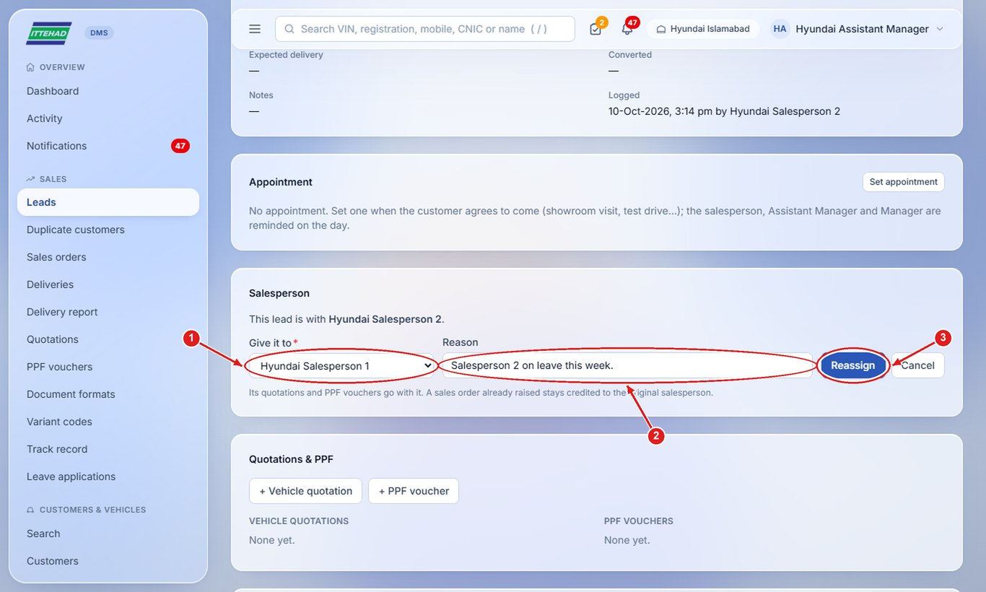
Note: Its quotations and PPF vouchers move with the lead.

3.6 Approve or reject a leave application
Leave applications of the sales team come to you for approval.
Step 1: Click Leave applications, then “Waiting for approval”, and open the application.
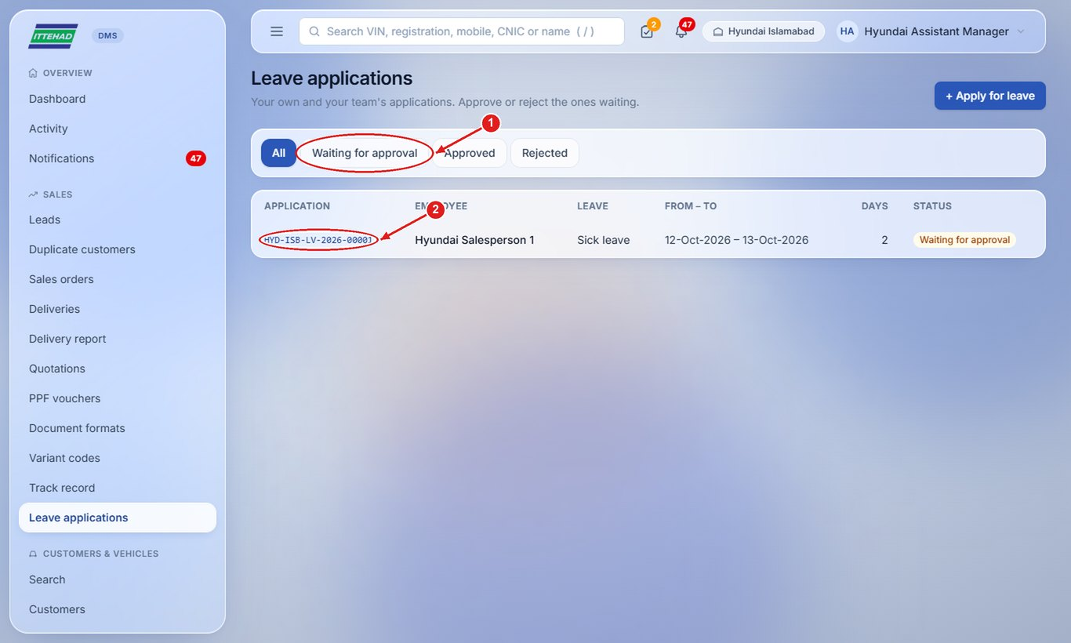
Step 2: Click Approve leave, or write a note and click Reject. The applicant is notified.
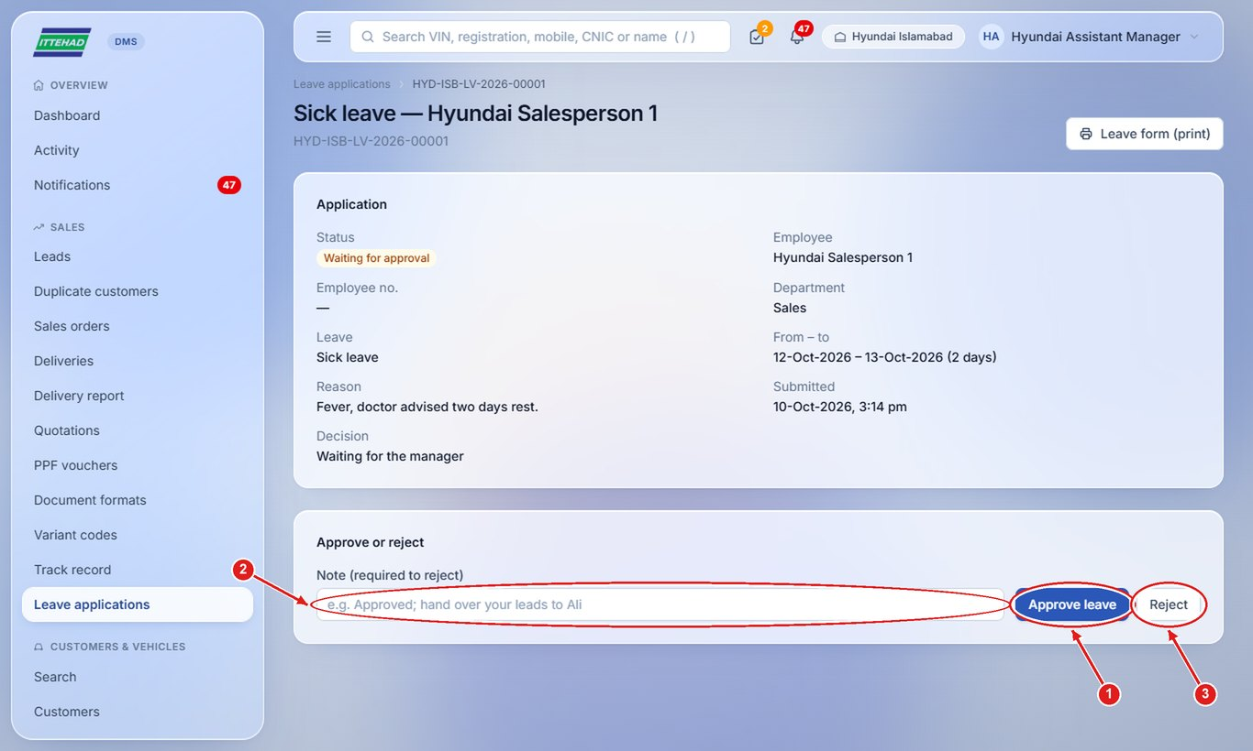

3.7 Schedule a delivery
Once the car is received and the order approved, fix the delivery date with the customer.
Step 1: Open the order, choose the delivery date and click Schedule delivery.
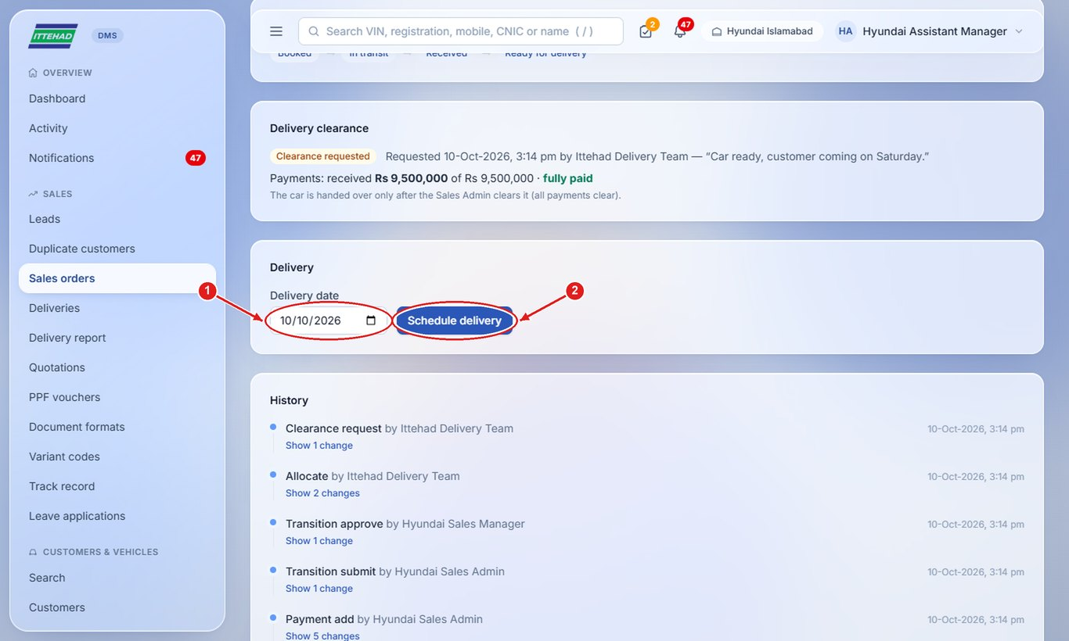

3.8 See the dealership’s customers
Every converted customer is saved in Customers.
Step 1: Click Customers in the menu; search by name, phone or CNIC and open a customer to see their cars and history.
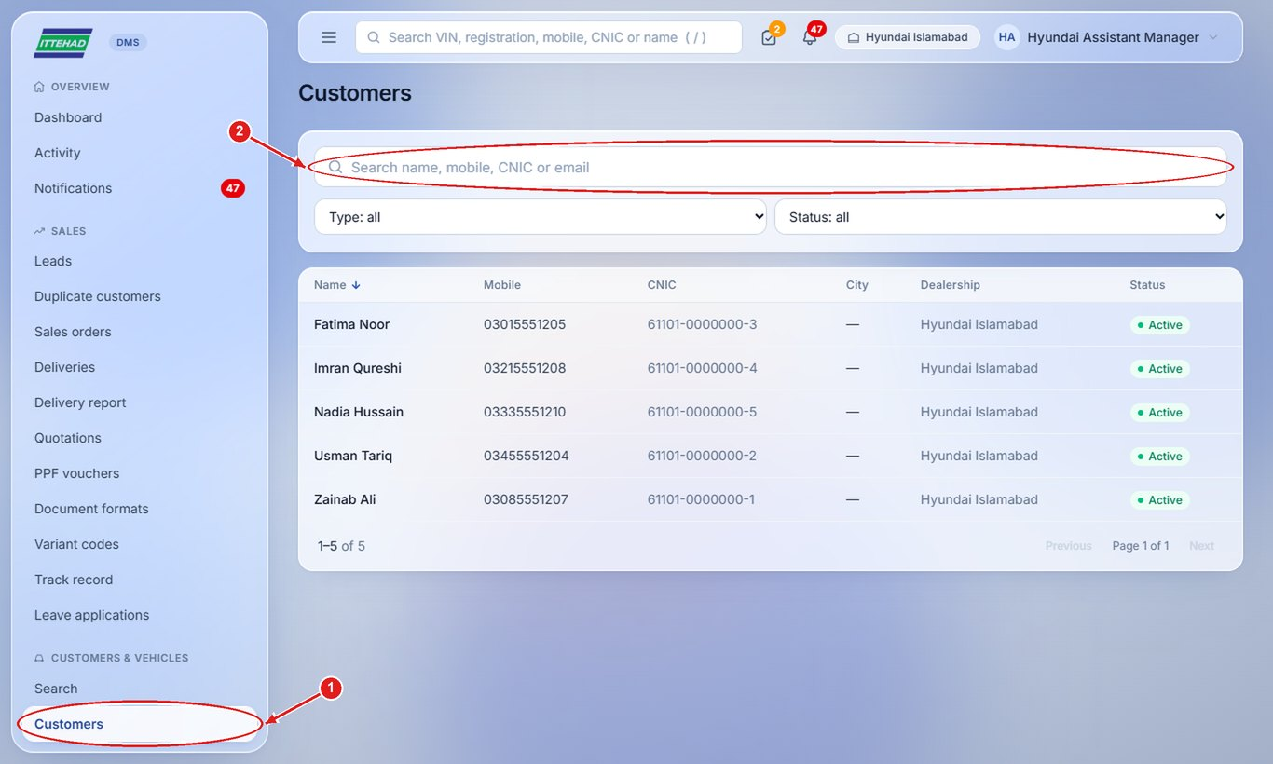

3.9 Update the quotation format, stamp and signature
The quotation, PPF voucher and leave form print in the dealership’s own format, which you can change.
Step 1: Click Document formats and choose Quotation, PPF voucher or Leave form.
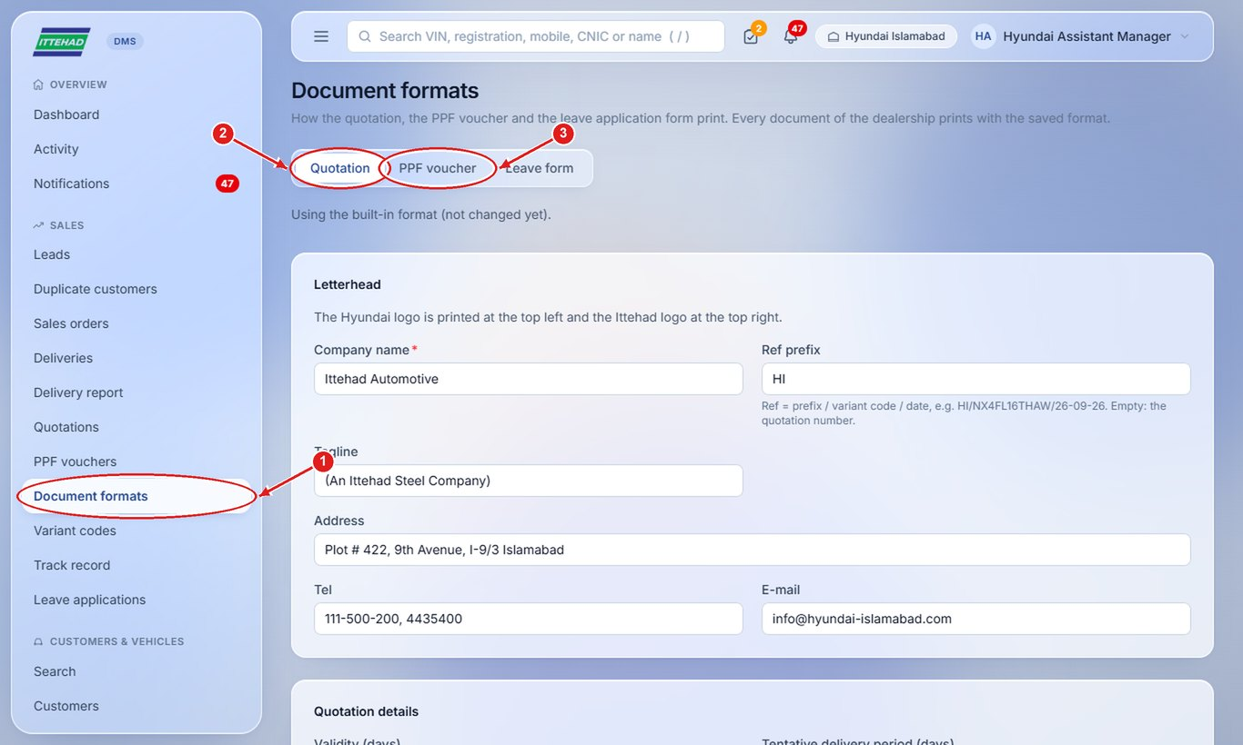
Step 2: Under Stamp & signature, upload the dealership stamp and the Manager’s signature (a clear photo or scan).
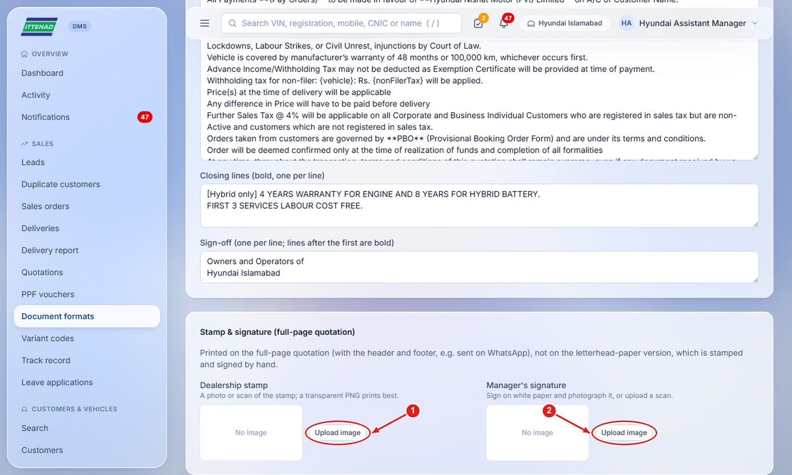
Step 3: Click Preview a sample quotation to check it, then Save format.
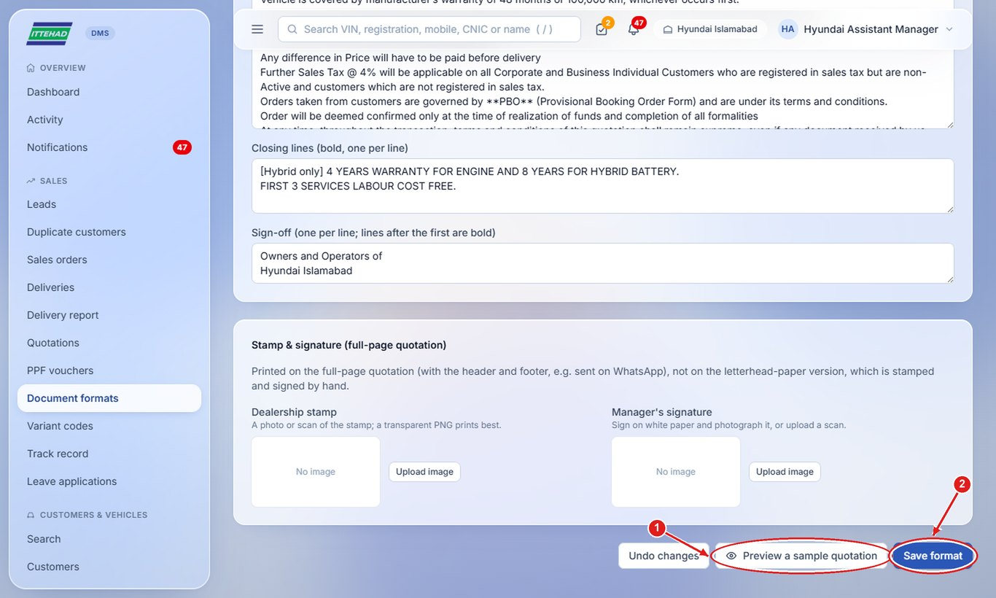
Note: Variant codes (in the menu) list the variant codes and descriptions used in the quotation Ref; add or import them there.

4. Sales Manager
The Sales Manager sees everything the Assistant Manager sees, approves sales orders, watches the team’s performance and manages the sales staff accounts.
Example login used in the screenshots: manager@hyundai.com
- 4.1 Approve a sales order
- 4.2 Watch the team’s performance
- 4.3 Add a new staff member
- 4.4 Reset a password, or deactivate someone who leaves
- 4.5 Export sales orders

4.1 Approve a sales order
Orders raised by the Sales Admin wait for your approval before the car is dispatched.
Step 1: Click Sales orders and the “Awaiting approval” box, then open the order.
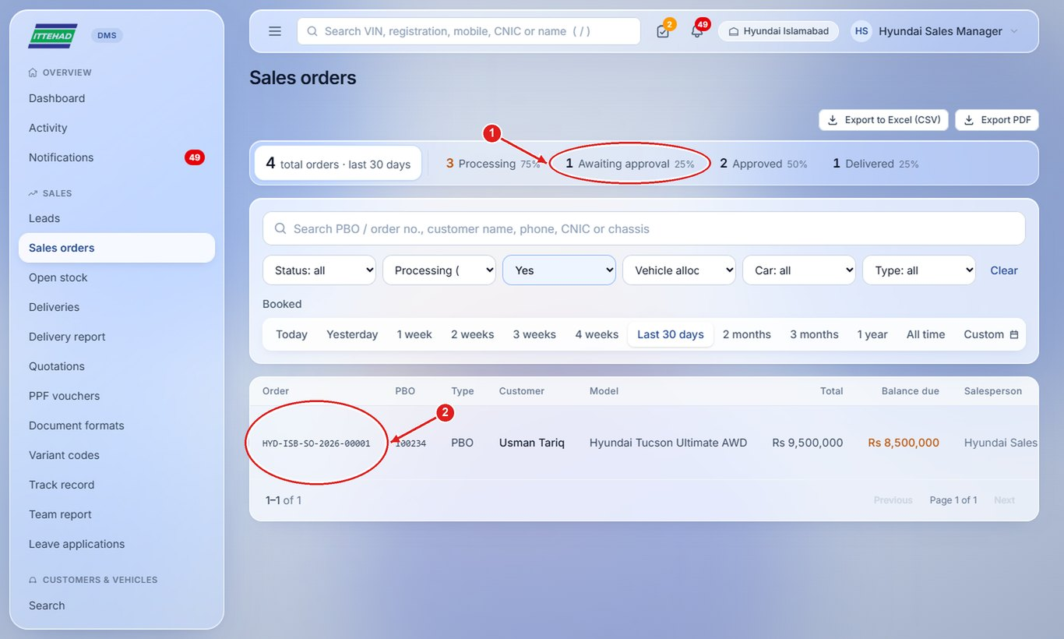
Step 2: Check the customer, price and payments, then click Approve (or Return to draft for corrections).
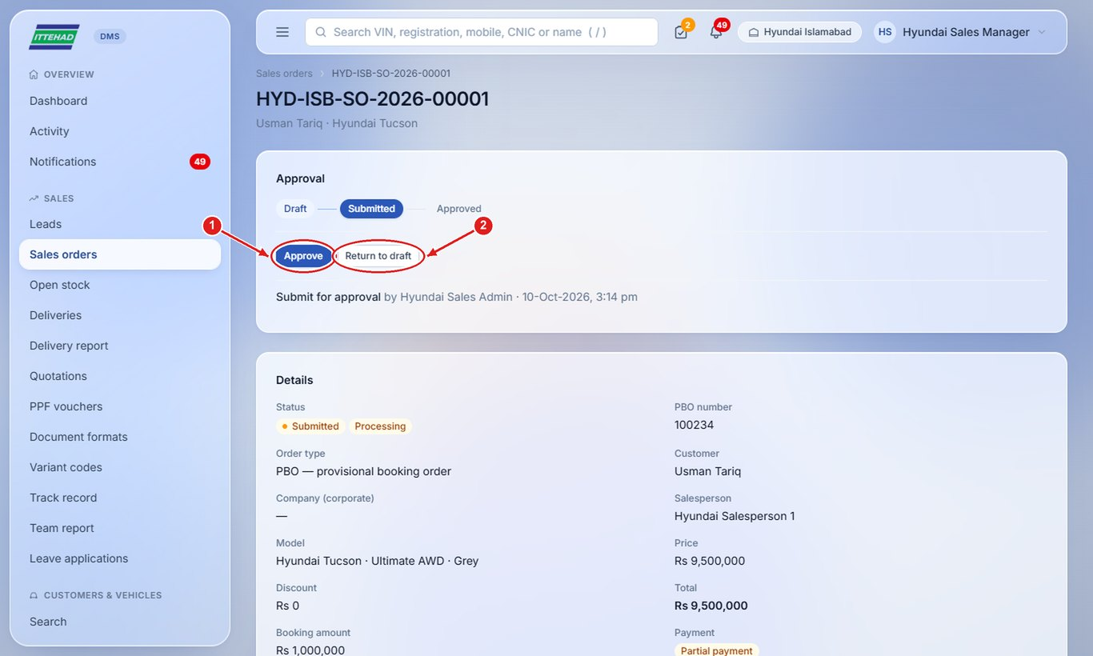

4.2 Watch the team’s performance
The Team report shows leads, walk-ins, conversions and orders per salesperson and per day.
Step 1: Click Team report and choose the From and To dates.
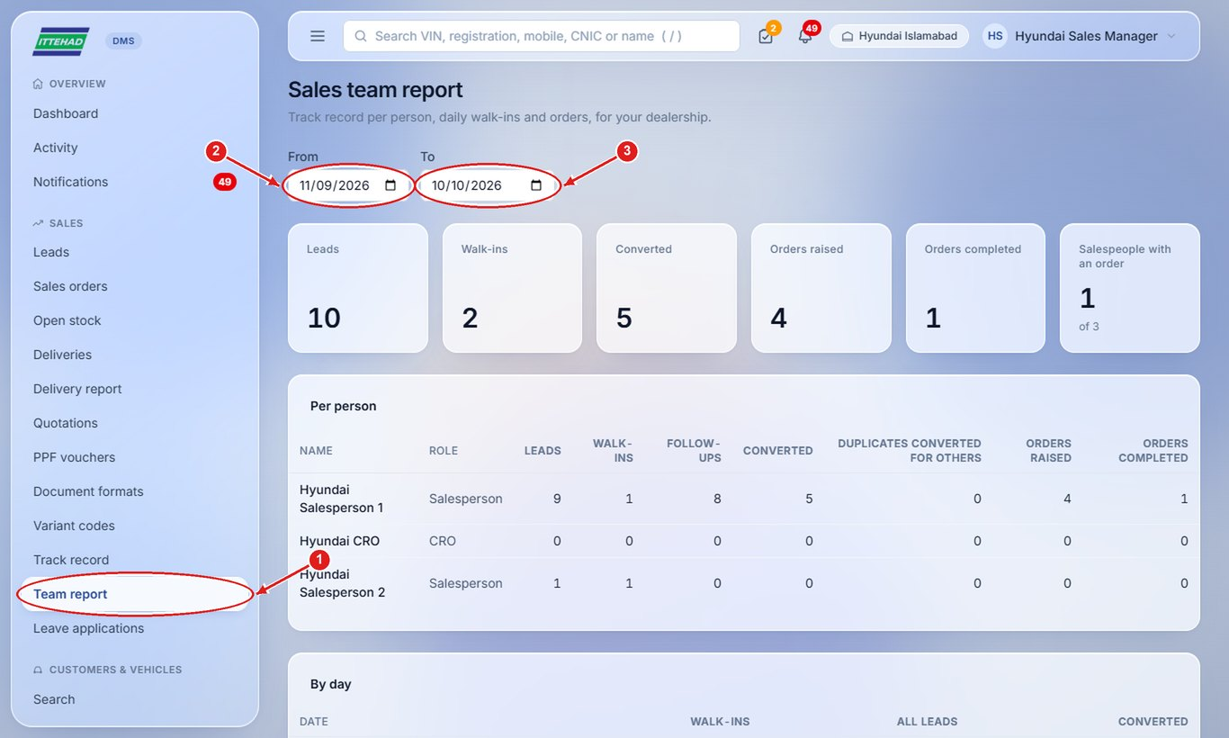
Step 2: Click Track record for each salesperson’s monthly conversions, cars and PPF sales; download it as PDF or CSV.
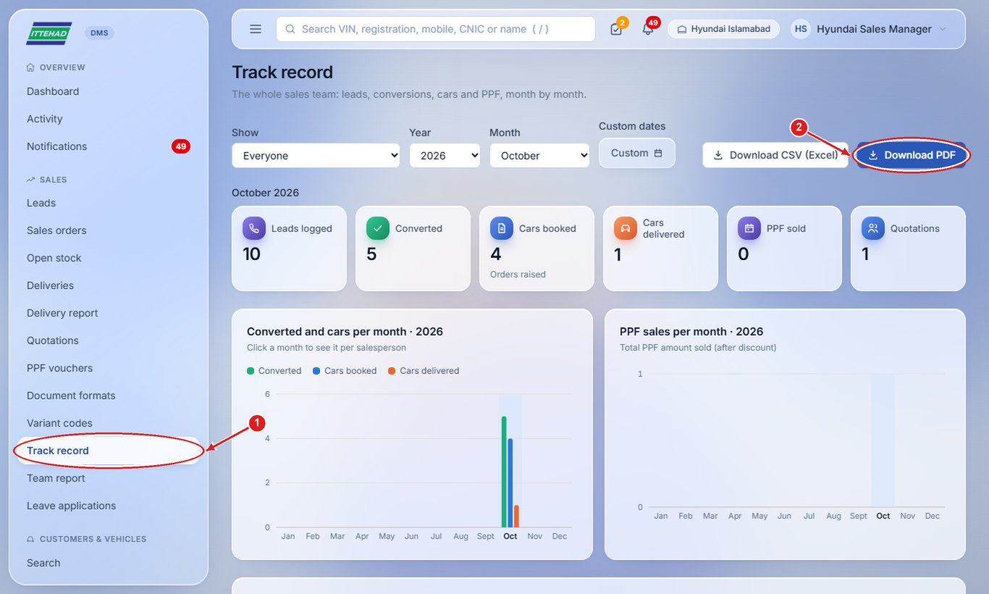

4.3 Add a new staff member
Create a login for a new salesperson, CRO, Admin or Assistant Manager.
Step 1: Click Users & staff in the menu, then + New user.
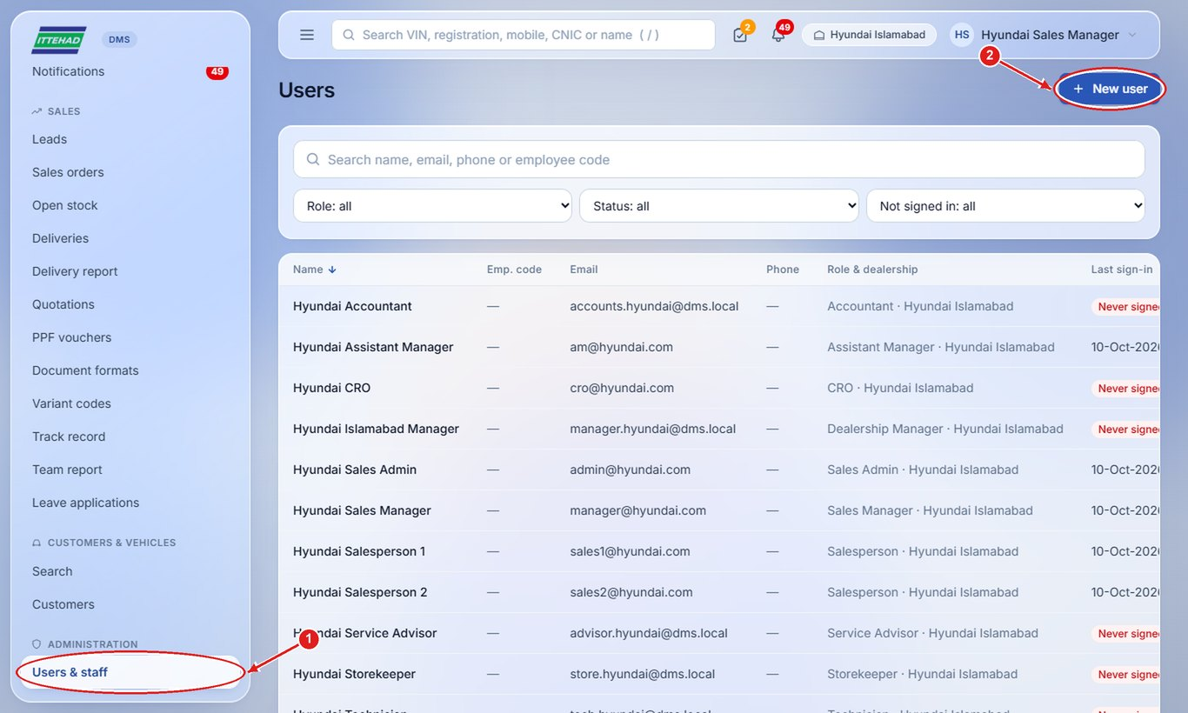
Step 2: Enter the email (used to sign in), full name and phone, and a first password.
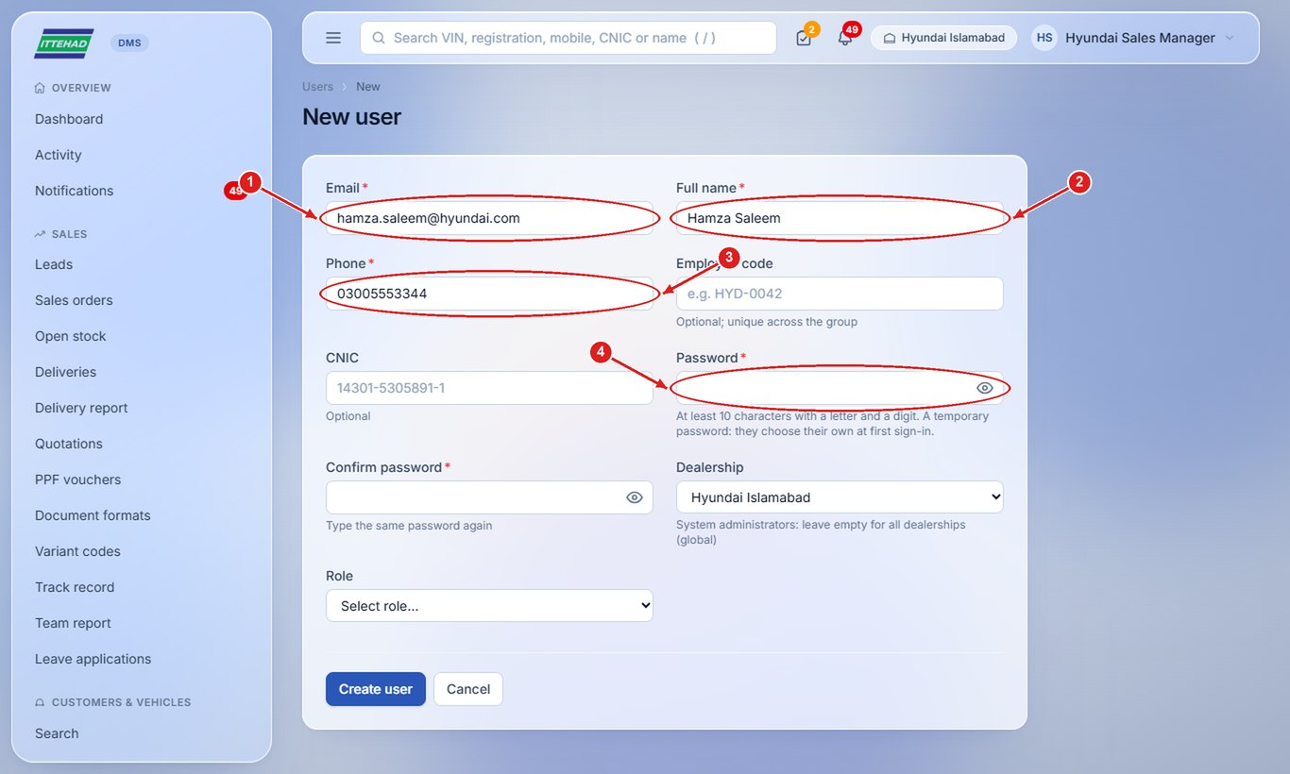
Step 3: Choose the dealership and the role (Salesperson, CRO, Sales Admin, Assistant Manager, Delivery Team), then click Create user.
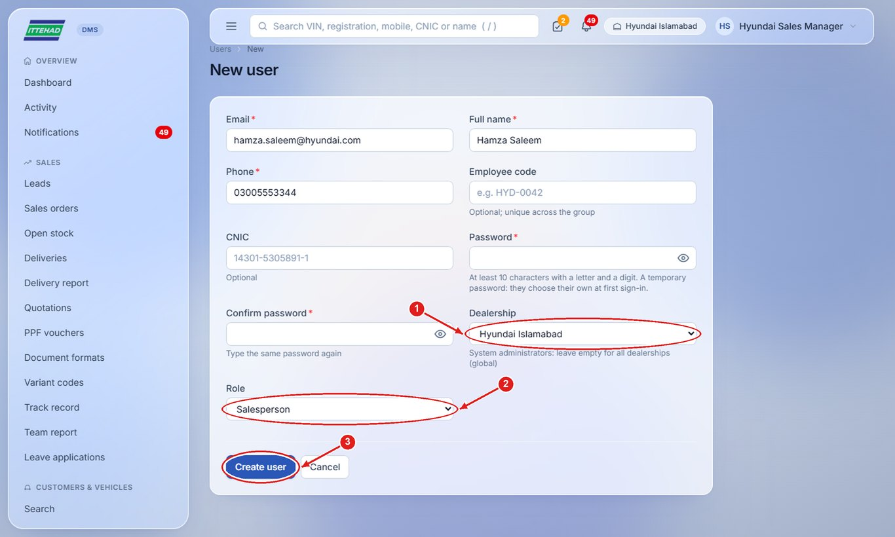
Note: The new user is asked to choose their own password at their first login.

4.4 Reset a password, or deactivate someone who leaves
When someone forgets their password or leaves the company.
Step 1: Open the user from Users & staff. Reset password gives them a temporary password (they choose their own at the next sign-in).
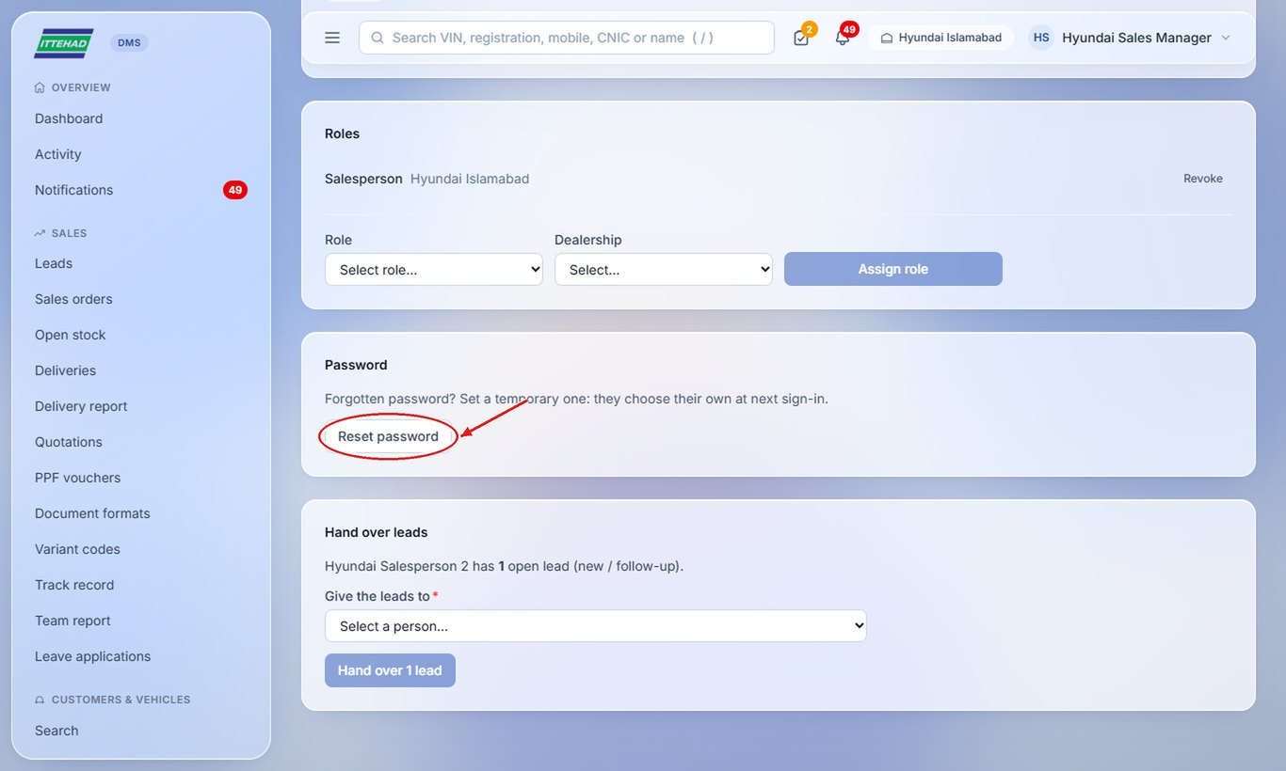
Step 2: When someone leaves, first give their open leads to another person and click Hand over.
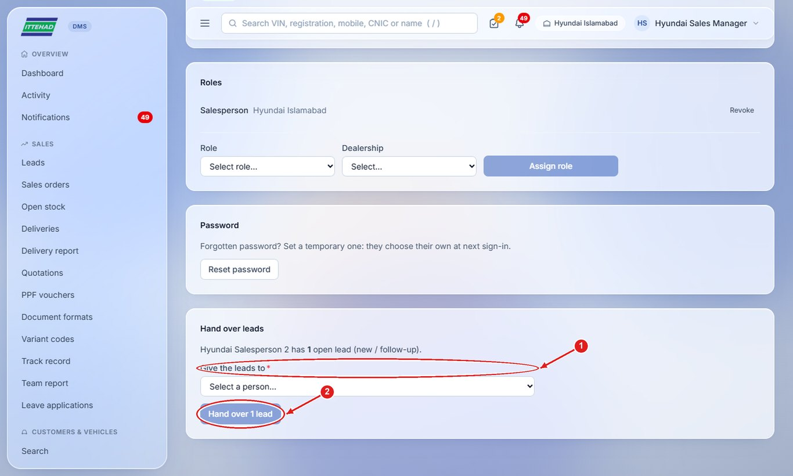
Step 3: Then click Edit, untick Active and click Save changes: they are signed out and can no longer sign in.
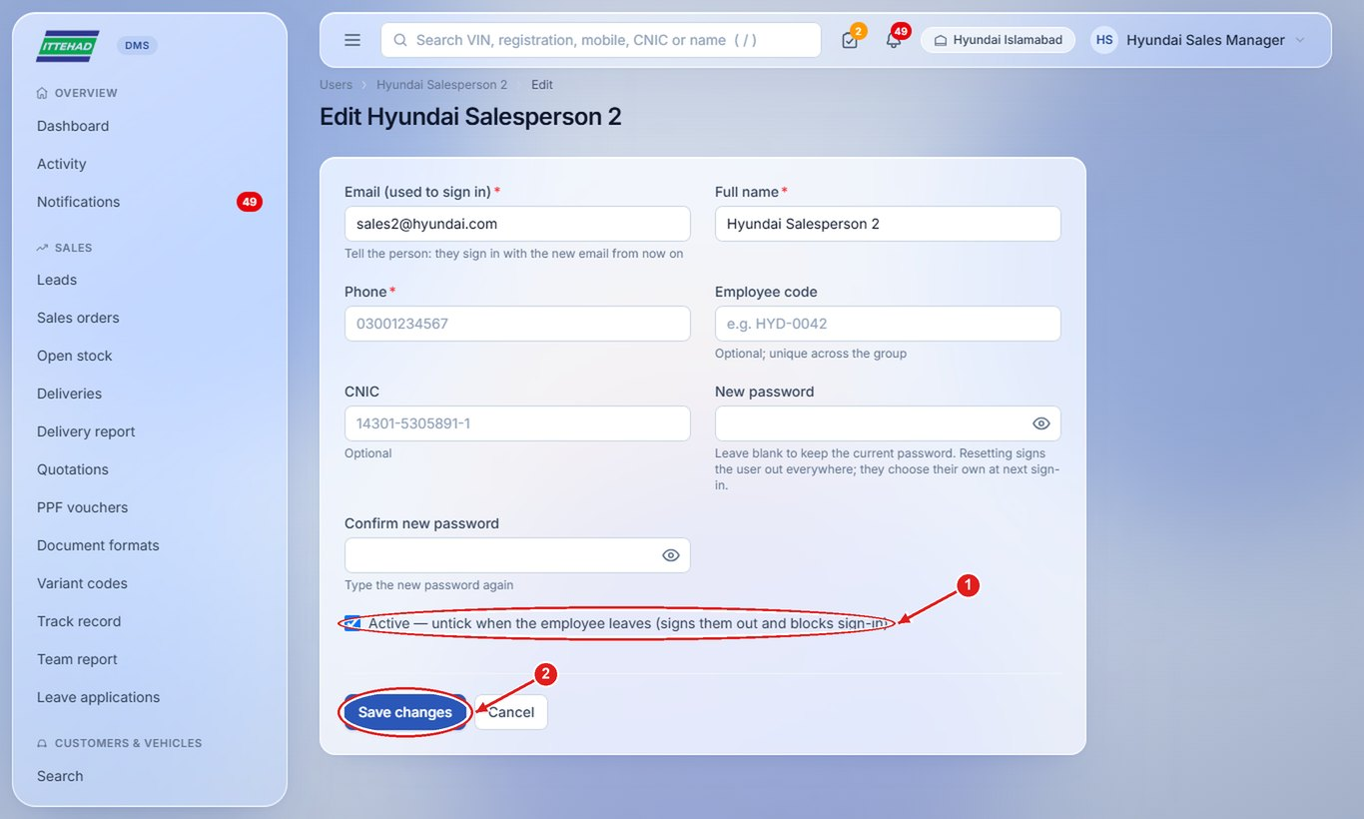

4.5 Export sales orders
Export every order of a period with the customer, car, payments and balance.
Step 1: On Sales orders, pick the period, then Export to Excel (CSV) or Export PDF.
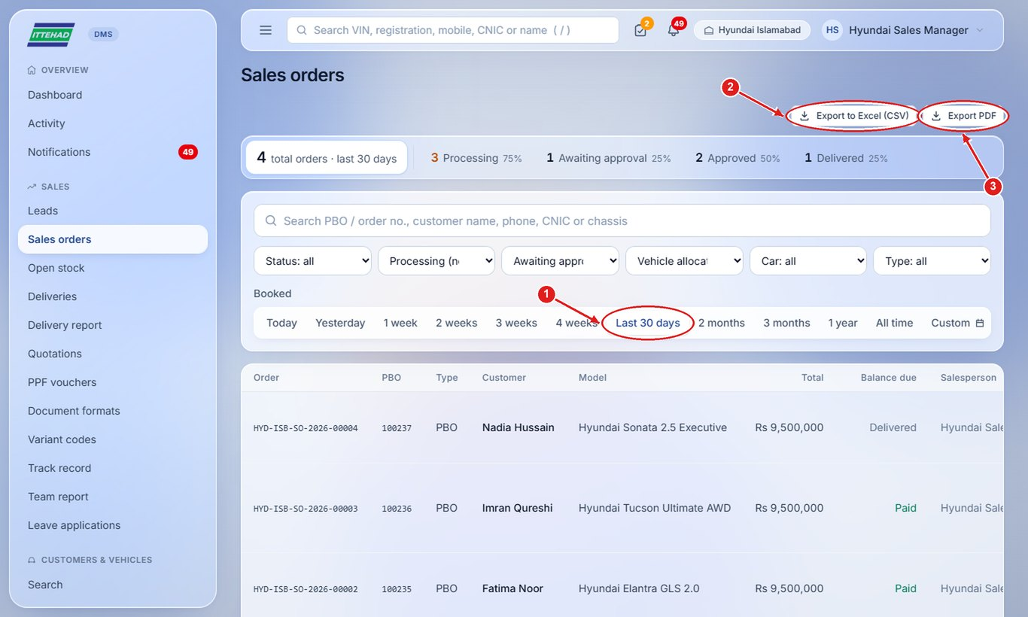

5. Sales Admin
The Sales Admin raises the sales order for every converted lead, records the payments, submits orders for the Manager’s approval and clears cars for delivery once all payments are in.
Example login used in the screenshots: admin@hyundai.com
- 5.1 Find converted leads waiting for an order
- 5.2 Raise a sales order
- 5.3 Record a payment
- 5.4 Submit the order for approval
- 5.5 Correct customer details
- 5.6 Clear a car for delivery
- 5.7 Edit or cancel an order

5.1 Find converted leads waiting for an order
Every converted lead needs a sales order.
Step 1: On the dashboard, “Converted leads need a sales order” lists them; click Open →.
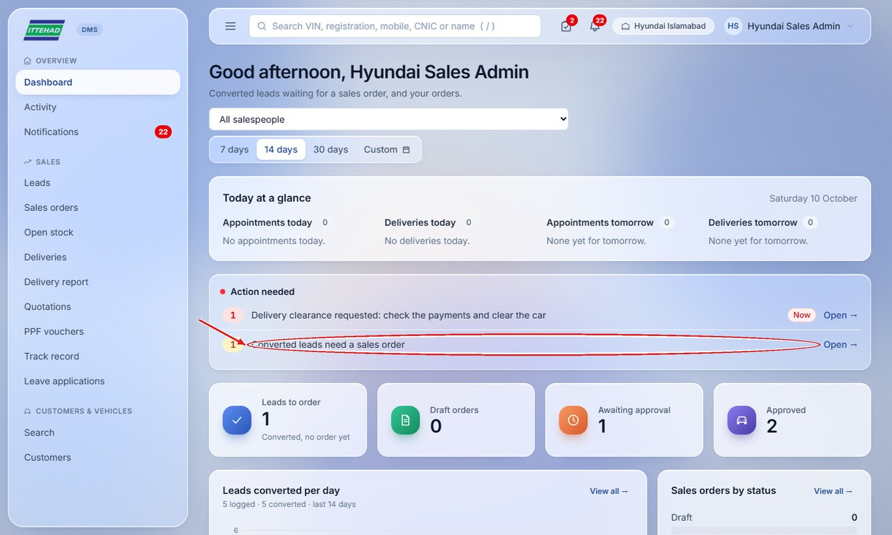

5.2 Raise a sales order
Raise the order with the PBO number from the head-office system.
Step 1: Open the converted lead and scroll to Raise sales order. Choose the order type and enter the PBO number and the customer’s CNIC.
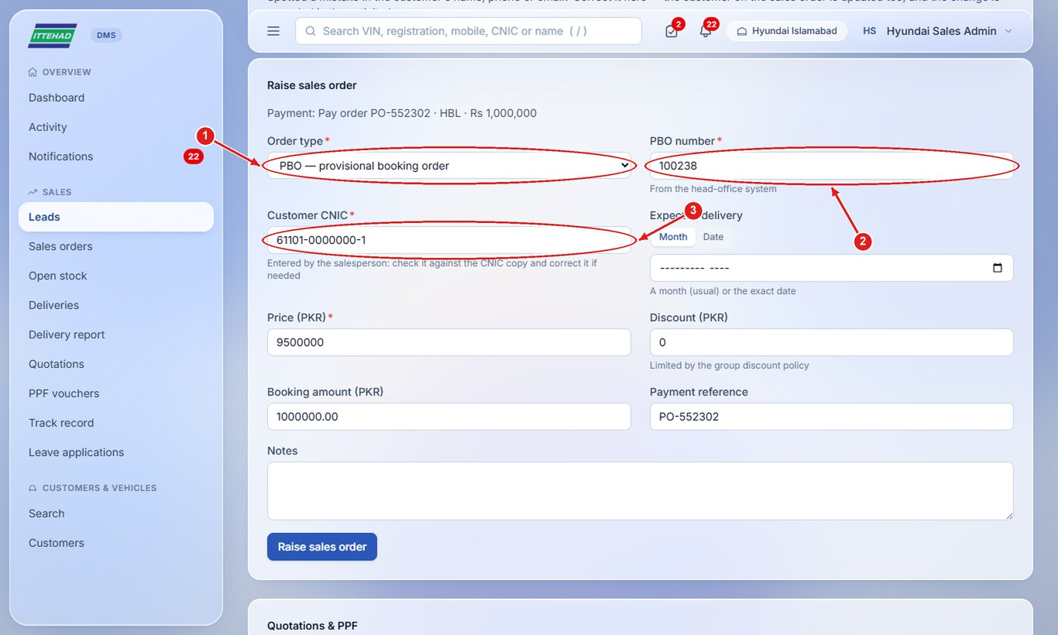
Step 2: Check the price (from the lead), discount and expected delivery, then click Raise sales order.
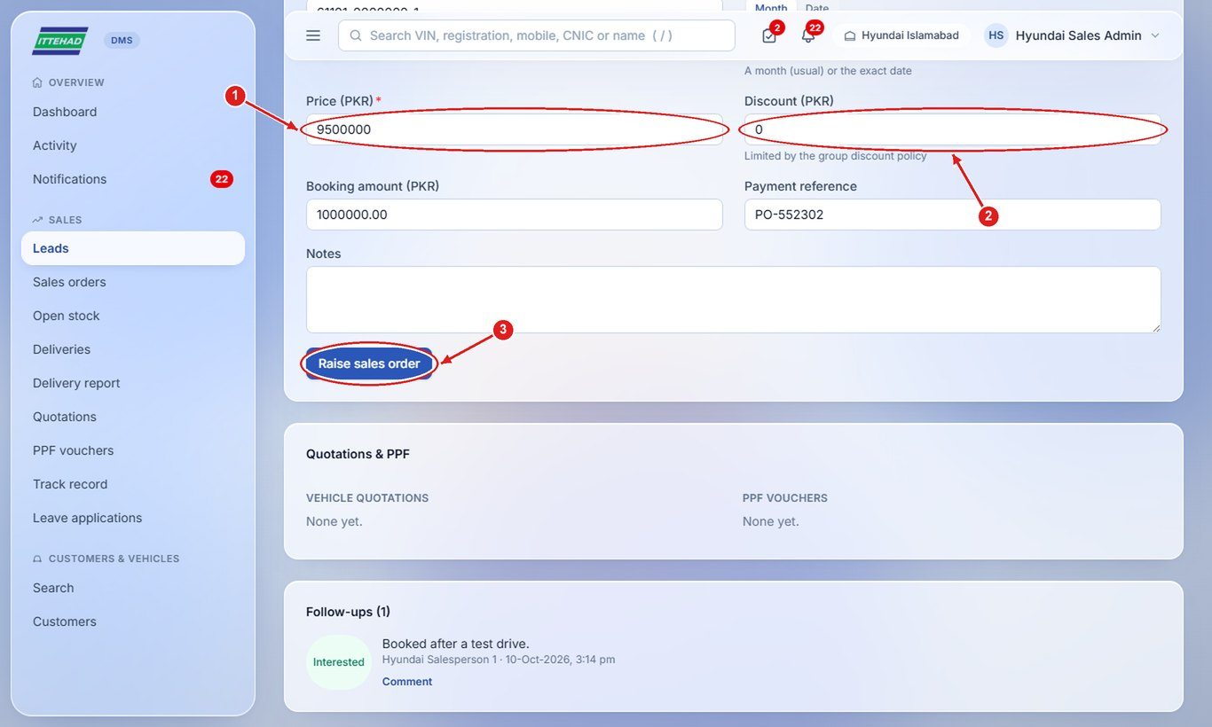

5.3 Record a payment
Record each payment received against the order: booking, part payments and the final payment.
Step 1: Open the order and, under Payments, click + Record payment.
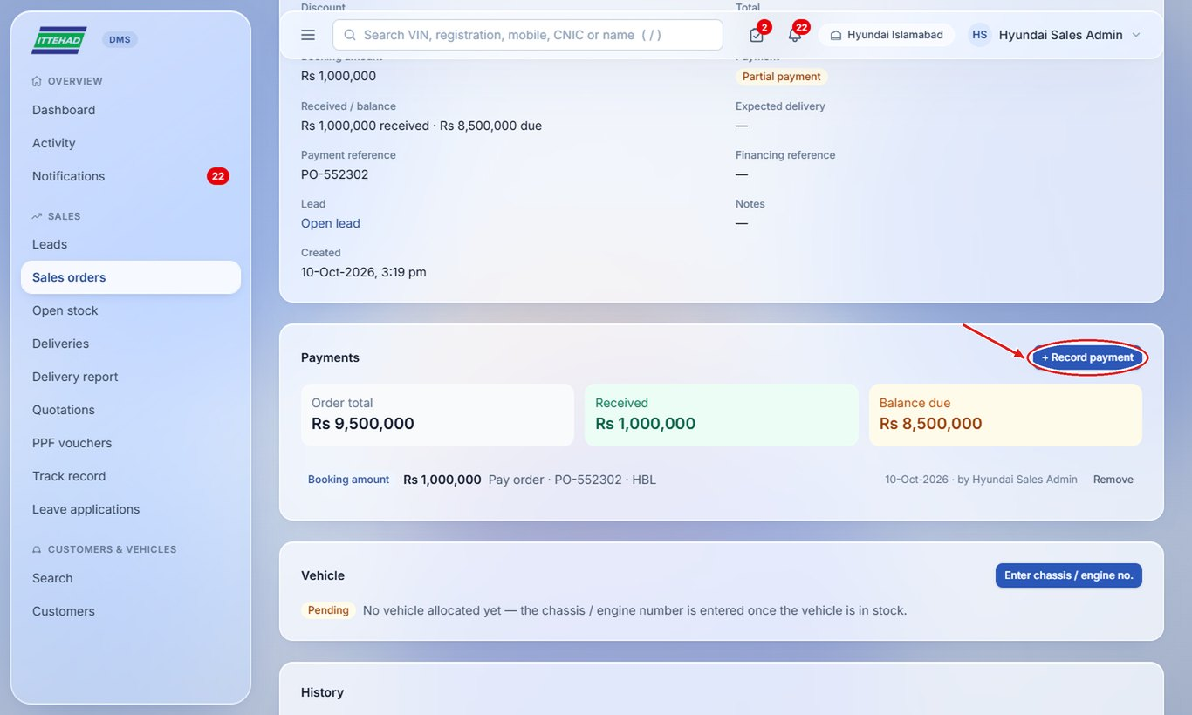
Step 2: Choose the payment type, amount, date, instrument (pay order, cheque…), its number and bank, then click Save payment.
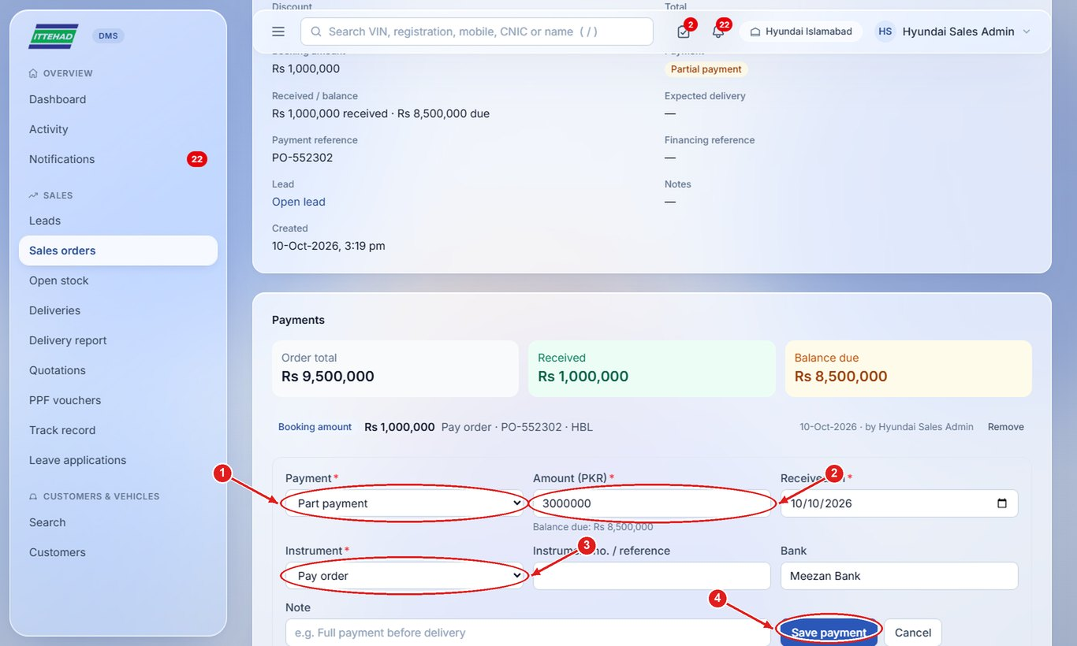
Note: The order shows the total received and the balance due; the balance must be zero before the car is cleared for delivery.

5.4 Submit the order for approval
When the order is complete, send it to the Manager.
Step 1: Open the order and click Submit for approval.
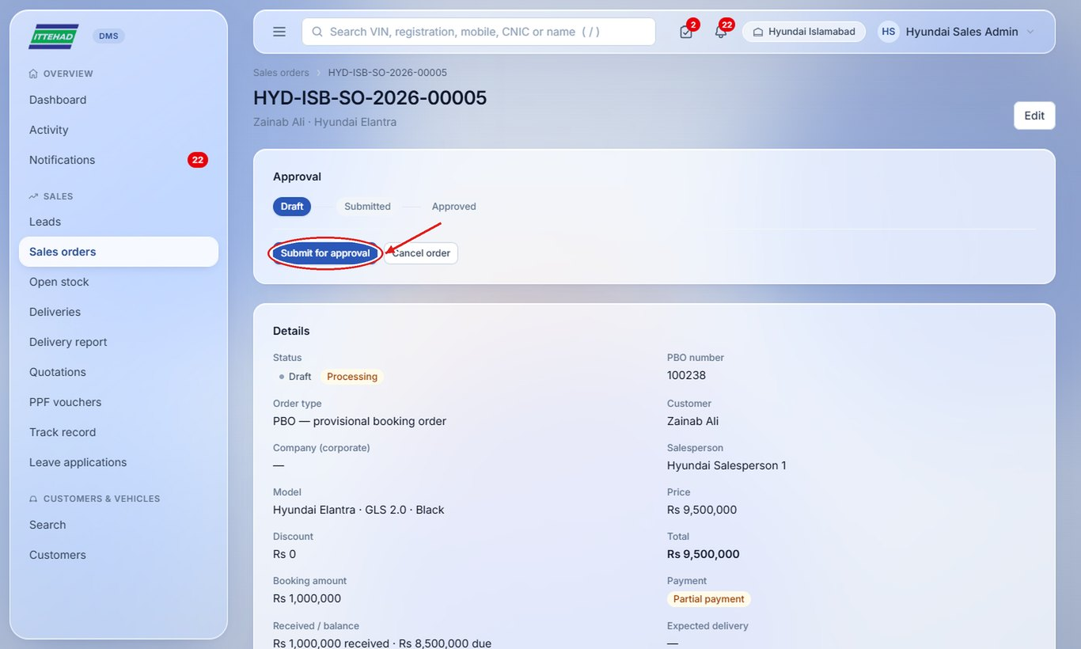

5.5 Correct customer details
Fix a wrong name, phone, CNIC or address on a converted lead.
Step 1: Open the lead and click Correct details under Customer details.
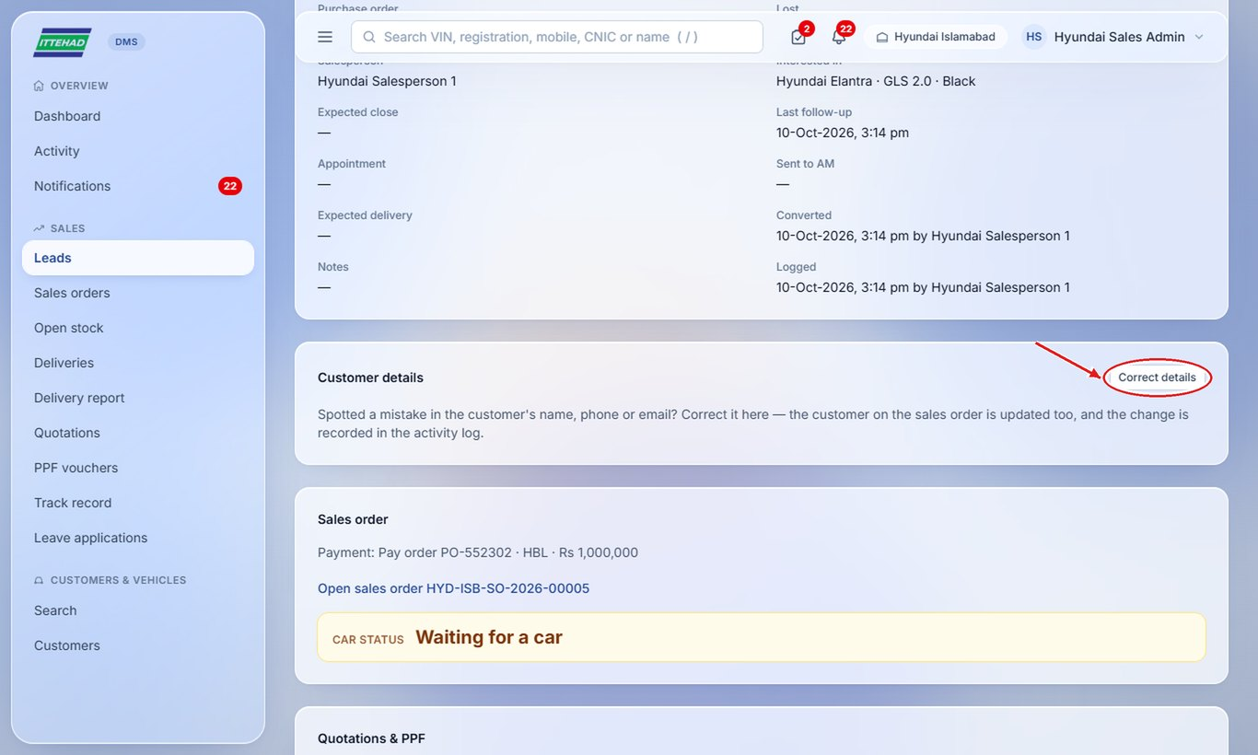

5.6 Clear a car for delivery
The Delivery Team asks for clearance when the car is ready. Check that every payment is in.
Step 1: Open the order (Action needed: “Delivery clearance requested”), check the balance, then click Approve: all clear, or write a note and Reject.
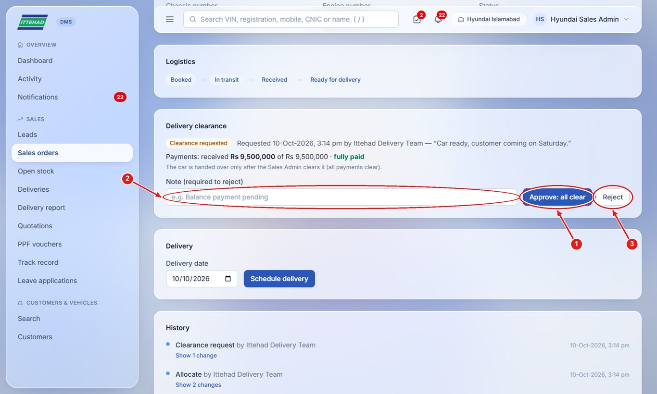

5.7 Edit or cancel an order
Change the order’s price or delivery date, or cancel it if the customer withdraws.
Step 1: Open the order and click Edit to change it, or Cancel order to cancel it.
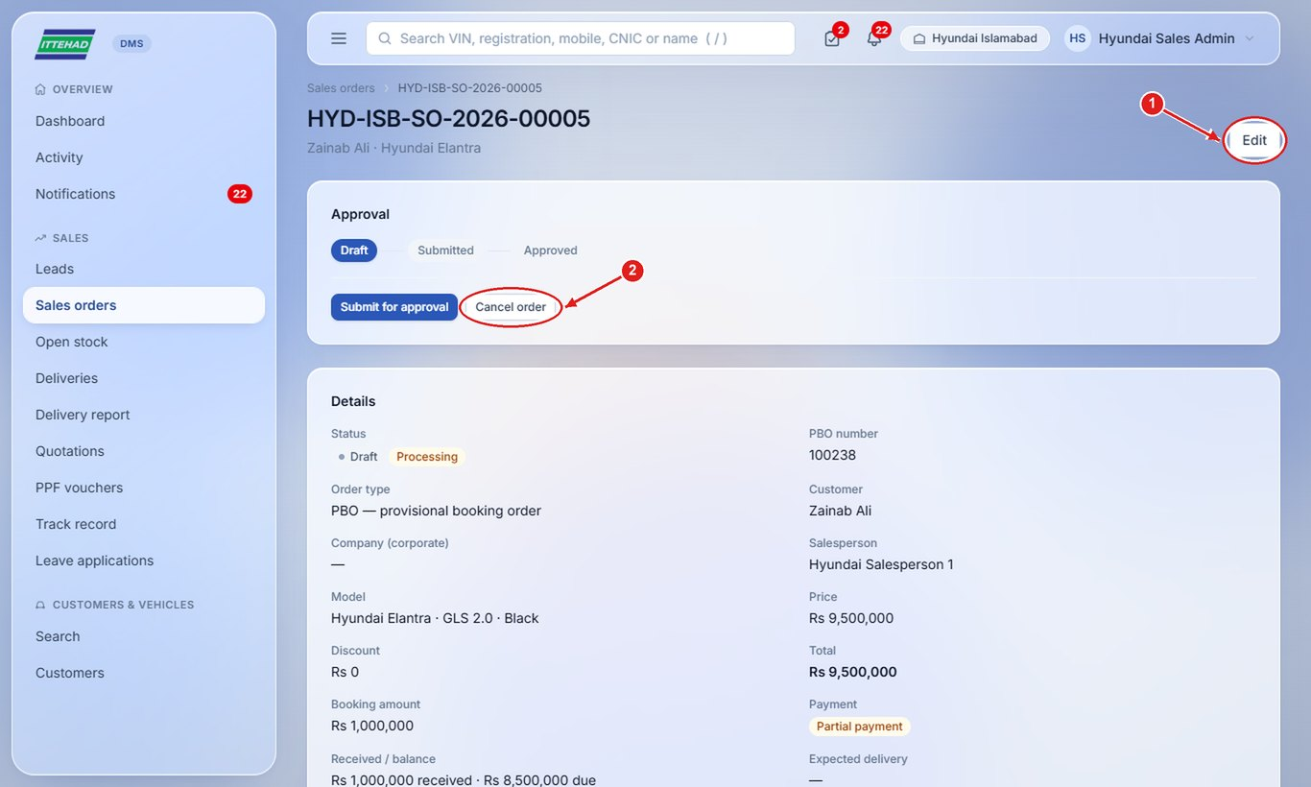

6. Delivery Team
The Delivery Team registers incoming cars in open stock, allocates them to booked orders, moves them through logistics (in transit → received → ready for delivery) and hands them over to the customer.
Example login used in the screenshots: delivery@ittehad.com
- 6.1 Your dashboard
- 6.2 Register a car in open stock
- 6.3 Allocate a car to an order
- 6.4 Move the car through logistics
- 6.5 Ask for delivery clearance
- 6.6 Schedule the delivery
- 6.7 Hand over the car (Mark as delivered)
- 6.8 Track deliveries and print the delivery note

6.1 Your dashboard
See open stock by stage, orders waiting for a car and the delivery queue.
Step 1: Action needed shows cars ready to hand over and orders waiting for a car; click Open → to go to them.
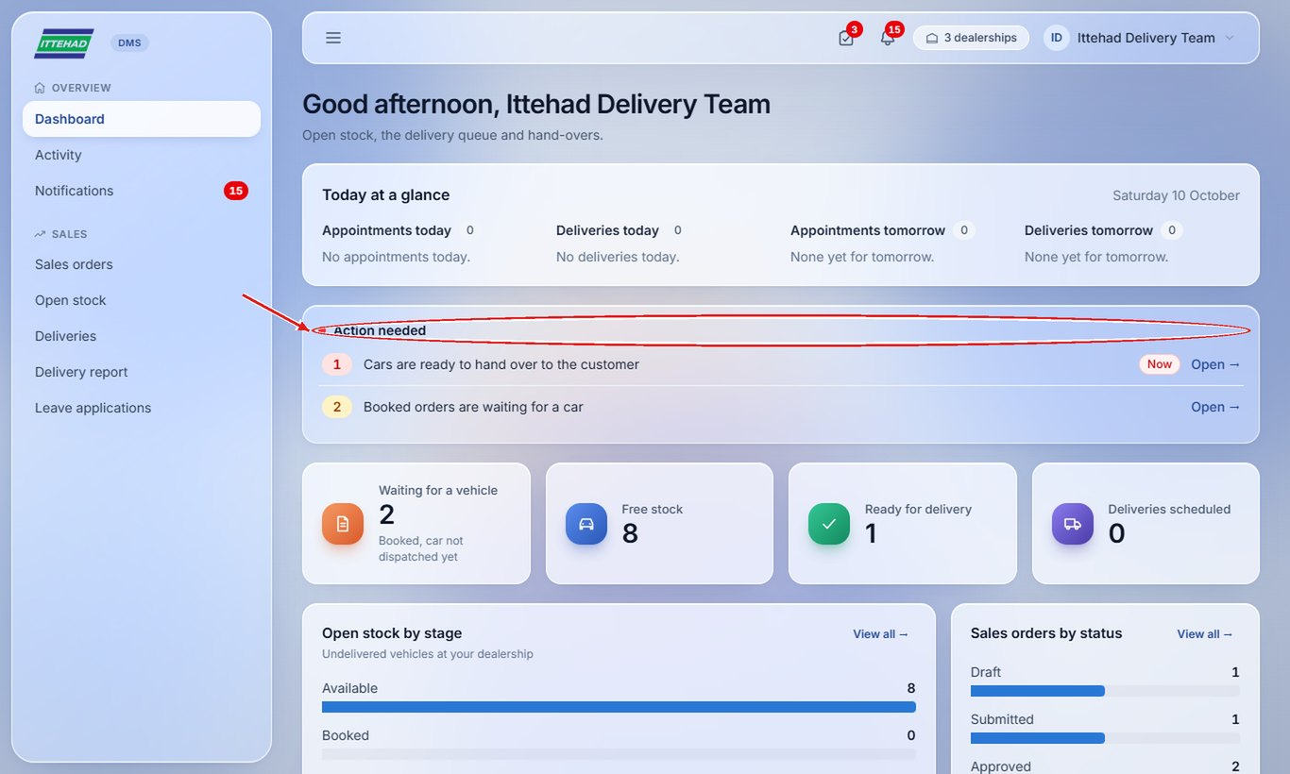

6.2 Register a car in open stock
Add each car that arrives (or is on its way) to open stock.
Step 1: Click Open stock, then New stock vehicle.
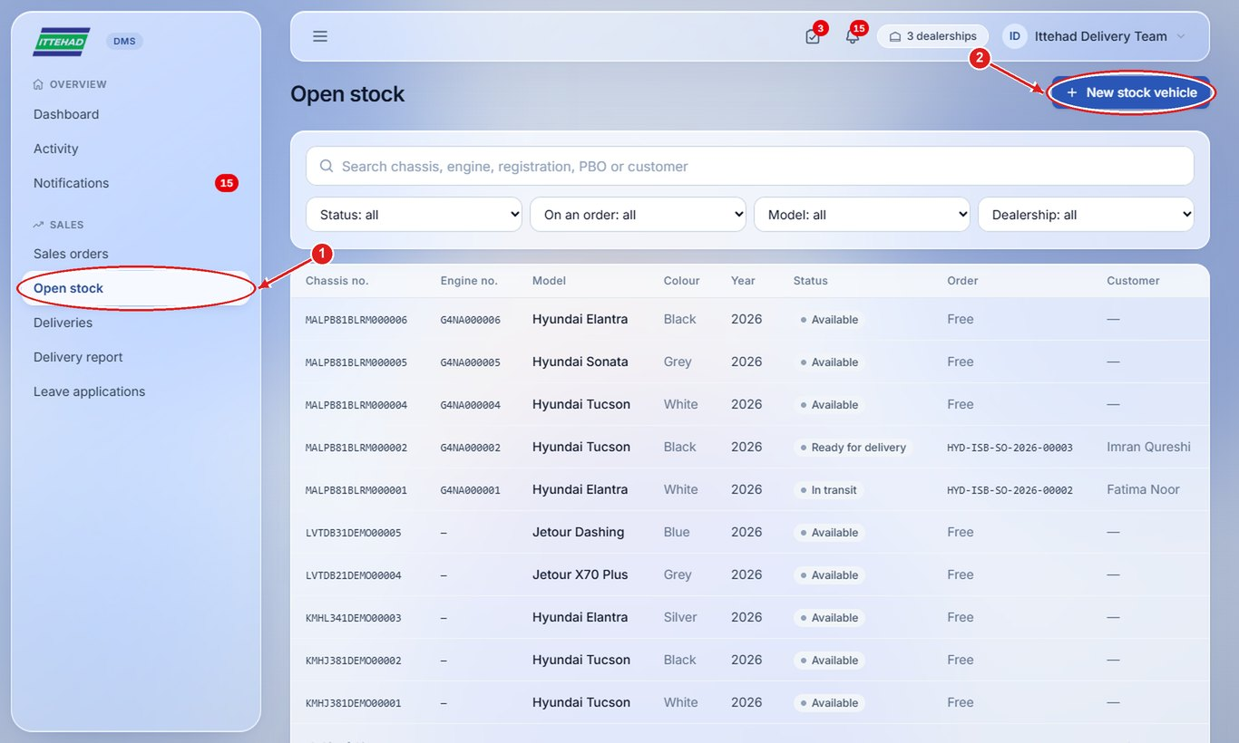
Step 2: Choose the model, enter the chassis (VIN) and engine numbers, colour and model year. Choose “For order” if the car came for a booked order.
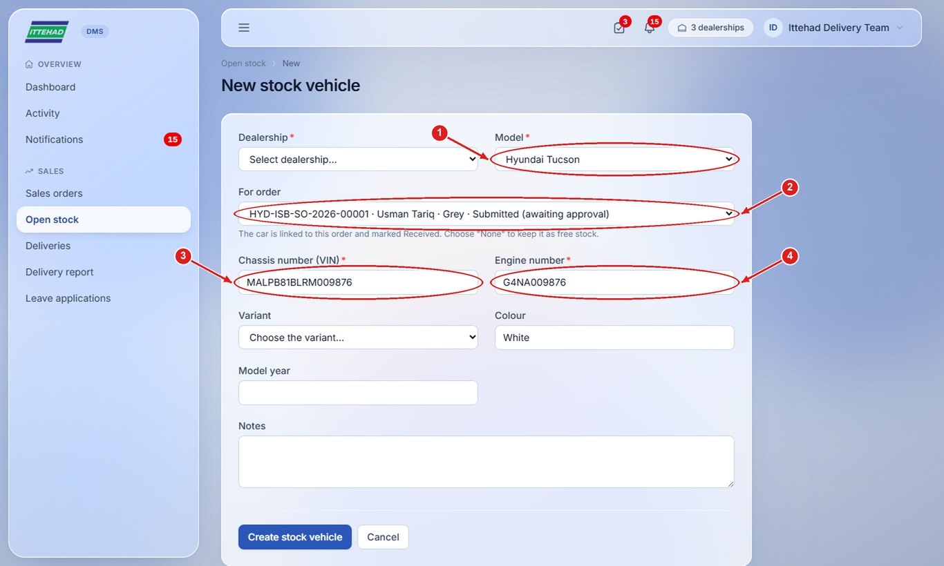
Step 3: Click Create stock vehicle.
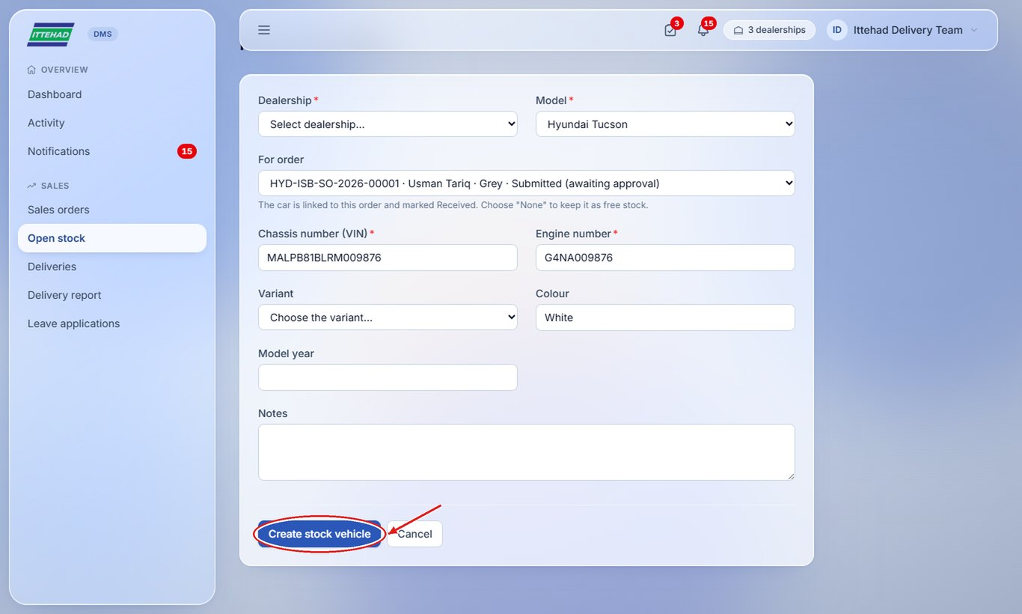

6.3 Allocate a car to an order
Give a free car from open stock to a booked order.
Step 1: Open the order, choose a car from open stock under Logistics and click Allocate.
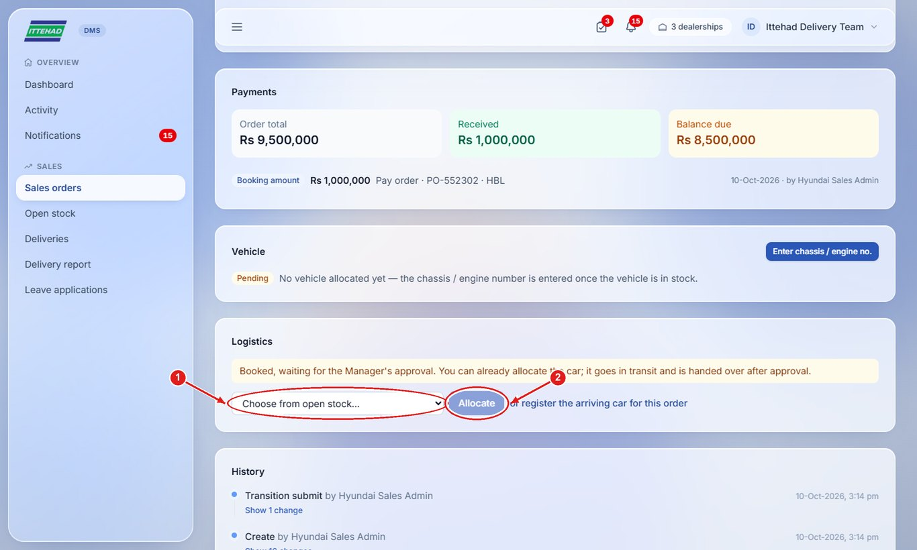

6.4 Move the car through logistics
Update the car’s stage so the salesperson and managers can tell the customer where it is.
Step 1: When the car arrives, click Mark received; then Mark ready for delivery after PDI. Put on hold pauses it; Release to stock frees the car.
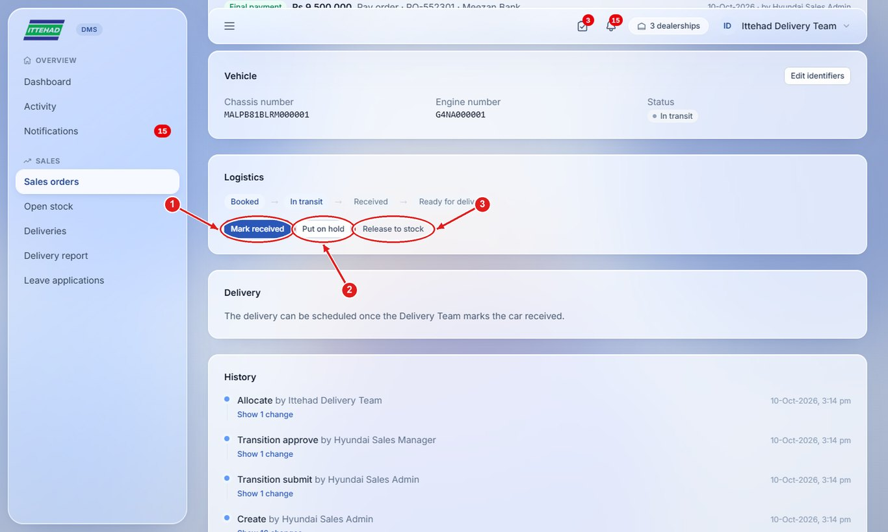

6.5 Ask for delivery clearance
Before handing over, the Sales Admin confirms every payment is in.
Step 1: Under Delivery clearance, write a note if needed and click Request clearance. You are notified when the Admin clears it.
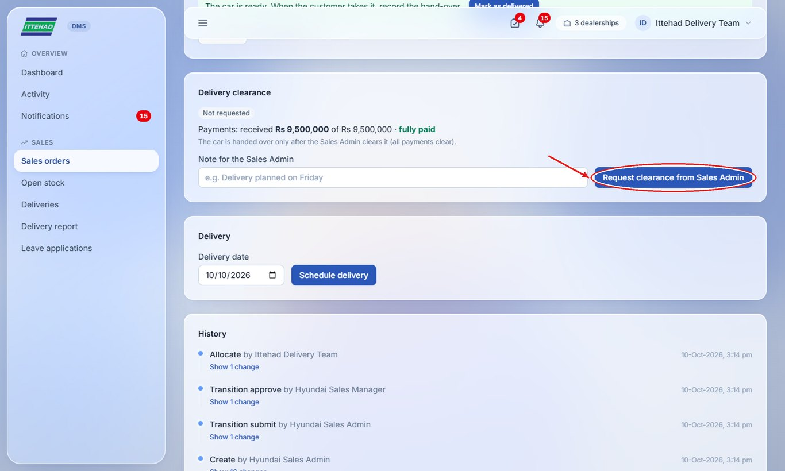

6.6 Schedule the delivery
Fix the hand-over date with the customer.
Step 1: Choose the delivery date and click Schedule delivery.
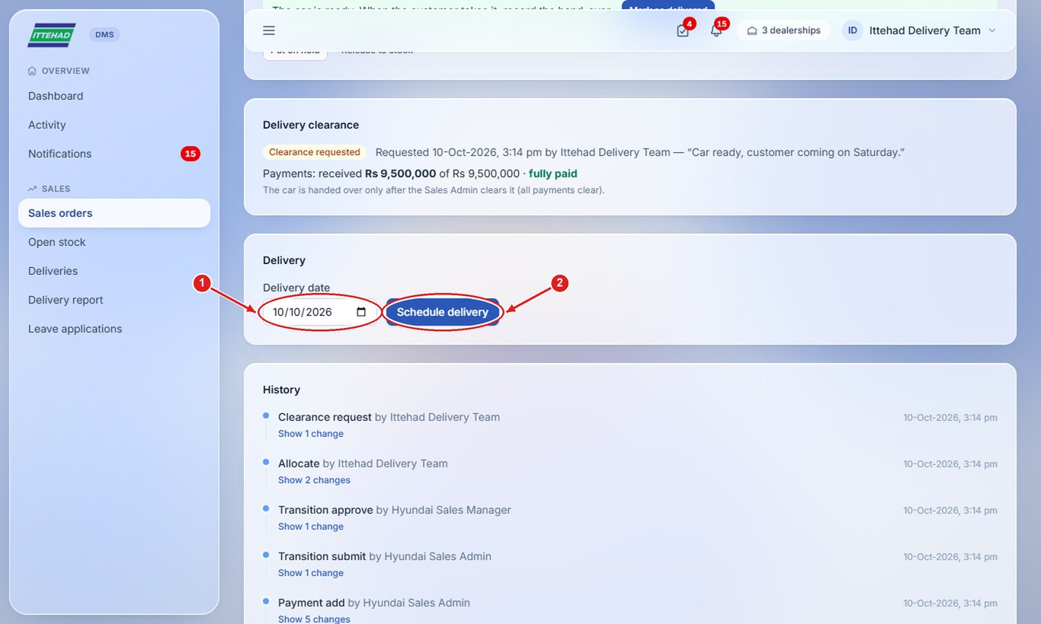

6.7 Hand over the car (Mark as delivered)
Record the hand-over when the customer takes the car. The order closes and the customer becomes the owner.
Step 1: Click Mark as delivered.
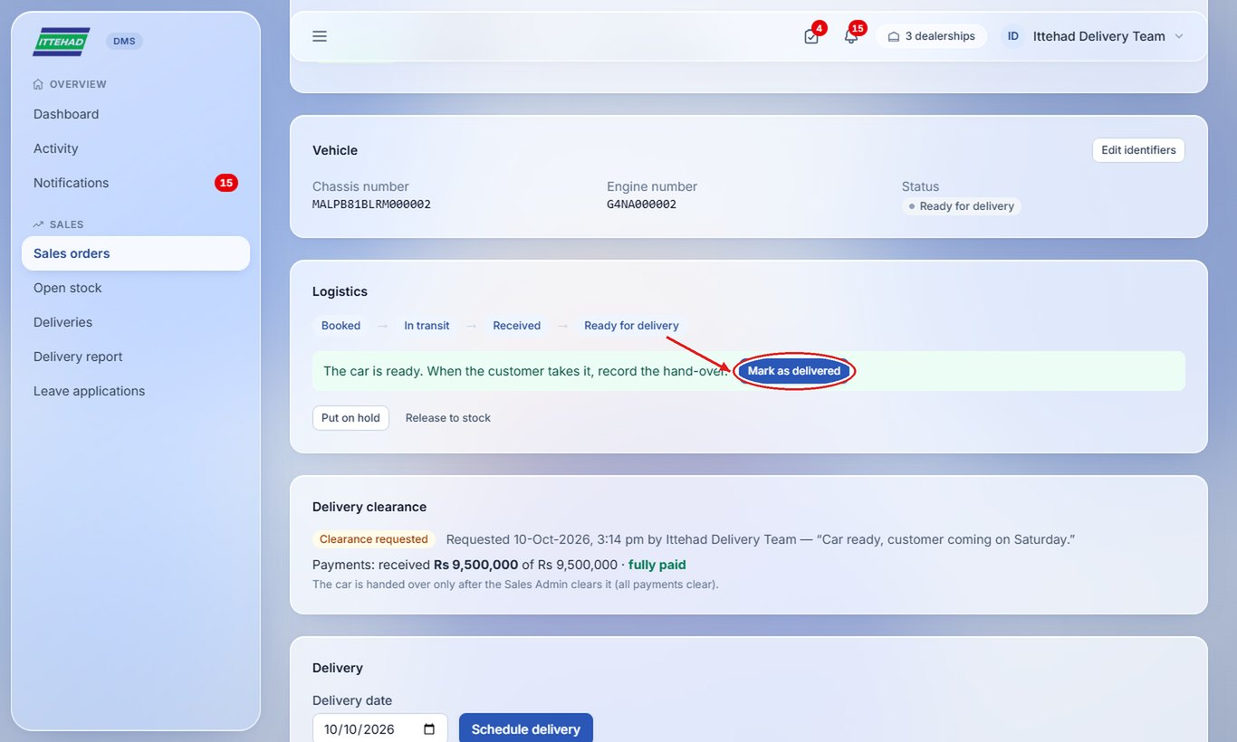
Step 2: Tick the pre-delivery checklist, enter the date and odometer reading, and tick the documents handed over.
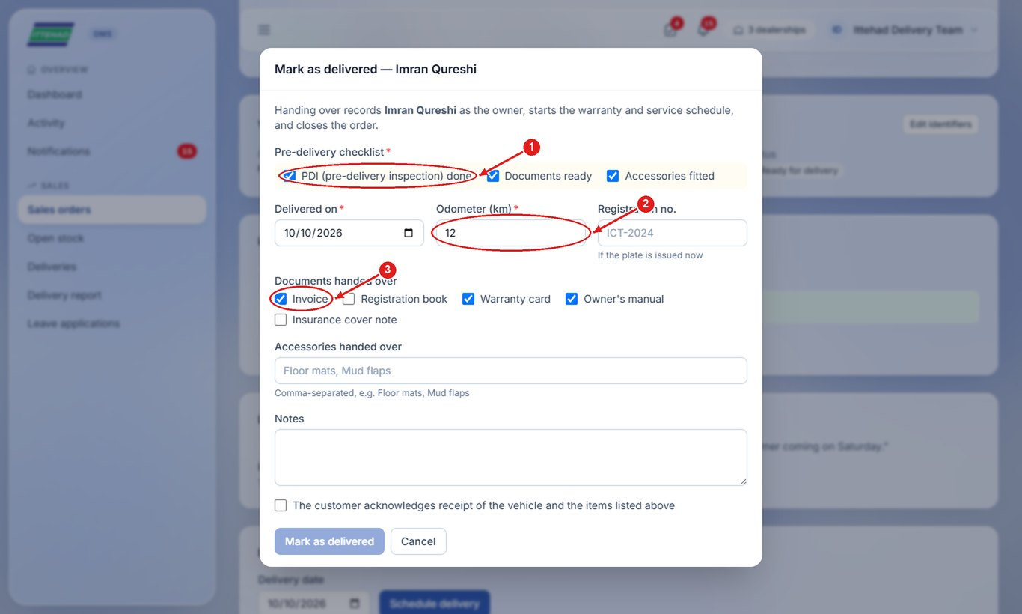
Step 3: Tick that the customer acknowledges receipt, then click Mark as delivered.
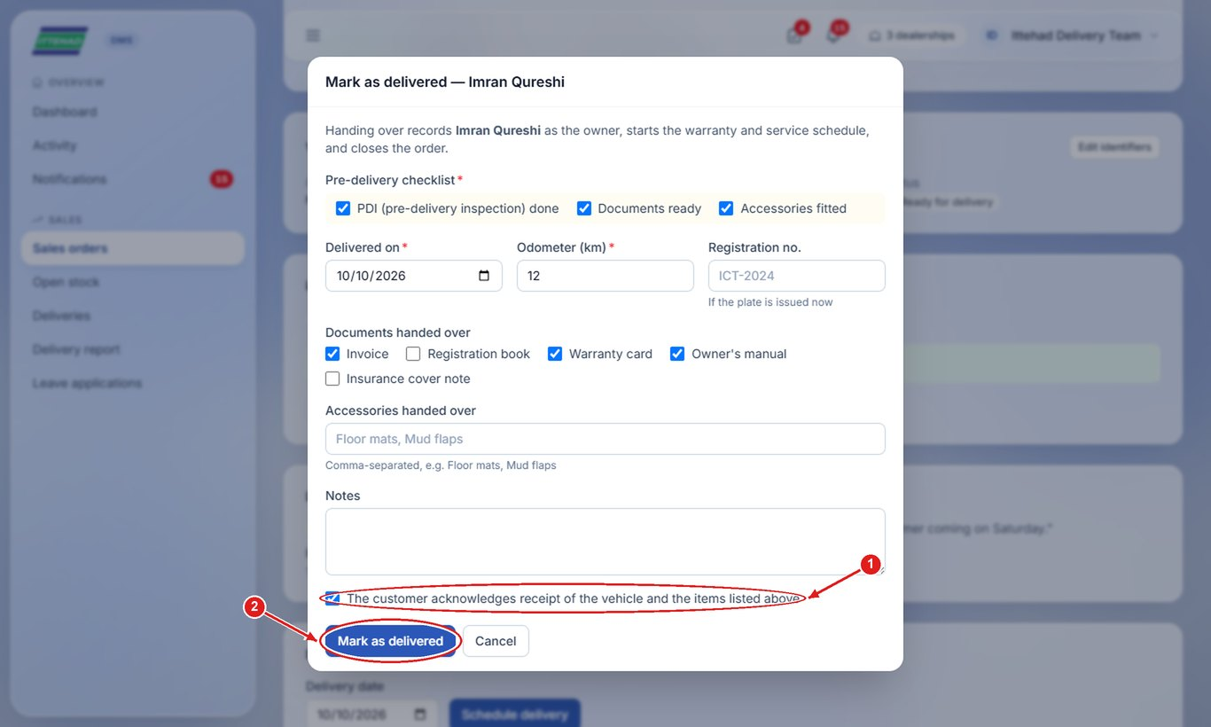

6.8 Track deliveries and print the delivery note
See every booked order by stage, and the monthly delivery report.
Step 1: Click Deliveries; the boxes show waiting for car, in transit, received, scheduled and delivered.
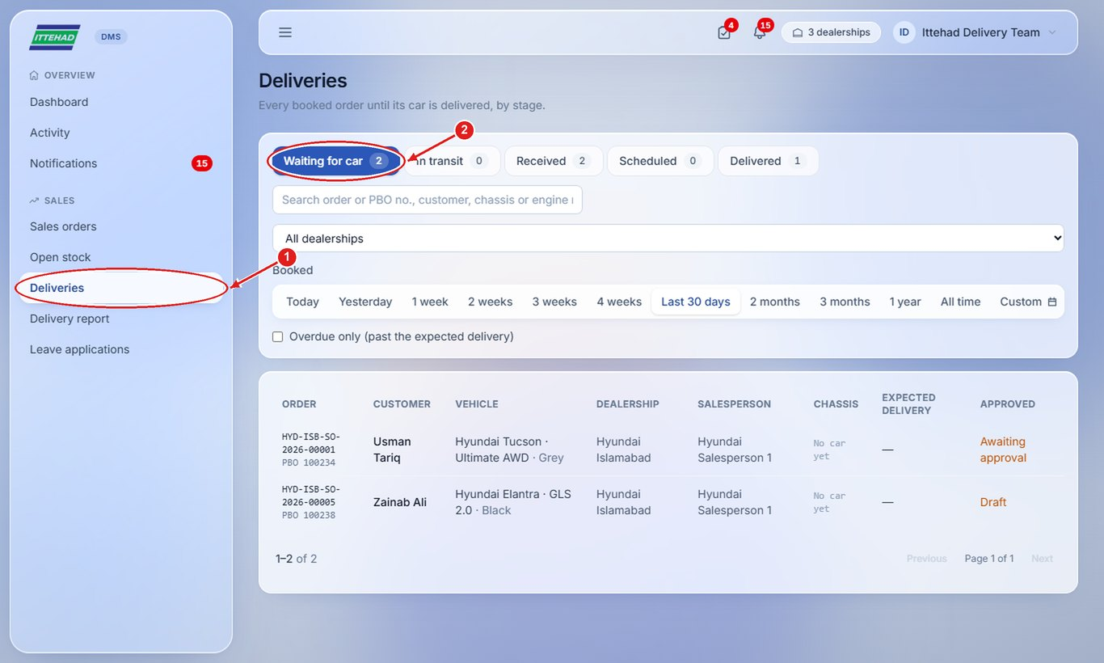
Step 2: Click Delivery report for deliveries by dealership and model; Print it or Download CSV.
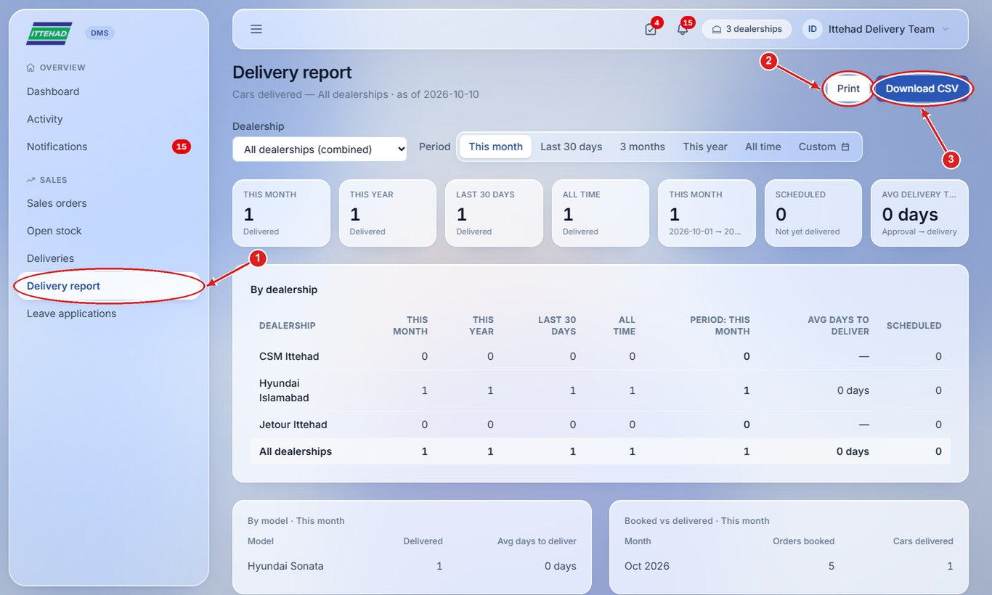
Note: A delivered order has a Delivery note (on the order or the delivery): open it to print or download it for the customer’s signature.

Getting help
- Forgotten password or locked out: ask your Sales Manager to reset it (Users & staff → Reset password).
- A customer’s details are wrong after conversion: ask the Sales Admin to use Correct details on the lead.
- A lead belongs to the wrong salesperson: ask the Assistant Manager to reassign it.
- Something looks wrong in the portal: note the page, the time and what you clicked, and tell your Assistant Manager.

