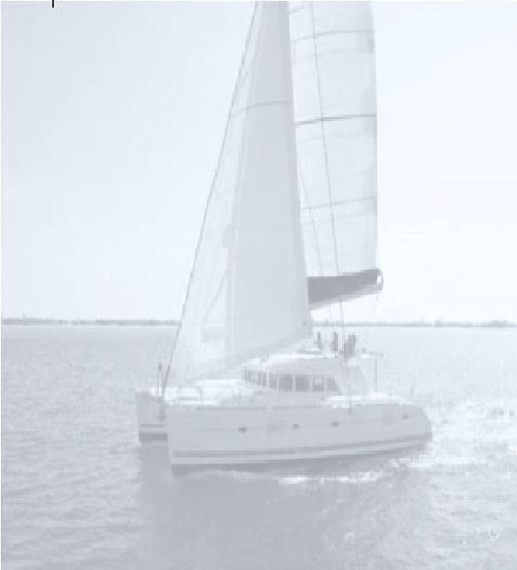

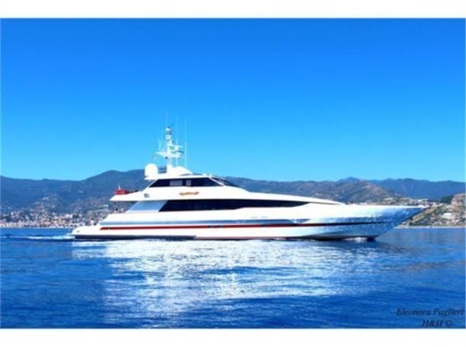

SPECIAL OFFER

Sports Fisher

TTD$135,000

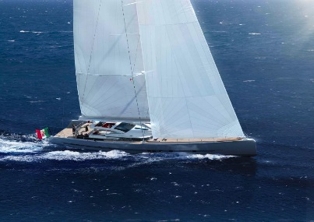

Sailboats TTD$235,000

Catamarans

as low as

TTD$50,000

Other Attractions:

* Live Music
* Food on Sale
* Free Boat Rides

Contact us:

Tel: 760-5546

Fax: 6658761

Opm.tt@gmail.com

Ocean Pacific Marina Ltd.

Presents

**Boat Sale**

**August 14th, 2021**

**From 2pm-6pm**

**Peake’s Marina, Chaguaramas**

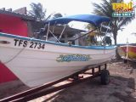

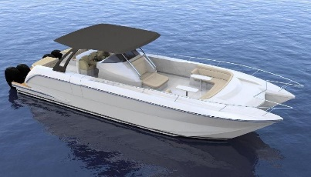

Pirogues

TTD$34,000